UNITED STATES

SECURITIES AND EXCHANGE COMMISSION

Washington, D.C. 20549

FORM 8-K

CURRENT REPORT

Pursuant to Section 13 or 15(d) of the Securities Exchange Act of 1934

Date of Report (Date of earliest event reported): March 2, 2012

___________________

Shenandoah Telecommunications Company

(Exact name of registrant as specified in its charter)

___________________

Virginia

(State or other jurisdiction of incorporation)

0-9881

(Commission File Number)

54-1162807

(IRS Employer Identification No.)

500 Shentel Way

P.O. Box 459

Edinburg, VA

(Address of principal executive offices)

22824

(Zip Code)

Registrant’s telephone number, including area code: (540) 984-4141

Not applicable

(Former name or former address, if changed since last report.)

Check the appropriate box below if the Form 8-K filing is intended to simultaneously satisfy the filing obligation of the registrant under any of the following provisions (see

General Instruction A.2. below):

- Written communications pursuant to Rule 425 under the Securities Act (17 CFR 230.425)

- Soliciting material pursuant to Rule 14a-12 under the Exchange Act (17 CFR 240.14a-12)

- Pre-commencement communications pursuant to Rule 14d-2(b) under the Exchange Act (17 CFR 240.14d-2-(b))

- Pre-commencement communications pursuant to Rule 13e-4(c) under the Exchange Act (17 CFR 240.13e-4(c))

1

Item 7.01 Regulation FD Disclosure.

The following information is furnished pursuant to Regulation FD: On March 2, 2012, Shenandoah Telecommunications Company held its fourth quarter 2011 earnings release conference call. The materials attached hereto as Exhibit 99.1 were utilized during the conference call. These materials are also available on the Company’s website.

These materials may contain forward-looking statements about Shenandoah Telecommunications regarding, among other things, our business strategy, our prospects and our financial position. These statements can be identified by the use of forward-looking terminology such as “believes,” “estimates,” “expects,” “intends,” “may,” “will,” “should,” “could,” or “anticipates” or the negative or other variation of these or similar words, or by discussions of strategy or risks and uncertainties. Shenandoah Telecommunications undertakes no obligation to revise or update such statements to reflect current events or circumstances after the date hereof, or to reflect the occurrence of unanticipated events.

Item 9.01 Financial Statements and Exhibits.

(c) Exhibits

The following exhibit is furnished with this Current Report on Form 8-K.

99.1 Fourth Quarter 2011 Earnings Release Conference Call Slides

SIGNATURE

Pursuant to the requirements of the Securities Exchange Act of 1934, the registrant has duly caused this report to be signed on its behalf by the undersigned thereunto duly authorized.

SHENANDOAH TELECOMMUNICATIONS COMPANY

(Registrant)

March 2, 2012 /S/ Adele M. Skolits

Adele M. Skolits

Vice President - Finance and

Chief Financial Officer

(Duly Authorized Officer)

2

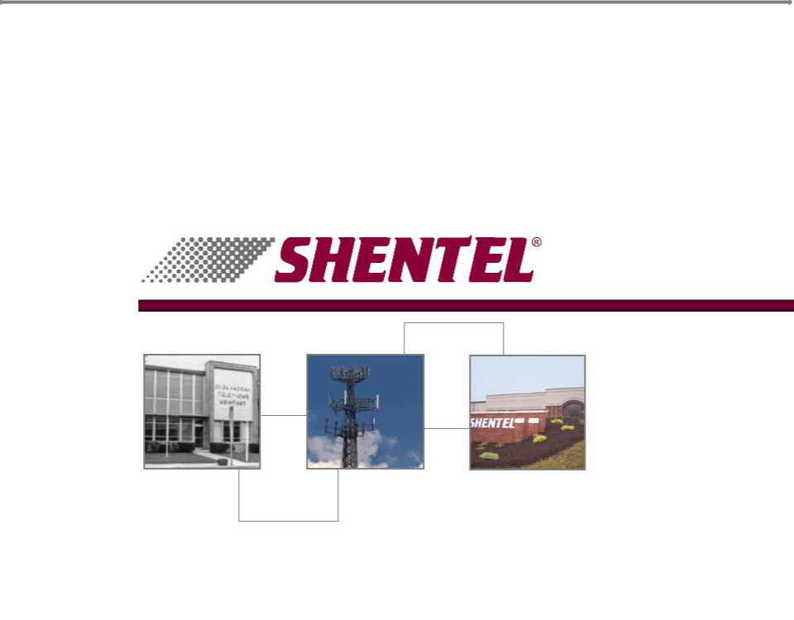
Exhibit 99.1

4Q 2011 Earnings Conference Call

March 2, 2012


Safe Harbor Statement

This presentation includes “forward-looking statements” within the meaning of Section 27A of the Securities Act and Section 21E of the Securities Exchange Act of 1934, as amended, regarding, among other things, our business strategy, our prospects and our financial position. These statements can be identified by the use of forward-looking terminology such as “believes,” “estimates,” “expects,” “intends,” “may,” “will,” “should,” “could,” or “anticipates” or the negative or other variation of these similar words, or by discussions of strategy or risks and uncertainties. These statements are based on current expectations of future events. If underlying assumptions prove inaccurate or unknown risks or uncertainties materialize, actual results could vary materially from the Company’s expectations and projections. Important factors that could cause actual results to differ materially from such forward-looking statements include, without limitation, risks related to the following:

qIncreasing competition in the communications industry; and qA complex and uncertain regulatory environment.

A further list and description of these risks, uncertainties and other factors can be found in the Company’s SEC filings which are available online at www.sec.gov, www.shentel.com or on request from the Company. The Company does not undertake to update any forward-looking statements as a result of new information or future events or developments.

2

Use of Non-GAAP Financial Measures

Included in this presentation are certain non-GAAP financial measures that are not determined in accordance with US generally accepted accounting principles. These financial performance measures are not indicative of cash provided or used by operating activities and exclude the effects of certain operating, capital and financing costs and may differ from comparable information provided by other companies, and they should not be considered in isolation, as an alternative to, or more meaningful than measures of financial performance determined in accordance with US generally accepted accounting principles. These financial performance measures are commonly used in the industry and are presented because Shentel believes they provide relevant and useful information to investors. Shentel utilizes these financial performance measures to assess its ability to meet future capital expenditure and working capital requirements, to incur indebtedness if necessary, return investment to shareholders and to fund continued growth. Shentel also uses these financial performance measures to evaluate the performance of its businesses and for budget planning purposes.

3

Chris French

CEO and President

4

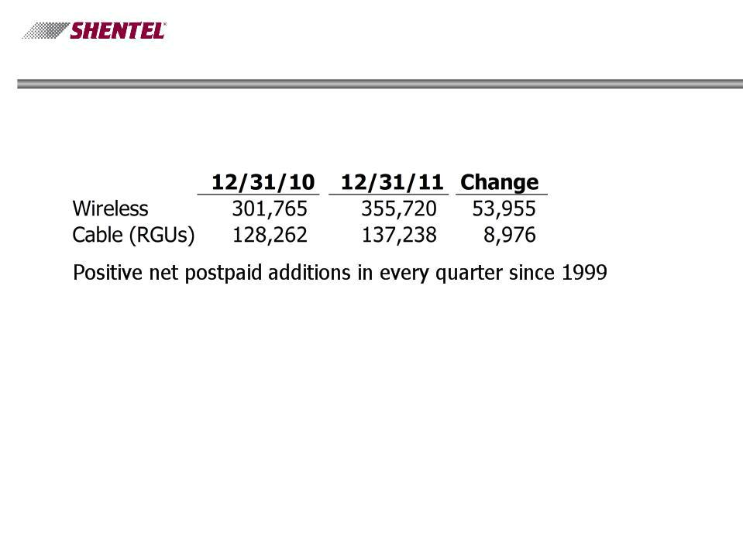
4Q’11 Highlights

- Customer Growth

- Revenue Growth

Revenues reach one-quarter billion

Revenue grew 15% over 4Q’10 to $66.5 million.

- Cash Dividend

52nd consecutive year of annual dividends

5

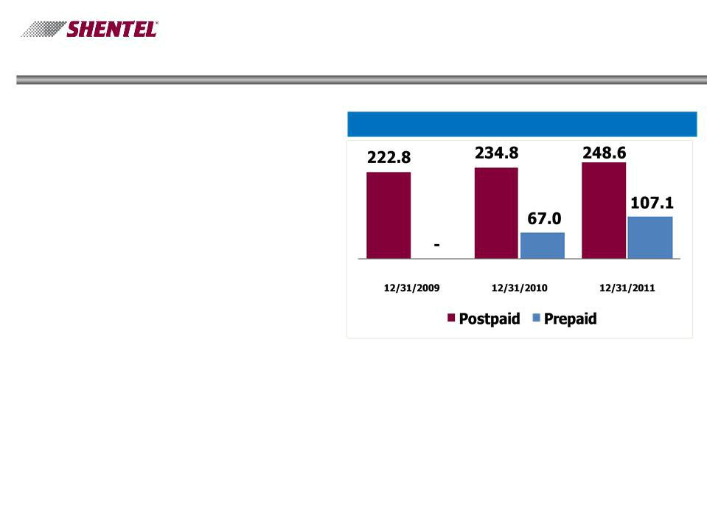
Wireless Highlights

qRapid Prepaid Growth Q4’11 net additions of 8,828; 107,100 prepaid subs at 12/31

qSteady Postpaid growth Postpaid customers up 6% in the last year

qPostpaid Churn improves Annual churn of 1.8% compared to 1.9% for 2010

q Earnings Improve

Annual operating income up

by $5.0 million over 2010

PCS Customers (000s)

6

Cable Highlights

q Cable Upgrades

- Former JetBroadband markets acquired in mid-2010 are approximately 51% complete

- Remainder scheduled for 2012

q RGU Growth

- Total RGU growth of 7% during 2011

- 137,238 RGUs at 12/31/2011

7

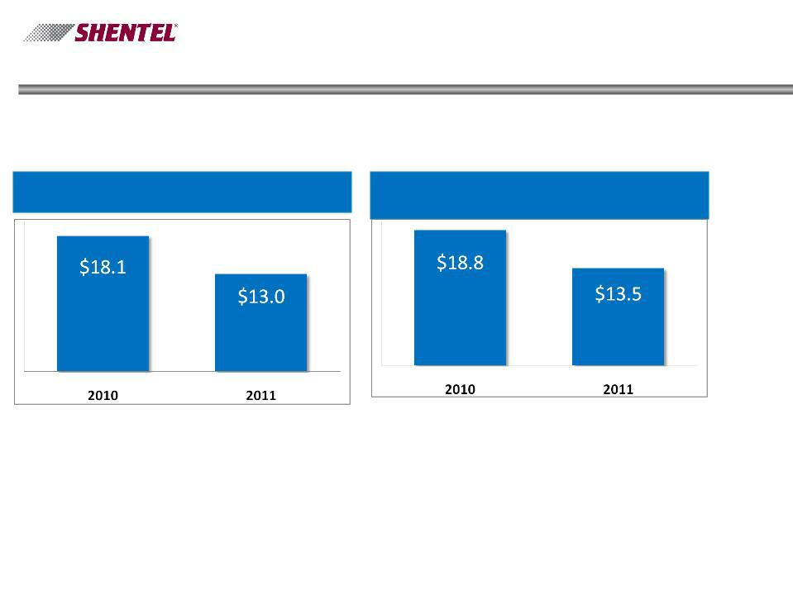
2011 Financial Highlights

Net Income | Net Income from Continuing Operations
(in millions) | (in millions)

8

Adele Skolits

CFO and VP of Finance

9

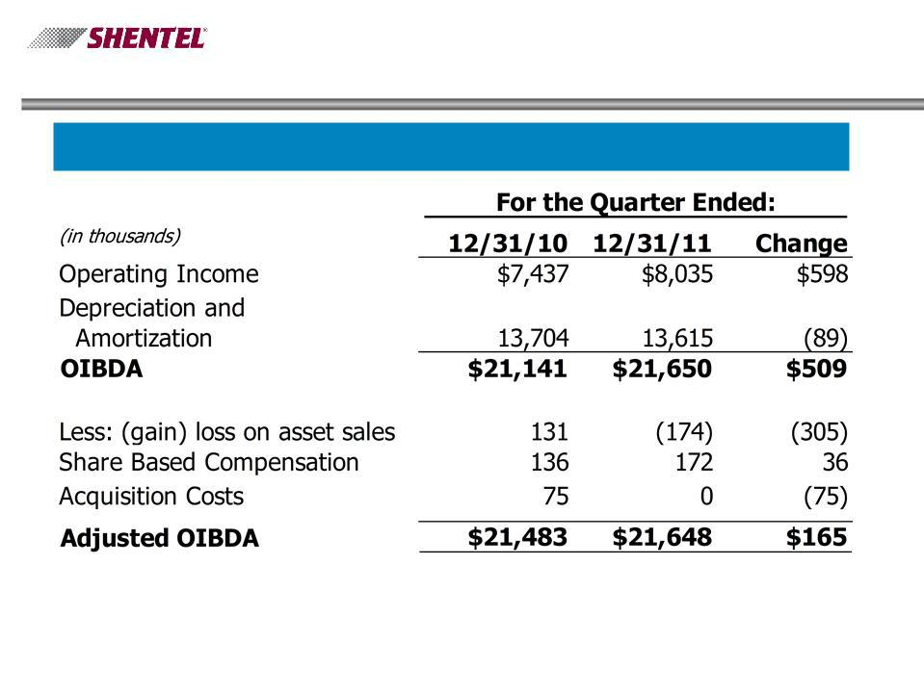
Profitability

Adjusted OIBDA ($ thousands)

10

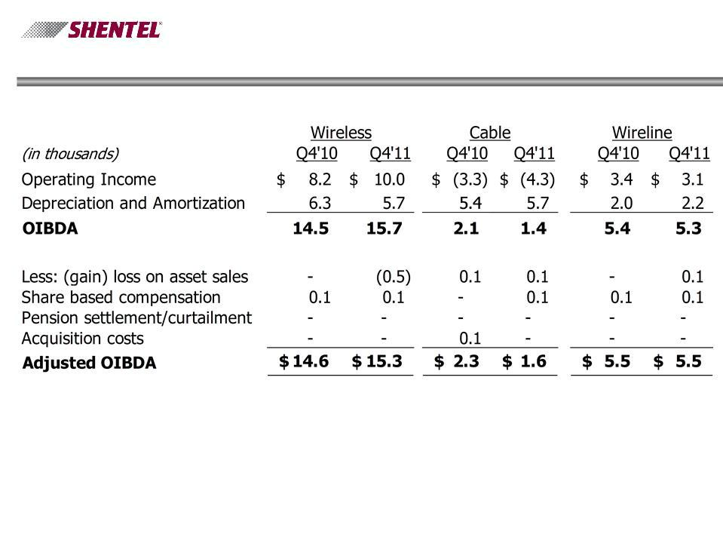
Adjusted OIBDA by Segment

11

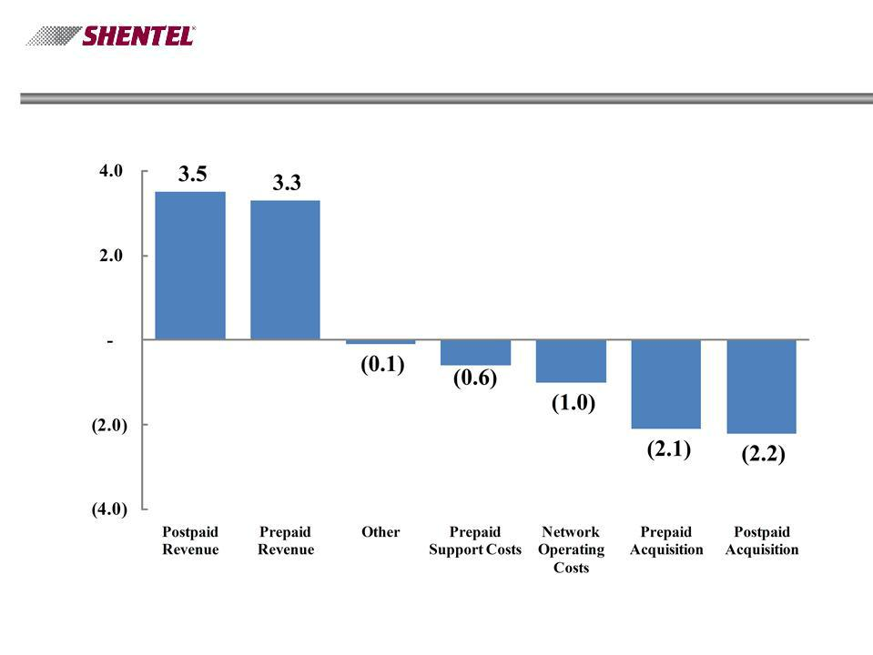
Wireless Segment - Change in Adjusted OIBDA Q4’11 vs. Q4’10

12

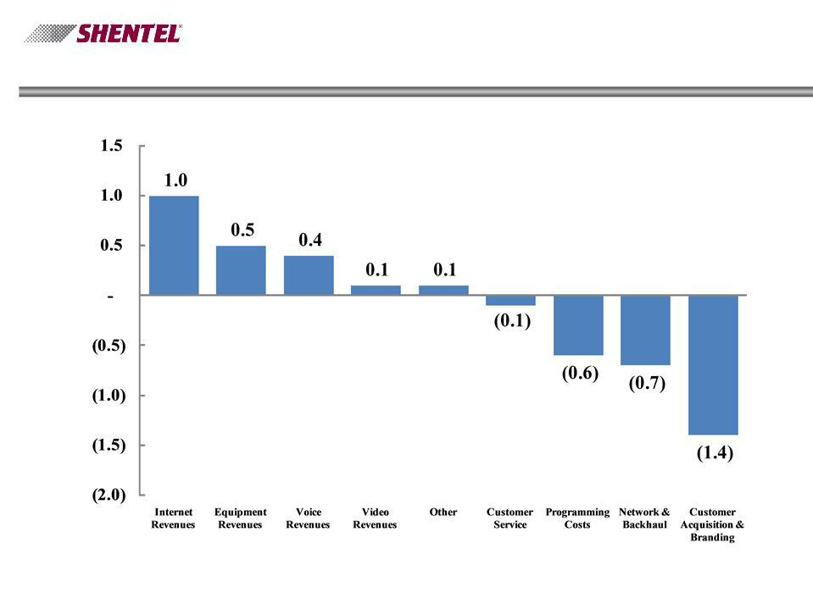
Cable Segment - Change in Adjusted OIBDA Q4’11 vs. Q4’10

13

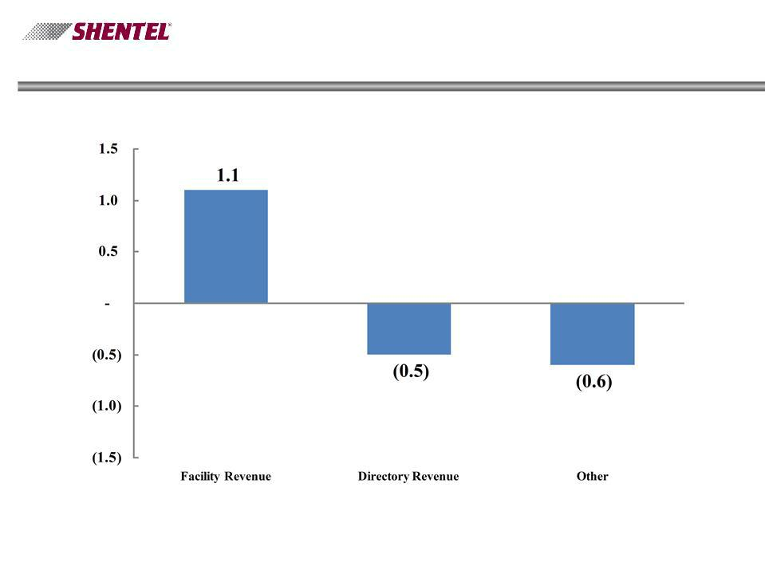
Wireline Segment - Change in Adjusted OIBDA Q4’11 vs. Q4’10

14

Earle MacKenzie

EVP and COO

15

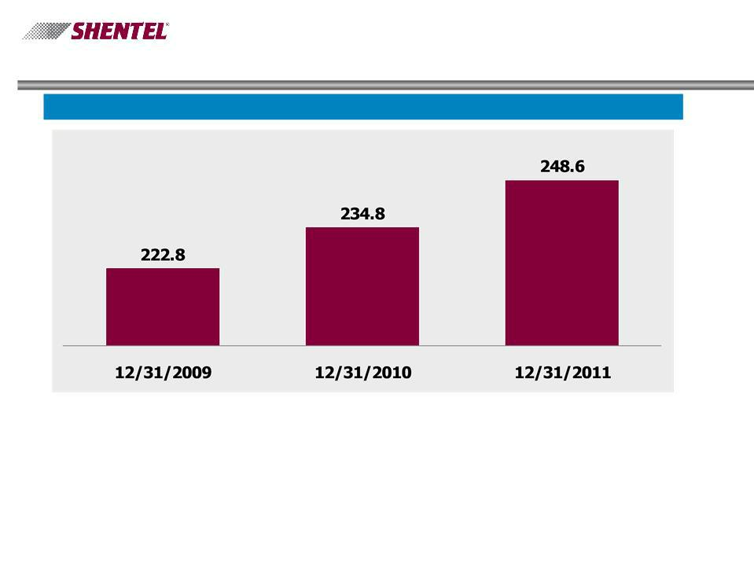
Key Operational Results - Wireless

PCS Postpaid Customers (000s)

16

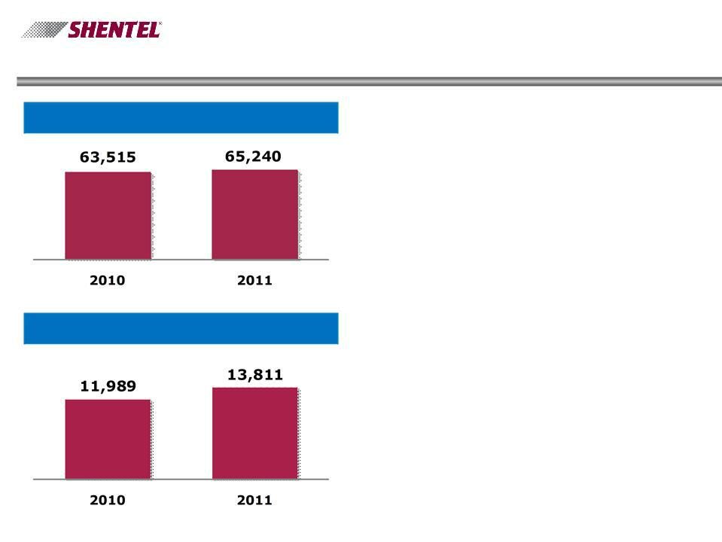
Key Operational Results - Wireless

Annual Gross Additions - Postpaid

Annual Net Additions - Postpaid

- 6% YOY postpaid net growth

- Q4 2011 net adds of 5,072, a 21% increase over Q4 2010.

- Q4 2011 churn of 1.89% up from 1.85% in Q4 2010

- 2011 annual churn of
1.78% improved from
1.89% in 2010

17

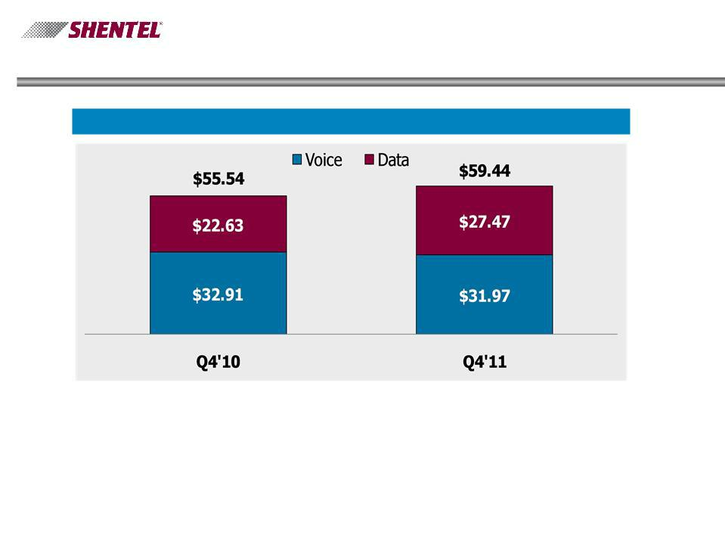
Key Operational Results - PCS

Gross Billed Revenue per Postpaid User - Data & Voice ¹

- - Before Service credits, bad debt, Sprint Nextel fees.

18

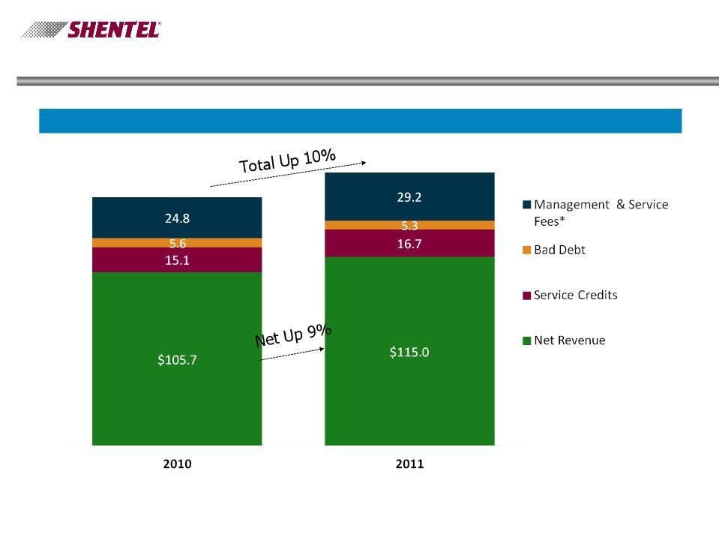
PCS Revenues

Annual Gross Billed Revenues - Postpaid ($ millions)

$166.2

$151.2

* The Net Service Fee percentage increased from 8.8% to 12% effective 6/1/2010
19

Postpaid PCS Customers Top Picks Q4 2011

n Top Service Plans - Gross Adds |  | n Top Devices - New Activations
u | Everything Data Family | - All Channels
 | 1500 - 56% | u | iPhone | 16%
u | Everything 450 - 18% | u | HTC EVO 4G | 10%
u | Everything Messaging | u | HTC EVO 3D | 8%
 | Family 1500 - 2% | u | LG Optimus S | 7%
 |  | u | Nexus S | 6%

n Smartphones made up 53% of
the Postpaid base in Q4 2011,
up from 48% in Q3 2011 and

34% in Q4 2010

20

iPhone Statistics - Q4’11

- 16% of Q4 Gross Adds

- 36% of iPhones were sold or upgraded in Shentel-controlled channels

- 3.6% of 12/31/11 Postpaid customers had the iPhone

- 58% iPhone 4S

- 42% iPhone 4

21

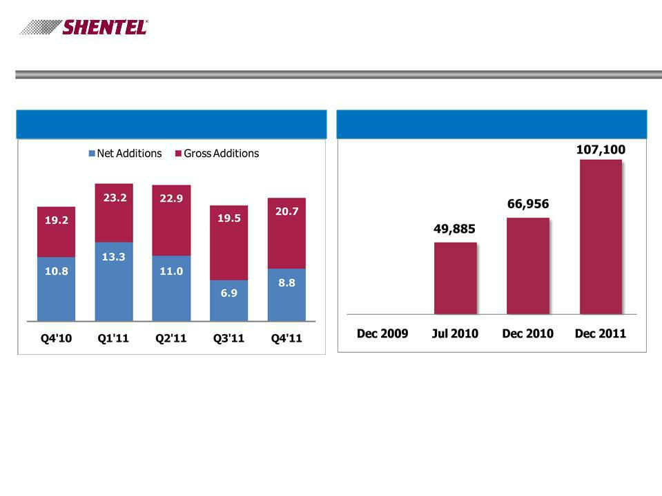
PCS Prepaid Statistics

Gross Additions (000s) Cumulative Customers

22

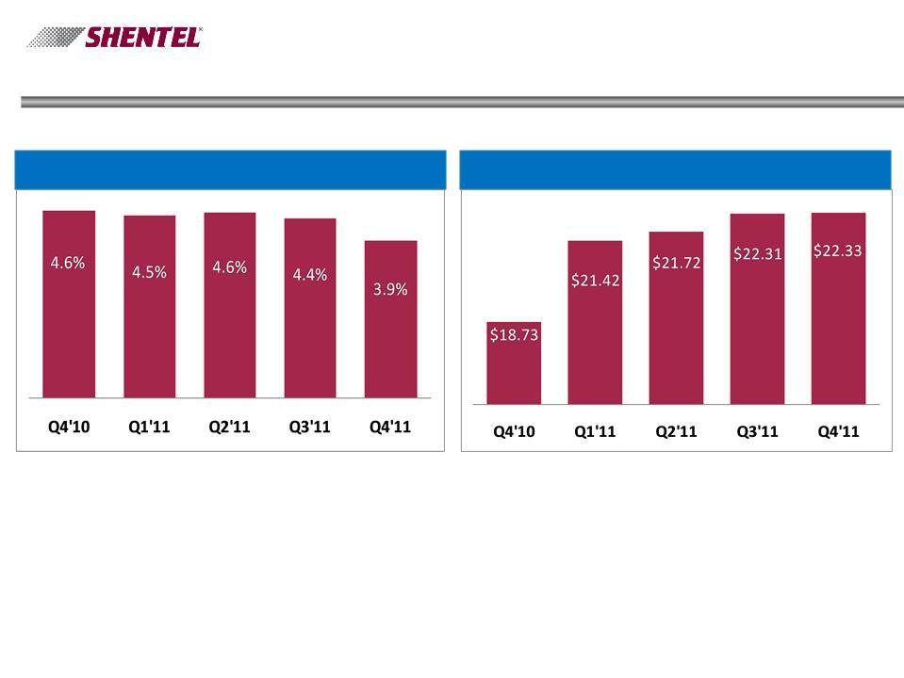
PCS Prepaid Statistics

Churn % Average Gross Billed Revenue

23

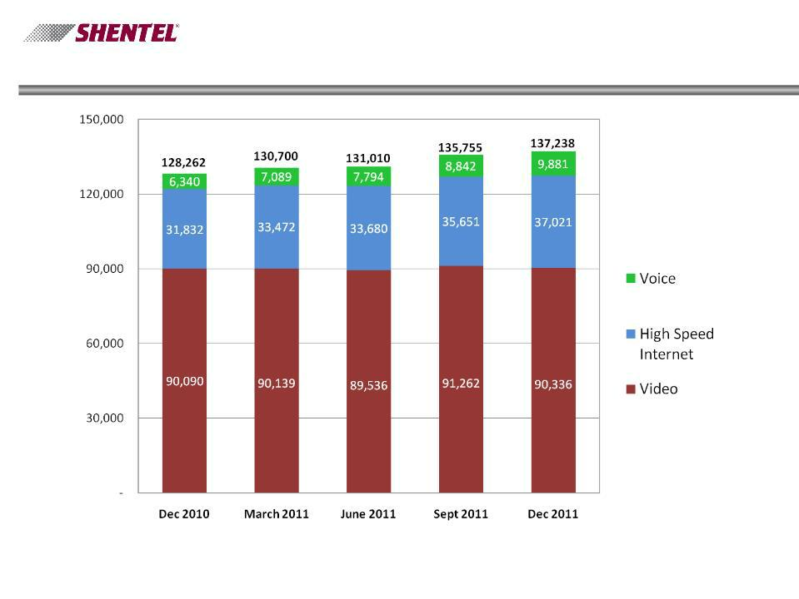
Cable - RGU Growth by Quarter

Customers | 74,178 | 74,657 | 73,930 | 75,131 | 75,348
RGU's/Customer | 1.73 | 1.75 | 1.77 | 1.81 | 1.82
24

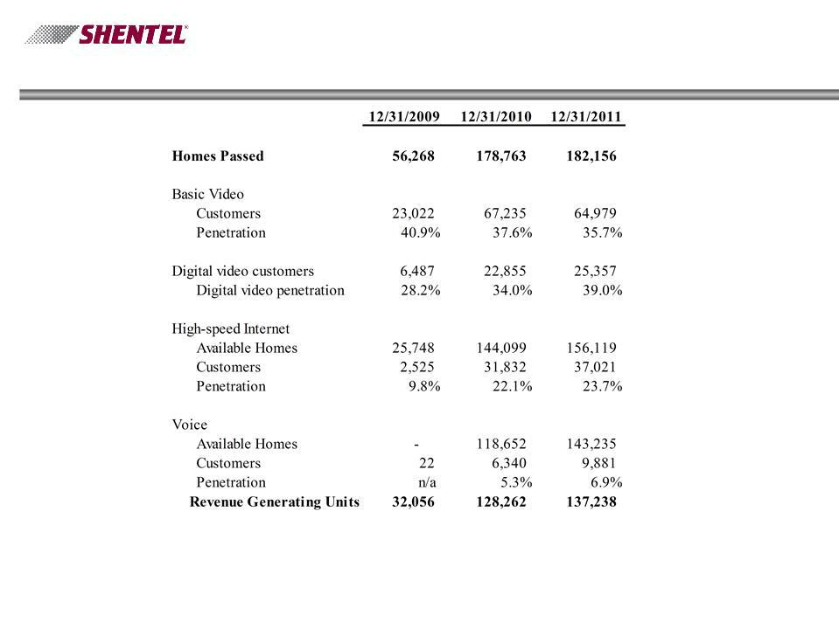
Key Operational Results - Cable

Note: Video homes passed includes 16K homes located in Shenandoah County, VA, where internet and voice services are provided by the Wireline segment.

25

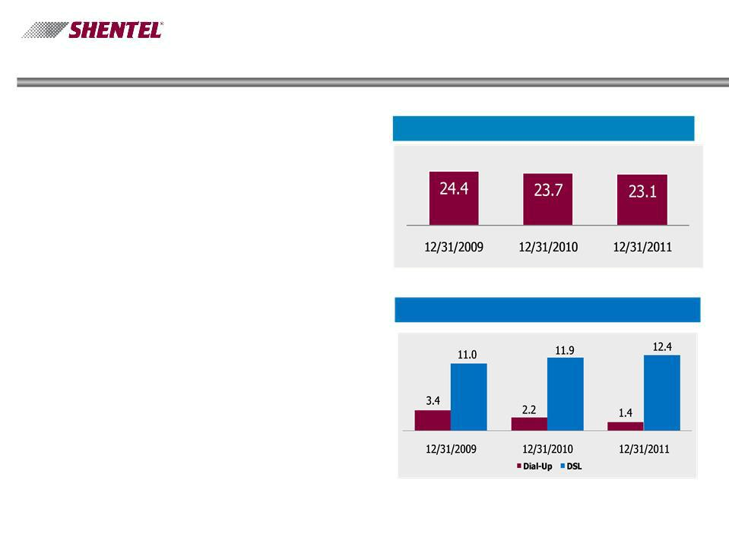
Key Operational Results - Wireline

- Modest access line loss of 3% in past 12 months

- Continued broadband penetration in LEC area to 53%

- 3% growth in DSL customers since 12/31/10, partially offsetting access line losses, resulting in total connections of 35.4 thousand, down from 35.6 thousand at 12/31/10

Access lines (000s)

Internet Customers (000s)

26

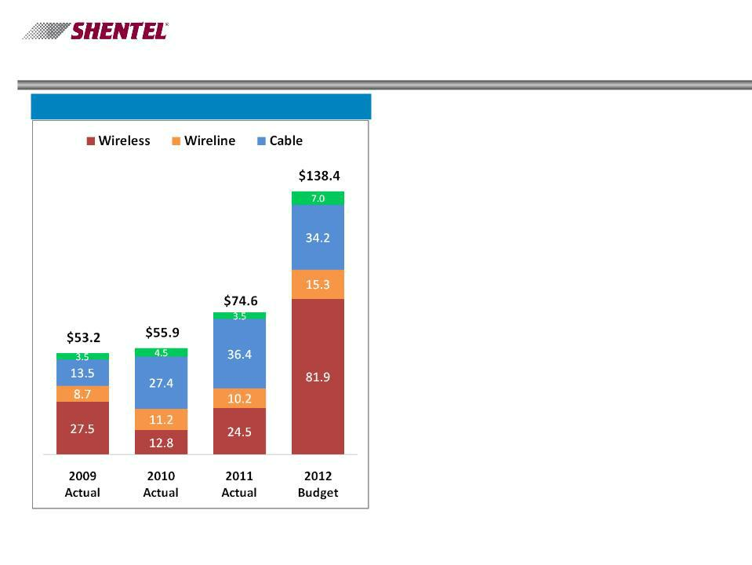
Investing in the Future

Capex Spending

n Upgrade of Jet Network is
approximately 51% complete

n All remaining systems in
Virginia, West Virginia and
Maryland to have upgrades

completed in 2012

n Network Vision expected to
drive $60M of spend in 2012

27

Investing in the Future - Network Vision

- Plan to upgrade 274 cell sites in 2012 and the remaining
236 in 2013 including:

- Multi-modal base station at each site

- Expanded backhaul capacity

- LTE in the PCS G-block

- Voice service in the 800Mhz block

- Expect to accelerate depreciation by

- $7.3M in 2012

- $5.3M in 2013

- Expect to launch LTE as early as Q3 2012

28

Q&A

29

Appendix

30

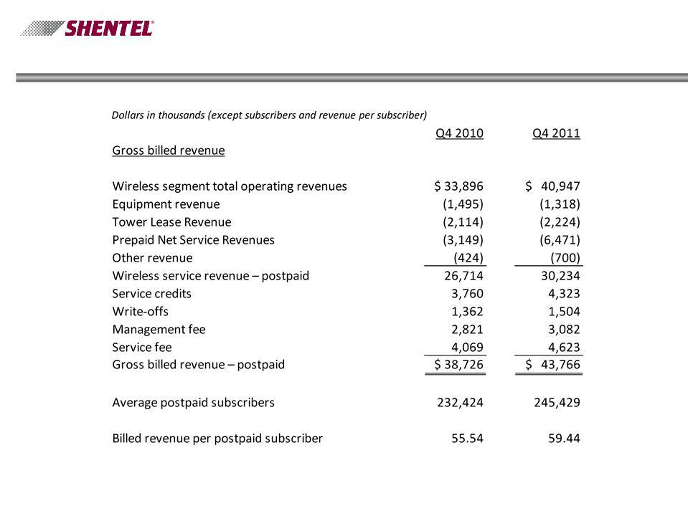
Non-GAAP Financial Measure - Billed Revenue per Postpaid Subscriber

31

