UNITED STATES

SECURITIES AND EXCHANGE COMMISSION

Washington, D.C. 20549

FORM 8-K

CURRENT REPORT

Pursuant to Section 13 or 15(d) of the Securities Exchange Act of 1934

Date of Report (Date of earliest event reported): April 19, 2010

___________________

Shenandoah Telecommunications Company

--------------------------------------------------------------------------------------------------------------------------------------

(Exact name of registrant as specified in its charter)

__________________

Virginia

(State or other jurisdiction of incorporation)

0-9881

(Commission File Number)

54-1162807

(IRS Employer Identification No.)

500 Shentel Way

P.O. Box 459

Edinburg, VA

(Address of principal executive offices)

22824

(Zip Code)

Registrant’s telephone number, including area code: (540) 984-4141

Not applicable

-------------------------------------------------

(Former name or former address, if changed since last report.)

Check the appropriate box below if the Form 8-K filing is intended to simultaneously satisfy the filing obligation of the registrant under any of the following provisions (see

General Instruction A.2. below):

- Written communications pursuant to Rule 425 under the Securities Act (17 CFR 230.425)

- Soliciting material pursuant to Rule 14a-12 under the Exchange Act (17 CFR 240.14a-12)

- Pre-commencement communications pursuant to Rule 14d-2(b) under the Exchange Act (17 CFR 240.14d-2-(b))

- Pre-commencement communications pursuant to Rule 13e-4(c) under the Exchange Act (17 CFR 240.13e-4(c))

1

Item 7.01 Regulation FD Disclosure.

The following information is furnished pursuant to Regulation FD: As previously reported, on April 16, 2010, Shenandoah Telecommunications Company (the “Company”) issued a press release announcing that it had signed an asset purchase agreement to acquire the cable operations of JetBroadband Holdings, LLC for $148 million in cash, subject to certain adjustments. The acquired cable operations offer video, high speed Internet and voice services representing approximately 66,500 revenue generating units in southern Virginia and southern West Virginia. The acquired networks pass approximately 114,000 homes.

The Company hosted a conference call on April 19, 2010, at 9 a.m. Eastern time to provide additional details about this acquisition. The presentation attached hereto as Exhibit 99.1 was presented during the call, and is also available on the Company’s website

The presentation may contain forward-looking statements about Shenandoah Telecommunications regarding, among other things, our business strategy, our prospects and our financial position. These statements can be identified by the use of forward-looking terminology such as “believes,” “estimates,” “expects,” “intends,” “may,” “will,” “should,” “could,” or “anticipates” or the negative or other variation of these or similar words, or by discussions of strategy or risks and uncertainties. Shenandoah Telecommunications undertakes no obligation to revise or update such statements to reflect current events or circumstances after the date hereof, or to reflect the occurrence of unanticipated events.

Item 9.01 Financial Statements and Exhibits.

(d) Exhibits

99.1 Pro forma combined historical operating statistics

SIGNATURE

Pursuant to the requirements of the Securities Exchange Act of 1934, the registrant has duly caused this report to be signed on its behalf by the undersigned thereunto duly authorized.

SHENANDOAH TELECOMMUNICATIONS COMPANY

(Registrant)

April 19, 2010 /s/ Adele M. Skolits

Adele M. Skolits

Vice President - Finance and

Chief Financial Officer

(Duly Authorized Officer)

2

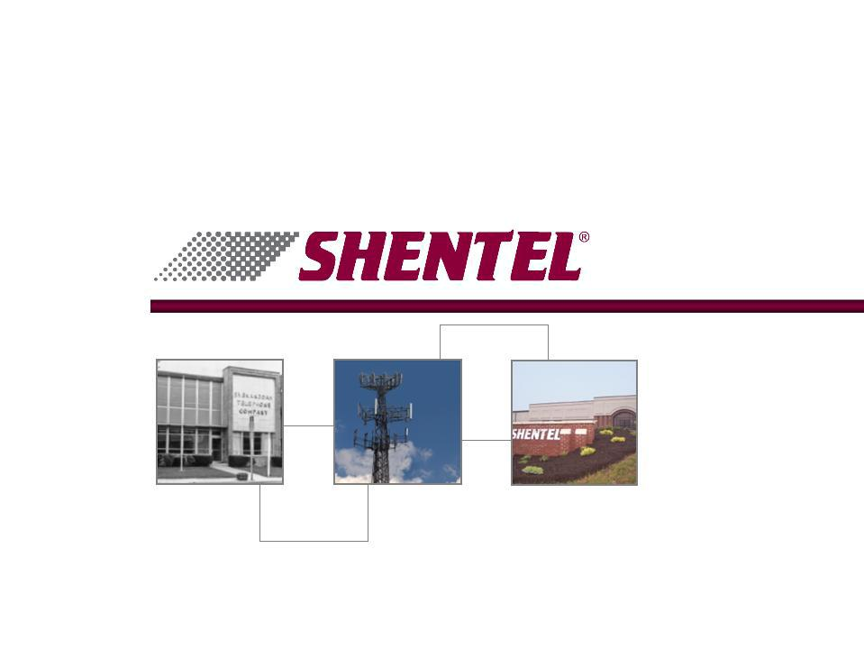
Exhibit 99.1

Investor Conference Call

April 19, 2010


Safe Harbor Statement

This presentation includes “forward-looking statements” within the meaning of Section 27A of the Securities Act and Section 21E of the Securities Exchange Act of 1934, as amended, regarding, among other things, our business strategy, our prospects and our financial position. These statements can be identified by the use of forward-looking terminology such as “believes,” “estimates,” “expects,” “intends,” “may,” “will,” “should,” “could,” or “anticipates” or the negative or other variation of these similar words, or by discussions of strategy or risks and uncertainties. These statements are based on current expectations of future events. If underlying assumptions prove inaccurate or unknown risks or uncertainties materialize, actual results could vary materially from the Company’s expectations and projections. Important factors that could cause actual results to differ materially from such forward-looking statements include, without limitation, risks related to the following:

qIncreasing competition in the communications industry; and qA complex and uncertain regulatory environment.

A further list and description of these risks, uncertainties and other factors can be found in the Company’s SEC filings which are available online at www.sec.gov, www.shentel.com or on request from the Company. The Company does not undertake to update any forward-looking statements as a result of new information or future events or developments

2

Use of Non-GAAP Financial Measures

Included in this presentation are certain non-GAAP financial measures that are not determined in accordance with US generally accepted accounting principles. These financial performance measures are not indicative of cash provided or used by operating activities and exclude the effects of certain operating, capital and financing costs and may differ from comparable information provided by other companies, and they should not be considered in isolation, as an alternative to, or more meaningful than measures of financial performance determined in accordance with US generally accepted accounting principles. These financial performance measures are commonly used in the industry and are presented because Shentel believes they provide relevant and useful information to investors. Shentel utilizes these financial performance measures to assess its ability to meet future capital expenditure and working capital requirements, to incur indebtedness if necessary, return investment to shareholders and to fund continued growth. Shentel also uses these financial performance measures to evaluate the performance of its businesses and for budget planning purposes.

3

Deal Highlights

- Structured as an asset purchase

- Purchase Price = $148

- 115 thousand homes passed and serves 66 thousand RGUs

- 44 thousand video customers

- 21 thousand data customers

- 2 thousand voice customers

- Network

- 3,200 miles

- 900 miles of fiber

- 84% two way

- Competition

- No fiber to the home

- CenturyLink and Verizon

- Satellite providers

4

Deal Highlights - Continued

- Operating Income before Interest and Depreciation

- $15.5 before Corporate office costs

- $13.8 after Corporate office costs

- Financing

- Syndicated debt deal

- $198m Term Loan

- $50m Undrawn Revolver

- Oversubscribed at more than 150% of needs

5

JBB Acquisition - Rationale

- Diversification

- Scale

- Below Market Penetration

- Geographic Fit

- Synergies

- Leveraging Core Competencies

- Coaxial Network

6

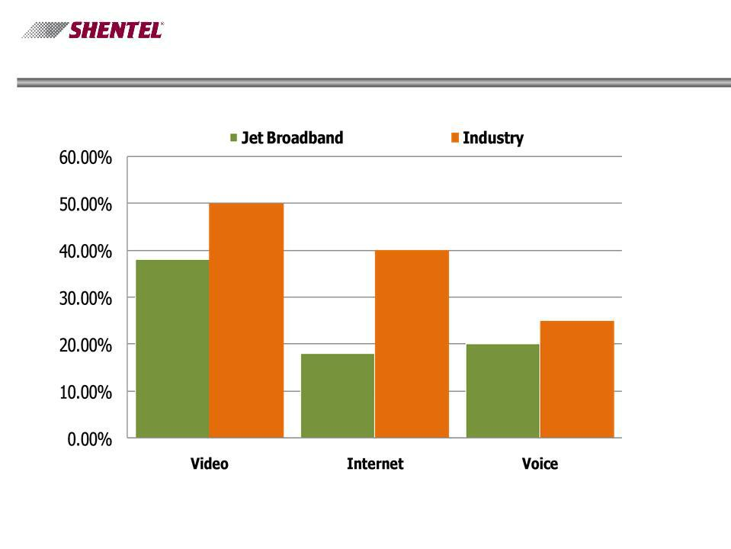
Percent of Homes Passed with Services

7

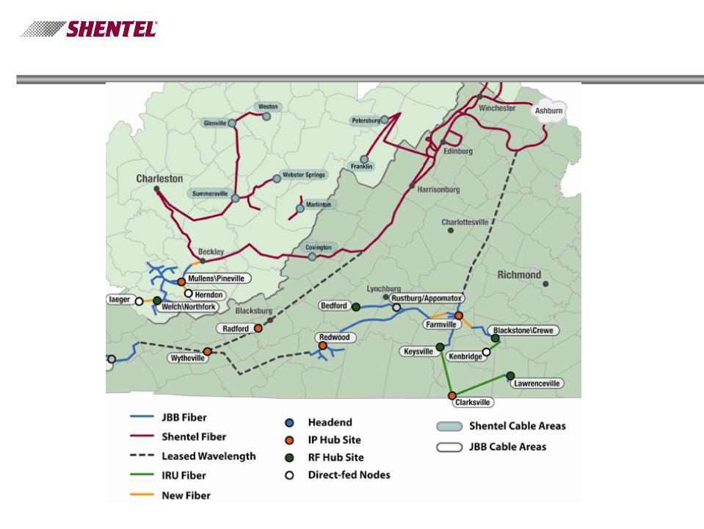
JBB Network

8

Key Operational Metrics - With Acquisition

Pro Forma for Periods Ending December 31, 2009

Cable Homes Passed (in 000’s) RGUs (in 000’s)

Revenues (in millions) OIBDA (in millions)

9

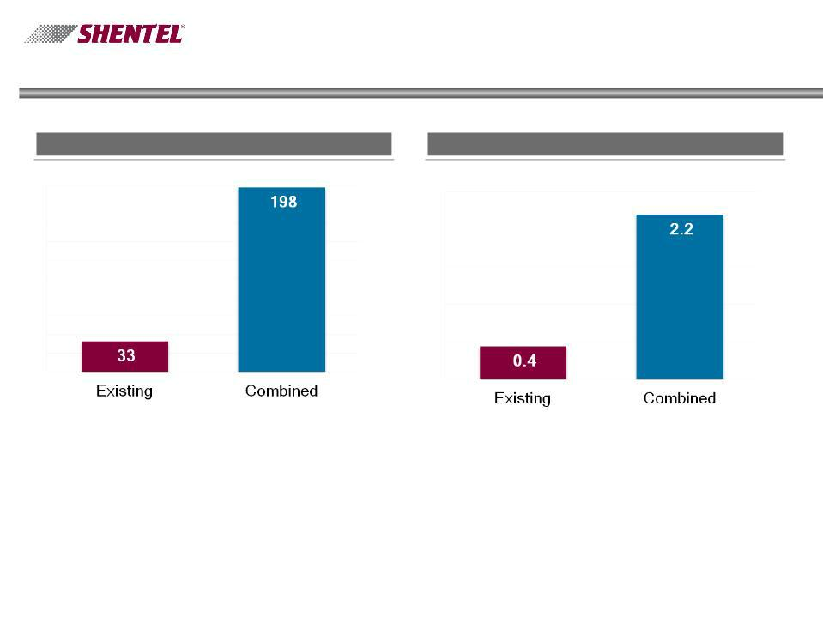
Level of Debt

Pro Forma for Periods Ending December 31, 2009

Debt (in millions) Debt to EBITDA Ratio

10

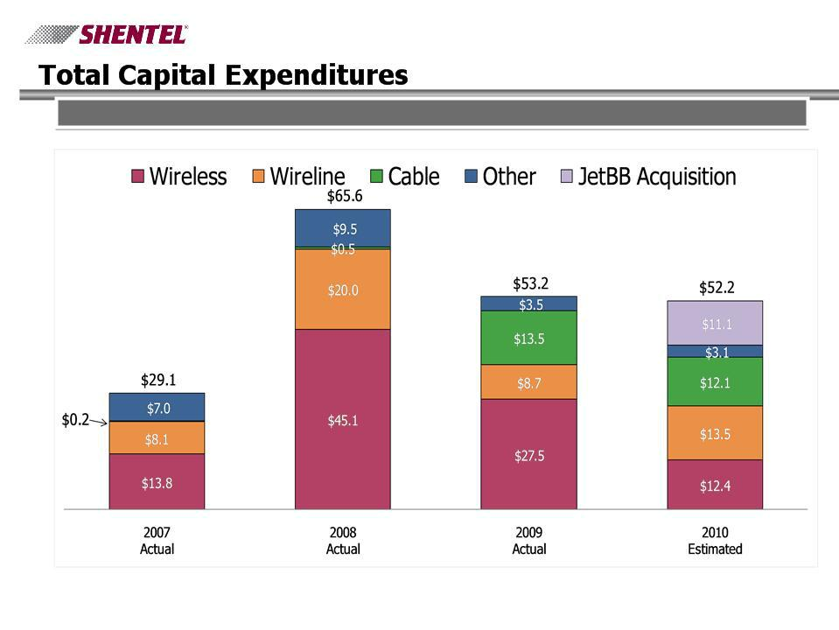
Capital Expenditures by Segment ($ millions)

11

JBB Execution

q Success with Rapid Acquisition

q Network Interconnection

q Proven Technologies

q Similar Demographics

- Proximity

- Low Regulatory Risk

- Strategic Owner Appeal

12

Q&A

13

