UNITED STATES

SECURITIES AND EXCHANGE COMMISSION
Washington, D.C. 20549

FORM 8-K

CURRENT REPORT

Pursuant to Section 13 or 15(d) of the Securities Exchange Act of 1934

Date of Report (Date of earliest event reported): May 12, 2010

___________________

Shenandoah Telecommunications Company

(Exact name of registrant as specified in its charter)

__________________

Virginia

(State or other jurisdiction of incorporation)

0-9881

(Commission File Number)

54-1162807

(IRS Employer Identification No.)

500 Shentel Way

P.O. Box 459

Edinburg, VA

(Address of principal executive offices)

22824

(Zip Code)

Registrant’s telephone number, including area code: (540) 984-4141

Not applicable

(Former name or former address, if changed since last report.)

Check the appropriate box below if the Form 8-K filing is intended to simultaneously satisfy the filing obligation of the registrant under any of the following provisions (see General Instruction A.2. below):

- Written communications pursuant to Rule 425 under the Securities Act (17 CFR 230.425)

- Soliciting material pursuant to Rule 14a-12 under the Exchange Act (17 CFR 240.14a-12)

- Pre-commencement communications pursuant to Rule 14d-2(b) under the Exchange Act (17 CFR 240.14d-2-(b))

- Pre-commencement communications pursuant to Rule 13e-4(c) under the Exchange Act (17 CFR 240.13e-4(c))

Item 8.01 Other Events.

On May 12, 2010, Shenandoah Telecommunications Company presented at the Jefferies 6th Annual Global Internet, Media & Telecom Conference in New York, New York. The presentation included materials related to the Company’s results of operations through March 31, 2010. The materials attached hereto as Exhibit 99.1 were utilized during the presentation. These materials are also available on the Company’s website.

These materials may contain forward-looking statements about Shenandoah Telecommunications regarding, among other things, our business strategy, our prospects and our financial position. These statements can be identified by the use of forward-looking terminology such as “believes,” “estimates,” “expects,” “intends,” “may,” “will,” “should,” “could,” or “anticipates” or the negative or other variation of these or similar words, or by discussions of strategy or risks and uncertainties. Shenandoah Telecommunications undertakes no obligation to revise or update such statements to reflect current events or circumstances after the date hereof, or to reflect the occurrence of unanticipated events.

Item 9.01 Financial Statements and Exhibits.

(c) Exhibits

The following exhibits are furnished with this Current Report on Form 8-K.

99.1 Jefferies 6th Annual Global Internet, Media & Telecom Conference Presentation Slides

SIGNATURE

Pursuant to the requirements of the Securities Exchange Act of 1934, the registrant has duly caused this report to be signed on its behalf by the undersigned thereunto duly authorized.

SHENANDOAH TELECOMMUNICATIONS COMPANY

(Registrant)

May 12, 2010 Adele M. Skolits

Adele M. Skolits

Vice President - Finance and

Chief Financial Officer

(Duly Authorized Officer)

2

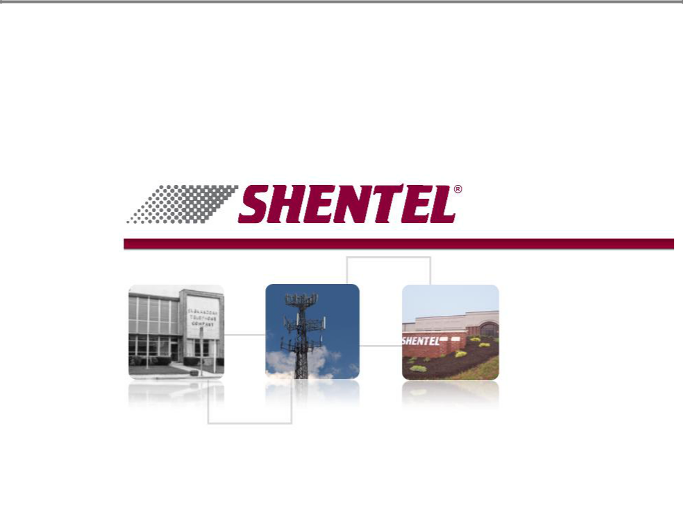
Exhibit 99.1

Jefferies

Global Internet, Media, & Telecom Conference

May 12, 2010


Safe Harbor Statement

This presentation includes “forward-looking statements” within the meaning of Section 27A of the Securities Act and Section 21E of the Securities Exchange Act of 1934, as amended, regarding, among other things, our business strategy, our prospects and our financial position. These statements can be identified by the use of forward-looking terminology such as “believes,” “estimates,” “expects,” “intends,” “may,” “will,” “should,” “could,” or “anticipates” or the negative or other variation of these similar words, or by discussions of strategy or risks and uncertainties. These statements are based on current expectations of future events. If underlying assumptions prove inaccurate or unknown risks or uncertainties materialize, actual results could vary materially from the Company’s expectations and projections. Important factors that could cause actual results to differ materially from such forward-looking statements include, without limitation, risks related to the following:

nIncreasing competition in the communications industry; and nA complex and uncertain regulatory environment.

A further list and description of these risks, uncertainties and other factors can be found in the Company’s Annual Report on Form 10-K for the fiscal year ended December 31, 2009. Copies of this Form 10-K, as well as subsequent filings, are available online at www.sec.gov, www.shentel.com or on request from the Company. The Company does not undertake to update any forward-looking statements as a result of new information or future events or developments.

1

Use of Non-GAAP Financial Measures

Included in this presentation are certain non-GAAP financial measures that are not determined in accordance with US generally accepted accounting principles. These financial performance measures are not indicative of cash provided or used by operating activities and exclude the effectors of certain operating, capital and financing costs and may differ from comparable information provided by other companies, and they should not be considered in isolation, as an alternative to, or more meaningful than measures of financial performance determined in accordance with US generally accepted accounting principles. These financial performance measures are commonly used in the industry and are presented because Shentel believes they provide relevant and useful information to investors. Shentel utilizes these financial performance measures to assess its ability to meet future capital expenditure and working capital requirements, to incur indebtedness if necessary, return investment to shareholders and to fund continued growth. Shentel also uses these financial performance measures to evaluate the performance of its business and for budget planning purposes.

2


Agenda

Introduction and Shentel Overview - Earle MacKenzie - EVP/COO

Overview of Wireless

Overview of Cable

Overview of Wireline

Financials - Adele Skolits - CFO

3

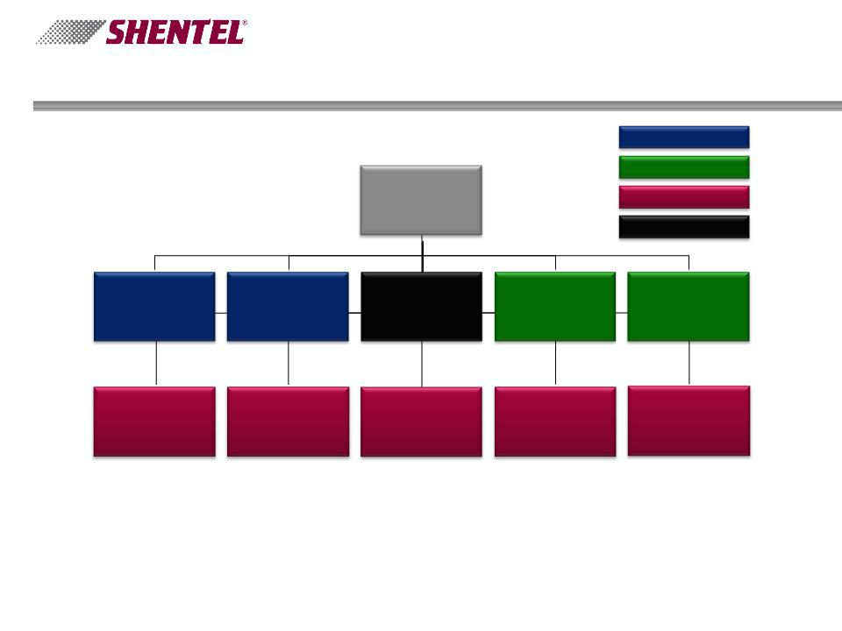
Shenandoah Telecommunications Company

 |  |  |  | Wireless Entities
 |  |  |  | Cable Entities
 |  | Shenandoah |  | Wireline Entities
 |  | Telecommunications |  | Wireline Entities
 |  | Company
 |  |  |  | Allocation Subsidiary
Shenandoah
Personal | Shenandoah Mobile | Shentel Management | Shenandoah Cable | Shentel Cable
Communications | Company | Company | Television Company | Company
Company

Shenandoah | Shentel Service | Shenandoah | Shentel | Shenandoah Long
Shenandoah | Shentel Service | Shenandoah | Communications | Shenandoah Long
Network Company | Company | Telephone Company | Communications | Distance Company
Network Company | Company | Telephone Company | Company | Distance Company

- Reporting Segments: Wireless, Wireline and Cable

- Shentel Management Company: Allocation subsidiary for all employees and shared expenses

4

Growth Strategy - Capitalize on Core Competencies

- Cable

- Focus on smaller less competitive markets

- Build clusters to gain operating efficiencies

- Upgrade networks to offer “Triple Play”

- Wireless

- Increase penetration in existing PCS footprint

- Look for new wireless opportunities in surrounding geographic areas

- Wireline

- Attractive markets at reasonable prices

5

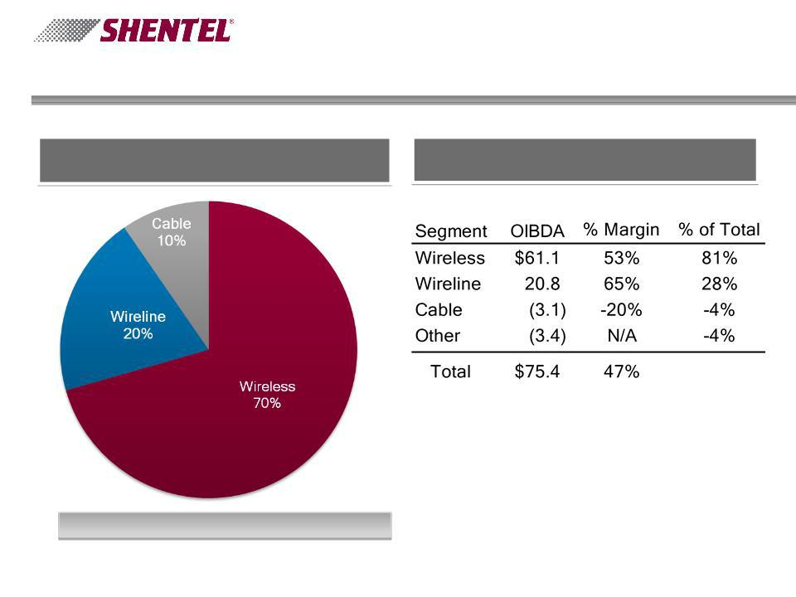
Segment Overview

Twelve Months Ending March 31, 2010

Revenue by Segment | Operating Income Before Depreciation
Revenue by Segment | & Amortization (OIBDA) by Segment

Total External Revenues = $162.0 million

6

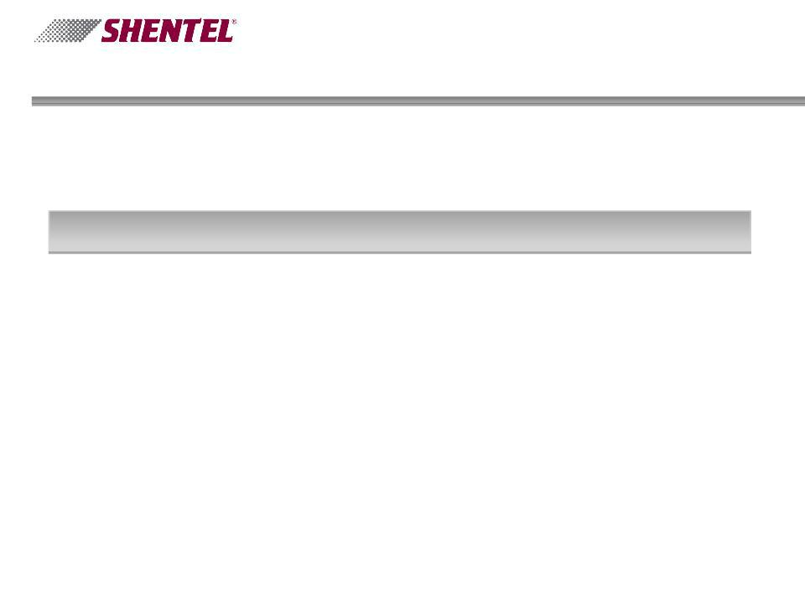
Agenda

Introduction and Shentel Overview

Overview of Wireless

Overview of Cable

Overview of Wireline

Financials

7

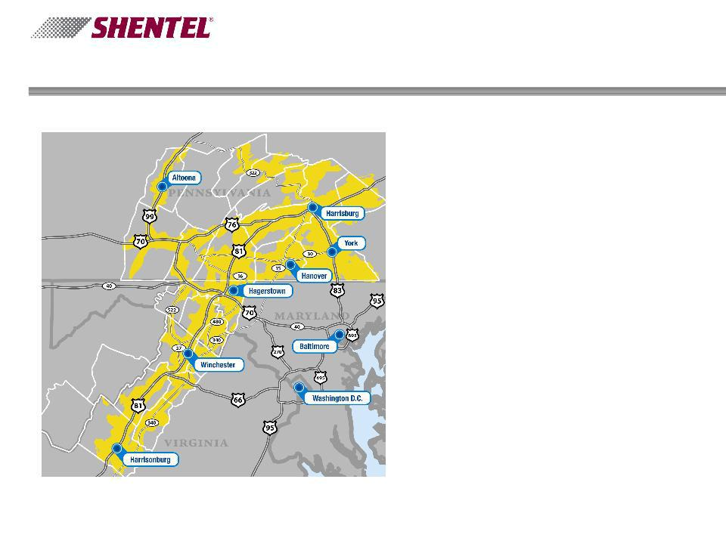
PCS Overview

n Only remaining public Sprint

Nextel affiliate

n 2.4 million licensed POPs

n 2.1 million covered POPs

n 225k total subscribers

u 11% penetration of covered

POPs

n 481 CDMA base stations

n 340 EVDO enabled cell sites

u 96% EVDO covered POPs

n $41,000 Estimated Average

household income

8

Profile of the Sprint Nextel Relationship

- Current contract through 2019 with two 10 year extensions
- Upon expiration of contract - Shentel compensated based on enterprise value
- Settlement simplification in place through contract unless amended by both parties

Ø8% of Revenue - Spectrum, Brand, National Platform
  - Fixed for life of contract
Ø8.8% of revenue - all other settlement items (billing, customer care, long distance, travel)
-Can change annually with maximum of 12%

- Launched 4G in York & Harrisburg, PA, May 2010 ØWholesale Clearwire Service
- Plan to be able to offer all CDMA prepaid offerings by end of Q2 2010

9

Key Operational Metrics - PCS

Periods Ending

Retail Subscribers (000s)

Number of Cell Sites

EVDO Sites

Non-EVDO Sites

Churn (%)

10

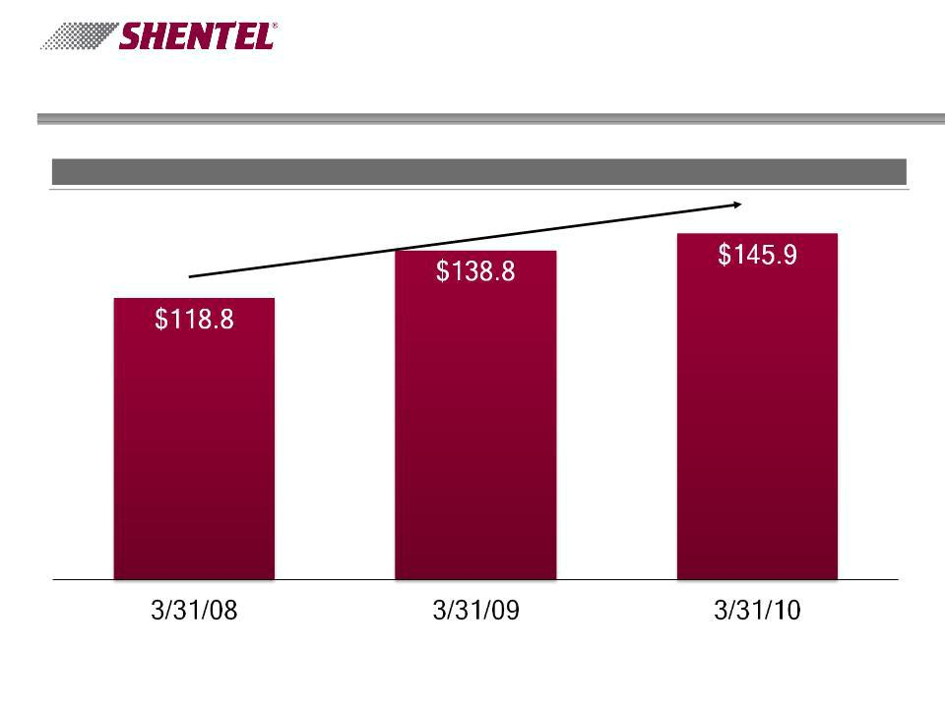
Attractive Service Revenue Growth - PCS

12 Months Ending

Gross Billed PCS Revenue ($ millions)¹

11 % CAGR

- Before credits and fees

11

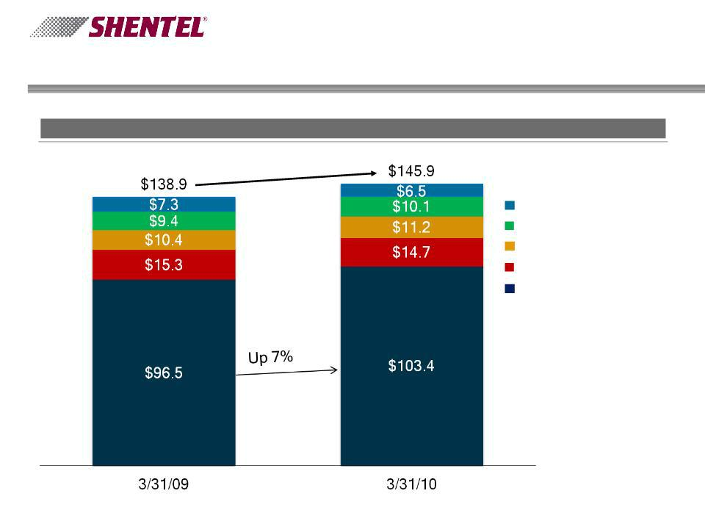
PCS Revenues

12 Months Ending

Billed Revenue ($ millions)

Up 5%

Bad Debt

Management Fee

Service Fee

Service Credits

Net Revenue

12

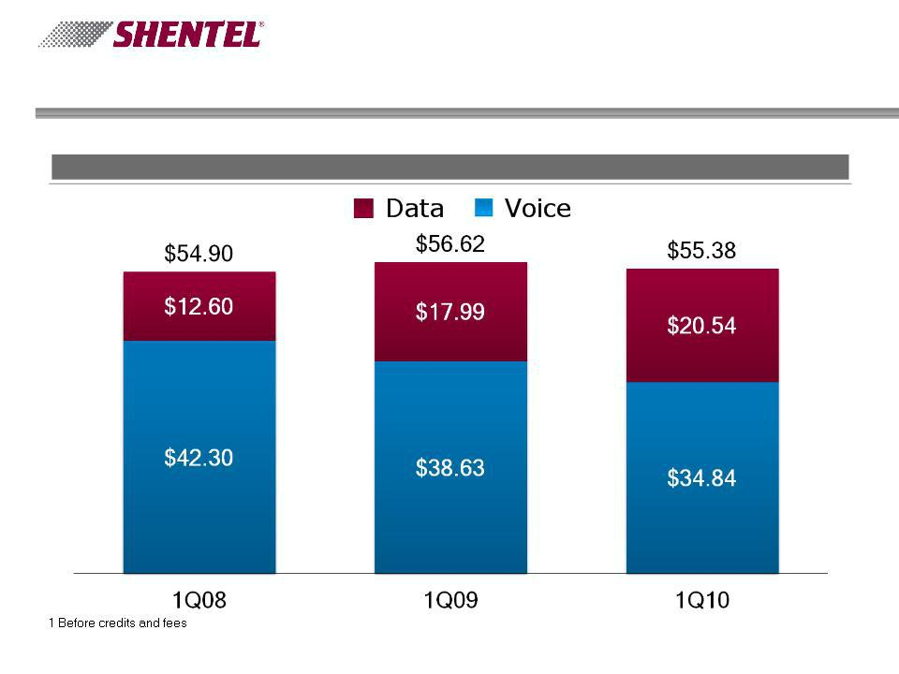
PCS Revenue per Subscriber

Period Ending

Gross Billed Revenue per Subscriber¹

13

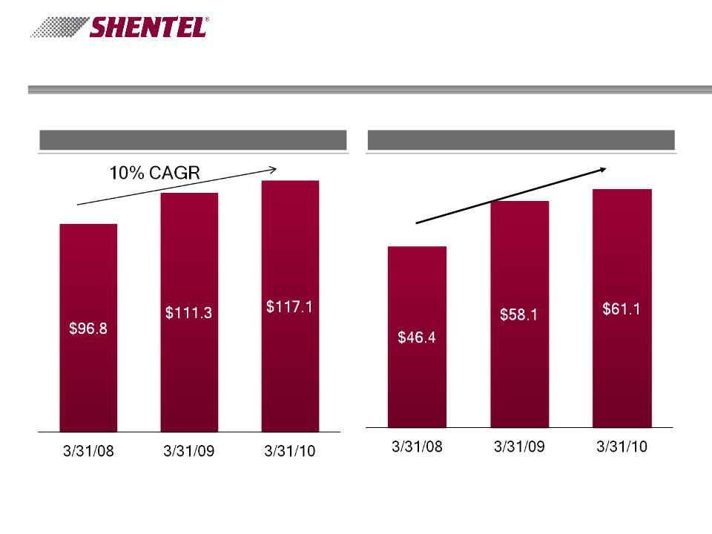
Wireless Segment

12 Months Ending

Reported Revenue ($ millions) OIBDA ($ millions)

15% CAGR

14

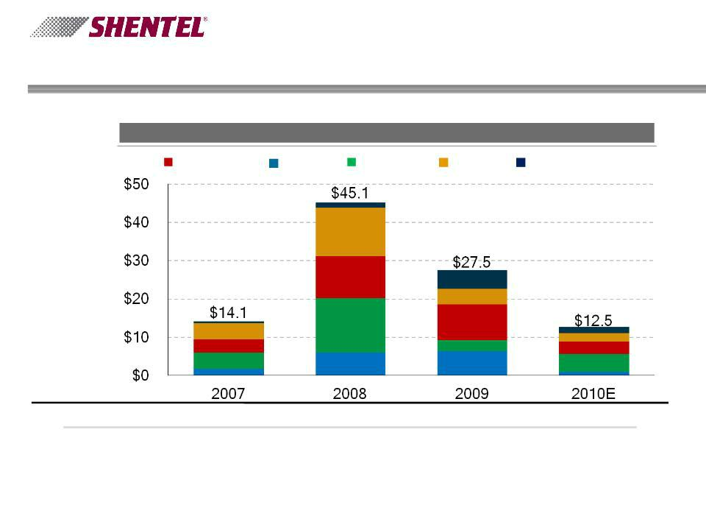
Capital Expenditures - Wireless

12 Months Ending

Capital Expenditures by Category ($ millions)

Coverage Other Capacity EVDO Towers

# Cell Sites | 346 | 411 | 476 | 503
% Covered POPs | 79% | 85% | 87% | 88%
# EVDO Sites | 52 | 211 | 334 | 365
% POPs Covered | 27% | 86% | 94% | 95%

15

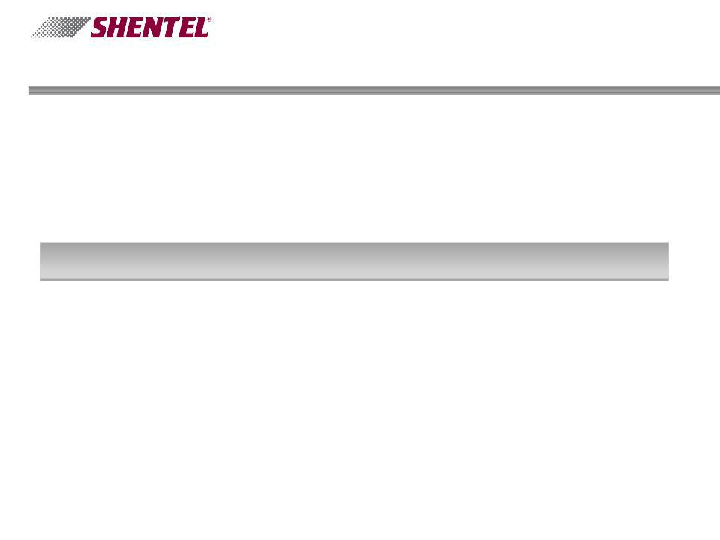
Agenda

Introduction and Shentel Overview

Overview of Wireless

Overview of Cable

Overview of Wireline

Financials

16

Cable TV Overview

- Complimentary (with LEC business) u 16k Homes Passed

u 8k Video Subscribers

- Offensive positioning (Outside ILEC) u 40k Homes Passed

u 15k Video and 3k Internet Subscribers u Voice service initiated 3/31/10
- All upgraded by 9/30/10

17

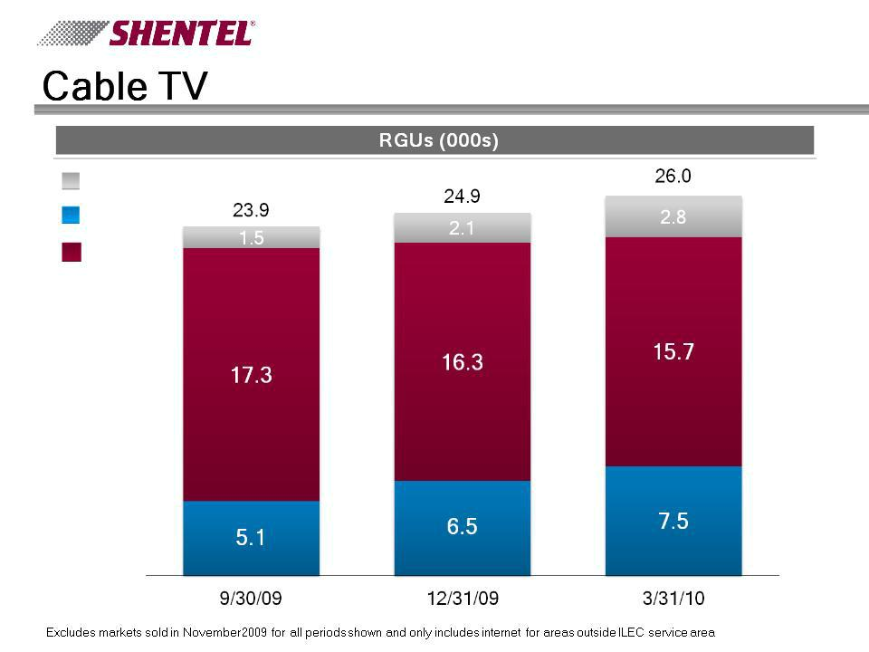

Internet

Basic

Digital

18

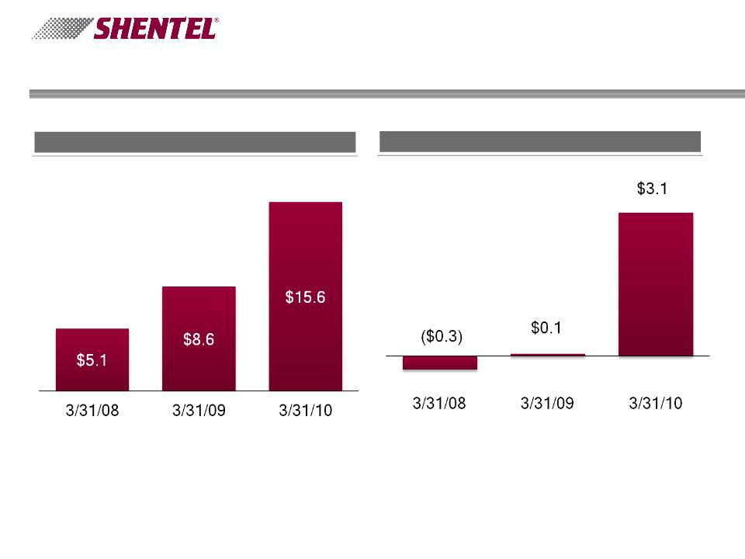
Cable TV

12 Months Ending

Revenue ($ millions) OIBDA ($ millions)

Includes Rapid Communications acquisition December 1, 2008

19

Deal Highlights - JetBroadband Acquisition

- Structured as an asset purchase

- Purchase Price = $148

- 115 thousand homes passed and serves 67 thousand RGUs

- 43 thousand video customers

- 22 thousand data customers

- 2 thousand voice customers

- Network

- 3,200 miles

- 900 miles of fiber

- 84% two way

- Competition

- No fiber to the home

- CenturyLink, Verizon and Frontier

- Satellite providers

20

JBB Acquisition - Rationale

- Diversification

- Scale

- Below Market Penetration

- Geographic Fit

- Synergies

- Leveraging Core Competencies

- Coaxial Network

21

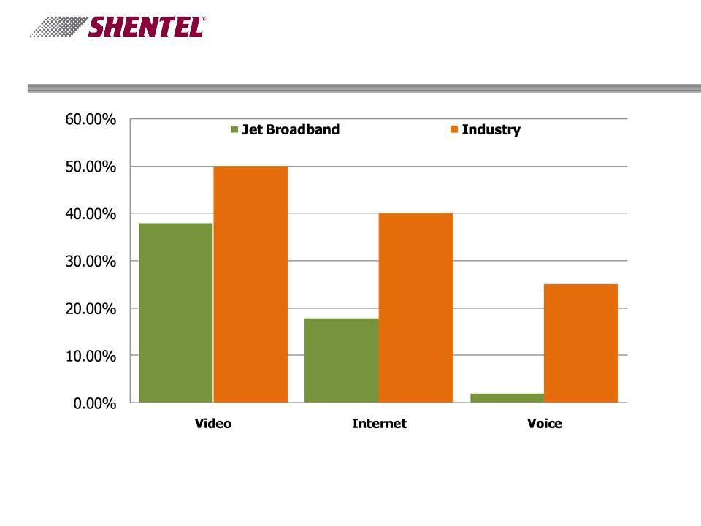
Percent of Homes Passed with Services

22

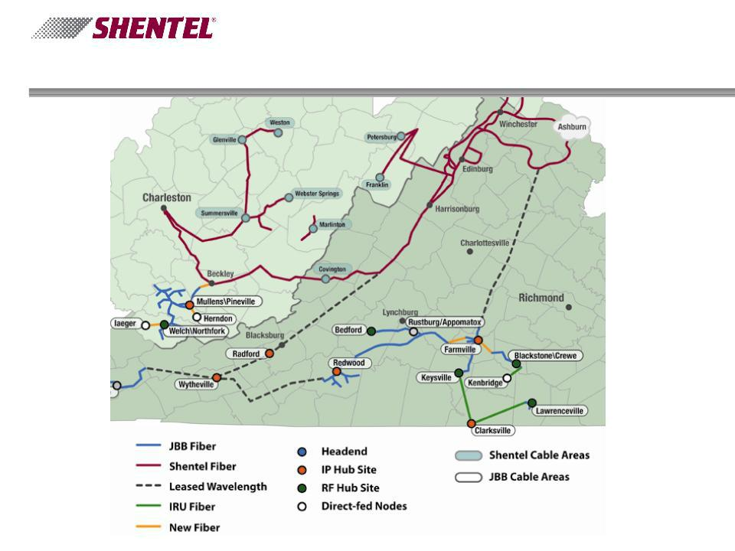
JBB Network

23

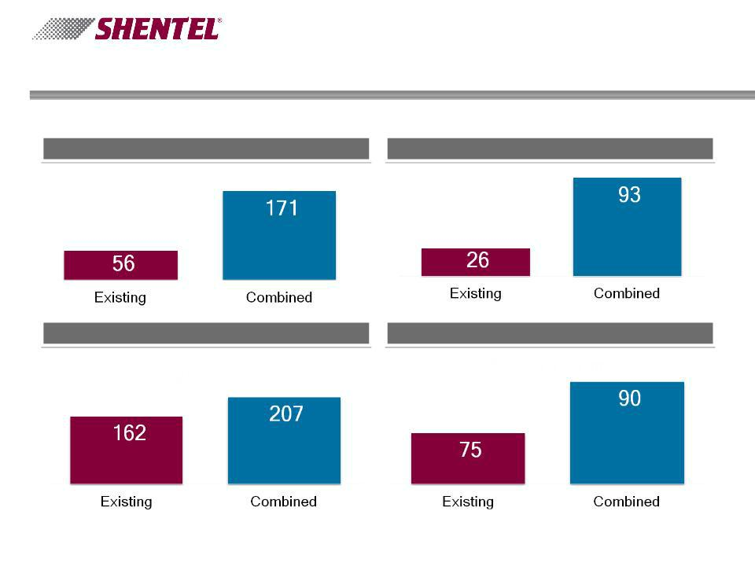
Key Operational Metrics - With Acquisition

Pro Forma for Periods Ending March 31, 2010

Cable Homes Passed (in 000’s) RGUs (in 000’s)

Revenues (in millions) OIBDA (in millions)

24

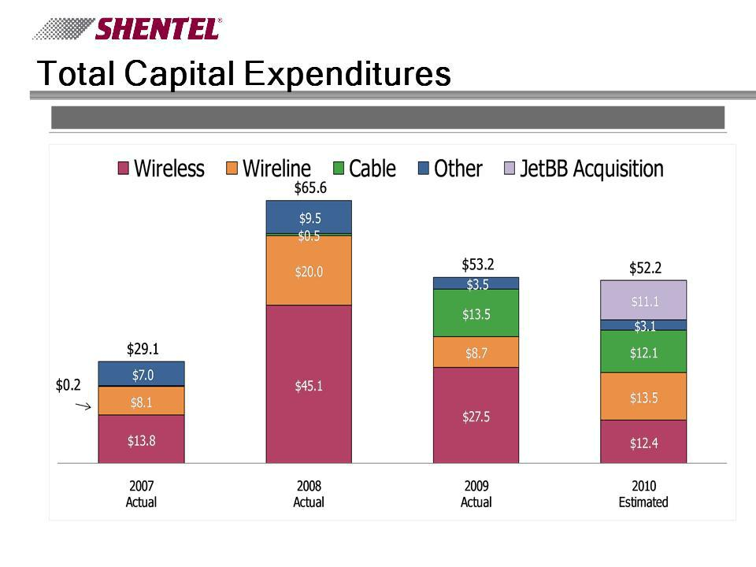
Capital Expenditures by Segment ($ millions)

25

JBB Execution

- Success with Rapid Acquisition

- Network Interconnection

- Proven Technologies

- Similar Demographics

- Proximity

- Low Regulatory Risk

- Strategic Owner Appeal

26

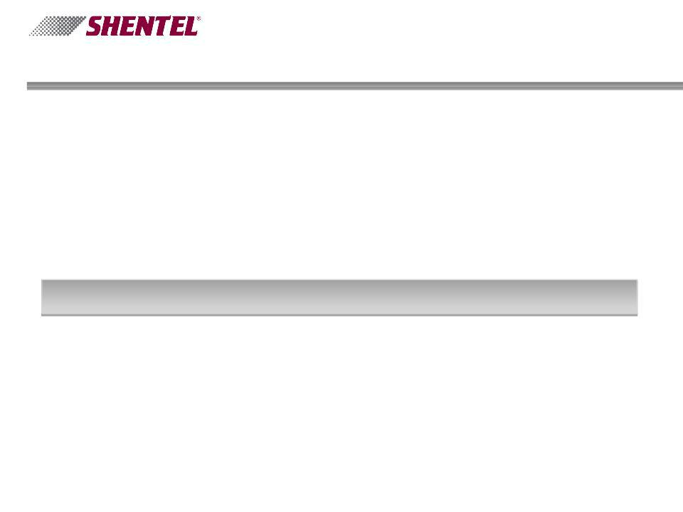
Agenda

Introduction and Shentel Overview

Overview of PCS

Overview of Cable

Overview of Wireline

Financials

27

Wireline Customers

March 31, 2010

- 24.2k LEC access lines

- Acquisition of North River Telephone closed November
₂nd

- 0.9k access lines

- 11.5k DSL subscribers

- 46% Penetration of Access Lines

- 3.0k dial-up Internet subscribers

- 10.9k long distance subscribers

- One FTTH community in service outside of LEC area

- Fiber Network

- Route miles: 1,570

28

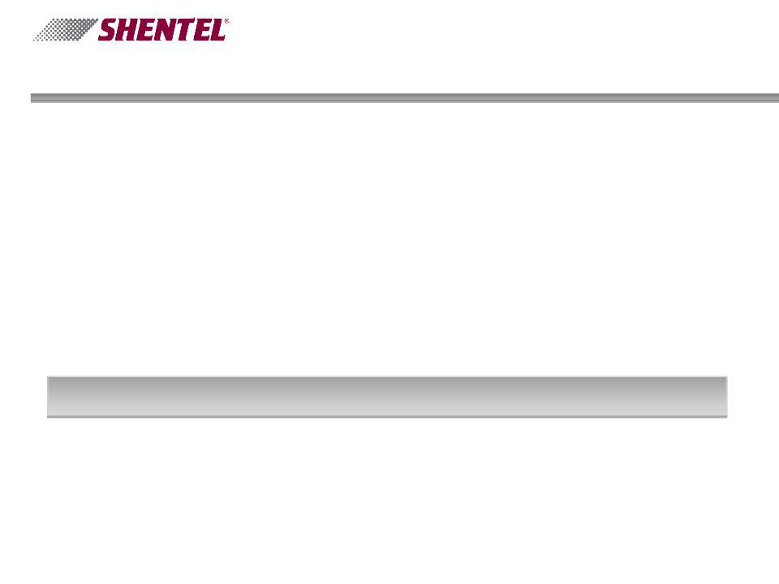
Agenda

Introduction and Shentel Overview

Overview of PCS

Overview of Cable

Overview of Wireline

Financials - Adele Skolits - CFO

29

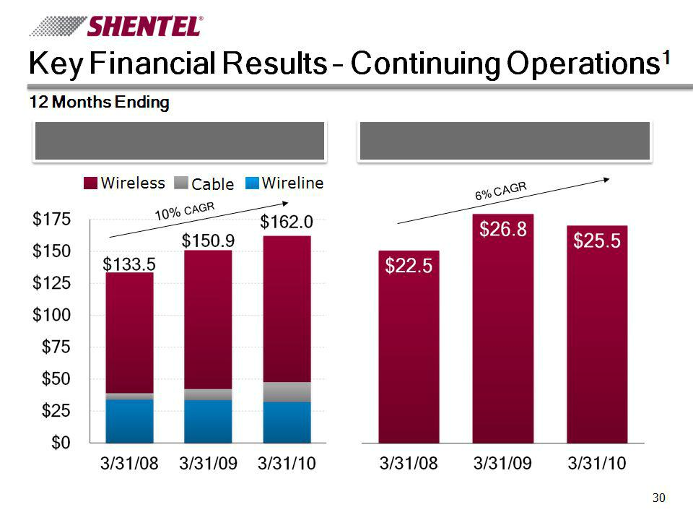

Revenue ($ millions) |  | Net Income from Continuing Operations
 |  | ($ millions)
Wireless | Cable | Wireline

- Shentel Converged Services has been reclassed as discontinued operations. All results have been restated.
30

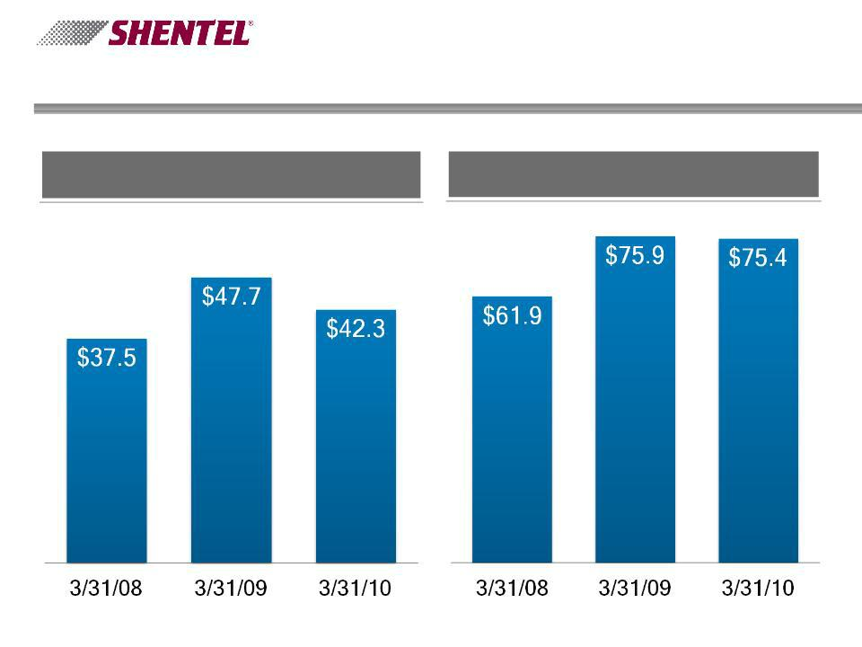
Key Financial Results - Continuing Operations¹

12 Months Ending

Operating Income ($ millions) | Operating Income Before Depreciation
Operating Income ($ millions) | & Amortization ($ millions)

¹ Shentel Converged Services has been reclassed as discontinued operations. All results have been restated.
31

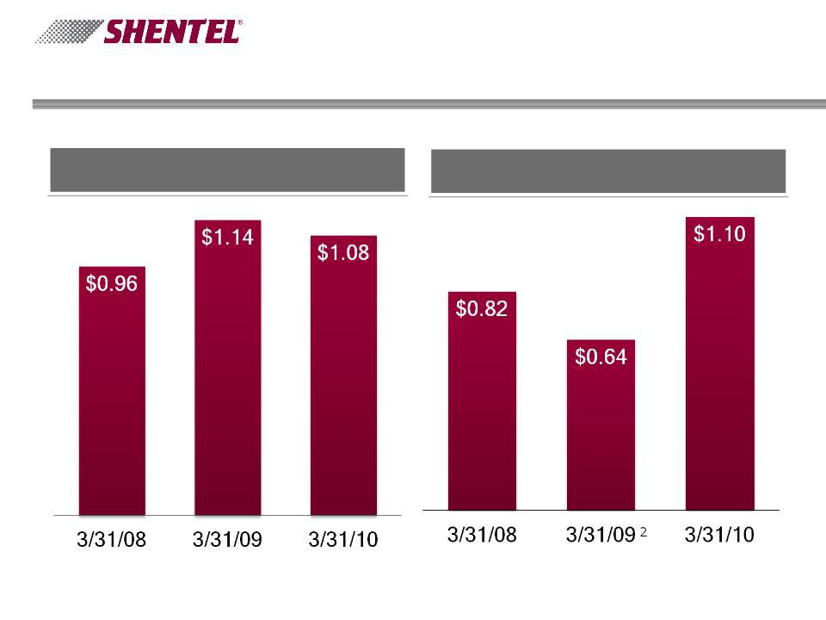
Key Financial Results - Consolidated

12 Months Ending

Earnings Per Share | Earnings Per Share
- Continuing Operations¹ | - Net Income

¹ Shentel Converged Services has been reclassed as discontinued operations. All results have been restated.
² Includes $10.7 million write down of Converged Service Business Unit ($0.45 per share) in Q1 2009
32

Jet BB Deal - Financial Highlights

- Operating Income before Interest and Depreciation

- $16.2 before Corporate office costs

- $14.6 after Corporate office costs

- Financing

- Syndicated debt deal

- $198m Term Loan

- $50m Undrawn Revolver

- Oversubscribed at more than 150% of needs

33

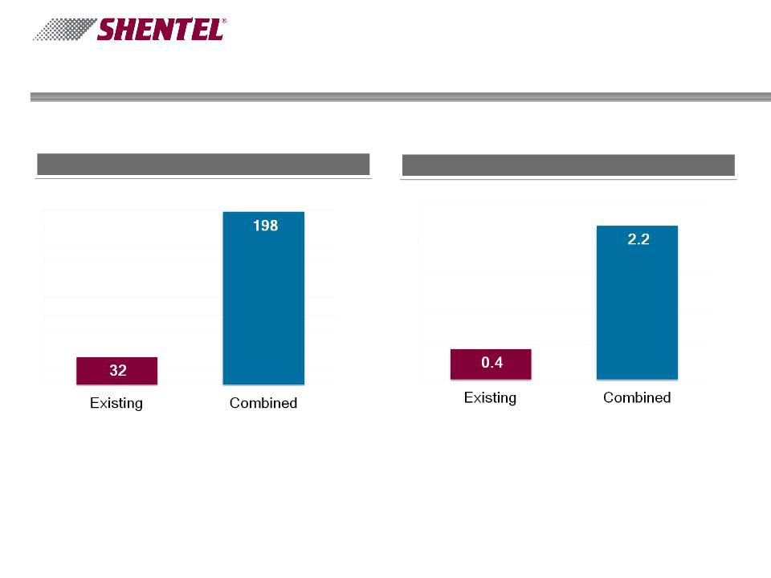
Level of Debt - Acquisition Impact

Pro Forma for Periods Ending March 31, 2010

Debt (in millions) Debt to EBITDA Ratio

34

Q&A

35

Appendix

36

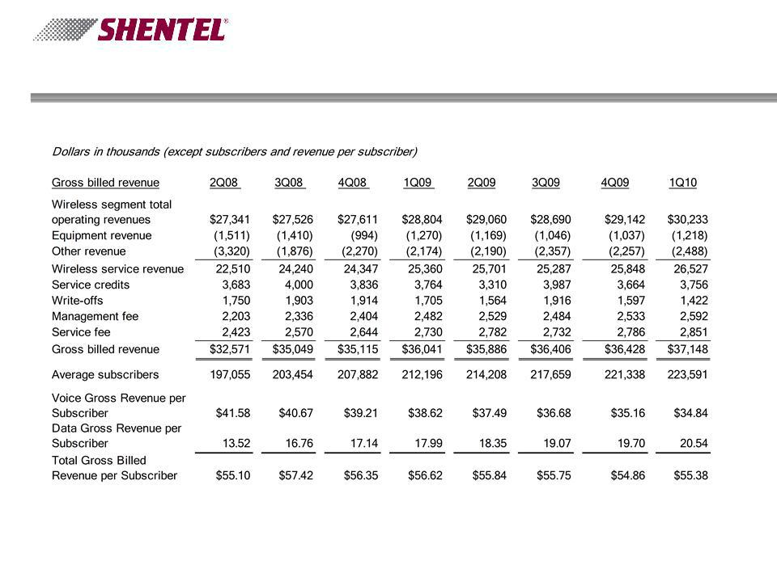
Non-GAAP Financial Measure - Billed Revenue per Subscriber

Period Ending

37

Non-GAAP Financial Measure - OIBDA

12 Months Ended 3/31/2010

Dollars in thousands
 | Wireless |  |  | Wireline |  |  |  | Cable |  |  | Other |  | Consolidated
Operating Income |  | $40,459 |  | $12,711 |  |  | ($7,172) |  |  | ($3,683) |  |  | $42,315
Depreciation and amortization | 20,660 |  |  | 8,090 |  |  | 4,045 |  |  | 308 |  |  | 33,103
OIBDA | $61,119 |  |  | $20,801 |  |  | ($3,127) |  |  | ($3,375) |  |  | $75,418

38

Non-GAAP Financial Measure - OIBDA

12 Months Ended 3/31/2009

Dollars in thousands
 | Wireless |  |  | Wireline |  |  |  | Cable |  |  | Other |  | Consolidated
Operating Income |  | $40,082 |  | $13,926 |  |  | ($1,684) |  |  | ($4,589) |  |  | $47,735
Depreciation and amortization | 18,039 |  |  | 8,071 |  |  | 1,738 |  |  | 315 |  |  | 28,163
OIBDA | $58,121 |  |  | $21,997 |  |  | $54 |  |  | ($4,274) |  |  | $75,898

39

Non-GAAP Financial Measure - OIBDA

12 Months Ended 3/31/2008

Dollars in thousands
 | Wireless |  |  | Wireline |  |  |  | Cable |  |  | Other |  | Consolidated
Operating Income |  | $29,739 |  | $14,199 |  |  | ($1,336) |  |  | ($5,082) |  |  | $37,520
Depreciation and amortization | 16,629 |  |  | 6,468 |  |  | 1,035 |  |  | 263 |  |  | 24,395
OIBDA | $46,368 |  |  | $20,667 |  |  | ($301) |  |  | ($4,819) |  |  | $61,915

40

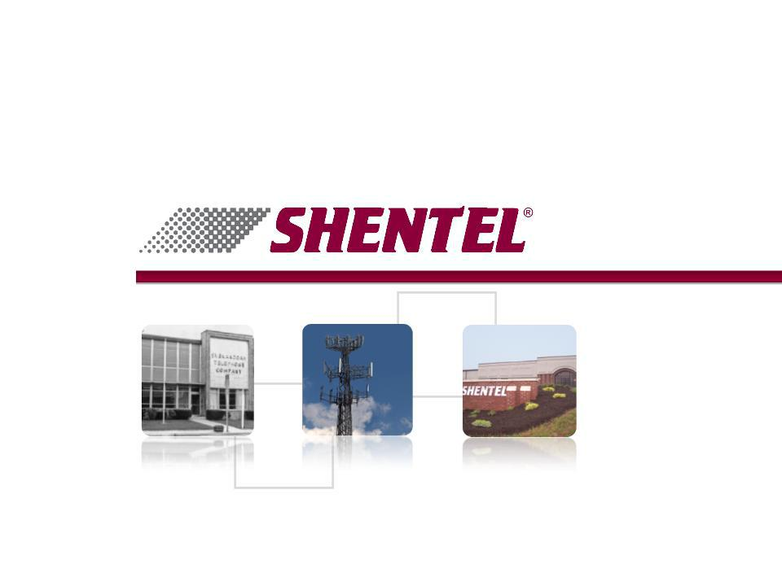
Jefferies

Global Internet, Media, & Telecom Conference

May 12, 2010

