UNITED STATES

SECURITIES AND EXCHANGE COMMISSION

Washington, D.C. 20549

_______________________________

FORM 8-K

_______________________________

CURRENT REPORT

Pursuant to Section 13 or 15(d) of the Securities Exchange Act of 1934

Date of Report (Date of earliest event reported): May 1, 2018

_______________________________


_______________________________

Shenandoah Telecommunications Company

(Exact name of registrant as specified in its charter)

_______________________________

Virginia

(State or other jurisdiction

of incorporation)

0-9881

(Commission File Number)

54-1162807

(IRS Employer

Identification No.)

500 Shentel Way

P.O. Box 459

Edinburg, VA 22824

(Address of principal executive offices) (Zip Code)

(540) 984-4141

(Registrant’s telephone number, including area code)

_______________________________

Check the appropriate box below if the Form 8-K filing is intended to simultaneously satisfy the filing obligation of the registrant under any of the following provisions:

- Written communications pursuant to Rule 425 under the Securities Act (17 CFR 230.425)

- Soliciting material pursuant to Rule 14a-12 under the Exchange Act (17 CFR 240.14a-12)

- Pre-commencement communications pursuant to Rule 14d-2(b) under the Exchange Act (17 CFR 240.14d-2(b))

- Pre-commencement communications pursuant to Rule 13e-4(c) under the Exchange Act (17 CFR 240.13e-4(c))

Indicate by check mark whether the registrant is an emerging growth company as defined in Rule 405 of the Securities Act of 1933 (§230.405 of this chapter) or Rule 12b-2 of the Securities Exchange Act of 1934 (§240.12b-2 of this chapter).

Emerging growth company ☐

If an emerging growth company, indicate by check mark if the registrant has elected not to use the extended transition period for complying with any new or revised financial accounting standards provided pursuant to Section 13(a) of the Exchange Act. ☐

Item 5.07. Submission of Matters to a Vote of Security Holders.

- On May 1, 2018, Shenandoah Telecommunications Company (the “Company”) held its annual shareholder meeting. At the meeting, three directors, as set forth below, were appointed to three year terms and two proposals, one to ratify the appointment of KPMG LLP as the Company’s independent registered public accounting firm for 2018, the second, in a non-binding vote, to approve named executive officer compensation, were approved by shareholders voting by proxy or in person.

- The Final voting results with respect to each proposal voted upon at the annual shareholder meeting are set forth below.

Proposal 1:

The Company’s shareholders elected each of the three nominees to the Board of Directors for a three-year term by a plurality of votes cast:

 |  |  | Votes For |  | Votes Withheld | Broker Non-Votes
Thomas A. Beckett |  |  | 32,384,802 |  | 363,936 | 5,986,628
Richard L. Koontz, Jr. |  |  | 32,103,977 |  | 644,761 | 5,986,628
Leigh Ann Schultz |  |  | 32,338,846 |  | 409,892 | 5,986,628
 | Proposal 2:
 | The Company’s shareholders ratified the appointment of KPMG LLP, as set forth below:
 |  | Votes For | Votes Against |  | Abstentions | Broker Non-Votes
37,599,578 |  |  | 1,043,438 |  | 92,350 | -

Proposal 3:

The Company’s shareholders approved by advisory vote the compensation paid to the Company’s named executive officers, as set forth below:

Votes For | Votes Withheld | Abstentions | Broker Non-Votes
29,712,225 | 2,719,863 | 316,650 | 5,986,628

Item 7.01. Regulation FD Disclosure

The following information is furnished pursuant to Regulation FD: On May 1, 2018, Shenandoah Telecommunications Company held its annual shareholder meeting.

The materials attached hereto as Exhibit 99.1 and Exhibit 99.2 were presented at the meeting. The presentations are also available on the Company’s website.

The presentation may contain forward-looking statements about Shenandoah Telecommunications regarding, among other things, our business strategy, our prospects and our financial position. These statements can be identified by the use of forward-looking terminology such as “believes,” “estimates,” “expects,” “intends,” “may,” “will,” “should,” “could,” or “anticipates” or the negative or other variation of these or similar words, or by discussions of strategy or risks and uncertainties.
Shenandoah Telecommunications undertakes no obligation to revise or update such statements to reflect current events or circumstances after the date hereof, or to reflect the occurrence of unanticipated events.

Item 9.01. Financial Statements and Exhibits.

(d) Exhibits

The following exhibit is furnished with this Current Report on Form 8-K.

99.1* |  | Annual Meeting Presentation Slides
99.2* |  | Annual Meeting Scripts

* Furnished herewith

SIGNATURES

Pursuant to the requirements of the Securities Exchange Act of 1934, the registrant has duly caused this report to be signed on its behalf by the undersigned thereunto duly authorized.

 | SHENANDOAH TELECOMMUNICATIONS COMPANY
Dated: May 2, 2018 | /s/ James F. Woodward
 | James F. Woodward
 | Senior Vice President - Finance and Chief Financial Officer

Exhibit 99.1
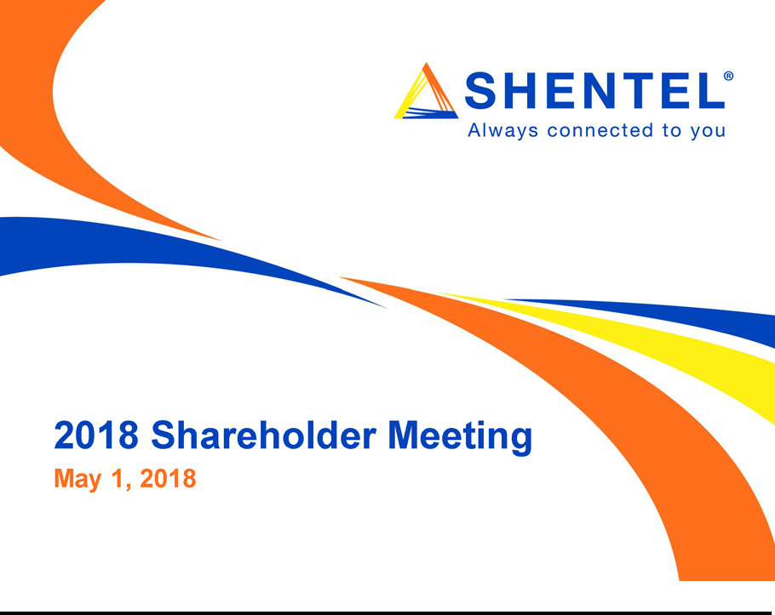

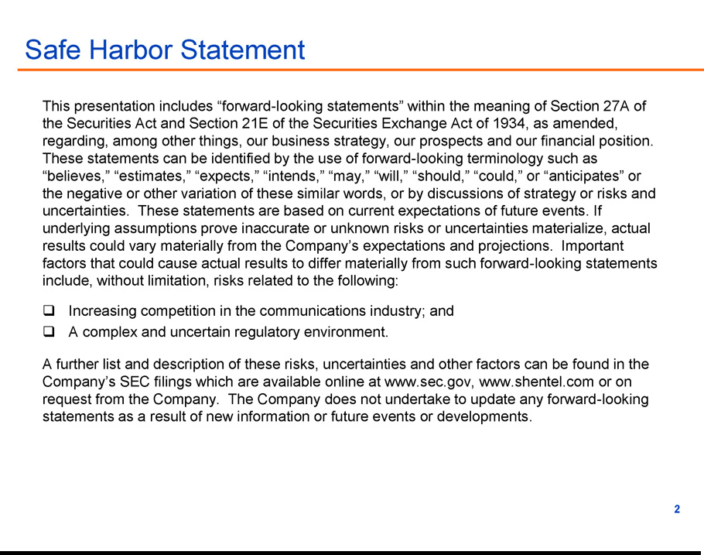

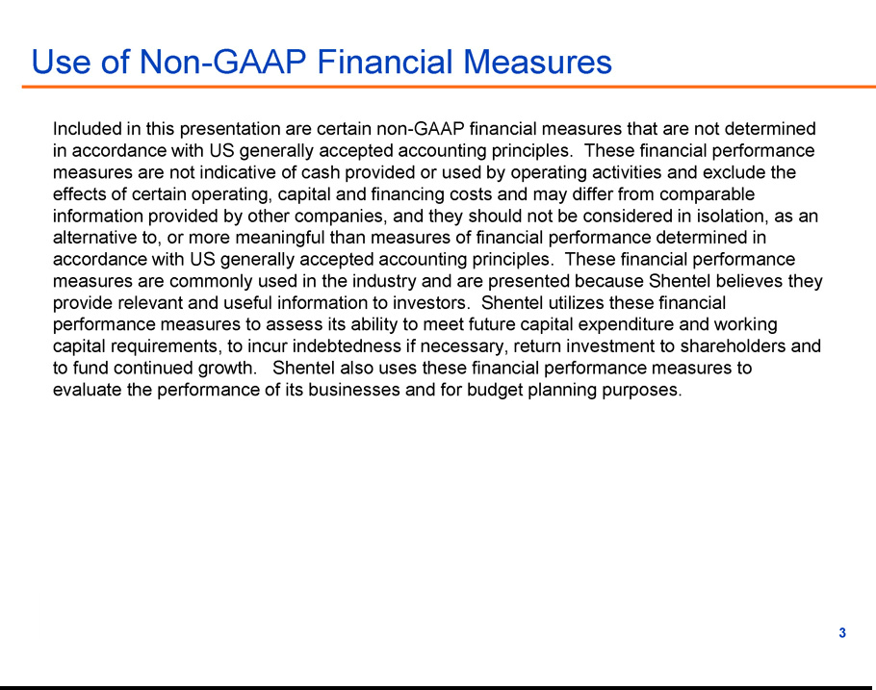

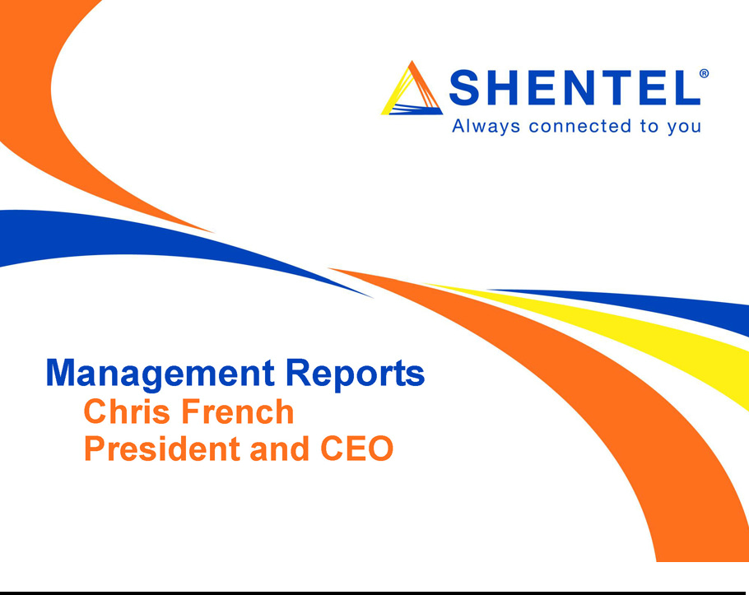

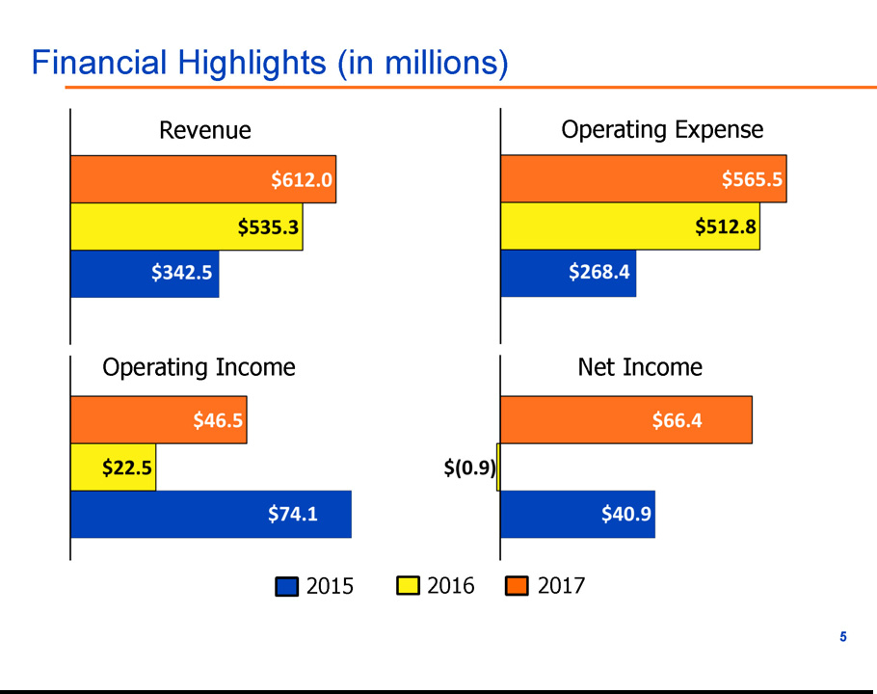

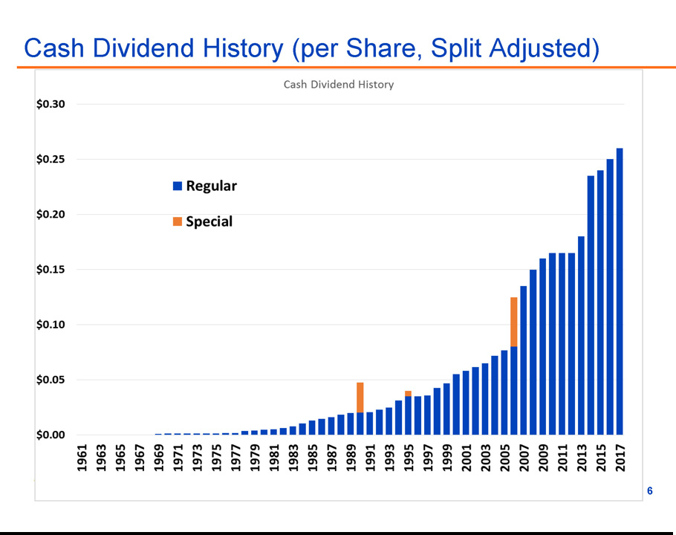

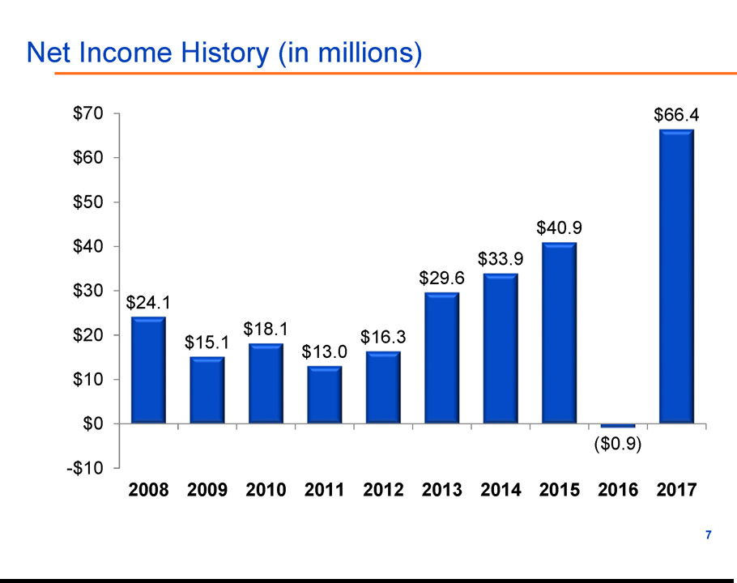

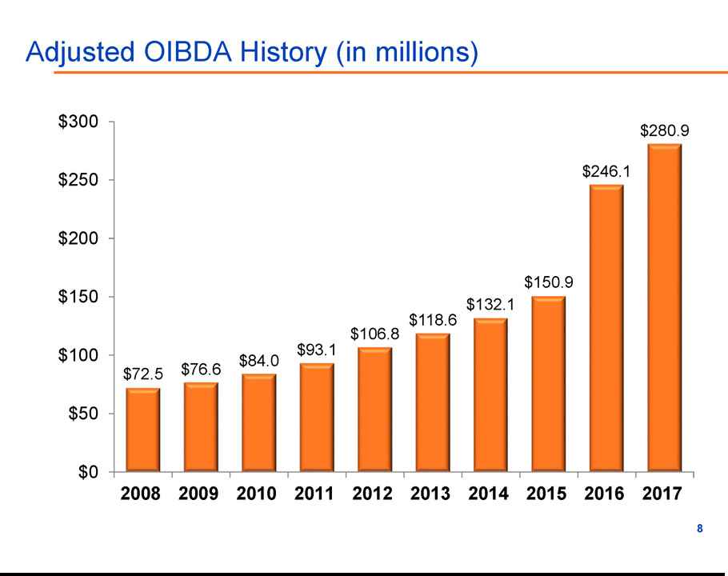

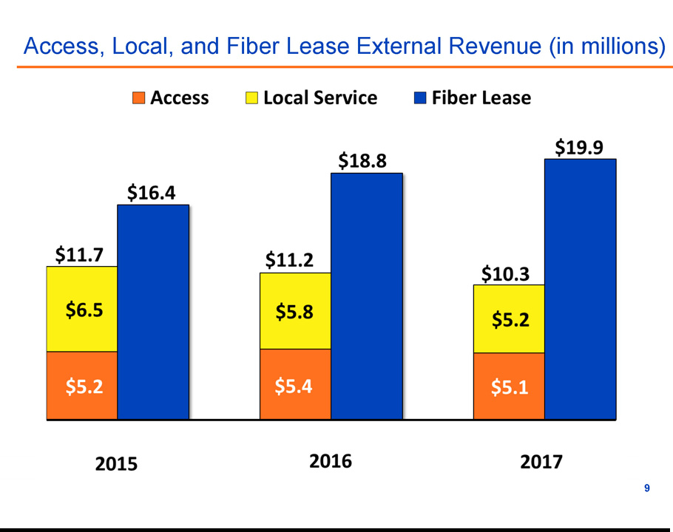

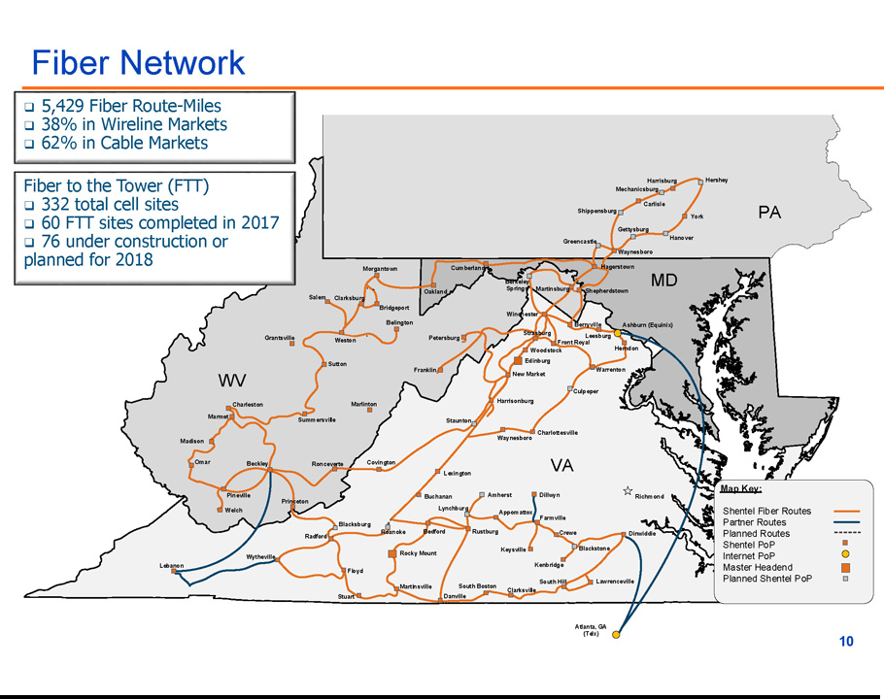

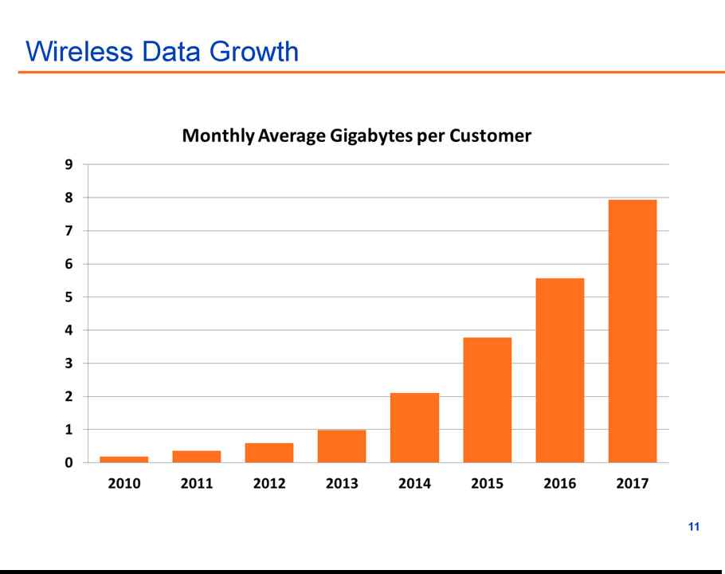

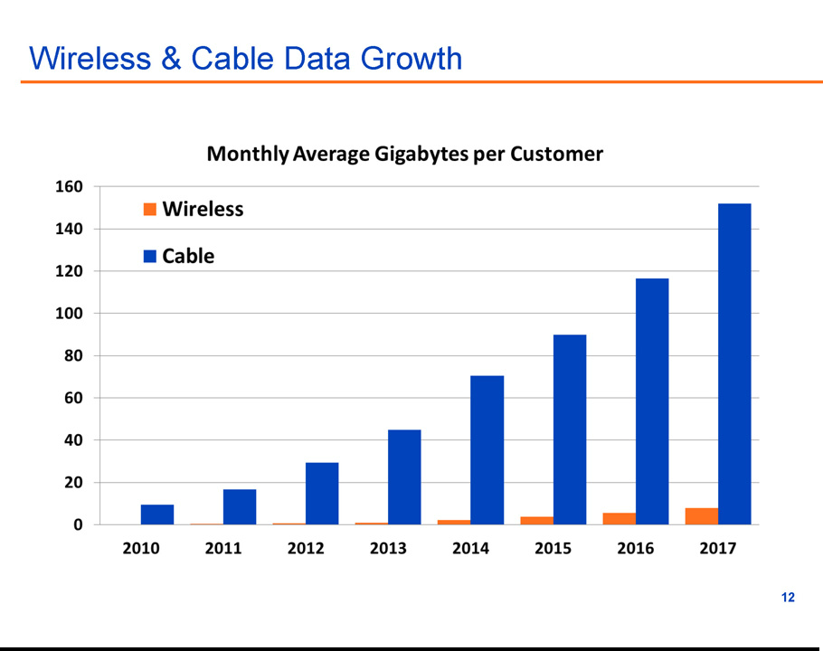

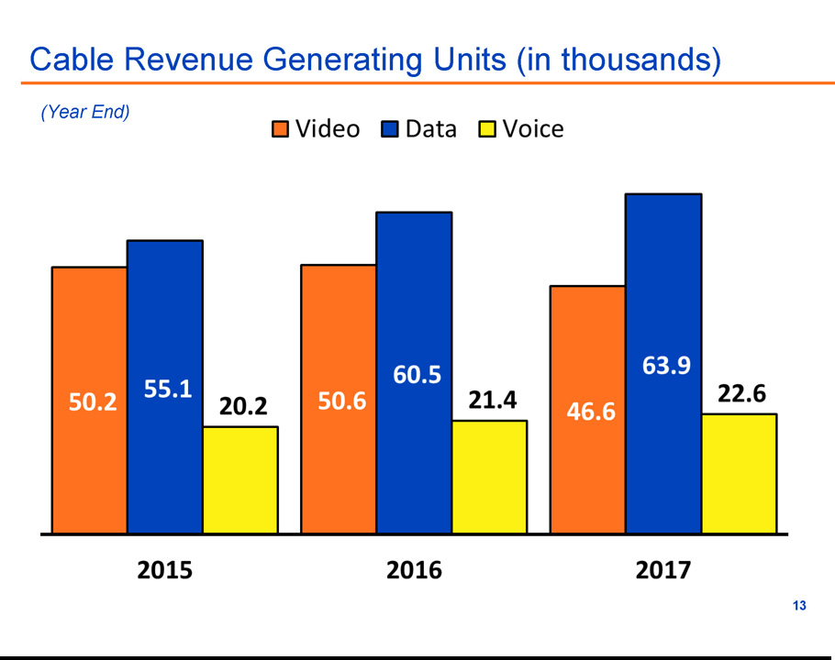

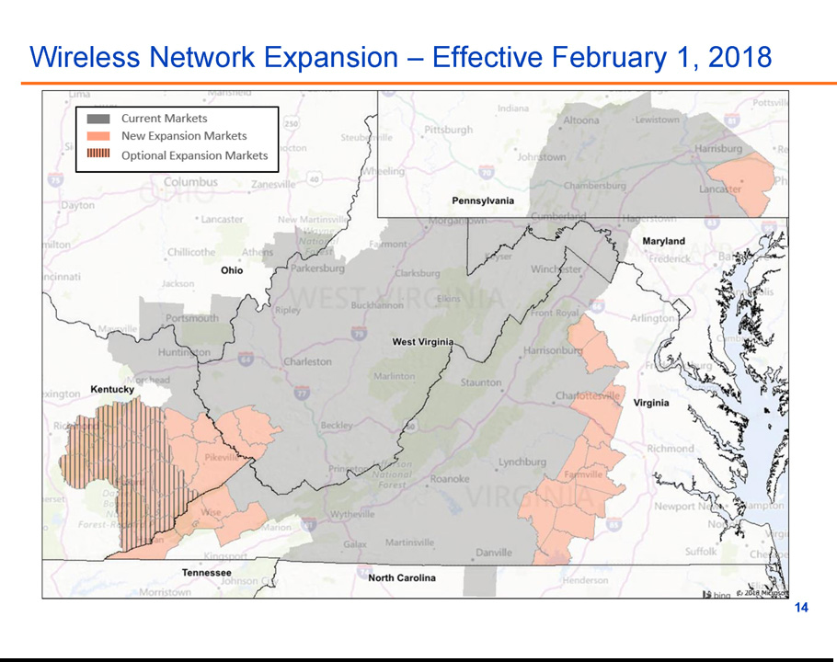

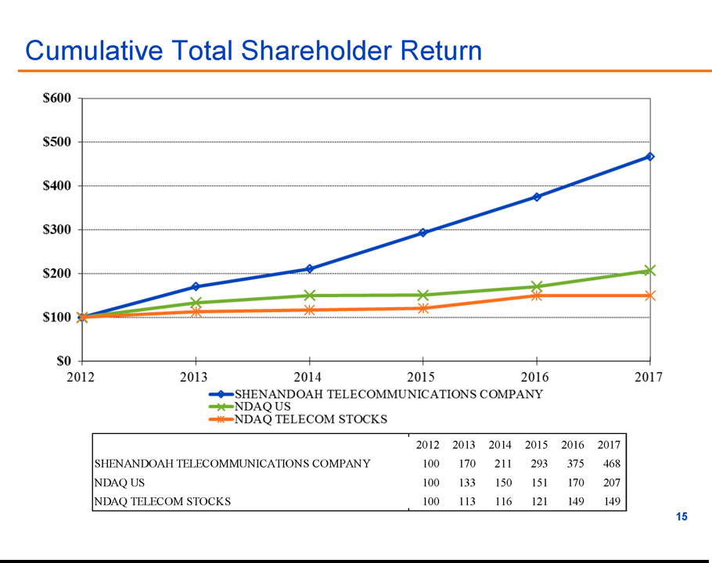

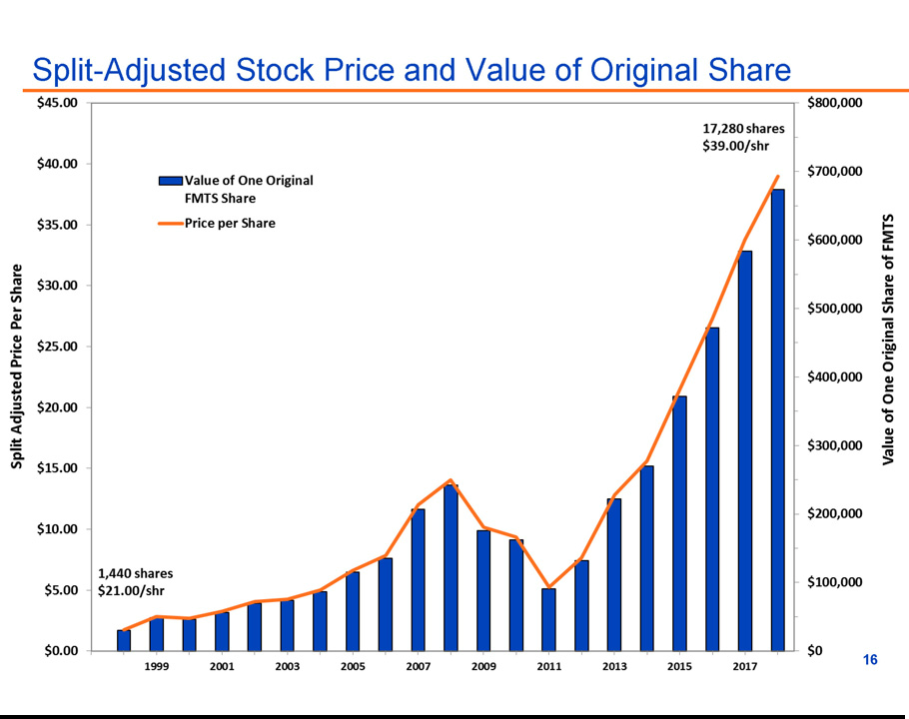

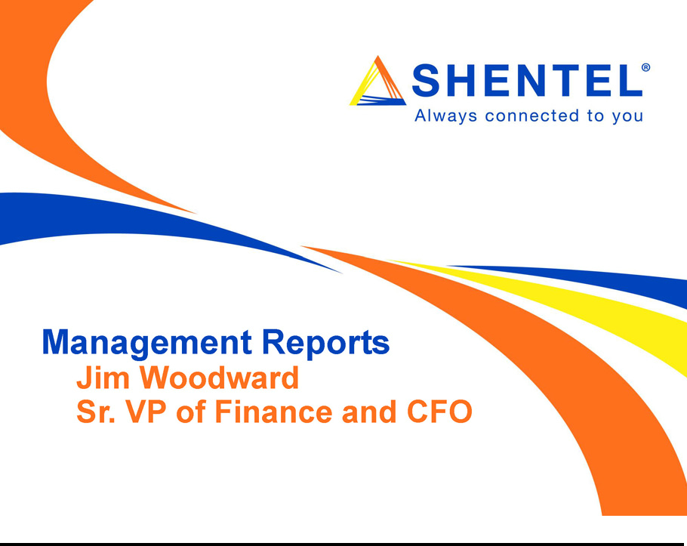

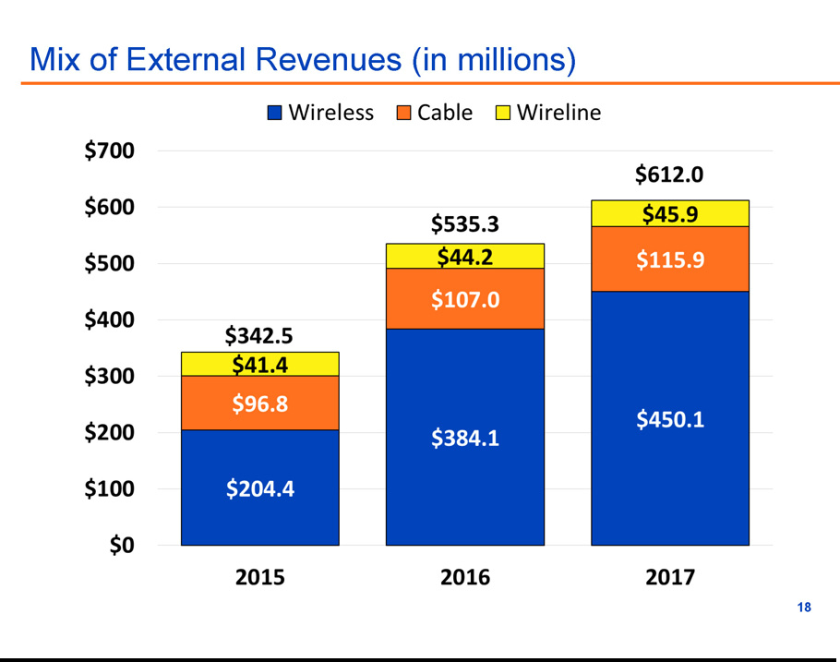

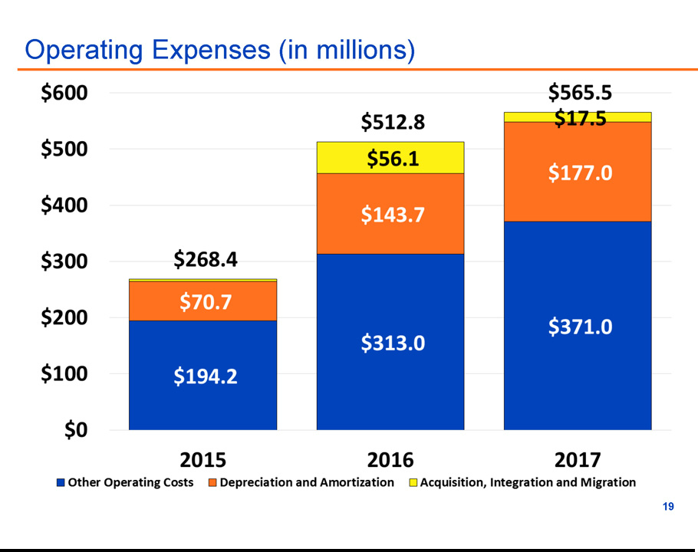

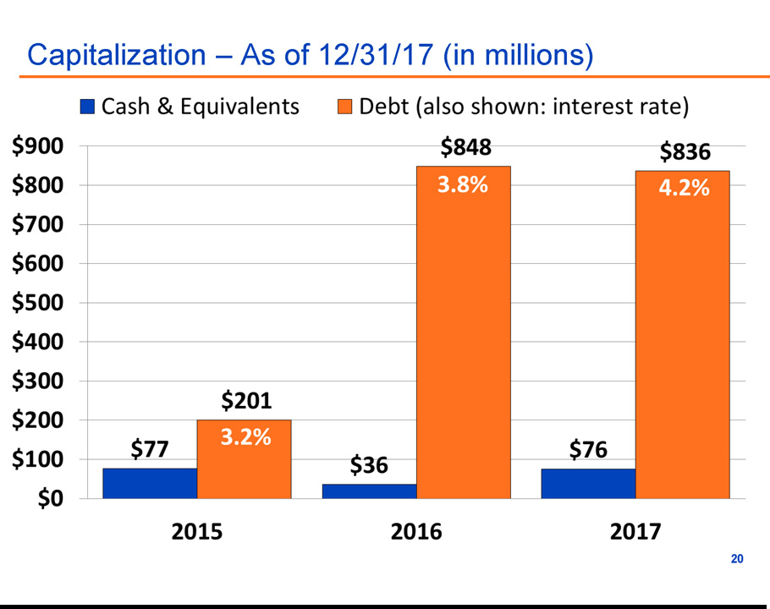

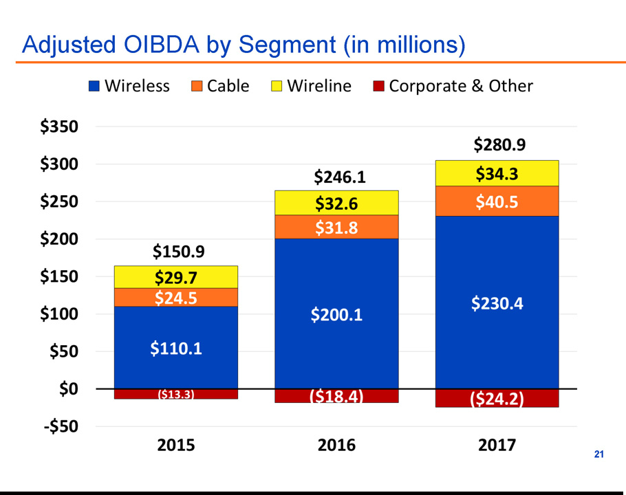

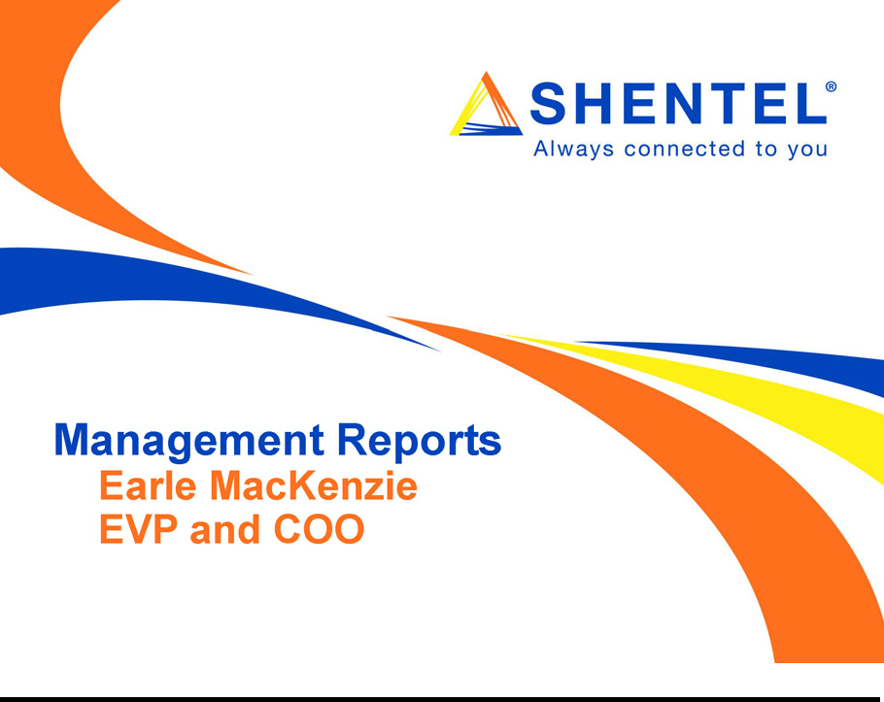

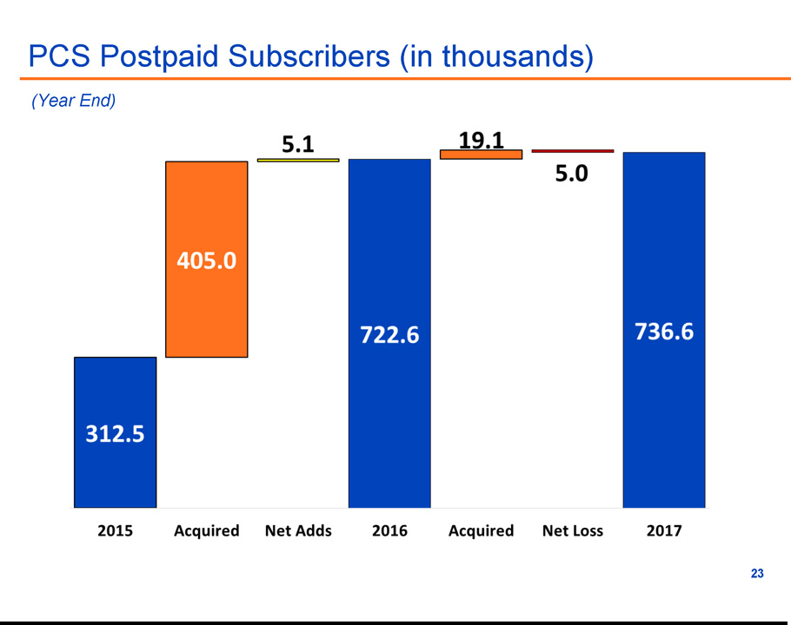

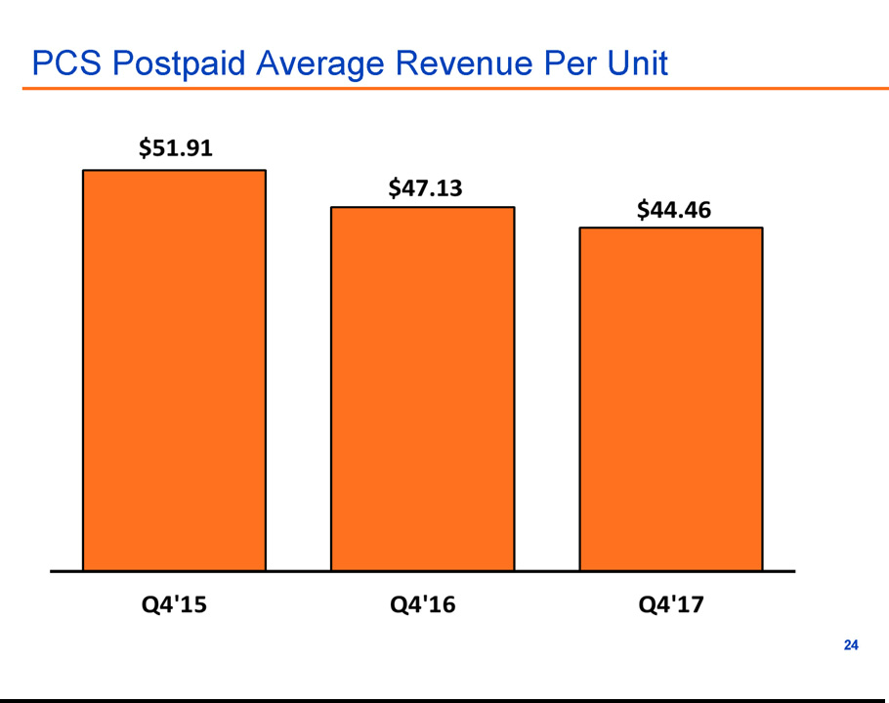

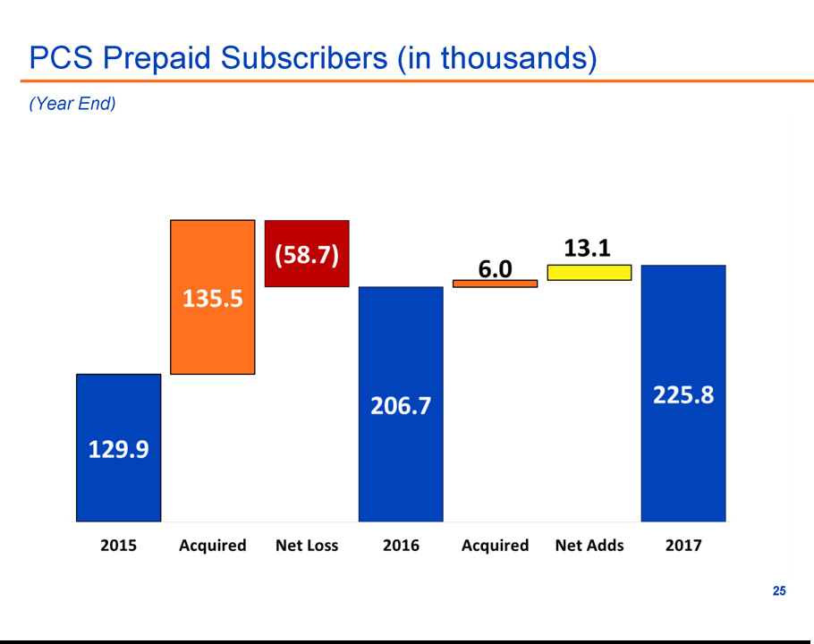

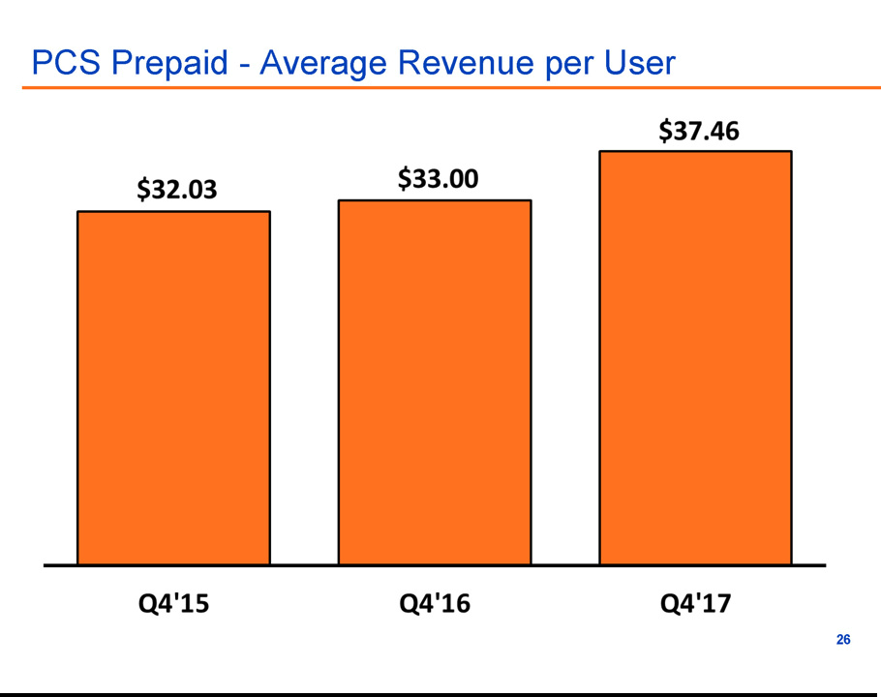

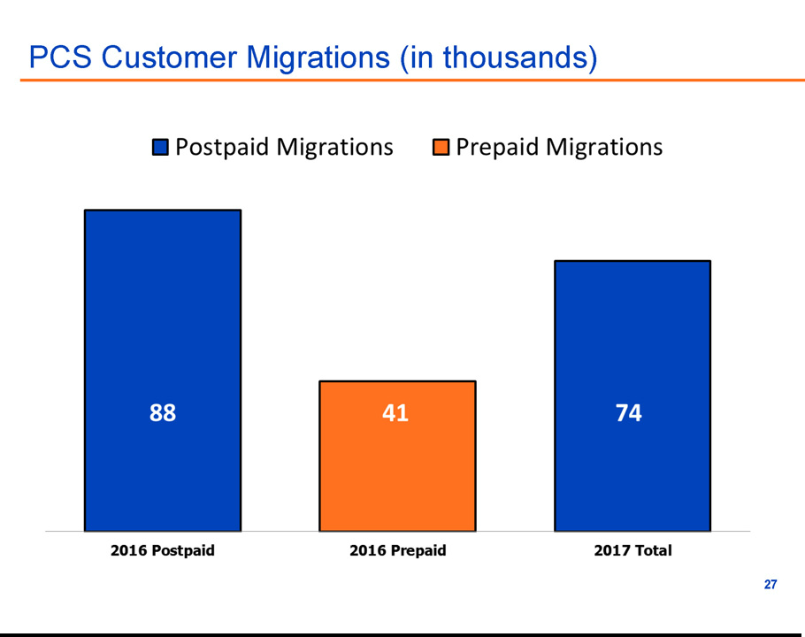

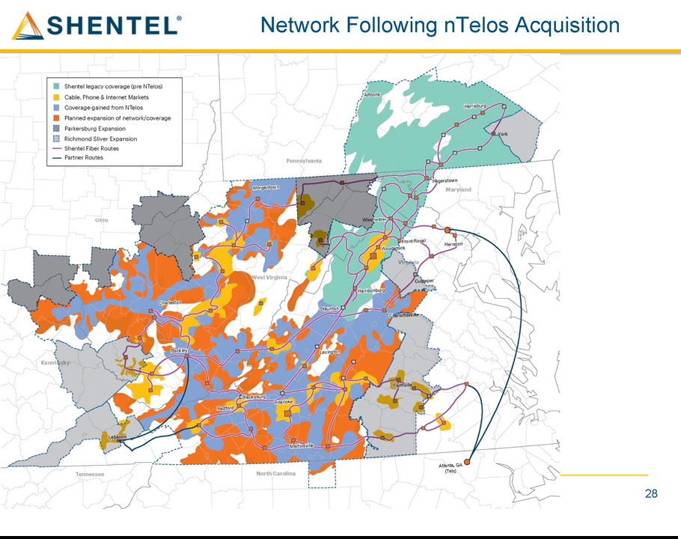

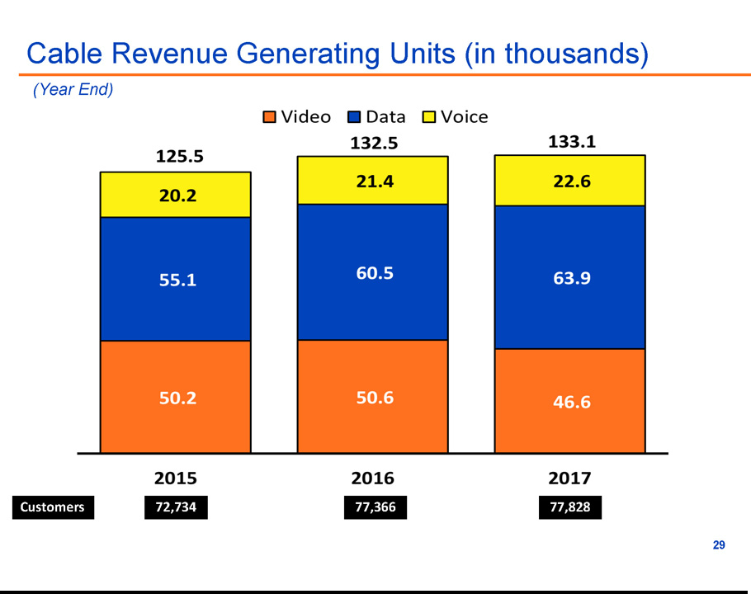

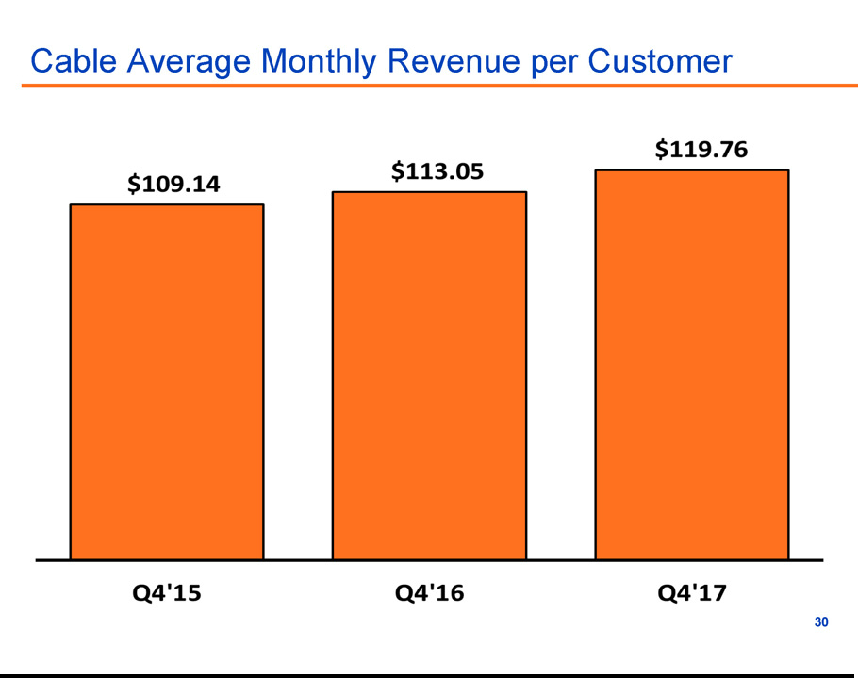

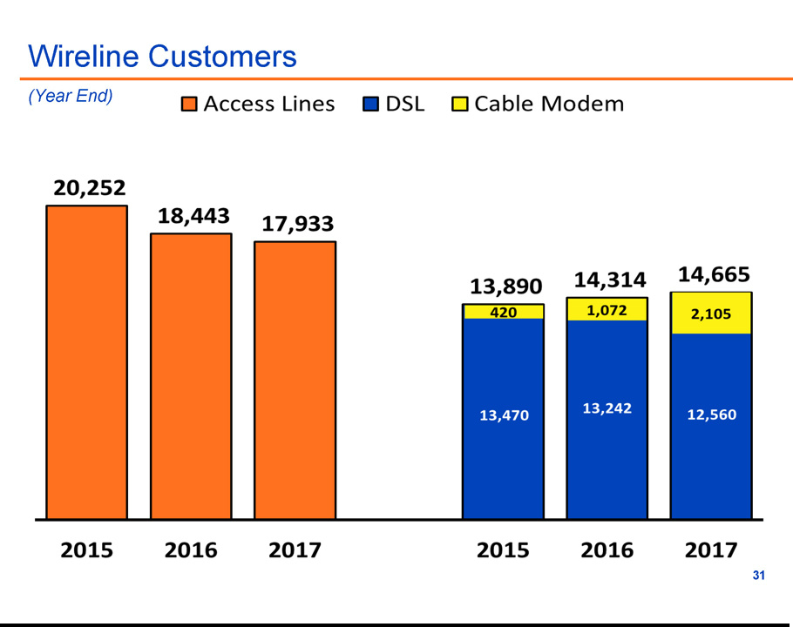

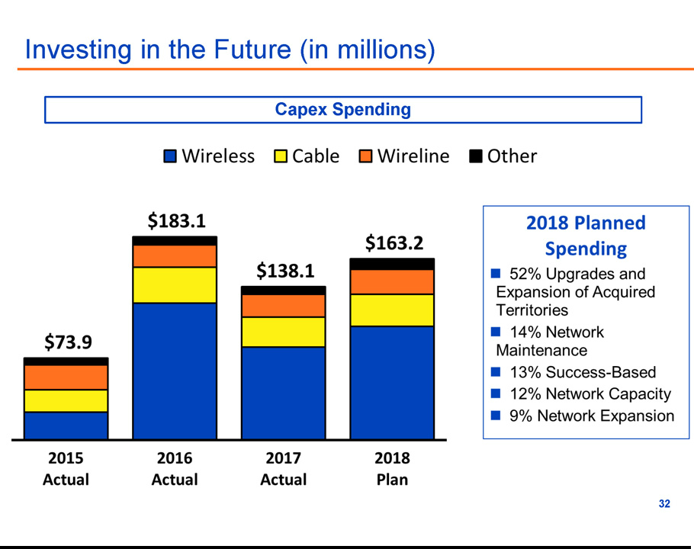

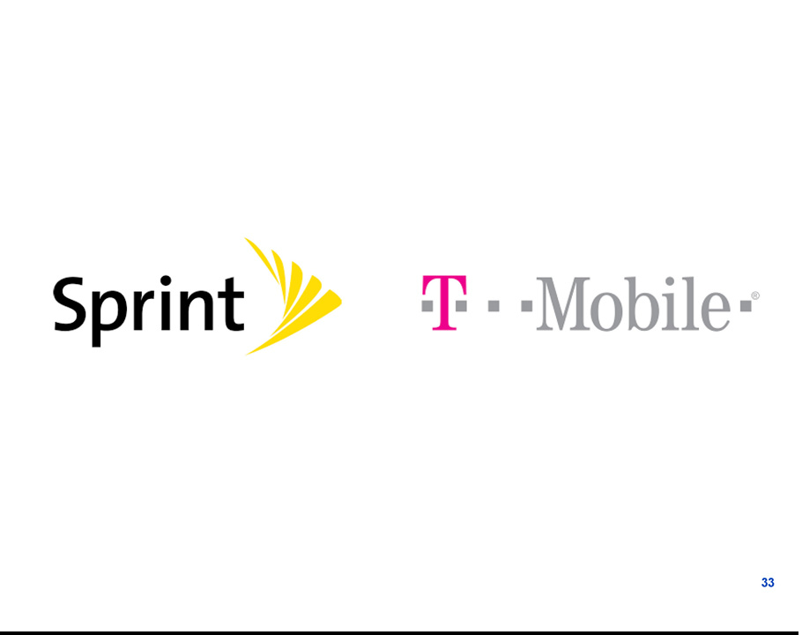

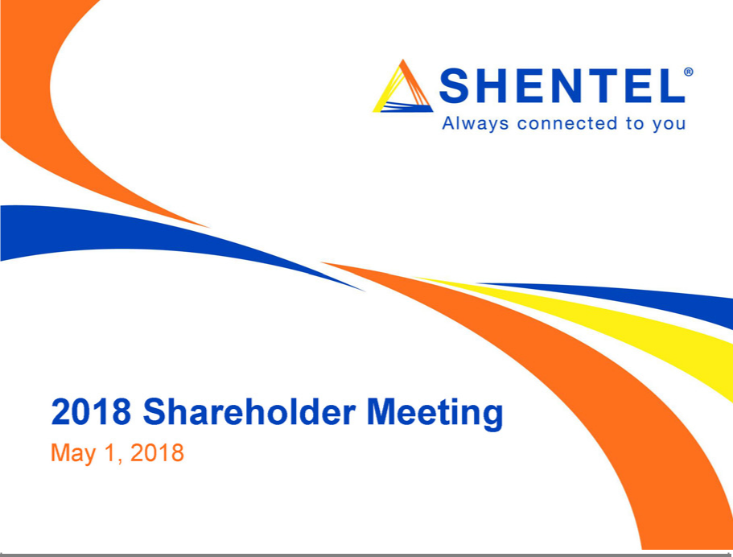

Exhibit 99.2

Shenandoah Telecommunications Company

President’s Report

Annual Meeting of Shareholders, May 1, 2018

Chris French

[Slide 1] to start

Let me start with disclosures regarding forward-looking statements and our use of non-GAAP financial measures. [Slide 2] Our presentations include “forward-looking statements” in accordance with the rules of the Securities and Exchange Commission, and they may contain our current expectations of future events. Also, [Slide 3] some of the performance metrics we discuss are not determined in accordance with generally accepted accounting principles, or GAAP, but they are commonly used in our industry and we believe they can provide relevant and useful information regarding our Company’s performance. [Slide 4]

2017 was a great year of accomplishments for Shenandoah Telecommunications. We exceeded our expectations for completing the transformation of nTelos into our Sprint affiliate wireless business and upgrading the network to 4G LTE, doing so a full quarter ahead of schedule and below our expected cost. We made great progress with our planned construction on new sites in the acquired market. By the end of the year, we had constructed 140 new sites, which was more than 60% of the total planned for this area.

Overall [Slide 5] financial results set new records for revenues and earnings. Revenues for 2017 were $612.0 million, an increase of $76.7 million, or 14.3 percent over 2016 while operating expenses were $565.5 million, an increase of $52.7 million, or 10.3 percent over 2016. Net income for the year was $66.4 million, a significant improvement over the operating loss of about $900 thousand in the prior year. 2017 results include an approximately $53.4 million non-cash tax benefit from revaluation of our net deferred tax liabilities due to federal tax law changes.

Page 1

The Board of Directors again increased the cash dividend [Slide 6], declaring a $0.26 per share dividend payable this past December, an increase of four percent over the 2016 dividend. This dividend represents the fifty-eighth year of continuous dividend payments since the Company paid its first dividend in 1960; and it was the eighteenth time we raised the dividend in the past twenty years. The increasing amount of cash we’re generating, as well as our positive expectations for the future, support these increases.

We’re very pleased with the 2017 financial results, and our longer term results are also impressive. [Slide 7] This chart shows ten years of our net income history. As we’ve discussed before, while trending higher over the long-term, this measure has its ups and downs year-to-year. This is a natural occurrence for our capital intensive telecommunications business. Before we can generate revenues, we have to build new cell sites, upgrade cable systems, construct new fiber routes, and add network capacity in order to be able to deliver services to our customers. In addition to the capital investment required, we incur expenses to operate these assets, such as tower and land rent expense, power, and maintenance. And we need the support of additional employees, all before we can start selling services. When we enter a new investment cycle, such as we did when upgrading our cable networks, and most recently when we began the investments related to the nTelos acquisition, our net income is reduced as we incur these costs in order to grow the business. In the past, these periods have been followed by renewed growth, and we saw the beginnings of that again in 2017, corresponding to increases in our stock price.

Another key financial measure is the amount of cash we generate, which gives you another perspective of our financial performance. [Slide 8]This slide gives a ten-year history of our Adjusted Operating Income Before Interest, Depreciation and Amortization, a measure of cash flow we generate from our operations. The cash we generate allows us to fund and support investments in growing our business. It enables us to have access to the capital needed, and lets us pay our vendors and our employees, and of course pay dividends to our shareholders. You can see from this chart that in this time period, we’ve almost quadrupled the amount of cash generated.

Page 2

Overall, your company is doing very well. We’ve had good performance across all of our business segments. [Slide 9] Our wireline segment is the one that our local shareholders are most familiar with, as it contains our local phone and cable service here in Shenandoah County, and also operates the more northern portion of our interstate fiber network. Many years ago we made the commitment and investment to ensure that all of our Shenandoah Telephone Company customers had broadband access. We have since enhanced our local broadband capabilities by deploying cable modem service in the county, and further invested in upgrades to the DSL network. We are the only local provider who can deliver essential broadband to all of our customers, a stark contrast to the Verizon and CenturyLink networks in the region.

The wireline segment continues to see a gradual decline of local telephone access lines, a trend that started many years ago, although we are experiencing a slower decline than others in our industry. We have been able to more than offset this decline, and the resulting loss of revenue, through increased broadband and fiber lease revenues. We have been able to successfully compete for high capacity fiber links to enterprise customers, municipalities and school systems. [Slide 10] Our networks deliver the reliable high-speed data services that these entities increasingly need to function effectively.

We added 321 additional route miles to our fiber network last year, bringing our total network to 5,429 route miles as of the end of 2017. This now includes a 95-mile route we constructed along Interstate 81 from Harrisonburg to Roanoke, in partnership with the Virginia Department of Transportation.

An added benefit to owning and operating our fiber network is how it supports our other segments. Our wireless and cable businesses deliver an ever increasing amount of data for our customers. Having the ability to handle this growing volume on our own network lowers our cost of doing business, and allows us to reliably accommodate our customers’ needs. Without this network, we would have a hard time keeping up with the surge in data usage.

Page 3

A couple years ago, I showed you some slides depicting the amount of data handled on our networks, and how fast it was growing. This slide [Slide 11] updates our wireless data volume, which continues to experience the fastest rate of growth. Average monthly total data per wireless user increased about 43% over the prior year. On the cable network, [Slide 12] it increased 30%, but you see the huge difference in volume of data consumed by customers on our cable network. The scale on this slide is in Gigabytes, which is a billion bytes. For comparison, one Gigabyte is approximately the amount of data contained in a broadcast quality movie.

Broadband data service has been the driver of improved financial performance for our Cable segment. In this segment [Slide 13] we sell three basic services: video, voice and data. Each service is considered a Revenue Generating Unit or RGU. As has been the case for a number of years, the number of video RGUs has been declining, a trend that is expected to continue. Customers increasingly prefer to download their video content from services like Netflix or Hulu instead of subscribing to traditional cable television programming packages. This trend is aggravated by the price increases programmers and content owners demand for their content to be delivered over our traditional cable network.

Retransmission consent fees, which we are required to pay for delivering content that local broadcasters provide free over the air, just experienced another large increase in early 2018. Retransmission fee increases, which are passed through to our customers, averaged over $4.00 per customer per month, with our most expensive market now incurring fees for the four local broadcast channels of $15.70 per customer, per month. Outside of ESPN, that makes those channels our most expensive programming. In addition, other programmers, particularly those that provide sports programming, have also demanded significant fee increases, which, when combined with the retransmission fee increases, makes it difficult for us to keep video price increases moderate.

Page 4

Both the Wireline and the Cable segments are solid performers for us, contributing to our bottom line by generating new revenues while also supporting the network needs of our larger Wireless segment. [Slide 14] Wireless has been our biggest segment for some time, and in 2017, with a full year of results from the acquired nTelos markets, wireless contributed approximately seventy-four percent of our external revenues. A key accomplishment for this segment was the successful completion of the nTelos transition, migrating the customer base to Sprint’s back office systems, and upgrading their 3G network to 4G LTE. Most of our organization was involved in these efforts. Thanks to their hard work, we upgraded 552 sites and deployed 140 additional sites in the network. We migrated approximately 161,700 postpaid and 41,100 prepaid customers from a legacy billing system to Sprint’s back office. We also converted or opened 134 new stores. With all these efforts, along with continued growth in our legacy markets, our wireless business ended the year with more than 962,000 wireless users.

We are now the sixth largest public wireless company in the country, and we have further expanded our affiliate agreement with Sprint. In 2017, and again in early 2018, we announced expansion of our affiliate service territory, allowing us to build networks and improve coverage between our current service areas and Sprint’s metropolitan networks, both extending our service to new potential customers, and improving service in the region for all Sprint customers. Our wireless business now has responsibility for providing service to a total population of approximately seven million people in the Mid-Atlantic region.

Our achievements would not have been possible without our dedicated team of employees. I am extremely proud of our entire team, who work with dedication and pride to provide quality services to our rural markets. As a thank-you from our Board of Directors, the company recently made a one-time additional contribution of $1,000 to each full-time employee’s 401(k) account, for non-senior management employees up through manager level. The total contribution was approximately $1 million.

Page 5

I mentioned earlier our history of increasing your cash dividend, a very tangible way we have delivered value to our shareholders. [Slide 15] Another measure of value is total shareholder return, which is depicted in this chart from our Form 10-K filed with the Securities and Exchange Commission. Our cumulative total shareholder return, assuming reinvestment of dividends, reflects a compounded annual rate of increase of over thirty-six percent for the five-year period ending December 31, 2017. This increase greatly exceeded the comparison indexes for the NASDAQ US Index and the NASDAQ Telecommunications Index.

I know many of you are long-time shareholders, and thus take an even longer-term view of our stock’s performance. Since its founding in 1902, one original share in the Farmers Mutual Telephone System of Shenandoah County has grown significantly in value. This chart [Slide 16] shows the past twenty years for both the split adjusted share price (on the left side scale) and the end of period value (on the right side) of what one original Farmers Mutual share has become. Twenty years ago, the one original mutual share had evolved into 1,440 shares of Shenandoah Telecommunications, and the stock was trading for about $21.00 at the end of 1998 for a total value of about $30,240. With subsequent splits and increases in our stock price, the one original share is now 17,280 shares of Shentel, and at a recent price of $39.00 per share, one share of Farmers Mutual now represents a total investment value of over $670,000.

This chart also shows that our stock price doesn’t always go up, as you can see the decline from 2008 to 2011. You’ll recall that this was the period we chose to continue investing for the future, making a big bet on cable during a time the country was in a bad economic downturn. The subsequent growth in stock value shows that these investments paid off, and were rewarded with a growing stock price.

Since our founding in 1902, our organization has focused on providing service to areas larger companies do not want to serve. We have done so by taking a disciplined and conservative approach. We continue to make decisions for the long-term benefit of our shareholders, leveraging our ability to continue providing quality services and real value to customers.

Page 6

An important part of being able to execute successfully is having the right team in place. We benefited greatly from the team members who came to Shentel in connection with the acquisition of nTelos. A more recent addition to our senior management team is Jim Woodward, who you will hear from in a few minutes. I briefly introduced Jim at the beginning of the meeting, but I’d like to give you a little more insight into his background and experience. Jim had a thirty-four year career with Media General, progressing through the ranks to become its Chief Financial Officer. He was part of growing that company to over a billion dollars in revenue, and a market valuation of approximately four and a half billion. During his seven years as their CFO, Media General’s share price grew from $1.50 to over $20.00 per share. Jim clearly has the experience of successfully running the finance and accounting team of a large organization, which is critical to support us as we continue to grow and take our company into the future. So Jim, again welcome, and could you please review our 2017 financial results. [Slide 17]

Financial Review – Jim Woodward

Thank you, Chris and good morning everyone. Chris gave you the highlights of our financial performance in 2017. I’ll add some additional color to those

results.

This slide [Slide 18] shows how the three segments of our business have contributed to the overall growth in revenues in recent years.

Beginning at the bottom of the chart and in blue, 2017 Wireless revenues increased $66 million or 17%. This is due to continued growth in both our legacy wireless markets and the full year impact of the nTelos Acquisition. We also completed an expansion deal with Sprint in April 2017, adding over 25,000 subscribers. During 2017 we largely completed the network upgrade related to the nTelos acquisition allowing Shentel to better serve our existing wireless customers and more importantly offer service to new and underserved customers. The completion of the network upgrade also allows us to expand our sales and marketing efforts to attract new customers, growing both revenues and shareholder value. The results are evident, the management team is executing on the plans to grow our new markets and realize the potential those markets have to improve our financial results and continue a long history of solid shareholder growth.

Page 7

The cable segment’s revenues are shown in the orange bars. Cable segment revenue grew almost $9 million in 2017. The growth is driven by changing consumer habits. Our customers continue to utilize more broadband capacity as they watch more and more video over the internet. Video subscribers continue to fall as the cost of this service increases due to high programming fees and video content continues to be readily available through other distribution channels. Our growth in broadband service revenues more than offsets the decline in video revenue and, due to the programming costs, a broadband customer is much more profitable than a video customer. We expect this trend to continue as the cost of providing content to our video customers rises.

At the top of the chart, Wireline revenues also continue to grow, driven primarily by our success in Fiber sales. As Chris mentioned we built 321 route miles of fiber, adding or renewing contracts with 181 customers. As we build out our fiber network we continue to leverage that investment through the sale of excess capacity. Our investments in fiber also contribute to making the communities we serve attractive for growing and new businesses. Fiber sales should continue to grow and represent another means through which the management team leverages our investments improving the return on invested capital.

Moving from revenues to expenses, this chart [Slide 19] depicts the changes in the components of our operating expenses for the last 3 years. In 2017, costs increased $53 million due primarily to the additional operating cost related to a full year of the nTelos acquisition. This included $18 million of acquisition and integration costs. We have completed the integration and will not have similar expenses in 2018. Depreciation and Amortization cost increased due to the continued investment in our network and routine maintenance of our physical plant. Other Operating Costs increased once again due to Wireless and represents a full year of the cost associated with the nTelos acquisition. As we continue to expand and build a robust and effective network, one with reliable coverage our operating cost will increase.

Page 8

[Slide 20] I also want to review a couple of key capital items. Cash on hand at year-end was $76 million, an improvement by nearly double over the prior year. Debt at year end was $836 million largely due to the nTelos acquisition. During 2017, we repaid $36 million of debt. The weighted average cost of debt at year end was 4.2%. In early 2018 we repriced our debt, lowering the rate by 50bps, which brings our current weighted average cost of debt to 4.0% and provides us some hedge against rising rates. Repricing the debt should save about $12 million of interest expense over the life of the loan. Leverage at year-end was 2.9 times and given our loan amortization schedule we expect leverage to continue to decline.

[Slide 21] Before I turn the presentation over to Earle, I want to review Adjusted OIBDA which, is a key metric that management and investors use to track the performance of the company and cash flows generated by the business. Results have improved across all three operating segments over the last 3 years. Wireless results increased in 2016 following the May nTelos acquisition, and again in 2017 due to our first full year that included the nTelos markets. Cable segment results have grown as our subscribers move from video to broadband. Wireline results continue to grow as a result of strong fiber sales. At the bottom of the chart, you’ll see that Corporate and Other expenses increased in both 2016 and 2017. This growth is primarily due to additional back-office expenses necessary to support the acquired nTelos areas. The main drivers of these expenses are higher headcount and professional services fees.

Lastly, I have been at Shentel and your CFO for about 4 months and I would like to thank the Board of Directors, Chris, Earle, the senior management team and really everyone at Shentel for the warm welcome and a smooth transition into the company. I am excited about the Shentel’s future including the opportunity to grow shareholder value and the opportunity to continue to serve our customers in Shenandoah County and in the other markets we cover.

I’ll now turn the podium over to Earle. [Slide 22] Thank you.

Page 9

Operating Results – Earle MacKenzie

Thanks Jim

As Chris and Jim have shared, there has been a lot of great news in 2017. Over the past two years, we have spoken a lot about the nTelos acquisition. The good news is that the transformation of nTelos is complete and we are moving forward adding new wireless customers.

My first slide [Slide 23] shows our postpaid wireless customers for the past three years. Prior to nTelos, we had 312 thousand customers at year end 2015. We added 405 thousand new customers from nTelos and Sprint in 2016 and ended 2017 at 736 thousand postpaid customers. Included in 2017, were 19 thousand customers we got from Sprint in an expansion deal that I will discuss further in a moment.

You see [Slide 24] that average revenue per postpaid customer has decreased over the past three years. This is primarily due to customers migrating from service plans that included a phone in service plans, to plans where the customer has to either purchase or lease their phone. The amount that the customer is paying per month hasn’t changed much, but with the phone separated on the bill, service revenues have decreased. There have also been deep promotional pricing plans that have contributed to the decrease.

Our prepaid wireless customers [Slide 25] have also grown significantly over the past three years. Prior to nTelos we had approximately 130 thousand prepaid customers. With the nTelos transaction, we gained 135 thousand additional prepaid customers. With growth and acquiring 6 thousand additional customers from Sprint, net of the losses we had from migrating nTelos customers and a change in how Sprint counted prepaid customers, we ended 2017 with almost 226 thousand prepaid customers.

Unlike our postpaid customers, [Slide 26] the average revenue per prepaid customer has increased. This is primarily due to a shift in our customer base from lower revenue Virgin Mobile brand customers to higher revenue Boost brand customers. You note that the difference between prepaid and postpaid monthly revenue per customer has narrowed to only $7.

Page 10

A major project required as part of the nTelos acquisition [Slide 27] was migrating 280 thousand nTelos customers from the nTelos billing system to the Sprint billing system and exchanging their phones for a Sprint network compatible phone. This was a huge project that took thousands of man hours. We completed 88 thousand postpaid customer migrations and 41 thousand prepaid migrations in 2016. We finished up the customer migrations in September of 2017, a full quarter ahead of plan. We ended up migrating almost twice the number of customers that Sprint estimated we would migrate. Your employees did an outstanding job taking care of the customers and preserving shareholder value.

Let me provide a visual of where your company provides service. [Slide 28A] This shows you the pre nTelos service areas. The aqua at the top is our original Sprint service area. The yellow is where we have cable and phone operations. The lines represent the over 5400 miles of fiber. [Slide 28B] The blue is the nTelos network we acquired. It was primarily a dated 3G network that we have upgraded to a state of the art 4G LTE network. [Slide 28C] The red are areas where the competitors, Verizon, AT&T and US Cellular have coverage that nTelos didn’t. We have built approximately 70% of these areas and will complete the construction to match the competitors’ coverage by the end of 2018. [Slide 28D] The gray area is new territory that we obtained from Sprint in April 2017. This area has approximately 500 thousand people and we picked up approximately 25 thousand customers, as shown on the prior slides. We have committed $23 million over three years to build a competitive network and expect to start marketing late in 2019. [Slide 28E] Finally in February of this year we got additional territory from Sprint. These areas have approximately 1.1 million people and we got 54 thousand customers. These new areas are very important to Shentel, because they are the areas between our network and the metro areas of Philadelphia, Baltimore, Washington and Richmond where Sprint has quality network. Sprint had not spent the money to build a robust network in these shaded areas, so we are at a competitive disadvantage. We have committed to spend $56 million over three years to build a quality network that will benefit both our customers and Sprint’s.

Page 11

We now have a wireless service area with over 7 million people, more than three times as large as we served less than two years ago and over a million customers, two times our pre nTelos level.

Moving to our cable segment [Slide 29], we continue to see the transformation from video to data. This slide shows you the number of services and customers we had at the end of the past three years. You see that the number of absolute customers and services have not grown significantly, but there has been a dramatic shift that has had the positive impact on financial results that Jim shared earlier. We are losing low margin video customers, as customers are giving up their video service from us, to get their entertainment from companies like Hulu and Netflix. Conversely, we are gaining high margin data and voice customers.

You see [Slide 30] that the average monthly revenue collected from our cable customers has grown over $10 since 2015. This is due to the significant price increases on video services as we pass through the higher costs of programming. The other contributor has been our data customers buying faster internet speeds with higher allowances as they consume more data and have more connected devices in their homes.

You have probably heard a lot over the past few years about Net Neutrality. Don’t feel bad if you don’t understand it, most people who think they do, don’t understand. Let me take a moment to give you some background and then talk about the company’s position. During the last administration, the tech giants, such as Google, Facebook and Netflix from Silicon Valley pushed the FCC to put more regulation on companies that provide internet services, such as Shentel. Their motivation was to assure themselves access to customers over our network without paying. There had not been a problem, but they convinced the public and subsequently the regulators that Internet providers needed to be regulated. Because the internet is relatively new, there were no regulations on the books that really fit and we would argue no basis for regulations. The FCC imposed the same regulations on internet providers that were written back in the 1930s for monopoly telephone. The terms you have probably heard were no blocking, throttling or paid priority, but the actual regulations went much further. We have never blocked, throttled or required paid priority. We don’t even monitor what you do on the internet, but all of a sudden we had a lot of burdensome regulations.

Page 12

Fortunately the current FCC saw through the false scare tactics and have reversed the burdensome regulations. Since the vast majority of the population, especially the younger consumers, never understood the issues and blindly swallowed the line being pushed by Google and Facebook, they believe with the regulations rolled back that the sky is falling. The truth is that there were no problems in 2014 before the regulations and we have just gone back to that level of oversight. Congress needs to get involved and put the issue to rest. We have been working though industry associations to get a permanent favorable outcome. We will continue to push for no or light regulations and will continue to provide unfettered access to our customers. Conversely, we continue to look for ways to provide more value for our customers. We recently increased the speed of all of our 15Mbps and greater internet customers without increasing their price.

Our wireline segment continues to grow [Slide 31] even with a drop in telephone customers. Since the end of 2015, we have lost over 2,300 telephone lines, primarily due to younger consumers not seeing the need for a wired phone and the change in our policy not to require a customer to have a voice line to get DSL or cable modem. Conversely, we have seen an increase in data users, with a larger percentage selecting cable modem over DSL. The good news is that the growth in data service revenues have offset the loss in voice revenues. Unlike most telephone companies in the US, overall our wireline segment has grown due to slower access line losses and the sale of capacity on our expanding fiber network.

My final slide [Slide 32] shows the amount we have invested in our networks over the past three years and what we expect to spend in 2018. Approximately $240 million of what is being spent between 2016 and 2018 is for the nTelos network. You see in 2018 we are only spending 14% to maintain our networks, with the balance being spent due to current and expected growth. Without any new expansion or acquisitions, we would expect capex spending to decrease in 2019 and beyond, but we hope that won’t be the case due to finding new opportunities to grow and invest. [Slide 33]

Page 13

After years of speculation, you may have seen over the weekend that Sprint and T-Mobile have announced plans to merge. What does that mean for Shentel? Fortunately, we have addressed what happens in our contract with Sprint. The headline is that it is good for Shentel. A merged Sprint/ T-Mobile will be a stronger competitor against Verizon and AT&T and will be a much more efficient operation. Today Verizon and AT&T have approximately 70% of the customers and generate approximately 80% of the cash flows. Together Sprint/T-Mobile will have more customers than AT&T and estimated billions of dollars in synergies. There is no guarantee that the government will approve the merger. Most analysts give it a little better than a 50/50 chance.

Specifically, how does it impact Shentel? There is a waterfall of events. First, Shentel agrees not to file an injunction to try to block the merger. Upon the closing of the deal, which could take up to two years, the new company - T-Sprint will have 60 days to decide if they want to buy our wireless business. Not all of Shentel, just the wireless subsidiary. Not the towers, fiber, cable operations or the phone company. If they do decide to buy our wireless business, there is a formula that should provide our shareholders a very handsome return. If they choose not to buy our wireless business, Shentel will remain an Affiliate of the new company and for the next 180 days we have the option to acquire the T-Mobile customers and network in our 7 million POPs service area at 75% of the value of the assets as determined by the merger value. If we can’t finance the purchase, then T-Sprint will finance the purchase at their cost of capital for up to 5 years. If Shentel decided not the buy the T-Mobile network and customers, then T-Sprint must turn off the T-Mobile network that overlaps Shentel within 2 years.

You see that there are several different scenarios that may unfold, but no matter the outcome, Shentel’s shareholders should be protected. Stay tuned.

[Slide 34]

Page 14

