UNITED STATES

SECURITIES AND EXCHANGE COMMISSION

Washington, D.C. 20549

FORM 8-K

CURRENT REPORT

Pursuant to Section 13 or 15(d) of the Securities Exchange Act of 1934

Date of Report (Date of earliest event reported): May 6, 2010

___________________

Shenandoah Telecommunications Company

(Exact name of registrant as specified in its charter)

__________________

Virginia

(State or other jurisdiction of incorporation)

0-9881

(Commission File Number)

54-1162807

(IRS Employer Identification No.)

500 Shentel Way

P.O. Box 459

Edinburg, VA

(Address of principal executive offices)

22824

(Zip Code)

Registrant’s telephone number, including area code: (540) 984-4141

Not applicable

(Former name or former address, if changed since last report.)

Check the appropriate box below if the Form 8-K filing is intended to simultaneously satisfy the filing obligation of the registrant under any of the following provisions (see

General Instruction A.2. below):

- Written communications pursuant to Rule 425 under the Securities Act (17 CFR 230.425)

- Soliciting material pursuant to Rule 14a-12 under the Exchange Act (17 CFR 240.14a-12)

- Pre-commencement communications pursuant to Rule 14d-2(b) under the Exchange Act (17 CFR 240.14d-2-(b))

- Pre-commencement communications pursuant to Rule 13e-4(c) under the Exchange Act (17 CFR 240.13e-4(c))

1

Item 7.01 Regulation FD Disclosure.

The following information is furnished pursuant to Regulation FD: On May 6, 2010, Shenandoah Telecommunications Company held its first quarter 2010 earnings release conference call. The materials attached hereto as Exhibit 99.1 were utilized during the conference call. These materials are also available on the Company’s website.

These materials may contain forward-looking statements about Shenandoah Telecommunications regarding, among other things, our business strategy, our prospects and our financial position. These statements can be identified by the use of forward-looking terminology such as “believes,” “estimates,” “expects,” “intends,” “may,” “will,” “should,” “could,” or “anticipates” or the negative or other variation of these or similar words, or by discussions of strategy or risks and uncertainties. Shenandoah Telecommunications undertakes no obligation to revise or update such statements to reflect current events or circumstances after the date hereof, or to reflect the occurrence of unanticipated events.

Item 9.01 Financial Statements and Exhibits.

(c) Exhibits

The following exhibit is furnished with this Current Report on Form 8-K.

99.1 First Quarter 2010 Earnings Release Conference Call Slides

SIGNATURE

Pursuant to the requirements of the Securities Exchange Act of 1934, the registrant has duly caused this report to be signed on its behalf by the undersigned thereunto duly authorized.

SHENANDOAH TELECOMMUNICATIONS COMPANY

(Registrant)

May 6, 2010 /S/ Adele M. Skolits

Adele M. Skolits

Vice President - Finance and

Chief Financial Officer

(Duly Authorized Officer)

2

Exhibit 99.1
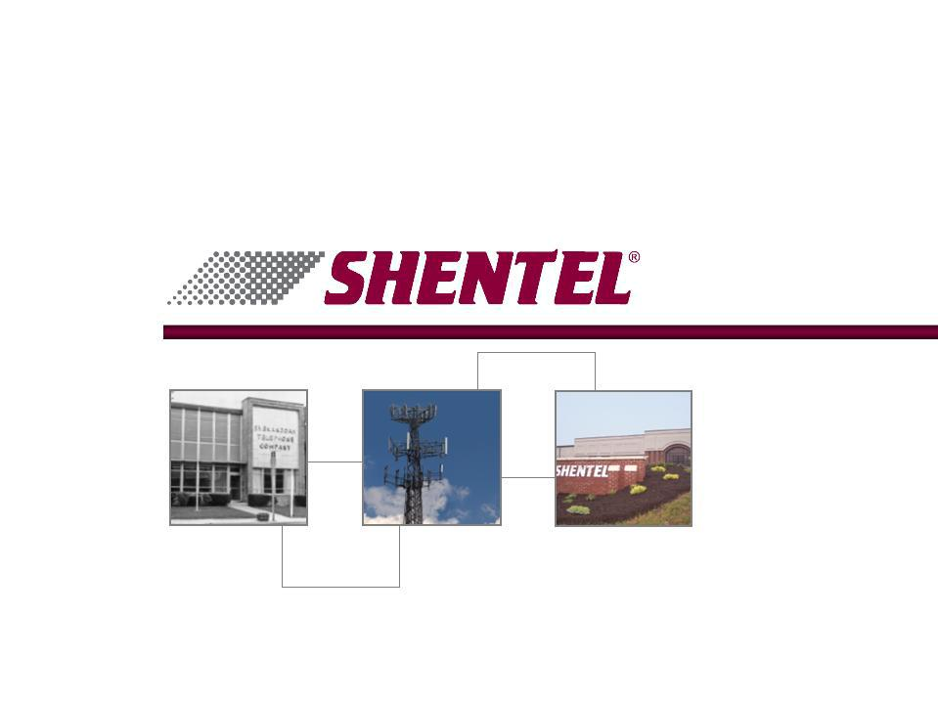

1Q 2010 Earnings Conference Call

May 6, 2010


Safe Harbor Statement

This presentation includes “forward-looking statements” within the meaning of Section 27A of the Securities Act and Section 21E of the Securities Exchange Act of 1934, as amended, regarding, among other things, our business strategy, our prospects and our financial position. These statements can be identified by the use of forward-looking terminology such as “believes,” “estimates,” “expects,” “intends,” “may,” “will,” “should,” “could,” or “anticipates” or the negative or other variation of these similar words, or by discussions of strategy or risks and uncertainties. These statements are based on current expectations of future events. If underlying assumptions prove inaccurate or unknown risks or uncertainties materialize, actual results could vary materially from the Company’s expectations and projections. Important factors that could cause actual results to differ materially from such forward-looking statements include, without limitation, risks related to the following:

qIncreasing competition in the communications industry; and qA complex and uncertain regulatory environment.

A further list and description of these risks, uncertainties and other factors can be found in the Company’s SEC filings which are available online at www.sec.gov, www.shentel.com or on request from the Company. The Company does not undertake to update any forward-looking statements as a result of new information or future events or developments.

2

Use of Non-GAAP Financial Measures

Included in this presentation are certain non-GAAP financial measures that are not determined in accordance with US generally accepted accounting principles. These financial performance measures are not indicative of cash provided or used by operating activities and exclude the effects of certain operating, capital and financing costs and may differ from comparable information provided by other companies, and they should not be considered in isolation, as an alternative to, or more meaningful than measures of financial performance determined in accordance with US generally accepted accounting principles. These financial performance measures are commonly used in the industry and are presented because Shentel believes they provide relevant and useful information to investors. Shentel utilizes these financial performance measures to assess its ability to meet future capital expenditure and working capital requirements, to incur indebtedness if necessary, return investment to shareholders and to fund continued growth. Shentel also uses these financial performance measures to evaluate the performance of its businesses and for budget planning purposes.

3

Chris French

CEO and President

4

1Q ‘10 Highlights

Net Income

(in millions)

Net Income from Continuing Operations

(in millions)

- Net Income - 1Q 2010 net income of $6.8 million

- Operating results - Net income from continuing operations of $6.6 million up 7%, with wireless up 4%

- Cable Loss - Net loss from the cable segment of $1.3 million
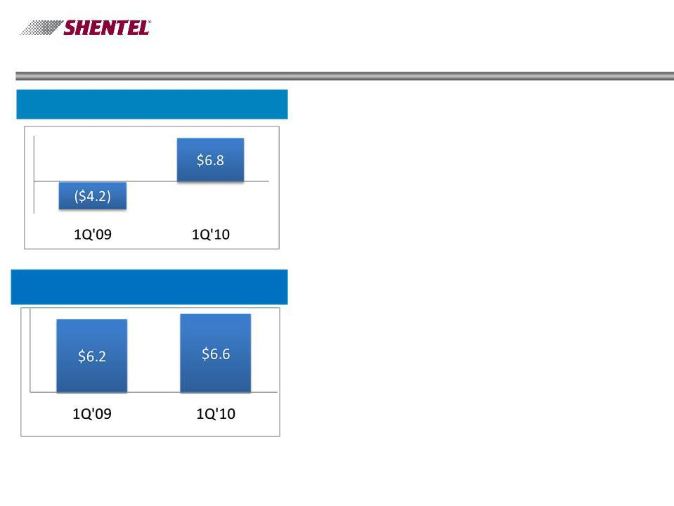

5

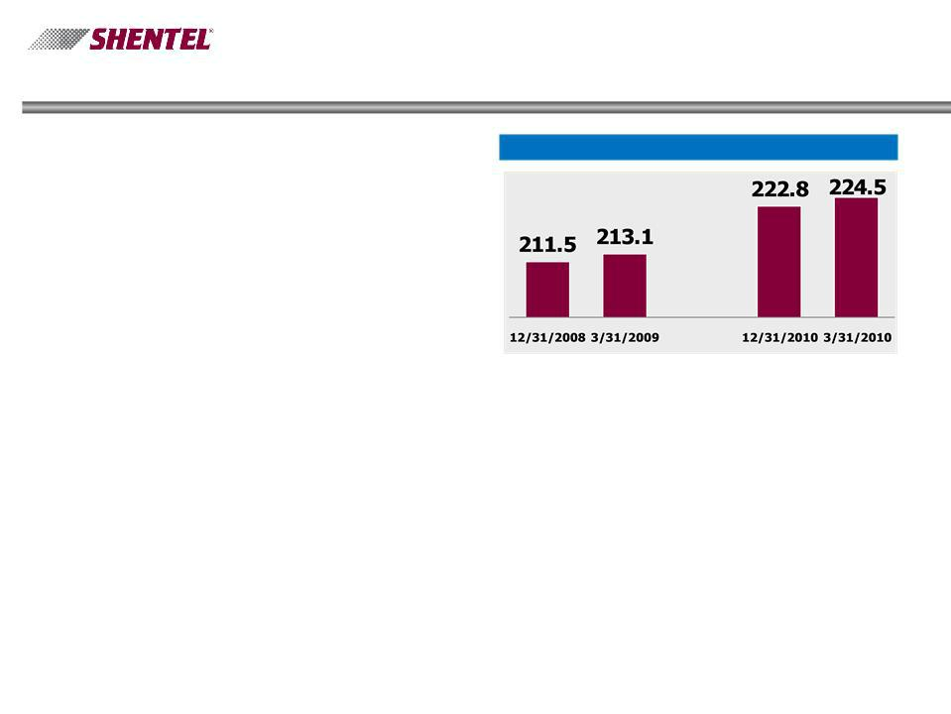
1Q ’10 Wireless Highlights

n Steady Wireless growth - customers | PCS Customers (000s)
up 5% in the last year, net adds up
7% this quarter

n Quarterly churn improves - | Q1
‘10 churn of 1.91% compared to
1.99% for Q4 ‘09 and 2.15% for Q1

’09

- Wireless upgrades completed - Capital Spending reduced as wireless high speed data upgrade and coverage improvement programs are completed

6

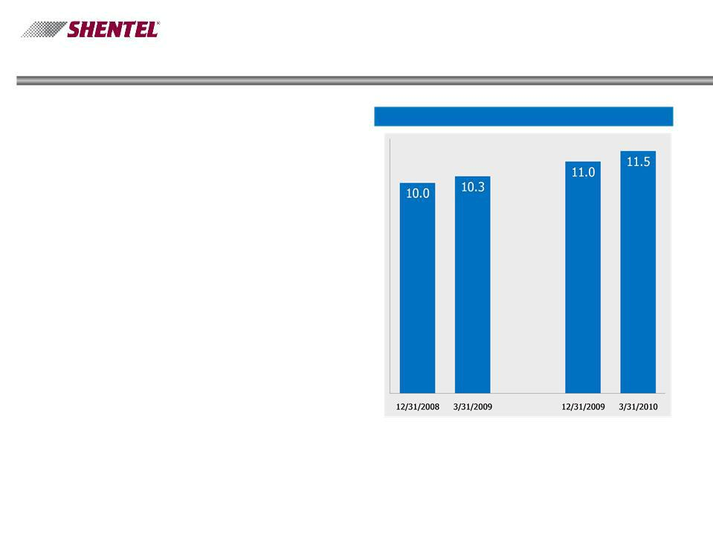
1Q ’10 Other Highlights

- Cable Triple Play - 68% of acquired homes passed upgraded through March 31

- North River commitments delivered - DSL service available to 100% of North River customers, up from 50% at year end

- Substantial DSL growth - DSL subs up 5% in Q1 2010

- Discontinued Operations - Converged Services sale process continues

DSL Customers (000s)

7

Adele Skolits

CFO and VP of Finance

8

EPS

Earnings per Share from Continuing

Operations

Earnings Per Share

- Solid Earnings- EPS from continuing operations of $.28 in 1Q ’10, up 8%
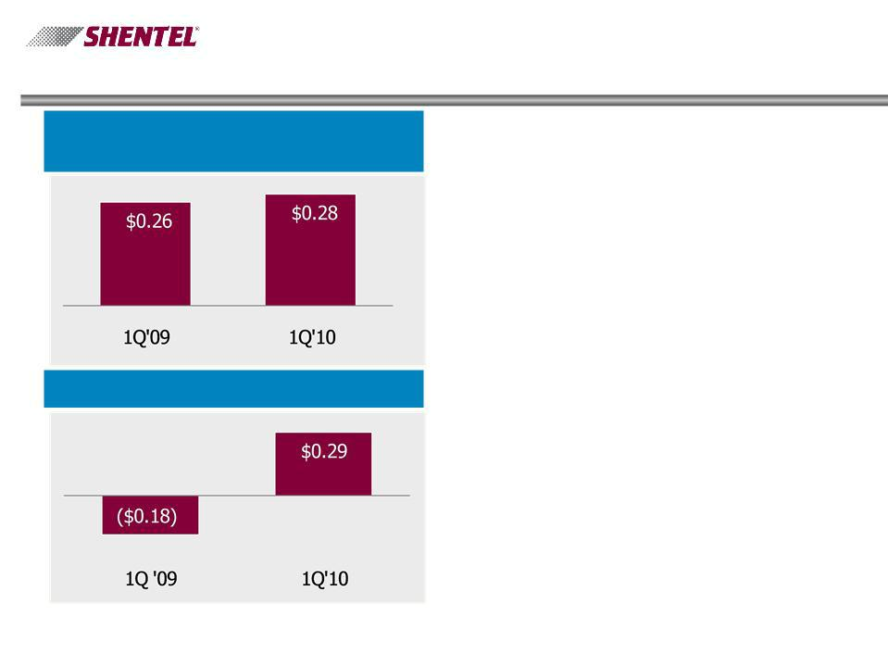

9

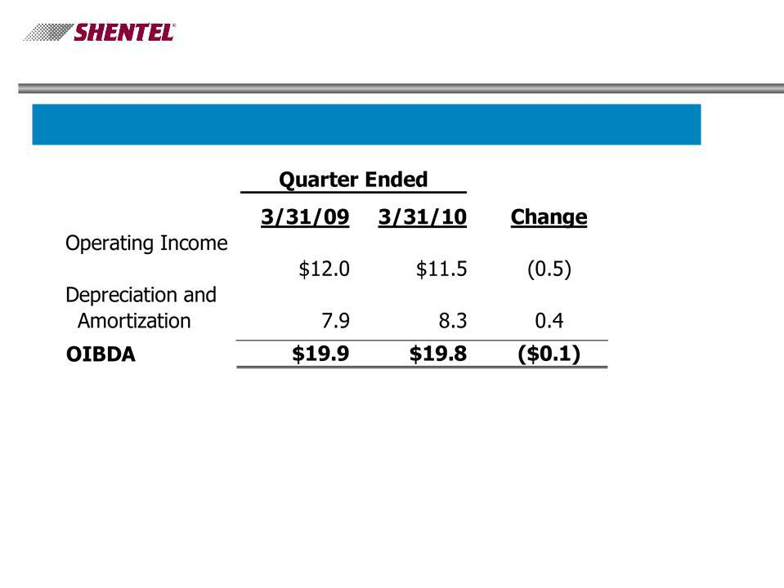
Profitability

OIBDA for the Quarter Ended ($ millions)

10

OIBDA

Change between 1Q’09and 1Q’10

in thousands

Wireless
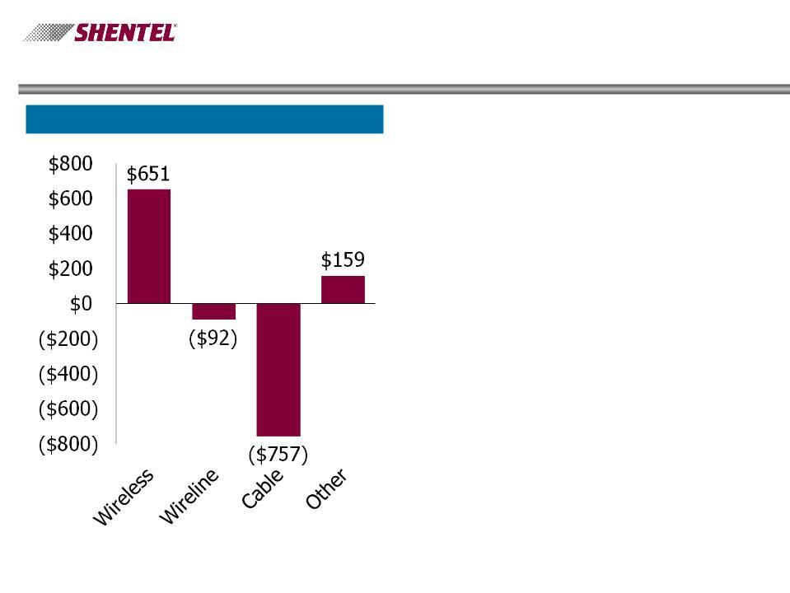

- Average customers and service revenues up 5%

- Operating costs associated with PCS network upgrades

Wireline

- Service revenues up 3%

Cable

- Revenues up despite having sold 7% of the RGU’s

- Increased costs associated with network upgrades and adding 1,172 net adds in Q1’10 vs. loss of 69 in Q1’09

11

Cash Flows

- Operating cash flow - Lower due to timing of payments vendor, tax and Sprint payments

- Capex - Expenditures flat with Q1’09 and lower than previous quarters as Wireless network improvements slow

- Cost of Capital will drop - The balance sheet will enable us to use leverage to acquire JetBB, shifting the fundamental capital structure and dropping capital costs

Cash Flows ($ millions)
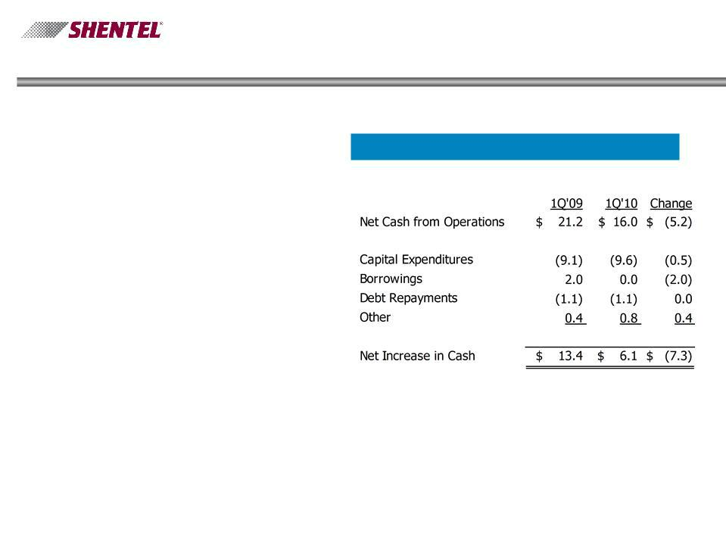

12

Earle MacKenzie

EVP and COO

13

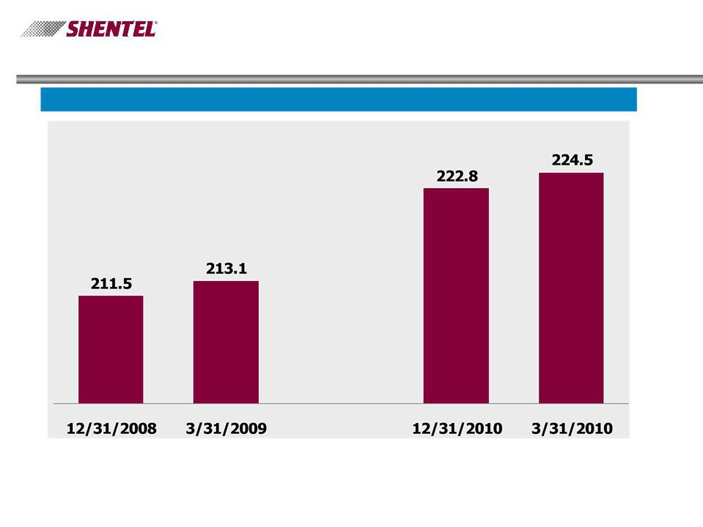
Key Operational Results - Wireless

PCS Customers (000s)

14

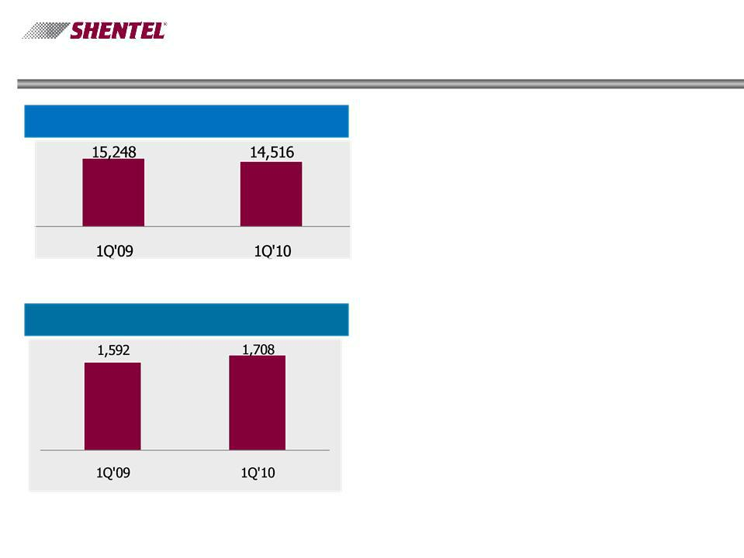
Key Operational Results - Wireless

Gross Additions

Net Additions

- Decrease in churn from 2.15% in Q1 ‘09 and

1.99% in Q4 ‘09 to 1.91% in Q1 ’10

- Improvements in retention lead to a 7% increase in net adds

- Bad Debt write-offs and credits are down 5% Q1’10 over Q1’09

15

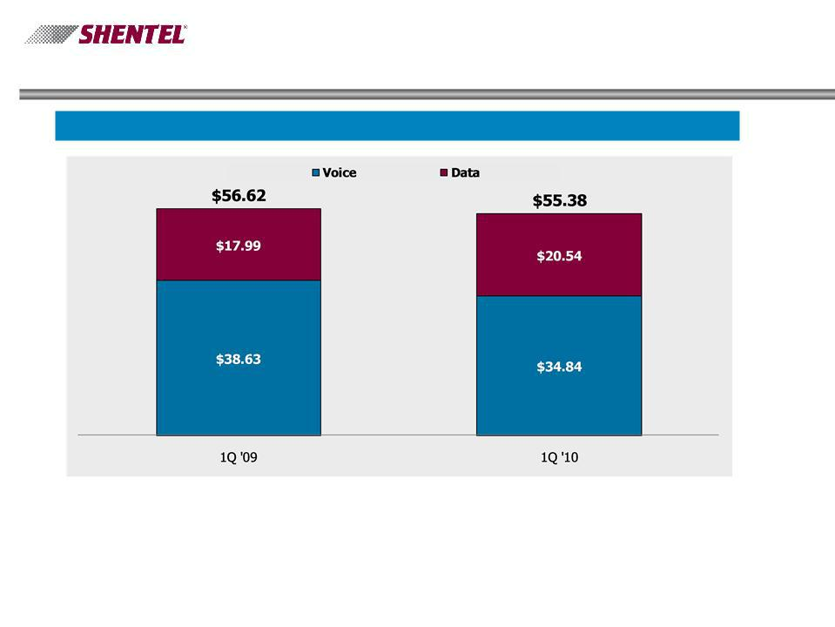
Key Operational Results - PCS

Gross Billed Revenue per User - Data & Voice ¹

- - Before Service credits, bad debt, Sprint Nextel fees. See reconciliation of Non-GAAP financial measures on slide 24

16

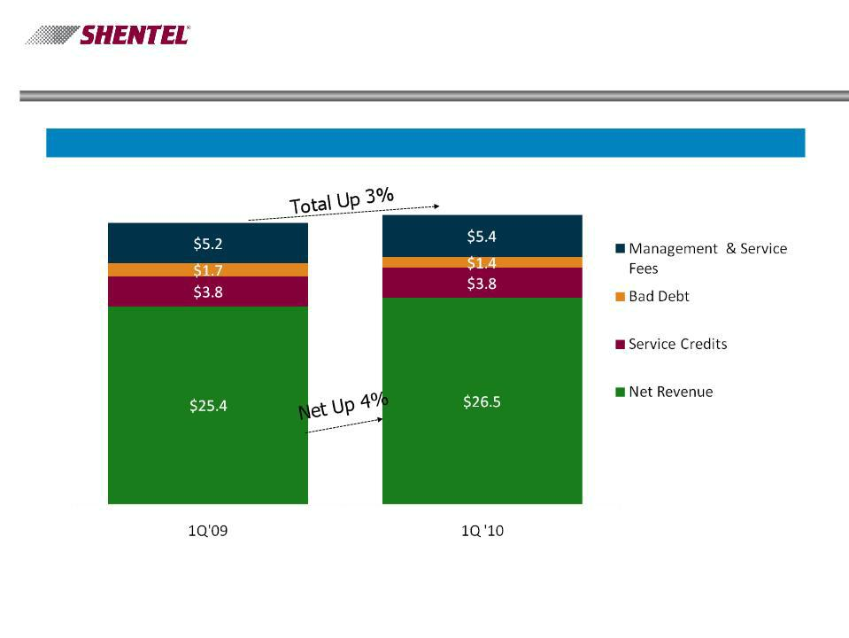
PCS Revenues

Gross Billed Revenues ($ millions)

_{$36.0} $37.1

17

PCS Customers Top Picks Q1 2010

n Top Service Plans - 49% of |  | n Top Devices - Shentel
Gross Adds |  | Controlled Channels
u | Everything Data Family | u | Sanyo 3810 12%
 | 1500 | u | Sanyo 2700 11%
 | Everything Messaging | u | Sanyo 2700 11%
u | Everything Messaging | u | Blackberry Curve 9%
 | Family 1500 | u | Blackberry Curve 9%
 | Family 1500 | u | Samsung Exclaim 9%
u | Everything 450 | u | Samsung Exclaim 9%
u LG Rumor 2 9%

u Mobile Data Cards 7%

18

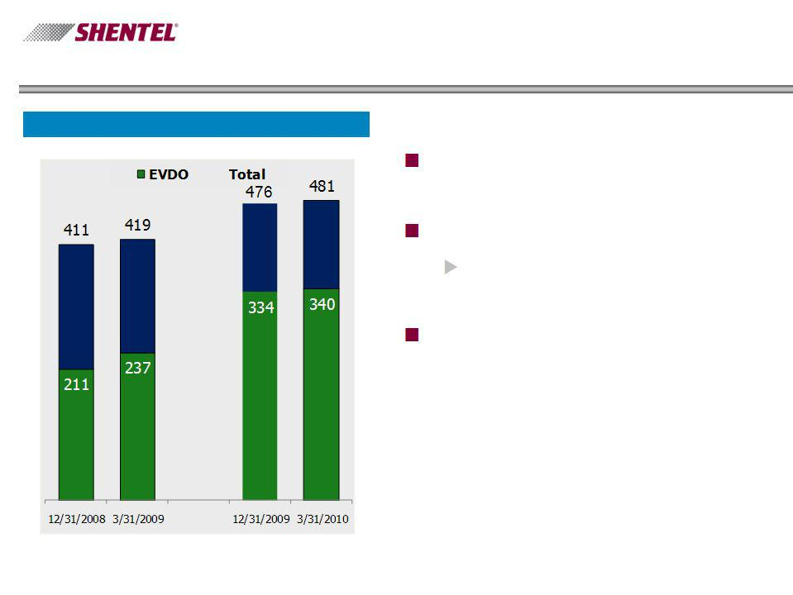
Meeting PCS Customer Needs

Number of Cell Sites

n Growth in sites and EVDO
coverage has slowed

n Expanded data offering

u Over 95% POP’s with
EVDO coverage

n Future investments success
based or maintenance related

19

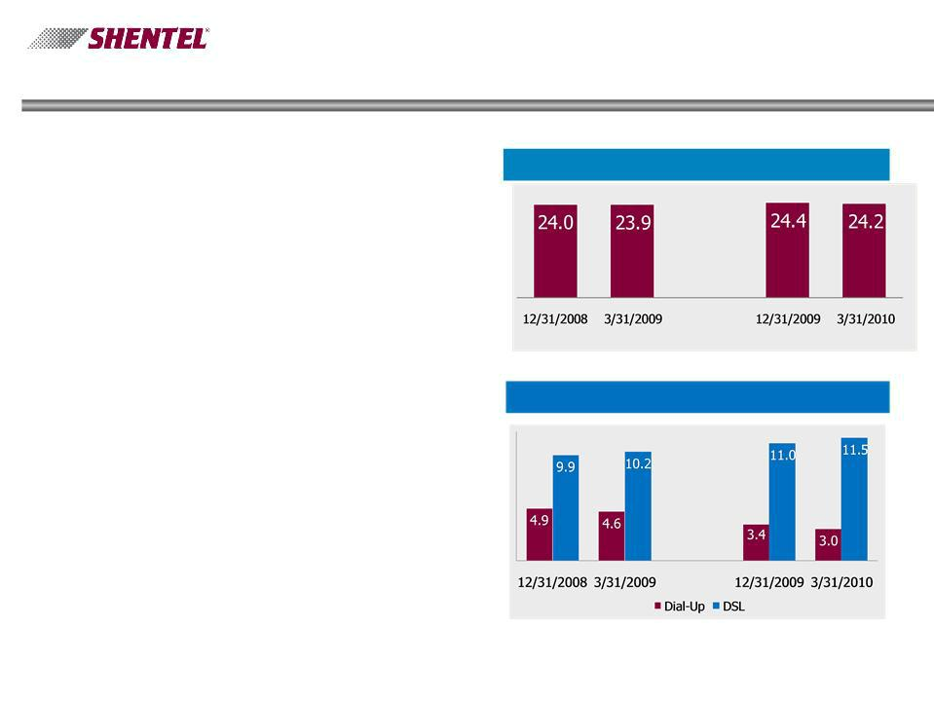
Key Operational Results - Wireline

- Modest access line loss

- 46% overall broadband penetration

- 12% growth in DSL customers since 3/31/09

Access lines (000s)

Internet Customers (000s)

- DSL only available within LEC area
- Dial-up offered inside and outside the LEC area

20

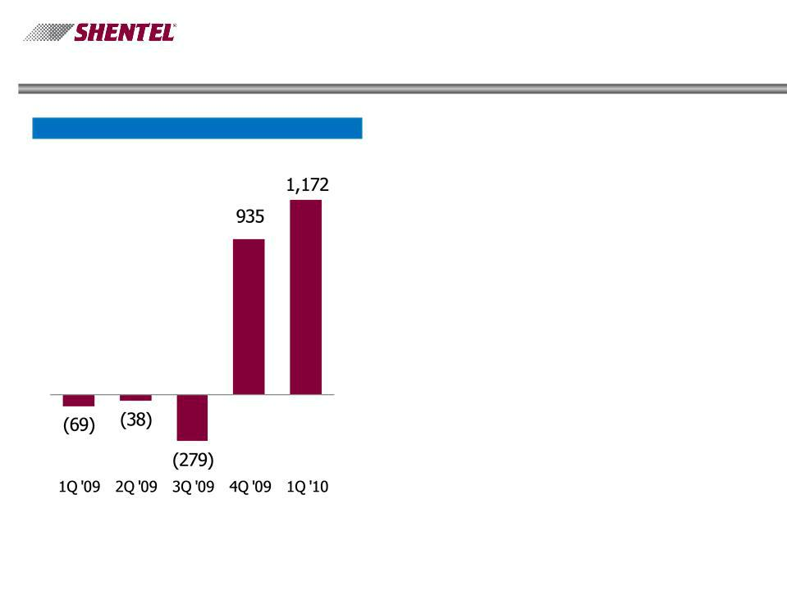
Key Operational Results - Cable

Cable Segment Net RGU Growth

n Upgrades continue to result in
substantial RGU growth

n 68% of homes passed
upgraded in acquired markets

n Voice service launched

21

Key Operational Results - Cable

 |  |  |  | 12/31/08 |  |  | 3/31/09 |  |  | 12/31/09 |  |  | 3/31/10
Video
Homes Passed |  |  |  | 64,365 |  |  | 64,365 |  |  | 56,268 |  |  | 56,268
Penetration |  |  |  | 38.70% |  |  | 38.50% |  |  | 40.50% |  |  | 41.30%
High-speed Internet
Available Homes |  |  |  | 19,405 |  |  | 19,405 |  |  | 25,748 |  |  | 27,522
Penetration |  |  |  | 5.80% |  |  | 6.20% |  |  | 8.10% |  |  | 10.10%
Voice
Available Homes |  |  |  | - |  |  | - |  |  | - |  |  | 6,355
Penetration |  |  |  |  | n/a |  |  | n/a |  |  | n/a |  | 0.60%

22

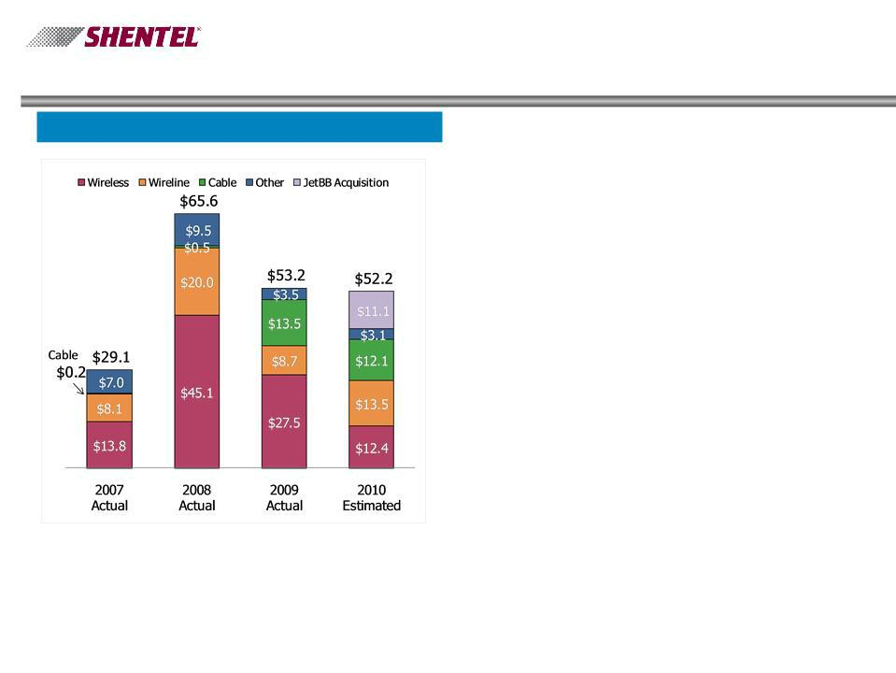
Investing in the Future

Capex Spending

n Wireless expansion slows to
success-based coverage &

capacity adds in 2010

n Complete program to increase
broadband speeds to 10 MB+

in LEC area

n Increased miles and capacity
of fiber

n Complete upgrade of existing
cable systems to 2-way to

provide triple play of services

n Initial JetBB upgrades

23

Q&A

24

Appendix

25


Non-GAAP Financial Measure - Billed Revenue per Subscriber

Dollars in thousands (except subscribers and revenue per subscriber)
 |  |  | 1Q '09 |  |  |  | 1Q '10
Gross billed revenue
Wireless segment total operating revenues |  | $28,804 |  |  | $30,233
Equipment revenue |  | -1,270 |  |  | -1,218
Other revenue |  | -2,174 |  |  |  | -2,488
Wireless service revenue |  | 25,360 |  |  | 26,527
Service credits |  | 3,764 |  |  | 3,756
Write-offs |  | 1,705 |  |  | 1,422
Management fee |  | 2,482 |  |  | 2,592
Service fee |  | 2,730 |  |  |  | 2,851
Gross billed revenue |  | 36,041 |  |  |  | 37,148
Average subscribers |  | 212,176 |  |  | 223,591
Billed revenue per subscriber |  | $56.62 |  |  | $55.38

26

