UNITED STATES
SECURITIES AND EXCHANGE COMMISSION
Washington, D.C. 20549
______________________________

FORM 8-K
______________________________

CURRENT REPORT
Pursuant to Section 13 or 15(d)
of the Securities Exchange Act of 1934
Date of Report (Date of earliest event reported): April 21, 2026
______________________________



Shenandoah Telecommunications Company
(Exact name of registrant as specified in its charter)
______________________________

Virginia | 000-09881 | 54-1162807
(State or other jurisdiction of incorporation) | (Commission File Number) | (IRS Employer Identification No.)

500 Shentel Way
P.O. Box 459
Edinburg, VA 22824
(Address of principal executive offices) (Zip Code)

(540) 984-4141
(Registrant’s telephone number, including area code)

______________________________

Check the appropriate box below if the Form 8-K filing is intended to simultaneously satisfy the filing obligation of the registrant under any of the following provisions:

☐ Written communications pursuant to Rule 425 under the Securities Act (17 CFR 230.425)

☐ Soliciting material pursuant to Rule 14a-12 under the Exchange Act (17 CFR 240.14a-12)

☐ Pre-commencement communications pursuant to Rule 14d-2(b) under the Exchange Act (17 CFR 240.14d-2(b))

☐ Pre-commencement communications pursuant to Rule 13e-4(c) under the Exchange Act (17 CFR 240.13e-4(c))

Securities registered pursuant to Section 12(b) of the Act:

Title of each class | Trading Symbol(s) | Name of each exchange on which registered
Common Stock (No Par Value) | SHEN | NASDAQ Global Select Market

Indicate by check mark whether the registrant is an emerging growth company as defined in Rule 405 of the Securities Act of 1933 (§230.405 of this chapter) or Rule 12b-2 of the Securities Exchange Act of 1934 (§240.12b-2 of this chapter).

Emerging growth company ☐

If an emerging growth company, indicate by check mark if the registrant has elected not to use the extended transition period for complying with any new or revised financial accounting standards provided pursuant to Section 13(a) of the Exchange Act. ☐

 | Item 5.07. | Submission of Matters to a Vote of Security Holders.

On April 21, 2026, Shenandoah Telecommunications Company (the “Company”) held its 2026 annual meeting of shareholders (the “Annual Meeting”). At the Annual Meeting, the following proposals were submitted to a vote of the Company’s shareholders:

Proposal 1 – Election of Directors

The following Director nominees were elected.

Matthew S. DeNichilo, Kenneth L. Quaglio and Michael A. Rhymes will serve a three (3) year term expiring at the Company’s annual meeting of shareholders in 2029.

 | Votes For | Votes Against | Abstentions | Broker Non-Votes
Matthew S. DeNichilo | 36,148,022 | 559,070 | 79,070 | 8,045,543
Kenneth L. Quaglio | 35,884,385 | 813,946 | 87,831 | 8,045,543
Michael A. Rhymes | 36,117,763 | 591,831 | 76,568 | 8,045,543

Proposal 2 – Ratification of Selection of Independent Registered Public Accounting Firm

The Company’s shareholders ratified the appointment of RSM US LLP, as set forth below:

Votes For | Votes Against | Abstentions | Broker Non-Votes
44,613,720 | 79,837 | 138,148 | -

Proposal 3 - Non-Binding Vote on Named Executive Officer Compensation

The Company’s shareholders approved, on a non-binding basis, the compensation paid to the Company’s named executive officers, as set forth below:

Votes For | Votes Against | Abstentions | Broker Non-Votes
35,844,332 | 790,299 | 151,531 | 8,045,543

 | Item 7.01. | Regulation FD Disclosure.

On April 21, 2026, following the formal portion of the Annual Meeting, Mr. Christopher French, Executive Chairman of the Board, Mr. Edward McKay, President and CEO and Mr. James Volk, Senior Vice President of Finance and CFO, provided a brief presentation on the Company. The presentation is attached as Exhibit 99.1 to this Current Report on Form 8-K.

 | Item 9.01. | Financial Statements and Exhibits.

(d) Exhibits.

Exhibit No. | Description
99.1 | Presentation Materials from the Annual Meeting, dated April 21, 2026
104 | Cover Page Interactive Data File (embedded within the Inline XBRL document)

SIGNATURES

Pursuant to the requirements of the Securities Exchange Act of 1934, the registrant has duly caused this report to be signed on its behalf by the undersigned thereunto duly authorized.

 | SHENANDOAH TELECOMMUNICATIONS COMPANY
Dated: April 22, 2026 | /s/ Angela M. Olsen
 | Angela M. Olsen
 | Vice President – Legal and General Counsel

Exhibit 99.1

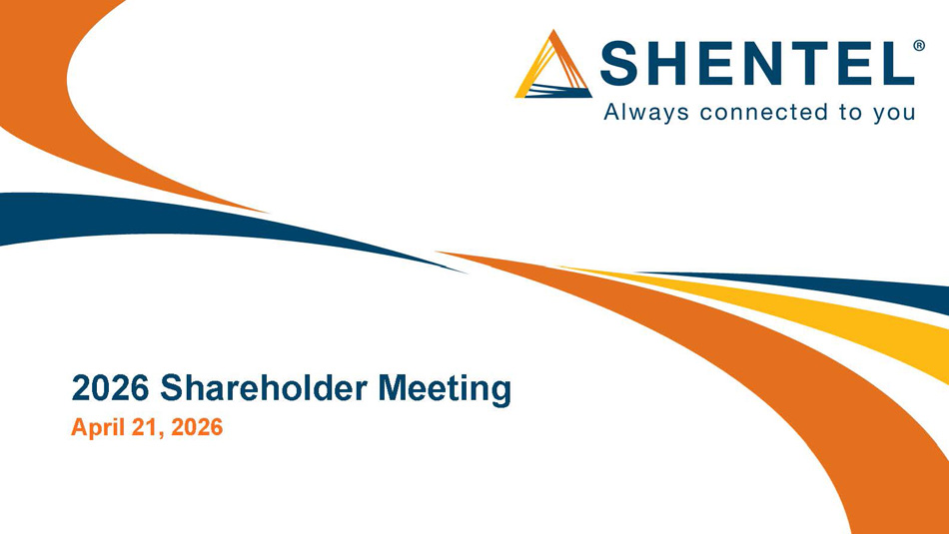
2026 Shareholder Meeting April 21, 2026

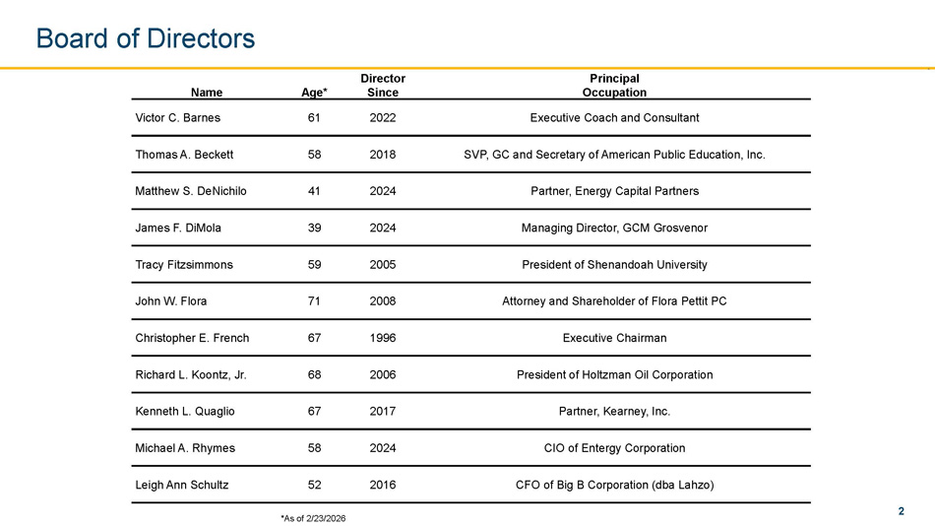
2 Principal Occupation Director Since Age* Name Executive Coach and Consultant 2022 61 Victor C. Barnes SVP, GC and Secretary of American Public Education, Inc. 2018 58 Thomas A. Beckett Partner, Energy Capital Partners 2024 41 Matthew S. DeNichilo Managing Director, GCM Grosvenor 2024 39 James F. DiMola President of Shenandoah University 2005 59 Tracy Fitzsimmons Attorney and Shareholder of Flora Pettit PC 2008 71 John W. Flora Executive Chairman 1996 67 Christopher E. French President of Holtzman Oil Corporation 2006 68 Richard L. Koontz, Jr. Partner, Kearney, Inc. 2017 67 Kenneth L. Quaglio CIO of Entergy Corporation 2024 58 Michael A. Rhymes CFO of Big B Corporation (dba Lahzo) 2016 52 Leigh Ann Schultz Board of Directors *As of 2/23/2026

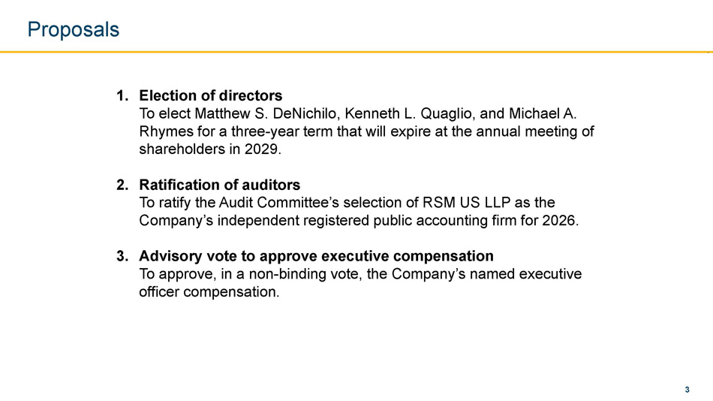
3 Proposals Election of directors 1. To elect Matthew S. DeNichilo, Kenneth L. Quaglio, and Michael A. Rhymes for a three - year term that will expire at the annual meeting of shareholders in 2029. Ratification of auditors 2. To ratify the Audit Committee’s selection of RSM US LLP as the Company’s independent registered public accounting firm for 2026. Advisory vote to approve executive compensation 3. To approve, in a non - binding vote, the Company’s named executive officer compensation.

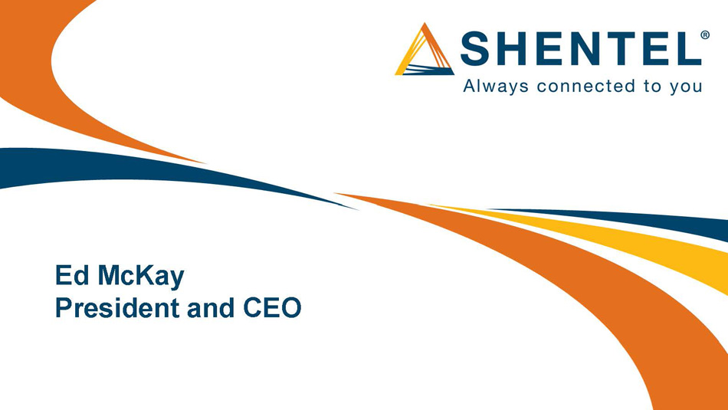
Ed McKay President and CEO

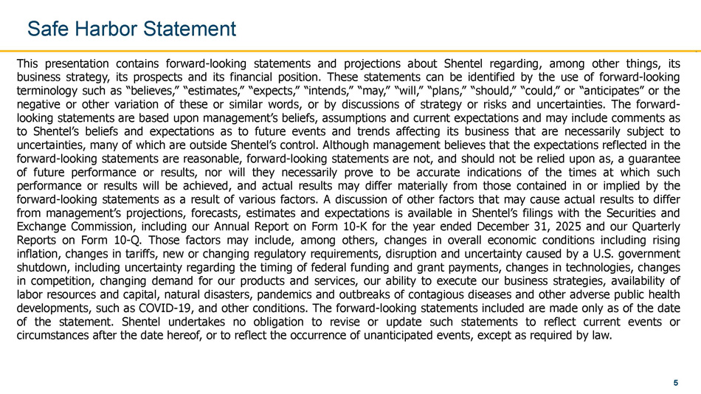
5 This presentation contains forward - looking statements and projections about Shentel regarding, among other things, its business strategy, its prospects and its financial position . These statements can be identified by the use of forward - looking terminology such as “believes,” “estimates,” “expects,” “intends,” “may,” “will,” “plans,” “should,” “could,” or “anticipates” or the negative or other variation of these or similar words, or by discussions of strategy or risks and uncertainties . The forward - looking statements are based upon management’s beliefs, assumptions and current expectations and may include comments as to Shentel’s beliefs and expectations as to future events and trends affecting its business that are necessarily subject to uncertainties, many of which are outside Shentel’s control . Although management believes that the expectations reflected in the forward - looking statements are reasonable, forward - looking statements are not, and should not be relied upon as, a guarantee of future performance or results, nor will they necessarily prove to be accurate indications of the times at which such performance or results will be achieved, and actual results may differ materially from those contained in or implied by the forward - looking statements as a result of various factors . A discussion of other factors that may cause actual results to differ from management’s projections, forecasts, estimates and expectations is available in Shentel’s filings with the Securities and Exchange Commission, including our Annual Report on Form 10 - K for the year ended December 31 , 2025 and our Quarterly Reports on Form 10 - Q . Those factors may include, among others, changes in overall economic conditions including rising inflation, changes in tariffs, new or changing regulatory requirements, disruption and uncertainty caused by a U . S . government shutdown, including uncertainty regarding the timing of federal funding and grant payments, changes in technologies, changes in competition, changing demand for our products and services, our ability to execute our business strategies, availability of labor resources and capital, natural disasters, pandemics and outbreaks of contagious diseases and other adverse public health developments, such as COVID - 19 , and other conditions . The forward - looking statements included are made only as of the date of the statement . Shentel undertakes no obligation to revise or update such statements to reflect current events or circumstances after the date hereof, or to reflect the occurrence of unanticipated events, except as required by law . Safe Harbor Statement

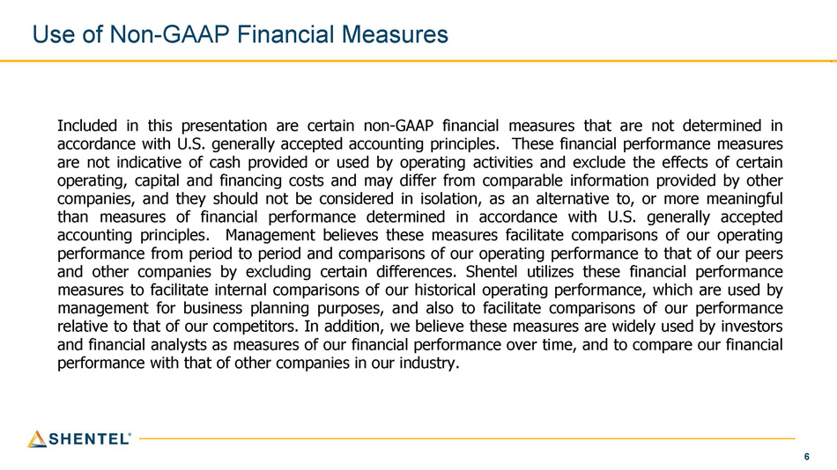
6 Use of Non - GAAP Financial Measures Included in this presentation are certain non - GAAP financial measures that are not determined in accordance with U . S . generally accepted accounting principles . These financial performance measures are not indicative of cash provided or used by operating activities and exclude the effects of certain operating, capital and financing costs and may differ from comparable information provided by other companies, and they should not be considered in isolation, as an alternative to, or more meaningful than measures of financial performance determined in accordance with U . S . generally accepted accounting principles . Management believes these measures facilitate comparisons of our operating performance from period to period and comparisons of our operating performance to that of our peers and other companies by excluding certain differences . Shentel utilizes these financial performance measures to facilitate internal comparisons of our historical operating performance, which are used by management for business planning purposes, and also to facilitate comparisons of our performance relative to that of our competitors . In addition, we believe these measures are widely used by investors and financial analysts as measures of our financial performance over time, and to compare our financial performance with that of other companies in our industry .

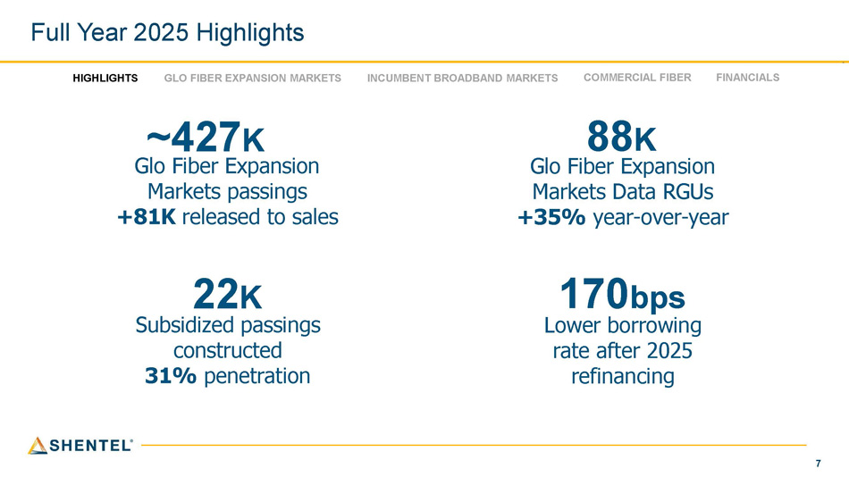
7 Full Year 2025 Highlights 88 K Glo Fiber Expansion Markets Data RGUs +35% year - over - year 170 bps Lower borrowing rate after 2025 refinancing ~427 K Glo Fiber Expansion Markets passings +81K released to sales 22 K Subsidized passings constructed 31% penetration HIGHLIGHTS INCUMBENT BROADBAND MARKETS COMMERCIAL FIBER FINANCIALS GLO FIBER EXPANSION MARKETS

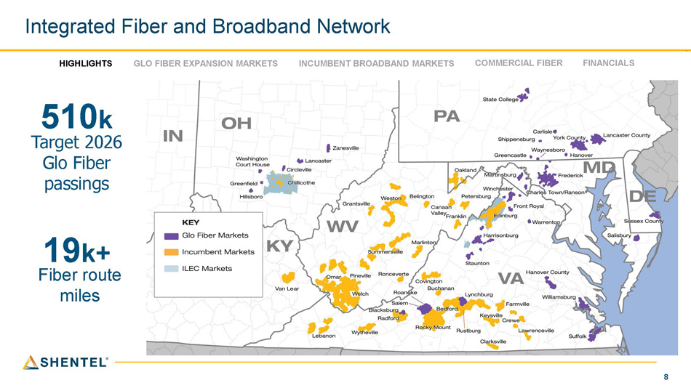
8 Integrated Fiber and Broadband Network HIGHLIGHTS INCUMBENT BROADBAND MARKETS COMMERCIAL FIBER FINANCIALS GLO FIBER EXPANSION MARKETS 510 k Target 2026 Glo Fiber passings 19 k+ Fiber route miles

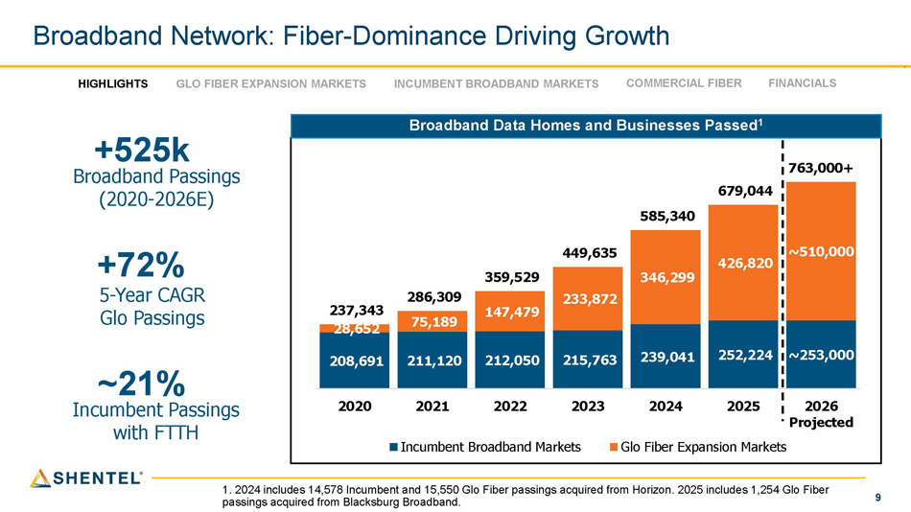
9 208,691 211,120 212,050 215,763 239,041 252,224 ~253,000 28,652 75,189 147,479 233,872 346,299 426,820 ~510,000 237,343 286,309 359,529 449,635 585,340 679,044 763,000+ 2020 2026 Projected 2021 2022 2023 Incumbent Broadband Markets 2024 2025 Glo Fiber Expansion Markets Broadband Network: Fiber - Dominance Driving Growth Broadband Data Homes and Businesses Passed 1 HIGHLIGHTS INCUMBENT BROADBAND MARKETS COMMERCIAL FIBER FINANCIALS GLO FIBER EXPANSION MARKETS +525k Broadband Passings (2020 - 2026E) +72% 5 - Year CAGR Glo Passings ~21% Incumbent Passings with FTTH 1. 2024 includes 14,578 Incumbent and 15,550 Glo Fiber passings acquired from Horizon. 2025 includes 1,254 Glo Fiber passings acquired from Blacksburg Broadband.

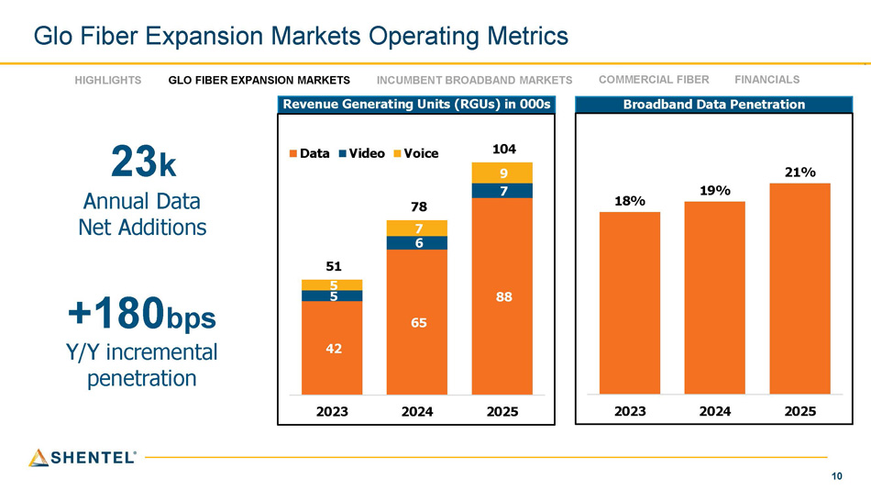
10 Glo Fiber Expansion Markets Operating Metrics Revenue Generating Units (RGUs) in 000s HIGHLIGHTS GLO FIBER EXPANSION MARKETS INCUMBENT BROADBAND MARKETS COMMERCIAL FIBER FINANCIALS 23 k Annual Data Net Additions +180 bps Y/Y incremental penetration 42 65 88 5 6 7 5 7 9 51 78 104 2023 2024 2025 Data Video Voice Broadband Data Penetration 21% 19% 18% 2025 2024 2023

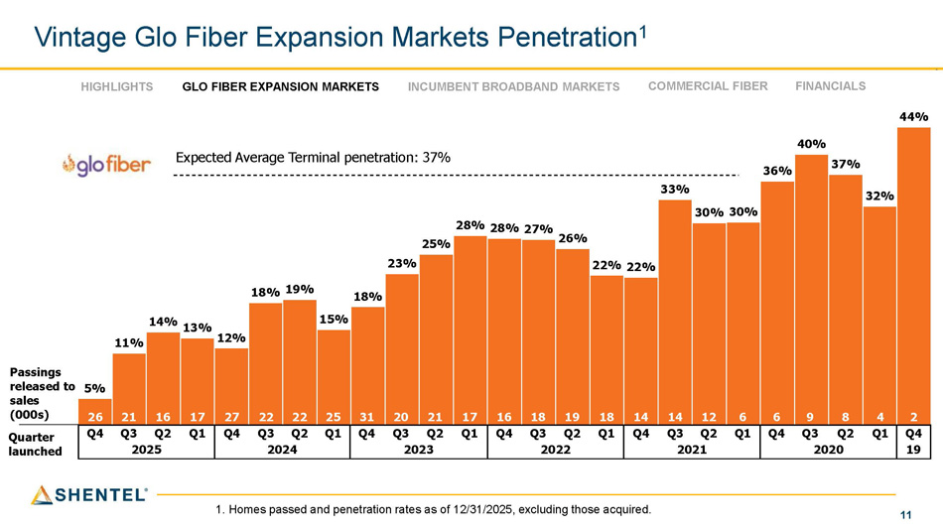
11 5% 11% 14% 13% 12% 18% 19% 15% 18% 23% 25% 28% 28% 27% 26% 22% 22% 33% 30% 30% 36% 40% 37% 32% 44% 4 3 2 1 4 3 2 1 4 3 2 1 4 3 2 1 4 3 2 1 4 3 2 1 4 Vintage Glo Fiber Expansion Markets Penetration 1 Quarter launched Expected Average Terminal penetration: 37% Passings released to sales (000s) 2 4 8 9 6 6 12 14 14 18 19 18 16 17 21 20 31 25 22 22 27 17 16 21 26 Q4 Q1 Q2 Q3 Q4 Q1 Q2 Q3 Q4 Q1 Q2 Q3 Q4 Q1 Q2 Q3 Q4 Q1 Q2 Q3 Q4 Q1 Q2 Q3 Q4 19 2020 2021 2022 2023 2024 2025 1. Homes passed and penetration rates as of 12/31/2025, excluding those acquired. HIGHLIGHTS INCUMBENT BROADBAND MARKETS COMMERCIAL FIBER FINANCIALS GLO FIBER EXPANSION MARKETS

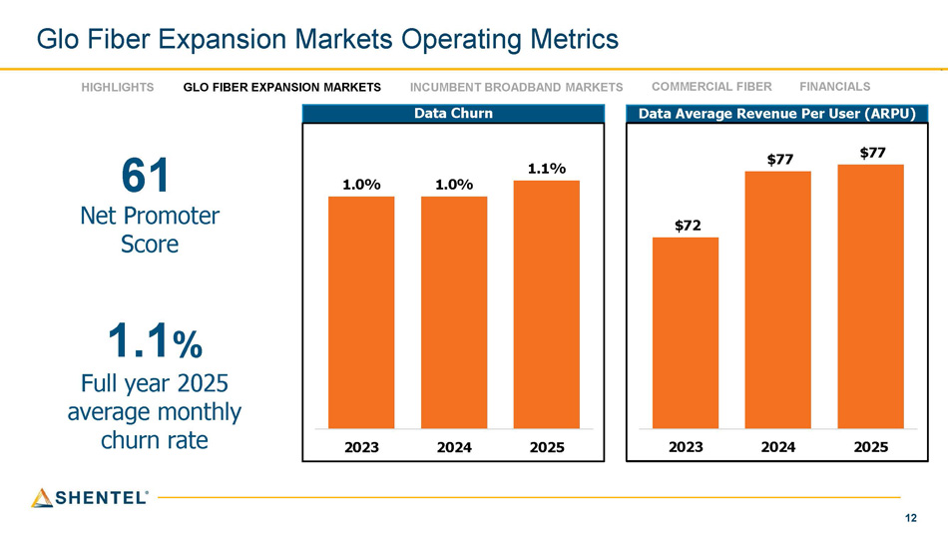
12 Glo Fiber Expansion Markets Operating Metrics Data Average Revenue Per User (ARPU) Data Churn HIGHLIGHTS GLO FIBER EXPANSION MARKETS INCUMBENT BROADBAND MARKETS COMMERCIAL FIBER FINANCIALS 61 Net Promoter Score 1.1 % Full year 2025 average monthly churn rate 1.0% 1.0% 1.1% 2023 2024 2025 $72 $77 $77 2023 2024 2025

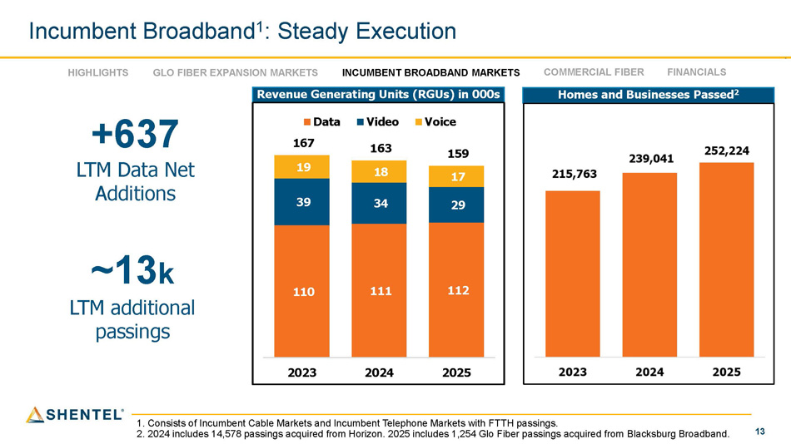
13 Homes and Businesses Passed 2 Revenue Generating Units (RGUs) in 000s HIGHLIGHTS GLO FIBER EXPANSION MARKETS INCUMBENT BROADBAND MARKETS COMMERCIAL FIBER FINANCIALS +637 LTM Data Net Additions ~13 k LTM additional passings Incumbent Broadband 1 : Steady Execution 1. Consists of Incumbent Cable Markets and Incumbent Telephone Markets with FTTH passings. 2. 2024 includes 14,578 passings acquired from Horizon. 2025 includes 1,254 Glo Fiber passings acquired from Blacksburg Broadband. 110 111 112 39 34 29 19 18 17 159 2023 2024 2025 Data Video Voice 167 163

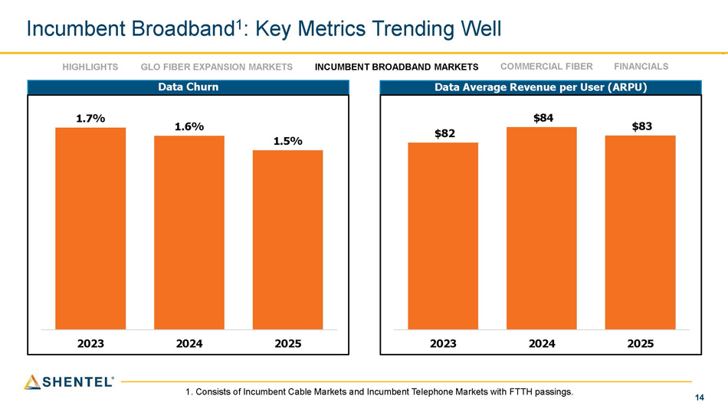
14 Data Average Revenue per User (ARPU) Data Churn HIGHLIGHTS GLO FIBER EXPANSION MARKETS INCUMBENT BROADBAND MARKETS COMMERCIAL FIBER FINANCIALS Incumbent Broadband 1 : Key Metrics Trending Well 1. Consists of Incumbent Cable Markets and Incumbent Telephone Markets with FTTH passings. 1.7% 1.6% 1.5% 2023 2024 2025 $82 $84 $83 2023 2024 2025

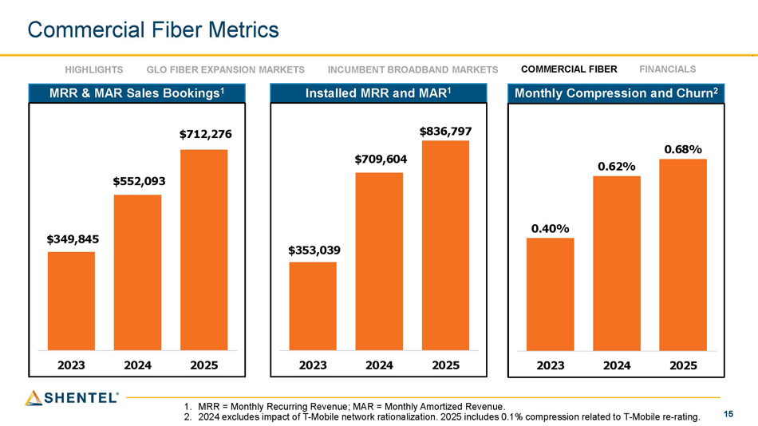
15 Commercial Fiber Metrics 1. MRR = Monthly Recurring Revenue; MAR = Monthly Amortized Revenue. 2. 2024 excludes impact of T - Mobile network rationalization. 2025 includes 0.1% compression related to T - Mobile re - rating. HIGHLIGHTS INCUMBENT BROADBAND MARKETS COMMERCIAL FIBER FINANCIALS GLO FIBER EXPANSION MARKETS MRR & MAR Sales Bookings 1 $712,276 $552,093 $349,845 2025 2024 2023 Installed MRR and MAR 1 $836,797 $709,604 $353,039 2025 2024 2023 Monthly Compression and Churn 2 0.68% 0.62% 0.40% 2025 2024 2023

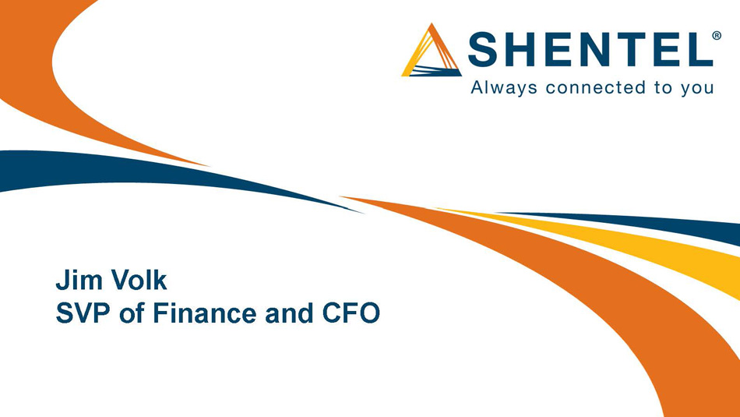
Jim Volk SVP of Finance and CFO

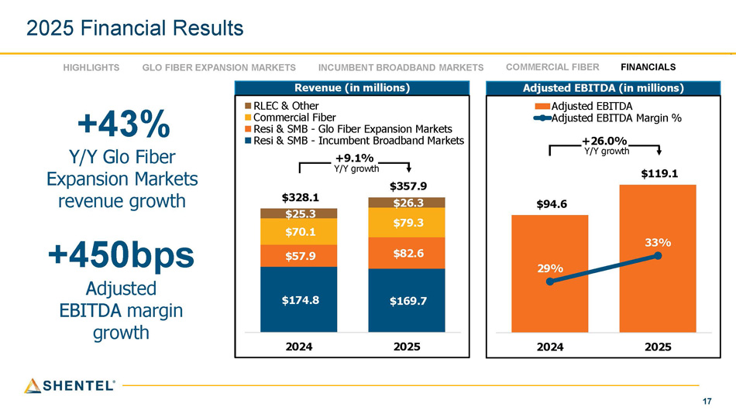
17 2025 Financial Results Adjusted EBITDA (in millions) Revenue (in millions) $174.8 $169.7 $57.9 $82.6 $70.1 $79.3 $25.3 $26.3 $328.1 $357.9 2024 2025 RLEC & Other Commercial Fiber Resi & SMB - Glo Fiber Expansion Markets Resi & SMB - Incumbent Broadband Markets +9.1% Y/Y growth +43% Y/Y Glo Fiber Expansion Markets revenue growth +450bps Adjusted EBITDA margin growth $94.6 $119.1 29% 33% 2024 2025 Adjusted EBITDA Adjusted EBITDA Margin % +26.0% Y/Y growth HIGHLIGHTS GLO FIBER EXPANSION MARKETS INCUMBENT BROADBAND MARKETS COMMERCIAL FIBER FINANCIALS

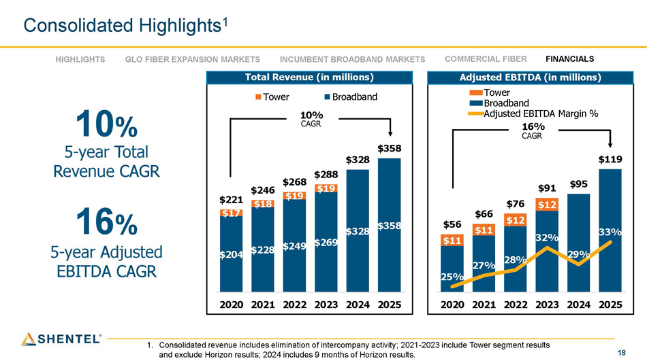
18 $11 $11 $12 $12 $56 $66 $76 $91 $95 $119 25% 27% 28% 32% 29% 33% 2020 2021 2022 2023 2024 2025 Tower Broadband Adjusted EBITDA Margin % $204 $228 $249 $269 $328 $358 $17 $18 $19 $19 $221 $246 $268 $288 $328 $358 2020 2021 2022 2023 2024 2025 Tower Broadband Consolidated Highlights 1 1. Consolidated revenue includes elimination of intercompany activity; 2021 - 2023 include Tower segment results and exclude Horizon results; 2024 includes 9 months of Horizon results. Adjusted EBITDA (in millions) Total Revenue (in millions) 10% CAGR 10 % 5 - year Total Revenue CAGR 16% CAGR 16 % 5 - year Adjusted EBITDA CAGR HIGHLIGHTS GLO FIBER EXPANSION MARKETS INCUMBENT BROADBAND MARKETS COMMERCIAL FIBER FINANCIALS

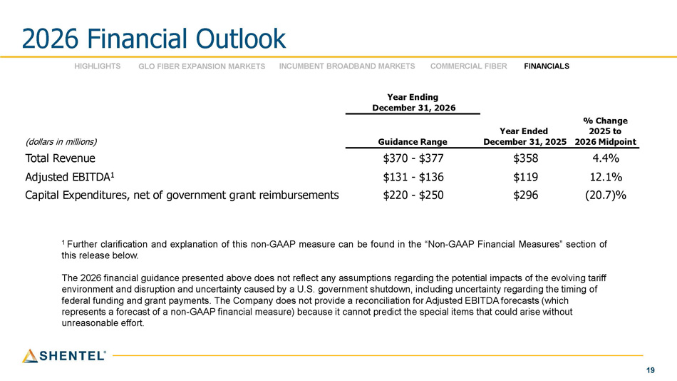
19 % Change 2025 to 2026 Midpoint Year Ending December 31, 2026 Year Ended December 31, 2025 Guidance Range (dollars in millions) 4.4% $358 $370 - $377 Total Revenue 12.1% $119 $131 - $136 Adjusted EBITDA 1 (20.7)% ection of ing tariff ing of t $296 nancial Measures” s al impacts of the evolv ainty regarding the tim DA forecasts (which at could arise withou $220 - $250 be found in the “Non - GAAP Fi sumptions regarding the potenti ment shutdown, including uncert a reconciliation for Adjusted EBIT annot predict the special items th Capital Expenditures, net of government grant reimbursements 1 Further clarification and explanation of this non - GAAP measure can this release below. The 2026 financial guidance presented above does not reflect any as environment and disruption and uncertainty caused by a U.S. govern federal funding and grant payments. The Company does not provide represents a forecast of a non - GAAP financial measure) because it c 2026 Financial Outlook unreasonable effort. HIGHLIGHTS GLO FIBER EXPANSION MARKETS INCUMBENT BROADBAND MARKETS COMMERCIAL FIBER FINANCIALS

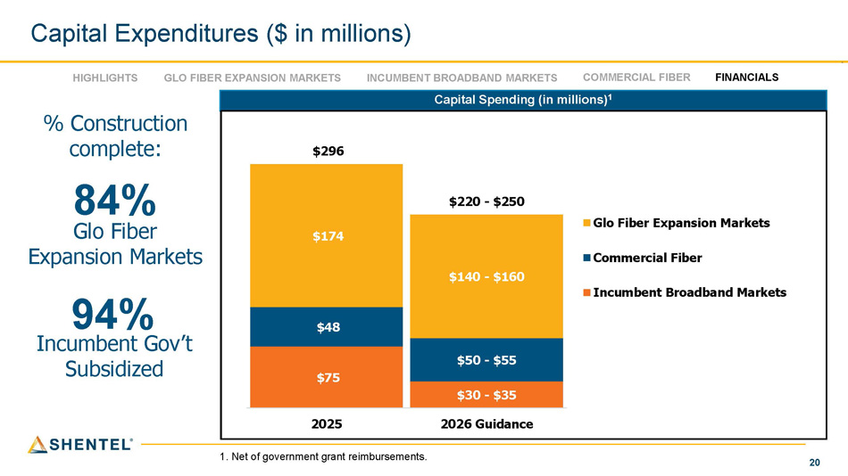
20 Capital Expenditures ($ in millions) 1. Net of government grant reimbursements. HIGHLIGHTS FINANCIALS GLO FIBER EXPANSION MARKETS INCUMBENT BROADBAND MARKETS COMMERCIAL FIBER Capital Spending (in millions) 1 $75 $30 - $35 $48 $50 - $55 $174 $140 - $160 $296 $220 - $250 2025 2026 Guidance Glo Fiber Expansion Markets Commercial Fiber Incumbent Broadband Markets % Construction complete: 84% Glo Fiber Expansion Markets 94% Incumbent Gov’t Subsidized

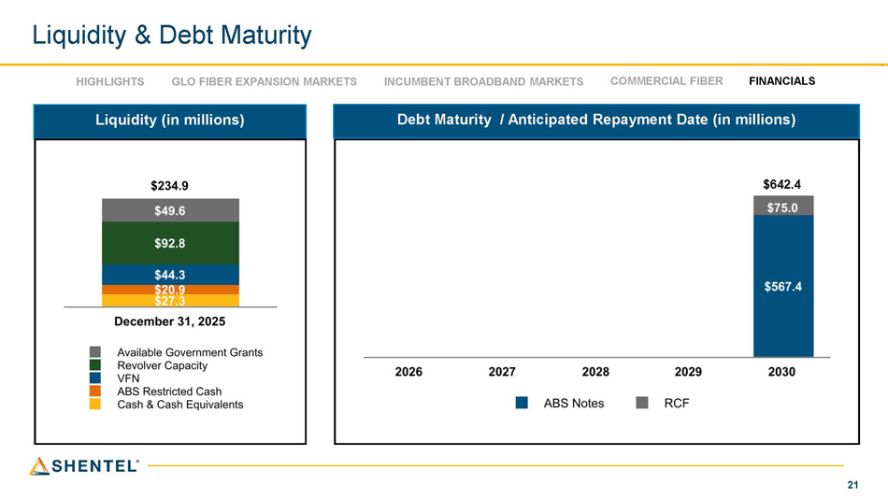
21 Debt Maturity / Anticipated Repayment Date (in millions) Liquidity (in millions) $642.4 Liquidity & Debt Maturity HIGHLIGHTS GLO FIBER EXPANSION MARKETS INCUMBENT BROADBAND MARKETS COMMERCIAL FIBER FINANCIALS

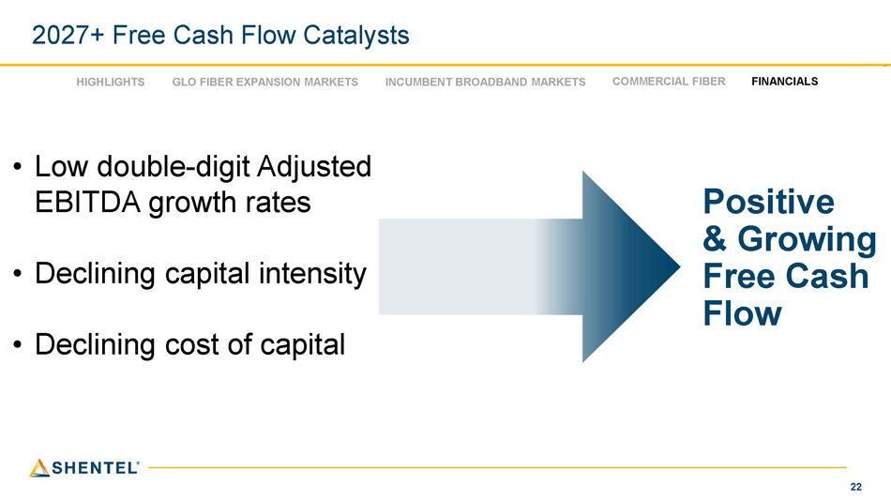
22 • Low double - digit Adjusted EBITDA growth rates • Declining capital intensity • Declining cost of capital Positive & Growing Free Cash Flow 2027+ Free Cash Flow Catalysts HIGHLIGHTS INCUMBENT BROADBAND MARKETS COMMERCIAL FIBER FINANCIALS GLO FIBER EXPANSION MARKETS

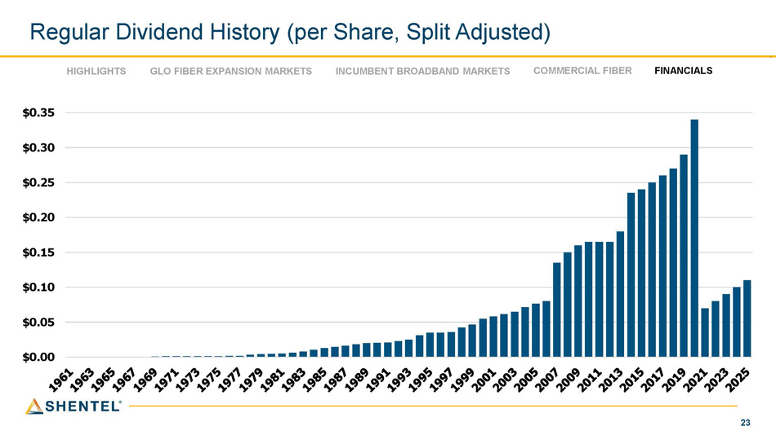
23 Regular Dividend History (per Share, Split Adjusted) $0.35 $0.30 $0.25 $0.20 $0.15 $0.10 $0.05 $0.00 HIGHLIGHTS INCUMBENT BROADBAND MARKETS COMMERCIAL FIBER FINANCIALS GLO FIBER EXPANSION MARKETS

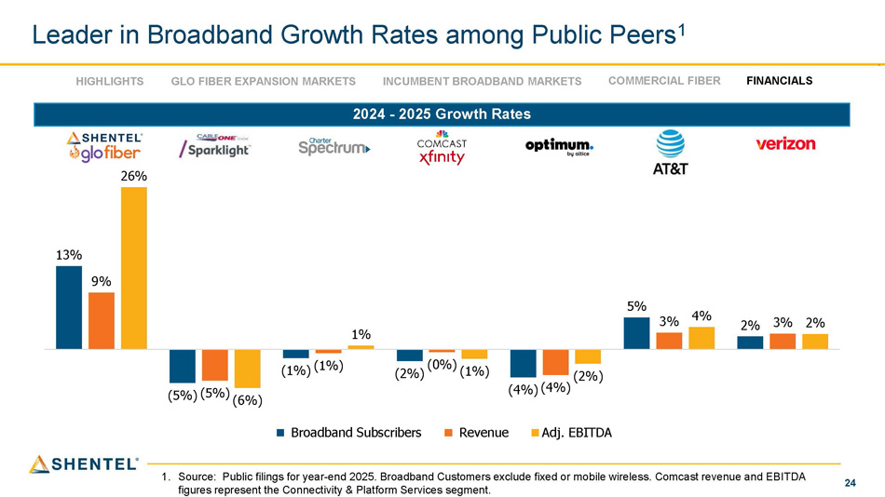
24 5% 2% 13% 9% (1%) (1%) (4%) (4%) 3% (5%) (5%) (6%) 26% 1% (2%) (0%) (1%) (2%) 4% 3% 2% Shentel Cable One Charter Comcast Optimum AT&T Verizon Broadband Subscribers Revenue Adj. EBITDA 1. Source: Public filings for year - end 2025. Broadband Customers exclude fixed or mobile wireless. Comcast revenue and EBITDA figures represent the Connectivity & Platform Services segment. Leader in Broadband Growth Rates among Public Peers 1 HIGHLIGHTS GLO FIBER EXPANSION MARKETS INCUMBENT BROADBAND MARKETS COMMERCIAL FIBER FINANCIALS 2024 - 2025 Growth Rates

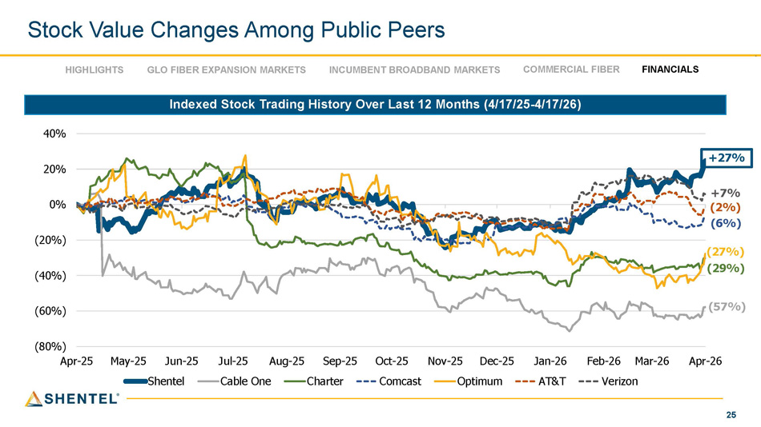
25 Stock Value Changes Among Public Peers HIGHLIGHTS INCUMBENT BROADBAND MARKETS COMMERCIAL FIBER FINANCIALS GLO FIBER EXPANSION MARKETS Indexed Stock Trading History Over Last 12 Months (4/17/25 - 4/17/26) +27% +7% (2%) (6%) (27%) (29%) (57%) (80%) (60%) (40%) (20%) 0% 20% 40% Apr - 25 May - 25 Jun - 25 Shentel Jul - 25 Aug - 25 Sep - 25 Jan - 26 Feb - 26 Mar - 26 Apr - 26 Cable One Charter Oct - 25 Nov - 25 Dec - 25 Comcast Optimum AT&T Verizon

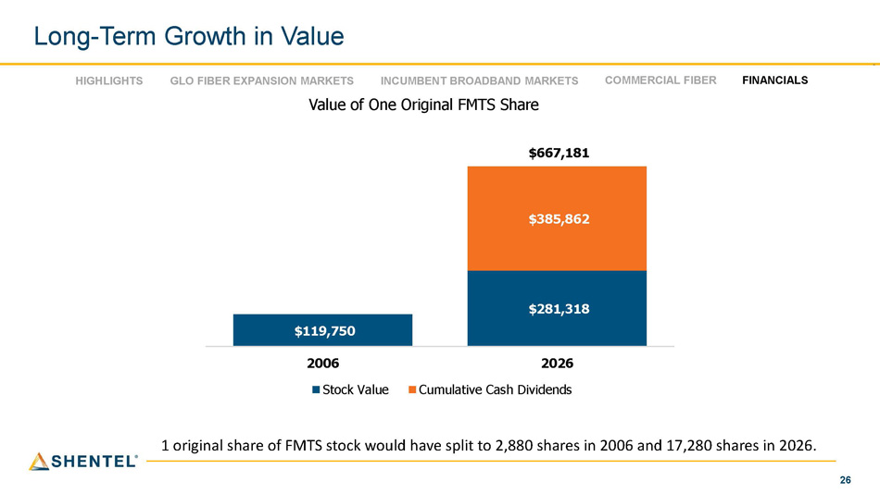
26 Long - Term Growth in Value 1 original share of FMTS stock would have split to 2,880 shares in 2006 and 17,280 shares in 2026. HIGHLIGHTS GLO FIBER EXPANSION MARKETS INCUMBENT BROADBAND MARKETS Value of One Original FMTS Share COMMERCIAL FIBER FINANCIALS $119,750 $281,318 $385,862 $667,181 2026 Cumulative Cash Dividends 2006 Stock Value

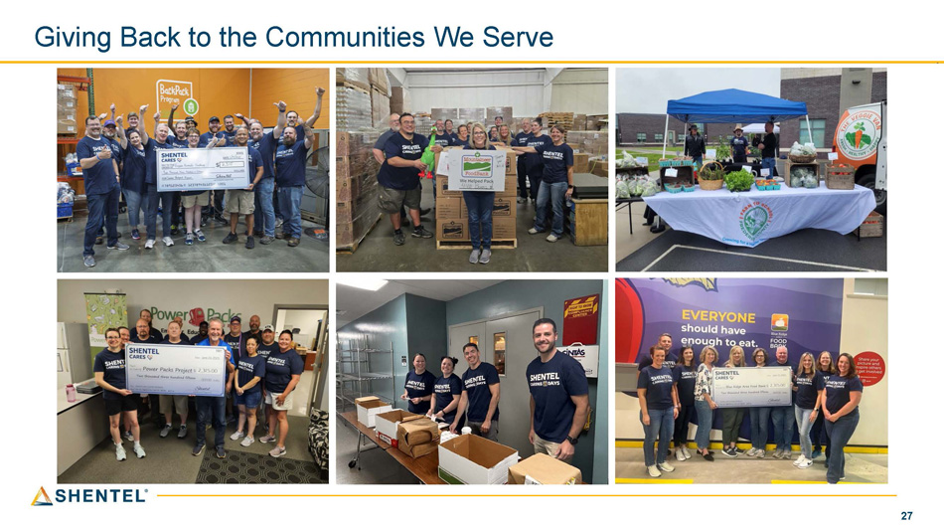
27 Giving Back to the Communities We Serve

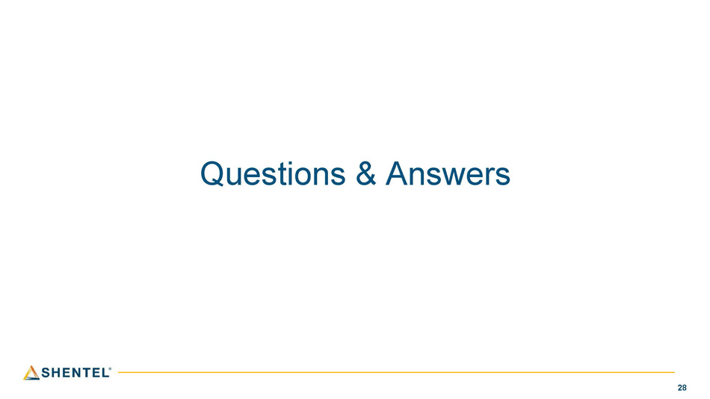
28 Questions & Answers

2026 Shareholder Meeting April 21, 2026

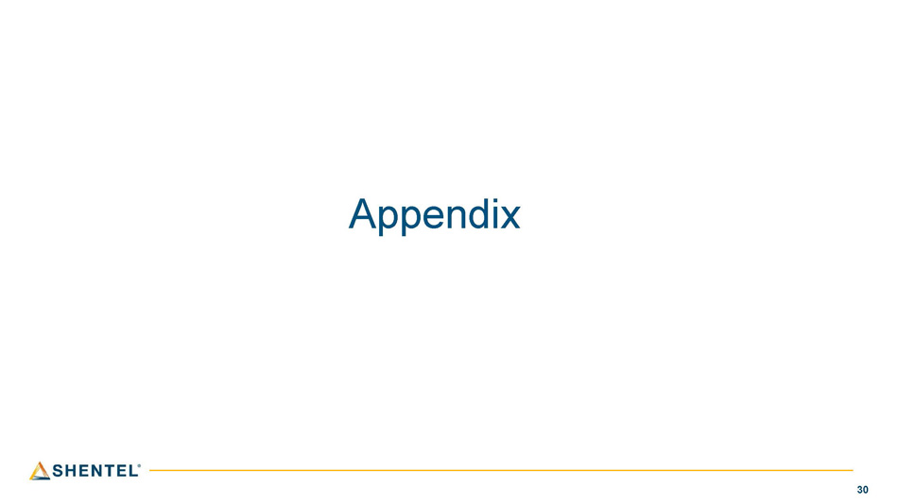
30 Appendix

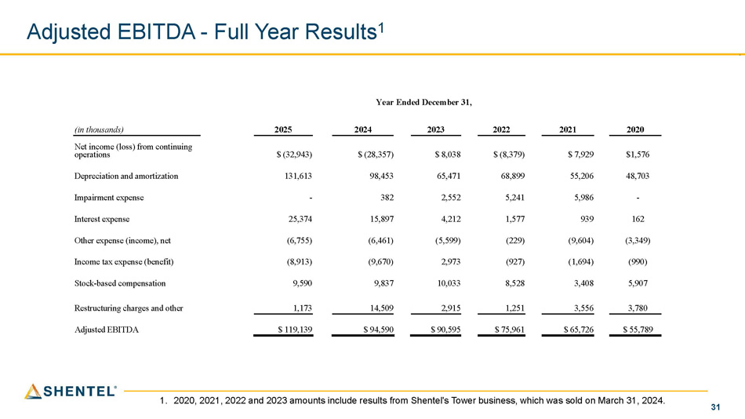
31 Year Ended December 31, 2020 2021 2022 2023 2024 2025 (in thousands) $1,576 $ 7,929 $ (8,379) $ 8,038 $ (28,357) $ (32,943) Net income (loss) from continuing operations 48,703 55,206 68,899 65,471 98,453 131,613 Depreciation and amortization - 5,986 5,241 2,552 382 - Impairment expense 162 939 1,577 4,212 15,897 25,374 Interest expense (3,349) (9,604) (229) (5,599) (6,461) (6,755) Other expense (income), net (990) (1,694) (927) 2,973 (9,670) (8,913) Income tax expense (benefit) 5,907 3,408 8,528 10,033 9,837 9,590 Stock - based compensation 3,780 3,556 1,251 2,915 14,509 1,173 Restructuring charges and other $ 55,789 $ 65,726 $ 75,961 $ 90,595 $ 94,590 $ 119,139 Adjusted EBITDA Adjusted EBITDA - Full Year Results 1 1. 2020, 2021, 2022 and 2023 amounts include results from Shentel's Tower business, which was sold on March 31, 2024.

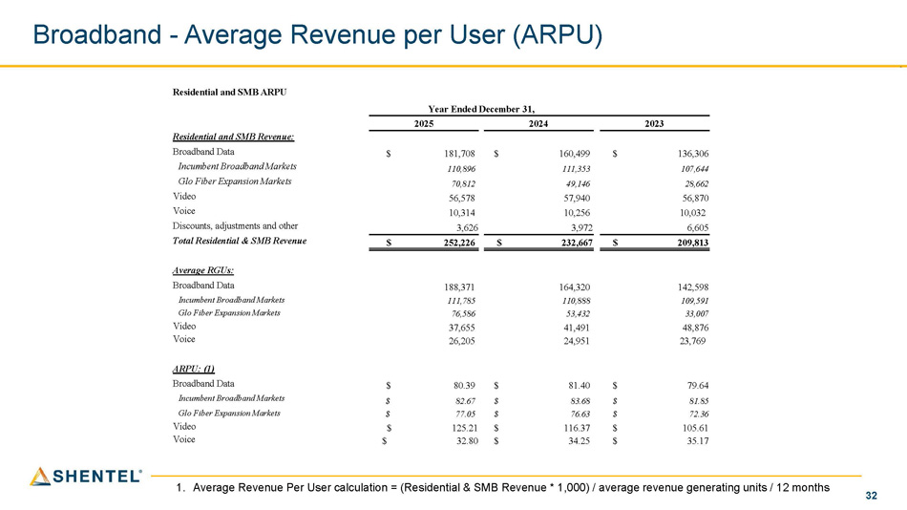
32 Broadband - Average Revenue per User (ARPU) Residential and SMB ARPU Year Ended December 31, 2023 2024 2025 Residential and SMB Revenue: $ 136,306 $ 160,499 $ 181,708 Broadband Data 107,644 111,353 110,896 Incumbent Broadband Markets 28,662 49,146 70,812 Glo Fiber Expansion Markets 56,870 57,940 56,578 Video 10,032 10,256 10,314 Voice 6,605 3,972 3,626 Discounts, adjustments and other $ 209,813 $ 232,667 $ 252,226 Total Residential

& SMB Revenue Average RGUs: 142,598 164,320 188,371 Broadband Data 109,591 110,888 111,785 Incumbent Broadband Markets 33,007 53,432 76,586 Glo Fiber Expansion Markets 48,876 41,491 37,655 Video 23,769 24,951 26,205 Voice ARPU: (1) $ 79.64 $ 81.40 $ 80.39 Broadband Data $ 81.85 $ 83.68 $ 82.67 Incumbent Broadband Markets $ 72.36 $ 76.63 $ 77.05 Glo Fiber Expansion Markets $ 105.61 $ 116.37 $ 125.21 Video $ 35.17 $ 34.25 $ 32.80 Voice 1. Average Revenue Per User calculation = (Residential & SMB Revenue * 1,000) / average revenue generating units / 12 months

