UNITED STATES OF AMERICA
SECURITIES AND EXCHANGE COMMISSION
Washington, D. C. 20549
FORM 10-K
(Mark One)
☒ |  |  | ANNUAL REPORT PURSUANT TO SECTION 13 OR 15(d) OF THE SECURITIES EXCHANGE ACT OF 1934
 |  |  | For the fiscal year ended December 31, 2025
☐ |  |  | TRANSITION REPORT PURSUANT TO SECTION 13 OR 15(d) OF THE SECURITIES EXCHANGE ACT OF 1934
 |  |  | For the transition period from__________ to __________
Commission File No.: 000-09881

SHENANDOAH TELECOMMUNICATIONS COMPANY
(Exact name of registrant as specified in its charter)
Virginia |  |  |  |  |  | 54-1162807
(State or other jurisdiction of incorporation or organization) |  |  |  |  |  | (I.R.S. Employer Identification No.)
500 Shentel Way, Edinburg, Virginia 22824
(Address of principal executive offices) (Zip Code)
(540) 984-4141 (Registrant’s telephone number, including area code)
SECURITIES REGISTERED PURSUANT TO SECTION 12(B) OF THE ACT:

Common Stock (No Par Value) |  |  | SHEN |  |  | NASDAQ Global Select Market |  |  | 55,301,648
(Title of Class) |  |  | (Trading Symbol) |  |  | (Name of Exchange on which Registered) |  |  | (The number of shares of the registrant's common stock outstanding on February 23, 2026)
SECURITIES REGISTERED PURSUANT TO SECTION 12(G) OF THE ACT: NONE
Indicate by check mark if the registrant is a well-known seasoned issuer, as defined in Rule 405 of the Securities Act. Yes ☒ No ☐
Indicate by check mark if the registrant is not required to file reports pursuant to Section 13 or Section 15(d) of the Exchange Act. Yes ☐ No ☒
Indicate by check mark whether the registrant (1) has filed all reports required to be filed by Section 13 or 15(d) of the Securities Exchange Act of 1934 during the preceding 12 months (or for such shorter period that the registrant was required to file such reports), and (2) has been subject to such filing requirements for the past 90 days. Yes ☒ No ☐
Indicate by check mark whether the registrant has submitted electronically every Interactive Data File required to be submitted pursuant to Rule 405 of Regulation S-T (§ 232.405 of this chapter) during the preceding 12 months (or for such shorter period that the registrant was required to submit and post such files). Yes ☒ No ☐
Indicate by check mark whether the registrant is a large accelerated filer, an accelerated filer, a non-accelerated filer, a smaller reporting company, or an emerging growth company. See the definitions of “large accelerated filer,” “accelerated filer,” “smaller reporting company,” and “emerging growth company” in Rule 12b-2 of the Exchange Act.
Large accelerated filer ☒ Accelerated filer ☐ Non-accelerated filer ☐ Smaller reporting company ☐ Emerging growth company ☐
If an emerging growth company, indicate by check mark if the registrant has elected not to use the extended transition period for complying with any new or revised financial accounting standards provided pursuant to Section 13(a) of the Exchange Act. ☐
Indicate by check mark whether the registrant has filed a report on and attestation to its management’s assessment of the effectiveness of its internal control over financial reporting under Section 404(b) of the Sarbanes-Oxley Act (15 U.S.C 7262(b)) by the registered public accounting firm that prepared or issued its audit report. Yes ☒ No ☐
If securities are registered pursuant to Section 12(b) of the Exchange Act, indicate by check mark whether the financial statements of the registrant included in the filing reflect the correction of an error to previously issued financial statements. ☐
Indicate by check mark whether any of those error corrections are restatements that required a recovery analysis of incentive-based compensation received by any of the registrant’s executive officers during the relevant recovery period pursuant to § 240.10D-1(b). ☐
Indicate by check mark whether the registrant is a shell company (as defined in Rule 12b-2 of the Exchange Act). Yes ☐ No ☒
The aggregate market value of the registrant’s voting stock held by non-affiliates of the registrant at June 30, 2025 based on the closing price of such stock on the Nasdaq Global Select Market on such date was approximately $0.6 billion.
DOCUMENTS INCORPORATED BY REFERENCE
Portions of the registrant’s definitive proxy statement relating to its 2026 annual meeting of shareholders (the “2026 Proxy Statement”) are incorporated by reference into Part III of this Annual Report on Form 10-K where indicated. The 2026 Proxy Statement will be filed with the U.S. Securities and Exchange Commission within 120 days after the end of the fiscal year to which this report relates.
Auditor Name: |  |  | RSM US LLP |  |  |  |  |  | Auditor Location: |  |  | Boston, Massachusetts |  |  |  |  |  | Auditor Firm ID: |  |  | 49

 |  |  | SHENANDOAH TELECOMMUNICATIONS COMPANY
 |  |  | TABLE OF CONTENTS
Item  Number |  |  |  |  |  | Page  Number
 |  |  | PART I
1. |  |  | Business |  |  | 4
1A. |  |  | Risk Factors |  |  | 15
1B. |  |  | Unresolved Staff Comments |  |  | 24
1C. |  |  | Cybersecurity |  |  | 24
2. |  |  | Properties |  |  | 26
3. |  |  | Legal Proceedings |  |  | 26
 |  |  | PART II
5. |  |  | Market for the Registrant's Common Equity, Related Stockholder Matters and Issuer Purchases of Equity Securities |  |  | 27
6. |  |  | [Reserved] |  |  | 29
7. |  |  | Management's Discussion and Analysis of Financial Condition and Results of Operations |  |  | 30
7A. |  |  | Quantitative and Qualitative Disclosures About Market Risk |  |  | 43
8. |  |  | Financial Statements and Supplementary Data |  |  | 43
9. |  |  | Changes in and Disagreements with Accountants on Accounting and Financial Disclosure |  |  | 44
9A. |  |  | Controls and Procedures |  |  | 44
9B. |  |  | Other Information |  |  | 44
9C. |  |  | Disclosure Regarding Foreign Jurisdictions that Prevent Inspections |  |  | 44
 |  |  | PART III
10. |  |  | Directors, Executive Officers and Corporate Governance |  |  | 45
11. |  |  | Executive Compensation |  |  | 45
12. |  |  | Security Ownership of Certain Beneficial Owners and Management and Related Stockholder Matters |  |  | 45
13. |  |  | Certain Relationships, Related Transactions and Director Independence |  |  | 45
14. |  |  | Principal Accounting Fees and Services |  |  | 45
 |  |  | PART IV
15. |  |  | Exhibits and Financial Statement Schedules |  |  | 46
16. |  |  | Form 10-K Summary |  |  | 46

2
Table of Contents
PART I

CAUTIONARY STATEMENT REGARDING FORWARD-LOOKING STATEMENTS:

This annual report includes forward-looking statements within the meaning of Section 27A of the Securities Act of 1933, as amended (the “Securities Act”), and Section 21E of the Securities Exchange Act of 1934, as amended (the “Exchange Act”), regarding, among other things, our plans, strategies and prospects, both business and financial including, without limitation, the forward-looking statements set forth in Part I. Item 1, under the heading “Business” and in Part II. Item 7, under the heading “Management’s Discussion and Analysis of Financial Condition and Results of Operations” in this annual report. Although we believe that our plans, intentions and expectations reflected in or suggested by these forward-looking statements are reasonable, we cannot assure you that we will achieve or realize these plans, intentions or expectations. Forward-looking statements are inherently subject to risks, uncertainties and assumptions, including, without limitation, the factors described in Part I. Item 1A, under “Risk Factors” and in Part II. Item 7, under the heading, “Management’s Discussion and Analysis of Financial Condition and Results of Operations” in this annual report. Many of the forward-looking statements contained in this annual report may be identified by the use of forward-looking words such as “believe,” “expect,” “anticipate,” “should,” “planned,” “will,” “may,” “intend,” “estimated,” “aim,” “on track,” “target,” “opportunity,” “tentative,” “positioning,” “designed,” “create,” “predict,” “project,” “initiatives,” “seek,” “would,” “could,” “continue,” “ongoing,” “upside,” “increases” and “potential,” among others. Important factors that could cause actual results to differ materially from the forward-looking statements we make in this annual report are set forth in this annual report and in other reports or documents that we file from time to time with the U.S. Securities and Exchange Commission (“SEC”), and include, but are not limited to:

•our ability to sustain and grow revenues and cash flow from operations by offering broadband internet, video, voice, fiber optic network services and other services to residential and commercial customers, to adequately meet the customer demands in our service areas and to maintain and grow our customer base, particularly in the face of increasingly aggressive competition;
•the impact of competition from other market participants, including but not limited to fiber to the home (“FTTH”) providers, incumbent telephone companies, direct broadcast satellite operators, wireless broadband providers, incumbent cable providers, commercial fiber providers, video provided over the internet by (i) market participants with streaming video services, (ii) traditional multichannel video distributors, and (iii) content providers that offer direct to consumer;
•the availability of cash on hand and access to capital to fund the growth of capital expenditures needed to execute our business plan;
•our ability to comply with all covenants in our various credit facilities, any violation of which, if not cured in a timely manner, could trigger an event of default;
•our ability to maintain high quality network service and any events that disrupt our networks, information systems or properties and impair our operating activities or our reputation;
•the ability to retain and hire key personnel;
•general business conditions, inflation, economic uncertainty or downturn, unemployment levels and the level of activity in the housing sector.

All forward-looking statements attributable to us or any person acting on our behalf are expressly qualified in their entirety by this cautionary statement. We are under no duty or obligation to update any of the forward-looking statements after the date of this annual report.

Unless we indicate otherwise, references in this report to “we,” “us,” “our,” “Shentel” and “the Company” means Shenandoah Telecommunications Company and its subsidiaries.

3
Table of Contents

ITEM 1.BUSINESS

Our Company

Shenandoah Telecommunications Company and its subsidiaries (“Shentel”, “we”, “our”, “us”, or the “Company”), provide broadband services through its high speed, state-of-the-art fiber-optic and cable networks to customers in eight contiguous states in the eastern United States. The Company’s services include: broadband internet, video and voice; high-speed Ethernet, dark fiber leasing; and managed network services. The Company owns an extensive regional network with approximately 19,000 route miles of fiber. For more information, please visit www.shentel.com.

Description of Business

Shentel provides broadband data, video and voice services to residential and commercial customers in portions of Virginia, West Virginia, Maryland, Pennsylvania, Kentucky, Delaware, Ohio and Indiana, via fiber optic and hybrid fiber coaxial (“HFC”) cable networks. We also lease dark fiber and provide Ethernet and Wavelength fiber optic services to enterprise and wholesale customers throughout the entirety of our service area. Shentel’s Broadband business also provides voice and digital subscriber line (“DSL”) services as a Rural Local Exchange Carrier (“RLEC”) to customers in Shenandoah County and portions of adjacent counties in Virginia, and in Ross County and portions of adjacent counties in Ohio. The Company served approximately 262,000 Revenue Generating Units (“RGUs”) at December 31, 2025.

New Entities formed to support securitized financing

During 2025, Shentel formed Shentel Guarantor LLC, Shentel Issuer LLC (“Shentel Issuer”), Shentel Asset Entity I LLC and Shentel Asset Entity II LLC (collectively, the “ABS Entities"”, each a bankruptcy-remote subsidiary of the Company. The ABS Entities were formed as part of a securitization transaction, pursuant to which certain of the Company’s fiber network assets and related customer contracts, primarily in Virginia, Ohio, Pennsylvania, Indiana, Maryland and West Virginia, were contributed to Shentel Asset Entity I LLC and Shentel Asset Entity II LLC (collectively, the “ABS Asset Entities”). The cash flow from these contributed assets are used to service the obligations under Shentel's “ABS Notes”, as defined in the following paragraph.

On December 5, 2025 (the “Closing”), Shentel Issuer, in relation to the securitization transaction referenced above, closed its inaugural offering of $567.4 million aggregate principal amount of secured fiber network revenue term notes, consisting of $489.1 million 5.64% Series 2025-1, Class A-2 term notes (“Class A-2 Notes”) and $78.3 million 6.03% Series 2025-1, Class B term notes (“Class B Notes”), each with an anticipated repayment date in December 2030.

As part of the securitization financing transaction, Shentel Issuer also entered into a revolving $175.0 million variable funding note facility (the “VFN”) due December 2029 with a group of financial institutions. VFN advances will be subject to certain pro-forma leverage and debt service coverage ratios as defined in the agreements governing the VFN (the “ABS Indenture”).

As part of the same ABS Indenture and fiber network assets and related customer contracts that govern and secure the ABS Notes, Shentel Issuer entered into a $25 million delay draw Liquidity Funding Note facility (the “LFN”, together with the Class A-2 Notes, Class B notes, and the VFN, the “ABS Notes”) with Bank of America.

Concurrently, Shentel Broadband Operations LLC (“Shentel Broadband”), a wholly-owned indirect subsidiary of the Company, entered into a new $175.0 million Revolving Credit Facility (the “RCF”) due December 2030 with a group of financial institutions. The RCF is secured by the cash flows and substantially all of the assets and equity interests of the Company’s subsidiaries excluding the ABS Entities.

Shentel and its non ABS Entities have no recourse of the loans of the ABS Entities. Likewise, the ABS Entities have no recourse of the loans of Shentel Broadband.

Shentel used the proceeds from the issuance of the ABS Notes and the RCF to repay the outstanding principal on the Company’s existing debt. Refer to Note 10, Debt to the Company’s 2025 consolidated financial statements for more information.

4
Table of Contents
Competition

As the incumbent broadband provider passing approximately 252,000 homes and businesses, we compete against incumbent local telephone companies that provide digital subscriber line (“DSL”) internet and voice services over hybrid fiber and copper-based networks as well as broadband overbuilder providers that offer data, voice, and video services over hybrid coaxial cable or fiber optic networks. Approximately 30% of our incumbent broadband passings compete with a wireline broadband competitor. In addition, we compete with fixed wireless broadband services and indirectly with wireless substitution as the bandwidth speeds from wireless providers have increased with 5th generation network technology upgrades.

Our Glo Fiber Fiber-To-The-Home (“FTTH”) service passes approximately 427,000 homes and businesses and competes against the incumbent cable companies’ broadband, video and voice services utilizing hybrid fiber-coaxial cable networks and the incumbent local telephone companies. Approximately 88% of the Glo Fiber passings compete with incumbent telephone company’s DSL internet and voice services via hybrid fiber and copper-based networks and approximately 12% of the Glo Fiber passings compete with the incumbent telephone company’s FTTH networks.

Competition is also intense and growing in the market for video services. Cable television systems are operated under non-exclusive franchises granted by local authorities, which may result in more than one operator providing video services in a particular market. Incumbent cable television companies, which have historically provided video service, also face competition from direct broadcast satellite providers such as Dish and DirecTV and online video services, such as Netflix, YouTube TV, Hulu, Disney and Amazon. Our ability to compete effectively with our competitors in video will depend, in part, on price, content cost and variety, service quality, access to content and the convenience of our service offerings.

A recent trend towards convergence of wireless and fiber broadband service offerings has started consolidation in the FTTH segment. If this trend continues, mergers, acquisitions and strategic alliances with large wireless carriers could also increase the level of competition we face.

Regulation

Shentel’s operations are subject to regulation by the Federal Communications Commission ("FCC"), state utility commissions, and other federal, state, and local governmental agencies across the Company’s footprint. The laws governing these agencies, and the regulations and policies that they administer, are subject to constant review and revision, and some of these changes could have material impacts on our revenues and expenses.

Regulation of Broadband Internet and Cable Video Services

We provide broadband internet, video, voice and fiber services to residential and business customers in franchise areas covering portions of Virginia, West Virginia, Maryland, Pennsylvania, Kentucky, Delaware, Ohio and Indiana.

The provision of cable service generally is subject to regulation by the FCC, and cable operators typically also must comply with the terms of the franchise agreement between the cable operator and the state or local franchising authority. Some states, including Virginia and West Virginia, have enacted regulations and franchise provisions that also can affect certain aspects of a cable provider’s operations. Our business may be significantly impacted by changes to the existing regulatory framework, whether caused by legislation or administrative or judicial actions.

The FCC originally classified broadband internet access services, such as those we offer, as an information service, which by law exempts the service from traditional common carrier communications laws and regulations. In 2015, the FCC determined that broadband internet access services, such as those we offer, were a form of telecommunications service under the Communications Act of 1934, as amended (the “Communications Act”), and, on that basis, imposed rules (commonly referred to as “Net Neutrality” rules) banning service providers from blocking access to lawful content, restricting data rates for downloading lawful content, prohibiting the attachment of non-harmful devices, giving special transmission priority to affiliates and offering third parties the ability to pay for priority routing. The Net Neutrality rules also imposed a transparency requirement, i.e., an obligation to disclose all material terms and conditions of our service to consumers. The legality of Net Neutrality rules have been disputed since the FCC’s 2015 determination, and in 2025, the U.S. Supreme Court ruled that the FCC does not have the authority to impose Net Neutrality rules. Consequently, broadband internet access services are currently classified as an information service.

5
Table of Contents
As the internet has matured, it has become the subject of increasing regulatory interest. Congress and Federal regulators have adopted a wide range of measures that either directly or indirectly impacted internet use and the adoption of new internet regulations or policies could adversely affect our business.

Federal and state governments have launched numerous programs to provide subsidies for the construction of high-speed broadband facilities to homes that do not have access to broadband service (currently defined by the FCC) including federal funding from the American Rescue Plan Act, the Coronavirus Aid, Relief, and Economic Security Act and the FCC’s Rural Digital Opportunities Fund, and state programs such as the Virginia Telecommunications Initiative (“VATI”), Maryland Network Infrastructure Grant Program and West Virginia Broadband Development Fund.

In January 2020, the FCC adopted an order approving the Rural Digital Opportunity Fund to disburse $20.4 billion over the course of 10 years to subsidize the deployment of networks for the provision of high-speed broadband internet access and voice services in unserved areas via a reverse auction, some of which may be directed to competitive providers in some of the states in which we operate. We prevailed as a winning bidder in the auction for certain areas with a grant of $0.9 million to serve approximately 900 unserved homes. The Company began fulfilling its obligation during 2023 and will complete its obligation before 2028.

In March 2021, Congress passed the American Rescue Plan Act to subsidize the deployment of high-speed broadband internet access in unserved areas. We have been awarded approximately $122.8 million in grants to serve approximately 26,900 unserved homes in the states of Virginia, Maryland, West Virginia and Ohio. The grants are paid to the Company as certain milestones are completed. The Company substantially completed its Virginia obligations in 2025 with approximately 20,000 previously unserved homes now with broadband service and expects to complete the majority of its obligations in Maryland, West Virginia and Ohio by the end of 2026.

In November 2021, Congress passed the Infrastructure Investment and Jobs Act (“IIJA”) that will provide an additional $42.5 billion for the Broadband Equity, Access, and Deployment (“BEAD”) Program to fund broadband construction and adoption programs that prioritize the expansion of high-speed broadband to unserved homes across the country. The Company has not been awarded any grants under the BEAD Program. The IIJA also included $1 billion for the Enabling Middle Mile Broadband Infrastructure Program for the construction, improvement or acquisition of middle mile infrastructure. As part of this program, the Company has been awarded approximately $27.5 million in grants to construct and upgrade middle mile networks in Ohio and expect to complete the majority of its obligations by the end of 2027.

Pricing and Packaging. Our video and broadband internet services are not subject to rate regulation in the states that we operate. These services are subject to federal laws requiring itemization of certain charges in notices and invoices to customers, and we must also comply with generally-applicable marketing and advertising requirements. Congress and the FCC from time to time have considered imposing packaging and consumer protection restrictions on cable operators. We cannot predict whether or when any such new marketing restrictions may be imposed on us or what effect they would have on our ability to provide cable service.

Must-Carry/Retransmission Consent. Local broadcast television stations can require a cable operator to carry their signals pursuant to federal “must-carry” requirements. Alternatively, local television stations may require that a cable operator obtain “retransmission consent” for carriage of the station’s signal, which can enable a popular local television station to obtain concessions from the cable operator for the right to carry the station’s signal. Although some local television stations today are carried by cable operators under the must-carry obligation, popular broadcast network affiliated stations, such as ABC, CBS, FOX, CW and NBC, typically are carried pursuant to retransmission consent agreements. The retransmission consent costs charged by broadcast networks affiliate stations have increased dramatically over the past decade. We cannot predict the extent to which such retransmission consent costs may increase in the future or the effect such cost increases may have on our ability to provide cable service.

Copyright Fees. Cable operators pay compulsory copyright fees, in addition to possible retransmission consent fees, to retransmit broadcast programming. Although the cable compulsory copyright license has been in place for more than 45 years, there have been legislative and regulatory proposals to modify or even replace the compulsory license with privately negotiated licenses. We cannot predict whether such proposals will be enacted and how they might affect our business.

Programming Costs. Non-broadcast channels (including satellite-delivered cable programming, such as ESPN, HBO and the Discovery Channel) are not subject to must-carry/retransmission consent regulations or a compulsory copyright license. The Company negotiates directly or through the National Cable Television Cooperative with these cable programmers for the right to carry their programming. The cost of acquiring the right to carry cable programming can increase as programmers demand rate increases and we cannot predict the extent to which any potential costs may impact our business.
6
Table of Contents

Franchise Matters. Cable and FTTH operators generally must apply for and obtain non-exclusive franchises from local or state franchising authorities before providing video and data services. The terms and conditions of franchises vary among jurisdictions, but franchises generally last for a fixed term and are subject to renewal, require the cable operator to collect a franchise fee of 5% of the cable operator’s gross revenue from video services, and contain certain service quality and customer service obligations. We believe that our ability to obtain franchises or our franchise renewal prospects are generally favorable, but we cannot guarantee the initial franchise award or future renewal of any individual franchise. A significant number of states today have processes in place for obtaining state-wide franchises. In addition, from time to time legislation and regulation are introduced in Congress, the FCC and in various states, including those in which we provide some form of video or data service, that would modify franchising processes, potentially lowering barriers to entry and increasing competition in the marketplace for video services. The states in which we currently operate largely leave franchising responsibility in the hands of local municipalities and counties, but these states govern the local government entities’ awards of such franchises and their conduct of franchise negotiations. We cannot predict the extent to which these rules and other developments will accelerate the pace of new entry into the video or data market or the effect, if any, they may have on our FTTH and cable operations.

Federal law imposes a 5% cap on franchise fees. The FCC has clarified that the value of in-kind contribution requirements set forth in cable franchises (such as channel capacity set aside for public, educational and governmental (“PEG”) use or free cable service to public buildings) is subject to the statutory cap on franchise fees, and it reaffirmed that state and local authorities are barred from imposing franchise fees on cable systems providing non-cable services such as internet services. Those rules were upheld by a federal court, but the court limited the amount of the in-kind franchise fee contribution credit to the operator’s marginal costs rather than its market valuation.

Pole Attachments. The Communications Act requires investor-owned (“IO”) utilities and telecommunications carriers to provide cable systems with access to poles and conduits and simultaneously subjects the rates, terms and conditions of access to either federal or state regulation. The FCC rules do not directly affect pole attachment rates in states that self-regulate (rather than allow the FCC to regulate) pole rates, but many of those states have substantially the same rate for cable and telecommunications attachments. Delaware, Kentucky, Ohio, Pennsylvania and West Virginia, five states in which we operate, self-regulate IO pole attachments, but do so using essentially the same rate formula and other pole attachment rules as the FCC. The FCC pole attachment rules also do not govern government or cooperatively owned utilities. States, however, are free to regulate such utilities and some do. Of the states in which Shentel operates, Virginia, Kentucky, Ohio and Delaware currently regulate cooperatively owned pole attachments. In addition, the FCC has interpreted another federal law governing state and local regulation of public rights of way to impose cost-based limitations on what government entities may charge for pole attachments.

“One touch” make-ready rules exist which allow new attachers to alter certain components of existing attachments for “simple make-ready” (i.e. where the alteration of existing attachments does not involve a reasonable expectation of a service outage, splicing, pole replacement or relocation of a wireless attachment). The rules are intended to promote broadband deployment and competition by facilitating competing communications providers’ service deployment. Certain aspects of the rules are still pending reconsideration at the FCC. Other aspects were upheld against challenge by the United States Court of Appeals for the Ninth Circuit. Although Kentucky, West Virginia and Pennsylvania self-regulate, each of these states has adopted the FCC’s “one touch” make-ready rules.

Privacy. The Company is subject to various federal and state laws intended to protect the privacy of end-users who subscribe to the Company’s services. For example, the Communications Act, limits our ability to collect, use and disclose customers’ personally identifiable information for our cable television/video, voice and internet services. We are subject to additional federal, state and local laws and regulations that impose additional restrictions on the collection, use and disclosure of consumer information. Further, the FCC, the Federal Trade Commission (“FTC”) and many states regulate and restrict the marketing practices of communications service providers, including telemarketing and sending unsolicited commercial emails. The FCC also has regulations that place restrictions on the permissible uses that we can make of customer-specific information, known as Customer Proprietary Network Information (“CPNI”), received from telecommunications service subscribers, and that govern procedures for release of such information in order to prevent identity theft schemes. Other laws impose criminal and other penalties for the violation of certain CPNI requirements and related privacy protections. The FCC or other regulators may expand these duties. For example, the FCC is currently considering a proposal to expand the CPNI breach reporting obligations for VoIP and telecommunications providers.

The FTC has the authority to enforce against unfair or deceptive acts and practices, to protect the privacy of internet service customers, including our use and disclosure of certain customer information.

7
Table of Contents
Many states and local authorities have considered legislative or other actions that would impose additional restrictions on our ability to collect, use and disclose certain information. We believe that Shentel’s operations continue to be in compliance with all state and local laws. We expect federal and state efforts to regulate online privacy, data security and cybersecurity to continue in 2026. We cannot predict whether any of these efforts will be successful, or how new legislation and regulations, if any, would affect our business. These efforts have the potential to create a patchwork of differing and/or conflicting state and/or federal regulations, and to increase the cost of providing our services.

In addition, restrictions exist, and new restrictions are considered from time to time by Congress, federal agencies and states, on the extent to which customers may receive unsolicited telemarketing calls, text messages, junk e-mail or spam. Congress, federal agencies and certain states also are considering, and may in the future consider imposing, additional requirements on entities that possess consumer information to protect the privacy of consumers. The Company is required to file an annual certification of compliance with the FCC’s CPNI rules. Complying with these requirements may impose costs on the Company or compel the Company to alter the way it provides or promotes its services.

Accessibility. The FCC imposes obligations on multi-channel video programming distributors (“MVPDs”), intended to ensure that individuals with disabilities are able to access and use video programming services and equipment. FCC rules require video programming delivered on MVPD systems to be closed captioned unless exempt and require MVPDs to pass through captions to consumers and to take all steps needed to monitor and maintain equipment to ensure that captioning reaches the consumer intact. Video programming delivered over the internet must be captioned if it was delivered previously on television with captions. An MVPD must also pass through audio description provided in broadcast and non-broadcast programming if it has the technical capability to do so, unless it is using the required technology for another purpose. FCC rules also require MVPDs to ensure that critical details about emergencies conveyed in video programming are accessible to persons with disabilities, and that video programming guides are accessible to persons who are blind or visually impaired. We cannot predict if or when additional changes will be made to the current FCC accessibility rules, or whether and how such changes will affect us.

Voice over Internet Protocol “VoIP” Services. We provide voice communications services over our cable and fiber networks utilizing interconnected VoIP technology and service arrangements. Although similar to telephone service in some ways, our VoIP service arrangement utilizes different technology. VoIP is subject to many of the same rules and regulations applicable to traditional telephone service.

Regulatory changes are being considered that could impact our VoIP service. The FCC and state regulatory authorities have considered, for example, whether certain common carrier regulations traditionally applied to incumbent local exchange carriers (including RLECs) should be modified or reduced, and the extent to which common carrier requirements should be extended to VoIP providers. The FCC has required VoIP providers to comply with several regulations that apply to other telephone services, including 911 emergency services, the Communications Assistance for Law Enforcement Act (“CALEA”), Universal Service Fund (“USF”) contribution, customer privacy and CPNI issues, number portability, network outage, rural call completion, disability access, battery backup, robocall mitigation, regulatory fees and discontinuance of service. We cannot predict whether the FCC will impose additional obligations on our VoIP services in the future.

We have registered with, or obtained certificates or authorizations from, the FCC and the state regulatory authorities in those states in which we offer competitive voice services in order to ensure the continuity of our services and to maintain needed network interconnection arrangements. Further, it is also unclear whether and how these and other ongoing regulatory matters ultimately will be resolved.

Other Issues. Our ability to provide our services may be affected by a wide range of additional regulatory and related issues, including FCC regulations pertaining to licensing of systems and facilities, set-top boxes, equipment compatibility, program exclusivity blackouts, commercial leased access of video channels by unaffiliated third parties, advertising, maintenance of online public files, accessibility to persons with disabilities, emergency alerts, equal employment opportunity, privacy, consumer protection, and technical standards. Further, the FCC recently adopted a plan to reallocate for other purposes certain spectrum currently used by satellite providers to deliver video programming to individual cable systems, which could be disruptive to the satellite video delivery platform we rely upon to provide our video services. We cannot predict the nature and pace of these and other developments or the effect they may have on our operations.

Regulation of Telephone Services

State Regulation. Shenandoah Telephone Company (“Shenandoah Telephone”) is a RLEC serving Shenandoah County, Virginia and portions of the Virginia counties of Rockingham, Frederick, and Augusta. The Chillicothe Telephone Company (“Chillicothe Telephone”) is a RLEC serving Ross County, Ohio. Shenandoah Telephone’s rates for local exchange service, intrastate toll service and intrastate access charges are subject to the review and approval of the Virginia State Corporation
8
Table of Contents
Commission (“VSCC”). The VSCC also oversees implementation of certain provisions of the federal and state telecommunications laws, including interconnection requirements, promotion of competition, and consumer protection standards. In addition, the VSCC regulates certain rates, service areas, service standards, accounting methods, affiliated transactions and certain other financial transactions. Further, Shenandoah Telephone is subject to certain obligations as the carrier of last resort in its service area, which has the effect of imposing greater operational costs and potential regulatory risks. Chillicothe Telephone’s rates are subject to the approval of the Ohio Public Utilities Commission (“PUC”) in certain circumstances. Further, Chillicothe Telephone is subject to certain obligations as the carrier of last resort in its service area, which has the effect of imposing greater operational costs and potential regulatory risks.

Interconnection. Federal law and FCC regulations impose certain obligations on incumbent local exchange carriers (including RLECs) to interconnect their networks with other telecommunications providers (either directly or indirectly) and to enter into interconnection agreements with certain types of telecommunications providers. Interconnection agreements typically are negotiated on a statewide basis and are subject to state approval. If an agreement cannot be reached, parties to interconnection negotiations can submit unresolved issues to federal or state regulators for arbitration. Disputes regarding intercarrier compensation can be brought in a number of forums (depending on the nature and jurisdiction of the dispute) including state public utility commissions (“PUCs”), the FCC, and the courts.

Regulation of Intercarrier Compensation. Shenandoah Telephone participates in the access revenue pools administered by the FCC-supervised National Exchange Carrier Association (“NECA”), which collects and distributes the revenues from interstate access charges that long-distance carriers pay us for originating and terminating interstate calls over our network. Shenandoah Telephone also participates in some NECA tariffs that govern the rates, terms and conditions of our interstate access offerings. Some of those tariffs are under review by the FCC, and we may be obligated to refund affected access charges collected in the past or in the future if the FCC ultimately finds that the tariffed rates were unreasonable. We cannot predict whether, when and to what extent such refunds may be due.

Universal Service Fund (“USF”). Shenandoah Telephone and Chillicothe Telephone receive disbursements from the federal USF. The Universal Service Administrative Company (“USAC”) administers the USF program under the FCC. On July 24, 2024, the U.S. Court of Appeals for the Fifth Circuit ruled that the current funding mechanism for the Universal Service Fund is an unconstitutional tax that violates the U.S. Constitution. On June 27, 2025, the U.S. Supreme Court reversed the Fifth Circuit ruling, thus upholding the FCC’s authority to tax and administer the USF. The Company is not able to predict if or when additional changes will be made to the USF, or whether and how such changes would affect the extent of our total federal universal service assessments, the amounts we receive, or our ability to recover costs associated with the USF.

If USAC were required to account for the USF program in accordance with generally accepted accounting principles for federal agencies under the Anti-Deficiency Act (the “ADA”), it could cause delays in USF payments to fund recipients and significantly increase the amount of USF contribution payments charged to wireline and wireless consumers. Each year since 2004, Congress has adopted short-term exemptions for the USAC from the ADA. Congress has from time to time considered adopting a longer term exemption for the USAC from the ADA, but we cannot predict whether any such exemption will be adopted or the effect it may have on the Company.

The FCC, USAC and other authorities have conducted, and in the future are expected to continue to conduct, more extensive audits of USF support recipients, as well as other heightened oversight activities. The impact of these activities on the Company, if any, is uncertain.

Other Regulatory Obligations. Shenandoah Telephone and Chillicothe Telephone are subject to requirements relating to the use and safeguard of customer proprietary network information, law enforcement access, interconnection, access to rights of way, number portability, number pooling, accessibility of telecommunications for those with disabilities, payment of various regulatory fees, robocall mitigation and protection of national security.

The FCC and other authorities continue to consider policies to encourage nationwide advanced broadband infrastructure development. For example, the FCC has largely deregulated DSL and other broadband services offered by RLECs. Such changes benefit our RLEC, but could make it more difficult for us (or for NECA) to tariff and pool DSL costs. Broadband networks and services are subject to CALEA rules, network management disclosure and prohibitions, requirements relating to consumer privacy, and other regulatory mandates.

911 Services. We are subject to FCC rules that require telecommunications carriers to make emergency 911 services available to their subscribers, including enhanced 911 services that convey the caller’s telephone number and detailed location information to emergency responders. As a 911 service provider that serves a public safety answering point (a “PSAP”) or other local emergency responder, we must take reasonable measures to ensure 911 circuit diversity, availability of backup power at
9
Table of Contents
central offices that directly serve PSAPs, and diversity of network monitoring links. Further, as a service provider offering multiline telephone system solutions to business and enterprise customers we must take certain additional actions to ensure emergency responders can properly respond to 911 calls, such as the delivery of specific location information and notices.

Long Distance Services. We offer long distance service to our customers through our subsidiary, Shenandoah Cable Television, LLC. Our long distance rates are not subject to FCC regulation, but we are required to offer long distance service through a subsidiary other than Shenandoah Telephone, to disclose our long distance rates on a website, to maintain geographically averaged rates, to pay contributions to the USF and make other mandatory payments based on our long-distance revenues, and to comply with other filing and regulatory requirements, including enhanced recordkeeping and quarterly reporting obligations and being subject to greater oversight.

Regulation of Our Other Services

Transfers, Assignments and Changes of Control of Spectrum Licenses. The FCC must give prior approval to the assignment of ownership or control of a spectrum license, as well as transfers involving substantial changes in such ownership or control. The FCC also requires licensees to maintain effective working control over their licenses.

Spectrum licenses are typically granted for ten-year terms. Our spectrum licenses for our service area are scheduled to expire on various dates. Spectrum licensees have an expectation of license renewal if they can satisfy three “safe harbor” certifications which, if made, will result in routine processing and grant of the license renewal application. Those certifications require the licensee to certify that it has satisfied any ongoing provision of service requirements applicable to the spectrum license, that it has not permanently discontinued operations (defined as 180 days continuously off the air), and that it has substantially complied with applicable rules and policies. If for some reason a licensee cannot meet these safe harbor requirements, it can file a detailed renewal showing based on the actual service provided by the station.

Human Capital Management

As of December 31, 2025, the Company employed 1,041 people, geographically located predominately in and around the Mid-Atlantic and Mid-West regions of the United States. Approximately 28% of our employees were female and approximately 24% of employees in management positions were female.

Our Chief Human Resources Officer (“CHRO”) is responsible for developing and executing the Company’s human capital management strategy in alignment with the business. This includes the attraction, acquisition, development, retention and engagement of talent to deliver on the Company’s strategy and the design of employee compensation and benefits programs. Our CHRO continuously evaluates, modifies and enhances our internal processes and technologies to increase employee engagement, productivity and effectiveness. In addition, our Chief Executive Officer (“CEO”) and CHRO regularly update the Company’s board of directors and its committees on the operation and status of these human capital trends and management programs. Key areas of focus include:

Culture, Values & Ethics

Shentel is committed to operating in a fair, honest, responsible and ethical manner and we expect our employees to commit to these same principles. The Company has adopted a Code of Business Conduct and Ethics, which is also clearly visible to our customers and vendors on our external Shentel website (https://investor.shentel.com/corporate-governance/governance-overview). Additionally, at time of hire and at least annually, we ask all employees and board members to review and certify their commitment to this Code.

In addition to compliance with our Code of Business Conduct and Ethics, the Company attempts to follow a Positive People Philosophy, which creates the foundation for how all employees work together to drive our collective success. Our culture is built upon values of always looking for opportunities to improve, taking ownership for resolving issues, effectively communicating to solve problems, working collaboratively as a team, and providing leadership by setting positive examples for others to follow.

Workplace Safety

The health and safety of our employees is our highest priority. Exceeding the Occupational Safety and Health Administration (“OSHA”) Regulations is the expectation for Shentel. We achieve this through our deliberate creation and management of both regional and corporate safety committees.
10
Table of Contents

Compensation and Benefits

We provide employees with compensation and benefits packages that are market-driven and aligned to a consistent Shentel Compensation and Rewards Philosophy. This philosophy is aligned with the needs of the business, and targeted to be competitive in the Company’s designated talent markets. As well as ensuring compensation competitiveness, the primary objectives of Shentel’s compensation programs are as follows:

•Create a competitive advantage to attract, motivate and retain the necessary talent for the Company;
•Focus both individual and organizational effort around strategy execution, accountability and Company core values for achieving key business outcomes;
•Emphasize individual performance-based differentiation linked to corporate and shareholder values.
•Establish job and salary structures that are market driven and reviewed on an ongoing basis in order to maintain long-term competitiveness;
•Ensure that pay processes are easily understood;
•Provide a consistent approach to delivering ongoing competitive compensation to employees of the Company. Consistency will be measured in terms of pay positioning relative to the Company’s defined competitive survey market as well as in comparison to the Company’s overall internal compensation philosophy and objectives; and
•Target the 50th percentile of the Company’s defined competitive survey market for each relevant compensation component.

Our compensation and rewards program consists of three primary components: Base Salary, Short-Term Incentive and Long-Term Incentive. Base Salary is paid for comparable knowledge, skills and experience. Short-Term Incentive is variable cash compensation designed to recognize and reward extraordinary performance and is based upon the achievement of a combination of Company-wide financial and service performance goals and achievement of individual objectives. Long-Term Incentive is equity based compensation that aligns eligible employees’ interests with those of shareholders and encourages a long term focus and retention.

We also provide eligible employees the ability to participate in a 401(k) Plan which has competitive Company contributions, as well as generous health and welfare benefits, paid time off, employee assistance programs, and educational assistance, among many others.

Training and Talent Management

To empower employees to realize their full potential, we provide a range of leadership development programs and learning opportunities, which emphasize skills and identify resources they can use to be successful. Our Shentel University platform supplements our talent development strategies and provides an online portal that enables employees to access virtual courses and self-directed web-based courses, leveraging both internally and externally developed and hosted content. In addition, we provide our employees with regular leadership and professional development events that focus on how we may best advance our team, effectively execute our business strategies, and continue to develop the talent and potential of our employees. We leverage our training and talent management efforts to ensure we have ready-now successors identified as the Company continues to grow and evolve. Our Board of Directors regularly reviews management development and management succession planning with our CEO, with more in-depth reviews of management development and succession planning designed to maximize the pool of internal candidates who can assume top management positions regularly conducted by the Compensation Committee.

Employee Engagement

Our annual employee satisfaction survey captures critical indicators of employee engagement and provides an overall understanding of employee favorability. During 2025, we conducted our annual enterprise-wide engagement survey, with the assistance of third-party consultants, which focused on measuring engagement, favorability and overall employee satisfaction. We will continue to poll our employees, as appropriate, and build action plans to address feedback shared by our team members.
11
Table of Contents
Information About Our Executive Officers

The following table presents information about our executive officers who, other than Christopher E. French, are not members of our board of directors. Our executive officers serve at the pleasure of the Board of Directors.
Name |  |  | Title |  |  | Age |  |  | Date in Position
Christopher E. French |  |  | Executive Chairman |  |  | 67 |  |  | September 2025
Edward H. McKay |  |  | President and Chief Executive Officer |  |  | 53 |  |  | September 2025
James J. Volk |  |  | Senior Vice President and Chief Financial Officer |  |  | 62 |  |  | June 2019
Tracy L. Willis |  |  | Vice President and Chief Accounting Officer |  |  | 61 |  |  | December 2024
Elaine M. Cheng |  |  | Senior Vice President and Chief Information Officer |  |  | 52 |  |  | March 2019
Heather K. Tormey |  |  | Vice President and Chief Human Resources Officer |  |  | 52 |  |  | July 2019
Richard W. Mason Jr. |  |  | Senior Vice President Engineering and Operations |  |  | 52 |  |  | July 2021
Angela M. Olsen |  |  | General Counsel, Vice President Legal and Corporate Secretary |  |  | 57 |  |  | August 2025
Dara Leslie |  |  | Senior Vice President Sales & Marketing |  |  | 58 |  |  | June 2022
Glenn E. Lytle |  |  | Senior Vice President Commercial Sales |  |  | 50 |  |  | April 2024

Mr. French is Executive Chairman for Shentel. He is responsible for all the business and affairs of the Board of Directors and primarily acts in an advisory capacity to assist the President and Chief Executive Officer. He has served as Executive Chairman since September 1, 2025 and previously served as President since 1988, and has been a member and Chairman of the Board of Directors since 1996. Prior to appointment as President, Mr. French held a variety of positions with the Company, including Vice President Network Service and Executive Vice President. Mr. French holds a bachelor’s degree in electrical engineering and an MBA, both from the University of Virginia. He has held board and officer positions in both state and national telecommunication associations, including service as a director of the Organization for the Promotion and Advancement of Small Telecommunications Companies (OPASTCO), membership on the Leadership Committee of the USTelecom Association, and was president and director of the Virginia Telecommunications Industry Association.

Mr. McKay is President and Chief Executive Officer for Shentel. He is responsible for providing overall leadership, setting strategic direction, and managing day-to-day operations for the Company. Together with the executive team, he oversees the execution of Board decisions and ensures effective implementation of the Company’s strategy. He joined Shentel in 2004 and has served as President and Chief Executive Officer since September 1, 2025. Mr. McKay has held a variety of leadership positions with the Company, including Executive Vice President and Chief Operating Officer, and Senior Vice President of Engineering and Operations. He played a key role in the growth and success of Shentel's former wireless business, led the expansion of the fiber-rich network supporting the Company’s broadband business, and has been responsible for delivering on Shentel’s Glo Fiber growth strategy. Mr. McKay began his telecommunications industry career in 1996, including previous management positions at UUNET and Verizon. He is a graduate of the University of Virginia, where he earned master’s and bachelor’s degrees in Electrical Engineering, and he represents the Company on the Board of ACA Connects.

Mr. Volk is Senior Vice President and Chief Financial Officer for Shentel. He joined Shentel in 2019, has more than 30 years of experience in the telecommunications industry and has served in a variety of senior financial management roles with both large corporations and high growth, early stage telecommunication providers. Prior to joining Shentel, he served as Vice President, Finance and Investor Relations of Uniti Group Inc. Prior to joining Uniti, he served as CFO of multiple public and private telecommunication companies, including PEG Bandwidth, Hargray Communications and UbiquiTel Inc. He previously held senior finance positions with AT&T and Comcast. Mr. Volk holds a Bachelor of Science Degree in Accounting from the University of Delaware and a Master of Business Administration from Villanova University.

Ms. Willis is Vice President and Chief Accounting Officer for Shentel. She leads all accounting, financial reporting, internal controls, SEC, Sarbanes-Oxley and income tax compliance. She joined Shentel in 2024. Prior to joining Shentel, Ms. Willis worked for The Walt Disney Company where she spent the last 35 years in progressive accounting and finance leadership positions including Vice President, Segment Controller of Parks and Resorts, Vice President, Senior Controller for The Walt
12
Table of Contents
Disney Company and most recently as Vice President, Senior Controller of Finance Transformation. Tracy is a CPA and graduate of the University of Delaware.

Mrs. Cheng is Senior Vice President and Chief Information Officer for Shentel. She leads the Information Technology organization, Enterprise Project Management Office (EPMO) and Enterprise Risk Management program, and is responsible for our Customer Care and Tech Support functions. She joined the Company in 2019 and has more than 30 years of experience in diverse business environments across all areas of Information Technology. Prior to joining Shentel, Mrs. Cheng served as Chief Information Officer and Managing Director of Global Strategic Design for CFA Institute in Charlottesville, Va. Prior to her time at CFA Institute, Mrs. Cheng held a number of different roles over 16 years with M&T Bank in Buffalo, NY, including Group Vice President, Technology Business Services, Vice President of Retail Operations and Assistant Vice President, Web Product Owner. She received her Bachelor of Arts degree from Vassar College and her Masters of Business Administration from the University of Rochester. Additionally, Mrs. Cheng is a founding board member of Charlottesville Women in Tech, a non-profit organization which encourages women to join and thrive in technology careers.

Ms. Tormey is Vice President and Chief Human Resources Officer at Shentel. She joined the Company in 2019. Ms. Tormey brings more than 25 years of experience in leading and managing strategic HR initiatives to Shentel. Prior to joining Shentel, Ms. Tormey was the Chief Human Resources Officer of American Woodmark, headquartered in Winchester, Virginia. Prior to American Woodmark, Ms. Tormey held numerous HR leadership positions with a variety of organizations across a range of industries, including Carlisle FoodService Products, UTC Aerospace Systems, Goodrich Corporation, Northern Power Systems, and IGT. She holds a Bachelor of Science in Psychology from Florida State University and a Master of Arts in Industrial Organizational Psychology from the University of New Haven.

Mr. Mason is Senior Vice President Engineering and Operations at Shentel and is responsible for leading our network strategy, engineering, construction and operations functions. Mr. Mason has served in his current role since 2021. He joined Shentel in 2019 as Vice President and Head of Business Operations responsible for Enterprise Program Management, Performance Management and Process Excellence across all business segments. Prior to joining Shentel, Mr. Mason was Head of Install and Repair Operations at Google Fiber. Before that, he held a variety of leadership roles over his more than 20 years career with Cincinnati Bell, culminating in Vice President of Field Operations. He received his Bachelor of Science degree in Electrical Engineering from Ohio University and has an MBA from Xavier University.

Ms. Olsen is General Counsel, Vice President Legal and Corporate Secretary for Shentel. She joined Shentel in 2025 and is responsible for all legal and regulatory compliance matters for the Company. She also acts as Corporate Secretary to the Company’s Board of Directors. Ms. Olsen joined Shentel from AquaBounty Technologies, Inc., where she served as General Counsel and Corporate Secretary from 2019 to 2025, during which time she advised the company on strategic growth-oriented business and legal strategies in complex global markets. Prior to AquaBounty, she served as Senior Advisor and Associate General Counsel at E.I. du Pont de Nemours and Company (DuPont), where she led legal and commercial matters in the areas of biotechnology, agriculture, government interactions, and global trade. She was also a trial attorney at the US Department of Justice and served in private practice at both Jones Day and Latham & Watkins, LLP. Ms. Olsen holds a Juris Doctorate from American University, Washington College of Law, a Bachelor of Arts from Hamilton College and a Master of Science from Catholic University of America.

Ms. Leslie is Senior Vice President of Sales and Marketing for Shentel. She joined Shentel in 2022 and has over 20 years of experience in the broadband industry, including 10 years with Comcast as Vice President of Sales and Marketing for the Big South Region and Vice President of Marketing for the Central Division, seven years with Atlantic Broadband as Vice President/General Manager of the Maryland-Delaware markets and Vice President of Customer Care and Marketing, and six years with Charter in various leadership roles. Ms. Leslie has a master’s degree from Old Dominion University and a bachelor’s degree from the University of North Carolina at Greensboro.

Mr. Lytle is Senior Vice President Commercial Sales for Shentel. He joined Shentel in 2024 and has over 25 years of telecommunications experience. Mr. Lytle most recently served as Chief Revenue Officer at Horizon from 2019 to 2024. Prior to Horizon, Mr. Lytle served as Vice President of Sales at Segra, where he was responsible for developing and growing the enterprise business, and he has also held a senior leadership role at Comcast. Mr. Lytle earned a bachelor’s degree from Baldwin Wallace University.

Websites and Additional Information

The Company maintains a corporate website at www.shentel.com. We make available free of charge, through our website, our annual report on Form 10-K, quarterly reports on Form 10-Q, current reports on Form 8-K and all amendments to those reports,
13
Table of Contents
as soon as reasonably practicable after we electronically file or furnish such reports with or to the SEC. The contents of our website are not a part of this report. In addition, the SEC maintains a website at www.sec.gov that contains reports, proxy and information statements and other information regarding the Company.

14
Table of Contents
ITEM 1A.RISK FACTORS

Our business and operations are subject to a number of risks and uncertainties. The risks set forth under “Part I Item 1. Business” and the following risk factors should be read carefully in connection with evaluating our business. The following risks (or additional risks and uncertainties not presently known to us) could materially affect our financial condition, liquidity, or operating results, as well as the price of our common stock.

Risks Related to Our Business

Intensifying competition may limit our ability to continue to grow our revenue.

The increasing demand for faster residential internet bandwidth driven by working and learning from home since the outbreak of COVID-19 has increased the availability of capital to fund FTTH and cable overbuilds. Approximately 30% of the passings in our incumbent broadband business currently have an FTTH or cable competitor. All of our Glo Fiber passings have an incumbent cable competitor and approximately 12% have an incumbent telephone competitor with FTTH services. Wireless and satellite providers have also entered the market for broadband. In some areas, wireless providers have partnered with broadband providers to offer a converged bundle of broadband and wireless. If competitive overbuilds increase in our incumbent cable or Glo Fiber service areas, more of our subscribers may select other providers’ offerings based on price, bandwidth speeds, capabilities or personal preference. Additionally, a recent trend towards convergence of wireless and fiber broadband service offerings has started consolidation in the FTTH segment. If this trend continues, mergers, acquisitions and strategic alliances with large wireless carriers could also increase the level of competition we face. Further, if new competitors offer lower prices, we may need to offer more value to retain our customers, driving lower revenue per subscriber.

Additionally, our HFC cable network will require upgrades in the future in order to meet expected demand from customers and to maintain network parity with potential FTTH competitors. These upgrades will require significant capital investment and management oversight. If we are unable to complete these upgrades, we may lose customers to our competitors and our Incumbent Broadband revenues could be adversely affected in the future.

Consumers are increasingly accessing video content from direct broadcast satellite providers and alternative sources, such as internet-based “over the top” providers such as Netflix, YouTube TV, Hulu, Disney+, Amazon and related platforms. The influx of competitors in this area, together with the development of new technologies to support them, are resulting in significant changes in the video business models and regulatory provisions that have applied to the provision of video and other services. These developments have led to a loss of video subscribers due to “cord cutting” as customers adopt alternative sources of accessing video content. We expect these trends to continue, which may lead to a decline in the demand, price and profitability of our video services.

We have experienced reductions in the number of access lines and DSL subscriptions in our RLEC markets, and we anticipate that the long-term trend may continue. Further, competitors in our RLEC markets may receive support under the Broadband Equity, Access, and Deployment (“BEAD”) Program to build broadband facilities to unserved homes that do not meet the minimum broadband speeds in some areas already served by our DSL networks. As a result, new competitors may overbuild these markets and our RLEC revenue decline may accelerate.

The Company’s commercial fiber business faces intense competition from several local and national providers. Most of our competitors possess greater resources, have greater brand recognition, have more extensive coverage areas, have access to technologies not available to us, are able to offer bundled service offerings that we are not able to duplicate and offer more services than we do. If a significant number of our customers elect to move to competing providers, our Commercial Fiber revenues could be adversely affected.

Our future growth is primarily dependent upon our expansion strategy, which may or may not be successful.

We are strategically focused on driving growth by expanding our broadband network in order to provide service in communities that are near or adjacent to our network. This expansion strategy includes our FTTH broadband service, which we offer under the Glo Fiber brand. The Glo Fiber brand, which is also used in our Commercial Fiber business, is relatively new in the marketplace and the success of our strategy will depend on the degree to which we are able to successfully establish and continue to enhance this brand, which is not assured. The expansion strategy requires considerable management resources and capital investment and it is uncertain whether and when it will contribute to positive free cash flow and the degree to which we will otherwise achieve our strategic objectives, on a timely basis or at all. As a result, we expect our capital expenditures to exceed the cash flow provided from continuing operations through 2026.
15
Table of Contents

Furthermore, attaching the Company’s cables to utility poles governed by the pole attachment agreements requires significant coordination with the owners of the utility poles which may result in delays if the owners of the utility poles cannot dedicate sufficient resources to assist in the attachment process. Similarly, Shentel must coordinate with local utility service providers when installing cables underground to ensure all current infrastructure, such as existing cabling or gas lines, is properly located. Delays related to locate services may result in delays in Shentel’s overall expansion strategy.

Difficulty in obtaining necessary resources may also adversely affect our go-to-market strategy as we expand into new markets, as could our ability to adequately market a new brand to customers unfamiliar to us as we expand to markets where we do not currently operate. We may face resistance from competitors who are already in markets we wish to enter. Incumbent telephone competitors may choose to overbuild their copper networks with fiber after we invest. If our expectations regarding our ability to attract customers in these communities are not met, or if the capital requirements to complete the network investment or the time required to attract our expected level of customers are incorrect, our financial performance and returns on investment may be negatively impacted.

We face additional risks associated with the wind down of the Glo Fiber construction phase. As we complete open projects and align staffing levels, contract resources, and inventory levels with our post-construction needs, we could incur unexpected expenses, experience employee turnover, or face outsourced construction labor shortages that could adversely affect earnings and the number of constructed passings.

We may be materially adversely affected by regulatory, legal and economic changes relating to our physical plant.

Our systems depend on physical facilities, including transmission equipment and miles of fiber and cable. Significant portions of those physical facilities occupy land in the public rights-of-way and are subject to local ordinances and governmental regulations. Other portions occupy private property under express or implied easements, and many miles of the cable are attached to utility poles governed by pole attachment agreements. No assurances can be given that we will be able to maintain and use our facilities in their current locations and at their current costs. Changes in governmental regulations or changes in these relationships could have a material adverse effect on our business and our results of operations. Additionally, lapses in U.S. federal government funding, such as the government shutdown experienced in the U.S. in October 2025, and other disruptions to government agency operations may have an adverse effect on our business and results of operations.

Some of our competitors are larger than we are and possess greater resources than we do.

In some instances, we compete against companies that have greater financial and personnel resources, greater brand name recognition, more extensive coverage areas, access to spectrum or technologies not available to us and long-established relationships with regulatory authorities and customers. These additional resources may allow these competitors to offer bundled service offerings that we are not able to duplicate and offer more services than we do. We may not be able to successfully compete with these larger competitors to attract new customers and key personnel and retain existing customers and key personnel. As a result, we could experience lower revenues, higher sales and marketing expenses and lower earnings, which could have an adverse effect on our business and our results of operations.

Alternative technologies, changes in the regulatory environment and current uncertainties in the marketplace may reduce future demand for existing telecommunication services and materially increase our capital expenditures.

The telecommunications industry is experiencing significant technological change, evolving industry standards, ongoing improvements in the capacity and quality of digital technology, shorter development cycles for new products and enhancements and changes in end-user requirements and preferences. Technological advances, industry changes and changes in the regulatory environment could cause the technology we use to become obsolete. We may not be able to respond to such changes and implement new technology on a timely basis or at an acceptable cost. Additionally, we may be required to select one developing or new technology over another and may not choose the technology that is ultimately determined to be the most economic, efficient or attractive to customers. We may also encounter difficulties in implementing new technologies, products and services and may encounter disruptions in service as a result. Additionally, as adoption of Artificial Intelligence (AI) technologies becomes a critical component of business, our pace of adoption for AI could impact our cost structure relative to peers. Should we be slow or unsuccessful in leveraging AI appropriately, our operating margins may be lower relative to peers. We have started leveraging AI in our operations and, as a result, introduce new risks associated with AI to our operations including AI vulnerabilities and dependence on AI models which could become faulty, biased or operationally unsound if not properly monitored and adjusted. If improperly used or implemented, issues with AI could negatively impact customer interactions or operational efficiency. As a result, AI could negatively impact our financial performance.

16
Table of Contents
Our programming costs continue to increase, and our relative size limits our ability to negotiate more favorable terms, which may have an adverse effect on our business and our results of operations.

The cable television industry has continued to experience an increase in the cost of programming, especially sports programming and retransmission fees. In addition, as we add programming to our video services for existing customers or distribute existing programming to more customers, we incur increased programming expenses. Broadcasters affiliated with major over-the-air network services have been increasing their demands for cash payments and other concessions for the right to carry local network television signals on our cable systems. As compared to large national providers, our smaller base of subscribers limits our ability to negotiate lower programming costs. While we pass programming rate increases on to our video customers, we may experience higher churn and lower revenues. If we are unable to raise our customers’ rates, these increased programming costs could have an adverse impact on our results of operations. Moreover, as our programming contracts and retransmission agreements with programming providers expire, there can be no assurance that they will be renewed on acceptable terms, which could lead to a loss of video customers and could have an adverse effect on our business and our results of operations.

We may not benefit from our acquisition strategy.

As part of our business strategy, we regularly evaluate opportunities to enhance the value of the Company by pursuing acquisitions of other businesses. Although we remain subject to financial and other covenants in our financing arrangements that may limit our ability to pursue certain strategic opportunities without lender approval, we intend to continue to evaluate and, when appropriate, pursue strategic acquisition opportunities as they arise. We cannot provide any assurance, however, with respect to the timing, likelihood, size or financial effect of any potential transaction involving the Company, as we may not be successful in identifying and consummating any acquisition or in integrating any newly acquired business into our operations.

The evaluation of business acquisition opportunities and the integration of any acquired businesses pose a number of significant risks, including the following:

•acquisitions may place significant strain on our management and financial and other resources by requiring us to expend a substantial amount of time and resources in the pursuit of acquisitions that we may not complete, or to devote significant attention to the various integration efforts of any newly acquired businesses, all of which will require the allocation of limited resources;
•acquisitions may not have a positive impact on our cash flows or financial performance;
•even if acquired businesses eventually contribute to an increase in our cash flows or financial performance, such acquisitions may adversely affect our operating results in the short term as a result of transaction-related expenses we will have to pay or the higher operating and administrative expenses we may incur in the periods immediately following an acquisition as we seek to integrate the acquired business into our operations;
•we may not be able to realize anticipated synergies, achieve the desired level of integration of the acquired business or eliminate as many redundant costs;
•we may not be able to maintain relationships with customers, suppliers and other business partners of the acquired business;
•our operating and financial systems and controls and information services may not be compatible with those of the businesses we may acquire and may not be adequate to support our integration efforts, and any steps we take to improve these systems and controls may not be sufficient;
•our business plans and projections used to justify the acquisitions and expansion investments may be based on assumptions of revenues per subscriber, penetration rates in specific markets where we operate and expected operating costs and these assumptions may not develop as projected, which may negatively impact our profitability or the value of our intangible assets;
•growth through acquisitions will increase our need for qualified personnel, who may not be available to us or, if they were employed by a business we acquire, remain with us after the acquisition; and
•acquired businesses may have unexpected liabilities and contingencies, which could be significant.

The future outbreak of another significant pandemic, like the COVID-19 pandemic, could disrupt the operation of our business resulting in adverse impacts to our financial condition, results of operations and cash flow and could create significant volatility in the trading and value of the Company’s common stock.

The COVID-19 pandemic negatively impacted the global economy, disrupted global supply chains and created significant volatility and disruption of financial markets, and another pandemic in the future could have similar effects. Given the ongoing
17
Table of Contents
and dynamic nature of the circumstances, it is difficult to predict how future pandemics will impact the Company, and there is no guarantee that efforts by Shentel, designed to address adverse impacts of future pandemics, will be effective.

Although the Company has instituted a distributed-first work environment, the COVID-19 pandemic did, and a future pandemic could, have material and adverse effects on our ability to successfully operate and on our financial condition, results of operations and cash flows.

Shentel has implemented policies and procedures designed to mitigate the risk of adverse impacts of a future pandemic on the Company’s operations, but we may still incur additional costs to ensure continuity of business operations caused by future pandemics, which could adversely affect its financial condition and results of operations.

Disruptions of our information technology infrastructure or operations could harm our business.

A disruption of our information technology infrastructure or overall operations, or the infrastructure or operations of certain vendors who provide information technology or overall operations services to us or our customers, could be caused by a natural disaster, power failure, manufacturing defect, telecommunications system failure, ransomware attack, cybersecurity attack or intrusion, terrorist attack, defective or improperly installed new or upgraded business management systems, or construction failure, including but not limited to a utility line strike. Although we make significant efforts to maintain the security and integrity of the Company’s operations and information technology infrastructure, there can be no assurance that our security efforts, business impact planning and disaster recovery measures will be effective or that attempted security breaches or catastrophic disruptions would not be successful or damaging, especially in light of the growing sophistication of cyber-attacks and intrusions sponsored by state or other interests. Portions of our information technology infrastructure also may experience interruptions, delays or cessations of service or produce errors in connection with systems integration or migration work that takes place from time to time. In the event of any such disruption, we may be unable to conduct our business in the normal course. Moreover, our business involves the processing, storage and transmission of data, which would also be negatively affected by such an event. A significant disruption of our information technology infrastructure or operations could result in damage to our reputation and credibility, customer dissatisfaction and ultimately a loss of customers or revenue. Significant loss of customers or revenue, or significant increase in costs of serving those customers, could adversely affect our growth, financial condition and results of operations. We also could incur significant expense in repairing system damage and taking other remedial measures. Like many organizations, we increasingly rely on third party software and infrastructure supports to deliver our services. Disruptions, failures, defects, or other security vulnerabilities experienced by those third parties could cause adverse operational impacts, damage our reputation, adversely affect our financial impacts, or harm our business if significant in nature.

Our earnings, margins and stock price may be adversely impacted by our current cost structure as a result of our relative size.

Our sales, general and administrative (“SG&A”) costs, including corporate overhead, are a higher percentage of revenue than larger broadband companies due to a lack of relative scale. We anticipate it may take multiple years of growth to reduce our SG&A as a percentage of revenue to be comparable to our broadband peers. If we cannot further grow our revenues at a faster pace than our expenses, our earnings and margins may be lower than our peers which may affect the value of our stock price.

Our success depends on consistent supply of physical goods and services to build and sustain services to customers. Significant disruptions to the supply chain, including increased tariffs, could adversely impact our growth, operations and revenue projections.

The supply of critical supplies, such as modems, consumer Wi-Fi equipment, energy, optical equipment and fiber is important to our business operations. These materials form the core components needed to deliver both video and data services to our customers. We work to ensure we have a forward-looking supply of these items and redundancy of supply types and suppliers. However, global impacts to supply chains, including cost increases as a result of changes to federal tariffs or retaliatory tariffs by the U.S. or foreign governments, across some or all suppliers and manufacturers could result in significant supply issues and/or increased cost. If supplies of these items became severely impacted, our plans to build out new networks could be adversely impacted. Additionally, the lack of certain equipment and/or supplies could limit our ability to service existing customers. Significant impact to supply chains could materially and adversely affect our business, including reduced revenues, loss of customers, significantly increased costs, and limitations on future growth. Additionally, at times we choose to leverage third-party suppliers to help us deliver services to customers because of efficiency reasons or because third-parties provide a service we cannot replicate easily. Should those third-party suppliers be impacted by a shortage of materials, equipment or resources, their inability to provide services to us could also negatively impact our ability to deliver network services or build out future network.

18
Table of Contents
Our success largely depends on our ability to retain and recruit key personnel, and any failure to do so could adversely affect our ability to manage our business.

Our historical operational and financial results have depended, and our future results will depend, upon the retention and continued performance of our management team, as well as the attraction and retention of relevant key roles across our organization. Specifically, the highly-competitive market for talent for key roles in our industry, including executive officers and key personnel to support our engineering, sales, service delivery, information technology, finance and accounting functions, could adversely impact our ability to retain and hire new key employees and contractors. The loss of the services of key members of executive management or other employees or contractors in critical roles, and the inability or delay in hiring new key employees and contractors could materially and adversely affect our ability to manage and expand our business and our future operational and financial results. Moreover, an inability to retain sufficient qualified personnel throughout our organization or to attract new personnel as we grow our business could adversely affect our ability to achieve our operational, sales and financial goals impacting our financial results, financial condition and our stock price.

We could suffer a loss of revenue and increased costs, exposure to significant liability, reputational harm and other serious negative consequences if we sustain cyber-attacks or other data security breaches that disrupt our operations or result in the dissemination of proprietary or confidential information about us or our customers or other third parties.

We utilize our information technology infrastructure to manage and store various proprietary information and sensitive or confidential data relating to our operations. We routinely process, store and transmit large amounts of data for our customers, including sensitive and personally identifiable information. We depend on our information technology infrastructure to conduct business operations and provide customer services. We may be subject to data breaches and disruptions of the information technology systems we use for these purposes. Our industry has witnessed an increase in the frequency, intensity and sophistication of cybersecurity incidents caused by threat actors such as foreign governments, criminals, hacktivists, terrorists and insider threats. Threat actors may be able to penetrate our network security and misappropriate or compromise our confidential, sensitive, personal or proprietary information, or that of third parties, and engage in the unauthorized use or dissemination of such information. They may be able to create system disruptions, or cause shutdowns. Threat actors may be able to develop and deploy viruses, malware, ransomware and other malicious software programs that attack our products or otherwise exploit security vulnerabilities of our systems causing operational damage that could impact our ability to serve customers and result in financial losses. In addition, sophisticated hardware and operating system software and applications that we procure from third parties may contain defects in design or manufacture, including “bugs,” cybersecurity vulnerabilities and other problems that could unexpectedly interfere with the operation or security of our systems.

Like many other companies, we increasingly leverage third-party Software as a Service (“SaaS”) solutions and external service providers to help us deliver services to our customers. In the delivery of these services, we are dependent on the security infrastructure of those third-party providers. These providers are also vulnerable to the myriad of possible cyber-attacks. In the case where a third-party provider becomes victim to an attack, it could have an impact on our operations or ability to service customers.

To date, interruptions of our information technology infrastructure and third party suppliers have been infrequent and have not had a material impact on our operations. However, because technology is increasingly complex and cyber-attacks are increasingly sophisticated and more frequent, there can be no assurance that such incidents will not have a material adverse effect on us in the future. The consequences of a breach of our security measures or those of a third-party provider, a cyber-related service or operational disruption, or a breach of personal, confidential, proprietary or sensitive data caused by a hacker or other malicious actor could be significant for us, our customers and other affected third parties. For example, the consequences could include damage to infrastructure and property, impairment of business operations, disruptions to customer service, financial costs and harm to our liquidity, costs associated with remediation, loss of revenues, loss of customers, competitive disadvantage, legal expenses associated with litigation, regulatory action, fines or penalties or damage to our brand and reputation.

In addition, the costs to us to eliminate or address the foregoing security challenges and vulnerabilities before or after a cyber-incident could be significant. In addition, our remediation efforts may not be successful and could result in interruptions, delays or cessation of service. We could also lose existing or potential customers for our services in connection with any actual or perceived security vulnerabilities in the services.

We are subject to laws, rules and regulations relating to the collection, use and security of user data. Our operations are also subject to federal and state laws governing information security. In the event of a data breach or operational disruption caused by an information security incident, such rules may require consumer and government agency notification and may result in regulatory enforcement actions with the potential of monetary forfeitures as well as civil litigation. We have incurred, and will
19
Table of Contents
continue to incur, expenses to comply with privacy and security standards and protocols imposed by law, regulation, industry standards and contractual obligations. Notification to customers could also result in reputational damage which could result in loss of customers or future customers due to a lack of confidence in our ability to secure their data.

Climate change could disrupt our operations and our distribution networks, cause us to incur increased costs related to such events, or otherwise negatively affect our business.

Our distribution networks may be subject to weather-related events that could damage our networks and impact service delivery, such as downed transmission lines, flooded facilities, power outages, fuel shortages, damaged or destroyed property and equipment, work interruptions, or network congestion, delays or failures, . It is predicted that warming global temperatures will increase the frequency and severity of such weather-related events. If there are more weather-related events, and should such events impact the region covered by our networks more frequently or more severely than in the past, our revenues and expenses could be materially adversely impacted. Concern over climate change may result in new or increased legal and regulatory requirements to reduce or mitigate the effects of climate change. Further, climate change regulations may require us to alter our proposed business plans or increase our operating costs due to increased regulation or environmental considerations, and could adversely affect our business and reputation.

Service Level Agreements (“SLAs”) with our largest customers may cause material fluctuations in our financial results.

Approximately 28% of commercial revenues are with the national wireless service providers who have carrier grade SLAs for network reliability and mean time to restore outages. If the Company and its network vendors providing off-network backhaul circuits to certain cellular towers do not meet the SLAs, contractual monetary penalties may be incurred which would have an adverse effect on revenues and profitability. Network investments may be required to remediate the issues.

Risks Related to Regulation and Legislation

Regulation by government agencies may increase our costs of providing service or require changes in services, either of which could impair our financial performance.

Our operations are subject to varying degrees of regulation by the FCC, the FTC, the Federal Aviation Administration, the Environmental Protection Agency and the Occupational Safety and Health Administration, as well as by state and local regulatory agencies and franchising authorities. Action by these regulatory bodies could negatively affect our operations and our costs of doing business.

Changes to the FCC’s Universal Service Fund (“USF”) framework may adversely impact our Broadband revenue, which may have a material adverse effect on our financial performance and our results of operations.

The FCC’s USF provides regulatory support to rural local exchange carriers to promote universal service and to eligible schools and libraries through the e-rate program and to regional healthcare providers and hospitals through the Rural Healthcare Program to obtain subsidized internet access and telecommunication services. Although unsuccessful, recent lawsuits against the USF have raised questions in Congress regarding future funding for the USF. Any reduction in the USF from similar successful lawsuits, or funding changes by Congress, could negatively impact the regulatory support revenue received by the Company’s RLEC business and the ability for schools, libraries, and healthcare providers to pay the Company for internet access and telecommunication services.

Changes to key regulatory requirements can affect our ability to compete.

Our industry is subject to governmental regulation, which impacts many aspects of our operations. Legislators and regulators at all levels of government frequently consider changing, and sometimes do change, existing statutes, regulations, and interpretations thereof. Future legislative, judicial, or administrative actions may increase our costs or impose additional challenges and restrictions on our business.

Federal law strictly limits the scope of permissible cable rate regulation, and none of our local franchising authorities currently regulate our rates for video services. Our rates for broadband services have historically not been subject to rate regulation. However, as broadband service is increasingly viewed as an essential service, governments could adopt new laws or regulations related to the prices we charge for our services that could adversely impact our existing business model, revenues, earnings and the value of cable industry stock prices.

20
Table of Contents
The Company provides data services and operates cable television systems in largely rural areas of Virginia, West Virginia, Maryland, Pennsylvania, Kentucky, Delaware, Ohio and Indiana pursuant to local franchise agreements. These franchises are not exclusive, and other entities may secure franchise authorizations in the future, thereby increasing direct competition to the Company.

Many franchises establish comprehensive facilities and service requirements, as well as specific customer service standards and monetary penalties for non-compliance. In many cases, franchises are terminable if the franchisee fails to comply with significant provisions set forth in the franchise agreement governing system operations. Franchises are generally granted for fixed terms and must be periodically renewed. Franchising authorities may resist granting a renewal if either past performance or the prospective operating proposal is considered inadequate. Franchise authorities often demand concessions or other commitments as a condition to renewal. If our local franchises are not renewed at expiration, we would have to cease operations or operate under either temporary operating agreements or without a franchise while negotiating renewal terms with the local franchising authorities. Although we have historically renewed our franchises without incurring significant costs, we cannot offer assurance that we will be able to renew, or to renew as favorably, our franchises in the future. A termination of or a sustained failure to renew a franchise in one or more key markets, or obtaining such franchise on unfavorable terms, could adversely affect our business in the affected geographic area.

Pole attachments are wires and cables that are attached to utility poles. Cable and fiber system attachments to investor-owned public utility poles historically have been regulated at the federal or state level, generally resulting in reasonable pole attachment rates for attachments used to provide cable service. In contrast, utility poles owned by municipalities or cooperatives are not subject to federal regulation and are, with exceptions, generally exempt from state regulation and their attachment rates tend to be higher. Future regulatory changes in this area could impact the pole attachment rates we pay utility companies.

The timing of receipt of or an altogether lack of government grant payments may adversely affect our liquidity and ability to complete our performance obligations.

Although the Company has executed contracts with several municipalities to reimburse a portion of the costs to construct broadband networks to unserved homes, delays in receipt of the grant payments may adversely affect the Company’s liquidity and our ability to complete our performance obligations. Additionally, recent uncertainty related to future U.S. government budget, operations and spending decisions could result in disruptions of governmental operations and payments from federal agencies. Such disruptions could also impact municipalities’ ability to fund grant payments. If we do not receive such grant payments on the expected timeline or at all, we may default on certain financial obligations, which would have an adverse effect on our business and results of operations.

The Company may fail to complete its performance obligations in regard to government grant awards and incur liquidated damages and/or create an event of default that could allow the municipality to cancel the grant.

Shentel has been awarded grants through various broadband infrastructure grant programs in Virginia, Maryland, West Virginia, Ohio and through the federal National Telecommunications and Information Administration (“NTIA”). As of December 31, 2025, the Company has been awarded grants totaling approximately $151.2 million. Most of the grants awarded under the above programs are funded through the American Rescue Plan Act. As the recipient of these grants, the Company has committed to expand its broadband network and improve broadband services to approximately 26,900 unserved homes in the states of Virginia, Maryland, West Virginia and Ohio and upgrade our middle mile network in Ohio within a specified period, as agreed to by the Company and each municipality. In the event the Company does not fulfill its commitment to extend its existing broadband network within the time frame allotted, the performance of the broadband network is inadequate, the Company is considered insolvent or the Company fails to meets its funding requirements of the grant projects, the Company may be declared in default of the grant contract. If the default is not cured in a timely manner, the grant contract could be terminated, grant reimbursements maybe withheld by the municipalities and the Company may be required to repay grant monies previously received, as well as additional penalties and liquidated damages. Furthermore, the Company may be liable to pay interest, administrative charges, collection costs, attorneys’ fees, expert fees, consultant fees, and other applicable fees, and interest on any outstanding repayment, all of which could lead to higher Company capital requirements, which may not be available, lower homes passed and unfavorable financial results for the Company.

Regulatory and technology constraints could impact our ability to adequately address increases in broadband usage and may cause network capacity limitations, resulting in service disruptions, reduced capacity or slower transmission speeds for our customers.

Video streaming services, gaming, peer-to-peer file sharing applications, and increased AI use requires significantly more bandwidth than other internet activity such as web browsing and email. As use of these services continues to grow, our broadband customers will likely use much more bandwidth than in the past. If this occurs, we could be required to make
21
Table of Contents
significant capital expenditures to increase network capacity in order to avoid service disruptions, service degradation or slower transmission speeds for our customers. Alternatively, we could choose to implement network management practices to reduce the network capacity available to bandwidth-intensive activities during certain times in market areas experiencing congestion, which could negatively affect our ability to retain and attract customers in affected markets. Competitive or regulatory constraints may preclude us from recovering costs of network investments designed to address these issues, which could adversely impact our operating margins, results of operations, financial condition and cash flows.

Our services may be adversely impacted by legislative or regulatory changes that affect our ability to develop and offer services or that could expose us to liability from customers or others.

The Company provides broadband internet access services to its fiber and cable customers. As the internet has matured, it has become the subject of increasing regulatory interest. Congress and Federal regulators have adopted a wide range of measures directly or potentially affecting internet use. The adoption of new internet regulations or policies could adversely affect our business.

The FCC imposes obligations on telecommunications service providers, including broadband internet access service providers, and multichannel video program distributors, like our Company. We cannot predict the nature and pace these requirements and other developments, or the impact they may have on our operations.

Risks Related to our Indebtedness

We may not be able to repay future indebtedness.

As of December 31, 2025, Shentel Issuer had $567.4 million of outstanding Notes consisting of $489.1 million 5.64% Series 2025-1, Class A-2 term notes, $78.3 million 6.03% Series 2025-1, Class B term notes, each with an anticipated repayment date in December 2030 (collectively, the “Notes”). If Shentel Issuer is unable to refinance the Notes maturities on terms acceptable to us or if we are not able to generate sufficient cash flows from ABS Entities operations to repay our outstanding indebtedness when such indebtedness becomes due, the ABS Indenture requires mandatory prepayment of principal of the Notes on each payment date on a pro-rata basis based on the alphanumerical designation of each class of Notes and additional interest will be charged until the Notes are refinanced or fully redeemed.

As of December 31, 2025, we had $75.0 million borrowed against a $175.0 million RCF due December 2030. If Shentel Broadband is unable to refinance our RCF maturities on terms acceptable to us or if we are not able to generate sufficient cash flows from Shentel Broadband operations, excluding the ABS Entities, to repay our outstanding indebtedness when such indebtedness becomes due, this could cause an event of default of the RCF and, if not cured or waived, allow lenders to exercise remedies in the RCF credit agreement, including the liquidation of assets, excluding the ABS Entities, to repay RCF indebtedness.

Our level of indebtedness could adversely affect our financial health and ability to compete.

As of December 31, 2025, we had $642.4 million of total indebtedness. Our level of indebtedness could have important adverse consequences. For example, it may:

•require us to dedicate a substantial portion of our cash flow from operations to payments on our indebtedness, thereby reducing the availability of our cash flow to fund working capital, capital expenditures, dividends and other general corporate purposes; and

•place us at a competitive disadvantage relative to companies that have less indebtedness.

Failure to comply with financial and operating covenants or make scheduled payments related to our Notes and the RCF may restrict our ability to borrow and could accelerate repayment of outstanding debt.

Under the ABS Indenture, Shentel Issuer is required to report specified Debt Service Coverage Ratios (“DSCR”) for each monthly payment date. If the monthly DSCR is below specific thresholds as outlined in the ABS Indenture, a portion of customer collections from the prior month held by indenture trustee will be retained as reserves or will be used to begin amortization of the Notes on a pro-rata basis based on the alphanumerical designation of each class of Notes until the monthly DSCR is above the threshold. In addition, if the DSCR is not above certain thresholds at the time we wish to borrow funds from the VFN, we will be unable to borrow VFN funds until the DSCR is above the threshold. If Shentel Issuer fails to comply with specified payment and operating covenants as outlined in the ABS Indenture, this will trigger an event of default and could
22
Table of Contents
trigger an acceleration of the maturity of the Notes upon written direction of more than 50% of the aggregate outstanding class principle balance of all classes of Notes.

Under the RCF credit agreement, Shentel Broadband is required to comply with specified financial and operating covenants. Our failure to comply with any of these covenants or to meet any payment obligations under the RCF credit agreement could result in an event of default which, if not cured or waived, would result in any amounts outstanding, including any accrued interest and unpaid fees, becoming immediately due and payable. Shentel Broadband might not have sufficient working capital or liquidity to satisfy any repayment obligations in the event of an acceleration of those obligations. In addition, if we are not in compliance with the financial and operating covenants at the time we wish to borrow funds, we will be unable to borrow RCF funds.

General Risk Factors

Adverse economic conditions in the United States and in our market area involving significantly reduced consumer spending or high inflation could have a negative impact on our results of operations.

Unfavorable general economic conditions could negatively affect our business. Although it is difficult to predict the impact of general economic conditions on our business, these conditions could adversely affect the affordability of, and customer demand for our services, and could cause customers to delay or forgo purchases of our services or could negatively impact customer payment for already contracted services. Any national economic weakness, restricted credit markets, high interest rates, high inflation or high unemployment rates could depress consumer spending, increase our expenses and harm our operating performance. In addition, any adverse economic conditions that affect our geographic markets in particular could have a disproportionately negative impact on our results.

Negative outcomes of legal proceedings may adversely affect our business and financial condition, results of operations and cash flows.

We become involved in legal proceedings from time to time. While we are not currently involved in any material legal proceedings, potential future proceedings may be complicated, costly and disruptive to our business operations. We might also incur significant expenses in defending these matters or may be required to pay significant fines, awards and settlements. Any of these potential outcomes, such as judgments, awards, settlements or orders could have a material adverse effect on our business, financial condition, operating results or our ability to do business.

Our business may be impacted by new or changing tax laws or regulations and actions by federal, state and/or local agencies, or how judicial authorities apply tax laws.

In connection with the products and services we sell, we calculate, collect and remit various federal, state and local taxes, surcharges and regulatory fees to numerous federal, state and local governmental authorities, including federal USF contributions and regulatory fees. In addition, we incur and pay state and local taxes and fees on purchases of goods and services used in our business.

Tax laws are subject to change as new laws are passed and new interpretations of the law are issued or applied. In many cases, the application of tax laws is uncertain and subject to differing interpretations, especially when evaluated against new technologies and telecommunications services, such as broadband internet access and cloud related services.

In the event that we have incorrectly calculated, assessed or remitted amounts that were due to governmental authorities, we could be subject to additional taxes, fines, penalties or other adverse actions, which could materially impact our business, financial condition and operating results. In the event that federal, state and/or local municipalities were to significantly increase taxes on our network, operations or services, or seek to impose new taxes, it could have a material adverse effect on our business, financial condition, operating results or ability to do business.

A material impairment in the carrying value of acquired goodwill or other intangible assets could negatively affect our results of operations.

A portion of our assets are goodwill and other intangible assets, the majority of which are not amortized but are reviewed for impairment at least annually and more often if indicators of impairment exist. If the carrying value of these assets exceeds the current estimated fair value, the asset is considered impaired, and this would result in a noncash charge to earnings, which could be material. Events and conditions that could result in impairment include a sustained drop in the market price of our common
23
Table of Contents
stock, increased competition or loss of market share, obsolescence, deterioration in macroeconomic conditions, or declining financial performance in comparison to projected results.

ITEM 1B.UNRESOLVED STAFF COMMENTS

None.

ITEM 1C.CYBERSECURITY

Risk Management & Strategy

Shentel’s Risk Management Program defines the framework for risk identification and assessment, including cybersecurity risks. Our overall Risk Management Program integrates processes for assessing, identifying and managing material risks from cybersecurity threats. Cybersecurity risks are identified through various means including, but not limited to, regularly conducted security assessments, external and internal penetration testing, data privacy assessments, external security evaluations, the testing and implementation, as applicable, of new technologies, and continuing education and awareness of existing and new threat vectors, industry trends, changes in the environment and changes in the overall technology landscape. Pursuant to our Information Security Program, once a cybersecurity risk is identified, the Information Security team, in collaboration with other areas of the organization, will assess the risk and implement an appropriate response. Security risk assessments comprise the reasonably foreseeable impacts to the Company and its stakeholders due to the threats and known vulnerabilities associated with the operation and use of information systems and the environments in which those systems operate.

To mitigate or address risks, Shentel leverages acceptable and well-known security tools and services allowing Shentel to maintain a robust security posture. Our Information Security Program addresses risks through a wide spectrum of measures, including enhanced monitoring, endpoint protection, multifactor authentication, privileged account security, web and email filtering and comprehensive internal employee training. Our security protocols are rooted in industry standards and guidelines issued by respected bodies such as the National Institute of Standards and Technology, the Department of Homeland Cybersecurity and Infrastructure Security Agency, and the Center for Internet Security. In addition, we regularly consult with external advisors regarding opportunities to enhance and strengthen our policies and practices.

With respect to third-party service providers, our Information Security Program includes conducting due diligence of relevant service providers’ information security programs prior to onboarding. We also contractually require third-party service providers with access to our information technology systems, sensitive business data or personal information to implement and maintain appropriate security controls and contractually restrict their ability to use our data, including personal information, for purposes other than to provide services to us, except as required by law. To oversee the risks associated with these service providers, we work with them to help ensure that their cybersecurity protocols are appropriate to the risk presented by their access to or use of our systems and/or data, including notification and coordination concerning incidents occurring on third-party systems that may affect us. Our service providers are contractually required to notify us promptly of actual or reasonably suspected information security incidents occurring on their systems that may affect our systems or data, including personal information.

Should a security breach or incident occur, the Chief Information Officer (the “CIO”) in collaboration with the Company’s General Counsel and Chief Accounting Officer (the “CAO”) will evaluate the materiality of any specific incident. The Company’s Chief Executive Officer (the “CEO”) and Chief Financial Officer (the “CFO”) will ultimately decide if an incident is material. Considerations of materiality will include a variety of factors, including, for example, the extent of expected financial cost, customers impacted, operational impacts, and/or data exposed or lost as a result of the incident.

The Information Security Program is intended to provide effective governance and oversight for assessing cybersecurity risks, recognizing that no program, no matter how well designed and implemented, can prevent all potential cybersecurity risks and that the benefits of any potential controls or mitigations should be considered in relation to their costs. While we have experienced cybersecurity incidents in the past, to date, cybersecurity incidents and threats have not materially affected our business strategy, results of operations or financial condition. Although we have invested in the protection of our data and information technology and monitor our systems on an ongoing basis, there can be no assurance that such efforts will in the future prevent material compromises to our information technology systems that could have a material adverse effect on our business. For more information on our cybersecurity related risks, see Item 1A. Risk Factors of this Form 10-K.

24
Table of Contents
Governance

Our Board of Directors has risk oversight responsibility for the Company and administers this responsibility both directly and with assistance from its committees. If applicable, these committees periodically report to the Board of Directors on their risk oversight activities. Cybersecurity is a critical component of our enterprise risk management program and our Board of Directors is involved in reviewing our information security and technology risks and opportunities (including cybersecurity) and discusses these topics on a regular basis. The Audit Committee, comprised solely of independent directors, oversees our enterprise risk management process and assists the Board of Directors in fulfilling its oversight responsibility with respect to our information security and technology risks, including cybersecurity.

Our Director of Information Security leads the Information Security Program and reports to the CIO, who also provides additional oversight of the Program. The Director of Information Security has over 20 years of experience in the information technology and information security fields and the CIO has over 30 years of experience in the information technology and information security fields. In addition, we have established a Security Steering Committee that provides guidance and direction to the CIO regarding the Information Security Program, including approval of the Program mission and its objectives. The Security Steering Committee meets regularly and its membership includes, at a minimum, the Director of Information Security, the CIO, the CFO, the Sr. Vice President of Engineering and Operations, the VP of Legal/General Counsel and the CEO. Information security risks are reviewed with the Security Steering Committee periodically or as needed.

The CIO, in connection with the General Counsel and CEO, updates the Audit Committee regularly on cybersecurity and other information technology risks and opportunities. Additionally, the CIO with guidance from General Counsel and CEO, provides updates to the Board of Directors on the Information Security Program at least annually. In the case of an information security incident or breach, the Director of Information Security and CIO will follow the Company’s Incident Response Plan and follow communication protocols within the plan, which, depending on the severity of the incident, include escalation timelines and responsibilities that involve updating the Audit Committee and the Board of Directors, as applicable.

25
Table of Contents

ITEM 2.PROPERTIES

The Company owns or leases switching and data centers, office and retail space, warehouses, fiber optic hubs and points of presence that support its operations located across a multi-state area covering Virginia, Pennsylvania, West Virginia, Maryland, Kentucky, Delaware, Ohio and Indiana. The Company considers the properties owned or leased generally to be in good operating condition and suitable for its business operations.

ITEM 3.LEGAL PROCEEDINGS

We are currently involved in, and may in the future become involved in, legal proceedings, claims and investigations in the ordinary course of our business. Although the results of these legal proceedings, claims and investigations cannot be predicted with certainty, we do not believe that the final outcome of any matters that we are currently involved in are reasonably likely to have a material adverse effect on our business, financial condition, results of operations or cash flows. Regardless of final outcomes, however, any such proceedings, claims, and investigations may nonetheless impose a significant burden on management and employees and be costly to defend, with unfavorable preliminary or interim rulings.

26
Table of Contents
PART II

ITEM 5.MARKET FOR THE REGISTRANT’S COMMON EQUITY, RELATED STOCKHOLDER MATTERS AND ISSUER PURCHASES OF EQUITY SECURITIES

Market Information

The Company’s stock is traded on the Nasdaq Global Select Market under the symbol “SHEN.” The following table indicates the closing high and low sales prices per share of common stock as reported by the Nasdaq Global Select Market for each quarter during the last two years:

2025 |  |  |  |  |  | High |  |  |  |  |  | Low
Fourth Quarter |  |  |  |  |  | $ | 13.90 |  |  |  |  | $ | 9.67
Third Quarter |  |  |  |  |  | 15.84 |  |  |  |  |  | 11.71
Second Quarter |  |  |  |  |  | 14.46 |  |  |  |  |  | 10.07
First Quarter |  |  |  |  |  | 13.61 |  |  |  |  |  | 9.77

2024 |  |  |  |  |  | High |  |  |  |  |  | Low
Fourth Quarter |  |  |  |  |  | $ | 16.28 |  |  |  |  | $ | 12.01
Third Quarter |  |  |  |  |  | 21.89 |  |  |  |  |  | 13.51
Second Quarter |  |  |  |  |  | 19.32 |  |  |  |  |  | 11.87
First Quarter |  |  |  |  |  | 22.27 |  |  |  |  |  | 16.95

Stock Performance Graph

The following graph and table show the cumulative total shareholder return on the Company’s common stock compared to the Nasdaq US Index and the Nasdaq Telecommunications Index for the period between December 31, 2020 and December 31, 2025. The graph tracks the performance of a $100 investment, with the reinvestment of all dividends, from December 31, 2020 to December 31, 2025.

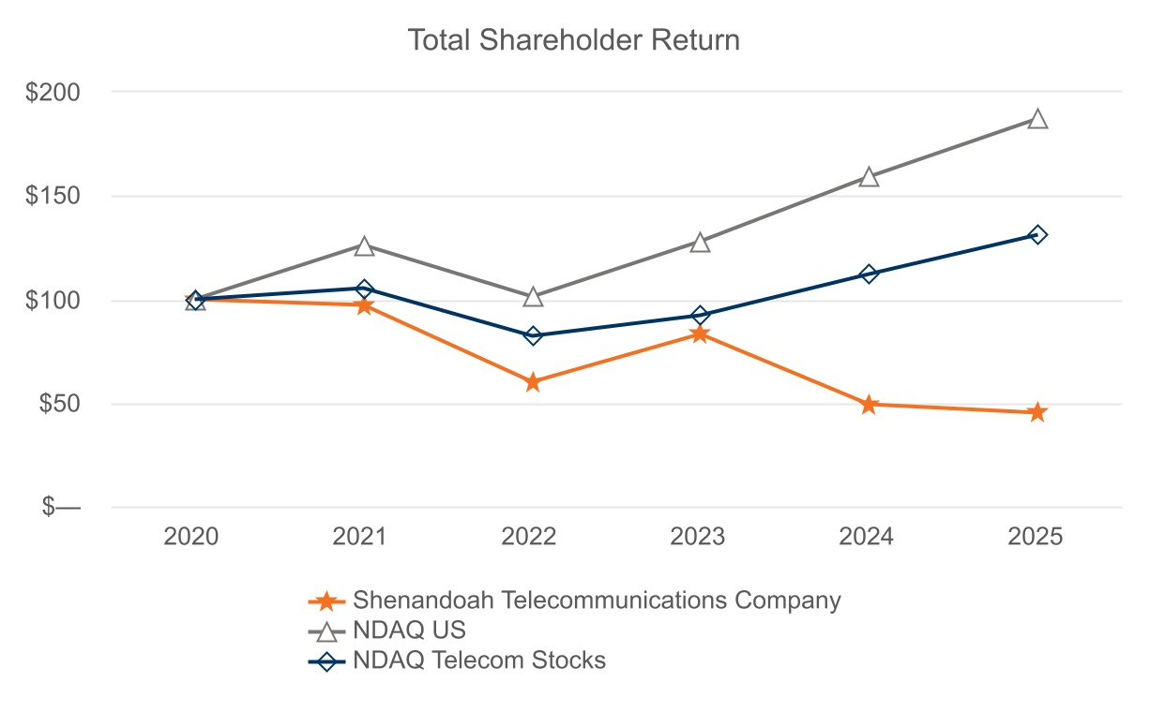
27
Table of Contents
 |  |  | 2020 |  |  | 2021 |  |  | 2022 |  |  | 2023 |  |  | 2024 |  |  | 2025
Shenandoah Telecommunications Company |  |  | $ | 100 |  | $ | 97 |  | $ | 60 |  | $ | 83 |  | $ | 49 |  | $ | 45
NDAQ US |  |  | $ | 100 |  | $ | 126 |  | $ | 101 |  | $ | 128 |  | $ | 159 |  | $ | 187
NDAQ Telecom Stocks |  |  | $ | 100 |  | $ | 105 |  | $ | 82 |  | $ | 92 |  | $ | 112 |  | $ | 131

Holders

As of February 23, 2026, there were 3,926 holders of record of the Company’s common stock.

Dividend Policy

Under the RCF, Shentel Broadband is subject to restrictions on its ability to pay dividends or make other distributions to Shentel Broadband Holding Inc. (“Shentel Holdings”), parent of Shentel Broadband and wholly subsidiary of Shentel. So long as no default exists, the Shentel Broadband may declare and pay lawful cash dividends or make distributions to Shentel Holdings within the limits set forth in the RCF credit agreement. Specifically, the financing arrangements permit: (i) annual cash dividends on Shentel’s common stock up to $7.5 million; (ii) additional distributions when the Borrower’s Total Net Leverage Ratio (as defined in the RCF credit agreement) is less than 2.50:1.00 on a pro forma basis; (iii) additional distributions to Shentel Holdings or Shentel with the proceeds received from the ABS Entities and (iv) certain non-cash distributions and employee-related redemptions. Dividends beyond these limits are prohibited unless the leverage ratio condition is satisfied.

The table below sets forth the cash dividends per share of our common stock that our board of directors declared during the following years:
 |  |  | Years Ended December 31,
 |  |  | 2021 |  |  | 2022 |  |  | 2023 |  |  | 2024 |  |  | 2025
Cash Dividend |  |  | $ | 18.82 |  | $ | 0.08 |  | $ | 0.09 |  | $ | 0.10 |  | $ | 0.11

Cash dividends in 2021 include a special dividend of $18.75 per share declared in the third quarter of 2021 following the sale of our Wireless operations and assets.

Future dividend payments remain subject to the discretion of the Board of Directors.

Dividend Reinvestment Plan

The Company maintains a dividend reinvestment plan (the “DRIP”) for the benefit of its shareholders. When shareholders remove shares from the DRIP, the Company issues whole shares in book entry form, pays out cash for any fractional shares, and cancels the fractional shares. In conjunction with the vesting of shares or exercise of stock options, the grantees may surrender awards necessary to cover the statutory tax withholding requirements and any amounts required to cover stock option strike prices associated with the transaction.

Purchases of Equity Securities by the Issuer or Affiliated Purchasers

None.

28
Table of Contents
ITEM 6.[Reserved]

29
Table of Contents
ITEM 7.MANAGEMENT’S DISCUSSION AND ANALYSIS OF FINANCIAL CONDITION AND RESULTS OF OPERATIONS

You should read the following discussion and analysis of our financial condition and results of operations in conjunction with our consolidated financial statements and notes thereto appearing elsewhere in this Annual Report on Form 10-K. In addition to historical consolidated financial information, the following discussion and analysis may contain forward-looking statements that involve risks, uncertainties and assumptions. Our actual results could differ materially from those anticipated by forward-looking statements as a result of many factors. We discuss factors that we believe could cause or contribute to these differences below and elsewhere in this Annual Report on Form 10-K, including those set forth under “Part I. Cautionary Statement Regarding Forward-Looking Statements” and “Part I. Item 1A. Risk Factors”.

Overview

Shenandoah Telecommunications Company (“Shentel”, “we”, “our”, “us”, or the “Company”), provides broadband services through its high speed, state-of-the-art fiber-optic and cable networks to customers in eight contiguous states in the eastern United States. The Company’s services include: broadband internet, video and voice; high-speed Ethernet, dedicated internet access and dark fiber leasing; and managed network services. The Company owns an extensive regional network with approximately 19,000 route miles of fiber.

2025 Developments

Refinancing Activities

Shentel Issuer, a limited-purpose, bankruptcy remote indirect wholly-owned subsidiary of Shentel, closed its inaugural offering of $567.4 million aggregate principal amount of secured fiber network revenue term notes, consisting of $489.1 million 5.64% Series 2025-1, Class A-2 term notes (the “Class A-2 Notes”) and $78.3 million 6.03% Series 2025-1, Class B term notes (the “Class B Notes”), each with an anticipated repayment date in December 2030. The Class A-2 Notes and Class B Notes are secured by certain fiber network assets and related customer contracts in the states of Virginia, Ohio, Pennsylvania, Indiana, Maryland and West Virginia.

As part of the same agreement governing the Class A-2 Notes and Class B Notes (the “ABS Indenture”) and fiber network assets and related customer contracts that govern and secure the ABS Notes, Shentel Issuer entered into a revolving $175.0 million variable funding note facility (the “VFN”) due December 2029 with a group of financial institutions. VFN advances will be subject to certain pro-forma leverage and debt service coverage ratios as defined in the ABS Indenture. The VFN will bear interest at term Secured Overnight Financing Rate (“SOFR”) plus a margin of 1.75%. The Company had no borrowings under the VFN at Closing.

As part of the same ABS Indenture and fiber network assets and related customer contracts that govern and secure the ABS Notes, Shentel Issuer entered into a $25 million delay draw Liquidity Funding Note facility (the “LFN”, together with the Class A-2 Notes, Class B notes, and the VFN, the “ABS Notes”) with Bank of America. The LFN is subject to the same collateral and covenant framework, including pro-forma leverage and debt service coverage ratios as defined in the ABS Indenture. Shentel Issuer may draw on the LFN solely for the purpose of funding amounts due and payable for certain Priority of Payments as defined in the ABS Indenture and when restricted cash funds required by ABS Indenture are insufficient. The LFN will bear interest at the Prime Rate plus a spread of 3.0%. The Company had no borrowings under the LFN at Closing.

Concurrently, Shentel Broadband, a wholly-owned indirect subsidiary of the Company, entered into a new $175.0 million Revolving Credit Facility (the “RCF”) due December 2030 with a group of financial institutions. The RCF is secured by substantially the cash flows and all of the assets and equity interests of its subsidiaries excluding Shentel Issuer; Shentel Guarantor LLC, a wholly-owned subsidiary of Shentel Broadband and parent of Shentel Issuer; Shentel Asset Entity I LLC, a wholly-owned subsidiary of Shentel Issuer; and Shentel Asset Entity II LLC, a wholly-owned subsidiary of Shentel Issuer. Borrowings under the RCF will bear interest at term SOFR plus a margin ranging from 2.50% to 3.00%. Shentel Broadband borrowed $75.0 million from the RCF at Closing.

Shentel and its non ABS Entities have no recourse of the loans of the ABS Entities. Likewise, the ABS Entities have no recourse of the loans of Shentel Broadband.

Shentel used a portion of the proceeds from the issuance of the ABS Notes and the RCF to repay the outstanding principal on the Company’s existing debt. Refer to Note 10, Debt in Shentel’s Consolidated 2025 Financial Statements for more information.
30
Table of Contents

Management Transitions

On July 31, 2025, the Company announced that its Board of Directors appointed Edward H. “Ed” McKay, the Company’s former Executive Vice President and Chief Operating Officer, as President and Chief Executive Officer (“CEO”), effective September 1, 2025. Christopher E. French, Shentel’s previous President and CEO, stepped into the role of Executive Chairman of the Board of Directors and remains active in steering the Company’s strategy while continuing to work closely with the senior leadership team and the Board of Directors.

Virginia Fiber Acquisition

In April 2025, the Company executed an Asset Purchase Agreement to acquire FTTH assets and operations of a fiber business based in Virginia for $5 million, including passings of approximately 1,500 homes and approximately 700 customers. The Company completed the acquisition on July 9, 2025.

H.R.1 - 119th Congress (2025-2026)

On July 4, 2025, H.R.1 was signed into law and includes numerous changes to existing tax law, including provisions providing current deductibility of certain property additions and limitations on interest deductions based on a tax EBITDA framework. These provisions are generally effective beginning in 2025, and we currently anticipate they will partially defer our income tax payments in future years. The legislation did not have a material impact on our consolidated financial statements for the year ended December 31, 2025.

31
Table of Contents
Results of Operations

Year Ended December 31, 2025 Compared with the Year Ended December 31, 2024

The Company’s consolidated results from operations are summarized as follows:
 |  |  |  |  |  | Year Ended December 31, |  |  |  |  |  |  |  |  |  |  |  |  |  |  |  |  |  | Change
($ in thousands) |  |  |  |  |  | 2025 |  |  | % of Revenue |  |  |  |  |  | 2024 |  |  | % of Revenue |  |  |  |  |  | $ |  |  |  |  |  | %
External revenue
Residential & SMB - Incumbent Broadband Markets |  |  |  |  |  | $ | 169,668 |  | 47.4 |  | % |  |  |  | $ | 174,795 |  | 53.3 |  | % |  |  |  | (5,127) |  |  |  |  |  | (2.9) |  | %
Residential & SMB - Glo Fiber Expansion Markets |  |  |  |  |  | 82,558 |  |  | 23.1 |  | % |  |  |  | 57,872 |  |  | 17.6 |  | % |  |  |  | 24,686 |  |  |  |  |  | 42.7 |  | %
Commercial Fiber |  |  |  |  |  | 79,315 |  |  | 22.2 |  | % |  |  |  | 70,057 |  |  | 21.4 |  | % |  |  |  | 9,258 |  |  |  |  |  | 13.2 |  | %
RLEC & Other |  |  |  |  |  | 26,313 |  |  | 7.4 |  | % |  |  |  | 25,334 |  |  | 7.7 |  | % |  |  |  | 979 |  |  |  |  |  | 3.9 |  | %
Total revenue |  |  |  |  |  | 357,854 |  |  | 100.0 |  | % |  |  |  | 328,058 |  |  | 100.0 |  | % |  |  |  | 29,796 |  |  |  |  |  | 9.1 |  | %
Operating expenses
Cost of services, exclusive of depreciation and amortization |  |  |  |  |  | 130,118 |  |  | 36.4 |  | % |  |  |  | 128,112 |  |  | 39.1 |  | % |  |  |  | 2,006 |  |  |  |  |  | 1.6 |  | %
Selling, general and administrative |  |  |  |  |  | 118,187 |  |  | 33.0 |  | % |  |  |  | 115,193 |  |  | 35.1 |  | % |  |  |  | 2,994 |  |  |  |  |  | 2.6 |  | %
Restructuring, integration and acquisition |  |  |  |  |  | 1,173 |  |  | 0.3 |  | % |  |  |  | 14,509 |  |  | 4.4 |  | % |  |  |  | (13,336) |  |  |  |  |  | (91.9) |  | %
Depreciation and amortization |  |  |  |  |  | 131,613 |  |  | 36.8 |  | % |  |  |  | 98,835 |  |  | 30.1 |  | % |  |  |  | 32,778 |  |  |  |  |  | 33.2 |  | %
Total operating expenses |  |  |  |  |  | 381,091 |  |  | 106.5 |  | % |  |  |  | 356,649 |  |  | 108.7 |  | % |  |  |  | 24,442 |  |  |  |  |  | 6.9 |  | %
Operating loss |  |  |  |  |  | (23,237) |  |  | (6.5) |  | % |  |  |  | (28,591) |  |  | (8.7) |  | % |  |  |  | 5,354 |  |  |  |  |  | NMF
Other (expense) income:
Interest expense |  |  |  |  |  | (25,374) |  |  | (7.1) |  | % |  |  |  | (15,897) |  |  | (4.8) |  | % |  |  |  | (9,477) |  |  |  |  |  | 59.6 |  | %
Other income, net |  |  |  |  |  | 6,755 |  |  | 1.9 |  | % |  |  |  | 6,461 |  |  | 2.0 |  | % |  |  |  | 294 |  |  |  |  |  | 4.6 |  | %
Loss from continuing operations before income taxes |  |  |  |  |  | (41,856) |  |  | (11.7) |  | % |  |  |  | (38,027) |  |  | (11.6) |  | % |  |  |  | (3,829) |  |  |  |  |  | 10.1 |  | %
Income tax benefit |  |  |  |  |  | (8,913) |  |  | (2.5) |  | % |  |  |  | (9,670) |  |  | (2.9) |  | % |  |  |  | 757 |  |  |  |  |  | (7.8) |  | %
Loss from continuing operations |  |  |  |  |  | (32,943) |  |  | (9.2) |  | % |  |  |  | (28,357) |  |  | (8.6) |  | % |  |  |  | (4,586) |  |  |  |  |  | 16.2 |  | %
Income from discontinued operations, net of tax |  |  |  |  |  | — |  |  | — |  | % |  |  |  | 222,174 |  |  | 67.7 |  | % |  |  |  | (222,174) |  |  |  |  |  | NMF
Net (loss) income |  |  |  |  |  | (32,943) |  |  | (9.2) |  | % |  |  |  | 193,817 |  |  | 59.1 |  | % |  |  |  | (226,760) |  |  |  |  |  | NMF
Dividends on redeemable noncontrolling interest |  |  |  |  |  | 6,449 |  |  | 1.8 |  | % |  |  |  | 3,429 |  |  | 1.0 |  | % |  |  |  | 3,020 |  |  |  |  |  | 88.1 |  | %
Net (loss) income attributable to common shareholders |  |  |  |  |  | $ | (39,392) |  | (11.0) |  | % |  |  |  | $ | 190,388 |  | 58.0 |  | % |  |  |  | (229,780) |  |  |  |  |  | NMF

Shentel acquired Horizon on April 1, 2024 and consequently, results for the year ended December 31, 2024 included nine months of Horizon revenue, whereas the comparable year ended December 31, 2025 included twelve months of Horizon revenue. Information about year over year variances noted below includes the results of the acquired Horizon markets during the first three months of 2025 and explanations of the remaining consolidated changes.

Shentel updated the presentation of certain Residential & SMB - Incumbent Broadband Market, Residential & SMB - Glo Fiber, Commercial Fiber and RLEC & Other revenues for the prior year to conform with changes in how management currently views these lines of business.

32
Table of Contents
Residential & SMB - Incumbent Broadband Markets revenue
Revenue from residential and small and medium business (“SMB”) customers in Incumbent Broadband Markets is primarily earned through the Company’s provision of data, video and voice services over primarily HFC cable and to a lesser extent FTTH networks in incumbent markets.

Residential & SMB - Incumbent Broadband Markets revenue decreased $5.1 million, or 2.9%. Shentel recognized $1.7 million of revenues earned in the acquired Horizon markets in the first quarter of 2025. The remaining decrease of $6.8 million was primarily due to lower video revenues from a 14.5% decline in video revenue generating units (“RGUs”), lower USF revenues and a 1.6% decline in data average revenue per unit (“ARPU”).

Residential & SMB - Glo Fiber Expansion Markets revenue
Revenue from residential and SMB customers in Glo Fiber Expansion Markets is primarily earned through the Company’s provision of data, video and voice services over FTTH networks in new greenfield expansion markets.

Residential & SMB - Glo Fiber Expansion Markets revenue increased $24.7 million, or 42.7%. Shentel recognized $0.7 million of revenues earned in the acquired Horizon markets in the first quarter of 2025. The remaining increase of $24.0 million was primarily due to 42.0% year-over-year growth in data RGUs and 16.3% year-over-year growth in video RGUs associated with the Company’s investment in expanded geographies for Glo Fiber.

Commercial Fiber revenue
Shentel’s Commercial Fiber revenue is primarily earned through the Company’s provision of high-speed Ethernet, dedicated internet access, wavelength services, dark fiber leasing and managed services over fiber optic networks to commercial customers.

Commercial Fiber revenue increased $9.3 million, or 13.2%. Shentel recognized $9.9 million of revenues earned in the acquired Horizon markets in the first quarter of 2025. The remaining decrease of $0.6 million was primarily due to non-cash deferred revenue adjustments for a carrier customer and early termination fees earned in the prior year.

RLEC & Other revenue
Shentel’s RLEC & Other revenue is primarily earned through the Company’s provision of voice and DSL telephone services over copper networks, primarily in Shenandoah County, Virginia and Ross County, Ohio. Shentel also earns governmental support revenue through the federal USF.

RLEC & Other revenue increased $1.0 million, or 3.9%. Shentel recognized $2.9 million of revenues earned in the acquired Horizon markets in the first quarter of 2025. The remaining decrease of $1.9 million was primarily due to lower data service line (“DSL”) revenue from a 19.8% decline of DSL RGUs, partially due to customers migrating to our broadband data service in the recently constructed passings supported by government grants.

Cost of services
Cost of services primarily consist of costs to acquire and deliver video programming, internal labor to maintain our network and service our customers, third party network maintenance, and line expenses.

Cost of services increased $2.0 million, or 1.6%. Shentel incurred $7.6 million of costs incurred in the acquired Horizon markets in the first quarter of 2025. The remaining decrease of $5.6 million was primarily due to decreases in network payroll and line costs driven by synergy savings and decreased programming expenses associated with the declines in video RGUs.

Selling, general and administrative
Selling, general and administrative expenses consist of employee compensation, advertising, software maintenance, stock-based compensation, and operating taxes.

Selling, general and administrative expense increased $3.0 million, or 2.6%. Shentel incurred $3.2 million of selling, general and administrative costs incurred in the acquired Horizon markets in the first quarter of 2025. The remaining decrease of $0.2 million was primarily due to decreases in employee compensation, professional fees driven by synergy savings and lower bad debt, partially offset by increases in operating taxes and advertising costs.

Restructuring, integration and acquisition
Integration and acquisition expense decreased $13.3 million, or 91.9%. Restructuring, integration and acquisition expense in 2024 related primarily to expenses incurred to effect the Horizon transaction and integration expenses incurred during the post-acquisition period.
33
Table of Contents

Depreciation and amortization
Depreciation and amortization increased $32.8 million, or 33.2%. Shentel incurred $9.2 million of depreciation and amortization related to the tangible and intangible assets acquired in the Horizon Transaction in the first quarter of 2025. The remaining increase of $23.6 million was due to the Company’s expansion of its Glo Fiber network and a $7.4 million write-off of inventory assets no longer expected to be used.

Interest expense
Interest expense increased by $9.5 million, or 59.6% primarily due to an increase in the Company’s outstanding debt.

Other income, net
Other income, net increased by $0.3 million, or 4.6% primarily due to a favorable settlement of the Horizon acquisition related escrow claim and a reclassification of unrecognized gains on interest rate swaps accumulated in other comprehensive income to the Company’s consolidated statements of operations with the termination of the hedging program. These gains were partially offset by higher interest income earned in the prior year.

Income tax benefit
The Company recognized $8.9 million of income tax benefit for 2025, compared with $9.7 million for 2024 due to higher excess tax benefits derived from vesting of restricted stock in 2025 compared to 2024.

34
Table of Contents
Year Ended December 31, 2024 Compared with the Year Ended December 31, 2023

The Company’s consolidated results from operations are summarized as follows:
 |  |  |  |  |  | Year Ended December 31, |  |  |  |  |  |  |  |  |  |  |  |  |  |  |  |  |  | Change
($ in thousands) |  |  |  |  |  | 2024 |  |  | % of Revenue |  |  |  |  |  | 2023 |  |  | % of Revenue |  |  |  |  |  | $ |  |  |  |  |  | %
External revenue
Residential & SMB - Incumbent Broadband Markets |  |  |  |  |  | $ | 174,795 |  | 53.3 |  | % |  |  |  | $ | 174,710 |  | 64.9 |  | % |  |  |  | 85 |  |  |  |  |  | — |  | %
Residential & SMB - Glo Fiber Expansion Markets |  |  |  |  |  | 57,872 |  |  | 17.6 |  | % |  |  |  | 35,103 |  |  | 13.0 |  | % |  |  |  | 22,769 |  |  |  |  |  | 64.9 |  | %
Commercial Fiber |  |  |  |  |  | 70,057 |  |  | 21.4 |  | % |  |  |  | 44,301 |  |  | 16.5 |  | % |  |  |  | 25,756 |  |  |  |  |  | 58.1 |  | %
RLEC & Other |  |  |  |  |  | 25,334 |  |  | 7.7 |  | % |  |  |  | 15,017 |  |  | 5.6 |  | % |  |  |  | 10,317 |  |  |  |  |  | 68.7 |  | %
Total revenue |  |  |  |  |  | 328,058 |  |  | 100.0 |  | % |  |  |  | 269,131 |  |  | 100.0 |  | % |  |  |  | 58,927 |  |  |  |  |  | 21.9 |  | %
Operating expenses
Cost of services, exclusive of depreciation and amortization |  |  |  |  |  | 128,112 |  |  | 39.1 |  | % |  |  |  | 100,850 |  |  | 37.5 |  | % |  |  |  | 27,262 |  |  |  |  |  | 27.0 |  | %
Selling, general and administrative |  |  |  |  |  | 115,193 |  |  | 35.1 |  | % |  |  |  | 99,304 |  |  | 36.9 |  | % |  |  |  | 15,889 |  |  |  |  |  | 16.0 |  | %
Restructuring, integration and acquisition |  |  |  |  |  | 14,509 |  |  | 4.4 |  | % |  |  |  | 2,915 |  |  | 1.1 |  | % |  |  |  | 11,594 |  |  |  |  |  | 397.7 |  | %
Depreciation and amortization |  |  |  |  |  | 98,835 |  |  | 30.1 |  | % |  |  |  | 65,920 |  |  | 24.5 |  | % |  |  |  | 32,915 |  |  |  |  |  | 49.9 |  | %
Total operating expenses |  |  |  |  |  | 356,649 |  |  | 108.7 |  | % |  |  |  | 268,989 |  |  | 99.9 |  | % |  |  |  | 87,660 |  |  |  |  |  | 32.6 |  | %
Operating (loss) income |  |  |  |  |  | (28,591) |  |  | (8.7) |  | % |  |  |  | 142 |  |  | 0.1 |  | % |  |  |  | (28,733) |  |  |  |  |  | NMF
Other income (expense):
Interest expense |  |  |  |  |  | (15,897) |  |  | (4.8) |  | % |  |  |  | (4,212) |  |  | (1.6) |  | % |  |  |  | (11,685) |  |  |  |  |  | 277.4 |  | %
Other income, net |  |  |  |  |  | 6,461 |  |  | 2.0 |  | % |  |  |  | 5,587 |  |  | 2.1 |  | % |  |  |  | 874 |  |  |  |  |  | 15.6 |  | %
(Loss) income from continuing operations before income taxes |  |  |  |  |  | (38,027) |  |  | (11.6) |  | % |  |  |  | 1,517 |  |  | 0.6 |  | % |  |  |  | (39,544) |  |  |  |  |  | NMF
Income tax (benefit) expense |  |  |  |  |  | (9,670) |  |  | (2.9) |  | % |  |  |  | 501 |  |  | 0.2 |  | % |  |  |  | (10,171) |  |  |  |  |  | NMF
(Loss) income from continuing operations |  |  |  |  |  | (28,357) |  |  | (8.6) |  | % |  |  |  | 1,016 |  |  | 0.4 |  | % |  |  |  | (29,373) |  |  |  |  |  | NMF
Income from discontinued operations, net of tax |  |  |  |  |  | 222,174 |  |  | 67.7 |  | % |  |  |  | 7,022 |  |  | 2.6 |  | % |  |  |  | 215,152 |  |  |  |  |  | NMF
Net income |  |  |  |  |  | $ | 193,817 |  | 59.1 |  | % |  |  |  | $ | 8,038 |  | 3.0 |  | % |  |  |  | 185,779 |  |  |  |  |  | NMF
Net income attributable to redeemable noncontrolling interest |  |  |  |  |  | 3,429 |  |  | 1.0 |  | % |  |  |  | — |  |  | — |  | % |  |  |  | 3,429 |  |  |  |  |  | NMF
Net income attributable to common shareholders |  |  |  |  |  | $ | 190,388 |  | 58.0 |  | % |  |  |  | $ | 8,038 |  | 3.0 |  | % |  |  |  | 182,350 |  |  |  |  |  | NMF

Shentel updated the presentation of certain Residential & SMB - Incumbent Broadband Market, Residential & SMB - Glo Fiber, Commercial Fiber and RLEC & Other revenues for the prior year to conform with changes in how management currently views these lines of business.

Residential & SMB - Incumbent Broadband Markets revenue
Residential & SMB - Incumbent Broadband Markets revenue decreased by $0.1 million. Shentel recognized $5.2 million of revenues earned in the newly acquired Horizon markets. The remaining decrease of $5.3 million was primarily due to lower video revenue from a 15.3% decline in video RGUs and lower voice revenue from a 21.5% decline in voice ARPU.

Residential & SMB - Glo Fiber Expansion Markets revenue
Residential & SMB - Glo Fiber Expansion Markets revenue increased by $22.8 million, or 64.9%. Shentel realized a $21.4 million increase in legacy Shentel markets and recognized $1.4 million of revenues earned in the newly acquired Horizon markets. The increase in legacy Shentel markets revenue was primarily due to 50.9% year-over-year growth in data RGUs associated with the Company’s investment in expanded geographies for Glo Fiber and a 7.3% increase in data ARPU.

Commercial Fiber revenue
35
Table of Contents
Commercial Fiber revenue increased by $25.8 million, or 58.1%. Shentel recognized $31.3 million of revenues earned in the newly acquired Horizon markets. The remaining decrease of $5.6 million was primarily due to the previously disclosed T-Mobile backhaul revenue churn associated with the decommissioning of the former Sprint network.

RLEC & Other revenue
RLEC & Other revenue increased by $10.3 million, or 68.7%, primarily due to $9.9 million of revenues earned in the newly acquired Horizon markets and an increase in governmental support revenue.

Cost of services
Cost of services increased by $27.3 million, or 27.0%. Shentel incurred $25.3 million of costs incurred in the newly acquired Horizon markets. The remaining increase of $2.0 million was primarily due to network maintenance costs for Glo Fiber market expansion.

Selling, general and administrative
Selling, general and administrative expense increased by $15.9 million, or 16.0%. Shentel incurred $11.7 million of selling, general and administrative costs incurred in the newly acquired Horizon markets. The remaining increase of $4.2 million was primarily due to higher advertising costs and sales headcount associated with the Company’s expansion of Shentel’s Glo Fiber network.

Restructuring, integration and acquisition
Integration and acquisition expense increased by $11.6 million primarily due to non-recurring Horizon acquisition-related costs related to banking, legal, insurance and software expenses.

Depreciation and amortization
Depreciation and amortization increased by $32.9 million, or 49.9%. Shentel incurred $25.5 million of depreciation and amortization related to the tangible and intangible assets acquired in the Horizon Transaction. The remaining increase of $9.6 million was primarily due to legacy Shentel’s expansion of its Glo Fiber network. Shentel also recognized $2.2 million less in impairment charges in 2024 compared to 2023.

Interest expense
Interest expense increased by $11.7 million, or 277.4%, primarily due to a higher outstanding debt balance during 2024 as compared to 2023.

Other income, net
Other income, net increased by $0.9 million, or 15.6%, primarily due to other income incurred in the newly acquired Horizon markets.

Income tax (benefit) expense
The Company recognized $9.7 million of income tax benefit for 2024, compared with $0.5 million of income tax expense for 2023. The income tax benefit was driven by higher pre-tax loss from continuing operations during 2024.

36
Table of Contents
Additional Information

Shentel provides broadband internet, video and voice services to residential and commercial customers in portions of Virginia, West Virginia, Maryland, Pennsylvania, Kentucky, Delaware, Ohio and Indiana, via fiber optic and HFC cable networks. We also lease dark fiber and provide Ethernet and Wavelength fiber optic services to enterprise and wholesale customers throughout the entirety of our service area. Shentel’s Broadband business also provides voice and DSL telephone services as a RLEC to customers in Shenandoah County and portions of adjacent counties in Virginia, and in Ross County and portions of adjacent counties in Ohio. These integrated networks are connected by 19,067 route miles of fiber.

The following table indicates selected operating statistics. Shentel updated the presentation of certain revenues and voice RGUs in the prior year to conform with changes in how management views these lines of business. This reclassification resulted in updated ARPU and voice RGUs for the prior period.
 |  |  |  |  |  | December 31,  2025 |  |  |  |  |  | December 31,  2024 |  |  |  |  |  | December 31,  2023
Homes and businesses passed (1)
Incumbent Broadband Markets |  |  |  |  |  | 252,224 |  |  |  |  |  | 239,041 |  |  |  |  |  | 215,763
Glo Fiber Expansion Markets |  |  |  |  |  | 426,820 |  |  |  |  |  | 346,299 |  |  |  |  |  | 233,872
Total homes and businesses passed |  |  |  |  |  | 679,044 |  |  |  |  |  | 585,340 |  |  |  |  |  | 449,635
Residential & SMB RGUs:
Incumbent Broadband Markets |  |  |  |  |  | 111,962 |  |  |  |  |  | 111,325 |  |  |  |  |  | 109,679
Glo Fiber Expansion Markets |  |  |  |  |  | 87,985 |  |  |  |  |  | 65,140 |  |  |  |  |  | 41,710
Broadband Data |  |  |  |  |  | 199,947 |  |  |  |  |  | 176,465 |  |  |  |  |  | 151,389
Video |  |  |  |  |  | 35,818 |  |  |  |  |  | 40,023 |  |  |  |  |  | 43,152
Voice |  |  |  |  |  | 26,693 |  |  |  |  |  | 25,528 |  |  |  |  |  | 24,097
Total Residential & SMB RGUs (excludes RLEC) |  |  |  |  |  | 262,458 |  |  |  |  |  | 242,016 |  |  |  |  |  | 218,638
Residential & SMB Penetration (2)
Incumbent Broadband Markets |  |  |  |  |  | 44.4 |  | % |  |  |  | 46.6 |  | % |  |  |  | 50.8 |  | %
Glo Fiber Expansion Markets |  |  |  |  |  | 20.6 |  | % |  |  |  | 18.8 |  | % |  |  |  | 17.8 |  | %
Broadband Data |  |  |  |  |  | 29.4 |  | % |  |  |  | 30.1 |  | % |  |  |  | 33.7 |  | %
Video |  |  |  |  |  | 5.3 |  | % |  |  |  | 6.8 |  | % |  |  |  | 9.6 |  | %
Voice |  |  |  |  |  | 4.2 |  | % |  |  |  | 4.5 |  | % |  |  |  | 5.6 |  | %
Residential & SMB ARPU (3)
Incumbent Broadband Markets |  |  |  |  |  | $ | 82.67 |  |  |  |  | $ | 83.68 |  |  |  |  | $ | 81.85
Glo Fiber Expansion Markets |  |  |  |  |  | $ | 77.05 |  |  |  |  | $ | 76.63 |  |  |  |  | $ | 72.36
Broadband Data |  |  |  |  |  | $ | 80.39 |  |  |  |  | $ | 81.40 |  |  |  |  | $ | 79.64
Video |  |  |  |  |  | $ | 125.21 |  |  |  |  | $ | 116.37 |  |  |  |  | $ | 105.61
Voice |  |  |  |  |  | $ | 32.80 |  |  |  |  | $ | 34.25 |  |  |  |  | $ | 35.17
Fiber route miles |  |  |  |  |  | 19,067 |  |  |  |  |  | 16,830 |  |  |  |  |  | 9,875
Total fiber miles (4) |  |  |  |  |  | 1,996,620 |  |  |  |  |  | 1,858,081 |  |  |  |  |  | 861,980
_______________________________________________________
(1)Homes and businesses are considered passed (“passings”) if we can connect them to our network without further extending the distribution system. Passings is an estimate based upon the best available information. Passings will vary among video, broadband data and voice services.
(2)Penetration is calculated by dividing the number of RGUs by the number of passings or available homes, as appropriate.
(3)Average Revenue Per RGU calculation = (Residential & SMB Revenue) / average RGUs / 12 months.
(4)Total fiber miles are measured by taking the number of fiber strands in a cable and multiplying that number by the route distance. For example, a 10 mile route with 144 fiber strands would equal 1,440 fiber miles.

37
Table of Contents
Financial Condition, Liquidity and Capital Resources

Sources and Uses of Cash: Shentel’s principal sources of liquidity are our cash and cash equivalents, restricted cash, cash generated from operations, government grants and capacity under the Company’s VFN and RCF.

In 2021, Congress passed the American Rescue Plan Act and the Infrastructure Investment and Jobs Act to subsidize the deployment of high-speed broadband internet access in unserved areas. We have been awarded approximately $151.2 million in grants to serve approximately 26,900 unserved homes in the states of Virginia, Ohio, Maryland and West Virginia and to upgrade the capacity of the Ohio middle mile network. The grants will be paid to the Company as certain milestones are completed. As of December 31, 2025, the Company had received a total of $101.6 million in cash receipts and had $49.6 million in grants available. The Company has constructed broadband service to approximately 20,000 previously unserved homes and expects to fulfill the majority of its obligations under these programs by 2026.

As of December 31, 2025, the Company’s total available liquidity was $234.9 million, consisting of (i) cash and cash equivalents totaling $27.3 million; (ii) restricted cash as required by the ABS indenture totaling $20.9 million (iii) $92.8 million of availability under the Shentel Broadband’s RCF; (iv) $44.3 million under Shentel Issuer’s VFN; and (v) an aggregate of $49.6 million remaining reimbursements available under government grants, which reimbursements are subject to fulfilling the terms of the underlying agreements. In addition, the Company has $130.7 million of VFN commitments that are not available to draw as of December 31, 2025. The available capacity of the VFN will increase based on the secured fiber network revenue growth from the ABS Entities multiplied by (i) a margin as defined in the ABS Indenture and (ii) 6.25x multiple.

Net cash provided by operating activities from continuing operations was approximately $103.3 million in 2025, representing an increase of $33.9 million compared with 2024, primarily driven by increases in revenue and changes in working capital.

Net cash used in investing activities from continuing operations was approximately $294.7 million in 2025, representing an decrease of $350.6 million compared with 2024, primarily driven by a $342.4 million decrease in cash disbursed for acquisitions, a $43.3 million increase in cash receipts from government grant programs and a $6.5 million receipt from a business acquisition escrow, partially offset by a $39.8 million increase in capital expenditures driven by government-subsidized network expansion projects in previously unserved areas of Incumbent Broadband Markets.

Net cash provided by financing activities from continuing operations was approximately $195.6 million in 2025, representing an increase of $11.7 million compared with 2024, primarily driven by an increase of $691.7 million in borrowings under various debt facilities, partially offset by an increase of $585.9 million in principal payments on long-term debt, a decrease of $79.4 million in cash inflows from issuance of redeemable noncontrolling interests and an increase of $14.1 million in payments for debt issuance and amendment costs.

Indebtedness: As of December 31, 2025, the Company’s net indebtedness was $628.2 million, including $642.4 million in outstanding ABS Notes and the RCF, net of unamortized loan fees of $14.2 million. The borrowed Class A-2 Notes and the Class B Notes incur interest at 5.64% and 6.03%, respectively. The borrowed RCF bears interest at a variable rate determined by one-month term SOFR, plus a margin based on net leverage. The weighted-average interest rate was 5.75% for the ABS Notes and RCF at December 31, 2025.

Shentel’s ABS Notes, which include Class A-2 Notes and Class B Notes, have outstanding balances of $489.1 million and $78.3 million, respectively. Shentel’s RCF has an outstanding balance of $75.0 million. The ABS Notes have a contractually stated anticipated repayment date (“ARD”) of December 2030 with the exception of the VFN described below. Shentel has not made any borrowings under its VFN or LFN as of December 31, 2025. In the event borrowings are made in the future, the initial anticipated repayment date for the VFN is December 2029 which may be extended, at the option of Shentel, to the December 2030, subject to the satisfaction of certain conditions. Amounts borrowed under the LFN do not have an anticipated repayment date. The legal final maturity date of each class of the ABS Notes is in December 2055. If Shentel has not repaid or refinanced any Series 2025-1 Notes prior to the relevant ARD, additional interest will accrue on outstanding principal. Shentel Broadband’s RCF matures on December 5, 2030. No principal payments on Shentel Broadband’s RCF are required prior to the final maturity date.

Shentel and its non ABS Entities have no recourse of the loans of the ABS Entities. Likewise, the ABS Entities have no recourse of the loans of Shentel Broadband.

Refer to Note 10, Debt in the Company’s 2025 Consolidated Financial Statements for information about the Company's outstanding debt.

As of December 31, 2025, the Company was in compliance with the financial covenants related to our outstanding debt.
38
Table of Contents

We expect our cash on hand, restricted cash, cash flows from continuing operations, availability of funds from our RCF and VFN agreements and government grants will be sufficient to meet our anticipated liquidity needs for business operations for the next twelve months. There can be no assurance that we will continue to generate cash flows at or above current levels.

During the year ended December 31, 2025, our capital expenditures of $358.9 million, net of government grants of $62.5 million, exceeded our net cash provided by operating activities from continuing operations by $193.1 million, and we expect our capital expenditures, net of government grants received, to exceed the net cash flows provided by continuing operations through 2026, as we expand our Glo Fiber broadband network.

The actual amount and timing of our future capital requirements may differ materially from our estimates depending on the demand for our products and services, new market developments and expansion opportunities.

Our cash flows from operations could be adversely affected by events outside our control, including, without limitation, changes in overall economic conditions including rising inflation, regulatory requirements, changes in technologies, changes in competition, demand for our products and services, availability of labor resources and capital, natural disasters, pandemics and other adverse public health developments, such as COVID-19, and other conditions. Our ability to attract and maintain a sufficient customer base, particularly in our Broadband markets, is critical to our ability to maintain a positive cash flow from operations. The foregoing events individually or collectively could affect our results.

During 2025, Shentel formed Shentel Guarantor LLC, Shentel Issuer LLC, Shentel Asset Entity I LLC and Shentel Asset Entity II LLC (collectively, the “ABS Entities”), each a bankruptcy-remote subsidiary of the Company. The ABS Entities were formed as part of a securitization transaction, pursuant to which certain of the Company’s fiber network assets and related customer contracts primarily in Virginia, Ohio, Pennsylvania, Indiana, Maryland and West Virginia were contributed to Shentel Asset Entity I LLC and Shentel Asset Entity II LLC (collectively, the “ABS Asset Entities”). As of December 31, 2025, all of the Company’s commercial fiber network assets and approximately 302,000 Glo Fiber passings were contributed to the ABS Asset Entities. The cash flow from these contributed assets are used to service the obligations under Shentel’s ABS Notes.

Our RCF requires consolidated financial statements of restricted subsidiaries under the RCF (the “Non-ABS Entities” or the “Restricted Subsidiaries”) and unrestricted subsidiaries (the “ABS Entities” or the “Unrestricted Subsidiaries”). Below is the consolidating balance sheet as of December 31, 2025 and the consolidating statement of operations for the year ended December 31, 2025. The ABS Entities consolidating statement of operations reflects the activity from December 5, 2025 (date of refinancing) through December 31, 2025.

39
Table of Contents
 |  |  |  |  |  | As of December 31, 2025
(in thousands) |  |  |  |  |  | Unrestricted Subsidiaries (ABS Entities) |  |  |  |  |  | Restricted Subsidiaries (Non-ABS Entities) |  |  |  |  |  | Eliminations |  |  |  |  |  | Consolidated
ASSETS
Current assets:
Cash and cash equivalents |  |  |  |  |  | $ | — |  |  |  |  | $ | 27,259 |  |  |  |  | $ | — |  |  |  |  | $ | 27,259
Restricted cash and cash equivalents |  |  |  |  |  | 20,945 |  |  |  |  |  | — |  |  |  |  |  | — |  |  |  |  |  | 20,945
Accounts receivable |  |  |  |  |  | 12,580 |  |  |  |  |  | 31,880 |  |  |  |  |  | (12,963) |  |  |  |  |  | 31,497
Prepaid expenses and other |  |  |  |  |  | 5,344 |  |  |  |  |  | 14,803 |  |  |  |  |  | (2,405) |  |  |  |  |  | 17,742
Total current assets |  |  |  |  |  | 38,869 |  |  |  |  |  | 73,942 |  |  |  |  |  | (15,368) |  |  |  |  |  | 97,443
Investments |  |  |  |  |  | — |  |  |  |  |  | 392,737 |  |  |  |  |  | (376,227) |  |  |  |  |  | 16,510
Property, plant and equipment, net |  |  |  |  |  | 793,874 |  |  |  |  |  | 807,735 |  |  |  |  |  | — |  |  |  |  |  | 1,601,609
Goodwill and intangible assets, net |  |  |  |  |  | 8,234 |  |  |  |  |  | 148,657 |  |  |  |  |  | — |  |  |  |  |  | 156,891
Operating lease right-of-use assets |  |  |  |  |  | 10,199 |  |  |  |  |  | 9,458 |  |  |  |  |  | — |  |  |  |  |  | 19,657
Deferred charges and other assets |  |  |  |  |  | 129,635 |  |  |  |  |  | 7,794 |  |  |  |  |  | (118,777) |  |  |  |  |  | 18,652
Total assets |  |  |  |  |  | $ | 980,811 |  |  |  |  | $ | 1,440,323 |  |  |  |  | $ | (510,372) |  |  |  |  | $ | 1,910,762
LIABILITIES, TEMPORARY EQUITY AND SHAREHOLDERS’ EQUITY
Current liabilities:
Accounts payable |  |  |  |  |  | $ | 7,561 |  |  |  |  | $ | 66,757 |  |  |  |  | $ | (12,963) |  |  |  |  | $ | 61,355
Advanced billings and customer deposits |  |  |  |  |  | 8,953 |  |  |  |  |  | 10,361 |  |  |  |  |  | (2,405) |  |  |  |  |  | 16,909
Accrued compensation |  |  |  |  |  | — |  |  |  |  |  | 13,334 |  |  |  |  |  | — |  |  |  |  |  | 13,334
Accrued liabilities and other |  |  |  |  |  | 3,894 |  |  |  |  |  | 14,116 |  |  |  |  |  | (1,112) |  |  |  |  |  | 16,898
Total current liabilities |  |  |  |  |  | 20,408 |  |  |  |  |  | 104,568 |  |  |  |  |  | (16,480) |  |  |  |  |  | 108,496
Long-term debt, less current maturities, net of unamortized loan fees |  |  |  |  |  | 554,288 |  |  |  |  |  | 73,949 |  |  |  |  |  | — |  |  |  |  |  | 628,237
Other long-term liabilities:
Deferred income taxes |  |  |  |  |  | — |  |  |  |  |  | 157,618 |  |  |  |  |  | — |  |  |  |  |  | 157,618
Other liabilities |  |  |  |  |  | 33,628 |  |  |  |  |  | 131,159 |  |  |  |  |  | (117,665) |  |  |  |  |  | 47,122
Total other long-term liabilities |  |  |  |  |  | 33,628 |  |  |  |  |  | 288,777 |  |  |  |  |  | (117,665) |  |  |  |  |  | 204,740
Temporary equity:
Redeemable noncontrolling interest |  |  |  |  |  | — |  |  |  |  |  | 88,506 |  |  |  |  |  | — |  |  |  |  |  | 88,506
Shareholders’ equity:
Total shareholders’ equity |  |  |  |  |  | 372,487 |  |  |  |  |  | 884,523 |  |  |  |  |  | (376,227) |  |  |  |  |  | 880,783
Total liabilities, temporary equity and shareholders’ equity |  |  |  |  |  | $ | 980,811 |  |  |  |  | $ | 1,440,323 |  |  |  |  | $ | (510,372) |  |  |  |  | $ | 1,910,762

40
Table of Contents
 |  |  |  |  |  | Year Ended December 31, 2025
(in thousands) |  |  |  |  |  | Unrestricted Subsidiaries |  |  |  |  |  | Restricted Subsidiaries |  |  |  |  |  | Eliminations |  |  |  |  |  | Consolidated
Service revenue and other |  |  |  |  |  | $ | 11,986 |  |  |  |  | $ | 350,335 |  |  |  |  | $ | (4,467) |  |  |  |  | $ | 357,854
Operating expenses:
Cost of services exclusive of depreciation and amortization |  |  |  |  |  | 5,474 |  |  |  |  |  | 127,406 |  |  |  |  |  | (2,762) |  |  |  |  |  | 130,118
Selling, general and administrative |  |  |  |  |  | 2,059 |  |  |  |  |  | 117,833 |  |  |  |  |  | (1,705) |  |  |  |  |  | 118,187
Restructuring, integration and acquisition |  |  |  |  |  | — |  |  |  |  |  | 1,173 |  |  |  |  |  | — |  |  |  |  |  | 1,173
Depreciation and amortization |  |  |  |  |  | 5,772 |  |  |  |  |  | 125,841 |  |  |  |  |  | — |  |  |  |  |  | 131,613
Total operating expenses |  |  |  |  |  | 13,305 |  |  |  |  |  | 372,253 |  |  |  |  |  | (4,467) |  |  |  |  |  | 381,091
Operating (loss) income |  |  |  |  |  | (1,319) |  |  |  |  |  | (21,918) |  |  |  |  |  | — |  |  |  |  |  | (23,237)
Other (expense) income:
Interest expense |  |  |  |  |  | (2,453) |  |  |  |  |  | (22,921) |  |  |  |  |  | — |  |  |  |  |  | (25,374)
Other income, net |  |  |  |  |  | 32 |  |  |  |  |  | 6,723 |  |  |  |  |  | — |  |  |  |  |  | 6,755
(Loss) income from continuing operations before income taxes |  |  |  |  |  | (3,740) |  |  |  |  |  | (38,116) |  |  |  |  |  | — |  |  |  |  |  | (41,856)
Income tax (benefit) expense |  |  |  |  |  | — |  |  |  |  |  | (8,913) |  |  |  |  |  | — |  |  |  |  |  | (8,913)
Net loss |  |  |  |  |  | (3,740) |  |  |  |  |  | (29,203) |  |  |  |  |  | — |  |  |  |  |  | (32,943)

Critical Accounting Estimates

The preparation of these consolidated financial statements requires us to make estimates and assumptions that affect our reported amounts of assets, liabilities, revenue and expenses, as well as related disclosures. To the extent that there are material differences between these estimates and actual results, our financial condition or operating results would be affected. We base our estimates on past experience and other assumptions that we believe are reasonable under the circumstances, and we evaluate these estimates on an ongoing basis. We refer to accounting estimates of this type as critical accounting estimates, which we discuss further below.

Valuation and Impairment Testing of Goodwill and Cable Franchise Rights

Goodwill

Goodwill results from business combinations and represents the excess amount of the consideration paid over the fair value of tangible net assets and identifiable intangible assets of the businesses acquired. As discussed in Note 2, Summary of Significant Accounting Policies, Shentel has only one reporting unit. Shentel’s total goodwill balance increased $0.5 million in the year ended December 31, 2025 as a result of the Virginia Fiber Acquisition discussed above.

Shentel tests goodwill for impairment at least annually or more frequently whenever events or substantive changes in circumstances indicate that the assets might be impaired. The impairment test is performed at the reporting unit level by analyzing quantitative or qualitative factors, or both. When performing a quantitative assessment, we estimate the fair value of our reporting unit primarily based on a discounted cash flow analysis that involves significant judgment, including market participant estimates of future cash flows expected to be generated by the business, estimate of a terminal growth rate and the selection of a discount rate. When performing this analysis, we also consider the reconciliation of the Company's market capitalization to the reporting unit value and consideration of an appropriate control premium. When performing a qualitative assessment, we assess whether events and circumstances indicate that it is more likely than not (that is, a likelihood of more than 50%) that an impairment exists. Events and circumstances considered include the impact of macroeconomic conditions, industry and market conditions, company specific events, changes in circumstances, after tax cash flows, and market capitalization trends.

We evaluated goodwill for impairment on October 1, 2025 on the basis of the quantitative factors described above. Based on this assessment, we concluded that the fair value of our reporting unit was higher than its carrying value.

Cable franchise rights

Cable franchise rights represent the value attributable to agreements with local franchising authorities, which allows access to homes and businesses via public rights of way. Shentel’s cable franchise rights were primarily acquired through business
41
Table of Contents
combinations. Cable franchise rights have an indefinite life; therefore, no amortization is recorded for these assets. Costs incurred in negotiating and renewing cable franchise rights are expensed as incurred.

Shentel tests its cable franchise rights for impairment at least annually, or more frequently whenever events or substantive changes in circumstances indicate that the assets might be impaired. The impairment test is performed by analyzing quantitative or qualitative factors, or both. When performing a quantitative evaluation, we estimate the fair values of our cable franchise rights primarily based on a greenfield model, a method under the income approach, which reflected the expected discounted cash flows of a notional start-up business with no assets other than the cable franchise rights being valued. The greenfield model involves significant judgment, including the estimate of revenue growth, the amount and timing of capital expenditures, EBITDA margins, terminal growth rates and the discount rate utilized. When performing a qualitative assessment, we assess whether events and circumstances indicate that it is more likely than not (that is, a likelihood of more than 50%) that an impairment exists. Events and circumstances considered include the impact of macroeconomic conditions, industry and market conditions, company specific events, changes in circumstances, after tax cash flows, and market capitalization trends.

Shentel evaluated cable franchise rights and spectrum licenses for impairment on October 1, 2025 using a quantitative assessment. As a result of this assessment, management concluded that the estimated fair value of the cable franchise rights exceeded the carrying value. As such, no impairment charge was recognized during the period.

Recently Issued Accounting Standards

Recently issued accounting standards and their expected impact, if any, are discussed in Note 2, Summary of Significant Accounting Policies in our consolidated financial statements.

42
Table of Contents
ITEM 7A.QUANTITATIVE AND QUALITATIVE DISCLOSURES ABOUT MARKET RISK

As of December 31, 2025, the Company has an outstanding debt balance of $642.4 million, which includes ABS Notes and an RCF. Shentel’s ABS Notes, which include Class A-2 Notes and Class B Notes, have outstanding balances of $489.1 million and $78.3 million, respectively. The borrowed Class A-2 Notes and the Class B Notes incur interest at the fixed rate 5.64% and 6.03%, respectively; therefore, the Class A-2 and the Class B Notes are not subject to fluctuations in market interest rates. The borrowed RCF bears interest at a variable rate determined by one-month term SOFR, plus a margin based on net leverage.

As of December 31, 2025, the Company had $75.0 million of gross variable rate debt outstanding under the RCF. The interest rate was 6.19% for the RCF at December 31, 2025. An increase in market interest rates of 1.00% would add approximately $0.8 million to annual interest expense.

ITEM 8.FINANCIAL STATEMENTS AND SUPPLEMENTARY DATA

Our consolidated financial statements and supplementary data are included as a separate section included within Item 15 of this Annual Report on Form 10-K commencing on page F-1 and are incorporated herein by reference.

43
Table of Contents
ITEM 9.CHANGES IN AND DISAGREEMENTS WITH ACCOUNTANTS ON ACCOUNTING AND FINANCIAL DISCLOSURE

None.

ITEM 9A.CONTROLS AND PROCEDURES

Evaluation of Disclosure Controls and Procedures

Our Chief Executive Officer, Chief Financial Officer, and Principal Accounting Officer (the certifying officers) have conducted an evaluation of the effectiveness of the design and operation of our disclosure controls and procedures (as defined in Rules 13a-15(e) and 15d-15(e) under the Securities Exchange Act of 1934, as amended (the Exchange Act)) as of December 31, 2025. Our certifying officers concluded that our disclosure controls and procedures were effective as of December 31, 2025.

Management’s Report on Internal Control over Financial Reporting

The Company’s management is responsible for establishing and maintaining adequate internal control over financial reporting. The Company’s internal control system was designed to provide reasonable assurance as to the integrity and reliability of the published financial statements. The Company’s management assessed the effectiveness of the Company’s internal control over financial reporting as of December 31, 2025. In making this assessment, the Company’s management used the criteria set forth by the Committee of Sponsoring Organizations of the Treadway Commission (COSO) in Internal Control - Integrated Framework (2013 framework). Based on its assessment, the Company’s management believes that, as of December 31, 2025, the Company’s internal control over financial reporting is effective based on those criteria.

RSM US LLP, an independent registered public accounting firm, which audited the Company’s consolidated financial statements included in this Annual Report, has issued an attestation report on the Company’s internal control over financial reporting containing the disclosure required by this Item.

Changes in Internal Control over Financial Reporting

There have been no changes in our internal control over financial reporting during the year ended December 31, 2025 that have materially affected, or are reasonably likely to materially affect, our internal control over financial reporting.

ITEM 9B.OTHER INFORMATION

During the year ended December 31, 2025, none of our officers or directors adopted or terminated any “Rule 10b5-1 trading arrangement” or any “non-Rule 10b5-1 trading arrangement” as each term is defined in Item 408 of Regulation S-K.

ITEM 9C. DISCLOSURE REGARDING FOREIGN JURISDICTIONS THAT PREVENT INSPECTIONS

Not applicable.

44
Table of Contents
PART III

ITEM 10.DIRECTORS, EXECUTIVE OFFICERS AND CORPORATE GOVERNANCE

See “Executive Officers of the Registrant” in Part 1, Item 1 of this report for information about our executive officers, which is incorporated by reference in this Item 10. Other information required by this Item 10 is incorporated by reference to the Company’s definitive proxy statement for its 2026 Annual Meeting of Shareholders, referred to as the “2026 proxy statement,” which we will file with the SEC on or before 120 days after our 2025 fiscal year end, and which appears in the 2026 proxy statement under the captions “Election of Directors” and “Section 16(a) Beneficial Ownership Reporting Compliance.”

We have adopted a code of ethics applicable to our chief executive officer and all senior financial officers, who include our principal financial officer, principal accounting officer, and persons performing similar functions. The code of ethics, which is part of our Code of Business Conduct and Ethics, is available on our website at www.shentel.com. To the extent required by SEC rules, we intend to disclose any amendments to our code of conduct and ethics, and any waiver of a provision of the code with respect to the Company’s directors, principal executive officer, principal financial officer, principal accounting officer, or persons performing similar functions, on our website referred to above within four business days following such amendment or waiver, or within any other period that may be required under SEC rules from time to time.

ITEM 11.EXECUTIVE COMPENSATION

Information required by this Item 11 is incorporated herein by reference to the 2026 proxy statement, including the information in the 2026 proxy statement appearing under the captions “Election of Directors-Director Compensation” and “Executive Compensation.”

ITEM 12.SECURITY OWNERSHIP OF CERTAIN BENEFICIAL OWNERS AND MANAGEMENT AND RELATED STOCKHOLDER MATTERS

Information required by Item 12 is incorporated herein by reference to the 2026 proxy statement appearing under the caption “Security Ownership.”

The Company has granted stock awards to its employees meeting certain eligibility requirements under two shareholder-approved company stock incentive plans, the “2014 Equity Incentive Plan” and the “2024 Equity Incentive Plan.” The 2024 Equity Incentive Plan authorized grants of up to an additional 3,000,000 shares over a ten-year period beginning in 2024. As a result of the adoption of the 2024 Equity Incentive Plan, additional grants will not be made under the 2014 Equity Incentive Plan, although outstanding grants may continue to vest, be distributed or exercised. Outstanding awards and the number of shares available for future issuance as of December 31, 2025 were as follows:

 |  |  | Number of securities to be issued upon exercise of outstanding awards |  |  |  |  |  | Weighted average exercise price of outstanding options |  |  |  |  |  | Number of securities remaining available for future issuance
2014 Equity Incentive Plan |  |  | 577,574 |  |  |  |  |  | $ | — |  |  |  |  | —
2024 Equity Incentive Plan |  |  | 969,772 |  |  |  |  |  | $ | — |  |  |  |  | 2,019,617
Total |  |  | 1,547,346 |  |  |  |  |  | $ | — |  |  |  |  | 2,019,617

ITEM 13.CERTAIN RELATIONSHIPS, RELATED TRANSACTIONS AND DIRECTOR INDEPENDENCE

Information required by Item 13 is incorporated herein by reference to the 2026 proxy statement, including the information in the 2026 proxy statement appearing under the caption “Executive Compensation-Certain Relationships and Related Transactions.”

ITEM 14.PRINCIPAL ACCOUNTANT FEES AND SERVICES

Information required by Item 14 is incorporated herein by reference to the 2026 proxy statement, including the information in the 2026 proxy statement appearing under the caption “Shareholder Ratification of Independent Registered Public Accounting Firm.”

45
Table of Contents
PART IV

ITEM 15.EXHIBITS AND FINANCIAL STATEMENT SCHEDULES

The following is a list of documents filed as a part of this report:

(1) Financial Statements:
The financial statements are filed as part of this Annual Report on Form 10-K directly following Item 16.

(2) Financial Statement Schedules:
The financial statement schedules are omitted as they are either not applicable or the information required is presented in the financial statements and notes thereto.

(3) Exhibits:
The exhibits required to be filed by Item 601 of Regulation S-K are listed in the Exhibit Index directly following the financial statements beginning on page F-1, within this Annual Report on Form 10-K.

ITEM 16.FORM 10-K SUMMARY

None.

46
Table of Contents

SHENANDOAH TELECOMMUNICATIONS COMPANY
AND SUBSIDIARIES

Index to the Consolidated 2025 Financial Statements

 |  |  | Page
Reports of Independent Registered Public Accounting Firm |  |  | F-2
Consolidated Financial Statements
Consolidated Balance Sheets as of December 31, 2025 and 2024 |  |  | F-5
Consolidated Statements of Operations for the years ended December 31, 2025, 2024 and 2023 |  |  | F-6
Consolidated Statements of Comprehensive (Loss) Income for the years ended December 31, 2025, 2024 and 2023 |  |  | F-7
Consolidated Statements of Shareholders’ Equity for the years ended December 31, 2025, 2024 and 2023 |  |  | F-8
Consolidated Statements of Cash Flows for the years ended December 31, 2025, 2024 and 2023 |  |  | F-9
Notes to Consolidated Financial Statements |  |  | F-11

F-1
Table of Contents
Report of Independent Registered Public Accounting Firm

To the Shareholders and the Board of Directors Shenandoah Telecommunications Company

Opinion on the Financial Statements
We have audited the accompanying consolidated balance sheets of Shenandoah Telecommunications Company and its subsidiaries (the Company) as of December 31, 2025 and 2024, the related consolidated statements of operations, comprehensive (loss) income, shareholders' equity and cash flows for each of the three years in the period ended December 31, 2025, and the related notes to the consolidated financial statements (collectively, the financial statements). In our opinion, the financial statements present fairly, in all material respects, the financial position of the Company as of December 31, 2025 and 2024, and the results of its operations and its cash flows for each of the three years in the period ended December 31, 2025, in conformity with accounting principles generally accepted in the United States of America.

We have also audited, in accordance with the standards of the Public Company Accounting Oversight Board (United States) (PCAOB), the Company's internal control over financial reporting as of December 31, 2025, based on criteria established in Internal Control — Integrated Framework issued by the Committee of Sponsoring Organizations of the Treadway Commission in 2013, and our report dated February 26, 2026 expressed an unqualified opinion on the effectiveness of the Company's internal control over financial reporting.

Basis for Opinion
These financial statements are the responsibility of the Company’s management. Our responsibility is to express an opinion on the Company’s financial statements based on our audits. We are a public accounting firm registered with the PCAOB and are required to be independent with respect to the Company in accordance with U.S. federal securities laws and the applicable rules and regulations of the Securities and Exchange Commission and the PCAOB.

We conducted our audits in accordance with the standards of the PCAOB. Those standards require that we plan and perform the audit to obtain reasonable assurance about whether the financial statements are free of material misstatement, whether due to error or fraud. Our audits included performing procedures to assess the risks of material misstatement of the financial statements, whether due to error or fraud, and performing procedures that respond to those risks. Such procedures included examining, on a test basis, evidence regarding the amounts and disclosures in the financial statements. Our audits also included evaluating the accounting principles used and significant estimates made by management, as well as evaluating the overall presentation of the financial statements. We believe that our audits provide a reasonable basis for our opinion.

Critical Audit Matters
The critical audit matters communicated below are matters arising from the current period audit of the financial statements that were communicated or required to be communicated to the audit committee and that: (1) relate to accounts or disclosures that are material to the financial statements and (2) involved our especially challenging, subjective or complex judgments. The communication of critical audit matters does not alter in any way our opinion on the financial statements, taken as a whole, and we are not, by communicating the critical audit matters below, providing separate opinions on the critical audit matters or on the accounts or disclosures to which they relate.

Goodwill Impairment Assessment
As discussed in Notes 2 and 7 to the financial statements, the Company’s goodwill balance was $67.5 million as of December 31, 2025. The Company performed its annual goodwill impairment assessment as of October 1, 2025, by performing a quantitative analysis in lieu of a qualitative analysis and concluded there was no impairment of goodwill. The fair value of the Company’s single reporting unit for the goodwill impairment assessment was estimated utilizing an income (discounted cash flow method) approach. The income approach involved using cash flow projections developed by management to calculate discounted cash flows, the sum of which is subject to certain adjustments to estimate the Company’s enterprise value, which management then reconciled to the market capitalization of the Company with consideration of a control premium. Significant judgment was required to forecast future cash flows and to determine the discount rate applicable to the reporting unit.

We identified the Company’s annual goodwill impairment assessment as a critical audit matter because of the significant assumptions management used in its annual impairment assessment, including the forecasted revenue growth rates and forecasted margin percentages used in the projected cash flows, as well as the determination of the discount rate applied to those cash flows. Auditing management’s judgments used in the impairment assessment involved a high degree of auditor judgment and increased audit effort, including the use of our valuation specialists, due to the impact these assumptions could have on the accounting estimate.

Our audit procedures related to the Company’s annual goodwill impairment assessment included the following, among others:
F-2
Table of Contents

•Obtaining an understanding of the relevant controls related to the Company’s goodwill impairment assessment, and tested such controls for design and operating effectiveness, including controls over management’s review of the significant assumptions described above.
•Testing management’s process for developing the forecasts by (i) understanding management’s process for developing the forecasted revenue growth rates and forecasted margins, (ii) testing the completeness, accuracy, and relevance of the underlying data used by management to develop the forecasted cash flows, and (iii) comparing the significant assumptions described above to historical results and to forecasted information included in external industry reports.
•Utilizing our valuation professionals to assist in (i) assessing the appropriateness of the valuation model used by management and testing its mathematical accuracy, and (ii) evaluating the reasonableness of the Company’s discount rate by comparing the inputs used by management to publicly available market data.

Cable Franchise Rights Impairment Assessment
As described in Notes 2 and 7 to the financial statements, the Company’s indefinite-lived cable franchise rights are $64.3 million as of December 31, 2025. The Company assesses its cable franchise rights for impairment annually on October 1, or more frequently whenever events or substantive changes in circumstances indicate that it is more likely than not that the cable franchise rights’ carrying value exceeds its estimated fair value. In connection with the annual impairment evaluation, the Company performed a quantitative analysis which involved estimating the fair value of the cable franchise rights. Management used a Greenfield Model, which is a valuation method under the income approach. Under this approach, fair value is based on estimated after-tax discounted future cash flows, assuming an initial hypothetical start-up operation maturing into an average performing operation with similar rights. The valuation technique used by management included theoretical assumptions of the costs that would be incurred to start-up operations when the only owned asset is the cable franchise right and the associated revenues, operating margins and capital expenditures expected to be incurred in the start-up years, which are inherently judgmental.

We identified the cable franchise rights impairment assessment as a critical audit matter because of the significant estimates and assumptions management used in the impairment assessment. Auditing management’s judgments used in the impairment assessment regarding forecasts of future revenue, operating margins, capital expenditures, and determining the discount rate applied to those cash flows involved a high degree of auditor judgment and increased audit effort, including the use of our valuation specialist, due to the impact these assumptions could have on the accounting estimate.

Our audit procedures related to the Company’s cable franchise rights impairment assessment included the following, among others:

•Obtaining an understanding of the relevant controls related to the Company’s cable franchise rights impairment assessment, and tested such controls for design and operating effectiveness, including controls over management’s review of the significant assumptions described above
•Testing management’s process for developing the forecasts by (i) understanding management’s process for developing the forecasted revenue growth rates, forecasted margins, and forecasted capital expenditures during the start-up and growth phases, (ii) testing the completeness, accuracy, and relevance of the underlying data used by management in the forecasted cash flows, and (iii) comparing the significant assumptions described above to historical results and to forecasted information included in external industry reports.
•Utilizing our valuation professionals to assist in (i) assessing the appropriateness of the valuation model method used by management and testing its mathematical accuracy, and (ii) evaluating the reasonableness of the Company’s discount rate by comparing the inputs used by management to publicly available market data.

/s/ RSM US LLP

We have served as the Company’s auditor since 2022.

Boston, Massachusetts
February 26, 2026
F-3
Table of Contents
Report of Independent Registered Public Accounting Firm

To the Shareholders and the Board of Directors of Shenandoah Telecommunications Company

Opinion on the Internal Control Over Financial Reporting
We have audited Shenandoah Telecommunications Company's (the Company) internal control over financial reporting as of December 31, 2025, based on criteria established in Internal Control — Integrated Framework issued by the Committee of Sponsoring Organizations of the Treadway Commission in 2013. In our opinion, the Company maintained, in all material respects, effective internal control over financial reporting as of December 31, 2025, based on criteria established in Internal Control — Integrated Framework issued by the Committee of Sponsoring Organizations of the Treadway Commission in 2013.

We have also audited, in accordance with the standards of the Public Company Accounting Oversight Board (United States) (PCAOB), the consolidated balance sheets as of December 31, 2025 and 2024, the related consolidated statements of operations, comprehensive (loss) income, shareholders’ equity, and cash flows for each of the three years in the period ended December 31, 2025, and the related notes to the consolidated financial statements of the Company and our report dated February 26, 2026 expressed an unqualified opinion.

Basis for Opinion
The Company’s management is responsible for maintaining effective internal control over financial reporting and for its assessment of the effectiveness of internal control over financial reporting in the accompanying Management’s Report on Internal Control Over Financial Reporting. Our responsibility is to express an opinion on the Company’s internal control over financial reporting based on our audit. We are a public accounting firm registered with the PCAOB and are required to be independent with respect to the Company in accordance with U.S. federal securities laws and the applicable rules and regulations of the Securities and Exchange Commission and the PCAOB.

We conducted our audit in accordance with the standards of the PCAOB. Those standards require that we plan and perform the audit to obtain reasonable assurance about whether effective internal control over financial reporting was maintained in all material respects. Our audit included obtaining an understanding of internal control over financial reporting, assessing the risk that a material weakness exists, and testing and evaluating the design and operating effectiveness of internal control based on the assessed risk. Our audit also included performing such other procedures as we considered necessary in the circumstances. We believe that our audit provides a reasonable basis for our opinion.

Definition and Limitations of Internal Control Over Financial Reporting
A company's internal control over financial reporting is a process designed to provide reasonable assurance regarding the reliability of financial reporting and the preparation of financial statements for external purposes in accordance with generally accepted accounting principles. A company's internal control over financial reporting includes those policies and procedures that (1) pertain to the maintenance of records that, in reasonable detail, accurately and fairly reflect the transactions and dispositions of the assets of the company; (2) provide reasonable assurance that transactions are recorded as necessary to permit preparation of financial statements in accordance with generally accepted accounting principles, and that receipts and expenditures of the company are being made only in accordance with authorizations of management and directors of the company; and (3) provide reasonable assurance regarding prevention or timely detection of unauthorized acquisition, use or disposition of the company's assets that could have a material effect on the financial statements.

Because of its inherent limitations, internal control over financial reporting may not prevent or detect misstatements. Also, projections of any evaluation of effectiveness to future periods are subject to the risk that controls may become inadequate because of changes in conditions, or that the degree of compliance with the policies or procedures may deteriorate.

/s/ RSM US LLP

Boston, Massachusetts
February 26, 2026

F-4
Table of Contents

SHENANDOAH TELECOMMUNICATIONS COMPANY AND SUBSIDIARIES
CONSOLIDATED BALANCE SHEETS
December 31, 2025 and 2024
(in thousands) |  |  | 2025 |  |  |  |  |  | 2024
ASSETS
Current assets:
Cash and cash equivalents |  |  | $ | 27,259 |  |  |  |  | $ | 46,272
Restricted cash and cash equivalents |  |  | 20,945 |  |  |  |  |  | —
Accounts receivable, net of allowance for credit losses of $829 and $1,156, respectively |  |  | 31,497 |  |  |  |  |  | 29,722
Income taxes receivable |  |  | 2,544 |  |  |  |  |  | 1,244
Prepaid expenses and other |  |  | 15,198 |  |  |  |  |  | 17,282
Total current assets |  |  | 97,443 |  |  |  |  |  | 94,520
Investments |  |  | 16,510 |  |  |  |  |  | 15,709
Property, plant and equipment, net |  |  | 1,601,609 |  |  |  |  |  | 1,438,538
Goodwill |  |  | 67,538 |  |  |  |  |  | 67,055
Intangible assets, net |  |  | 89,353 |  |  |  |  |  | 90,668
Operating lease right-of-use assets |  |  | 19,657 |  |  |  |  |  | 19,548
Deferred charges and other assets |  |  | 18,652 |  |  |  |  |  | 14,235
Total assets |  |  | $ | 1,910,762 |  |  |  |  | $ | 1,740,273
LIABILITIES, TEMPORARY EQUITY AND SHAREHOLDERS’ EQUITY
Current liabilities:
Current maturities of long-term debt, net of unamortized loan fees |  |  | $ | — |  |  |  |  | $ | 9,204
Accounts payable |  |  | 61,355 |  |  |  |  |  | 57,820
Advanced billings and customer deposits |  |  | 16,909 |  |  |  |  |  | 16,104
Accrued compensation |  |  | 13,334 |  |  |  |  |  | 16,283
Current operating lease liabilities |  |  | 2,819 |  |  |  |  |  | 3,060
Accrued liabilities and other |  |  | 14,079 |  |  |  |  |  | 12,100
Total current liabilities |  |  | 108,496 |  |  |  |  |  | 114,571
Long-term debt, less current maturities, net of unamortized loan fees |  |  | 628,237 |  |  |  |  |  | 407,675
Other long-term liabilities:
Deferred income taxes |  |  | 157,618 |  |  |  |  |  | 167,716
Benefit plan obligations |  |  | 4,150 |  |  |  |  |  | 4,945
Non-current operating lease liabilities |  |  | 10,632 |  |  |  |  |  | 10,794
Other liabilities |  |  | 32,340 |  |  |  |  |  | 33,525
Total other long-term liabilities |  |  | 204,740 |  |  |  |  |  | 216,980
Commitments and contingencies (Note 16)
Temporary equity:
Redeemable noncontrolling interest |  |  | 88,506 |  |  |  |  |  | 82,464
Shareholders’ equity:
Common stock, no par value, authorized 96,000; 54,899 and 54,605 issued and outstanding at December 31, 2025 and 2024, respectively |  |  | — |  |  |  |  |  | —
Additional paid in capital |  |  | 157,216 |  |  |  |  |  | 147,733
Retained earnings |  |  | 723,567 |  |  |  |  |  | 768,997
Accumulated other comprehensive income, net of taxes |  |  | — |  |  |  |  |  | 1,853
Total shareholders’ equity |  |  | 880,783 |  |  |  |  |  | 918,583
Total liabilities, temporary equity and shareholders’ equity |  |  | $ | 1,910,762 |  |  |  |  | $ | 1,740,273

See accompanying notes to consolidated financial statements.

F-5
Table of Contents
SHENANDOAH TELECOMMUNICATIONS COMPANY AND SUBSIDIARIES
CONSOLIDATED STATEMENTS OF OPERATIONS
Years Ended December 31, 2025, 2024 and 2023

(in thousands, except per share amounts) |  |  | 2025 |  |  |  |  |  | 2024 |  |  |  |  |  | 2023
Service revenue and other |  |  | $ | 357,854 |  |  |  |  | $ | 328,058 |  |  |  |  | $ | 269,131
Operating expenses:
Cost of services exclusive of depreciation and amortization |  |  | 130,118 |  |  |  |  |  | 128,112 |  |  |  |  |  | 100,850
Selling, general and administrative |  |  | 118,187 |  |  |  |  |  | 115,193 |  |  |  |  |  | 99,304
Restructuring, integration and acquisition |  |  | 1,173 |  |  |  |  |  | 14,509 |  |  |  |  |  | 2,915
Depreciation and amortization |  |  | 131,613 |  |  |  |  |  | 98,835 |  |  |  |  |  | 65,920
Total operating expenses |  |  | 381,091 |  |  |  |  |  | 356,649 |  |  |  |  |  | 268,989
Operating (loss) income |  |  | (23,237) |  |  |  |  |  | (28,591) |  |  |  |  |  | 142
Other (expense) income:
Interest expense |  |  | (25,374) |  |  |  |  |  | (15,897) |  |  |  |  |  | (4,212)
Other income, net |  |  | 6,755 |  |  |  |  |  | 6,461 |  |  |  |  |  | 5,587
(Loss) income from continuing operations before income taxes |  |  | (41,856) |  |  |  |  |  | (38,027) |  |  |  |  |  | 1,517
Income tax (benefit) expense |  |  | (8,913) |  |  |  |  |  | (9,670) |  |  |  |  |  | 501
(Loss) income from continuing operations |  |  | (32,943) |  |  |  |  |  | (28,357) |  |  |  |  |  | 1,016
Discontinued operations:
Income from discontinued operations, net of tax |  |  | — |  |  |  |  |  | 1,957 |  |  |  |  |  | 7,022
Gain on the sale of discontinued operations, net of tax |  |  | — |  |  |  |  |  | 220,217 |  |  |  |  |  | —
Total income from discontinued operations, net of tax |  |  | — |  |  |  |  |  | 222,174 |  |  |  |  |  | 7,022
Net (loss) income |  |  | (32,943) |  |  |  |  |  | 193,817 |  |  |  |  |  | 8,038
Dividends on redeemable noncontrolling interest |  |  | 6,449 |  |  |  |  |  | 3,429 |  |  |  |  |  | —
Net (loss) income attributable to common shareholders |  |  | $ | (39,392) |  |  |  |  | $ | 190,388 |  |  |  |  | $ | 8,038
Net (loss) income per share attributable to common shareholders, basic and diluted:
Basic - (Loss) income from continuing operations |  |  | $ | (0.71) |  |  |  |  | $ | (0.59) |  |  |  |  | $ | 0.02
Basic - Income from discontinued operations, net of tax |  |  | — |  |  |  |  |  | 4.13 |  |  |  |  |  | 0.14
Basic net (loss) income per share |  |  | $ | (0.71) |  |  |  |  | $ | 3.54 |  |  |  |  | $ | 0.16
Diluted - (Loss) income from continuing operations |  |  | $ | (0.71) |  |  |  |  | $ | (0.59) |  |  |  |  | $ | 0.02
Diluted - Income from discontinued operations, net of tax |  |  | — |  |  |  |  |  | 4.13 |  |  |  |  |  | 0.14
Diluted net (loss) income per share |  |  | $ | (0.71) |  |  |  |  | $ | 3.54 |  |  |  |  | $ | 0.16
Weighted average shares outstanding, basic |  |  | 55,100 |  |  |  |  |  | 53,722 |  |  |  |  |  | 50,396
Weighted average shares outstanding, diluted |  |  | 55,100 |  |  |  |  |  | 53,722 |  |  |  |  |  | 50,715
Cash dividends declared per common share |  |  | $ | 0.11 |  |  |  |  | $ | 0.10 |  |  |  |  | $ | 0.09

See accompanying notes to consolidated financial statements.
F-6
Table of Contents

SHENANDOAH TELECOMMUNICATIONS COMPANY AND SUBSIDIARIES
CONSOLIDATED STATEMENTS OF COMPREHENSIVE (LOSS) INCOME
Years Ended December 31, 2025, 2024 and 2023
(in thousands) |  |  | 2025 |  |  |  |  |  | 2024 |  |  |  |  |  | 2023
Net (loss) income |  |  | $ | (32,943) |  |  |  |  | $ | 193,817 |  |  |  |  | $ | 8,038
Other comprehensive income (loss):
Net change in unrealized gain |  |  | 126 |  |  |  |  |  | 1,850 |  |  |  |  |  | 1,668
Amounts reclassified from accumulated other comprehensive income |  |  | (1,979) |  |  |  |  |  | (1,665) |  |  |  |  |  | —
Comprehensive (loss) income |  |  | (34,796) |  |  |  |  |  | 194,002 |  |  |  |  |  | 9,706
Dividends on redeemable noncontrolling interest |  |  | 6,449 |  |  |  |  |  | 3,429 |  |  |  |  |  | —
Comprehensive (loss) income attributable to common shareholders |  |  | $ | (41,245) |  |  |  |  | $ | 190,573 |  |  |  |  | $ | 9,706

See accompanying notes to consolidated financial statements.

F-7
Table of Contents
SHENANDOAH TELECOMMUNICATIONS COMPANY AND SUBSIDIARIES
CONSOLIDATED STATEMENTS OF SHAREHOLDERS’ EQUITY
Years Ended December 31, 2025, 2024 and 2023
(in thousands)
 |  |  |  |  |  | Redeemable Noncontrolling Interest |  |  |  |  |  |  |  |  |  |  |  |  |  |  | Common Stock
 |  |  |  |  |  | Shares |  |  |  |  |  | Amount |  |  |  |  |  |  |  |  | Shares (no par value) |  |  |  |  |  | Additional Paid in Capital |  |  |  |  |  | Retained Earnings |  |  |  |  |  | Accumulated Other Comprehensive Income (Loss) |  |  |  |  |  | Total Shareholders' Equity
Balance, December 31, 2022 |  |  |  |  |  | — |  |  |  |  |  | — |  |  |  |  |  |  |  |  | 50,110 |  |  |  |  |  | $ | 57,453 |  |  |  |  | $ | 580,554 |  |  |  |  | $ | — |  |  |  |  | $ | 638,007
Net income |  |  |  |  |  | — |  |  |  |  |  | — |  |  |  |  |  |  |  |  | — |  |  |  |  |  | — |  |  |  |  |  | 8,038 |  |  |  |  |  | — |  |  |  |  |  | 8,038
Unrealized gain on interest rate hedge, net of tax |  |  |  |  |  | — |  |  |  |  |  | — |  |  |  |  |  |  |  |  | — |  |  |  |  |  | — |  |  |  |  |  | — |  |  |  |  |  | 1,668 |  |  |  |  |  | 1,668
Dividends declared |  |  |  |  |  | — |  |  |  |  |  | — |  |  |  |  |  |  |  |  | — |  |  |  |  |  | — |  |  |  |  |  | (4,523) |  |  |  |  |  | — |  |  |  |  |  | (4,523)
Stock-based compensation |  |  |  |  |  | — |  |  |  |  |  | — |  |  |  |  |  |  |  |  | 231 |  |  |  |  |  | 10,823 |  |  |  |  |  | — |  |  |  |  |  | — |  |  |  |  |  | 10,823
Common stock issued |  |  |  |  |  | — |  |  |  |  |  | — |  |  |  |  |  |  |  |  | 2 |  |  |  |  |  | 44 |  |  |  |  |  | — |  |  |  |  |  | — |  |  |  |  |  | 44
Shares surrendered for settlement of employee taxes upon issuance of vested equity awards |  |  |  |  |  | — |  |  |  |  |  | — |  |  |  |  |  |  |  |  | (71) |  |  |  |  |  | (1,387) |  |  |  |  |  | — |  |  |  |  |  | — |  |  |  |  |  | (1,387)
Balance, December 31, 2023 |  |  |  |  |  | — |  |  |  |  |  | — |  |  |  |  |  |  |  |  | 50,272 |  |  |  |  |  | 66,933 |  |  |  |  |  | 584,069 |  |  |  |  |  | 1,668 |  |  |  |  |  | 652,670
Net income |  |  |  |  |  | — |  |  |  |  |  | — |  |  |  |  |  |  |  |  | — |  |  |  |  |  | — |  |  |  |  |  | 193,817 |  |  |  |  |  | — |  |  |  |  |  | 193,817
Unrealized gain on interest rate hedge, net of tax |  |  |  |  |  | — |  |  |  |  |  | — |  |  |  |  |  |  |  |  | — |  |  |  |  |  | — |  |  |  |  |  | — |  |  |  |  |  | 1,850 |  |  |  |  |  | 1,850
Amounts reclassified from accumulated other comprehensive income |  |  |  |  |  | — |  |  |  |  |  | — |  |  |  |  |  |  |  |  | — |  |  |  |  |  | — |  |  |  |  |  | — |  |  |  |  |  | (1,665) |  |  |  |  |  | (1,665)
Dividends declared |  |  |  |  |  | — |  |  |  |  |  | — |  |  |  |  |  |  |  |  | — |  |  |  |  |  | — |  |  |  |  |  | (5,460) |  |  |  |  |  | — |  |  |  |  |  | (5,460)
Stock-based compensation |  |  |  |  |  | — |  |  |  |  |  | — |  |  |  |  |  |  |  |  | 319 |  |  |  |  |  | 10,651 |  |  |  |  |  | — |  |  |  |  |  | — |  |  |  |  |  | 10,651
Common stock issued |  |  |  |  |  | — |  |  |  |  |  | — |  |  |  |  |  |  |  |  | 4,103 |  |  |  |  |  | 71,876 |  |  |  |  |  | — |  |  |  |  |  | — |  |  |  |  |  | 71,876
Shares surrendered for settlement of employee taxes upon issuance of vested equity awards |  |  |  |  |  | — |  |  |  |  |  | — |  |  |  |  |  |  |  |  | (89) |  |  |  |  |  | (1,727) |  |  |  |  |  | — |  |  |  |  |  | — |  |  |  |  |  | (1,727)
Issuance of redeemable noncontrolling interest, net of financing fees paid |  |  |  |  |  | 81 |  |  |  |  |  | 79,380 |  |  |  |  |  |  |  |  | — |  |  |  |  |  | — |  |  |  |  |  | — |  |  |  |  |  | — |  |  |  |  |  | —
Preferred stock dividends - paid in kind |  |  |  |  |  | — |  |  |  |  |  | 3,084 |  |  |  |  |  |  |  |  | — |  |  |  |  |  | — |  |  |  |  |  | (3,084) |  |  |  |  |  | — |  |  |  |  |  | (3,084)
Preferred stock dividends - participating |  |  |  |  |  | — |  |  |  |  |  | — |  |  |  |  |  |  |  |  | — |  |  |  |  |  | — |  |  |  |  |  | (345) |  |  |  |  |  | — |  |  |  |  |  | (345)
Balance, December 31, 2024 |  |  |  |  |  | 81 |  |  |  |  |  | 82,464 |  |  |  |  |  |  |  |  | 54,605 |  |  |  |  |  | 147,733 |  |  |  |  |  | 768,997 |  |  |  |  |  | 1,853 |  |  |  |  |  | 918,583
Net loss |  |  |  |  |  | — |  |  |  |  |  | — |  |  |  |  |  |  |  |  | — |  |  |  |  |  | — |  |  |  |  |  | (32,943) |  |  |  |  |  | — |  |  |  |  |  | (32,943)
Unrealized gain on interest rate hedge, net of tax |  |  |  |  |  | — |  |  |  |  |  | — |  |  |  |  |  |  |  |  | — |  |  |  |  |  | — |  |  |  |  |  | — |  |  |  |  |  | 126 |  |  |  |  |  | 126
Amounts reclassified from accumulated other comprehensive income |  |  |  |  |  | — |  |  |  |  |  | — |  |  |  |  |  |  |  |  | — |  |  |  |  |  | — |  |  |  |  |  | — |  |  |  |  |  | (1,979) |  |  |  |  |  | (1,979)
Dividends declared |  |  |  |  |  | — |  |  |  |  |  | — |  |  |  |  |  |  |  |  | — |  |  |  |  |  | — |  |  |  |  |  | (6,038) |  |  |  |  |  | — |  |  |  |  |  | (6,038)
Stock-based compensation |  |  |  |  |  | — |  |  |  |  |  | — |  |  |  |  |  |  |  |  | 375 |  |  |  |  |  | 10,463 |  |  |  |  |  | — |  |  |  |  |  | — |  |  |  |  |  | 10,463
Common stock issued |  |  |  |  |  | — |  |  |  |  |  | — |  |  |  |  |  |  |  |  | 3 |  |  |  |  |  | 55 |  |  |  |  |  | — |  |  |  |  |  | — |  |  |  |  |  | 55
Shares surrendered for settlement of employee taxes upon issuance of vested equity awards |  |  |  |  |  | — |  |  |  |  |  | — |  |  |  |  |  |  |  |  | (84) |  |  |  |  |  | (1,035) |  |  |  |  |  | — |  |  |  |  |  | — |  |  |  |  |  | (1,035)
Preferred stock dividends - paid in kind |  |  |  |  |  | — |  |  |  |  |  | 6,042 |  |  |  |  |  |  |  |  | — |  |  |  |  |  | — |  |  |  |  |  | (6,042) |  |  |  |  |  | — |  |  |  |  |  | (6,042)
Preferred stock dividends - participating |  |  |  |  |  | — |  |  |  |  |  | — |  |  |  |  |  |  |  |  | — |  |  |  |  |  | — |  |  |  |  |  | (407) |  |  |  |  |  | — |  |  |  |  |  | (407)
Balance, December 31, 2025 |  |  |  |  |  | 81 |  |  |  |  |  | 88,506 |  |  |  |  |  |  |  |  | 54,899 |  |  |  |  |  | $ | 157,216 |  |  |  |  | $ | 723,567 |  |  |  |  | $ | — |  |  |  |  | $ | 880,783
See accompanying notes to consolidated financial statements.

F-8
Table of Contents
SHENANDOAH TELECOMMUNICATIONS COMPANY AND SUBSIDIARIES
CONSOLIDATED STATEMENTS OF CASH FLOWS
Years Ended December 31, 2025, 2024 and 2023
(in thousands) |  |  | 2025 |  |  |  |  |  | 2024 |  |  |  |  |  | 2023
Cash flows from operating activities:
Net (loss) income |  |  | $ | (32,943) |  |  |  |  | $ | 193,817 |  |  |  |  | $ | 8,038
Income from discontinued operations, net of tax |  |  | — |  |  |  |  |  | 222,174 |  |  |  |  |  | 7,022
(Loss) income from continuing operations |  |  | (32,943) |  |  |  |  |  | (28,357) |  |  |  |  |  | 1,016
Adjustments to reconcile net (loss) income to net cash provided by operating activities:
Depreciation and amortization |  |  | 129,677 |  |  |  |  |  | 96,908 |  |  |  |  |  | 62,878
Amortization of intangible assets |  |  | 1,936 |  |  |  |  |  | 1,545 |  |  |  |  |  | 490
Provision for credit losses |  |  | 1,452 |  |  |  |  |  | 2,132 |  |  |  |  |  | 2,852
Stock-based compensation expense, net of amount capitalized |  |  | 9,590 |  |  |  |  |  | 9,837 |  |  |  |  |  | 10,033
Deferred income taxes |  |  | (9,463) |  |  |  |  |  | (9,759) |  |  |  |  |  | 2,973
Impairment expense |  |  | — |  |  |  |  |  | 382 |  |  |  |  |  | 2,552
Gain on sale of FCC spectrum licenses |  |  | — |  |  |  |  |  | — |  |  |  |  |  | (1,328)
Other, net |  |  | (52) |  |  |  |  |  | 626 |  |  |  |  |  | (462)
Changes in assets and liabilities, net of effects of business acquisition:
Accounts receivable |  |  | 413 |  |  |  |  |  | (2,452) |  |  |  |  |  | (143)
Current income taxes |  |  | 973 |  |  |  |  |  | 1,382 |  |  |  |  |  | 25,532
Operating lease assets and liabilities, net |  |  | (914) |  |  |  |  |  | (361) |  |  |  |  |  | 65
Other assets |  |  | (868) |  |  |  |  |  | (3,268) |  |  |  |  |  | 4,879
Accounts payable |  |  | 1,029 |  |  |  |  |  | (2,240) |  |  |  |  |  | (2,959)
Other deferrals and accruals |  |  | 2,441 |  |  |  |  |  | 3,004 |  |  |  |  |  | (4,048)
Net cash provided by operating activities - continuing operations |  |  | 103,271 |  |  |  |  |  | 69,379 |  |  |  |  |  | 104,330
Net cash (used in) provided by operating activities - discontinued operations |  |  | (2,273) |  |  |  |  |  | (6,812) |  |  |  |  |  | 9,444
Net cash provided by operating activities |  |  | 100,998 |  |  |  |  |  | 62,567 |  |  |  |  |  | 113,774
Cash flows from investing activities:
Capital expenditures |  |  | (358,919) |  |  |  |  |  | (319,070) |  |  |  |  |  | (255,070)
Government grants received |  |  | 62,515 |  |  |  |  |  | 19,238 |  |  |  |  |  | 1,904
Proceeds from escrow related to business acquisition |  |  | 6,471 |  |  |  |  |  | — |  |  |  |  |  | —
Cash disbursed for acquisition, net of cash acquired |  |  | (5,000) |  |  |  |  |  | (347,411) |  |  |  |  |  | —
Proceeds from the sale of FCC spectrum licenses |  |  | — |  |  |  |  |  | — |  |  |  |  |  | 17,300
Proceeds from sale of assets and other |  |  | 269 |  |  |  |  |  | 2,010 |  |  |  |  |  | 655
Net cash used in investing activities - continuing operations |  |  | (294,664) |  |  |  |  |  | (645,233) |  |  |  |  |  | (235,211)
Net cash provided by (used in) investing activities - discontinued operations |  |  | — |  |  |  |  |  | 305,827 |  |  |  |  |  | (1,480)
Net cash used in investing activities |  |  | (294,664) |  |  |  |  |  | (339,406) |  |  |  |  |  | (236,691)
Cash flows from financing activities:
Principal payments on long-term debt |  |  | (592,956) |  |  |  |  |  | (7,044) |  |  |  |  |  | —
Proceeds from credit facility borrowings |  |  | 816,736 |  |  |  |  |  | 125,000 |  |  |  |  |  | 225,000
Payments for debt issuance and amendment costs |  |  | (18,691) |  |  |  |  |  | (4,570) |  |  |  |  |  | (300)
Proceeds from the issuance of redeemable noncontrolling interest, net of financing fees paid |  |  | — |  |  |  |  |  | 79,380 |  |  |  |  |  | —
Dividends paid |  |  | (6,445) |  |  |  |  |  | (5,805) |  |  |  |  |  | (4,523)
Taxes paid for equity award issuances |  |  | (1,035) |  |  |  |  |  | (1,727) |  |  |  |  |  | (1,387)
Payments for financing arrangements and other |  |  | (2,011) |  |  |  |  |  | (1,378) |  |  |  |  |  | (679)
Net cash provided by financing activities |  |  | 195,598 |  |  |  |  |  | 183,856 |  |  |  |  |  | 218,111
Net increase (decrease) in cash, cash equivalents, and restricted cash |  |  | 1,932 |  |  |  |  |  | (92,983) |  |  |  |  |  | 95,194
Cash, cash equivalents, and restricted cash, beginning of period |  |  | 46,272 |  |  |  |  |  | 139,255 |  |  |  |  |  | 44,061
Cash, cash equivalents, and restricted cash, end of period |  |  | $ | 48,204 |  |  |  |  | $ | 46,272 |  |  |  |  | $ | 139,255
Supplemental Disclosures of Cash Flow Information
Interest paid, net of amounts capitalized |  |  | $ | (20,798) |  |  |  |  | $ | (12,075) |  |  |  |  | $ | (3,026)

See accompanying notes to consolidated financial statements.
F-9
Table of Contents

The following table provides a reconciliation of the cash, cash equivalents, and restricted cash balances as of December 31, 2025 and 2024 as shown above:

(in thousands) |  |  | 2025 |  |  |  |  |  | 2024
Cash and cash equivalents |  |  | $ | 27,259 |  |  |  |  | $ | 46,272
Restricted cash |  |  | 20,945 |  |  |  |  |  | —
Cash, cash equivalents, and restricted cash |  |  | $ | 48,204 |  |  |  |  | $ | 46,272

See accompanying notes to consolidated financial statements.

F-10
Table of Contents
SHENANDOAH TELECOMMUNICATIONS COMPANY AND SUBSIDIARIES
NOTES TO CONSOLIDATED FINANCIAL STATEMENTS

Note 1. Nature of Operations

Shenandoah Telecommunications Company and its subsidiaries (collectively, “Shentel”, “we”, “our”, “us”, or the “Company”) provide broadband data, video and voice services to residential and commercial customers in portions of Virginia, West Virginia, Maryland, Pennsylvania, Kentucky, Delaware, Ohio and Indiana, via fiber optic and hybrid fiber coaxial (“HFC”) cable networks. We also lease dark fiber and provide Ethernet and wavelength fiber optic services to enterprise and wholesale customers throughout the entirety of our service area. Shentel’s Broadband business also provides voice and digital subscriber line (“DSL”) services as a Rural Local Exchange Carrier (“RLEC”) to customers in Shenandoah County and portions of adjacent counties in Virginia, and in Ross County and portions of adjacent counties in Ohio. These integrated networks are connected by a fiber network.

Refinancing Activities

During 2025, Shentel formed Shentel Guarantor LLC, Shentel Issuer LLC (“Shentel Issuer”), Shentel Asset Entity I LLC and Shentel Asset Entity II LLC (collectively, the “ABS Entities”), each a bankruptcy-remote subsidiary of the Company. The ABS Entities were formed as part of a securitization transaction, pursuant to which certain of the Company’s fiber network assets and related customer contracts in Virginia, Ohio, Pennsylvania, Indiana, Maryland and West Virginia were contributed to Shentel Asset Entity I LLC and Shentel Asset Entity II LLC (collectively, the “ABS Asset Entities”). The cash flow from these contributed assets are used to service the obligations under Shentel’s “ABS Notes”, as defined in the following paragraph.

On December 5, 2025 (the “Closing”), Shentel Issuer, in relation to the securitization transaction referenced above, closed its inaugural offering of $567.4 million aggregate principal amount of secured fiber network revenue term notes, consisting of $489.1 million 5.64% Series 2025-1, Class A-2 term notes (“Class A-2 Notes”) and $78.3 million 6.03% Series 2025-1, Class B term notes (“Class B Notes”), each with an anticipated repayment date in December 2030.

As part of the securitization financing transaction, Shentel Issuer also entered into a revolving $175.0 million variable funding note facility (the “VFN”) due December 2029 with a group of financial institutions. VFN advances will be subject to certain pro-forma leverage and debt service coverage ratios as defined in the agreements governing the securitization (the “ABS Indenture”). The VFN will bear interest at term Secured Overnight Financing Rate (“SOFR”) plus a margin of 1.75%. The Company had no borrowings under the VFN at Closing.

As part of the same ABS Indenture and fiber network assets and related customer contracts that govern and secure the ABS Notes, Shentel Issuer entered into a $25 million delay draw Liquidity Funding Note facility (the “LFN”, together with the Class A-2 Notes, Class B notes, and the VFN, the “ABS Notes”) with Bank of America. The LFN is subject to the same collateral and covenant framework, including pro-forma leverage and debt service coverage ratios as defined in the ABS Indenture. Shentel Issuer may draw on the LFN solely for the purpose of funding amounts due and payable for certain Priority of Payments as defined in the ABS Indenture and when restricted cash funds required by ABS Indenture are insufficient. The LFN will bear interest at the Prime Rate plus a spread of 3.0%. The Company had no borrowings under the LFN at Closing.

Concurrently, Shentel Broadband Operations LLC (“Shentel Broadband”), a wholly-owned indirect subsidiary of the Company, entered into a new $175.0 million Revolving Credit Facility (the “RCF”) due December 2030 with a group of financial institutions. The RCF is secured by the cash flows and substantially all of the assets and equity interests of its subsidiaries excluding the ABS Entities. Borrowings under the RCF will bear interest at term SOFR plus a margin ranging from 2.50% to 3.00%. Shentel Broadband borrowed $75.0 million from the RCF at Closing.

Shentel and its non ABS Entities have no recourse of the loans of the ABS Entities. Likewise, the ABS Entities have no recourse of the loans of Shentel Broadband.

Shentel used the proceeds from the issuance of the ABS Notes and the RCF to repay the outstanding principal on the Company’s existing debt. Refer to Note 10, Debt for more information.

Virginia Fiber Acquisition

On July 9 2025, Shentel completed an acquisition of FTTH assets and operations of a fiber business based in Virginia for $5 million, including passings of approximately 1,500 homes and approximately 700 customers.

F-11
Table of Contents

Note 2. Summary of Significant Accounting Policies

Principles of consolidation: The accompanying consolidated financial statements include the accounts of Shenandoah Telecommunications Company and all of its wholly owned subsidiaries. All intercompany accounts and transactions for continuing operations have been eliminated in consolidation.

Under the Accounting Standards Codification ("ASC") 810, Consolidation (“ASC 810”), the ABS Entities are considered, as a whole, a variable interest entity and are consolidated in Shentel’s consolidated financial statements because the Company is the primary beneficiary. ASC 810 provides guidance on the identification of entities for which control is achieved through means other than voting rights (“variable interest entities” or “VIEs”) and the determination of which business enterprise, if any, should consolidate the VIEs. Generally, the consideration of whether an entity is a VIE applies when either: (1) the equity investors (if any) lack (i) the ability to make decisions about the entity’s activities through voting or similar rights, (ii) the obligation to absorb the expected losses of the entity, or (iii) the right to receive the expected residual returns of the entity; (2) the equity investment at risk is insufficient to finance that entity’s activities without additional subordinated financial support; or (3) the equity investors have voting rights that are not proportionate to their economic interests and substantially all of the activities of the entity involve or are conducted on behalf of an investor with a disproportionately small voting interest. The Company consolidates VIEs in which it is considered to be the primary beneficiary. The primary beneficiary is defined as the entity having both of the following characteristics: (1) the power to direct the activities that, when taken together, most significantly impact the VIE’s performance; and (2) the obligation to absorb losses and right to receive the returns from the VIE that would be significant to the VIE. The Non-ABS Entities are contractually required to provide certain management services to support the operations of the ABS Entities.

As described in Note 1, Nature of Operations, the assets and liabilities owned by the ABS Entities and related to Shentel’s VIE arrangements are used to service the obligations under Shentel's ABS Notes and may not be freely transferred to the Non-ABS Entities. Additionally, certain cash and cash equivalent amounts may be restricted from general use by Shentel based on covenants related to the ABS Notes. Refer to the “Restricted cash and cash equivalents” section within this note for further information on accounting for such restrictions. The assets and liabilities related to Shentel’s VIE arrangements included in the Company’s consolidated balance sheets were as follows:
(in thousands) |  |  |  |  |  | December 31,  2025
ASSETS
Restricted cash and cash equivalents |  |  |  |  |  | $ | 20,945
Accounts receivable |  |  |  |  |  | 12,580
Prepaid expenses and other |  |  |  |  |  | 5,344
Property, plant and equipment, net |  |  |  |  |  | 793,874
Intangible assets, net |  |  |  |  |  | 8,234
Operating lease right-of-use assets |  |  |  |  |  | 10,199
Deferred charges and other assets |  |  |  |  |  | 129,635
Total assets |  |  |  |  |  | $ | 980,811
LIABILITIES
Current liabilities:
Accounts payable |  |  |  |  |  | $ | 7,561
Advanced billings and customer deposits |  |  |  |  |  | 8,953
Current operating lease liabilities |  |  |  |  |  | 1,236
Accrued liabilities and other |  |  |  |  |  | 2,658
Long-term debt, less current maturities, net of unamortized loan fees |  |  |  |  |  | 554,288
Non-current operating lease liabilities |  |  |  |  |  | 4,925
Other liabilities |  |  |  |  |  | 28,703
Total liabilities |  |  |  |  |  | $ | 608,324

Use of estimates: The preparation of financial statements in conformity with accounting principles generally accepted in the United States, requires us to make estimates and assumptions that affect reported amounts of assets, liabilities, revenues and expenses and related disclosures. Due to the inherent uncertainty involved in making estimates, actual results reported in future periods could differ from our estimates.
F-12
Table of Contents

Revenue recognition: The Company recognizes revenue in accordance with ASC 606, Revenue from Contracts with Customers (“ASC 606”).

The Company provides broadband data, video and voice services to residential, small and midsize businesses (“SMB”) and commercial customers in Virginia, West Virginia, Maryland, Pennsylvania, Kentucky, Delaware, Ohio and Indiana, via fiber optic and HFC cable networks. The Company also provides voice and DSL telephone services to customers in Virginia’s Shenandoah County and portions of adjacent counties and Ohio’s Ross County and portions of adjacent counties as a RLEC.

Transaction price is measured as the amount billed, which is generally determined by list prices for goods and services less discounts offered. We allocate the total transaction price in these transactions based upon the standalone selling price of each distinct good or service. We generally recognize these revenues over time as customers simultaneously receive and consume the benefits of the service, with the exception of equipment sales and home wiring, which are recognized as revenue at a point in time when control transfers and when installation is complete, respectively. A significant portion of the Company’s revenues are derived from customers who may cancel their subscriptions at any time without penalty. As such, the amount of deferred revenue related to unsatisfied performance obligations is not necessarily indicative of the future revenue to be recognized from the Company’s existing customers. Installation fees charged upfront without transfer of commensurate goods or services to the customer are allocated to services and are recognized ratably over the longer of the contract term or the period in which the unrecognized fee remains material to the contract, which we estimate to be approximately one year. Additionally, the Company incurs commission expenses related to in-house sales team members and third-party vendors which are capitalized and amortized over the expected customer benefit period.

The Company also provides Ethernet and Wavelength fiber optic services to commercial fiber customers under capacity agreements, and the related revenue is recognized over time. In some cases, non-refundable upfront fees are charged for connecting commercial fiber customers to our fiber network. Those amounts are recognized ratably over the initial contract term.

The Company also leases dedicated fiber optic strands to customers as part of “dark fiber” agreements, which are accounted for as leases under ASC 842, Leases (“ASC 842”).

Advertising costs: The Company expenses advertising costs and marketing production costs as incurred and includes such costs within selling, general and administrative expenses in the consolidated statements of operations. Advertising expense for the years ended December 31, 2025, 2024 and 2023 was $15.9 million, $15.0 million and $11.4 million, respectively.

Fair value measurements: The Company measures certain assets and liabilities at fair value. Fair value is defined as the exchange price that would be received to sell an asset or paid to transfer a liability in the principal or most advantageous market for the asset or liability in an orderly transaction between market participants on the measurement date. The Company uses the fair value hierarchy to evaluate inputs used in determining the fair value of its assets and liabilities. The three levels of inputs used to measure fair value are (i) observable inputs, such as quoted prices in active markets (level 1); (ii) inputs other than quoted prices in active markets that are observable either directly or indirectly (level 2); and (iii) unobservable inputs that require the Company to use present value and other valuation techniques in the determination of fair value (level 3).

The Company remeasures long-lived assets such as property, plant and equipment, intangible assets and goodwill at fair value when they are deemed to be impaired. The fair value of these assets is determined with valuation techniques using the best information available and may include quoted market prices, market comparables or discounted cash flow models.

The carrying amounts reported in the Company’s consolidated financial statements for cash and cash equivalents, restricted cash, accounts receivable, accounts payable and accrued liabilities approximate fair value because of the short-term nature of these financial instruments.

As described in more detail in Note 3, Acquisitions, Shentel determined the fair values of assets acquired and liabilities assumed as a result of acquisitions of businesses as of the acquisition date.

Cash and cash equivalents: Cash equivalents include all investments with an original maturity of three months or less. The Company places its temporary cash investments with high credit quality financial institutions. Generally, such investments are in excess of FDIC or SIPC insurance limits.

Restricted cash and cash equivalents: Restricted cash and cash equivalents represent funds that are restricted for an obligation under the ABS Notes to maintain certain reserves for interest, fees and other network operating expenses.
F-13
Table of Contents

Allowance for credit losses: Accounts receivable have been reduced by an allowance for amounts that may be uncollectible in the future. This estimated allowance is based primarily on aging, historical collection experience and management’s evaluation of the financial condition of the customer. The Company writes off accounts receivable balances deemed uncollectible against the allowance for credit losses generally when the account is turned over for collection to an outside collection agency.

Changes in the Company’s allowance for credit losses for accounts receivable for the years ended December 31, 2025, 2024 and 2023 are summarized below:
(in thousands) |  |  |  |  |  | Balance at Beginning of Year |  |  |  |  |  | Recoveries added to allowance |  |  |  |  |  | Provision for Credit Losses |  |  |  |  |  | Write-offs |  |  |  |  |  | Balance at End of Year
Year Ended December 31, 2025
Allowance for credit losses |  |  |  |  |  | $ | 1,156 |  |  |  |  | $ | 299 |  |  |  |  | $ | 1,452 |  |  |  |  | $ | (2,078) |  |  |  |  | $ | 829
Year Ended December 31, 2024
Allowance for credit losses |  |  |  |  |  | $ | 886 |  |  |  |  | $ | 599 |  |  |  |  | $ | 2,132 |  |  |  |  | $ | (2,461) |  |  |  |  | $ | 1,156
Year Ended December 31, 2023
Allowance for credit losses |  |  |  |  |  | $ | 776 |  |  |  |  | $ | 424 |  |  |  |  | $ | 2,852 |  |  |  |  | $ | (3,166) |  |  |  |  | $ | 886

Investments: The Company investments measured at fair value primarily consist of supplemental executive retirement plan (“SERP”) investments in a rabbi trust as a source of funding for future payments under the plan. The SERP’s investments were designated as trading securities and will be liquidated and paid out to the participants six months after retirement. The benefit obligation to participants is always equal to the value of the SERP assets under ASC 710, Compensation (ASC 710). Changes to the investments’ fair value are presented in other income, net, while the reciprocal changes in the liability representative of compensatory expense, are presented in selling, general and administrative expense in the Company’s consolidated statements of operations.

The Company’s investments measured at cost primarily consist of CoBank’s Class A common stock derived from the CoBank patronage program. The investment is recognized as the Company’s initial investment in CoBank plus subsequent patronage distributions received from CoBank.

Property, plant and equipment: Property, plant and equipment is stated at cost less accumulated depreciation and amortization. The Company capitalizes all costs associated with the purchase, deployment and installation of property, plant and equipment, including interest costs and internal labor costs on major capital projects during the period of their construction. Maintenance expense is recognized as incurred when repairs are performed that do not extend the life of property, plant and equipment. Expenses for major renewals and improvements, which significantly extend the useful lives of existing property and equipment, are capitalized and depreciated. Depreciation is calculated on the straight-line method over the estimated useful lives of the assets. Labor costs associated with customer installation activities at existing service locations are expensed as incurred under industry specific guidance. Leasehold improvements are amortized over the lesser of their useful lives or respective lease terms. Land is not depreciated.

Indefinite-lived intangible assets: Goodwill represents the excess of acquisition costs over the fair value of tangible net assets and identifiable intangible assets of the businesses acquired.

Cable franchise rights represent the value attributed to our non-exclusive right to operate in and provide services in a specified area. Spectrum licenses issued by the Federal Communications Commission (“FCC”) provide us with either an exclusive or priority access right to utilize designated radio frequency spectrum within specific geographic service areas to provide wireless communication services. While some cable franchises and spectrum licenses are issued for a fixed time period (generally ten years and up to fifteen years, respectively), renewals have been granted routinely at a nominal cost. The Company believes it will be able to meet all requirements necessary to secure renewal of its cable franchise rights and spectrum licenses. Moreover, the Company has determined that there are currently no legal, regulatory, contractual, competitive, economic or other factors that limit the useful lives of our cable franchises or spectrum licenses and, as a result, we account for cable franchise rights and spectrum licenses as indefinite-lived intangible assets.

Indefinite-lived intangible assets are not amortized but rather, are subject to impairment testing annually, or whenever events or changes in circumstances indicate that the carrying amount may not be fully recoverable. Goodwill is evaluated for impairment based on the identification of reporting units. Our reporting unit aligns with our one reportable segment.

F-14
Table of Contents
Shentel evaluated goodwill for impairment on October 1, 2025 using a quantitative assessment. This assessment estimated the fair value of our reporting unit primarily based on a discounted cash flow analysis that included market participant estimates of future cash flows expected to be generated by the business. We also considered the reconciliation of the Company's market capitalization to the reporting unit value and consideration of an appropriate control premium. As a result of this assessment, management concluded that the estimated fair value of the reporting unit exceeded the carrying value by 8%. As such, no impairment charge was recognized during the period.

Shentel evaluated cable franchise rights and spectrum licenses for impairment on October 1, 2025 using a quantitative assessment. The quantitative assessment for cable franchise rights estimated the fair value using a greenfield model, a method under the income approach, which reflected the expected discounted cash flows of a notional start-up business with no assets other than the cable franchise rights being valued. The significant assumptions used to develop this estimate included revenue growth, the amount and timing of capital expenditures, EBITDA margins and the discount rate utilized. As a result of this assessment, management concluded that the estimated fair value of the cable franchise rights exceeded the carrying value. As such, no impairment charge was recognized during the period. The quantitative assessment for spectrum licenses estimated the fair value using a market approach, which observed pricing of recent sales of similar assets. As a result of this assessment, management concluded that the estimated fair value of the spectrum licenses was equal to the carrying value. As such, no impairment charge was recognized during the period.

Long-lived assets: Finite-lived intangible assets, property, plant, and equipment, and other long-lived assets held for use are amortized or depreciated over their estimated useful lives, as summarized in the respective notes below. These assets are evaluated for impairment based on the identification of one consolidated asset group. We evaluated our asset groups for impairment during the fourth quarter of 2025 and concluded that there were no indicators that an asset group impairment was more likely than not.

Debt issuance costs: Shentel records debt issuance costs on the Company’s consolidated balance sheets for incremental costs that are directly attributable to the issuance of debt. Debt issuance costs are recorded and presented as either assets or contra-liabilities in prepaid expenses and other, deferred changes and other assets, current maturities of long-term debt, net of unamortized loan fees, or long-term debt, less current maturities, net of unamortized loan fees. Debt issuance costs recorded and presented as an asset represent amounts allocated to undrawn commitments, while debt issuance costs recorded and presented as a contra-liability represent amounts allocated to outstanding borrowed amounts. Debt issuance costs recorded as assets are amortized on a straight-line basis. Debt issuance costs recorded as contra-liabilities are amortized based on the effective interest method along with the associated borrowing.

Benefit plan obligations: The Benefit plan obligations caption includes the following:
($ in thousands) |  |  | December 31, 2025 |  |  |  |  |  | December 31, 2024
Supplemental executive retirement plans |  |  | $ | 3,190 |  |  |  |  | $ | 2,812
Postretirement medical benefits plans |  |  | 960 |  |  |  |  |  | 1,889
Pension plan obligation |  |  | — |  |  |  |  |  | 244
Total |  |  | $ | 4,150 |  |  |  |  | $ | 4,945

Shentel maintains a supplemental executive retirement plan for certain employees (the “SERP”). The SERP is a benefit plan that provides deferred compensation to certain employees which holds investments in a rabbi trust as a source of funding for future payments under the plan. The SERP’s investments were designated as trading securities and will be liquidated and paid out to the participants upon retirement. The benefit obligation to participants is always equal to the value of the Funded SERP assets under ASC 710. Changes to the investments’ fair value are presented in other income, net, while the reciprocal changes in the liability representative of compensatory expense, are presented in selling, general and administrative expense in the Company’s consolidated statements of operations.

Shentel also maintains two frozen unfunded postretirement medical benefits plans and two frozen defined benefit plans.

Both of Shentel’s postretirement medical benefits plans represent frozen, unfunded, defined benefit plans. The total postretirement plan liability was determined using discount rates of 5.4% and 5.5% as of December 31, 2025 and 2024, respectively.

The total fair value of pension plan assets was $21.2 million as of December 31, 2025. These investments were held in pooled investment funds and were valued based on their respective net asset values per share. The pension plan projected benefit obligations was $20.4 million as of December 31, 2025, determined using a discount rate of 5.0%. The total fair value of
F-15
Table of Contents
pension plan assets was $21.6 million as of December 31, 2024. These investments were held in mutual funds and were valued based on the net asset value per share. The pension plan projected benefit obligations was $21.4 million as of December 31, 2024, determined using a discount rate of 5.0%. The net asset position of the plans are presented in deferred charged and other assets in Shentel’s consolidated balance sheets.

Leases: The Company leases various telecommunications sites, warehouses, retail stores, and office facilities for use in our business. These agreements include fixed rental payments as well as variable rental payments such as those based on relevant inflation indices. The accounting lease term includes optional renewal periods that we are reasonably certain to exercise based on our assessment of relevant contractual and economic factors. The related lease payments are discounted at lease commencement using the Company’s incremental borrowing rate in order to measure the lease liability and right-of-use asset.

The incremental borrowing rate is determined using a portfolio approach based on the rate of interest that the Company would have to pay to borrow an amount equal to the lease payments on a collateralized basis over a similar term. The Company uses the observable unsecured borrowing rate and risk-adjusts that rate to approximate a collateralized rate.

Income taxes: The Company accounts for income taxes under the asset and liability method, which requires the recognition of deferred tax assets and liabilities for the expected future tax consequences of events that have been included in the consolidated financial statements. Under this method, deferred tax assets and liabilities are determined based on the differences between the financial statement and tax basis of assets and liabilities using enacted tax rates in effect for the year in which the differences are expected to reverse. The effect of a change in tax rates on deferred tax assets and liabilities is recognized in income in the period that includes the enactment date.

In assessing the ability to realize deferred tax assets, the Company considers whether it is more likely than not that some portion or all of the deferred tax assets will not be realized. The ultimate realization of deferred tax assets is dependent upon generating future taxable income during the periods in which those temporary differences become deductible. The Company considers the scheduled reversal of deferred tax liabilities, projected future taxable income, taxable income in prior carryback years if available and tax planning strategies in making this assessment. Based upon the level of historical taxable income, projections for future taxable income over the periods for which the deferred tax assets are deductible, and the option to elect out of bonus depreciation on in-serviced fixed assets, the Company believes it more likely than not that the net deferred tax assets will be realized.

The Company recognizes a tax benefit from an uncertain tax position when it is more likely than not that the position will be sustained upon examination, including resolutions of any related appeals or litigation processes, based on the technical merits. The Company records a liability for the difference between the benefit recognized and measured for financial statement purposes and the tax position taken or expected to be taken on the tax return. Changes in the estimate are recorded in the period in which such determination is made.

Stock-based compensation: The cost of employee services received in exchange for share-based awards classified as equity is measured using the estimated fair value of the award on the date of the grant, and the related expense is recorded over the recipient’s respective service period. The fair value for the Company’s RSUs are determined using the Company’s stock price and the fair value for the Company’s RTSR awards are determined using a Monte Carlo simulation. The Company records forfeitures for its RSUs and RTSRs as they occur. Certain of the Company’s share-based awards contain retirement clauses which state that awards will continue to vest without the requirement of continuous employment after a participant achieves certain service- and age-based requirements (“Retirement Eligibility”). The Company accelerates expense associated with eligible awards for employees who have achieved Retirement Eligibility on the later of the grant date or the date in which Retirement Eligibility is achieved.

Government grants: Shentel receives grants from the U.S. Government and its agencies, as well as various state governments under various programs designed to fund telecommunications operations and broadband infrastructure expansion into rural or underserved areas. The grant programs are evaluated to determine if they represent grants related to revenue or capital expenditures. Grants for revenue and operating activities are recorded as RLEC & Other revenue, which is a category within service revenue and other in the Company’s consolidated statements of operations as the services are provided. Grants for capital expenditures are recorded as a reduction to the corresponding property, plant and equipment asset balance and are recognized through a reduction in depreciation expense over the life of the corresponding asset in the Company’s consolidated statements of operations. Government grants related to revenue and operations are classified as operating cash inflows and grants for capital expenditures are classified as investing cash inflows.

The Company monitors government grants for requirements to ensure that conditions related to grants have been met and there is reasonable assurance that the Company will be able to retain the grant proceeds and to ensure that any contingencies that may
F-16
Table of Contents
arise from not meeting the conditions are appropriately recognized. See Note 15, Government Grants for additional information.

Redeemable noncontrolling interest: In 2024, Shentel Broadband Holding Inc., a wholly-owned subsidiary of Shentel (“Shentel Broadband”), issued 81,000 shares of Series A Preferred Stock in exchange for $81 million in cash. The Series A Preferred Stock has a par value of $0.01 per share. As of December 31, 2025, 100,000 shares of the Series A Preferred Stock were authorized for issuance and 81,000 shares of the Series A Preferred Stock were outstanding. The Series A Preferred Stock is exchangeable at the option of the holder of the Series A Preferred Stock (the “Investor”) or Shentel in certain circumstances for shares of Common Stock at an exchange price of $24.50 per share (as it may be adjusted pursuant to the terms of the Investment Agreement, the “Exchange Price”).

The Series A Preferred Stock ranks senior to Shentel’s Common Stock with respect to the payment of dividends and with respect to the distribution of assets upon Shentel Broadband’s liquidation, dissolution or winding up. Dividends on the Series A Preferred Stock accrue at 7% per annum compounded and payable quarterly in arrears, and, at Shentel’s option, may be paid in cash or in kind (such dividends paid in kind, “PIK Dividends”). The PIK Dividend rate is subject to increase to 8.5% and 10% after the fifth and seventh anniversaries of the Closing Date, respectively, to the extent any dividends accrued during the period from and including such anniversary dates are paid in the form of PIK Dividends.

Beginning two years after April 1, 2024 (the “Closing Date”), Shentel may require the Investor to exchange the Series A Preferred Stock for shares of Common Stock if the price per share of the Common Stock exceeds 125% of the Exchange Price, subject to certain conditions. After five years, Shentel may redeem all of the Series A Preferred Stock for the greater of (i) $1,000 per share, plus (a) any accrued PIK Dividend amount and (b) accrued and unpaid dividends to, but excluding the redemption date (to the extent such accrued and unpaid dividends are not included in such PIK Dividend amount), and (ii) the value of the shares of Common Stock for which such Series A Preferred Stock are exchangeable.

Shentel has applied the guidance in ASC 480-10-S99-3A, “SEC Staff Announcement: Classification and Measurement of Redeemable Securities”, and has therefore classified the Series A Preferred Stock outside of shareholders’ equity on the Company’s consolidated balance sheets because the shares contain liquidation features that are not solely within the Company’s control. The Series A Preferred Stock was recorded at its fair value on the date of issuance, net of $1.6 million of issuance costs. The Company does not adjust the carrying value of the Series A Preferred Stock to the liquidation preference of such shares because of the uncertainty of whether or when a liquidation event would occur. Subsequent adjustments to increase the carrying value to the liquidation preferences will be made only when it becomes probable that such a liquidation event will occur. Furthermore, the Company classifies the Series A Preferred Stock as redeemable noncontrolling interest due to the fact that the Series A Preferred Stock is issued by its subsidiary, Shentel Broadband. See Note 13, Redeemable Noncontrolling Interest for additional information.

Accounting for acquisitions: The Company accounts for acquisitions by using the acquisition method of accounting, in accordance with ASC 805, Business Combinations (ASC 805). Under the acquisition method of accounting, the total purchase price is allocated to the tangible and intangible assets acquired and liabilities assumed in connection with the acquisition based on their estimated fair values. Fair values are determined using the income approach, market approach and/or cost approach depending on the nature of the asset or liability being valued and the reliability of available information. The income approach estimates fair value by discounting associated lifetime expected future cash flows to their present value and relies on significant assumptions regarding future revenues, expenses, working capital levels and discount rates. The market approach estimates fair value by analyzing recent actual market transactions for similar assets or liabilities. The cost approach estimates fair value based on the expected cost to replace or reproduce the asset or liability and relies on assumptions regarding the occurrence and extent of any physical, functional and/or economic obsolescence.

Segments: Shentel’s Chief Executive Officer represents the Company’s chief operating decision maker (“CODM”). The CODM regularly reviews the Company’s results to assess performance and allocates resources at a consolidated level. All of Shentel’s services are delivered through an integrated network. Furthermore, the decision to allocate resources is made at the consolidated level. As such, management has identified one operating segment, Broadband, which is the Company’s reportable segment under this organizational and reporting structure.

New Accounting Standards

In December 2023, Financial Accounting Standards Board (“FASB”) issued Accounting Standards Update (“ASU”) 2023-09 “Income Taxes (Topic 740), Improvements to Income Tax Disclosures” (“ASU 2023-09”). This accounting update requires public entities, on an annual basis, to provide disclosure of specific categories in the rate reconciliation, as well as disclosure of
F-17
Table of Contents
income taxes paid disaggregated by jurisdiction. The Company has adopted this ASU and has included the required disclosures within these consolidated financial statements. See Note 12, Income Taxes for additional information.

In November 2024, FASB issued ASU 2024-03 “Income Statement—Reporting Comprehensive Income—Expense Disaggregation Disclosures (Subtopic 220-40)” (“ASU 2024-03”). This accounting update requires disclosure of disaggregated expense in prescribed categories underlying any relevant income statement expense caption. The updated disclosure requirements are to be adopted for annual periods beginning after December 15, 2026, and interim reporting periods beginning after December 15, 2027. The Company is currently assessing the impact of adopting ASU 2024-03 on the consolidated financial statements and related disclosures. The Company expects the adoption of the standard to result in additional disaggregation of expense captions within its note disclosures.

In December 2025, the FASB issued ASU 2025-10, “Government Grants (Topic 832): Accounting for Government Grants Received by Business Entities” (“ASU 2025-10”). This accounting update establishes guidance for the recognition, measurement, presentation and disclosure of government grants. The updated requirements are effective for public business entities for annual reporting periods beginning after December 15, 2028, and interim periods therein, with early adoption permitted. The Company is currently assessing the impact of adopting ASU 2025-10 on its consolidated financial statements and related disclosures.

Note 3. Acquisitions

Virginia Fiber Acquisition

On July 9, 2025, Shentel completed an acquisition of the fiber to the home (“FTTH”) assets and operations of a fiber business based in Virginia to expand its footprint. Shentel concluded that the set of acquired assets and operations meets the definition of a business, and therefore, applied the acquisition method of accounting, in accordance with the FASB’s ASC 805, “Business Combinations.”

The total purchase price used to apply the acquisition method was $5.0 million. Shentel recorded $3.9 million in property, plant and equipment assets, $0.6 million in definite-lived intangible assets and $0.5 million in goodwill.

Horizon Acquisition

On April 1, 2024, Shentel completed the acquisition of Horizon Acquisition Parent LLC, a Delaware limited liability company (“Horizon”), pursuant to the terms of an Agreement and Plan of Merger, dated October 24, 2023, by and among Shentel, Horizon, the sellers set forth on the signature pages thereto and the other parties thereto (as amended by the First Amendment to Agreement and Plan of Merger, dated April 1, 2024).

The total purchase price used to apply the acquisition method was $416.2 million, which consisted of $349.4 million of cash consideration paid and $71.8 million of common stock, representing the fair value of 4,100,375 shares of Shentel’s common stock issued to a selling shareholder of Horizon. The fair value of Shentel’s common stock issued was determined on the basis of the opening market price of the common stock on the acquisition date. The cash consideration paid was primarily financed with proceeds from the sale of Shentel’s Tower Portfolio and cash on-hand.

In accordance with ASC 805, the allocation of the consideration value was subject to adjustment until the Company completed its analysis, in a period of time, but not to exceed one year after the date of acquisition, or April 1, 2025, in order to provide the Company with the time to complete the valuation of its assets and liabilities. As of April 1, 2025, the Company completed and finalized its analysis and allocation of the consideration value to assets acquired and liabilities assumed. In July 2025, Shentel received a $6.5 million refund of escrow amounts related to the original purchase price.

The allocation of the purchase price was based upon management’s valuation of the fair values of tangible and intangible assets acquired and liabilities assumed in the acquisition of Horizon, with the excess recorded as goodwill.

F-18
Table of Contents
(in thousands) |  |  |  |  |  | Amount
Current and other assets |  |  |  |  |  | $ | 11,795
Property, plant and equipment |  |  |  |  |  | 380,101
Goodwill |  |  |  |  |  | 63,811
Intangible assets |  |  |  |  |  | 14,249
Operating lease right-of-use assets |  |  |  |  |  | 7,792
Other long-term assets |  |  |  |  |  | 1,843
Total assets acquired |  |  |  |  |  | 479,591
Current liabilities |  |  |  |  |  | 16,164
Deferred tax liabilities |  |  |  |  |  | 25,427
Non-current operating lease liabilities |  |  |  |  |  | 4,706
Government grant liabilities |  |  |  |  |  | 7,122
Other long-term liabilities |  |  |  |  |  | 9,978
Total liabilities assumed |  |  |  |  |  | 63,397
Net assets acquired |  |  |  |  |  | $ | 416,194

Current and other assets acquired include $6.1 million of accounts receivable, net of allowance for credit losses of $0.2 million. Intangible assets acquired primarily relate to customer relationships. Property, plant and equipment and customer relationships were primarily valued using the cost approach to determine the cost that would be incurred to replace these assets. Lease right-of-use assets were valued using an income approach to compare actual rental rates paid by the Company to current market rates to determine the degree to which the value of the right-of-use assets are above or below market value. Customer relationship assets acquired represent finite-lived intangibles which are being amortized over the assets’ useful lives, which is estimated to be ten years.

The Company has included the results of the operations of Horizon for financial reporting purposes for the period subsequent to the date of acquisition.

In connection with the acquisition, Shentel incurred integration and acquisition-related costs of $0.6 million, $14.3 million and $2.9 million related to banking, severance, information technology, representation and warranty insurance and other similar expenses for the years ended December 31, 2025, 2024 and 2023, respectively. Included in these costs were $6.9 million of direct acquisition-related costs incurred by Shentel during the year ended December 31, 2024. These costs are recorded in restructuring, integration and acquisition expenses in the Company’s consolidated statements of operations.

Horizon’s revenue of $47.7 million and loss before income taxes of $17.1 million for the period between April 1, 2024 and December 31, 2024 are included in Shentel’s consolidated statements of operations for the year ended December 31, 2024. The unaudited pro forma results of the Company, as if the acquisition of Horizon had occurred on January 1, 2023, were as follows:

(in thousands) |  |  | 2024 |  |  |  |  |  | 2023
Operating revenues |  |  | $ | 343,928 |  |  |  |  | $ | 334,727
Loss before income taxes |  |  | $ | (42,964) |  |  |  |  | $ | (16,279)
The pro forma disclosures shown above are based upon estimated preliminary valuations of the assets acquired and liabilities assumed as well as preliminary estimates of depreciation and amortization charges thereon, that may differ from the final fair values of the acquired assets and assumed liabilities and the resulting depreciation and amortization charges thereon. Other pro forma adjustments include the following:

•historical depreciation expense was adjusted for the fair value adjustment increasing the basis of property, plant and equipment and shorter estimated useful lives to conform to the Company’s standard policy and the acceleration of depreciation on certain equipment;
•incremental amortization due to the customer-based contract rights associated with acquired customers; and
F-19
Table of Contents
•removal of Horizon’s interest expense and amortization of deferred financing fees due to the repayment of the outstanding principal of Horizon’s debt.

Note 4. Revenue from Contracts with Customers

The Company’s revenues by activity type were as follows:

(in thousands) |  |  |  |  |  | 2025 |  |  |  |  |  | 2024 |  |  |  |  |  | 2023
Residential & SMB - Incumbent Broadband Markets1 |  |  |  |  |  | $ | 169,668 |  |  |  |  | $ | 174,795 |  |  |  |  | $ | 174,710
Residential & SMB - Glo Fiber Expansion Markets2 |  |  |  |  |  | 82,558 |  |  |  |  |  | 57,872 |  |  |  |  |  | 35,103
Commercial Fiber |  |  |  |  |  | 79,315 |  |  |  |  |  | 70,057 |  |  |  |  |  | 44,301
RLEC & Other |  |  |  |  |  | 26,313 |  |  |  |  |  | 25,334 |  |  |  |  |  | 15,017
Service revenue and other |  |  |  |  |  | $ | 357,854 |  |  |  |  | $ | 328,058 |  |  |  |  | $ | 269,131
_______________________________________________________
1.Incumbent Broadband Markets consists of Incumbent Cable Markets and Incumbent Telephone Markets with FTTH passings.
2.Glo Fiber Expansion Markets consists of FTTH passings in greenfield expansion markets.

Shentel updated the presentation of certain Residential & SMB - Incumbent Broadband Markets, Residential & SMB - Glo Fiber Expansion Markets, Commercial Fiber and RLEC & Other revenues for the prior years to conform with changes in how management currently views these lines of business.

Shentel’s revenue recognized under ASC 606 vs. ASC 842 is summarized in the following table:

(in thousands) |  |  |  |  |  | 2025 |  |  |  |  |  | 2024 |  |  |  |  |  | 2023
Revenue from contracts with customers (ASC 606) |  |  |  |  |  | $ | 351,069 |  |  |  |  | $ | 322,220 |  |  |  |  | $ | 266,490
Income from leasing arrangements (ASC 842) |  |  |  |  |  | 6,785 |  |  |  |  |  | 5,838 |  |  |  |  |  | 2,641
Service revenue and other |  |  |  |  |  | $ | 357,854 |  |  |  |  | $ | 328,058 |  |  |  |  | $ | 269,131

Income from leasing arrangements primarily relates to Shentel’s commercial fiber business. Refer to Note 9, Leases for more information.

Shentel had $19.5 million and $27.4 million of gross trade receivables from customers as of December 31, 2025 and 2024, respectively.

Contract Assets

The Company’s contract assets primarily include commissions incurred to acquire contracts with customers. The Company incurs commission expenses related to in-house sales team members and third-party vendors which are capitalized and amortized over the expected customer benefit period which is approximately six years. The Company’s current contract assets are included in prepaid expenses and other and the Company’s non-current contract assets are included in deferred charges and other assets in its consolidated balance sheets. Amortization of capitalized commission expenses is recorded in selling, general and administrative expenses in the Company’s consolidated statements of operations.

The following tables present the activity of current and non-current contract assets:
(in thousands) |  |  | 2025 |  |  |  |  |  | 2024
Beginning Balance |  |  | $ | 10,251 |  |  |  |  | $ | 8,633
Commission payments |  |  | 6,750 |  |  |  |  |  | 4,857
Contract asset amortization |  |  | (3,895) |  |  |  |  |  | (3,239)
Ending Balance |  |  | $ | 13,106 |  |  |  |  | $ | 10,251

Contract Liabilities

Shentel’s contract liabilities include services that are billed in advance and recorded as deferred revenue. The Company typically bills service one month in advance, which is the primary component of the contract liability balance. The Company
F-20
Table of Contents
also recognizes installation fees that are charged upfront without transfer of commensurate goods or services to the customer. Contract liabilities are recognized as revenue when services are provided to the customer. The Company’s current contract liabilities are included in advanced billings and customer deposits in its consolidated balance sheets and the Company’s non-current contract liabilities are included in other liabilities in its consolidated balance sheets. Shentel’s current contract liability balances were $13.4 million and $12.5 million as of December 31, 2025 and 2024, respectively. Shentel’s non-current contract liability balances were $11.1 million and $9.5 million as of December 31, 2025 and 2024, respectively. Shentel expects its current contract liability balances to be recognized as revenues during the twelve-month periods following the respective balance sheet dates. The majority of Shentel’s non-current contract liability balance is expected to be recognized as revenues within approximately 5 years.

No customer accounted for more than 10% of revenue for the years ended December 31, 2025, 2024, and 2023 and no customer made up more than 10% of accounts receivable as of December 31, 2025 and 2024.

Note 5. Investments

Investments consisted of the following:
(in thousands) |  |  | December 31,  2025 |  |  |  |  |  | December 31,  2024
SERP investments at fair value |  |  | $ | 3,056 |  |  |  |  | $ | 2,670
Cost method investments |  |  | 13,250 |  |  |  |  |  | 12,813
Equity method investments |  |  | 204 |  |  |  |  |  | 226
Total investments |  |  | $ | 16,510 |  |  |  |  | $ | 15,709

SERP investments at fair value: The fair value of the SERP investments are based on unadjusted quoted prices in active markets and are classified as Level 1 of the fair value hierarchy.

Cost method investments: Shentel’s investment in CoBank’s Class A common stock, derived from the CoBank patronage program, represented substantially all of the Company’s cost method investments with a balance of $12.6 million and $12.1 million at December 31, 2025 and 2024, respectively. Shentel recognized approximately $2.8 million, $1.7 million and $0.5 million of patronage income in other income, net in 2025, 2024 and 2023, respectively. The Company expects that approximately 75% of the patronage distributions will be collected in cash and 25% in equity, to be paid and distributed in 2026.

F-21
Table of Contents
Note 6. Property, Plant and Equipment

Property, plant and equipment consisted of the following:

($ in thousands) |  |  | Estimated Useful Lives |  |  |  |  |  | December 31,  2025 |  |  |  |  |  | December 31,  2024
Land |  |  |  |  |  |  |  |  | $ | 4,498 |  |  |  |  | $ | 4,514
Land improvements |  |  | 10 years |  |  |  |  |  | 3,699 |  |  |  |  |  | 3,717
Buildings and structures |  |  | 10 - 45 years |  |  |  |  |  | 54,562 |  |  |  |  |  | 52,706
Cable and fiber |  |  | 12 - 30 years |  |  |  |  |  | 1,519,669 |  |  |  |  |  | 1,294,689
Equipment and software |  |  | 4 - 12 years |  |  |  |  |  | 476,939 |  |  |  |  |  | 417,057
Plant in service |  |  |  |  |  |  |  |  | 2,059,367 |  |  |  |  |  | 1,772,683
Plant under construction |  |  |  |  |  |  |  |  | 181,060 |  |  |  |  |  | 207,428
Total property, plant and equipment |  |  |  |  |  |  |  |  | 2,240,427 |  |  |  |  |  | 1,980,111
Less: accumulated depreciation and amortization |  |  |  |  |  |  |  |  | (638,818) |  |  |  |  |  | (541,573)
Property, plant and equipment, net |  |  |  |  |  |  |  |  | $ | 1,601,609 |  |  |  |  | $ | 1,438,538

Property, plant and equipment, net increased primarily due to capital expenditures to support the Company’s Glo Fiber market expansion. The Company’s accounts payable as of December 31, 2025 and 2024 included amounts associated with capital expenditures of approximately $55.6 million and $55.1 million, respectively. Depreciation and amortization expense was $129.7 million, $96.9 million, and $62.9 million for the years ended December 31, 2025, 2024, and 2023, respectively. The Company disposed of fully depreciated property, plant and equipment assets, which reduced plant in service by approximately $22.8 million and $34.2 million, with a corresponding offset to accumulated depreciation and amortization, during the years ended December 31, 2025 and 2024, respectively. The Company also wrote off $7.4 million plant under construction inventory assets during the year ended December 31, 2025. The write-off related to plant under construction inventory assets that are no longer planned to be used. These amounts are presented in depreciation and amortization in the Company’s consolidated statements of operations.

Note 7. Goodwill and Intangible Assets

Goodwill and intangible assets consisted of the following:
 |  |  | December 31, 2025 |  |  |  |  |  |  |  |  |  |  |  |  |  |  |  |  |  | December 31, 2024
(in thousands) |  |  | Gross  Carrying  Amount |  |  |  |  |  | Accumulated Amortization and Other |  |  |  |  |  | Net |  |  |  |  |  | Gross  Carrying  Amount |  |  |  |  |  | Accumulated Amortization and Other |  |  |  |  |  | Net
Goodwill |  |  | $ | 67,538 |  |  |  |  | $ | — |  |  |  |  | $ | 67,538 |  |  |  |  | $ | 67,055 |  |  |  |  | $ | — |  |  |  |  | $ | 67,055
Indefinite-lived intangibles:
Cable franchise rights |  |  | $ | 64,334 |  |  |  |  | $ | — |  |  |  |  | $ | 64,334 |  |  |  |  | $ | 64,334 |  |  |  |  | $ | — |  |  |  |  | $ | 64,334
FCC spectrum licenses |  |  | 12,122 |  |  |  |  |  | — |  |  |  |  |  | 12,122 |  |  |  |  |  | 12,122 |  |  |  |  |  | — |  |  |  |  |  | 12,122
Railroad crossing rights and other |  |  | 557 |  |  |  |  |  | — |  |  |  |  |  | 557 |  |  |  |  |  | 526 |  |  |  |  |  | — |  |  |  |  |  | 526
Total indefinite-lived intangibles |  |  | 77,013 |  |  |  |  |  | — |  |  |  |  |  | 77,013 |  |  |  |  |  | 76,982 |  |  |  |  |  | — |  |  |  |  |  | 76,982
Finite-lived intangibles:
Subscriber relationships |  |  | 43,012 |  |  |  |  |  | (30,792) |  |  |  |  |  | 12,220 |  |  |  |  |  | 42,447 |  |  |  |  |  | (28,882) |  |  |  |  |  | 13,565
Other intangibles |  |  | 537 |  |  |  |  |  | (417) |  |  |  |  |  | 120 |  |  |  |  |  | 510 |  |  |  |  |  | (389) |  |  |  |  |  | 121
Total finite-lived intangibles |  |  | 43,549 |  |  |  |  |  | (31,209) |  |  |  |  |  | 12,340 |  |  |  |  |  | 42,957 |  |  |  |  |  | (29,271) |  |  |  |  |  | 13,686
Total goodwill and intangible assets |  |  | $ | 188,100 |  |  |  |  | $ | (31,209) |  |  |  |  | $ | 156,891 |  |  |  |  | $ | 186,994 |  |  |  |  | $ | (29,271) |  |  |  |  | $ | 157,723

Amortization expense was $1.9 million, $1.5 million and $0.5 million for the years ended December 31, 2025, 2024 and 2023, respectively.

F-22
Table of Contents
Our finite-lived intangible assets are amortized over the following estimated useful lives:
 |  |  |  |  |  | Estimated Useful Life
Subscriber relationships |  |  |  |  |  | 3 - 10 years
Other intangibles |  |  |  |  |  | 15 - 20 years

The following table summarizes expected amortization of intangible assets at December 31, 2025:
(in thousands) |  |  |  |  |  | Amortization of Intangible Assets
2026 |  |  |  |  |  | $ | 1,604
2027 |  |  |  |  |  | 1,566
2028 |  |  |  |  |  | 1,518
2029 |  |  |  |  |  | 1,517
2030 |  |  |  |  |  | 1,508
2031 and thereafter |  |  |  |  |  | 4,627
Total |  |  |  |  |  | $ | 12,340

Note 8. Other Assets and Accrued Liabilities

Prepaid expenses and other, classified as current assets, included the following:
(in thousands) |  |  |  |  |  | December 31,  2025 |  |  |  |  |  | December 31,  2024
Prepaid maintenance expenses |  |  |  |  |  | $ | 7,055 |  |  |  |  | $ | 7,437
Broadband contract acquisition costs |  |  |  |  |  | 3,818 |  |  |  |  |  | 3,165
Other |  |  |  |  |  | 4,325 |  |  |  |  |  | 6,680
Prepaid expenses and other |  |  |  |  |  | $ | 15,198 |  |  |  |  | $ | 17,282

Deferred charges and other assets, classified as long-term assets, included the following:
(in thousands) |  |  |  |  |  | December 31,  2025 |  |  |  |  |  | December 31,  2024
Broadband contract acquisition costs |  |  |  |  |  | $ | 9,288 |  |  |  |  | $ | 7,086
Prepaid expenses and other |  |  |  |  |  | 9,364 |  |  |  |  |  | 7,149
Deferred charges and other assets |  |  |  |  |  | $ | 18,652 |  |  |  |  | $ | 14,235
F-23
Table of Contents

Accrued liabilities and other, classified as current liabilities, included the following:
(in thousands) |  |  |  |  |  | December 31,  2025 |  |  |  |  |  | December 31,  2024
Accrued programming costs |  |  |  |  |  | $ | 3,232 |  |  |  |  | $ | 4,227
Other current liabilities |  |  |  |  |  | 10,847 |  |  |  |  |  | 7,873
Accrued liabilities and other |  |  |  |  |  | $ | 14,079 |  |  |  |  | $ | 12,100

Other liabilities, classified as long-term liabilities, included the following:
(in thousands) |  |  |  |  |  | December 31,  2025 |  |  |  |  |  | December 31,  2024
Noncurrent portion of deferred revenue |  |  |  |  |  | $ | 27,246 |  |  |  |  | $ | 26,809
Other |  |  |  |  |  | 5,094 |  |  |  |  |  | 6,716
Other liabilities |  |  |  |  |  | $ | 32,340 |  |  |  |  | $ | 33,525

Implementation Activities

During 2024, as a result of the Horizon Transaction, we implemented an integration plan in which certain employees were notified their positions were being eliminated. Shentel incurred $2.9 million in severance expense for the year ended December 31, 2024 related to this integration, included in restructuring, integration and acquisition expense in the consolidated statements of operations, and made $0.8 million and $2.1 million in severance payments for the years ended December 31, 2025 and 2024, respectively.

Note 9. Leases

The Company leases various broadband network sites, fiber optic cable routes, warehouses, retail stores and office facilities for use in our business.

The components of lease costs were as follows:

 |  |  | Classification |  |  |  |  |  | Years Ended December 31,
(in thousands) |  |  |  |  |  |  |  |  | 2025 |  |  |  |  |  | 2024 |  |  |  |  |  | 2023
Finance lease cost
Amortization of leased assets |  |  | Depreciation |  |  |  |  |  | $ | 726 |  |  |  |  | $ | 665 |  |  |  |  | $ | 477
Interest on lease liabilities |  |  | Interest expense |  |  |  |  |  | 103 |  |  |  |  |  | 95 |  |  |  |  |  | 78
Operating lease cost |  |  | Operating expense1 |  |  |  |  |  | 4,382 |  |  |  |  |  | 4,316 |  |  |  |  |  | 3,054
Lease cost |  |  |  |  |  |  |  |  | $ | 5,211 |  |  |  |  | $ | 5,076 |  |  |  |  | $ | 3,609
_________________________________________
(1)Operating lease expense is presented in cost of service or selling, general and administrative expense based on the use of the relevant facility.

F-24
Table of Contents
The following table summarizes the expected maturity of lease liabilities at December 31, 2025:
(in thousands) |  |  |  |  |  | Operating Leases |  |  |  |  |  | Finance Leases |  |  |  |  |  | Total
2026 |  |  |  |  |  | $ | 3,616 |  |  |  |  | $ | 443 |  |  |  |  | $ | 4,059
2027 |  |  |  |  |  | 2,569 |  |  |  |  |  | 246 |  |  |  |  |  | 2,815
2028 |  |  |  |  |  | 2,140 |  |  |  |  |  | 202 |  |  |  |  |  | 2,342
2029 |  |  |  |  |  | 1,751 |  |  |  |  |  | 206 |  |  |  |  |  | 1,957
2030 |  |  |  |  |  | 1,502 |  |  |  |  |  | 206 |  |  |  |  |  | 1,708
2031 and thereafter |  |  |  |  |  | 6,544 |  |  |  |  |  | 3,272 |  |  |  |  |  | 9,816
Total lease payments |  |  |  |  |  | 18,122 |  |  |  |  |  | 4,575 |  |  |  |  |  | 22,697
Less: interest |  |  |  |  |  | (4,671) |  |  |  |  |  | (2,336) |  |  |  |  |  | (7,007)
Present value of lease liabilities |  |  |  |  |  | $ | 13,451 |  |  |  |  | $ | 2,239 |  |  |  |  | $ | 15,690

 |  |  | December 31,  2025 |  |  |  |  |  | December 31,  2024
Operating leases
Weighted average remaining lease term (years) |  |  | 8.4 |  |  |  |  |  | 8.5
Weighted average discount rate |  |  | 6.3 |  | % |  |  |  | 6.1 |  | %
Finance leases
Weighted average remaining lease term (years) |  |  | 17.3 |  |  |  |  |  | 9.0
Weighted average discount rate |  |  | 6.5 |  | % |  |  |  | 5.3 |  | %

 |  |  |  |  |  | Years Ended December 31,
(in thousands) |  |  |  |  |  | 2025 |  |  |  |  |  | 2024 |  |  |  |  |  | 2023
Cash paid for operating lease liabilities |  |  |  |  |  | $ | 4,526 |  |  |  |  | $ | 4,480 |  |  |  |  | $ | 3,218
Operating lease right-of-use assets obtained in exchange for new lease liabilities (includes new leases or modifications of existing leases) |  |  |  |  |  | $ | 1,731 |  |  |  |  | $ | 2,250 |  |  |  |  | $ | 1,968

The Company recognized $6.8 million, $5.8 million and $2.6 million of operating lease revenue for the years ended December 31, 2025, 2024 and 2023, respectively, related to the dedicated fiber optic strands that we lease to our customers, which is included in service revenue and other in the consolidated statements of operations. Substantially all of our lease revenue relates to fixed lease payments.

Below is a summary of our contractual minimum rental receipts expected under the lease agreements in place at December 31, 2025:
(in thousands) |  |  |  |  |  | Operating Leases
2026 |  |  |  |  |  | $ | 4,047
2027 |  |  |  |  |  | 3,650
2028 |  |  |  |  |  | 3,457
2029 |  |  |  |  |  | 3,303
2030 |  |  |  |  |  | 3,097
2031 and thereafter |  |  |  |  |  | 14,710
Total |  |  |  |  |  | $ | 32,264

F-25
Table of Contents
Note 10. Debt

Shentel’s outstanding long-term debt obligations as of December 31, 2025 and 2024 are as follows:

(in thousands) |  |  | Interest Rates |  |  |  |  |  | December 31,  2025 |  |  |  |  |  | December 31,  2024
Shentel Issuer Class A-2 Notes |  |  | 5.64% |  |  |  |  |  | $ | 489,142 |  |  |  |  | $ | —
Shentel Issuer Class B Notes |  |  | 6.03% |  |  |  |  |  | 78,263 |  |  |  |  |  | —
Shentel Broadband RCF |  |  | Floating(1) |  |  |  |  |  | 75,000 |  |  |  |  |  | —
Shentel Broadband Term loan A-1 |  |  | Floating(1) |  |  |  |  |  | — |  |  |  |  |  | 144,451
Shentel Broadband Term loan A-2 |  |  | Floating(1) |  |  |  |  |  | — |  |  |  |  |  | 148,506
Shentel Broadband Term loan A-3 |  |  | Floating(1) |  |  |  |  |  | — |  |  |  |  |  | 125,000
Total debt |  |  |  |  |  |  |  |  | 642,405 |  |  |  |  |  | 417,957
Less: unamortized loan fees |  |  |  |  |  |  |  |  | (14,168) |  |  |  |  |  | (1,078)
Total debt, net of unamortized loan fees |  |  |  |  |  |  |  |  | $ | 628,237 |  |  |  |  | $ | 416,879
(1) The RCF bears interest at one-month term SOFR plus a margin. The margin is variable and determined by the Company’s net leverage ratio. This interest rate was 6.19% at December 31, 2025. The term loans outstanding in the prior year bore interest at one-month term SOFR plus a margin. The margin was variable and determined by the Company’s net leverage ratio. The weighted-average interest rate was 6.42% as of December 31, 2024

Refinancing activities

Shentel Broadband, an indirect wholly owned subsidiary of Shentel, had a credit agreement which contained (i) a $150 million revolving credit facility (the “Revolver”) and $525 million in delayed draw amortizing term loans (the “Term Loans” and collectively with Revolver, the “Previous Credit Agreement”). On December 5, 2025, Shentel completed a refinancing of the Previous Credit Agreement which resulted in the issuance of the ABS Notes and the RCF loans and the repayment of the outstanding long-term debt obligation under the Previous Credit Agreement. The ABS Notes include $489.1 million and $78.3 million in borrowed Class A-2 Notes and Class B Notes, respectively. In connection with the same ABS Indenture, Shentel Issuer issued the VFN and the LFN which have undrawn borrowing commitments of $175.0 million and $25.0 million, respectively. As of December 31, 2025, the available capacity of the VFN was $44.3 million. The available capacity of the VFN will increase based on the secured fiber network revenue growth from the ABS Entities multiplied by (i) a margin as defined in the ABS Indenture and (ii) 6.25x multiple. Shentel Issuer may draw on the LFN solely for the purpose of funding amounts due and payable for certain Priority of Payments as defined in the ABS Indenture and when restricted cash funds required by ABS Indenture are insufficient. The RCF has a borrowing capacity of $175.0 million, of which Shentel initially borrowed $75.0 million. Shentel used a portion of the proceeds from the issuance of the ABS Notes and the RCF to settle the outstanding principal on the Company’s Previous Credit Agreement.

Shentel evaluated the repayment of principal on the Company’s Previous Credit Agreement and concluded that the majority of the repayment represented an extinguishment of the Previous Credit Agreements, resulting in a $1.2 million loss on extinguishment recorded in other income, net in the Company’s consolidated statements of operations. A portion of the Revolver that was refinanced via the proceeds of the RCF was deemed to represent an increase in borrowing capacity, as defined in ASC 470-50-40-21. Consequently, unamortized debt issuance costs related to this portion of the Revolver remained on Shentel’s balance sheet and will now be amortized over the life of the RCF.

In connection with the issuance of the ABS Notes and the RCF, the Company incurred debt issuance costs of $18.7 million. The debt issuance costs were allocated to the various tranches of the ABS Notes and the RCF based on the relative fair value of each tranche. Approximately $4.5 million of the debt issuance costs were allocated to undrawn portions of the ABS Notes and RCF and are consequently recorded in prepaid expenses and other and deferred charges and other assets on Shentel’s consolidated balance sheet.

Fair values

The carrying amounts of the Company’s long-term debt under the Previous Credit Agreements, which had floating interest rates, approximated their fair values. Similarly, the carrying amount amounts of the Company’s RCF, which has a floating interest rate, approximates its fair value. The fair values of Shentel’s the Class A-2 Notes and Class B Notes were as follows:

F-26
Table of Contents
(in thousands) |  |  | December 31,  2025
Shentel Issuer Class A-2 Notes |  |  | $ | 494,278
Shentel Issuer Class B Notes |  |  | 77,676

Commitment fees

Shentel is charged commitment fees on unutilized portions of its debt. The Company recorded $0.8 million, $0.9 million and $0.5 million related to these fees for the years ended December 31, 2025, 2024 and 2023, respectively, which are included in interest expense in the consolidated statements of operations.

Interest Expense

Shentel pays interest on a monthly basis. Interest expense recorded in Shentel’s consolidated statements of operations consisted of the following for the years ended:

(in thousands) |  |  |  |  |  | 2025 |  |  |  |  |  | 2024 |  |  |  |  |  | 2023
Interest expense |  |  |  |  |  | $ | 36,055 |  |  |  |  | $ | 24,415 |  |  |  |  | $ | 9,633
Less: capitalized interest |  |  |  |  |  | (10,681) |  |  |  |  |  | (8,518) |  |  |  |  |  | (5,421)
Interest expense, net of capitalized interest |  |  |  |  |  | $ | 25,374 |  |  |  |  | $ | 15,897 |  |  |  |  | $ | 4,212

Maturity dates and other information

Shentel Broadband’s debt includes various covenants, including total net leverage ratio and debt service coverage ratio financial covenants.

The ABS Notes have a contractually stated anticipated repayment date (“ARD”) of December 2030 with the exception of the VFN described below. The legal final maturity date of each class of the ABS Notes is in December 2055. If Shentel has not repaid or refinanced any of the ABS Notes prior to the relevant ARD, the ABS Indenture requires mandatory prepayment of Note principle on each payment date on a pro-rata basis based on the alphanumerical designation of each class of Notes and additional interest will be charged until the Notes are refinanced or fully redeemed. Amortization on Shentel Issuer’s ABS Notes could be required prior to ARD if Shentel Issuer’s debt service coverage ratio is below certain thresholds in the ABS Indenture.

Shentel Issuer has not made any borrowings under its VFN or LFN as of December 31, 2025. In the event borrowings are made in the future, the initial anticipated repayment date for the VFN is December 2029 which may be extended, at the option of Shentel, to December 2030, subject to the satisfaction of certain conditions. Amounts borrowed under the LFN do not have an anticipated repayment date and have a final maturity date of December 2055.

Shentel’s RCF matures on December 5, 2030. No principal payments on Shentel Broadband’s RCF are required prior to the final maturity date.

Shentel has executed letter of credit arrangements totaling $7.2 million that reduce the available balance of the RCF. The letter of credit arrangements were executed primarily pursuant to the requirements of the National Telecommunications and Information government grant program, discussed further in Note 15, Government Grants. These amounts are not considered borrowed, as no cash has been disbursed to Shentel or other parties.

The ABS Notes and the VFN are guaranteed by each ABS Asset Entity and the ABS Issuer’s parent, Shentel Guarantor LLC (each, a “Notes Guarantor”), and such guarantees and the ABS Notes are secured by security interests in the equity interests the ABS Issuer and substantially all of the assets of the ABS Issuer and the other ABS Entities. The ABS Entities are not in any way liable for the obligations of Shentel or its subsidiaries under Shentel’s other debt agreements. Likewise, Shentel and its non ABS Entities have no recourse to the loans of the ABS Entities.

F-27
Table of Contents
The RCF is fully secured by a pledge and unconditional guarantee from substantially all of Shentel Broadband’s subsidiaries, excluding the ABS Entities. This provides the lenders a security interest in substantially all of the assets of the Company, excluding assets held by the ABS Entities.

Note 11. Derivatives and Hedging

During the second quarter of 2023, Shentel entered into pay fixed (2.90%), receive variable (one-month term SOFR) interest rate swaps totaling $150.0 million of notional principal (the “Swaps”). The Swaps contained monthly payment terms that became effective in May 2024 and were expected to continue through their maturity dates in June 2026. The Swaps were designated as cash flow hedges, representing 50% of the Company’s outstanding debt under Term Loan A-1 and Term Loan A-2. The Company used the Swaps to manage its exposure to interest rate risk for its long-term variable-rate Term Loans.

Prior to August 2025, the Swaps were determined to be highly effective hedges and therefore all change in the fair value of the Swaps was recognized in accumulated other comprehensive income. In August 2025, certain future interest rate payments that represent forecasted hedged transactions became probable of not occurring. Amounts related to these forecasted hedged transactions were reclassified from accumulated other comprehensive income on the Company’s consolidated balance sheets to other income, net in the Company’s consolidated statements of operations.

Concurrently with the repayment of the Term Loans in December 2025, Shentel terminated the Swaps and received a final settlement payment of approximately $0.6 million. Consequently, all balances related to the Swaps were derecognized during the year ended December 31, 2025.

The table below presents the fair value of the Swaps as well as their classification in the consolidated balance sheets. The fair value of these instruments was estimated using an income approach and observable market inputs (Level 2):

(in thousands) |  |  | December 31,  2024
Balance sheet line items containing derivative financial instruments:
Prepaid expenses and other |  |  | $ | 1,766
Deferred charges and other assets |  |  | 721
Total fair value of derivatives designated as hedging instruments |  |  | $ | 2,487

The table below summarizes changes in accumulated other comprehensive income by component:
(in thousands) |  |  |  |  |  | Gain on Swaps |  |  |  |  |  | Income tax expense |  |  |  |  |  | Accumulated Other Comprehensive Income, net of taxes
Balance as of December 31, 2024 |  |  |  |  |  | $ | 2,487 |  |  |  |  | $ | (634) |  |  |  |  | $ | 1,853
Net change in unrealized gain |  |  |  |  |  | 173 |  |  |  |  |  | (47) |  |  |  |  |  | 126
Amounts reclassified from accumulated other comprehensive income |  |  |  |  |  | (2,660) |  |  |  |  |  | 681 |  |  |  |  |  | (1,979)
Net current period other comprehensive income (loss) |  |  |  |  |  | (2,487) |  |  |  |  |  | 634 |  |  |  |  |  | (1,853)
Balance as of December 31, 2025 |  |  |  |  |  | $ | — |  |  |  |  | $ | — |  |  |  |  | $ | —

(in thousands) |  |  |  |  |  | Gain on Swaps |  |  |  |  |  | Income tax expense |  |  |  |  |  | Accumulated Other Comprehensive Income, net of taxes
Balance as of December 31, 2023 |  |  |  |  |  | $ | 2,241 |  |  |  |  | $ | (573) |  |  |  |  | $ | 1,668
Net change in unrealized gain |  |  |  |  |  | 2,420 |  |  |  |  |  | (570) |  |  |  |  |  | 1,850
Amounts reclassified from accumulated other comprehensive income |  |  |  |  |  | (2,174) |  |  |  |  |  | 509 |  |  |  |  |  | (1,665)
Net current period other comprehensive income (loss) |  |  |  |  |  | 246 |  |  |  |  |  | (61) |  |  |  |  |  | 185
Balance as of December 31, 2024 |  |  |  |  |  | $ | 2,487 |  |  |  |  | $ | (634) |  |  |  |  | $ | 1,853
F-28
Table of Contents

(in thousands) |  |  |  |  |  | Gain on Swaps |  |  |  |  |  | Income tax expense |  |  |  |  |  | Accumulated Other Comprehensive Income, net of taxes
Balance as of December 31, 2022 |  |  |  |  |  | $ | — |  |  |  |  | $ | — |  |  |  |  | $ | —
Net change in unrealized gain |  |  |  |  |  | 2,241 |  |  |  |  |  | (573) |  |  |  |  |  | 1,668
Balance as of December 31, 2023 |  |  |  |  |  | $ | 2,241 |  |  |  |  | $ | (573) |  |  |  |  | $ | 1,668

Note 12. Income Taxes

The Company files a consolidated U.S. federal income tax return and various state income tax returns. The provision for the federal and state income taxes attributable to (loss) income from continuing operations consisted of the following components:
 |  |  | Years Ended December 31,
(in thousands) |  |  | 2025 |  |  |  |  |  | 2024 |  |  |  |  |  | 2023
Current expense (benefit)
Federal taxes |  |  | $ | (110) |  |  |  |  | $ | — |  |  |  |  | $ | (2,707)
State taxes |  |  | 660 |  |  |  |  |  | 89 |  |  |  |  |  | (680)
Total current provision |  |  | 550 |  |  |  |  |  | 89 |  |  |  |  |  | (3,387)
Deferred (benefit) expense
Federal taxes |  |  | (7,032) |  |  |  |  |  | (5,238) |  |  |  |  |  | 4,564
State taxes |  |  | (2,431) |  |  |  |  |  | (4,521) |  |  |  |  |  | (676)
Total deferred (benefit) expense |  |  | (9,463) |  |  |  |  |  | (9,759) |  |  |  |  |  | 3,888
Income tax (benefit) expense |  |  | $ | (8,913) |  |  |  |  | $ | (9,670) |  |  |  |  | $ | 501
Effective tax rate |  |  | 21.3 |  | % |  |  |  | 25.4 |  | % |  |  |  | 33.0 |  | %

As further described in Note 2, Summary of Significant Accounting Policies , the Company has elected to prospectively adopt the guidance in ASU No. 2023-09. The following table is a reconciliation of income tax (benefit) expense determined by applying the federal and state tax rates to (loss) income from continuing operations before income taxes for the year ended December 31, 2025:
(in thousands) |  |  | Amount |  |  |  |  |  | Percent
Expected tax (benefit) expense at federal statutory |  |  | $ | (8,790) |  |  |  |  | 21.0 |  | %
State income tax (benefit) expense, net of federal tax effect1 |  |  | (1,399) |  |  |  |  |  | 3.3 |  | %
Nontaxable and nondeductible items:
Excess tax deficiency from share-based compensation |  |  | 1,142 |  |  |  |  |  | (2.7) |  | %
Other |  |  | 134 |  |  |  |  |  | (0.3) |  | %
Income tax (benefit) expense |  |  | $ | (8,913) |  |  |  |  | 21.3 |  | %

_______________________________________________________
1.For the year ended December 31, 2025, Virginia made up greater than 50% of the state income taxes in this category.

A reconciliation of income tax (benefit) expense determined by applying the federal and state tax rates to (loss) income from continuing operations before income taxes for the years ended December 31, 2024 and 2023, is as follows:
F-29
Table of Contents
 |  |  | Years Ended December 31,
(in thousands) |  |  | 2024 |  |  |  |  |  | 2023
Expected tax (benefit) expense at federal statutory |  |  | $ | (7,986) |  |  |  |  | $ | 319
State income tax (benefit) expense, net of federal tax effect |  |  | (3,159) |  |  |  |  |  | 268
Revaluation of deferred tax liabilities |  |  | — |  |  |  |  |  | (1,373)
Excess tax deficiency from share-based compensation and other expense, net |  |  | 1,475 |  |  |  |  |  | 764
Valuation allowance |  |  | — |  |  |  |  |  | 523
Income tax (benefit) expense |  |  | $ | (9,670) |  |  |  |  | $ | 501

The following table presents income taxes paid (net of refunds received) by jurisdiction pursuant to the disclosure requirements of ASU 2023-09 for the year ended December 31, 2025:
(in thousands) |  |  | Income Taxes Paid
Federal |  |  | $ | 936
US state and local
Pennsylvania |  |  | 930
Virginia |  |  | 120
Other |  |  | 64
Total |  |  | $ | 2,050

The Company received $1.3 million and $25.6 million in cash refunds for income taxes for the years ended December 31, 2024 and 2023, respectively. The Company paid $8.4 million, and $0.1 million in income taxes for the years ended December 31, 2024 and 2023, respectively.

Deferred tax assets and liabilities are measured using enacted tax rates that are expected to apply in the year of reversal or settlement and arise from temporary differences between the US GAAP and tax bases of the following assets and liabilities:
(in thousands) |  |  | December 31,  2025 |  |  |  |  |  | December 31,  2024
Deferred tax assets:
Net operating loss carryforwards |  |  | $ | 117,691 |  |  |  |  | $ | 64,599
Business interest limitation carryforwards |  |  | 15,659 |  |  |  |  |  | 11,669
Accruals and stock-based compensation |  |  | 4,552 |  |  |  |  |  | 5,274
Leases |  |  | 4,395 |  |  |  |  |  | 4,399
Other |  |  | 12,575 |  |  |  |  |  | 12,020
Total gross deferred tax assets |  |  | 154,872 |  |  |  |  |  | 97,961
Less valuation allowance |  |  | — |  |  |  |  |  | —
Net deferred tax assets |  |  | 154,872 |  |  |  |  |  | 97,961
Deferred tax liabilities:
Property, plant and equipment |  |  | 285,250 |  |  |  |  |  | 239,180
Intangible assets |  |  | 18,386 |  |  |  |  |  | 17,866
Leases |  |  | 5,406 |  |  |  |  |  | 5,356
Prepaid assets and other |  |  | 3,448 |  |  |  |  |  | 3,275
Total gross deferred tax liabilities |  |  | 312,490 |  |  |  |  |  | 265,677
Net deferred tax liabilities |  |  | $ | 157,618 |  |  |  |  | $ | 167,716

The Company has a deferred tax asset of $117.7 million related to federal and various state net operating losses. As of December 31, 2025, the Company had approximately $519.7 million of federal net operating losses, including approximately $508.3 million of federal net operating losses generated after 2017. Federal net operating losses generated prior to 2018 expire through 2034. The Horizon federal net operating losses are subject to limitations under Section 382 of the Code. The Company also had approximately $187.3 million of state net operating losses, most of which can be carried forward indefinitely. The
F-30
Table of Contents
Company’s income tax expense (benefit) for the year ended December 31, 2023 included tax expense of $0.5 million for the valuation allowance on deferred tax assets related to federal net operating losses expected to expire unused. The Company recorded no valuation allowances for the year ended December 31, 2025 and 2024.

As of December 31, 2025 and 2024, the Company had no unrecognized tax benefits.

The Company’s returns are generally open to examination from 2022 forward. The net operating losses acquired from Horizon are open to examination from 2013 forward. The Company is currently involved in one state income tax audit and no federal income tax audits as of December 31, 2025.

On July 4, 2025, H.R.1 was signed into law and includes numerous changes to existing tax law, including provisions providing current deductibility of certain property additions and limitations on interest deductions based on a tax EBITDA framework. These provisions are generally effective beginning in 2025, and we currently anticipate they will partially defer our income tax payments in future years. The legislation did not have a material impact on the Company’s effective tax rate for the year ended December 31, 2025.

Note 13. Redeemable Noncontrolling Interest

As discussed in Note 2, Summary of Significant Accounting Policies, the Company must pay either a cash or PIK Dividend related to the Series A Preferred Stock on a quarterly basis. The Company paid four PIK Dividends during the year ended December 31, 2025, resulting in a $6.0 million increase in the liquidation preference. The Company paid two PIK Dividends during the year ended December 31, 2024, resulting in a $3.1 million increase in the liquidation preference. The liquidation preference was $90.1 million and $84.1 million as of December 31, 2025 and 2024, respectively.

The Series A Preferred Stock also participates in dividends paid to common shareholders on an “as-converted” basis. As such, the Company paid $0.4 million and $0.3 million in participating dividends to the Series A Preferred Stock shareholder during the years ended December 31, 2025 and 2024, respectively.

As described in Note 2, Summary of Significant Accounting Policies, the Series A Preferred Stock is exchangeable at the option of the Investor or Shentel in certain circumstances for shares of Common Stock at an exchange price of $24.50 per share. As of December 31, 2025, the Series A Preferred Stock was exchangeable for 3,678,627 shares of Common Stock.

Note 14. Stock Compensation and Earnings per Share

The Company’s 2024 Equity Incentive Plan (the “Plan”) allows for the grant of equity based incentive compensation to all employees. The Plan authorizes grants of up to an additional 3,000,000 shares over a ten-year period. Under the Plan, grants may take the form of stock awards, awards of options to acquire stock, stock appreciation rights and other forms of equity based compensation. As of December 31, 2025, the only forms of stock awards outstanding are restricted stock units (“RSUs”) and Relative Total Shareholder Return RSUs (“RTSRs”) and there were 2,019,617 shares available for future issuance under the Plan.

The Company’s RSUs generally have service conditions only or performance and service conditions with vesting periods ranging from one year for directors to five years for employees. RSUs that have both performance and service conditions are referred to as performance stock units (“PSUs”). The actual number of shares to be issued upon PSU performance measurement can range from 0% to 100% of the awards granted.

RTSRs vest approximately three years from the grant date. The performance condition applied to the RTSR awards is based upon the Company’s stock performance compared to a group of peer companies. The actual number of shares to be issued upon RTSRs performance measurement can range from 0% to 150% of the awards granted.

Activity related to the Company’s equity compensation, which includes the Company’s RSUs and PSUs, was as follows:

F-31
Table of Contents
(in thousands, except weighted average grant price) |  |  | Number of Shares |  |  |  |  |  | Weighted Average Grant Price
Outstanding awards, December 31, 2022 |  |  | 649 |  |  |  |  |  | $ | 23.39
Granted |  |  | 385 |  |  |  |  |  | 19.05
Vested |  |  | (200) |  |  |  |  |  | 25.01
Forfeited |  |  | (9) |  |  |  |  |  | 21.67
Outstanding awards, December 31, 2023 |  |  | 825 |  |  |  |  |  | $ | 21.16
Granted |  |  | 403 |  |  |  |  |  | 20.22
Vested |  |  | (308) |  |  |  |  |  | 21.74
Forfeited |  |  | (45) |  |  |  |  |  | 19.44
Outstanding awards, December 31, 2024 |  |  | 875 |  |  |  |  |  | $ | 20.63
Granted |  |  | 756 |  |  |  |  |  | 12.06
Vested |  |  | (369) |  |  |  |  |  | 20.58
Forfeited |  |  | (75) |  |  |  |  |  | 17.39
Outstanding awards, December 31, 2025 |  |  | 1,187 |  |  |  |  |  | $ | 15.39

The total fair value of RSUs vested was $4.4 million during the year ended December 31, 2025.

Activity related to the Company’s RTSRs was as follows:
(in thousands, except weighted average grant price) |  |  | Number of Shares |  |  |  |  |  | Weighted Average Grant Price
Outstanding awards, December 31, 2022 |  |  | 202 |  |  |  |  |  | $ | 29.46
Granted |  |  | 134 |  |  |  |  |  | 23.64
Vested |  |  | (30) |  |  |  |  |  | 36.27
Forfeited |  |  | (13) |  |  |  |  |  | 36.27
Outstanding awards, December 31, 2023 |  |  | 293 |  |  |  |  |  | $ | 25.80
Granted |  |  | 136 |  |  |  |  |  | 22.30
Vested |  |  | (32) |  |  |  |  |  | 34.05
Forfeited |  |  | (138) |  |  |  |  |  | 25.74
Outstanding awards, December 31, 2024 |  |  | 259 |  |  |  |  |  | $ | 22.96
Granted |  |  | 246 |  |  |  |  |  | 12.31
Vested |  |  | (71) |  |  |  |  |  | 23.64
Forfeited |  |  | (74) |  |  |  |  |  | 21.93
Outstanding awards, December 31, 2025 |  |  | 360 |  |  |  |  |  | $ | 15.77

The total fair value of RTSRs vested was $0.8 million during the year ended December 31, 2025.

Stock-based compensation expense was as follows:
 |  |  | Years Ended December 31,
(in thousands) |  |  | 2025 |  |  |  |  |  | 2024 |  |  |  |  |  | 2023
Stock compensation expense |  |  | $ | 10,463 |  |  |  |  | $ | 10,651 |  |  |  |  | $ | 10,823
Capitalized stock compensation |  |  | (873) |  |  |  |  |  | (814) |  |  |  |  |  | (790)
Stock compensation expense, net |  |  | $ | 9,590 |  |  |  |  | $ | 9,837 |  |  |  |  | $ | 10,033

As of December 31, 2025, there was $6.8 million of total unrecognized compensation cost related to non-vested incentive awards which is expected to be recognized over weighted average period of 2.2 years.
F-32
Table of Contents

The following table indicates the computation of basic and diluted earnings (loss) per share:
 |  |  | Years Ended December 31,
(in thousands, except per share amounts) |  |  | 2025 |  |  |  |  |  | 2024 |  |  |  |  |  | 2023
Calculation of net (loss) income per share:
(Loss) income from continuing operations |  |  | $ | (32,943) |  |  |  |  | $ | (28,357) |  |  |  |  | $ | 1,016
Income from discontinued operations, net of tax |  |  | — |  |  |  |  |  | 222,174 |  |  |  |  |  | 7,022
Net (loss) income |  |  | $ | (32,943) |  |  |  |  | $ | 193,817 |  |  |  |  | $ | 8,038
Amounts attributable to common shareholders
(Loss) income from continuing operations |  |  | $ | (39,392) |  |  |  |  | $ | (31,786) |  |  |  |  | $ | 1,016
Income from discontinued operations, net of tax |  |  | — |  |  |  |  |  | 222,174 |  |  |  |  |  | 7,022
Net (loss) income attributable to common shareholders |  |  | $ | (39,392) |  |  |  |  | $ | 190,388 |  |  |  |  | $ | 8,038
Basic weighted average shares outstanding |  |  | 55,100 |  |  |  |  |  | 53,722 |  |  |  |  |  | 50,396
Per share amounts attributable to common shareholders
Basic net (loss) income per share - continuing operations |  |  | $ | (0.71) |  |  |  |  | $ | (0.59) |  |  |  |  | $ | 0.02
Basic net income per share - discontinued operations |  |  | — |  |  |  |  |  | 4.13 |  |  |  |  |  | 0.14
Basic net (loss) income per share |  |  | $ | (0.71) |  |  |  |  | $ | 3.54 |  |  |  |  | $ | 0.16
Effect of stock-based compensation awards outstanding:
Basic weighted average shares outstanding |  |  | 55,100 |  |  |  |  |  | 53,722 |  |  |  |  |  | 50,396
Effect from dilutive shares and options outstanding |  |  | — |  |  |  |  |  | — |  |  |  |  |  | 319
Diluted weighted average shares outstanding |  |  | 55,100 |  |  |  |  |  | 53,722 |  |  |  |  |  | 50,715
Diluted net (loss) income per share - continuing operations |  |  | $ | (0.71) |  |  |  |  | $ | (0.59) |  |  |  |  | $ | 0.02
Diluted net income per share - discontinued operations |  |  | — |  |  |  |  |  | 4.13 |  |  |  |  |  | 0.14
Diluted net (loss) income per share |  |  | $ | (0.71) |  |  |  |  | $ | 3.54 |  |  |  |  | $ | 0.16
The Company applies the two-class method when computing net income (loss) per share attributable to common shareholders as the Company has issued preferred stock that meets the definition of a participating security. The Company considers Series A Preferred Stock to be a participating security as the holders are entitled to receive cumulative dividends.

The Company determines the dilutive impact of equity awards and the Series A Preferred Stock (on an as-converted basis) by applying the treasury stock method and the if-converted method, respectively. The following table presents potentially dilutive instruments:

 |  |  | Years Ended December 31,
(in thousands) |  |  | 2025 |  |  |  |  |  | 2024 |  |  |  |  |  | 2023
Potentially dilutive equity awards |  |  | 506 |  |  |  |  |  | 325 |  |  |  |  |  | 319
Potentially dilutive shares related to the Series A Preferred Stock |  |  | 3,679 |  |  |  |  |  | 3,432 |  |  |  |  |  | —
Total potentially dilutive instruments |  |  | 4,185 |  |  |  |  |  | 3,757 |  |  |  |  |  | 319

Potentially dilutive instruments were excluded from the calculation of diluted weighted average shares outstanding for the years ended December 31, 2025 and 2024, due to the fact that they were anti-dilutive as a result of the Company’s loss from continuing operations for the applicable periods. Additionally, there were approximately 117,000 anti-dilutive awards outstanding for the year ended December 31, 2023.

F-33
Table of Contents
Note 15. Government Grants

Shentel engages with various governmental entities to receive awards under broadband infrastructure grant programs to strategically expand the Company’s broadband network in order to provide broadband services to unserved residences in the partnering counties in Virginia, Maryland, West Virginia and Ohio.

To receive such grant distributions, the Company entered into agreements with each partnering county in Virginia, Maryland, West Virginia and Ohio. These agreements outline certain build-out milestones. The constructed network is required to meet certain performance conditions to ensure that minimum download and upload speeds are able to be provided to the unserved residences.

Shentel has been granted approximately $151.2 million in commitments under these grant programs. As of December 31, 2025, Shentel has $49.6 million of remaining available grant funding.

As discussed in Note 2, Summary of Significant Accounting Policies, government assistance that is used to fund capital expenditures is recorded as a reduction to property, plant and equipment. Given the primary purpose of the programs listed above is to fund build-out of the Company’s broadband network, amounts recognized under these programs are recorded as a reduction to the related property, plant and equipment and cash receipts are presented as cash flows from investing activities in the Company’s consolidated statements of cash flows. The Company recognizes grant receivables at the time it becomes probable that the Company will be eligible to receive the grant, which is estimated to correspond with the date when specified build-out milestones are achieved. As a result of these programs, the Company received $62.5 million, $19.2 million and $1.9 million in cash reimbursements during the years ended December 31, 2025, 2024 and 2023, respectively, and had recorded approximately $10.5 million and $0.3 million in accounts receivable as of December 31, 2025 and 2024, respectively.

Prior to the acquisition of Horizon, Horizon entered into agreements with the Department of Development in Ohio under the state’s Ohio Residential Broadband Expansion program. As part of these agreements, Horizon committed to expand its broadband network resulting in total project costs of $57.4 million, with government matching grants totaling $30.1 million. Approximately $18.0 million of the grant was paid to Horizon up-front, while the remainder will be paid upon the achievement of specified milestones. Shentel assumed these agreements as a result of the acquisition of Horizon and is therefore obligated under these programs to continue the build-out of this network. Shentel received an additional $9.0 million payment under this program during the year ended December 31, 2025. If Shentel fails to complete the build-out, Shentel may be required to repay a portion or all of the up-front grant payments. Consequently, the portion of the up-front grant payment associated with unfulfilled obligations is recorded in other liabilities in the Company’s consolidated balance sheets. Consistent with Shentel’s existing policy for accounting for government grants, the Company reclassifies amounts from other liabilities to reduce the related property, plant and equipment as the Company fulfills its obligations under this grant program. The balance related to this activity was $2.6 million and $3.7 million as of December 31, 2025 and 2024, respectively.

Note 16. Commitments and Contingencies

Shentel is committed to make payments to satisfy its lease liabilities. The scheduled payments under those obligations are summarized in Note 9, Leases. Shentel also has outstanding unconditional purchase commitments to procure programming, marketing services and IT software licenses through 2029. For the years ended December 31, 2025, 2024 and 2023 we paid $7.5 million, $6.1 million and $4.6 million, respectively, for the programming, marketing and IT software license purchase commitments. The Company is obligated to make the following future minimum payments under the non-cancelable terms of these commitments as of December 31, 2025:

(in thousands) |  |  | Purchase Commitments
2026 |  |  | $ | 5,885
2027 |  |  | 3,018
2028 |  |  | 657
2029 |  |  | 397
Total |  |  | $ | 9,957

From time to time the Company is involved in various litigation matters arising out of the normal course of business. The Company consults with legal counsel on those issues related to litigation and seeks input from other experts and advisors with respect to such matters. Estimating the probable losses or a range of probable losses resulting from litigation, government actions and other legal proceedings is inherently difficult and requires an extensive degree of judgment, particularly where the
F-34
Table of Contents
matters involve indeterminate claims for monetary damages, may involve discretionary amounts, present novel legal theories, are in the early stages of the proceedings, or are subject to appeal. Whether any losses, damages or remedies ultimately resulting from such matters could reasonably have a material effect on the Company’s business, financial condition, results of operations, or cash flows will depend on a number of variables, including, for example, the timing and amount of such losses or damages (if any) and the structure and type of any such remedies. The Company’s management does not believe that the final outcome of any matters that we are currently involved in are reasonably likely to have a material adverse effect on our business, financial condition, results of operations or cash flows.

Note 17. Discontinued Operations

On March 29, 2024, Shenandoah Mobile, LLC, a wholly-owned subsidiary of Shenandoah Telecommunications Company, completed the initial closing of its previously disclosed sale of substantially all of Shentel’s tower portfolio and operations (“Tower Portfolio”) to Vertical Bridge Holdco, LLC (Vertical Bridge) for $309.9 million (the “Tower Transaction”). The Company received $305.8 million, net of certain transaction costs at the time of the closing.

The Tower Portfolio represented substantially all of the assets and operations in Shentel’s previously reported Tower Reporting Segment and the Tower Transaction represented a strategic shift in the Company’s business. Consequently, the Tower Portfolio has been reclassified as a discontinued operation. For all periods presented, operating results and cash flows related to the Tower Portfolio were reflected as a discontinued operations in our consolidated statements of operations and consolidated statements of cash flows, including tax return extension payments made in 2025 related to the Tower Transaction.

Income from discontinued operations, net of tax in the consolidated statements of operations consisted of the following for years ended December 31, 2024 and 2023:

(in thousands) |  |  |  |  |  | 2024 |  |  |  |  |  | 2023
Service revenue and other |  |  |  |  |  | $ | 4,542 |  |  |  |  | $ | 18,635
Operating expenses:
Cost of services |  |  |  |  |  | 1,059 |  |  |  |  |  | 5,625
Selling, general and administrative |  |  |  |  |  | 572 |  |  |  |  |  | 1,412
Depreciation and amortization |  |  |  |  |  | 222 |  |  |  |  |  | 2,104
Total operating expenses |  |  |  |  |  | 1,853 |  |  |  |  |  | 9,141
Operating income |  |  |  |  |  | 2,689 |  |  |  |  |  | 9,494
Other income:
Gain on sale of disposition of Tower Portfolio |  |  |  |  |  | 294,250 |  |  |  |  |  | —
Other expense |  |  |  |  |  | (81) |  |  |  |  |  | —
Income before income taxes |  |  |  |  |  | 296,858 |  |  |  |  |  | 9,494
Income tax expense |  |  |  |  |  | 74,684 |  |  |  |  |  | 2,472
Income from discontinued operations, net of tax |  |  |  |  |  | $ | 222,174 |  |  |  |  | $ | 7,022

Consummation of the sale triggered the recognition of approximately $4.4 million of incremental transaction costs during the year ended December 31, 2024, for contingent deal advisory fees and legal expenses, which are netted against the gain on sale of disposition of Tower Portfolio.

Note 18. Segment Information

The Company operates as one segment. The accounting policies of the Company’s segment are the same as those described in the summary of significant accounting policies.

During the third quarter of 2025, in conjunction with the change in Shentel’s CEO, the Company evaluated and concluded that the Chief Executive Officer role continues to represent the Company’s Chief Operating Decision Maker (“CODM”). The Company’s CODM assesses company performance at a consolidated level and decides how to allocate resources based on Earnings before Interest, Taxes, Depreciation and Amortization, as adjusted for certain non-recurring items, (“Adjusted EBITDA”) from continuing operations of the Broadband business.
F-35
Table of Contents

The measure of segment assets is reported on the balance sheet as total consolidated assets.

The CODM uses (loss) income from continuing operations and Adjusted EBITDA to evaluate income generated from segment assets (return on assets) in deciding whether to reinvest profits into the operations of the Company or for other purposes, such as for acquisitions or to pay dividends.

Adjusted EBITDA is used to monitor budget versus actual results. The CODM also uses Adjusted EBITDA to analyze the Company’s growth by monitoring current results versus prior year results. The analyses are used in assessing performance of the Company and in establishing management’s compensation.

Adjusted EBITDA is a non-GAAP financial measure. The Company defines Adjusted EBITDA as (loss) income from continuing operations calculated in accordance with GAAP, adjusted for the impact of depreciation and amortization, impairment expense, other income (expense), net, interest income, interest expense, income tax expense (benefit), stock compensation expense, transaction costs related to acquisition and disposition events (including professional advisory fees, integration costs, and related compensatory matters), restructuring expense, tax on equity award vesting and exercise events, and other non-comparable items. The Company believes that the exclusion of the expense and income items eliminated in calculating Adjusted EBITDA provides management and investors a useful measure for period-to-period comparisons of the Company’s core operating results by excluding items that are not comparable across reporting periods or that do not otherwise relate to the Company’s ongoing operations. Accordingly, the Company believes that Adjusted EBITDA provides useful information to investors and others in understanding and evaluating the Company’s operating results.

The following table summarizes the Company’s revenue, (loss) income from continuing operations, Adjusted EBITDA and significant expenses:

(in thousands) |  |  | 2025 |  |  |  |  |  | 2024 |  |  |  |  |  | 2023
Service revenue and other |  |  | $ | 357,854 |  |  |  |  | $ | 328,058 |  |  |  |  | $ | 269,131
Significant expenses and other items:
Cost of services exclusive of depreciation and amortization |  |  | 130,118 |  |  |  |  |  | 128,112 |  |  |  |  |  | 100,850
Selling, general and administrative exclusive of stock-based compensation |  |  | 108,597 |  |  |  |  |  | 105,356 |  |  |  |  |  | 89,271
Adjusted EBITDA |  |  | 119,139 |  |  |  |  |  | 94,590 |  |  |  |  |  | 79,010
Stock-based compensation expense, net of amount capitalized |  |  | 9,590 |  |  |  |  |  | 9,837 |  |  |  |  |  | 10,033
Restructuring, integration and acquisition |  |  | 1,173 |  |  |  |  |  | 14,509 |  |  |  |  |  | 2,915
Depreciation and amortization |  |  | 131,613 |  |  |  |  |  | 98,835 |  |  |  |  |  | 65,920
Interest expense |  |  | 25,374 |  |  |  |  |  | 15,897 |  |  |  |  |  | 4,212
Other benefit items |  |  | (6,755) |  |  |  |  |  | (6,461) |  |  |  |  |  | (5,587)
Income tax (benefit) expense |  |  | (8,913) |  |  |  |  |  | (9,670) |  |  |  |  |  | 501
(Loss) income from continuing operations |  |  | $ | (32,943) |  |  |  |  | $ | (28,357) |  |  |  |  | $ | 1,016

Other benefit items included in (loss) income from continuing operations interest income, patronage income and benefit plan gains.

Note 19. Subsequent Events

On February 23, 2026, the Company announced a reduction in force of approximately 10% of its employees to align the business with the end of the Glo Fiber construction phase that is expected to be substantially complete by end of 2026. Employee departure dates will be staggered with the largest impact in the fourth quarter of 2026. The Company expects to save approximately $12.3 million annually beginning in 2027 with approximately half of the savings impacting operating expenses and half impacting capitalized labor that is included in capital expenditures. The Company expects to incur approximately $3.1 million in restructuring costs to achieve these savings.

F-36
Table of Contents

Exhibits Index
Exhibit  Number |  |  | Exhibit Description
2.1 |  |  | Agreement and Plan of Merger, dated October 24, 2023, by and among Shenandoah Telecommunications Company, Fox Merger Sub I Inc., Fox Merger Sub II LLC, Horizon Acquisition Parent LLC, Novacap TMT V, L.P. and the Sellers set forth on the signature pages thereto (incorporated by reference from Exhibit 2.1 to the Company’s Current Report on Form 8-K filed on October 26, 2023).
2.2*** |  |  | Purchase and Sale Agreement, dated February 29, 2024, by and among Shenandoah Mobile, LLC and Vertical Bridge Holdco, LLC (incorporated by reference to Exhibit 10.1 to Shentel’s Current Report on Form 8-K filed March 1, 2024).
2.3*** |  |  | Amendment No. 1 to Purchase and Sale Agreement, dated March 29, 2024, by and among Shenandoah Mobile, LLC and Vertical Bridge Holdco, LLC (incorporated by reference to Exhibit 2.2 to Shentel’s Current Report on Form 8-K filed March 29, 2024).
2.4*** |  |  | First Amendment to Agreement and Plan of Merger, dated April 1, 2024, by and among Shenandoah Telecommunications Company and Novacap TMT V, L.P., as Seller Representative (incorporated by reference to Exhibit 2.2 to Shentel’s Current Report on Form 8-K filed April 1, 2024).
3.1 |  |  | Amended and Restated Articles of Incorporation of Shenandoah Telecommunications Company, effective August 31, 2019 (incorporated by reference from Exhibit 3.2 to the Company’s Quarterly Report on Form 10-Q filed on September 30, 2019).
3.2 |  |  | Amended and Restated Bylaws of Shenandoah Telecommunications Company, effective July 29, 2025 (incorporated by reference from Exhibit 3.1 to the Company’s Current Report on Form 8-K filed on July 31, 2025).
4.1* |  |  | Description of the Company’s Common Stock Registered Under Section 12 of the Exchange Act of 1934.
4.2 |  |  | Shenandoah Telecommunications Company Dividend Reinvestment Plan (incorporated by reference from Exhibit 4.4 to the Company’s Registration Statement on Form S-3D (No. 333-74297).
4.3 |  |  | Base Indenture, dated as of December 5, 2025, by and among Shentel Issuer LLC, Shentel Asset Entity I LLC and Shentel Asset Entity II LLC, as obligors, and Citibank N.A., as trustee (incorporated by reference from Exhibit 4.1 to the Company’s Current Report on Form 8-K filed on December 10, 2025).
4.4 |  |  | Series 2025-1 Supplement, dated as of December 5, 2025, by and among Shentel Issuer LLC, Shentel Asset Entity I LLC and Shentel Asset Entity II LLC, as obligors, and Citibank N.A. as trustee (incorporated by reference from Exhibit 4.2 to the Company’s Current Report on Form 8-K filed on December 10, 2025).
10.1 |  |  | Supplemental Executive Retirement Plan as amended and restated (incorporated by reference from Exhibit 10.14 to the Company’s Current Report on Form 8-K filed on March 23, 2007).
10.2 |  |  | Investment Agreement, dated October 24, 2023, by and among Shenandoah Telecommunications Company, Shentel Broadband Holding Inc., ECP Fiber Holdings, LP and, solely for the limited purposes specified therein, Hill City Holdings, LP (incorporated by reference from Exhibit 2.2 to the Company’s Current Report on Form 8-K filed on October 26, 2023).
10.3*** |  |  | Investor Rights Agreement, dated April 1, 2024, between Shenandoah Telecommunications Company and LIF Vista, LLC (incorporated by reference to Exhibit 10.2 to Shentel’s Current Report on Form 8-K filed April 1, 2024).
10.4*** |  |  | Registration Rights Agreement, dated April 1, 2024, by and among Shenandoah Telecommunications Company, ECP Fiber Holdings, LP and, solely for the limited purposes specified therein, Hill City Holdings, LP (incorporated by reference to Exhibit 10.3 to Shentel’s Current Report on Form 8-K filed April 1, 2024).
F-37
Table of Contents
10.5 |  |  | Class A-1-V Note Purchase Agreement, dated December 5, 2025, among Shentel Issuer LLC, Shentel Asset Entity I LLC and Shentel Asset Entity II LLC, Shentel Broadband Operations LLC, as manager of the securitization program, certain committed note purchasers, conduit investors and funding agents, and Bank of America, N.A., as the letter of credit provider and the administrative agent (incorporated by reference from Exhibit 10.1 to the Company’s Current Report on Form 8-K filed on December 10, 2025).
10.6 |  |  | Credit Agreement, dated December 5, 2025, among Shentel Broadband Operations LLC, as borrower, Shentel Broadband Holding Inc., as Holdco and a guarantor, certain subsidiaries of Holdco, as guarantors, the lenders party thereto and Bank of America, N.A., as administrative agent (incorporated by reference from Exhibit 10.2 to the Company’s Current Report on Form 8-K filed on December 10, 2025).
10.7 |  |  | Form of Restricted Stock Unit Award for Executives under the 2014 Equity Incentive Plan (incorporated by reference from Exhibit 10.5 to the Company’s Annual Report on Form 10-K filed on February 22, 2023).
10.8 |  |  | Form of RTSR Performance Share Unit Award for Executives under the 2014 Equity Incentive Plan (incorporated by reference from Exhibit 10.6 to the Company’s Annual Report on Form 10-K filed on February 22, 2023).
10.9 |  |  | Form of Strategic Retention Performance Share Unit Award (incorporated by reference from Exhibit 10.1 to the Company’s Current Report on Form 8-K filed on September 23, 2022).
10.10 |  |  | 2024 Equity Incentive Plan (incorporated by reference from Appendix II to the Company’s Definitive Proxy Statement filed on March 14, 2024 (No. 333-279106)).
10.11* |  |  | Form of Restricted Stock Unit Award for Executives under the 2024 Equity Incentive Plan.
10.12* |  |  | Form of RTSR Performance Share Unit Award for Executives under the 2024 Equity Incentive Plan.
10.13* |  |  | Form of Strategic Performance Share Unit Award under the 2024 Equity Incentive Plan.
10.14 |  |  | Form of Severance Agreement (incorporated by reference from Exhibit 10.1 to the Company’s Current Report on Form 8-K filed on February 11, 2020).
19* |  |  | Insider trading policies and procedures
21* |  |  | List of Subsidiaries.
23.1* |  |  | Consent of RSM US LLP, Independent Registered Public Accounting Firm.
31.1* |  |  | Certification of Chief Executive Officer pursuant to Rule 13a-14(a) under the Securities Exchange Act of 1934.
31.2* |  |  | Certification of Principal Financial Officer pursuant to Rule 13a-14(a) under the Securities Exchange Act of 1934.
31.3* |  |  | Certification of Principal Accounting Officer pursuant to Rule 13a-14(a) under the Securities Exchange Act of 1934.
32** |  |  | Certifications pursuant to Rule 13a-14(b) under the Securities Exchange Act of 1934 and 18 U.S.C. § 1350.
97.1* |  |  | Shenandoah Telecommunications Company Incentive Award Recoupment Policy.
(101) |  |  | Formatted in XBRL (Extensible Business Reporting Language)

Table of Contents
 |  |  | 101.INS |  |  | XBRL Instance Document - the instance document does not appear in the interactive data filing because its XBRL tags are embedded within the Inline XBRL document
 |  |  | 101.SCH |  |  | XBRL Taxonomy Extension Schema Document
 |  |  | 101.CAL |  |  | XBRL Taxonomy Extension Calculation Linkbase Document
 |  |  | 101.DEF |  |  | XBRL Taxonomy Extension Definition Linkbase Document
 |  |  | 101.LAB |  |  | XBRL Taxonomy Extension Label Linkbase Document
 |  |  | 101.PRE |  |  | XBRL Taxonomy Extension Presentation Linkbase Document
 |  |  | 104 |  |  | Cover Page Interactive Data File (embedded within the Inline XBRL document)

* Filed herewith
** This certification is deemed not filed for purposes of Section 18 of the Securities Exchange Act of 1934, as amended (Exchange Act), or otherwise subject to the liability of that section, nor shall it be deemed incorporated by reference into any filing under the Securities Act of 1933, as amended (Securities Act), or the Exchange Act.
*** Schedules and exhibits have been omitted pursuant to Item 601(b)(2) of Regulation S-K. Shentel agrees to furnish supplementally to the SEC a copy of any omitted schedule upon request by the SEC.

Table of Contents
SIGNATURES

Pursuant to the requirements of Sections 13 or 15(d) of the Securities Exchange Act of 1934, the Registrant has duly caused this report to be signed on its behalf by the undersigned, thereunto duly authorized.

SHENANDOAH TELECOMMUNICATIONS COMPANY
February 26, 2026 |  |  | /S/EDWARD H. MCKAY
 |  |  | Edward H. McKay, President and Chief Executive Officer
 |  |  | (Principal Executive Officer)

Pursuant to the requirements of the Securities Exchange Act of 1934, this report has been signed by the following persons on behalf of the Registrant and in the capacities and on the dates indicated.
F-40
Table of Contents
/s/EDWARD H. MCKAY |  |  | President and Chief Executive Officer,
February 26, 2026 |  |  | (Principal Executive Officer)
Edward H. McKay
/s/JAMES J. VOLK |  |  | Senior Vice President – Chief Financial Officer
February 26, 2026 |  |  | (Principal Financial Officer)
James J. Volk
/s/TRACY L. WILLIS |  |  | Vice President - Chief Accounting Officer
February 26, 2026 |  |  | (Principal Accounting Officer)
Tracy L. Willis
/s/CHRISTOPHER E. FRENCH |  |  | Executive Chairman
February 26, 2026
Christopher E. French
/s/VICTOR C. BARNES |  |  | Director
February 26, 2026
Victor C. Barnes
/s/THOMAS A. BECKETT |  |  | Director
February 26, 2026
Thomas A. Beckett
/s/MATTHEW S. DENICHILO |  |  | Director
February 26, 2026
Matthew S. DeNichilo
/s/JAMES F. DIMOLA |  |  | Director
February 26, 2026
James F. DiMola
/s/TRACY FITZSIMMONS |  |  | Director
February 26, 2026
Tracy Fitzsimmons
/s/JOHN W. FLORA |  |  | Director
February 26, 2026
John W. Flora
/s/ RICHARD L. KOONTZ, JR. |  |  | Director
February 26, 2026
Richard L. Koontz, Jr.
/s/KENNETH L. QUAGLIO |  |  | Director
February 26, 2026
Kenneth L. Quaglio
/s/MICHAEL A. RHYMES |  |  | Director
February 26, 2026
Michael A. Rhymes
/s/LEIGH ANN SCHULTZ |  |  | Director
February 26, 2026
Leigh Ann Schultz

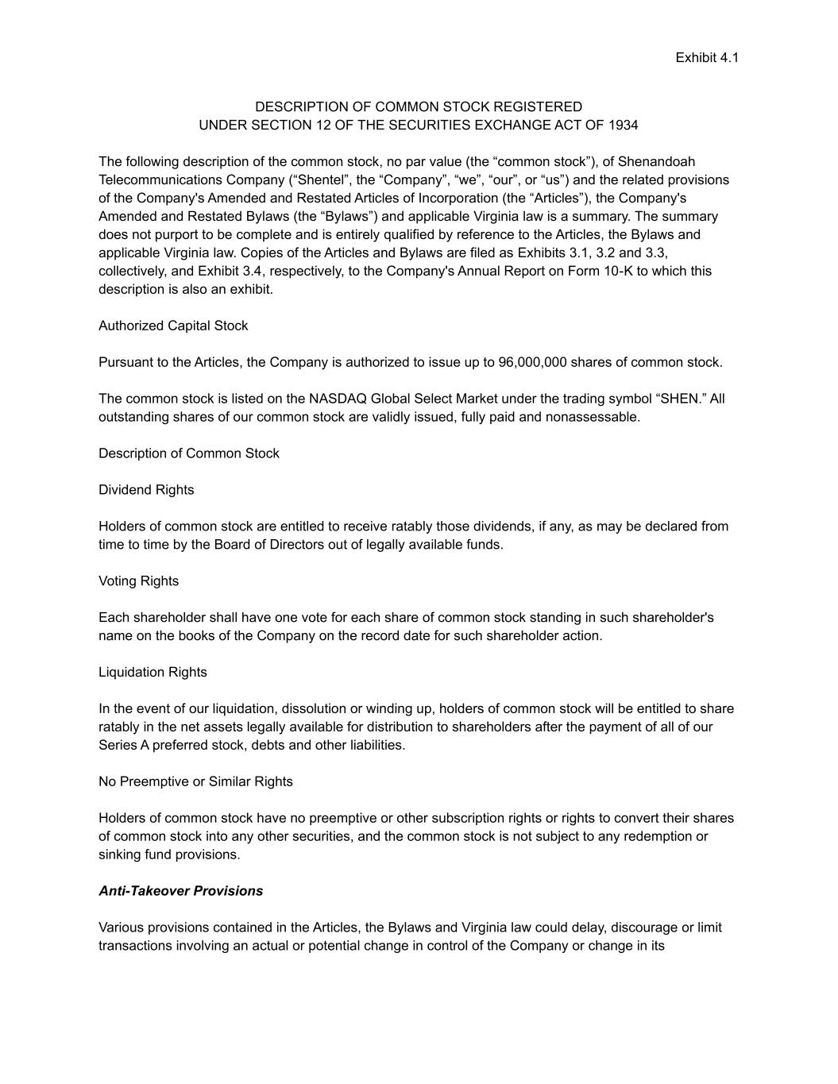
F-41
Exhibit 4.1 DESCRIPTION OF COMMON STOCK REGISTERED UNDER SECTION 12 OF THE SECURITIES EXCHANGE ACT OF 1934 The following description of the common stock, no par value (the “common stock”), of Shenandoah Telecommunications Company (“Shentel”, the “Company”, “we”, “our”, or “us”) and the related provisions of the Company's Amended and Restated Articles of Incorporation (the “Articles”), the Company's Amended and Restated Bylaws (the “Bylaws”) and applicable Virginia law is a summary. The summary does not purport to be complete and is entirely qualified by reference to the Articles, the Bylaws and applicable Virginia law. Copies of the Articles and Bylaws are filed as Exhibits 3.1, 3.2 and 3.3, collectively, and Exhibit 3.4, respectively, to the Company's Annual Report on Form 10-K to which this description is also an exhibit. Authorized Capital Stock Pursuant to the Articles, the Company is authorized to issue up to 96,000,000 shares of common stock. The common stock is listed on the NASDAQ Global Select Market under the trading symbol “SHEN.” All outstanding shares of our common stock are validly issued, fully paid and nonassessable. Description of Common Stock Dividend Rights Holders of common stock are entitled to receive ratably those dividends, if any, as may be declared from time to time by the Board of Directors out of legally available funds. Voting Rights Each shareholder shall have one vote for each share of common stock standing in such shareholder's name on the books of the Company on the record date for such shareholder action. Liquidation Rights In the event of our liquidation, dissolution or winding up, holders of common stock will be entitled to share ratably in the net assets legally available for distribution to shareholders after the payment of all of our Series A preferred stock, debts and other liabilities. No Preemptive or Similar Rights Holders of common stock have no preemptive or other subscription rights or rights to convert their shares of common stock into any other securities, and the common stock is not subject to any redemption or sinking fund provisions. Anti-Takeover Provisions Various provisions contained in the Articles, the Bylaws and Virginia law could delay, discourage or limit transactions involving an actual or potential change in control of the Company or change in its

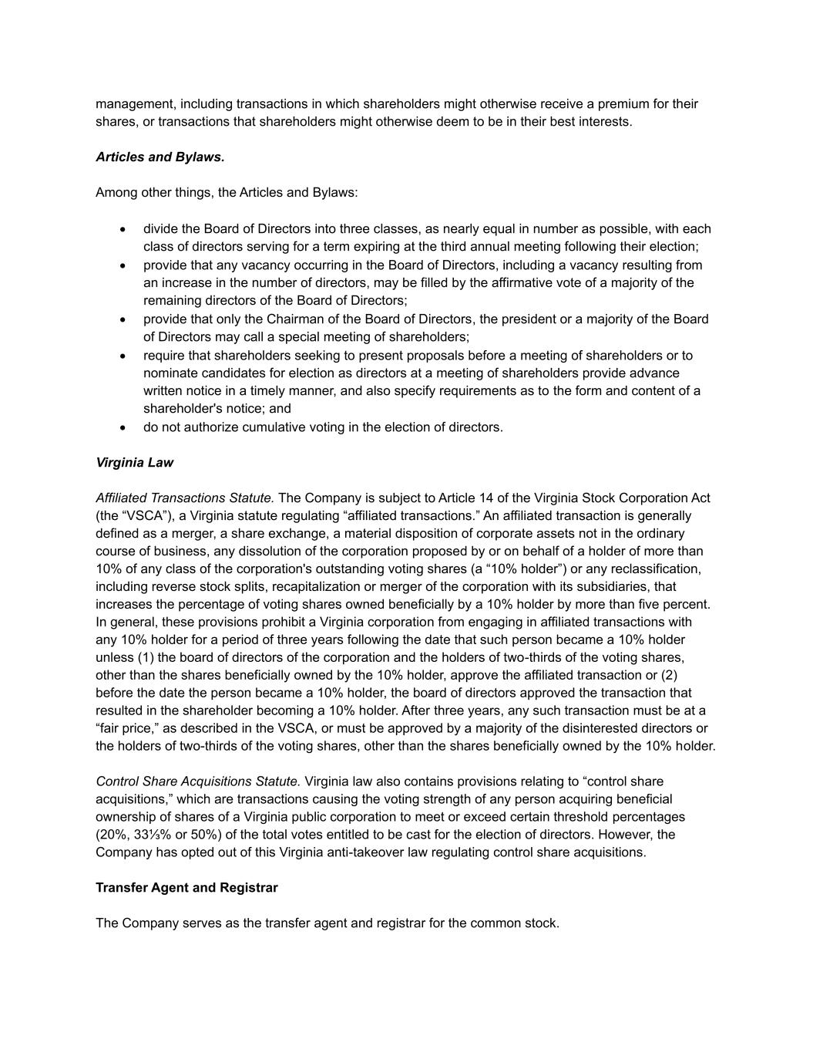
management, including transactions in which shareholders might otherwise receive a premium for their shares, or transactions that shareholders might otherwise deem to be in their best interests. Articles and Bylaws. Among other things, the Articles and Bylaws: • divide the Board of Directors into three classes, as nearly equal in number as possible, with each class of directors serving for a term expiring at the third annual meeting following their election; • provide that any vacancy occurring in the Board of Directors, including a vacancy resulting from an increase in the number of directors, may be filled by the affirmative vote of a majority of the remaining directors of the Board of Directors; • provide that only the Chairman of the Board of Directors, the president or a majority of the Board of Directors may call a special meeting of shareholders; • require that shareholders seeking to present proposals before a meeting of shareholders or to nominate candidates for election as directors at a meeting of shareholders provide advance written notice in a timely manner, and also specify requirements as to the form and content of a shareholder's notice; and • do not authorize cumulative voting in the election of directors. Virginia Law Affiliated Transactions Statute. The Company is subject to Article 14 of the Virginia Stock Corporation Act (the “VSCA”), a Virginia statute regulating “affiliated transactions.” An affiliated transaction is generally defined as a merger, a share exchange, a material disposition of corporate assets not in the ordinary course of business, any dissolution of the corporation proposed by or on behalf of a holder of more than 10% of any class of the corporation's outstanding voting shares (a “10% holder”) or any reclassification, including reverse stock splits, recapitalization or merger of the corporation with its subsidiaries, that increases the percentage of voting shares owned beneficially by a 10% holder by more than five percent. In general, these provisions prohibit a Virginia corporation from engaging in affiliated transactions with any 10% holder for a period of three years following the date that such person became a 10% holder unless (1) the board of directors of the corporation and the holders of two-thirds of the voting shares, other than the shares beneficially owned by the 10% holder, approve the affiliated transaction or (2) before the date the person became a 10% holder, the board of directors approved the transaction that resulted in the shareholder becoming a 10% holder. After three years, any such transaction must be at a “fair price,” as described in the VSCA, or must be approved by a majority of the disinterested directors or the holders of two-thirds of the voting shares, other than the shares beneficially owned by the 10% holder. Control Share Acquisitions Statute. Virginia law also contains provisions relating to “control share acquisitions,” which are transactions causing the voting strength of any person acquiring beneficial ownership of shares of a Virginia public corporation to meet or exceed certain threshold percentages (20%, 33⅓% or 50%) of the total votes entitled to be cast for the election of directors. However, the Company has opted out of this Virginia anti-takeover law regulating control share acquisitions. Transfer Agent and Registrar The Company serves as the transfer agent and registrar for the common stock.

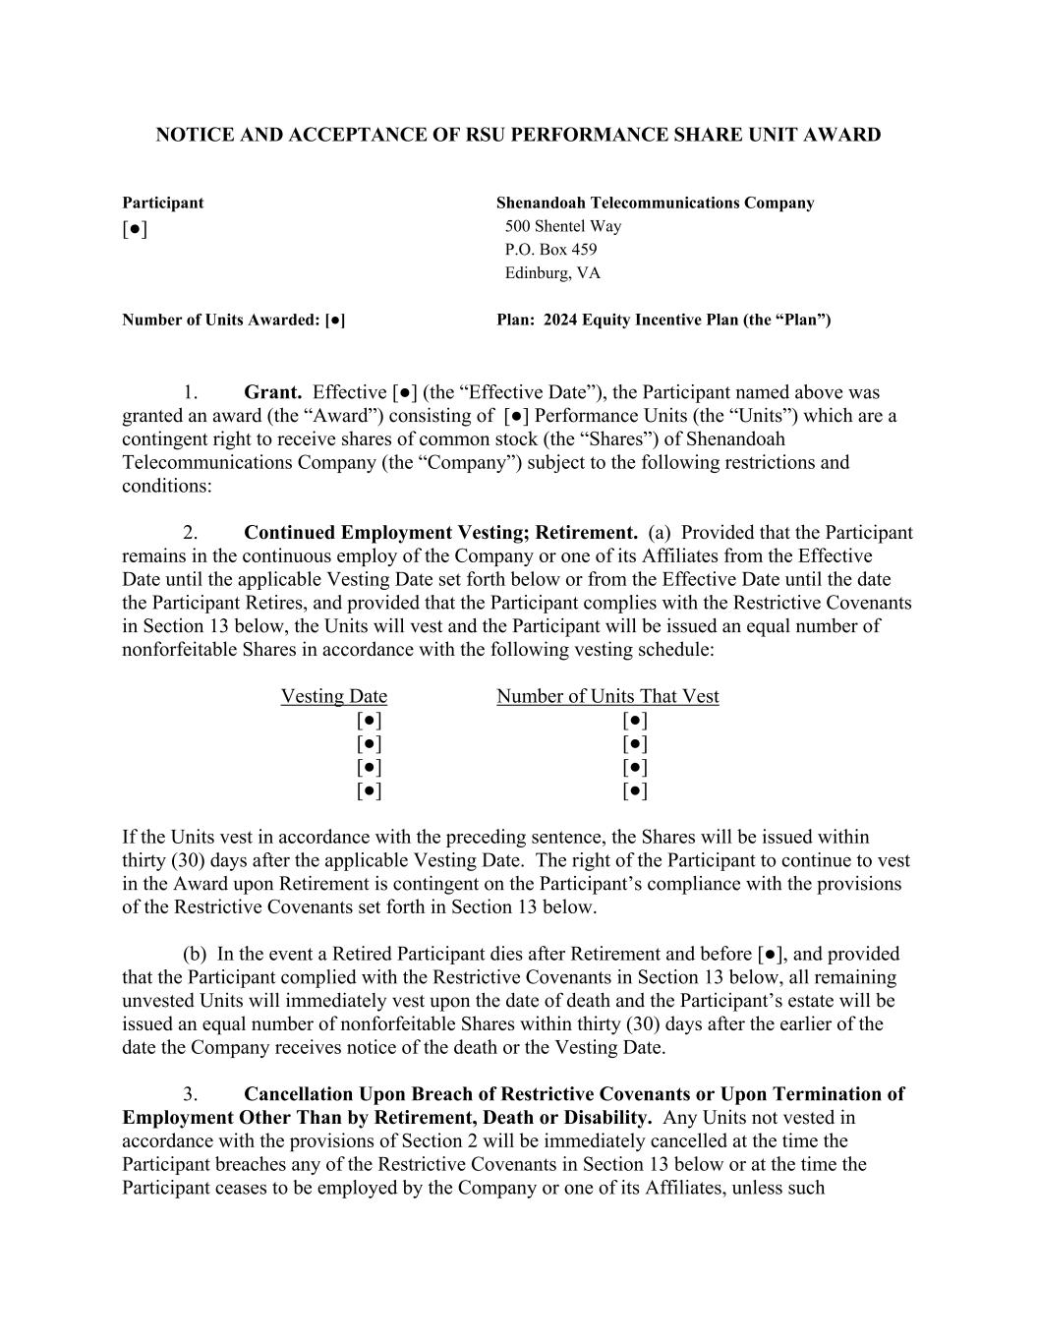
NOTICE AND ACCEPTANCE OF RSU PERFORMANCE SHARE UNIT AWARD Participant Shenandoah Telecommunications Company [●] 500 Shentel Way P.O. Box 459 Edinburg, VA Number of Units Awarded: [●] Plan: 2024 Equity Incentive Plan (the “Plan”) 1. Grant. Effective [●] (the “Effective Date”), the Participant named above was granted an award (the “Award”) consisting of [●] Performance Units (the “Units”) which are a contingent right to receive shares of common stock (the “Shares”) of Shenandoah Telecommunications Company (the “Company”) subject to the following restrictions and conditions: 2. Continued Employment Vesting; Retirement. (a) Provided that the Participant remains in the continuous employ of the Company or one of its Affiliates from the Effective Date until the applicable Vesting Date set forth below or from the Effective Date until the date the Participant Retires, and provided that the Participant complies with the Restrictive Covenants in Section 13 below, the Units will vest and the Participant will be issued an equal number of nonforfeitable Shares in accordance with the following vesting schedule: Vesting Date Number of Units That Vest [●] [●] [●] [●] [●] [●] [●] [●] If the Units vest in accordance with the preceding sentence, the Shares will be issued within thirty (30) days after the applicable Vesting Date. The right of the Participant to continue to vest in the Award upon Retirement is contingent on the Participant’s compliance with the provisions of the Restrictive Covenants set forth in Section 13 below. (b) In the event a Retired Participant dies after Retirement and before [●], and provided that the Participant complied with the Restrictive Covenants in Section 13 below, all remaining unvested Units will immediately vest upon the date of death and the Participant’s estate will be issued an equal number of nonforfeitable Shares within thirty (30) days after the earlier of the date the Company receives notice of the death or the Vesting Date. 3. Cancellation Upon Breach of Restrictive Covenants or Upon Termination of Employment Other Than by Retirement, Death or Disability. Any Units not vested in accordance with the provisions of Section 2 will be immediately cancelled at the time the Participant breaches any of the Restrictive Covenants in Section 13 below or at the time the Participant ceases to be employed by the Company or one of its Affiliates, unless such

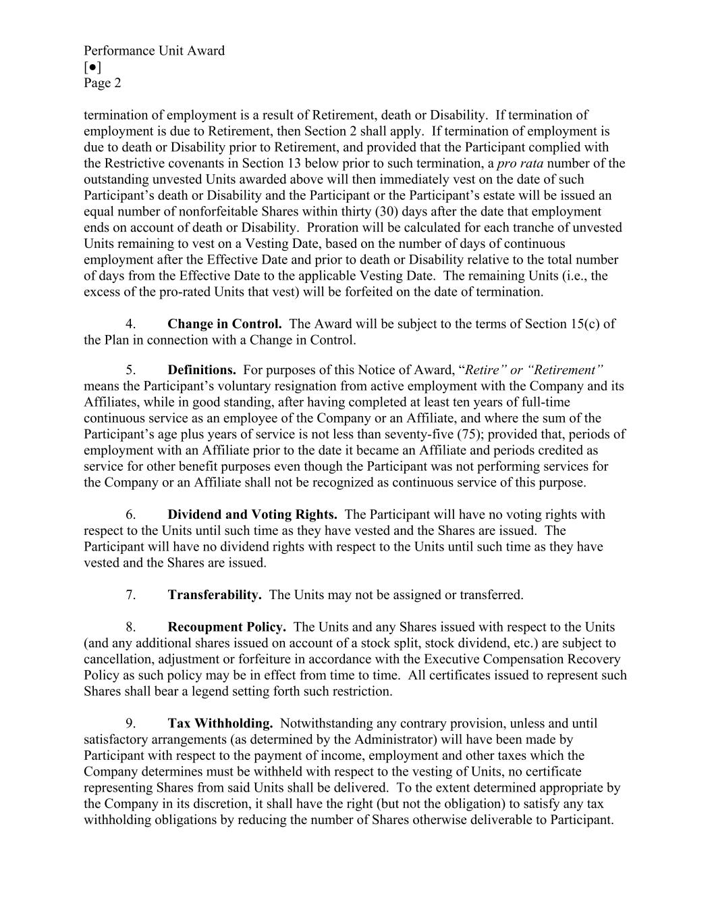
Performance Unit Award [●] Page 2 termination of employment is a result of Retirement, death or Disability. If termination of employment is due to Retirement, then Section 2 shall apply. If termination of employment is due to death or Disability prior to Retirement, and provided that the Participant complied with the Restrictive covenants in Section 13 below prior to such termination, a pro rata number of the outstanding unvested Units awarded above will then immediately vest on the date of such Participant’s death or Disability and the Participant or the Participant’s estate will be issued an equal number of nonforfeitable Shares within thirty (30) days after the date that employment ends on account of death or Disability. Proration will be calculated for each tranche of unvested Units remaining to vest on a Vesting Date, based on the number of days of continuous employment after the Effective Date and prior to death or Disability relative to the total number of days from the Effective Date to the applicable Vesting Date. The remaining Units (i.e., the excess of the pro-rated Units that vest) will be forfeited on the date of termination. 4. Change in Control. The Award will be subject to the terms of Section 15(c) of the Plan in connection with a Change in Control. 5. Definitions. For purposes of this Notice of Award, “Retire” or “Retirement” means the Participant’s voluntary resignation from active employment with the Company and its Affiliates, while in good standing, after having completed at least ten years of full-time continuous service as an employee of the Company or an Affiliate, and where the sum of the Participant’s age plus years of service is not less than seventy-five (75); provided that, periods of employment with an Affiliate prior to the date it became an Affiliate and periods credited as service for other benefit purposes even though the Participant was not performing services for the Company or an Affiliate shall not be recognized as continuous service of this purpose. 6. Dividend and Voting Rights. The Participant will have no voting rights with respect to the Units until such time as they have vested and the Shares are issued. The Participant will have no dividend rights with respect to the Units until such time as they have vested and the Shares are issued. 7. Transferability. The Units may not be assigned or transferred. 8. Recoupment Policy. The Units and any Shares issued with respect to the Units (and any additional shares issued on account of a stock split, stock dividend, etc.) are subject to cancellation, adjustment or forfeiture in accordance with the Executive Compensation Recovery Policy as such policy may be in effect from time to time. All certificates issued to represent such Shares shall bear a legend setting forth such restriction. 9. Tax Withholding. Notwithstanding any contrary provision, unless and until satisfactory arrangements (as determined by the Administrator) will have been made by Participant with respect to the payment of income, employment and other taxes which the Company determines must be withheld with respect to the vesting of Units, no certificate representing Shares from said Units shall be delivered. To the extent determined appropriate by the Company in its discretion, it shall have the right (but not the obligation) to satisfy any tax withholding obligations by reducing the number of Shares otherwise deliverable to Participant.

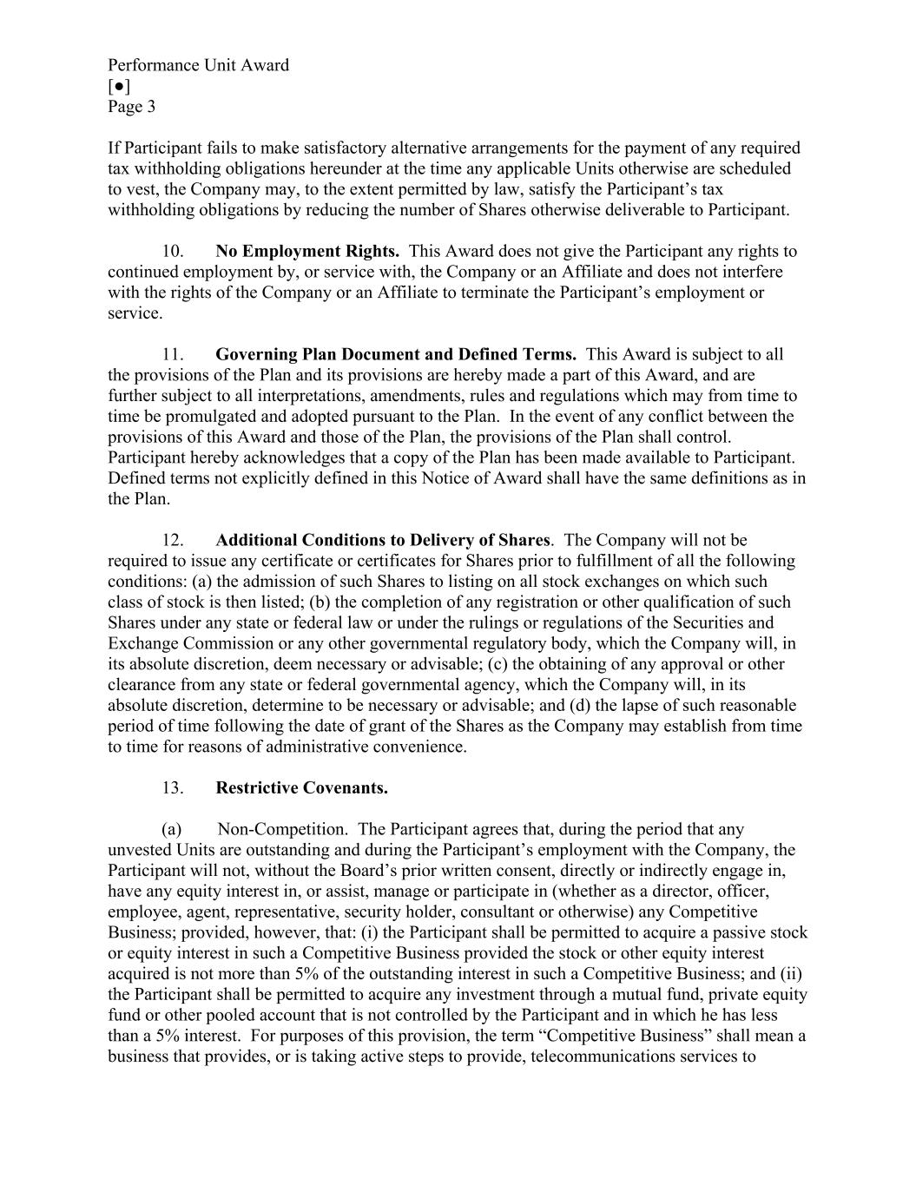
Performance Unit Award [●] Page 3 If Participant fails to make satisfactory alternative arrangements for the payment of any required tax withholding obligations hereunder at the time any applicable Units otherwise are scheduled to vest, the Company may, to the extent permitted by law, satisfy the Participant’s tax withholding obligations by reducing the number of Shares otherwise deliverable to Participant. 10. No Employment Rights. This Award does not give the Participant any rights to continued employment by, or service with, the Company or an Affiliate and does not interfere with the rights of the Company or an Affiliate to terminate the Participant’s employment or service. 11. Governing Plan Document and Defined Terms. This Award is subject to all the provisions of the Plan and its provisions are hereby made a part of this Award, and are further subject to all interpretations, amendments, rules and regulations which may from time to time be promulgated and adopted pursuant to the Plan. In the event of any conflict between the provisions of this Award and those of the Plan, the provisions of the Plan shall control. Participant hereby acknowledges that a copy of the Plan has been made available to Participant. Defined terms not explicitly defined in this Notice of Award shall have the same definitions as in the Plan. 12. Additional Conditions to Delivery of Shares. The Company will not be required to issue any certificate or certificates for Shares prior to fulfillment of all the following conditions: (a) the admission of such Shares to listing on all stock exchanges on which such class of stock is then listed; (b) the completion of any registration or other qualification of such Shares under any state or federal law or under the rulings or regulations of the Securities and Exchange Commission or any other governmental regulatory body, which the Company will, in its absolute discretion, deem necessary or advisable; (c) the obtaining of any approval or other clearance from any state or federal governmental agency, which the Company will, in its absolute discretion, determine to be necessary or advisable; and (d) the lapse of such reasonable period of time following the date of grant of the Shares as the Company may establish from time to time for reasons of administrative convenience. 13. Restrictive Covenants. (a) Non-Competition. The Participant agrees that, during the period that any unvested Units are outstanding and during the Participant’s employment with the Company, the Participant will not, without the Board’s prior written consent, directly or indirectly engage in, have any equity interest in, or assist, manage or participate in (whether as a director, officer, employee, agent, representative, security holder, consultant or otherwise) any Competitive Business; provided, however, that: (i) the Participant shall be permitted to acquire a passive stock or equity interest in such a Competitive Business provided the stock or other equity interest acquired is not more than 5% of the outstanding interest in such a Competitive Business; and (ii) the Participant shall be permitted to acquire any investment through a mutual fund, private equity fund or other pooled account that is not controlled by the Participant and in which he has less than a 5% interest. For purposes of this provision, the term “Competitive Business” shall mean a business that provides, or is taking active steps to provide, telecommunications services to

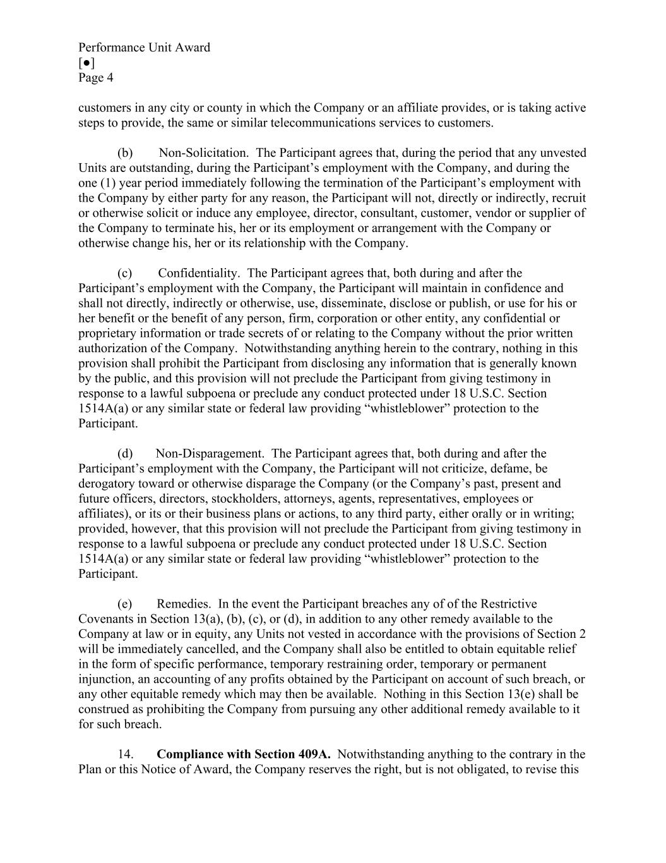
Performance Unit Award [●] Page 4 customers in any city or county in which the Company or an affiliate provides, or is taking active steps to provide, the same or similar telecommunications services to customers. (b) Non-Solicitation. The Participant agrees that, during the period that any unvested Units are outstanding, during the Participant’s employment with the Company, and during the one (1) year period immediately following the termination of the Participant’s employment with the Company by either party for any reason, the Participant will not, directly or indirectly, recruit or otherwise solicit or induce any employee, director, consultant, customer, vendor or supplier of the Company to terminate his, her or its employment or arrangement with the Company or otherwise change his, her or its relationship with the Company. (c) Confidentiality. The Participant agrees that, both during and after the Participant’s employment with the Company, the Participant will maintain in confidence and shall not directly, indirectly or otherwise, use, disseminate, disclose or publish, or use for his or her benefit or the benefit of any person, firm, corporation or other entity, any confidential or proprietary information or trade secrets of or relating to the Company without the prior written authorization of the Company. Notwithstanding anything herein to the contrary, nothing in this provision shall prohibit the Participant from disclosing any information that is generally known by the public, and this provision will not preclude the Participant from giving testimony in response to a lawful subpoena or preclude any conduct protected under 18 U.S.C. Section 1514A(a) or any similar state or federal law providing “whistleblower” protection to the Participant. (d) Non-Disparagement. The Participant agrees that, both during and after the Participant’s employment with the Company, the Participant will not criticize, defame, be derogatory toward or otherwise disparage the Company (or the Company’s past, present and future officers, directors, stockholders, attorneys, agents, representatives, employees or affiliates), or its or their business plans or actions, to any third party, either orally or in writing; provided, however, that this provision will not preclude the Participant from giving testimony in response to a lawful subpoena or preclude any conduct protected under 18 U.S.C. Section 1514A(a) or any similar state or federal law providing “whistleblower” protection to the Participant. (e) Remedies. In the event the Participant breaches any of of the Restrictive Covenants in Section 13(a), (b), (c), or (d), in addition to any other remedy available to the Company at law or in equity, any Units not vested in accordance with the provisions of Section 2 will be immediately cancelled, and the Company shall also be entitled to obtain equitable relief in the form of specific performance, temporary restraining order, temporary or permanent injunction, an accounting of any profits obtained by the Participant on account of such breach, or any other equitable remedy which may then be available. Nothing in this Section 13(e) shall be construed as prohibiting the Company from pursuing any other additional remedy available to it for such breach. 14. Compliance with Section 409A. Notwithstanding anything to the contrary in the Plan or this Notice of Award, the Company reserves the right, but is not obligated, to revise this

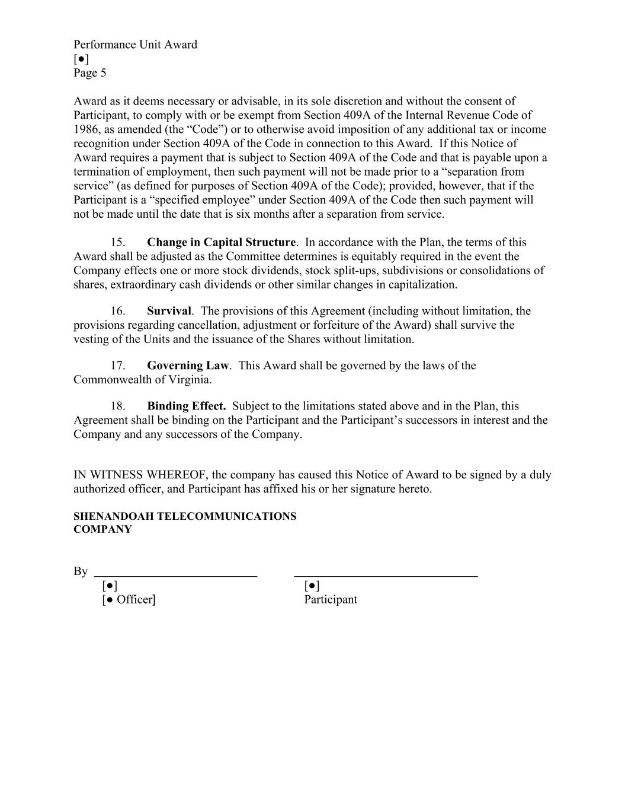
Performance Unit Award [●] Page 5 Award as it deems necessary or advisable, in its sole discretion and without the consent of Participant, to comply with or be exempt from Section 409A of the Internal Revenue Code of 1986, as amended (the “Code”) or to otherwise avoid imposition of any additional tax or income recognition under Section 409A of the Code in connection to this Award. If this Notice of Award requires a payment that is subject to Section 409A of the Code and that is payable upon a termination of employment, then such payment will not be made prior to a “separation from service” (as defined for purposes of Section 409A of the Code); provided, however, that if the Participant is a “specified employee” under Section 409A of the Code then such payment will not be made until the date that is six months after a separation from service. 15. Change in Capital Structure. In accordance with the Plan, the terms of this Award shall be adjusted as the Committee determines is equitably required in the event the Company effects one or more stock dividends, stock split-ups, subdivisions or consolidations of shares, extraordinary cash dividends or other similar changes in capitalization. 16. Survival. The provisions of this Agreement (including without limitation, the provisions regarding cancellation, adjustment or forfeiture of the Award) shall survive the vesting of the Units and the issuance of the Shares without limitation. 17. Governing Law. This Award shall be governed by the laws of the Commonwealth of Virginia. 18. Binding Effect. Subject to the limitations stated above and in the Plan, this Agreement shall be binding on the Participant and the Participant’s successors in interest and the Company and any successors of the Company. IN WITNESS WHEREOF, the company has caused this Notice of Award to be signed by a duly authorized officer, and Participant has affixed his or her signature hereto. SHENANDOAH TELECOMMUNICATIONS COMPANY By [●] [●] [● Officer] Participant

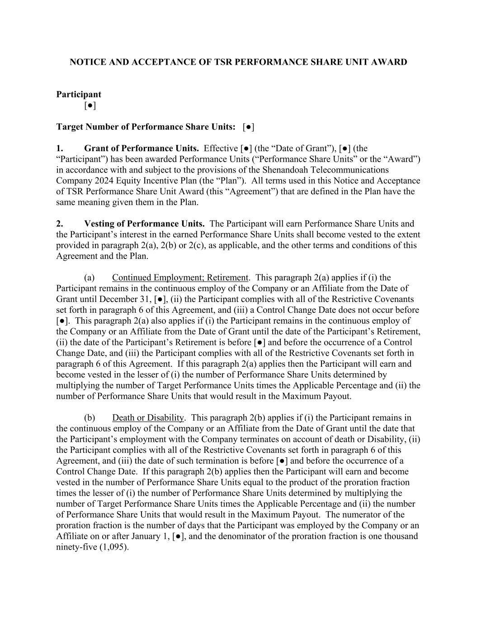
NOTICE AND ACCEPTANCE OF TSR PERFORMANCE SHARE UNIT AWARD Participant [●] Target Number of Performance Share Units: [●] 1. Grant of Performance Units. Effective [●] (the “Date of Grant”), [●] (the “Participant”) has been awarded Performance Units (“Performance Share Units” or the “Award”) in accordance with and subject to the provisions of the Shenandoah Telecommunications Company 2024 Equity Incentive Plan (the “Plan”). All terms used in this Notice and Acceptance of TSR Performance Share Unit Award (this “Agreement”) that are defined in the Plan have the same meaning given them in the Plan. 2. Vesting of Performance Units. The Participant will earn Performance Share Units and the Participant’s interest in the earned Performance Share Units shall become vested to the extent provided in paragraph 2(a), 2(b) or 2(c), as applicable, and the other terms and conditions of this Agreement and the Plan. (a) Continued Employment; Retirement. This paragraph 2(a) applies if (i) the Participant remains in the continuous employ of the Company or an Affiliate from the Date of Grant until December 31, [●], (ii) the Participant complies with all of the Restrictive Covenants set forth in paragraph 6 of this Agreement, and (iii) a Control Change Date does not occur before [●]. This paragraph 2(a) also applies if (i) the Participant remains in the continuous employ of the Company or an Affiliate from the Date of Grant until the date of the Participant’s Retirement, (ii) the date of the Participant’s Retirement is before [●] and before the occurrence of a Control Change Date, and (iii) the Participant complies with all of the Restrictive Covenants set forth in paragraph 6 of this Agreement. If this paragraph 2(a) applies then the Participant will earn and become vested in the lesser of (i) the number of Performance Share Units determined by multiplying the number of Target Performance Units times the Applicable Percentage and (ii) the number of Performance Share Units that would result in the Maximum Payout. (b) Death or Disability. This paragraph 2(b) applies if (i) the Participant remains in the continuous employ of the Company or an Affiliate from the Date of Grant until the date that the Participant’s employment with the Company terminates on account of death or Disability, (ii) the Participant complies with all of the Restrictive Covenants set forth in paragraph 6 of this Agreement, and (iii) the date of such termination is before [●] and before the occurrence of a Control Change Date. If this paragraph 2(b) applies then the Participant will earn and become vested in the number of Performance Share Units equal to the product of the proration fraction times the lesser of (i) the number of Performance Share Units determined by multiplying the number of Target Performance Share Units times the Applicable Percentage and (ii) the number of Performance Share Units that would result in the Maximum Payout. The numerator of the proration fraction is the number of days that the Participant was employed by the Company or an Affiliate on or after January 1, [●], and the denominator of the proration fraction is one thousand ninety-five (1,095).


TSR Performance Share Unit Award [●] Page 2 (c) Change in Control. This paragraph 2(c) applies if (i) a Control Change Date occurs before 2025, (ii) the Participant remains in the continuous employ of the Company or an Affiliate from the Date of Grant until that Control Change Date, and (iii) the Participant complies with all of the Restrictive Covenants set forth in paragraph 6 of this Agreement. This paragraph 2(c) also applies if (i) a Control Change Date occurs before [●] but on or after the date of the Participant’s Retirement in accordance with paragraph 2(a) and (ii) the Participant complies with all of the Restrictive Covenants set forth in paragraph 6 of this Agreement. If this paragraph 2(c) applies, then the Participant will earn and become vested in the lesser of (i) the number of Performance Units determined by multiplying the number of Target Performance Units times the Applicable Percentage and (ii) the number of Performance Units that would result in the Maximum Payout. If this paragraph 2(c) applies, the Participant shall become vested in the right to receive the Control Change Payout on the Control Change Date. Except as provided in this paragraph 2, the Participant’s rights with respect to the Performance Share Units and the Control Change Payout shall be forfeited on the date that the Participant’s employment with the Company and its Affiliates terminates for any reason. Moreover, the Participant’s rights with respect to the Performance Share Unites and the Control Change Payout shall be forfeited on the date that the Participant breaches any of the Restrictive Covenants set forth in paragraph 6 of this Agreement. 3. Settlement. (a) Before a Change in Control. As soon as practicable after the end of the applicable Measurement Period, but in all events no later than March 15 of the year following the end of the applicable Measurement Period, the Committee shall determine and certify the number of Performance Share Units that have been earned and vested under paragraph 2(a) or 2(b). On the date of the Committee’s certification, the Committee shall direct the transfer agent to issue shares of Common Stock to the Participant (or the estate of the Participant in the case of the Participant’s death on or before such date). The number of shares of Common Stock issued to the Participant will equal the number of Performance Share Units that the Committee has certified have been earned and vested by the Participant under paragraph 2(a) or 2(b); provided, however, that only whole shares of Common Stock will be issued and a cash payment will be made in settlement of any fractional share of Common Stock that otherwise would be issued to the Participant. (b) On and After a Change in Control. As soon as practicable after a Control Change Date, but in all events no later than March 15 of the year following the year in which the Control Change Date occurs, the Committee shall determine and certify the number of Performance Share Units that have been earned under paragraph 2(c) and the amount of the Control Change Payout. The Control Change Payout certified by the Committee shall be paid on the date of the Committee’s certification. The Control Change Payout shall be paid in a single payment in stock that is readily tradeable on an established securities market, cash or a combination of such stock and cash.

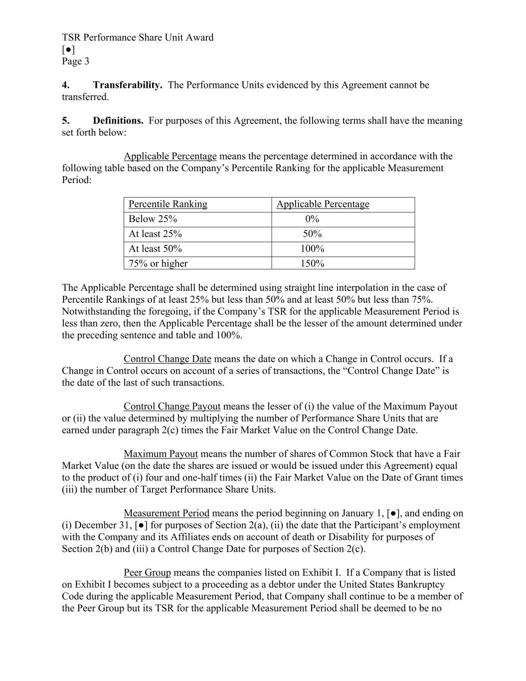
TSR Performance Share Unit Award [●] Page 3 4. Transferability. The Performance Units evidenced by this Agreement cannot be transferred. 5. Definitions. For purposes of this Agreement, the following terms shall have the meaning set forth below: Applicable Percentage means the percentage determined in accordance with the following table based on the Company’s Percentile Ranking for the applicable Measurement Period: Percentile Ranking Applicable Percentage Below 25% 0% At least 25% 50% At least 50% 100% 75% or higher 150% The Applicable Percentage shall be determined using straight line interpolation in the case of Percentile Rankings of at least 25% but less than 50% and at least 50% but less than 75%. Notwithstanding the foregoing, if the Company’s TSR for the applicable Measurement Period is less than zero, then the Applicable Percentage shall be the lesser of the amount determined under the preceding sentence and table and 100%. Control Change Date means the date on which a Change in Control occurs. If a Change in Control occurs on account of a series of transactions, the “Control Change Date” is the date of the last of such transactions. Control Change Payout means the lesser of (i) the value of the Maximum Payout or (ii) the value determined by multiplying the number of Performance Share Units that are earned under paragraph 2(c) times the Fair Market Value on the Control Change Date. Maximum Payout means the number of shares of Common Stock that have a Fair Market Value (on the date the shares are issued or would be issued under this Agreement) equal to the product of (i) four and one-half times (ii) the Fair Market Value on the Date of Grant times (iii) the number of Target Performance Share Units. Measurement Period means the period beginning on January 1, [●], and ending on (i) December 31, [●] for purposes of Section 2(a), (ii) the date that the Participant’s employment with the Company and its Affiliates ends on account of death or Disability for purposes of Section 2(b) and (iii) a Control Change Date for purposes of Section 2(c). Peer Group means the companies listed on Exhibit I. If a Company that is listed on Exhibit I becomes subject to a proceeding as a debtor under the United States Bankruptcy Code during the applicable Measurement Period, that Company shall continue to be a member of the Peer Group but its TSR for the applicable Measurement Period shall be deemed to be no

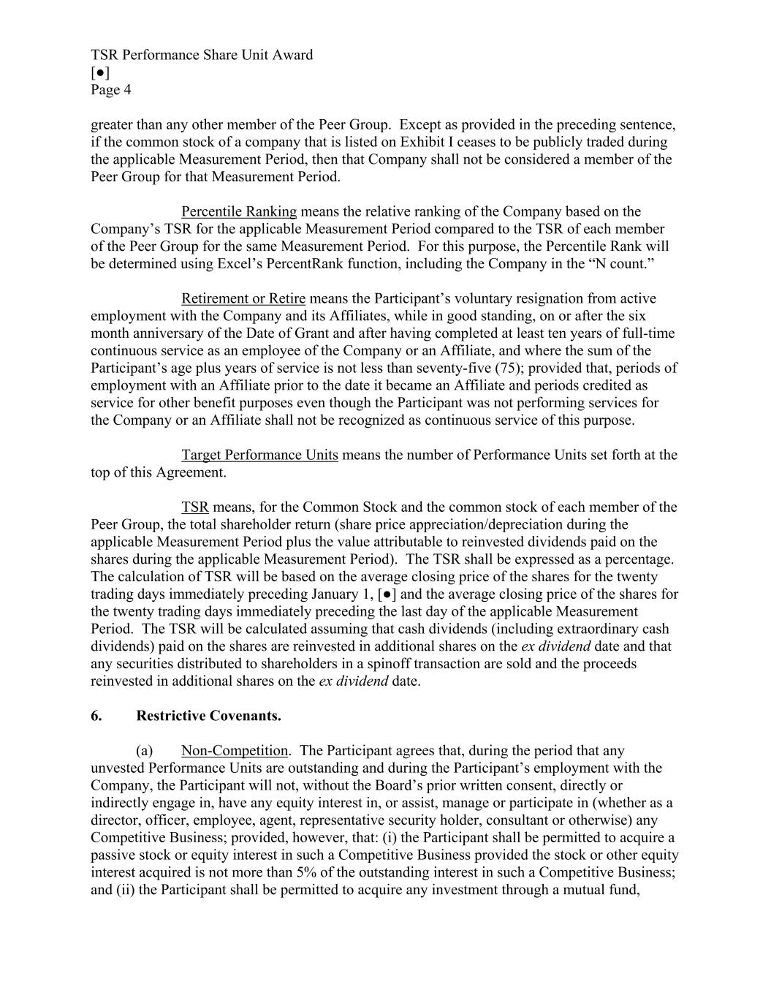
TSR Performance Share Unit Award [●] Page 4 greater than any other member of the Peer Group. Except as provided in the preceding sentence, if the common stock of a company that is listed on Exhibit I ceases to be publicly traded during the applicable Measurement Period, then that Company shall not be considered a member of the Peer Group for that Measurement Period. Percentile Ranking means the relative ranking of the Company based on the Company’s TSR for the applicable Measurement Period compared to the TSR of each member of the Peer Group for the same Measurement Period. For this purpose, the Percentile Rank will be determined using Excel’s PercentRank function, including the Company in the “N count.” Retirement or Retire means the Participant’s voluntary resignation from active employment with the Company and its Affiliates, while in good standing, on or after the six month anniversary of the Date of Grant and after having completed at least ten years of full-time continuous service as an employee of the Company or an Affiliate, and where the sum of the Participant’s age plus years of service is not less than seventy-five (75); provided that, periods of employment with an Affiliate prior to the date it became an Affiliate and periods credited as service for other benefit purposes even though the Participant was not performing services for the Company or an Affiliate shall not be recognized as continuous service of this purpose. Target Performance Units means the number of Performance Units set forth at the top of this Agreement. TSR means, for the Common Stock and the common stock of each member of the Peer Group, the total shareholder return (share price appreciation/depreciation during the applicable Measurement Period plus the value attributable to reinvested dividends paid on the shares during the applicable Measurement Period). The TSR shall be expressed as a percentage. The calculation of TSR will be based on the average closing price of the shares for the twenty trading days immediately preceding January 1, [●] and the average closing price of the shares for the twenty trading days immediately preceding the last day of the applicable Measurement Period. The TSR will be calculated assuming that cash dividends (including extraordinary cash dividends) paid on the shares are reinvested in additional shares on the ex dividend date and that any securities distributed to shareholders in a spinoff transaction are sold and the proceeds reinvested in additional shares on the ex dividend date. 6. Restrictive Covenants. (a) Non-Competition. The Participant agrees that, during the period that any unvested Performance Units are outstanding and during the Participant’s employment with the Company, the Participant will not, without the Board’s prior written consent, directly or indirectly engage in, have any equity interest in, or assist, manage or participate in (whether as a director, officer, employee, agent, representative security holder, consultant or otherwise) any Competitive Business; provided, however, that: (i) the Participant shall be permitted to acquire a passive stock or equity interest in such a Competitive Business provided the stock or other equity interest acquired is not more than 5% of the outstanding interest in such a Competitive Business; and (ii) the Participant shall be permitted to acquire any investment through a mutual fund,

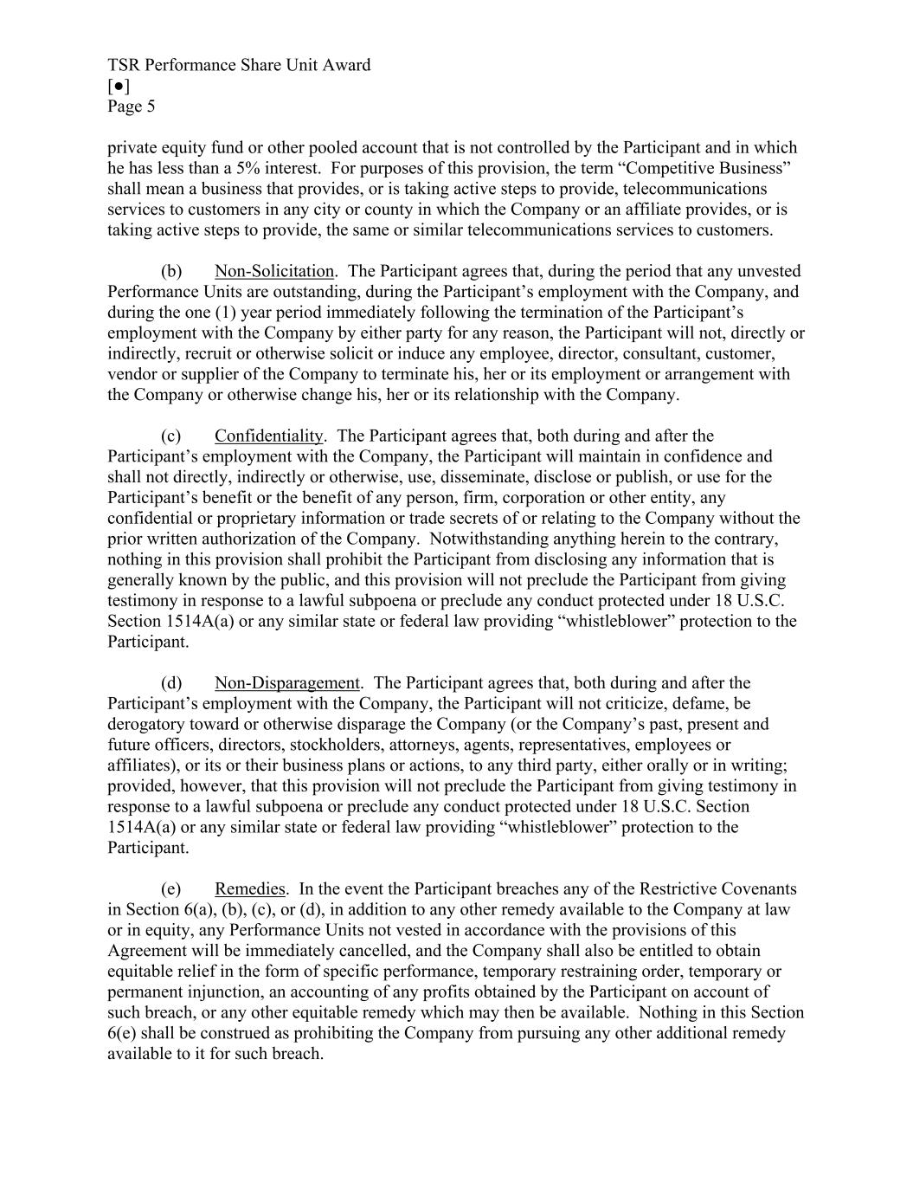
TSR Performance Share Unit Award [●] Page 5 private equity fund or other pooled account that is not controlled by the Participant and in which he has less than a 5% interest. For purposes of this provision, the term “Competitive Business” shall mean a business that provides, or is taking active steps to provide, telecommunications services to customers in any city or county in which the Company or an affiliate provides, or is taking active steps to provide, the same or similar telecommunications services to customers. (b) Non-Solicitation. The Participant agrees that, during the period that any unvested Performance Units are outstanding, during the Participant’s employment with the Company, and during the one (1) year period immediately following the termination of the Participant’s employment with the Company by either party for any reason, the Participant will not, directly or indirectly, recruit or otherwise solicit or induce any employee, director, consultant, customer, vendor or supplier of the Company to terminate his, her or its employment or arrangement with the Company or otherwise change his, her or its relationship with the Company. (c) Confidentiality. The Participant agrees that, both during and after the Participant’s employment with the Company, the Participant will maintain in confidence and shall not directly, indirectly or otherwise, use, disseminate, disclose or publish, or use for the Participant’s benefit or the benefit of any person, firm, corporation or other entity, any confidential or proprietary information or trade secrets of or relating to the Company without the prior written authorization of the Company. Notwithstanding anything herein to the contrary, nothing in this provision shall prohibit the Participant from disclosing any information that is generally known by the public, and this provision will not preclude the Participant from giving testimony in response to a lawful subpoena or preclude any conduct protected under 18 U.S.C. Section 1514A(a) or any similar state or federal law providing “whistleblower” protection to the Participant. (d) Non-Disparagement. The Participant agrees that, both during and after the Participant’s employment with the Company, the Participant will not criticize, defame, be derogatory toward or otherwise disparage the Company (or the Company’s past, present and future officers, directors, stockholders, attorneys, agents, representatives, employees or affiliates), or its or their business plans or actions, to any third party, either orally or in writing; provided, however, that this provision will not preclude the Participant from giving testimony in response to a lawful subpoena or preclude any conduct protected under 18 U.S.C. Section 1514A(a) or any similar state or federal law providing “whistleblower” protection to the Participant. (e) Remedies. In the event the Participant breaches any of the Restrictive Covenants in Section 6(a), (b), (c), or (d), in addition to any other remedy available to the Company at law or in equity, any Performance Units not vested in accordance with the provisions of this Agreement will be immediately cancelled, and the Company shall also be entitled to obtain equitable relief in the form of specific performance, temporary restraining order, temporary or permanent injunction, an accounting of any profits obtained by the Participant on account of such breach, or any other equitable remedy which may then be available. Nothing in this Section 6(e) shall be construed as prohibiting the Company from pursuing any other additional remedy available to it for such breach.

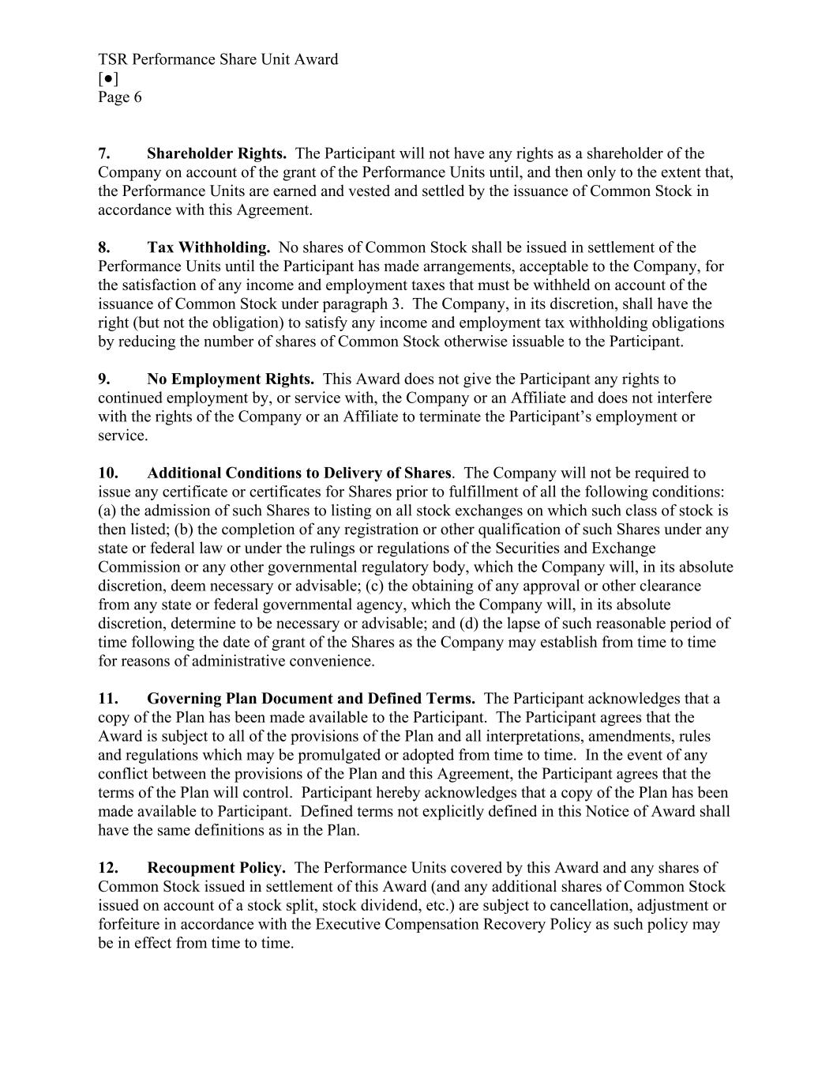
TSR Performance Share Unit Award [●] Page 6 7. Shareholder Rights. The Participant will not have any rights as a shareholder of the Company on account of the grant of the Performance Units until, and then only to the extent that, the Performance Units are earned and vested and settled by the issuance of Common Stock in accordance with this Agreement. 8. Tax Withholding. No shares of Common Stock shall be issued in settlement of the Performance Units until the Participant has made arrangements, acceptable to the Company, for the satisfaction of any income and employment taxes that must be withheld on account of the issuance of Common Stock under paragraph 3. The Company, in its discretion, shall have the right (but not the obligation) to satisfy any income and employment tax withholding obligations by reducing the number of shares of Common Stock otherwise issuable to the Participant. 9. No Employment Rights. This Award does not give the Participant any rights to continued employment by, or service with, the Company or an Affiliate and does not interfere with the rights of the Company or an Affiliate to terminate the Participant’s employment or service. 10. Additional Conditions to Delivery of Shares. The Company will not be required to issue any certificate or certificates for Shares prior to fulfillment of all the following conditions: (a) the admission of such Shares to listing on all stock exchanges on which such class of stock is then listed; (b) the completion of any registration or other qualification of such Shares under any state or federal law or under the rulings or regulations of the Securities and Exchange Commission or any other governmental regulatory body, which the Company will, in its absolute discretion, deem necessary or advisable; (c) the obtaining of any approval or other clearance from any state or federal governmental agency, which the Company will, in its absolute discretion, determine to be necessary or advisable; and (d) the lapse of such reasonable period of time following the date of grant of the Shares as the Company may establish from time to time for reasons of administrative convenience. 11. Governing Plan Document and Defined Terms. The Participant acknowledges that a copy of the Plan has been made available to the Participant. The Participant agrees that the Award is subject to all of the provisions of the Plan and all interpretations, amendments, rules and regulations which may be promulgated or adopted from time to time. In the event of any conflict between the provisions of the Plan and this Agreement, the Participant agrees that the terms of the Plan will control. Participant hereby acknowledges that a copy of the Plan has been made available to Participant. Defined terms not explicitly defined in this Notice of Award shall have the same definitions as in the Plan. 12. Recoupment Policy. The Performance Units covered by this Award and any shares of Common Stock issued in settlement of this Award (and any additional shares of Common Stock issued on account of a stock split, stock dividend, etc.) are subject to cancellation, adjustment or forfeiture in accordance with the Executive Compensation Recovery Policy as such policy may be in effect from time to time.

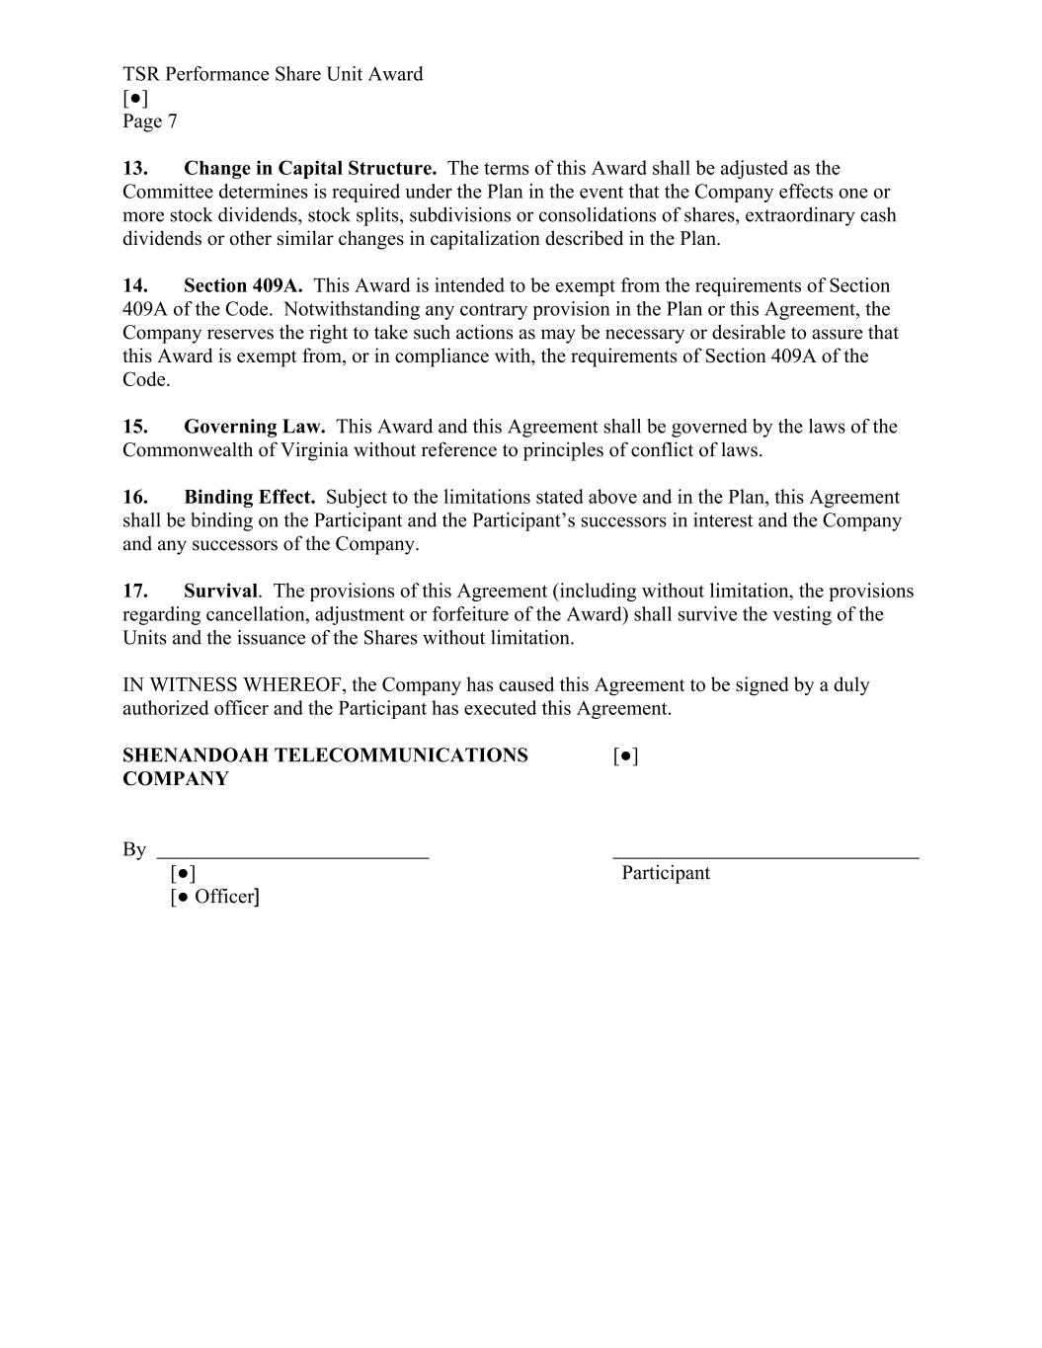
TSR Performance Share Unit Award [●] Page 7 13. Change in Capital Structure. The terms of this Award shall be adjusted as the Committee determines is required under the Plan in the event that the Company effects one or more stock dividends, stock splits, subdivisions or consolidations of shares, extraordinary cash dividends or other similar changes in capitalization described in the Plan. 14. Section 409A. This Award is intended to be exempt from the requirements of Section 409A of the Code. Notwithstanding any contrary provision in the Plan or this Agreement, the Company reserves the right to take such actions as may be necessary or desirable to assure that this Award is exempt from, or in compliance with, the requirements of Section 409A of the Code. 15. Governing Law. This Award and this Agreement shall be governed by the laws of the Commonwealth of Virginia without reference to principles of conflict of laws. 16. Binding Effect. Subject to the limitations stated above and in the Plan, this Agreement shall be binding on the Participant and the Participant’s successors in interest and the Company and any successors of the Company. 17. Survival. The provisions of this Agreement (including without limitation, the provisions regarding cancellation, adjustment or forfeiture of the Award) shall survive the vesting of the Units and the issuance of the Shares without limitation. IN WITNESS WHEREOF, the Company has caused this Agreement to be signed by a duly authorized officer and the Participant has executed this Agreement. SHENANDOAH TELECOMMUNICATIONS [●] COMPANY By [●] Participant [● Officer]


TSR Performance Share Unit Award [●] Page 8 Exhibit I Peer Group Companies Ticker Company Name

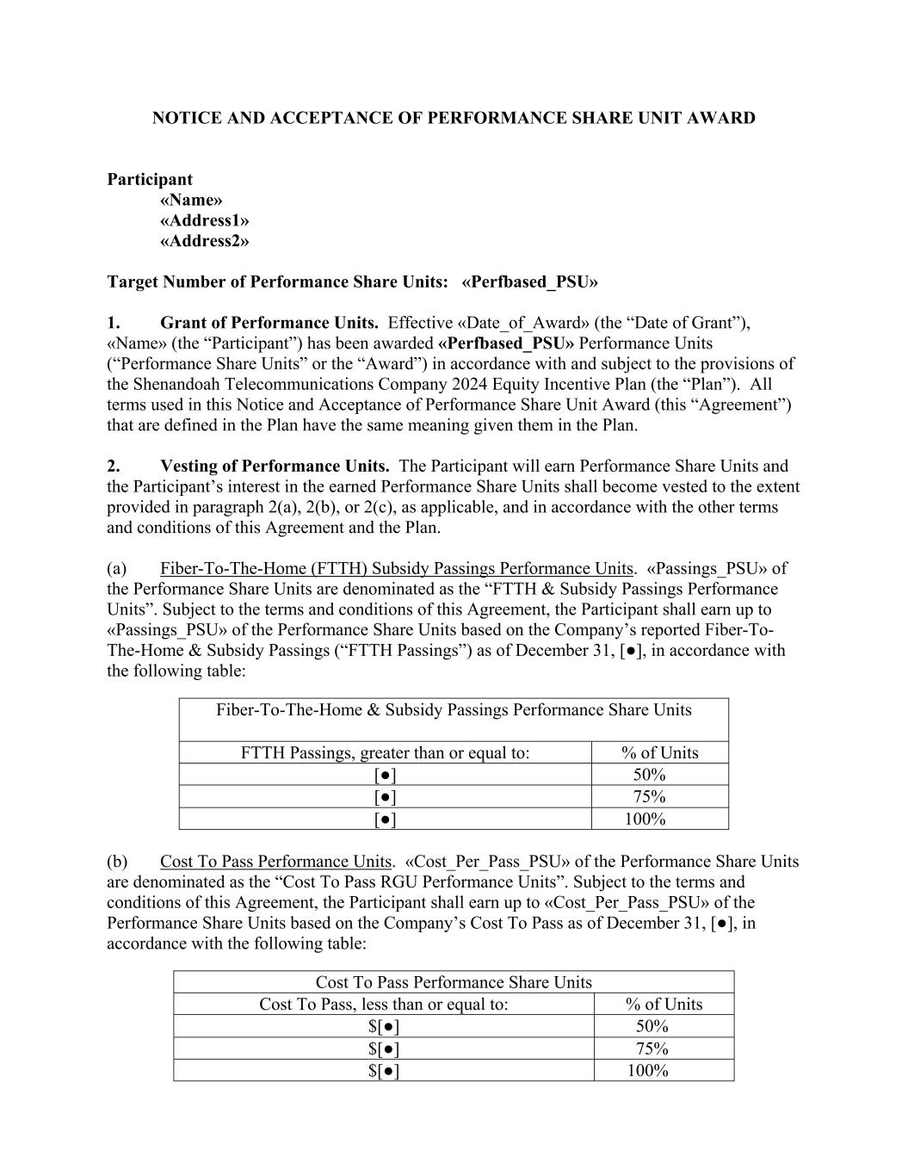
NOTICE AND ACCEPTANCE OF PERFORMANCE SHARE UNIT AWARD Participant «Name» «Address1» «Address2» Target Number of Performance Share Units: «Perfbased_PSU» 1. Grant of Performance Units. Effective «Date_of_Award» (the “Date of Grant”), «Name» (the “Participant”) has been awarded «Perfbased_PSU» Performance Units (“Performance Share Units” or the “Award”) in accordance with and subject to the provisions of the Shenandoah Telecommunications Company 2024 Equity Incentive Plan (the “Plan”). All terms used in this Notice and Acceptance of Performance Share Unit Award (this “Agreement”) that are defined in the Plan have the same meaning given them in the Plan. 2. Vesting of Performance Units. The Participant will earn Performance Share Units and the Participant’s interest in the earned Performance Share Units shall become vested to the extent provided in paragraph 2(a), 2(b), or 2(c), as applicable, and in accordance with the other terms and conditions of this Agreement and the Plan. (a) Fiber-To-The-Home (FTTH) Subsidy Passings Performance Units. «Passings_PSU» of the Performance Share Units are denominated as the “FTTH & Subsidy Passings Performance Units”. Subject to the terms and conditions of this Agreement, the Participant shall earn up to «Passings_PSU» of the Performance Share Units based on the Company’s reported Fiber-To- The-Home & Subsidy Passings (“FTTH Passings”) as of December 31, [●], in accordance with the following table: Fiber-To-The-Home & Subsidy Passings Performance Share Units FTTH Passings, greater than or equal to: % of Units [●] 50% [●] 75% [●] 100% (b) Cost To Pass Performance Units. «Cost_Per_Pass_PSU» of the Performance Share Units are denominated as the “Cost To Pass RGU Performance Units”. Subject to the terms and conditions of this Agreement, the Participant shall earn up to «Cost_Per_Pass_PSU» of the Performance Share Units based on the Company’s Cost To Pass as of December 31, [●], in accordance with the following table: Cost To Pass Performance Share Units Cost To Pass, less than or equal to: % of Units $[●] 50% $[●] 75% $[●] 100%

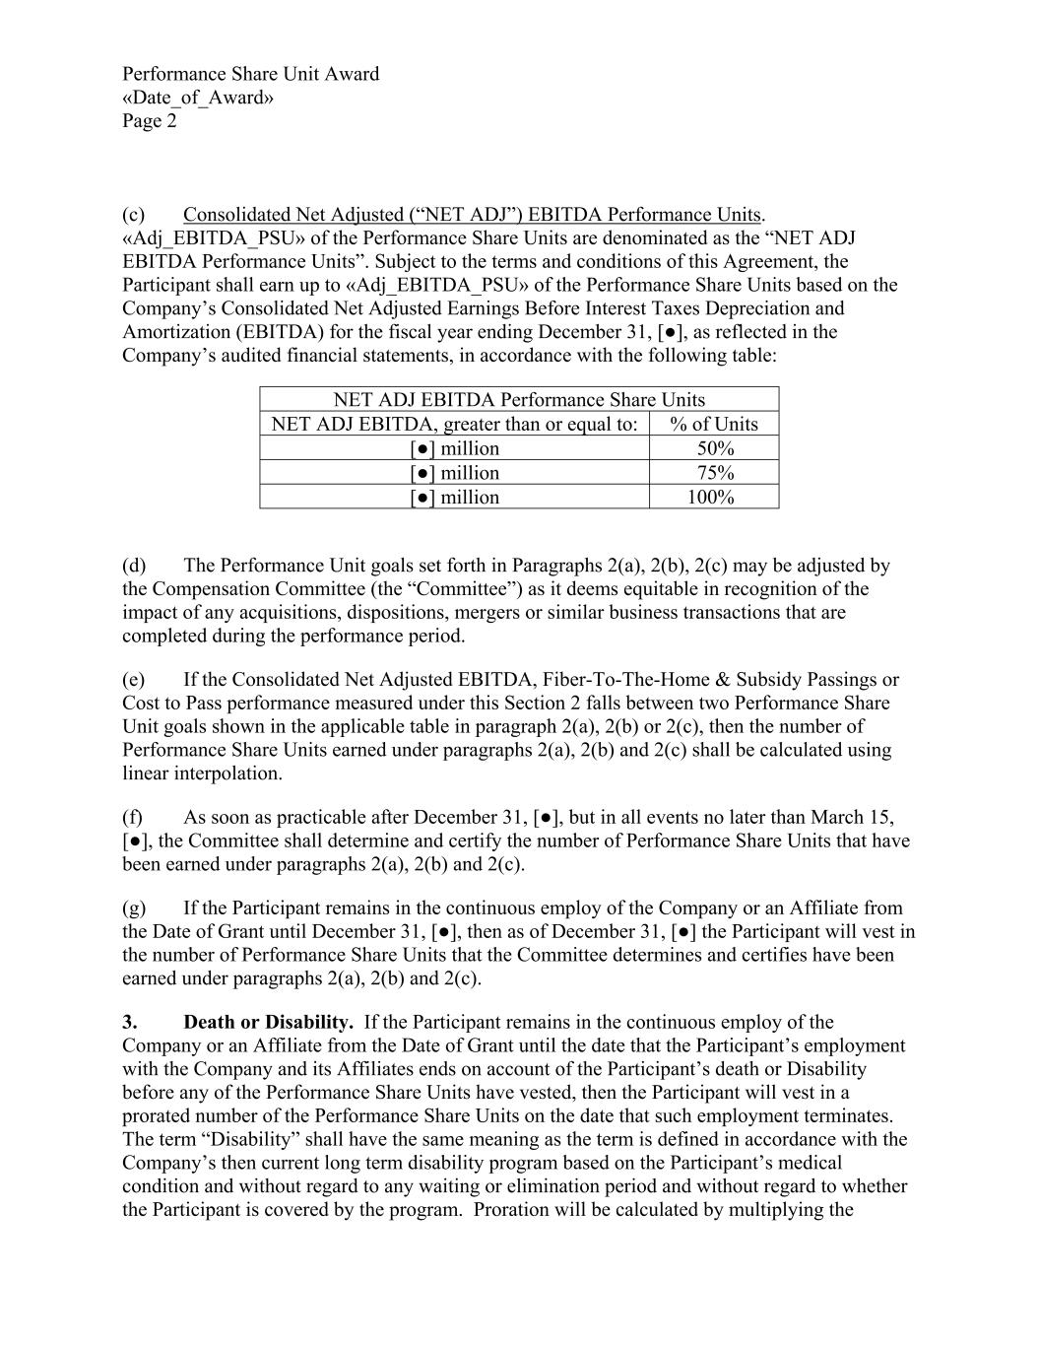
Performance Share Unit Award «Date_of_Award» Page 2 (c) Consolidated Net Adjusted (“NET ADJ”) EBITDA Performance Units. «Adj_EBITDA_PSU» of the Performance Share Units are denominated as the “NET ADJ EBITDA Performance Units”. Subject to the terms and conditions of this Agreement, the Participant shall earn up to «Adj_EBITDA_PSU» of the Performance Share Units based on the Company’s Consolidated Net Adjusted Earnings Before Interest Taxes Depreciation and Amortization (EBITDA) for the fiscal year ending December 31, [●], as reflected in the Company’s audited financial statements, in accordance with the following table: NET ADJ EBITDA Performance Share Units NET ADJ EBITDA, greater than or equal to: % of Units [●] million 50% [●] million 75% [●] million 100% (d) The Performance Unit goals set forth in Paragraphs 2(a), 2(b), 2(c) may be adjusted by the Compensation Committee (the “Committee”) as it deems equitable in recognition of the impact of any acquisitions, dispositions, mergers or similar business transactions that are completed during the performance period. (e) If the Consolidated Net Adjusted EBITDA, Fiber-To-The-Home & Subsidy Passings or Cost to Pass performance measured under this Section 2 falls between two Performance Share Unit goals shown in the applicable table in paragraph 2(a), 2(b) or 2(c), then the number of Performance Share Units earned under paragraphs 2(a), 2(b) and 2(c) shall be calculated using linear interpolation. (f) As soon as practicable after December 31, [●], but in all events no later than March 15, [●], the Committee shall determine and certify the number of Performance Share Units that have been earned under paragraphs 2(a), 2(b) and 2(c). (g) If the Participant remains in the continuous employ of the Company or an Affiliate from the Date of Grant until December 31, [●], then as of December 31, [●] the Participant will vest in the number of Performance Share Units that the Committee determines and certifies have been earned under paragraphs 2(a), 2(b) and 2(c). 3. Death or Disability. If the Participant remains in the continuous employ of the Company or an Affiliate from the Date of Grant until the date that the Participant’s employment with the Company and its Affiliates ends on account of the Participant’s death or Disability before any of the Performance Share Units have vested, then the Participant will vest in a prorated number of the Performance Share Units on the date that such employment terminates. The term “Disability” shall have the same meaning as the term is defined in accordance with the Company’s then current long term disability program based on the Participant’s medical condition and without regard to any waiting or elimination period and without regard to whether the Participant is covered by the program. Proration will be calculated by multiplying the

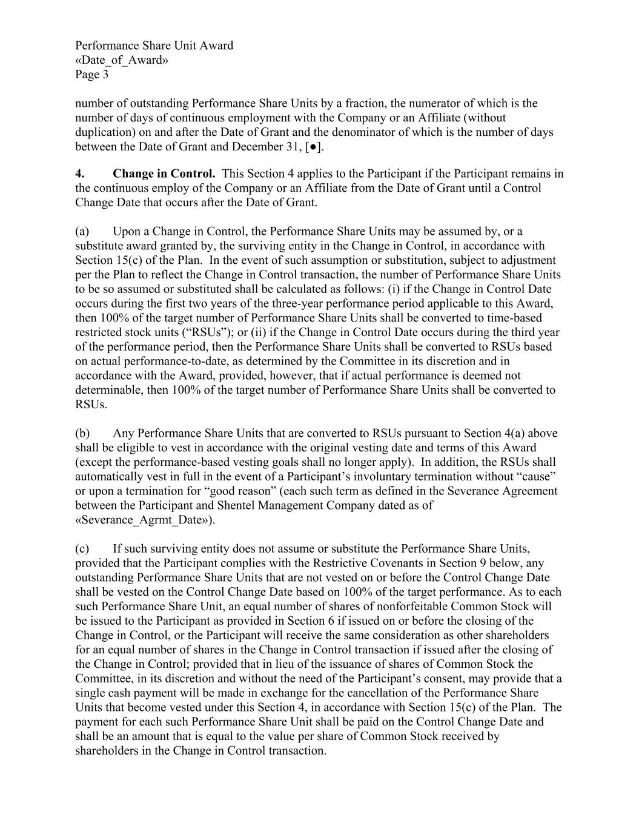
Performance Share Unit Award «Date_of_Award» Page 3 number of outstanding Performance Share Units by a fraction, the numerator of which is the number of days of continuous employment with the Company or an Affiliate (without duplication) on and after the Date of Grant and the denominator of which is the number of days between the Date of Grant and December 31, [●]. 4. Change in Control. This Section 4 applies to the Participant if the Participant remains in the continuous employ of the Company or an Affiliate from the Date of Grant until a Control Change Date that occurs after the Date of Grant. (a) Upon a Change in Control, the Performance Share Units may be assumed by, or a substitute award granted by, the surviving entity in the Change in Control, in accordance with Section 15(c) of the Plan. In the event of such assumption or substitution, subject to adjustment per the Plan to reflect the Change in Control transaction, the number of Performance Share Units to be so assumed or substituted shall be calculated as follows: (i) if the Change in Control Date occurs during the first two years of the three-year performance period applicable to this Award, then 100% of the target number of Performance Share Units shall be converted to time-based restricted stock units (“RSUs”); or (ii) if the Change in Control Date occurs during the third year of the performance period, then the Performance Share Units shall be converted to RSUs based on actual performance-to-date, as determined by the Committee in its discretion and in accordance with the Award, provided, however, that if actual performance is deemed not determinable, then 100% of the target number of Performance Share Units shall be converted to RSUs. (b) Any Performance Share Units that are converted to RSUs pursuant to Section 4(a) above shall be eligible to vest in accordance with the original vesting date and terms of this Award (except the performance-based vesting goals shall no longer apply). In addition, the RSUs shall automatically vest in full in the event of a Participant’s involuntary termination without “cause” or upon a termination for “good reason” (each such term as defined in the Severance Agreement between the Participant and Shentel Management Company dated as of «Severance_Agrmt_Date»). (c) If such surviving entity does not assume or substitute the Performance Share Units, provided that the Participant complies with the Restrictive Covenants in Section 9 below, any outstanding Performance Share Units that are not vested on or before the Control Change Date shall be vested on the Control Change Date based on 100% of the target performance. As to each such Performance Share Unit, an equal number of shares of nonforfeitable Common Stock will be issued to the Participant as provided in Section 6 if issued on or before the closing of the Change in Control, or the Participant will receive the same consideration as other shareholders for an equal number of shares in the Change in Control transaction if issued after the closing of the Change in Control; provided that in lieu of the issuance of shares of Common Stock the Committee, in its discretion and without the need of the Participant’s consent, may provide that a single cash payment will be made in exchange for the cancellation of the Performance Share Units that become vested under this Section 4, in accordance with Section 15(c) of the Plan. The payment for each such Performance Share Unit shall be paid on the Control Change Date and shall be an amount that is equal to the value per share of Common Stock received by shareholders in the Change in Control transaction.

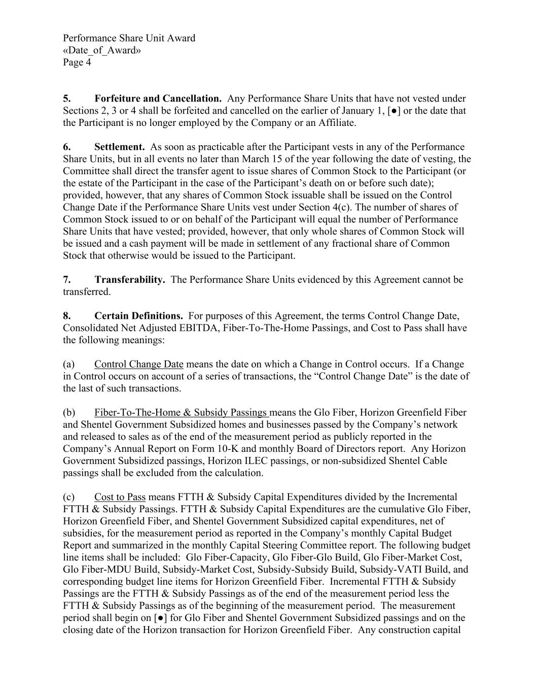
Performance Share Unit Award «Date_of_Award» Page 4 5. Forfeiture and Cancellation. Any Performance Share Units that have not vested under Sections 2, 3 or 4 shall be forfeited and cancelled on the earlier of January 1, [●] or the date that the Participant is no longer employed by the Company or an Affiliate. 6. Settlement. As soon as practicable after the Participant vests in any of the Performance Share Units, but in all events no later than March 15 of the year following the date of vesting, the Committee shall direct the transfer agent to issue shares of Common Stock to the Participant (or the estate of the Participant in the case of the Participant’s death on or before such date); provided, however, that any shares of Common Stock issuable shall be issued on the Control Change Date if the Performance Share Units vest under Section 4(c). The number of shares of Common Stock issued to or on behalf of the Participant will equal the number of Performance Share Units that have vested; provided, however, that only whole shares of Common Stock will be issued and a cash payment will be made in settlement of any fractional share of Common Stock that otherwise would be issued to the Participant. 7. Transferability. The Performance Share Units evidenced by this Agreement cannot be transferred. 8. Certain Definitions. For purposes of this Agreement, the terms Control Change Date, Consolidated Net Adjusted EBITDA, Fiber-To-The-Home Passings, and Cost to Pass shall have the following meanings: (a) Control Change Date means the date on which a Change in Control occurs. If a Change in Control occurs on account of a series of transactions, the “Control Change Date” is the date of the last of such transactions. (b) Fiber-To-The-Home & Subsidy Passings means the Glo Fiber, Horizon Greenfield Fiber and Shentel Government Subsidized homes and businesses passed by the Company’s network and released to sales as of the end of the measurement period as publicly reported in the Company’s Annual Report on Form 10-K and monthly Board of Directors report. Any Horizon Government Subsidized passings, Horizon ILEC passings, or non-subsidized Shentel Cable passings shall be excluded from the calculation. (c) Cost to Pass means FTTH & Subsidy Capital Expenditures divided by the Incremental FTTH & Subsidy Passings. FTTH & Subsidy Capital Expenditures are the cumulative Glo Fiber, Horizon Greenfield Fiber, and Shentel Government Subsidized capital expenditures, net of subsidies, for the measurement period as reported in the Company’s monthly Capital Budget Report and summarized in the monthly Capital Steering Committee report. The following budget line items shall be included: Glo Fiber-Capacity, Glo Fiber-Glo Build, Glo Fiber-Market Cost, Glo Fiber-MDU Build, Subsidy-Market Cost, Subsidy-Subsidy Build, Subsidy-VATI Build, and corresponding budget line items for Horizon Greenfield Fiber. Incremental FTTH & Subsidy Passings are the FTTH & Subsidy Passings as of the end of the measurement period less the FTTH & Subsidy Passings as of the beginning of the measurement period. The measurement period shall begin on [●] for Glo Fiber and Shentel Government Subsidized passings and on the closing date of the Horizon transaction for Horizon Greenfield Fiber. Any construction capital

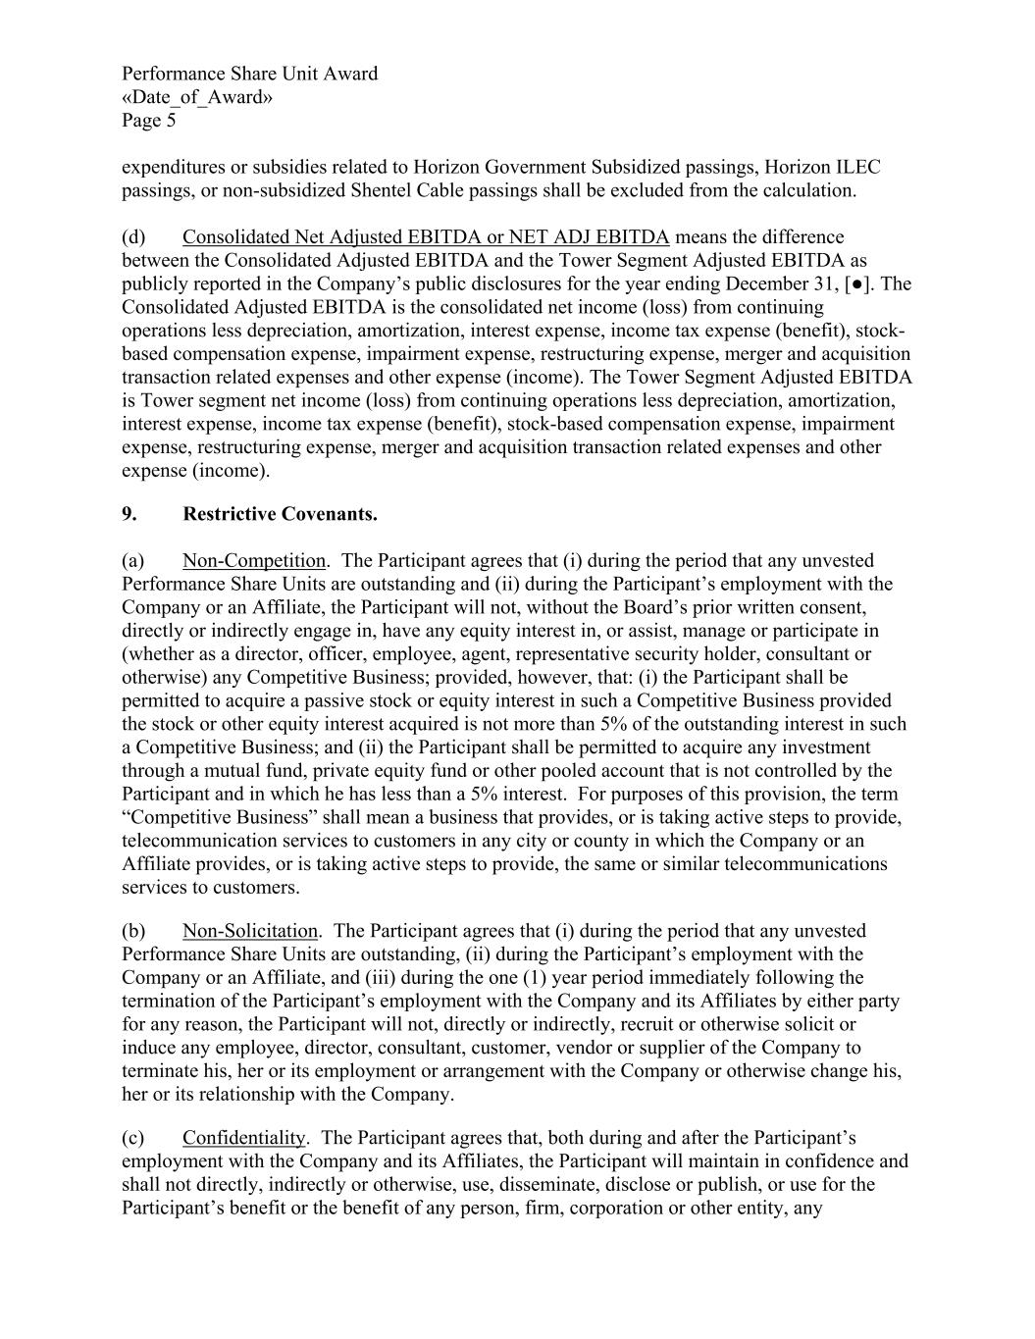
Performance Share Unit Award «Date_of_Award» Page 5 expenditures or subsidies related to Horizon Government Subsidized passings, Horizon ILEC passings, or non-subsidized Shentel Cable passings shall be excluded from the calculation. (d) Consolidated Net Adjusted EBITDA or NET ADJ EBITDA means the difference between the Consolidated Adjusted EBITDA and the Tower Segment Adjusted EBITDA as publicly reported in the Company’s public disclosures for the year ending December 31, [●]. The Consolidated Adjusted EBITDA is the consolidated net income (loss) from continuing operations less depreciation, amortization, interest expense, income tax expense (benefit), stock- based compensation expense, impairment expense, restructuring expense, merger and acquisition transaction related expenses and other expense (income). The Tower Segment Adjusted EBITDA is Tower segment net income (loss) from continuing operations less depreciation, amortization, interest expense, income tax expense (benefit), stock-based compensation expense, impairment expense, restructuring expense, merger and acquisition transaction related expenses and other expense (income). 9. Restrictive Covenants. (a) Non-Competition. The Participant agrees that (i) during the period that any unvested Performance Share Units are outstanding and (ii) during the Participant’s employment with the Company or an Affiliate, the Participant will not, without the Board’s prior written consent, directly or indirectly engage in, have any equity interest in, or assist, manage or participate in (whether as a director, officer, employee, agent, representative security holder, consultant or otherwise) any Competitive Business; provided, however, that: (i) the Participant shall be permitted to acquire a passive stock or equity interest in such a Competitive Business provided the stock or other equity interest acquired is not more than 5% of the outstanding interest in such a Competitive Business; and (ii) the Participant shall be permitted to acquire any investment through a mutual fund, private equity fund or other pooled account that is not controlled by the Participant and in which he has less than a 5% interest. For purposes of this provision, the term “Competitive Business” shall mean a business that provides, or is taking active steps to provide, telecommunication services to customers in any city or county in which the Company or an Affiliate provides, or is taking active steps to provide, the same or similar telecommunications services to customers. (b) Non-Solicitation. The Participant agrees that (i) during the period that any unvested Performance Share Units are outstanding, (ii) during the Participant’s employment with the Company or an Affiliate, and (iii) during the one (1) year period immediately following the termination of the Participant’s employment with the Company and its Affiliates by either party for any reason, the Participant will not, directly or indirectly, recruit or otherwise solicit or induce any employee, director, consultant, customer, vendor or supplier of the Company to terminate his, her or its employment or arrangement with the Company or otherwise change his, her or its relationship with the Company. (c) Confidentiality. The Participant agrees that, both during and after the Participant’s employment with the Company and its Affiliates, the Participant will maintain in confidence and shall not directly, indirectly or otherwise, use, disseminate, disclose or publish, or use for the Participant’s benefit or the benefit of any person, firm, corporation or other entity, any

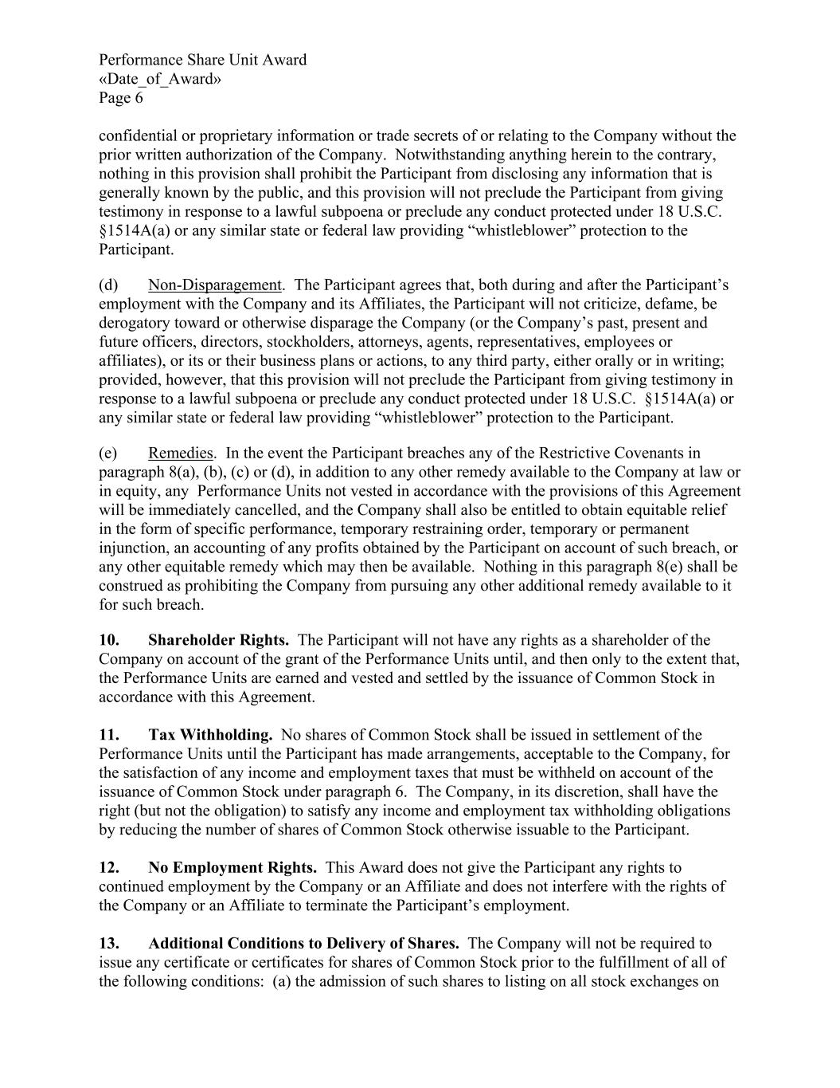
Performance Share Unit Award «Date_of_Award» Page 6 confidential or proprietary information or trade secrets of or relating to the Company without the prior written authorization of the Company. Notwithstanding anything herein to the contrary, nothing in this provision shall prohibit the Participant from disclosing any information that is generally known by the public, and this provision will not preclude the Participant from giving testimony in response to a lawful subpoena or preclude any conduct protected under 18 U.S.C. §1514A(a) or any similar state or federal law providing “whistleblower” protection to the Participant. (d) Non-Disparagement. The Participant agrees that, both during and after the Participant’s employment with the Company and its Affiliates, the Participant will not criticize, defame, be derogatory toward or otherwise disparage the Company (or the Company’s past, present and future officers, directors, stockholders, attorneys, agents, representatives, employees or affiliates), or its or their business plans or actions, to any third party, either orally or in writing; provided, however, that this provision will not preclude the Participant from giving testimony in response to a lawful subpoena or preclude any conduct protected under 18 U.S.C. §1514A(a) or any similar state or federal law providing “whistleblower” protection to the Participant. (e) Remedies. In the event the Participant breaches any of the Restrictive Covenants in paragraph 8(a), (b), (c) or (d), in addition to any other remedy available to the Company at law or in equity, any Performance Units not vested in accordance with the provisions of this Agreement will be immediately cancelled, and the Company shall also be entitled to obtain equitable relief in the form of specific performance, temporary restraining order, temporary or permanent injunction, an accounting of any profits obtained by the Participant on account of such breach, or any other equitable remedy which may then be available. Nothing in this paragraph 8(e) shall be construed as prohibiting the Company from pursuing any other additional remedy available to it for such breach. 10. Shareholder Rights. The Participant will not have any rights as a shareholder of the Company on account of the grant of the Performance Units until, and then only to the extent that, the Performance Units are earned and vested and settled by the issuance of Common Stock in accordance with this Agreement. 11. Tax Withholding. No shares of Common Stock shall be issued in settlement of the Performance Units until the Participant has made arrangements, acceptable to the Company, for the satisfaction of any income and employment taxes that must be withheld on account of the issuance of Common Stock under paragraph 6. The Company, in its discretion, shall have the right (but not the obligation) to satisfy any income and employment tax withholding obligations by reducing the number of shares of Common Stock otherwise issuable to the Participant. 12. No Employment Rights. This Award does not give the Participant any rights to continued employment by the Company or an Affiliate and does not interfere with the rights of the Company or an Affiliate to terminate the Participant’s employment. 13. Additional Conditions to Delivery of Shares. The Company will not be required to issue any certificate or certificates for shares of Common Stock prior to the fulfillment of all of the following conditions: (a) the admission of such shares to listing on all stock exchanges on

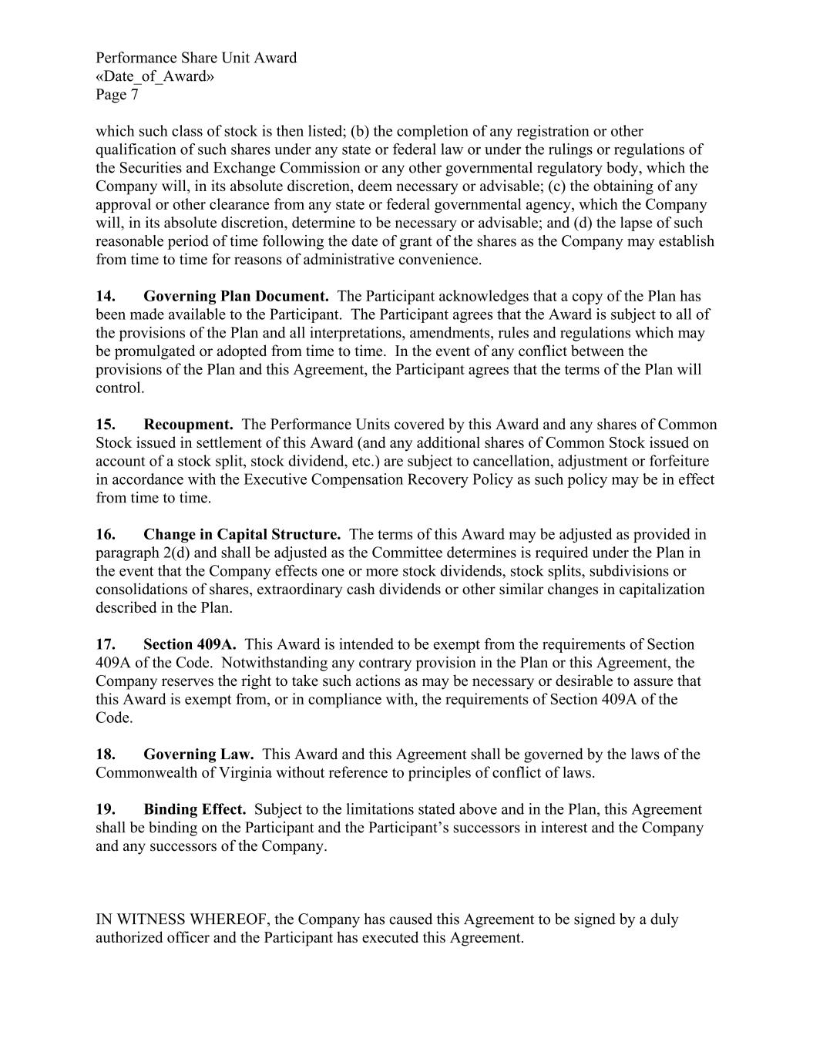
Performance Share Unit Award «Date_of_Award» Page 7 which such class of stock is then listed; (b) the completion of any registration or other qualification of such shares under any state or federal law or under the rulings or regulations of the Securities and Exchange Commission or any other governmental regulatory body, which the Company will, in its absolute discretion, deem necessary or advisable; (c) the obtaining of any approval or other clearance from any state or federal governmental agency, which the Company will, in its absolute discretion, determine to be necessary or advisable; and (d) the lapse of such reasonable period of time following the date of grant of the shares as the Company may establish from time to time for reasons of administrative convenience. 14. Governing Plan Document. The Participant acknowledges that a copy of the Plan has been made available to the Participant. The Participant agrees that the Award is subject to all of the provisions of the Plan and all interpretations, amendments, rules and regulations which may be promulgated or adopted from time to time. In the event of any conflict between the provisions of the Plan and this Agreement, the Participant agrees that the terms of the Plan will control. 15. Recoupment. The Performance Units covered by this Award and any shares of Common Stock issued in settlement of this Award (and any additional shares of Common Stock issued on account of a stock split, stock dividend, etc.) are subject to cancellation, adjustment or forfeiture in accordance with the Executive Compensation Recovery Policy as such policy may be in effect from time to time. 16. Change in Capital Structure. The terms of this Award may be adjusted as provided in paragraph 2(d) and shall be adjusted as the Committee determines is required under the Plan in the event that the Company effects one or more stock dividends, stock splits, subdivisions or consolidations of shares, extraordinary cash dividends or other similar changes in capitalization described in the Plan. 17. Section 409A. This Award is intended to be exempt from the requirements of Section 409A of the Code. Notwithstanding any contrary provision in the Plan or this Agreement, the Company reserves the right to take such actions as may be necessary or desirable to assure that this Award is exempt from, or in compliance with, the requirements of Section 409A of the Code. 18. Governing Law. This Award and this Agreement shall be governed by the laws of the Commonwealth of Virginia without reference to principles of conflict of laws. 19. Binding Effect. Subject to the limitations stated above and in the Plan, this Agreement shall be binding on the Participant and the Participant’s successors in interest and the Company and any successors of the Company. IN WITNESS WHEREOF, the Company has caused this Agreement to be signed by a duly authorized officer and the Participant has executed this Agreement.

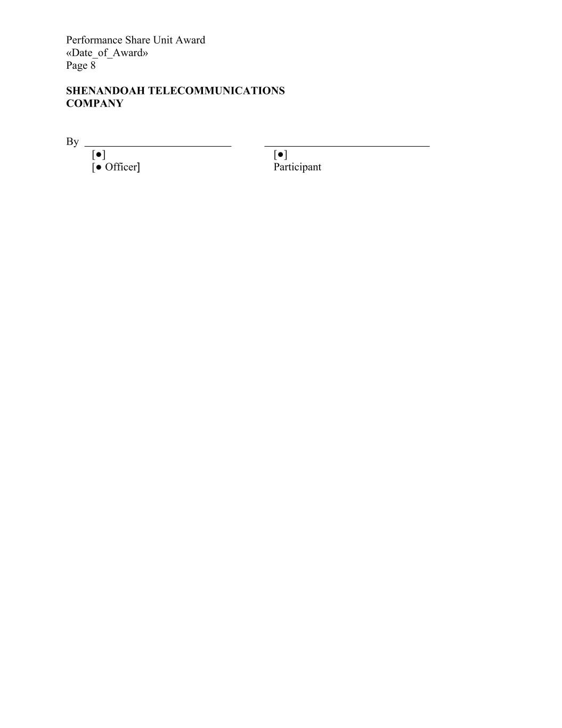
Performance Share Unit Award «Date_of_Award» Page 8 SHENANDOAH TELECOMMUNICATIONS COMPANY By [●] [●] [● Officer] Participant

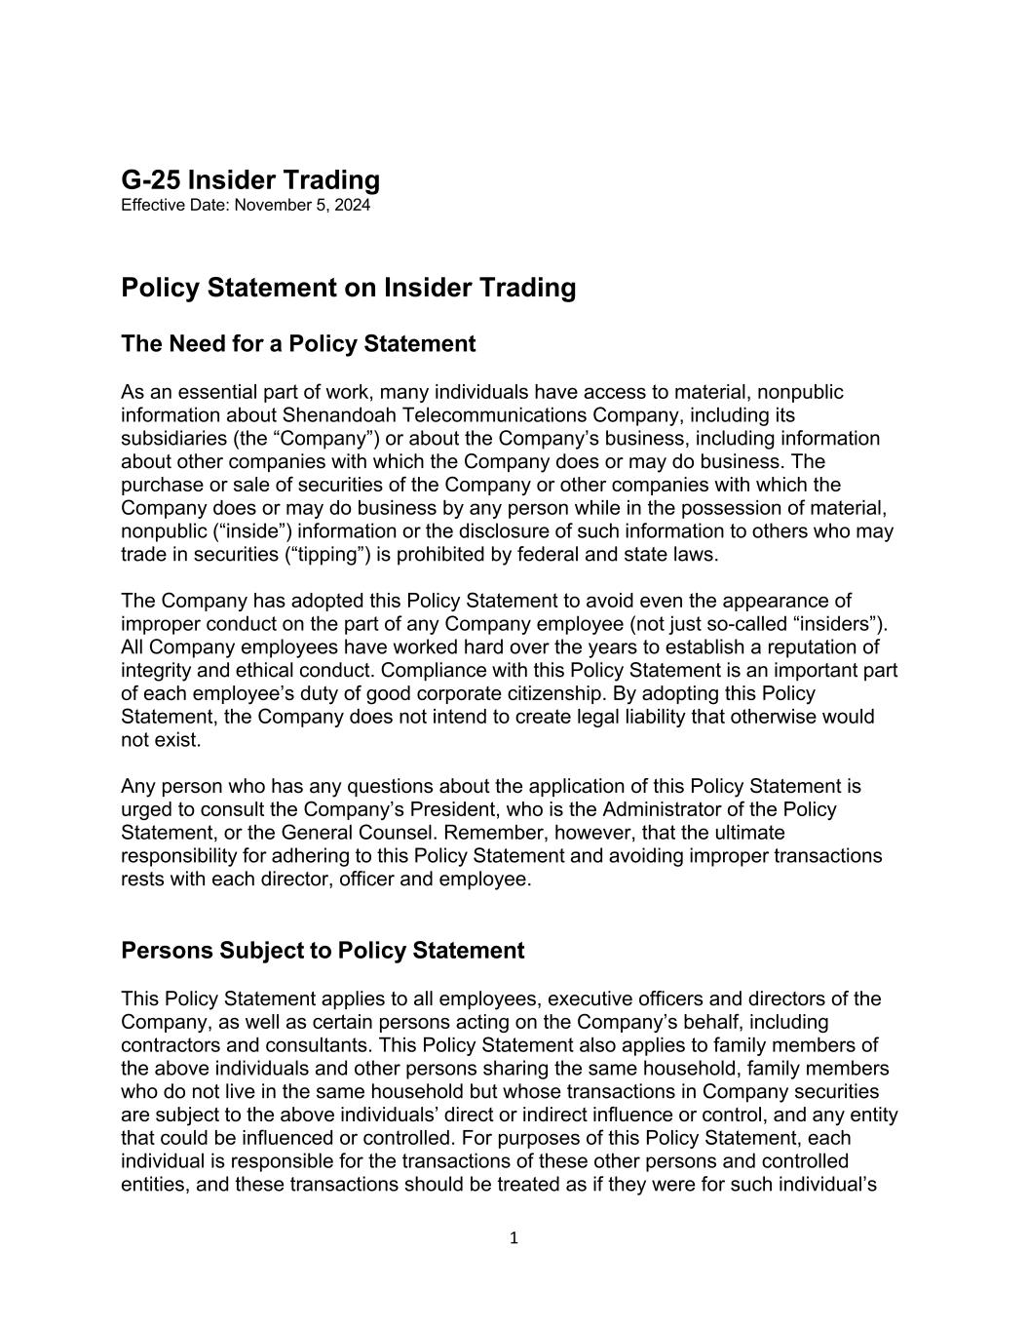
1 G-25 Insider Trading Effective Date: November 5, 2024 Policy Statement on Insider Trading The Need for a Policy Statement As an essential part of work, many individuals have access to material, nonpublic information about Shenandoah Telecommunications Company, including its subsidiaries (the “Company”) or about the Company’s business, including information about other companies with which the Company does or may do business. The purchase or sale of securities of the Company or other companies with which the Company does or may do business by any person while in the possession of material, nonpublic (“inside”) information or the disclosure of such information to others who may trade in securities (“tipping”) is prohibited by federal and state laws. The Company has adopted this Policy Statement to avoid even the appearance of improper conduct on the part of any Company employee (not just so-called “insiders”). All Company employees have worked hard over the years to establish a reputation of integrity and ethical conduct. Compliance with this Policy Statement is an important part of each employee’s duty of good corporate citizenship. By adopting this Policy Statement, the Company does not intend to create legal liability that otherwise would not exist. Any person who has any questions about the application of this Policy Statement is urged to consult the Company’s President, who is the Administrator of the Policy Statement, or the General Counsel. Remember, however, that the ultimate responsibility for adhering to this Policy Statement and avoiding improper transactions rests with each director, officer and employee. Persons Subject to Policy Statement This Policy Statement applies to all employees, executive officers and directors of the Company, as well as certain persons acting on the Company’s behalf, including contractors and consultants. This Policy Statement also applies to family members of the above individuals and other persons sharing the same household, family members who do not live in the same household but whose transactions in Company securities are subject to the above individuals’ direct or indirect influence or control, and any entity that could be influenced or controlled. For purposes of this Policy Statement, each individual is responsible for the transactions of these other persons and controlled entities, and these transactions should be treated as if they were for such individual’s

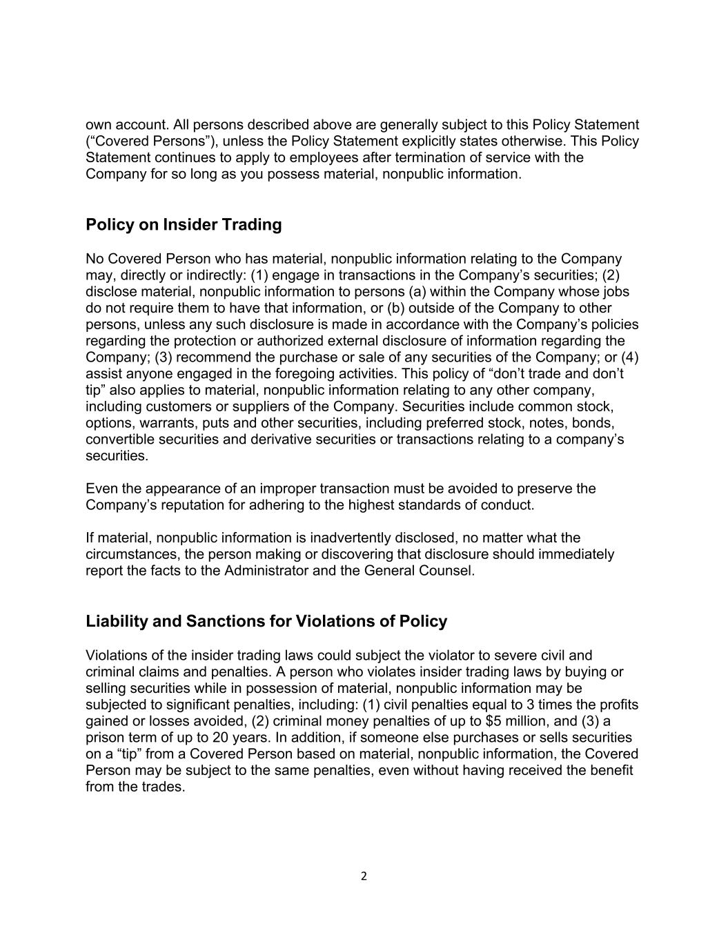
2 own account. All persons described above are generally subject to this Policy Statement (“Covered Persons”), unless the Policy Statement explicitly states otherwise. This Policy Statement continues to apply to employees after termination of service with the Company for so long as you possess material, nonpublic information. Policy on Insider Trading No Covered Person who has material, nonpublic information relating to the Company may, directly or indirectly: (1) engage in transactions in the Company’s securities; (2) disclose material, nonpublic information to persons (a) within the Company whose jobs do not require them to have that information, or (b) outside of the Company to other persons, unless any such disclosure is made in accordance with the Company’s policies regarding the protection or authorized external disclosure of information regarding the Company; (3) recommend the purchase or sale of any securities of the Company; or (4) assist anyone engaged in the foregoing activities. This policy of “don’t trade and don’t tip” also applies to material, nonpublic information relating to any other company, including customers or suppliers of the Company. Securities include common stock, options, warrants, puts and other securities, including preferred stock, notes, bonds, convertible securities and derivative securities or transactions relating to a company’s securities. Even the appearance of an improper transaction must be avoided to preserve the Company’s reputation for adhering to the highest standards of conduct. If material, nonpublic information is inadvertently disclosed, no matter what the circumstances, the person making or discovering that disclosure should immediately report the facts to the Administrator and the General Counsel. Liability and Sanctions for Violations of Policy Violations of the insider trading laws could subject the violator to severe civil and criminal claims and penalties. A person who violates insider trading laws by buying or selling securities while in possession of material, nonpublic information may be subjected to significant penalties, including: (1) civil penalties equal to 3 times the profits gained or losses avoided, (2) criminal money penalties of up to $5 million, and (3) a prison term of up to 20 years. In addition, if someone else purchases or sells securities on a “tip” from a Covered Person based on material, nonpublic information, the Covered Person may be subject to the same penalties, even without having received the benefit from the trades.

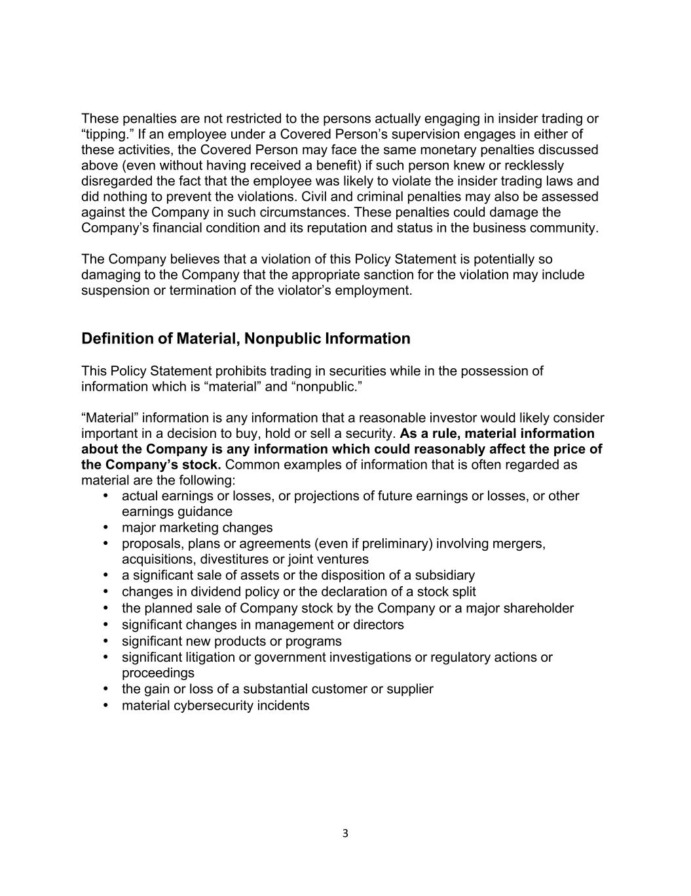
3 These penalties are not restricted to the persons actually engaging in insider trading or “tipping.” If an employee under a Covered Person’s supervision engages in either of these activities, the Covered Person may face the same monetary penalties discussed above (even without having received a benefit) if such person knew or recklessly disregarded the fact that the employee was likely to violate the insider trading laws and did nothing to prevent the violations. Civil and criminal penalties may also be assessed against the Company in such circumstances. These penalties could damage the Company’s financial condition and its reputation and status in the business community. The Company believes that a violation of this Policy Statement is potentially so damaging to the Company that the appropriate sanction for the violation may include suspension or termination of the violator’s employment. Definition of Material, Nonpublic Information This Policy Statement prohibits trading in securities while in the possession of information which is “material” and “nonpublic.” “Material” information is any information that a reasonable investor would likely consider important in a decision to buy, hold or sell a security. As a rule, material information about the Company is any information which could reasonably affect the price of the Company’s stock. Common examples of information that is often regarded as material are the following: • actual earnings or losses, or projections of future earnings or losses, or other earnings guidance • major marketing changes • proposals, plans or agreements (even if preliminary) involving mergers, acquisitions, divestitures or joint ventures • a significant sale of assets or the disposition of a subsidiary • changes in dividend policy or the declaration of a stock split • the planned sale of Company stock by the Company or a major shareholder • significant changes in management or directors • significant new products or programs • significant litigation or government investigations or regulatory actions or proceedings • the gain or loss of a substantial customer or supplier • material cybersecurity incidents

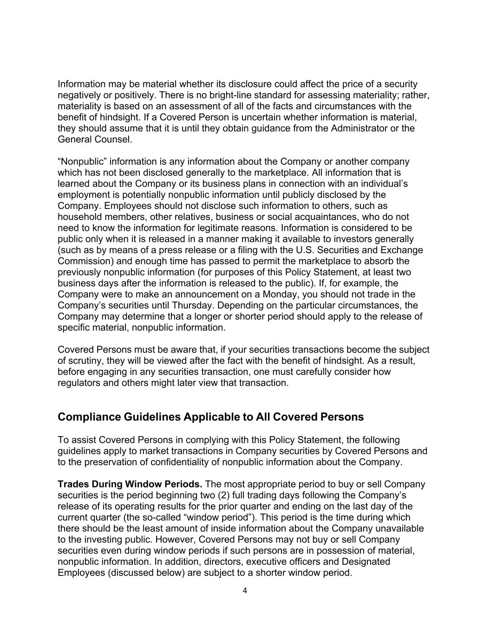
4 Information may be material whether its disclosure could affect the price of a security negatively or positively. There is no bright-line standard for assessing materiality; rather, materiality is based on an assessment of all of the facts and circumstances with the benefit of hindsight. If a Covered Person is uncertain whether information is material, they should assume that it is until they obtain guidance from the Administrator or the General Counsel. “Nonpublic” information is any information about the Company or another company which has not been disclosed generally to the marketplace. All information that is learned about the Company or its business plans in connection with an individual’s employment is potentially nonpublic information until publicly disclosed by the Company. Employees should not disclose such information to others, such as household members, other relatives, business or social acquaintances, who do not need to know the information for legitimate reasons. Information is considered to be public only when it is released in a manner making it available to investors generally (such as by means of a press release or a filing with the U.S. Securities and Exchange Commission) and enough time has passed to permit the marketplace to absorb the previously nonpublic information (for purposes of this Policy Statement, at least two business days after the information is released to the public). If, for example, the Company were to make an announcement on a Monday, you should not trade in the Company’s securities until Thursday. Depending on the particular circumstances, the Company may determine that a longer or shorter period should apply to the release of specific material, nonpublic information. Covered Persons must be aware that, if your securities transactions become the subject of scrutiny, they will be viewed after the fact with the benefit of hindsight. As a result, before engaging in any securities transaction, one must carefully consider how regulators and others might later view that transaction. Compliance Guidelines Applicable to All Covered Persons To assist Covered Persons in complying with this Policy Statement, the following guidelines apply to market transactions in Company securities by Covered Persons and to the preservation of confidentiality of nonpublic information about the Company. Trades During Window Periods. The most appropriate period to buy or sell Company securities is the period beginning two (2) full trading days following the Company’s release of its operating results for the prior quarter and ending on the last day of the current quarter (the so-called “window period”). This period is the time during which there should be the least amount of inside information about the Company unavailable to the investing public. However, Covered Persons may not buy or sell Company securities even during window periods if such persons are in possession of material, nonpublic information. In addition, directors, executive officers and Designated Employees (discussed below) are subject to a shorter window period.

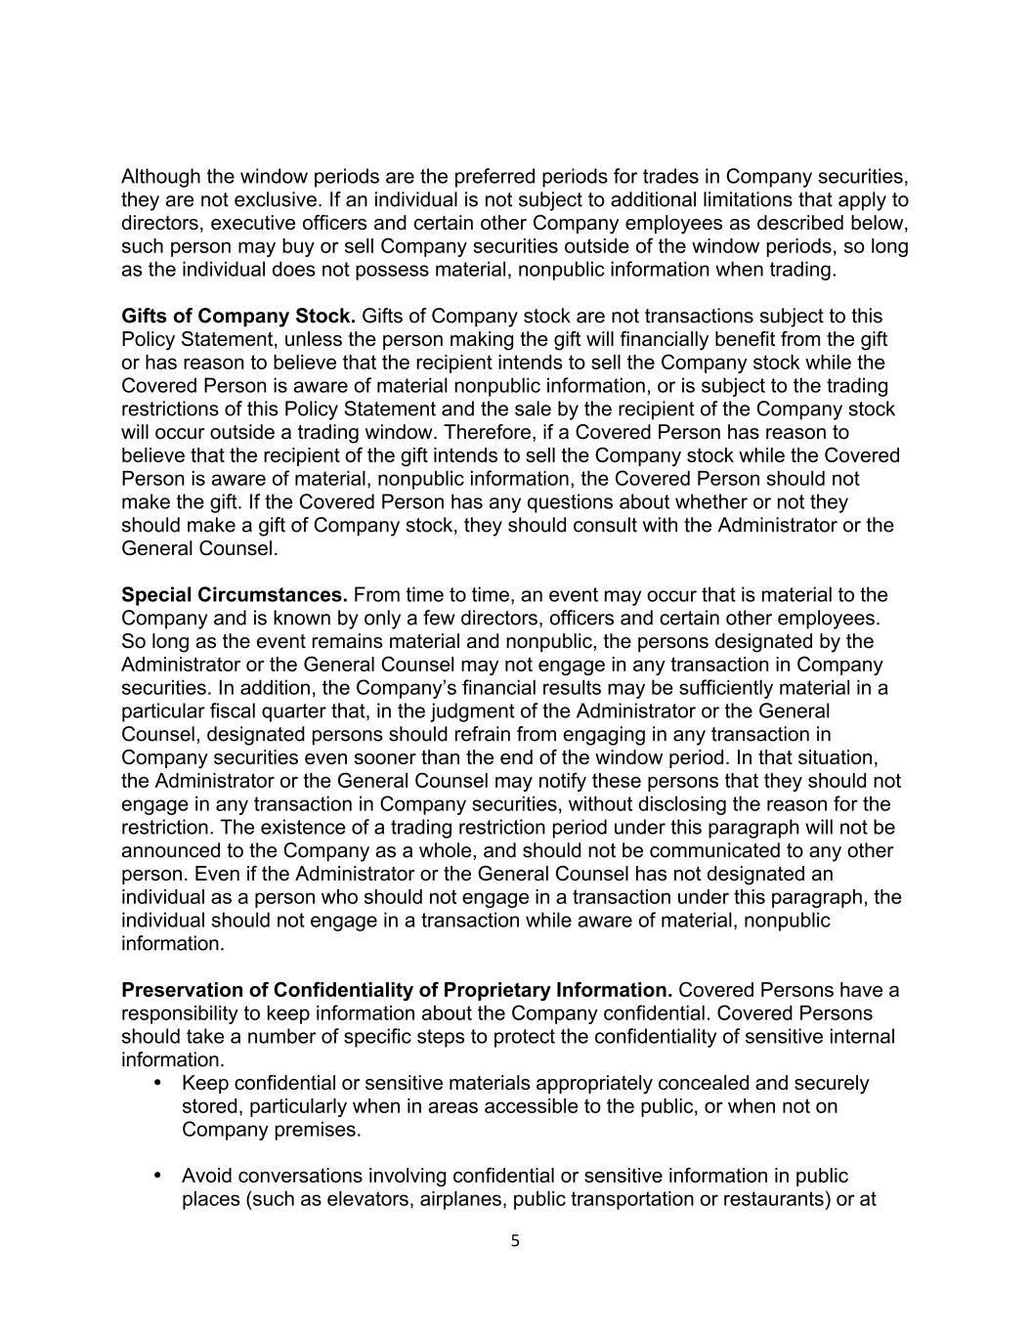
5 Although the window periods are the preferred periods for trades in Company securities, they are not exclusive. If an individual is not subject to additional limitations that apply to directors, executive officers and certain other Company employees as described below, such person may buy or sell Company securities outside of the window periods, so long as the individual does not possess material, nonpublic information when trading. Gifts of Company Stock. Gifts of Company stock are not transactions subject to this Policy Statement, unless the person making the gift will financially benefit from the gift or has reason to believe that the recipient intends to sell the Company stock while the Covered Person is aware of material nonpublic information, or is subject to the trading restrictions of this Policy Statement and the sale by the recipient of the Company stock will occur outside a trading window. Therefore, if a Covered Person has reason to believe that the recipient of the gift intends to sell the Company stock while the Covered Person is aware of material, nonpublic information, the Covered Person should not make the gift. If the Covered Person has any questions about whether or not they should make a gift of Company stock, they should consult with the Administrator or the General Counsel. Special Circumstances. From time to time, an event may occur that is material to the Company and is known by only a few directors, officers and certain other employees. So long as the event remains material and nonpublic, the persons designated by the Administrator or the General Counsel may not engage in any transaction in Company securities. In addition, the Company’s financial results may be sufficiently material in a particular fiscal quarter that, in the judgment of the Administrator or the General Counsel, designated persons should refrain from engaging in any transaction in Company securities even sooner than the end of the window period. In that situation, the Administrator or the General Counsel may notify these persons that they should not engage in any transaction in Company securities, without disclosing the reason for the restriction. The existence of a trading restriction period under this paragraph will not be announced to the Company as a whole, and should not be communicated to any other person. Even if the Administrator or the General Counsel has not designated an individual as a person who should not engage in a transaction under this paragraph, the individual should not engage in a transaction while aware of material, nonpublic information. Preservation of Confidentiality of Proprietary Information. Covered Persons have a responsibility to keep information about the Company confidential. Covered Persons should take a number of specific steps to protect the confidentiality of sensitive internal information. • Keep confidential or sensitive materials appropriately concealed and securely stored, particularly when in areas accessible to the public, or when not on Company premises. • Avoid conversations involving confidential or sensitive information in public places (such as elevators, airplanes, public transportation or restaurants) or at

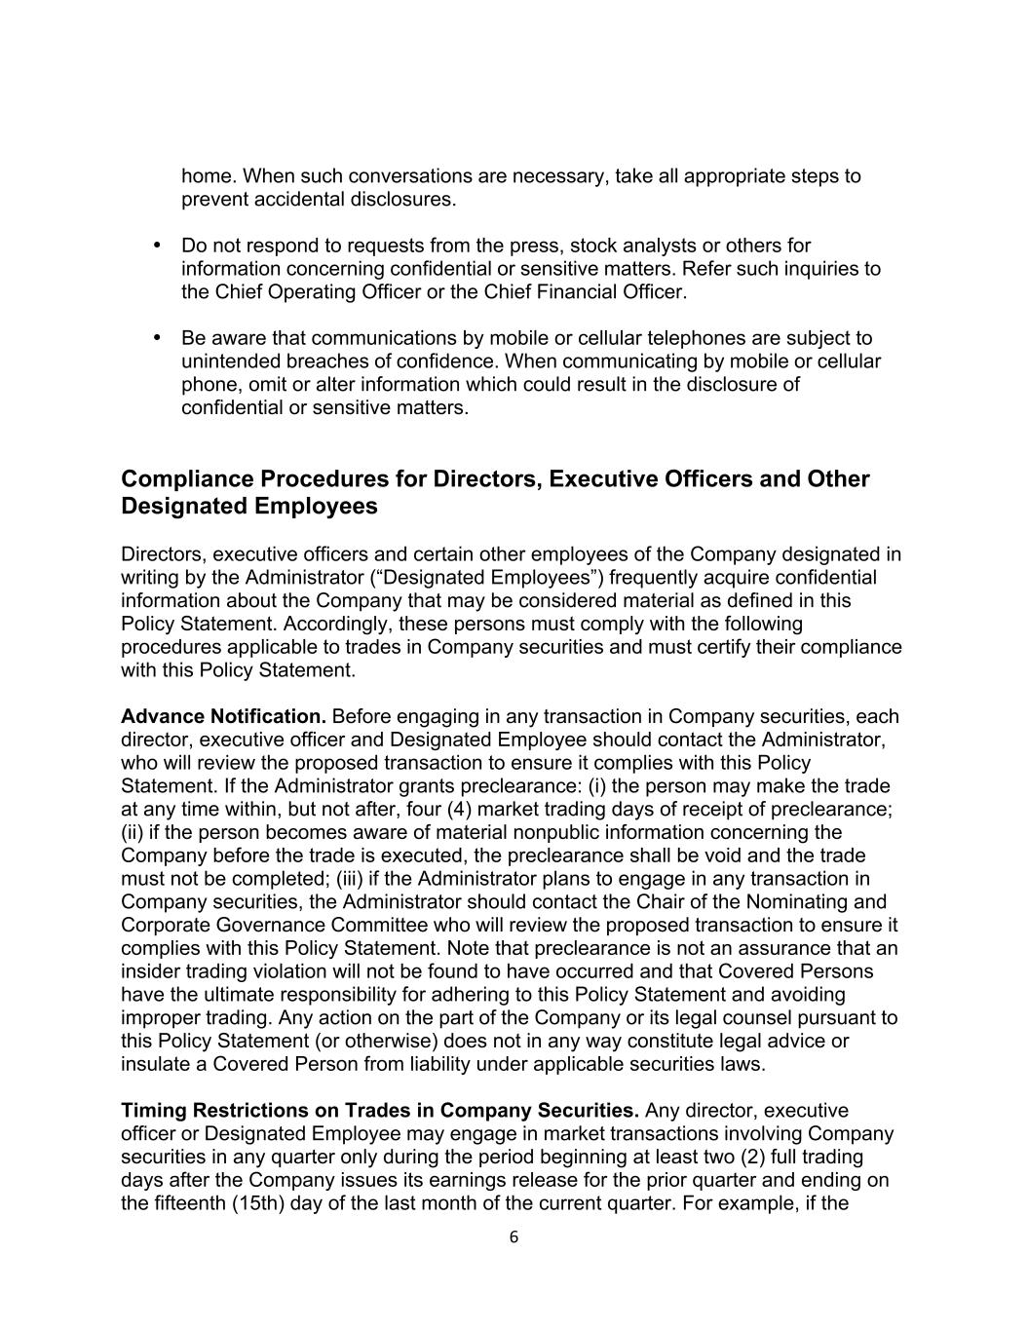
6 home. When such conversations are necessary, take all appropriate steps to prevent accidental disclosures. • Do not respond to requests from the press, stock analysts or others for information concerning confidential or sensitive matters. Refer such inquiries to the Chief Operating Officer or the Chief Financial Officer. • Be aware that communications by mobile or cellular telephones are subject to unintended breaches of confidence. When communicating by mobile or cellular phone, omit or alter information which could result in the disclosure of confidential or sensitive matters. Compliance Procedures for Directors, Executive Officers and Other Designated Employees Directors, executive officers and certain other employees of the Company designated in writing by the Administrator (“Designated Employees”) frequently acquire confidential information about the Company that may be considered material as defined in this Policy Statement. Accordingly, these persons must comply with the following procedures applicable to trades in Company securities and must certify their compliance with this Policy Statement. Advance Notification. Before engaging in any transaction in Company securities, each director, executive officer and Designated Employee should contact the Administrator, who will review the proposed transaction to ensure it complies with this Policy Statement. If the Administrator grants preclearance: (i) the person may make the trade at any time within, but not after, four (4) market trading days of receipt of preclearance; (ii) if the person becomes aware of material nonpublic information concerning the Company before the trade is executed, the preclearance shall be void and the trade must not be completed; (iii) if the Administrator plans to engage in any transaction in Company securities, the Administrator should contact the Chair of the Nominating and Corporate Governance Committee who will review the proposed transaction to ensure it complies with this Policy Statement. Note that preclearance is not an assurance that an insider trading violation will not be found to have occurred and that Covered Persons have the ultimate responsibility for adhering to this Policy Statement and avoiding improper trading. Any action on the part of the Company or its legal counsel pursuant to this Policy Statement (or otherwise) does not in any way constitute legal advice or insulate a Covered Person from liability under applicable securities laws. Timing Restrictions on Trades in Company Securities. Any director, executive officer or Designated Employee may engage in market transactions involving Company securities in any quarter only during the period beginning at least two (2) full trading days after the Company issues its earnings release for the prior quarter and ending on the fifteenth (15th) day of the last month of the current quarter. For example, if the

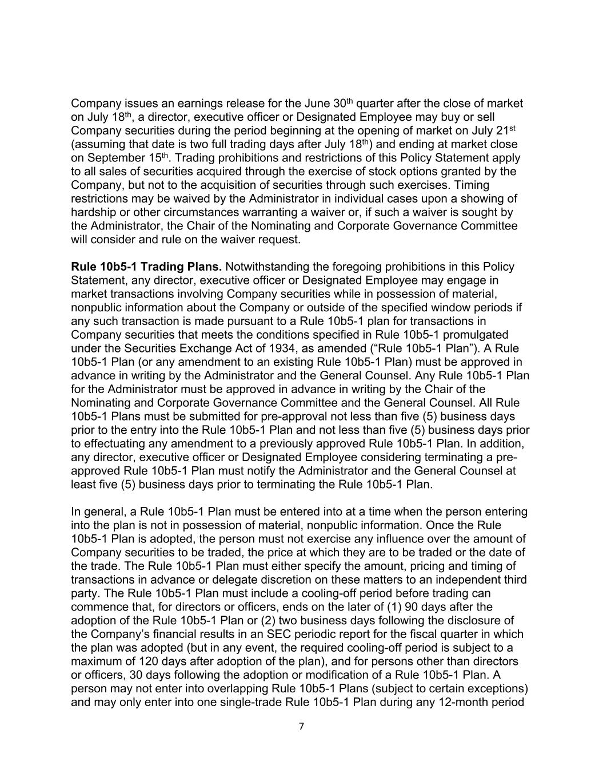
7 Company issues an earnings release for the June 30th quarter after the close of market on July 18th, a director, executive officer or Designated Employee may buy or sell Company securities during the period beginning at the opening of market on July 21st (assuming that date is two full trading days after July 18th) and ending at market close on September 15th. Trading prohibitions and restrictions of this Policy Statement apply to all sales of securities acquired through the exercise of stock options granted by the Company, but not to the acquisition of securities through such exercises. Timing restrictions may be waived by the Administrator in individual cases upon a showing of hardship or other circumstances warranting a waiver or, if such a waiver is sought by the Administrator, the Chair of the Nominating and Corporate Governance Committee will consider and rule on the waiver request. Rule 10b5-1 Trading Plans. Notwithstanding the foregoing prohibitions in this Policy Statement, any director, executive officer or Designated Employee may engage in market transactions involving Company securities while in possession of material, nonpublic information about the Company or outside of the specified window periods if any such transaction is made pursuant to a Rule 10b5-1 plan for transactions in Company securities that meets the conditions specified in Rule 10b5-1 promulgated under the Securities Exchange Act of 1934, as amended (“Rule 10b5-1 Plan”). A Rule 10b5-1 Plan (or any amendment to an existing Rule 10b5-1 Plan) must be approved in advance in writing by the Administrator and the General Counsel. Any Rule 10b5-1 Plan for the Administrator must be approved in advance in writing by the Chair of the Nominating and Corporate Governance Committee and the General Counsel. All Rule 10b5-1 Plans must be submitted for pre-approval not less than five (5) business days prior to the entry into the Rule 10b5-1 Plan and not less than five (5) business days prior to effectuating any amendment to a previously approved Rule 10b5-1 Plan. In addition, any director, executive officer or Designated Employee considering terminating a pre- approved Rule 10b5-1 Plan must notify the Administrator and the General Counsel at least five (5) business days prior to terminating the Rule 10b5-1 Plan. In general, a Rule 10b5-1 Plan must be entered into at a time when the person entering into the plan is not in possession of material, nonpublic information. Once the Rule 10b5-1 Plan is adopted, the person must not exercise any influence over the amount of Company securities to be traded, the price at which they are to be traded or the date of the trade. The Rule 10b5-1 Plan must either specify the amount, pricing and timing of transactions in advance or delegate discretion on these matters to an independent third party. The Rule 10b5-1 Plan must include a cooling-off period before trading can commence that, for directors or officers, ends on the later of (1) 90 days after the adoption of the Rule 10b5-1 Plan or (2) two business days following the disclosure of the Company’s financial results in an SEC periodic report for the fiscal quarter in which the plan was adopted (but in any event, the required cooling-off period is subject to a maximum of 120 days after adoption of the plan), and for persons other than directors or officers, 30 days following the adoption or modification of a Rule 10b5-1 Plan. A person may not enter into overlapping Rule 10b5-1 Plans (subject to certain exceptions) and may only enter into one single-trade Rule 10b5-1 Plan during any 12-month period

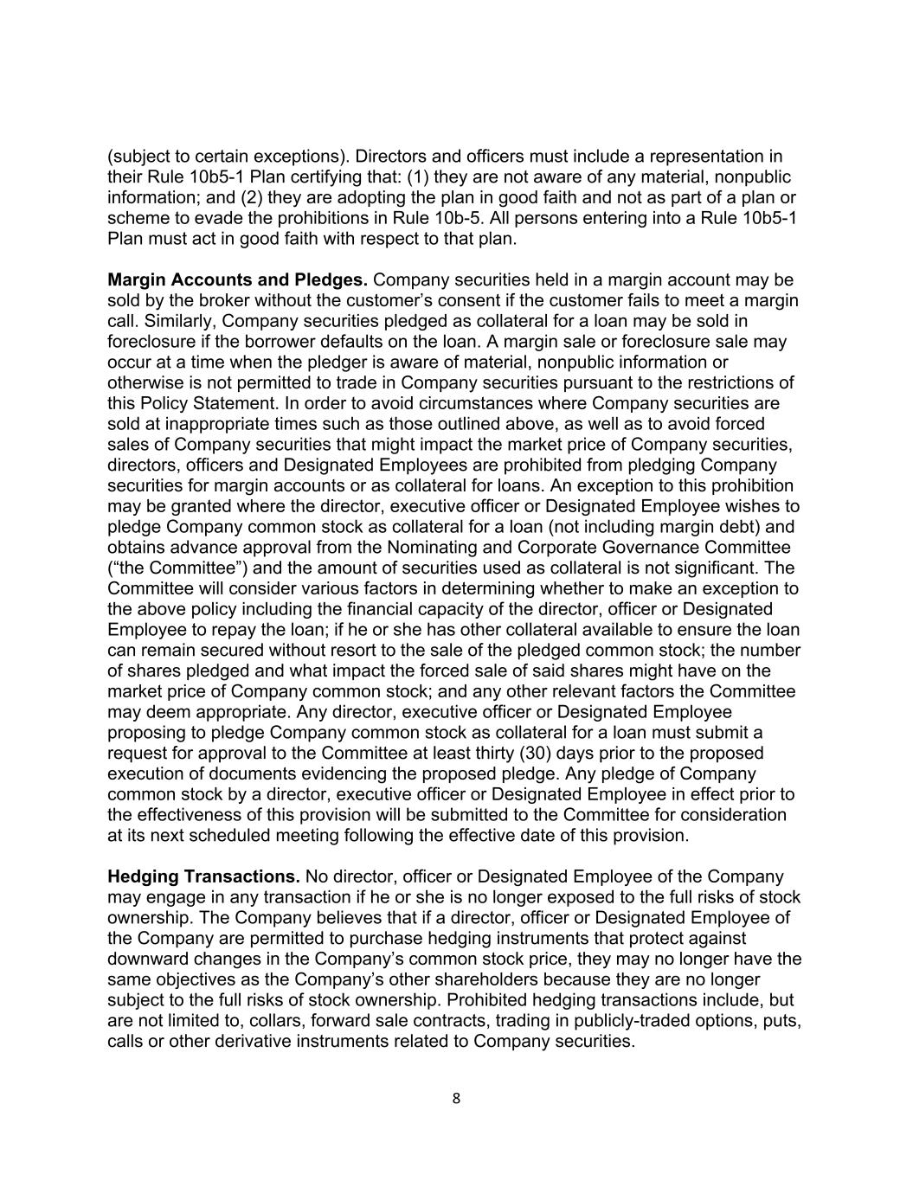
8 (subject to certain exceptions). Directors and officers must include a representation in their Rule 10b5-1 Plan certifying that: (1) they are not aware of any material, nonpublic information; and (2) they are adopting the plan in good faith and not as part of a plan or scheme to evade the prohibitions in Rule 10b-5. All persons entering into a Rule 10b5-1 Plan must act in good faith with respect to that plan. Margin Accounts and Pledges. Company securities held in a margin account may be sold by the broker without the customer’s consent if the customer fails to meet a margin call. Similarly, Company securities pledged as collateral for a loan may be sold in foreclosure if the borrower defaults on the loan. A margin sale or foreclosure sale may occur at a time when the pledger is aware of material, nonpublic information or otherwise is not permitted to trade in Company securities pursuant to the restrictions of this Policy Statement. In order to avoid circumstances where Company securities are sold at inappropriate times such as those outlined above, as well as to avoid forced sales of Company securities that might impact the market price of Company securities, directors, officers and Designated Employees are prohibited from pledging Company securities for margin accounts or as collateral for loans. An exception to this prohibition may be granted where the director, executive officer or Designated Employee wishes to pledge Company common stock as collateral for a loan (not including margin debt) and obtains advance approval from the Nominating and Corporate Governance Committee (“the Committee”) and the amount of securities used as collateral is not significant. The Committee will consider various factors in determining whether to make an exception to the above policy including the financial capacity of the director, officer or Designated Employee to repay the loan; if he or she has other collateral available to ensure the loan can remain secured without resort to the sale of the pledged common stock; the number of shares pledged and what impact the forced sale of said shares might have on the market price of Company common stock; and any other relevant factors the Committee may deem appropriate. Any director, executive officer or Designated Employee proposing to pledge Company common stock as collateral for a loan must submit a request for approval to the Committee at least thirty (30) days prior to the proposed execution of documents evidencing the proposed pledge. Any pledge of Company common stock by a director, executive officer or Designated Employee in effect prior to the effectiveness of this provision will be submitted to the Committee for consideration at its next scheduled meeting following the effective date of this provision. Hedging Transactions. No director, officer or Designated Employee of the Company may engage in any transaction if he or she is no longer exposed to the full risks of stock ownership. The Company believes that if a director, officer or Designated Employee of the Company are permitted to purchase hedging instruments that protect against downward changes in the Company’s common stock price, they may no longer have the same objectives as the Company’s other shareholders because they are no longer subject to the full risks of stock ownership. Prohibited hedging transactions include, but are not limited to, collars, forward sale contracts, trading in publicly-traded options, puts, calls or other derivative instruments related to Company securities.

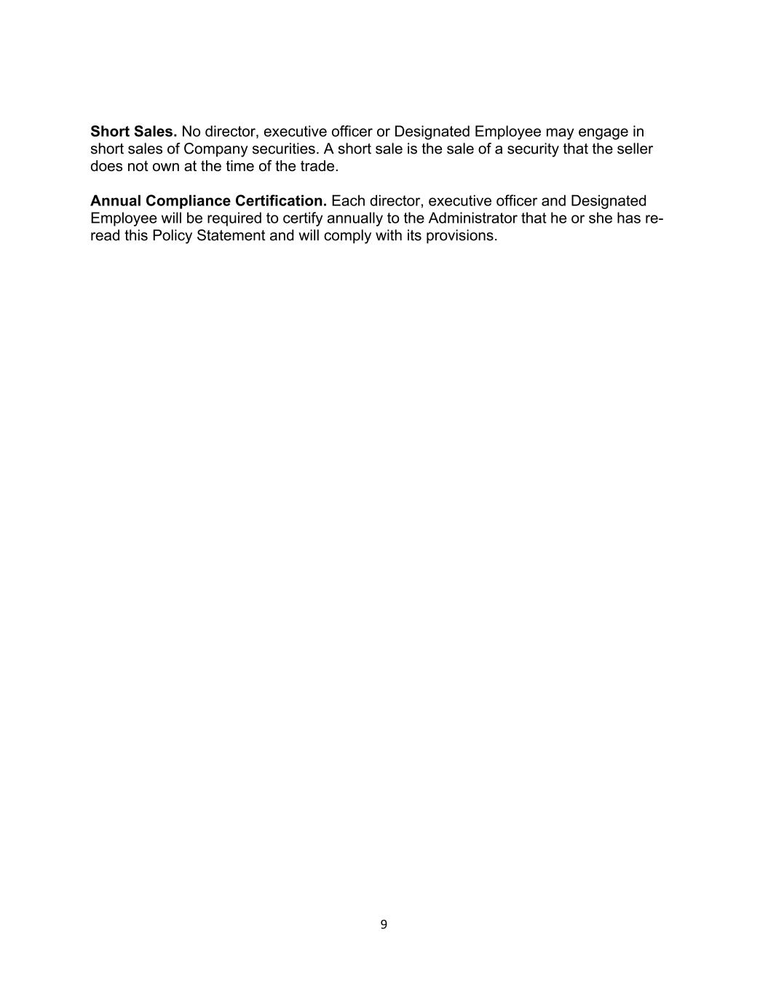
9 Short Sales. No director, executive officer or Designated Employee may engage in short sales of Company securities. A short sale is the sale of a security that the seller does not own at the time of the trade. Annual Compliance Certification. Each director, executive officer and Designated Employee will be required to certify annually to the Administrator that he or she has re- read this Policy Statement and will comply with its provisions.

EXHIBIT 21 LIST OF SUBSIDIARIES
SHENANDOAH TELECOMMUNICATIONS COMPANY AND SUBSIDIARIES
The following are all significant subsidiaries of Shenandoah Telecommunications Company, and are organized in the Commonwealth of Virginia.
Shenandoah Cable Television LLC
Shentel Management Company
Shenandoah Mobile LLC
Shenandoah Personal Communications LLC
Shenandoah Telephone Company
Shentel Broadband Operations LLC
Shentel Broadband Holding LLC
Shentel Issuer LLC
Shentel Asset Entity I LLC
Shentel Asset Entity II LLC
Horizon Acquisition Parent LLC
Horizon Telcom Inc.
The Chillicothe Telephone Company
Horizon Services, Inc.
Horizon Technology, Inc.
Urban Systems LLC
Infinity Fiber LLC

Exhibit 23.1

Consent of Independent Registered Public Accounting Firm

We consent to the incorporation by reference in the Registration Statements on Form S-3D (No. 333-74297) and Form S-8 (Nos. 333-279106 and 333-196990) of Shenandoah Telecommunications Company of our reports dated February 26, 2026, relating to the consolidated financial statements and the effectiveness of internal control over financial reporting of Shenandoah Telecommunications Company, appearing in this Annual Report on Form 10-K of Shenandoah Telecommunications Company for the year ended December 31, 2025.

/s/ RSM US LLP
Boston, Massachusetts
February 26, 2026

EXHIBIT 31.1

CERTIFICATION

I, Edward H. McKay, certify that:

1.I have reviewed this annual report on Form 10-K of Shenandoah Telecommunications Company, Inc.;
2.Based on my knowledge, this report does not contain any untrue statement of a material fact or omit to state a material fact necessary to make the statements made, in light of the circumstances under which such statements were made, not misleading with respect to the period covered by this report;
3.Based on my knowledge, the financial statements, and other financial information included in this report, fairly present in all material respects the financial condition, results of operations and cash flows of the registrant as of, and for, the periods presented in this report;
4.The registrant’s other certifying officer(s) and I are responsible for establishing and maintaining disclosure controls and procedures (as defined in Exchange Act Rules 13a-15(e) and 15d-15(e)) and internal control over financial reporting (as defined in Exchange Act Rules 13a-15(f) and 15d-15(f)) for the registrant and have:
a.Designed such disclosure controls and procedures, or caused such disclosure controls and procedures to be designed under our supervision, to ensure that material information relating to the registrant, including its consolidated subsidiaries, is made known to us by others within those entities, particularly during the period in which this report is being prepared;
b.Designed such internal control over financial reporting, or caused such internal control over financial reporting to be designed under our supervision, to provide reasonable assurance regarding the reliability of financial reporting and the preparation of financial statements for external purposes in accordance with generally accepted accounting principles;
c.Evaluated the effectiveness of the registrant’s disclosure controls and procedures and presented in this report our conclusions about the effectiveness of the disclosure controls and procedures, as of the end of the period covered by this report based on such evaluation; and
d.Disclosed in this report any change in the registrant’s internal control over financial reporting that occurred during the registrant’s most recent fiscal quarter (the registrant’s fourth fiscal quarter in the case of an annual report) that has materially affected, or is reasonably likely to materially affect, the registrant’s internal control over financial reporting; and
5.The registrant’s other certifying officer(s) and I have disclosed, based on our most recent evaluation of internal control over financial reporting, to the registrant’s auditors and the audit committee of the registrant’s board of directors (or persons performing the equivalent functions):
a.All significant deficiencies and material weaknesses in the design or operation of internal control over financial reporting which are reasonably likely to adversely affect the registrant’s ability to record, process, summarize and report financial information; and
b.Any fraud, whether or not material, that involves management or other employees who have a significant role in the registrant’s internal control over financial reporting.

/S/ EDWARD H. MCKAY
Edward H. McKay, President and Chief Executive Officer
(Principal Executive Officer)
Date: February 26, 2026

EXHIBIT 31.2

CERTIFICATION

I, James J. Volk, certify that:
1.I have reviewed this annual report on Form 10-K of Shenandoah Telecommunications Company, Inc.;
2.Based on my knowledge, this report does not contain any untrue statement of a material fact or omit to state a material fact necessary to make the statements made, in light of the circumstances under which such statements were made, not misleading with respect to the period covered by this report;
3.Based on my knowledge, the financial statements, and other financial information included in this report, fairly present in all material respects the financial condition, results of operations and cash flows of the registrant as of, and for, the periods presented in this report;
4.The registrant’s other certifying officer(s) and I are responsible for establishing and maintaining disclosure controls and procedures (as defined in Exchange Act Rules 13a-15(e) and 15d-15(e)) and internal control over financial reporting (as defined in Exchange Act Rules 13a-15(f) and 15d-15(f)) for the registrant and have:
a.Designed such disclosure controls and procedures, or caused such disclosure controls and procedures to be designed under our supervision, to ensure that material information relating to the registrant, including its consolidated subsidiaries, is made known to us by others within those entities, particularly during the period in which this report is being prepared;
b.Designed such internal control over financial reporting, or caused such internal control over financial reporting to be designed under our supervision, to provide reasonable assurance regarding the reliability of financial reporting and the preparation of financial statements for external purposes in accordance with generally accepted accounting principles;
c.Evaluated the effectiveness of the registrant’s disclosure controls and procedures and presented in this report our conclusions about the effectiveness of the disclosure controls and procedures, as of the end of the period covered by this report based on such evaluation; and
d.Disclosed in this report any change in the registrant’s internal control over financial reporting that occurred during the registrant’s most recent fiscal quarter (the registrant’s fourth fiscal quarter in the case of an annual report) that has materially affected, or is reasonably likely to materially affect, the registrant’s internal control over financial reporting; and
5.The registrant’s other certifying officer(s) and I have disclosed, based on our most recent evaluation of internal control over financial reporting, to the registrant’s auditors and the audit committee of the registrant’s board of directors (or persons performing the equivalent functions):
a.All significant deficiencies and material weaknesses in the design or operation of internal control over financial reporting which are reasonably likely to adversely affect the registrant’s ability to record, process, summarize and report financial information; and
b.Any fraud, whether or not material, that involves management or other employees who have a significant role in the registrant’s internal control over financial reporting.

/s/JAMES J. VOLK
James J. Volk, Senior Vice President – Chief Financial Officer
(Principal Financial Officer)
Date: February 26, 2026

EXHIBIT 31.3

CERTIFICATION

I, Tracy L. Willis, certify that:
1.I have reviewed this annual report on Form 10-K of Shenandoah Telecommunications Company, Inc.;
2.Based on my knowledge, this report does not contain any untrue statement of a material fact or omit to state a material fact necessary to make the statements made, in light of the circumstances under which such statements were made, not misleading with respect to the period covered by this report;
3.Based on my knowledge, the financial statements, and other financial information included in this report, fairly present in all material respects the financial condition, results of operations and cash flows of the registrant as of, and for, the periods presented in this report;
4.The registrant’s other certifying officer(s) and I are responsible for establishing and maintaining disclosure controls and procedures (as defined in Exchange Act Rules 13a-15(e) and 15d-15(e)) and internal control over financial reporting (as defined in Exchange Act Rules 13a-15(f) and 15d-15(f)) for the registrant and have:
a.Designed such disclosure controls and procedures, or caused such disclosure controls and procedures to be designed under our supervision, to ensure that material information relating to the registrant, including its consolidated subsidiaries, is made known to us by others within those entities, particularly during the period in which this report is being prepared;
b.Designed such internal control over financial reporting, or caused such internal control over financial reporting to be designed under our supervision, to provide reasonable assurance regarding the reliability of financial reporting and the preparation of financial statements for external purposes in accordance with generally accepted accounting principles;
c.Evaluated the effectiveness of the registrant’s disclosure controls and procedures and presented in this report our conclusions about the effectiveness of the disclosure controls and procedures, as of the end of the period covered by this report based on such evaluation; and
d.Disclosed in this report any change in the registrant’s internal control over financial reporting that occurred during the registrant’s most recent fiscal quarter (the registrant’s fourth fiscal quarter in the case of an annual report) that has materially affected, or is reasonably likely to materially affect, the registrant’s internal control over financial reporting; and
5.The registrant’s other certifying officer(s) and I have disclosed, based on our most recent evaluation of internal control over financial reporting, to the registrant’s auditors and the audit committee of the registrant’s board of directors (or persons performing the equivalent functions):
a.All significant deficiencies and material weaknesses in the design or operation of internal control over financial reporting which are reasonably likely to adversely affect the registrant’s ability to record, process, summarize and report financial information; and
b.Any fraud, whether or not material, that involves management or other employees who have a significant role in the registrant’s internal control over financial reporting.

/s/TRACY L. WILLIS
Tracy L. Willis, Vice President - Chief Accounting Officer
(Principal Accounting Officer)
Date: February 26, 2026

EXHIBIT 32

Written Statement of Chief Executive Officer and Chief Financial Officer
Pursuant to Section 906 of the Sarbanes-Oxley Act of 2002

Each of the undersigned, the President and Chief Executive Officer and the Senior Vice President - Chief Financial Officer, of Shenandoah Telecommunications Company (the “Company”), hereby certifies that, on the date hereof:

(1) The annual report on Form 10-K of the Company for the year ended December 31, 2025 filed on the date hereof with the Securities and Exchange Commission (the “Report”) fully complies with the requirements of Section 13(a) or 15(d) of the Securities Exchange Act of 1934; and

(2) Information contained in the Report fairly presents, in all material respects, the financial condition and result of operations of the Company.

/S/EDWARD H. MCKAY
Edward H. McKay
President and Chief Executive Officer
(Principal Executive Officer)
February 26, 2026
/S/JAMES J. VOLK
James J. Volk
Senior Vice President – Chief Financial Officer
(Principal Financial Officer)
February 26, 2026

The foregoing certification is being furnished solely pursuant to Rule 13a-14(b) under the Securities Exchange Act of 1934 (the “Exchange Act”) and 18 U.S.C. Section 1350 and is not being filed as part of the Report or as a separate disclosure document. This certification shall not be deemed “filed” for purposes of Section 18 of the Exchange Act or otherwise subject to liability under that section. This certification shall not be deemed to be incorporated by reference into any filing under the Securities Act of 1933 or the Exchange Act except to the extent this Exhibit 32 is expressly and specifically incorporated by reference in any such filing.

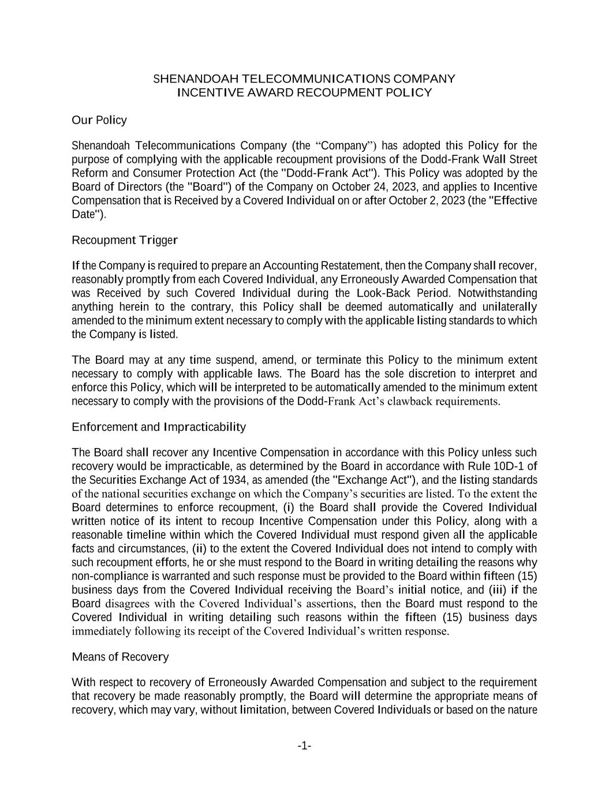

-1- SHENANDOAH TELECOMMUNICATIONS COMPANY INCENTIVE AWARD RECOUPMENT POLICY Our Policy Shenandoah Telecommunications Company (the “Company”) has adopted this Policy for the purpose of complying with the applicable recoupment provisions of the Dodd-Frank Wall Street Reform and Consumer Protection Act (the "Dodd-Frank Act"). This Policy was adopted by the Board of Directors (the "Board") of the Company on October 24, 2023, and applies to Incentive Compensation that is Received by a Covered Individual on or after October 2, 2023 (the "Effective Date"). Recoupment Trigger If the Company is required to prepare an Accounting Restatement, then the Company shall recover, reasonably promptly from each Covered Individual, any Erroneously Awarded Compensation that was Received by such Covered Individual during the Look-Back Period. Notwithstanding anything herein to the contrary, this Policy shall be deemed automatically and unilaterally amended to the minimum extent necessary to comply with the applicable listing standards to which the Company is listed. The Board may at any time suspend, amend, or terminate this Policy to the minimum extent necessary to comply with applicable laws. The Board has the sole discretion to interpret and enforce this Policy, which will be interpreted to be automatically amended to the minimum extent necessary to comply with the provisions of the Dodd-Frank Act’s clawback requirements. Enforcement and Impracticability The Board shall recover any Incentive Compensation in accordance with this Policy unless such recovery would be impracticable, as determined by the Board in accordance with Rule 10D-1 of the Securities Exchange Act of 1934, as amended (the "Exchange Act"), and the listing standards of the national securities exchange on which the Company’s securities are listed. To the extent the Board determines to enforce recoupment, (i) the Board shall provide the Covered Individual written notice of its intent to recoup Incentive Compensation under this Policy, along with a reasonable timeline within which the Covered Individual must respond given all the applicable facts and circumstances, (ii) to the extent the Covered Individual does not intend to comply with such recoupment efforts, he or she must respond to the Board in writing detailing the reasons why non-compliance is warranted and such response must be provided to the Board within fifteen (15) business days from the Covered Individual receiving the Board’s initial notice, and (iii) if the Board disagrees with the Covered Individual’s assertions, then the Board must respond to the Covered Individual in writing detailing such reasons within the fifteen (15) business days immediately following its receipt of the Covered Individual’s written response. Means of Recovery With respect to recovery of Erroneously Awarded Compensation and subject to the requirement that recovery be made reasonably promptly, the Board will determine the appropriate means of recovery, which may vary, without limitation, between Covered Individuals or based on the nature

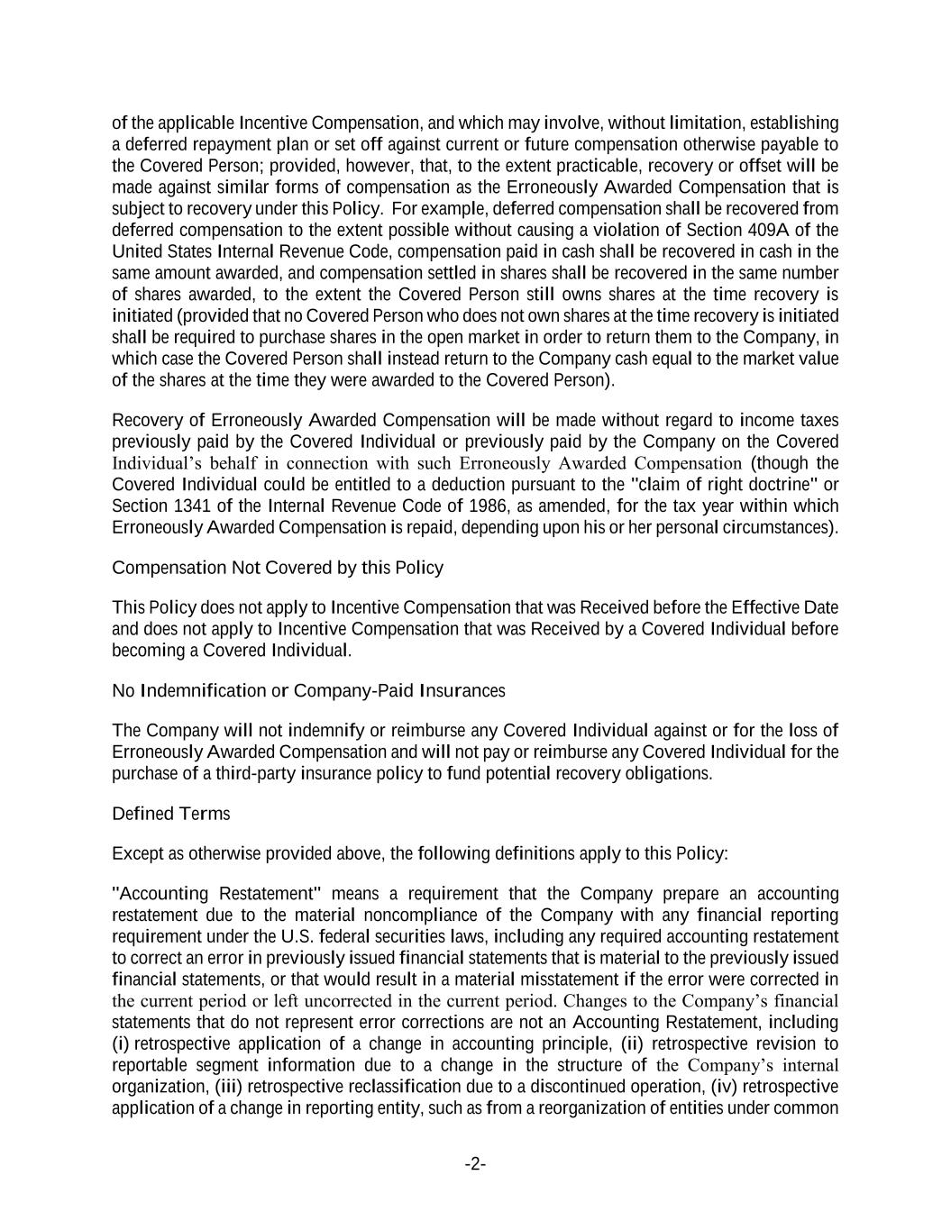
-2- of the applicable Incentive Compensation, and which may involve, without limitation, establishing a deferred repayment plan or set off against current or future compensation otherwise payable to the Covered Person; provided, however, that, to the extent practicable, recovery or offset will be made against similar forms of compensation as the Erroneously Awarded Compensation that is subject to recovery under this Policy. For example, deferred compensation shall be recovered from deferred compensation to the extent possible without causing a violation of Section 409A of the United States Internal Revenue Code, compensation paid in cash shall be recovered in cash in the same amount awarded, and compensation settled in shares shall be recovered in the same number of shares awarded, to the extent the Covered Person still owns shares at the time recovery is initiated (provided that no Covered Person who does not own shares at the time recovery is initiated shall be required to purchase shares in the open market in order to return them to the Company, in which case the Covered Person shall instead return to the Company cash equal to the market value of the shares at the time they were awarded to the Covered Person). Recovery of Erroneously Awarded Compensation will be made without regard to income taxes previously paid by the Covered Individual or previously paid by the Company on the Covered Individual’s behalf in connection with such Erroneously Awarded Compensation (though the Covered Individual could be entitled to a deduction pursuant to the "claim of right doctrine" or Section 1341 of the Internal Revenue Code of 1986, as amended, for the tax year within which Erroneously Awarded Compensation is repaid, depending upon his or her personal circumstances). Compensation Not Covered by this Policy This Policy does not apply to Incentive Compensation that was Received before the Effective Date and does not apply to Incentive Compensation that was Received by a Covered Individual before becoming a Covered Individual. No Indemnification or Company-Paid Insurances The Company will not indemnify or reimburse any Covered Individual against or for the loss of Erroneously Awarded Compensation and will not pay or reimburse any Covered Individual for the purchase of a third-party insurance policy to fund potential recovery obligations. Defined Terms Except as otherwise provided above, the following definitions apply to this Policy: "Accounting Restatement" means a requirement that the Company prepare an accounting restatement due to the material noncompliance of the Company with any financial reporting requirement under the U.S. federal securities laws, including any required accounting restatement to correct an error in previously issued financial statements that is material to the previously issued financial statements, or that would result in a material misstatement if the error were corrected in the current period or left uncorrected in the current period. Changes to the Company’s financial statements that do not represent error corrections are not an Accounting Restatement, including (i) retrospective application of a change in accounting principle, (ii) retrospective revision to reportable segment information due to a change in the structure of the Company’s internal organization, (iii) retrospective reclassification due to a discontinued operation, (iv) retrospective application of a change in reporting entity, such as from a reorganization of entities under common

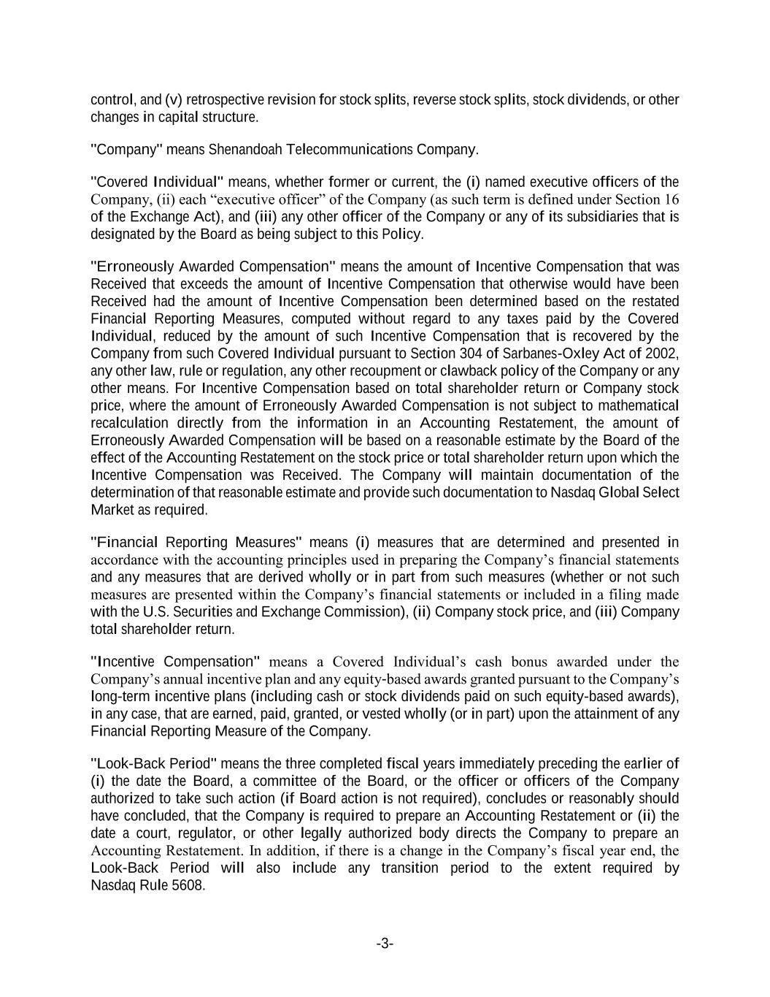
-3- control, and (v) retrospective revision for stock splits, reverse stock splits, stock dividends, or other changes in capital structure. "Company" means Shenandoah Telecommunications Company. "Covered Individual" means, whether former or current, the (i) named executive officers of the Company, (ii) each “executive officer” of the Company (as such term is defined under Section 16 of the Exchange Act), and (iii) any other officer of the Company or any of its subsidiaries that is designated by the Board as being subject to this Policy. "Erroneously Awarded Compensation" means the amount of Incentive Compensation that was Received that exceeds the amount of Incentive Compensation that otherwise would have been Received had the amount of Incentive Compensation been determined based on the restated Financial Reporting Measures, computed without regard to any taxes paid by the Covered Individual, reduced by the amount of such Incentive Compensation that is recovered by the Company from such Covered Individual pursuant to Section 304 of Sarbanes-Oxley Act of 2002, any other law, rule or regulation, any other recoupment or clawback policy of the Company or any other means. For Incentive Compensation based on total shareholder return or Company stock price, where the amount of Erroneously Awarded Compensation is not subject to mathematical recalculation directly from the information in an Accounting Restatement, the amount of Erroneously Awarded Compensation will be based on a reasonable estimate by the Board of the effect of the Accounting Restatement on the stock price or total shareholder return upon which the Incentive Compensation was Received. The Company will maintain documentation of the determination of that reasonable estimate and provide such documentation to Nasdaq Global Select Market as required. "Financial Reporting Measures" means (i) measures that are determined and presented in accordance with the accounting principles used in preparing the Company’s financial statements and any measures that are derived wholly or in part from such measures (whether or not such measures are presented within the Company’s financial statements or included in a filing made with the U.S. Securities and Exchange Commission), (ii) Company stock price, and (iii) Company total shareholder return. "Incentive Compensation" means a Covered Individual’s cash bonus awarded under the Company’s annual incentive plan and any equity-based awards granted pursuant to the Company’s long-term incentive plans (including cash or stock dividends paid on such equity-based awards), in any case, that are earned, paid, granted, or vested wholly (or in part) upon the attainment of any Financial Reporting Measure of the Company. "Look-Back Period" means the three completed fiscal years immediately preceding the earlier of (i) the date the Board, a committee of the Board, or the officer or officers of the Company authorized to take such action (if Board action is not required), concludes or reasonably should have concluded, that the Company is required to prepare an Accounting Restatement or (ii) the date a court, regulator, or other legally authorized body directs the Company to prepare an Accounting Restatement. In addition, if there is a change in the Company’s fiscal year end, the Look-Back Period will also include any transition period to the extent required by Nasdaq Rule 5608.


-4- "Received" means, with respect to Incentive Compensation of a Covered Individual, the fiscal year to which the Financial Reporting Measure is attained, irrespective of whether the Incentive Compensation is subject to additional time or non-financial performance vesting conditions. * * * * *

