UNITED STATES OF AMERICA

SECURITIES AND EXCHANGE COMMISSION

Washington, D. C. 20549

FORM 10-Q
(Mark One)

- QUARTERLY REPORT PURSUANT TO SECTION 13 OR 15(d) OF THE SECURITIES EXCHANGE ACT OF 1934 For the quarterly period ended September 30, 2019

- TRANSITION REPORT PURSUANT TO SECTION 13 OR 15(d) OF THE SECURITIES EXCHANGE ACT OF 1934 For the transition period from__________ to __________

Commission File No.: 000-09881


SHENANDOAH TELECOMMUNICATIONS COMPANY

(Exact name of registrant as specified in its charter)

 | Virginia |  |  |  |  | 54-1162807
(State or other jurisdiction of incorporation or organization) |  |  |  |  |  | (I.R.S. Employer Identification No.)
 |  | 500 Shentel Way, Edinburg, Virginia |  | 22824
 |  | (Address of principal executive offices) (Zip Code)
 |  | (540) 984-4141
 |  | (Registrant's telephone number, including area code)
 | SECURITIES REGISTERED PURSUANT TO SECTION 12(B) OF THE ACT:
Common Stock (No Par Value) | SHEN |  | NASDAQ Global Select Market |  |  | 49,857,142
(Title of Class) | (Trading Symbol) |  | (Name of Exchange on which Registered) |  |  | (The number of shares of the registrant's common stock outstanding on October 25,
(Title of Class) | (Trading Symbol) |  |  |  |  | 2019)

Indicate by check mark whether the registrant (1) has filed all reports required to be filed by Section 13 or 15(d) of the Securities Exchange Act of 1934 during the preceding 12 months (or for such shorter period that the registrant was required to file such reports), and (2) has been subject to such filing requirements for the past 90 days. Yes ☑ No ☐

Indicate by check mark whether the registrant has submitted electronically every Interactive Data File required to be submitted pursuant to Rule 405 of Regulation S-T (§232.405 of this chapter) during the preceding 12 months (or for such shorter period that the registrant was required to submit such files). Yes ☑ No ☐

Indicate by check mark whether the registrant is a large accelerated filer, an accelerated filer, a non-accelerated filer, smaller reporting company, or an emerging growth company. See the definitions of “large accelerated filer,” “accelerated filer,” “smaller reporting company,” and "emerging growth company" in Rule 12b-2 of the Exchange Act.

Large accelerated filer ☑ Accelerated filer ☐ Non-accelerated filer ☐ Smaller reporting company ☐ Emerging growth company ☐

If an emerging growth company, indicate by check mark if the registrant has elected not to use the extended transition period for complying with any new or revised financial accounting standards provided pursuant to Section 13(a) of the Exchange Act. ☐

Indicate by check mark whether the registrant is a shell company (as defined in Rule 12b-2 of the Exchange Act).

Yes ☐ No ☑

 |  |  |  |  |  | SHENANDOAH TELECOMMUNICATIONS COMPANY
 |  |  |  |  |  |  |  |  |  |  | INDEX
 |  |  |  |  |  |  |  |  |  |  |  |  |  | Page
 |  |  |  |  |  |  |  |  |  |  |  |  |  | Numbers
PART I. | FINANCIAL INFORMATION
Item 1. | Financial Statements
 | Unaudited Condensed Consolidated Balance Sheets |  |  |  |  |  |  |  |  |  |  |  |  |  | 3
 | Unaudited Condensed Consolidated Statements of Operations and Comprehensive Income |  |  |  |  |  |  |  |  |  |  |  |  |  | 4
 | Unaudited Condensed Consolidated Statements of Shareholders’ Equity |  |  |  |  |  |  |  |  |  |  |  |  |  | 5
 | Unaudited Condensed Consolidated Statements of Cash Flows |  |  |  |  |  |  |  |  |  |  |  |  |  | 6
 | Notes to Unaudited Condensed Consolidated Financial Statements |  |  |  |  |  |  |  |  |  |  |  |  |  | 7
Item 2. | Management’s Discussion and Analysis of Financial Condition and Results of Operations |  |  |  |  |  |  |  |  |  |  |  |  |  | 20
Item 3. | Quantitative and Qualitative Disclosures about Market Risk |  |  |  |  |  |  |  |  |  |  |  |  |  | 35
Item 4. | Controls and Procedures |  |  |  |  |  |  |  |  |  |  |  |  |  | 36
PART II. | OTHER INFORMATION
Item 1A. | Risk Factors |  |  |  |  |  |  |  |  |  |  |  |  |  | 37
Item 2. | Unregistered Sales of Equity Securities and Use of Proceeds |  |  |  |  |  |  |  |  |  |  |  |  | 37
Item 6. | Exhibits |  |  |  |  |  |  |  |  |  |  |  |  |  | 38
 | Signatures |  |  |  |  |  |  |  |  |  |  |  |  | 40

Index

SHENANDOAH TELECOMMUNICATIONS COMPANY AND SUBSIDIARIES
UNAUDITED CONDENSED CONSOLIDATED BALANCE SHEETS
(in thousands)
 |  | September 30,
 |  | 2019 |  |  | December 31, 2018
ASSETS
Current assets:
Cash and cash equivalents | $ | 97,415 |  | $ | 85,086
Accounts receivable, net of allowance for doubtful accounts of $563 and $534, respectively |  | 60,084 |  |  | 54,407
Income taxes receivable |  | 2,983 |  |  | 5,282
Inventory, net of allowances of $196 and $113, respectively |  | 4,561 |  |  | 5,265
Prepaid expenses and other |  | 56,597 |  |  | 60,162
Total current assets |  | 221,640 |  |  | 210,202
Investments |  | 11,851 |  |  | 10,788
Property, plant and equipment, net |  | 688,516 |  |  | 701,359
Intangible assets, net |  | 328,831 |  |  | 366,029
Goodwill |  | 149,070 |  |  | 146,497
Operating lease right-of-use assets |  | 400,489 |  |  | —
Deferred charges and other assets |  | 50,469 |  |  | 49,891
Total assets | $ | 1,850,866 |  | $ | 1,484,766
LIABILITIES AND SHAREHOLDERS’ EQUITY
Current liabilities:
Current maturities of long-term debt, net of unamortized loan fees | $ | 31,634 |  | $ | 20,618
Accounts payable |  | 26,470 |  |  | 35,987
Advanced billings and customer deposits |  | 8,127 |  |  | 7,919
Accrued compensation |  | 6,915 |  |  | 9,452
Current operating lease liabilities |  | 44,178 |  |  | —
Accrued liabilities and other |  | 14,731 |  |  | 14,563
Total current liabilities |  | 132,055 |  |  | 88,539
Long-term debt, less current maturities, net of unamortized loan fees |  | 696,378 |  |  | 749,624
Other long-term liabilities:
Deferred income taxes |  | 129,651 |  |  | 127,453
Deferred lease |  | — |  |  | 22,436
Asset retirement obligations |  | 29,956 |  |  | 28,584
Retirement plan obligations |  | 10,311 |  |  | 11,519
Noncurrent operating lease liabilities |  | 359,985 |  |  | —
Other liabilities |  | 16,676 |  |  | 14,364
Total other long-term liabilities |  | 546,579 |  |  | 204,356
Shareholders’ equity:
Common stock, no par value, authorized 96,000; 49,857 and 49,630 issued and outstanding at September 30, 2019 and December 31, 2018,
respectively |  | — |  |  | —
Additional paid in capital |  | 48,083 |  |  | 47,456
Retained earnings |  | 427,925 |  |  | 386,511
Accumulated other comprehensive income (loss), net of taxes |  | (154) |  |  | 8,280
Total shareholders’ equity |  | 475,854 |  |  | 442,247
Total liabilities and shareholders’ equity | $ | 1,850,866 |  | $ | 1,484,766

See accompanying notes to unaudited condensed consolidated financial statements.

3

Index

SHENANDOAH TELECOMMUNICATIONS COMPANY AND SUBSIDIARIES

UNAUDITED CONDENSED CONSOLIDATED STATEMENTS OF OPERATIONS AND COMPREHENSIVE INCOME

(in thousands, except per share amounts)
 |  | Three Months Ended |  |  |  |  |  | Nine Months Ended
 |  | September 30, |  |  |  |  |  | September 30,
Operating revenue: |  | 2019 |  |  | 2018 |  |  | 2019 |  |  | 2018
Service revenue and other | $ | 138,832 |  | $ | 142,768 |  | $ | 424,122 |  | $ | 419,819
Equipment revenue |  | 16,320 |  |  | 15,963 |  |  | 48,787 |  |  | 49,551
Total operating revenue |  | 155,152 |  |  | 158,731 |  |  | 472,909 |  |  | 469,370
Operating expenses:
Cost of services |  | 50,164 |  |  | 47,886 |  |  | 149,179 |  |  | 146,362
Cost of goods sold |  | 15,825 |  |  | 15,036 |  |  | 46,336 |  |  | 46,007
Selling, general and administrative |  | 27,178 |  |  | 27,452 |  |  | 83,070 |  |  | 86,117
Depreciation and amortization |  | 36,626 |  |  | 40,028 |  |  | 120,158 |  |  | 124,632
Total operating expenses |  | 129,793 |  |  | 130,402 |  |  | 398,743 |  |  | 403,118
Operating income |  | 25,359 |  |  | 28,329 |  |  | 74,166 |  |  | 66,252
Other income (expense):
Interest expense |  | (7,505) |  |  | (9,001) |  |  | (22,981) |  |  | (27,184)
Other |  | 1,099 |  |  | 1,054 |  |  | 3,562 |  |  | 2,882
Income before income taxes |  | 18,953 |  |  | 20,382 |  |  | 54,747 |  |  | 41,950
Income tax expense |  | 4,599 |  |  | 4,848 |  |  | 13,333 |  |  | 10,207
Net income |  | 14,354 |  |  | 15,534 |  |  | 41,414 |  |  | 31,743
Other comprehensive income (loss):
Unrealized gain (loss) on interest rate hedge, net of tax |  | (1,494) |  |  | 465 |  |  | (8,434) |  |  | 4,360
Comprehensive income | $ | 12,860 |  | $ | 15,999 |  | $ | 32,980 |  | $ | 36,103
Net income per share, basic and diluted:
Basic net income per share | $ | 0.29 |  | $ | 0.31 |  | $ | 0.83 |  | $ | 0.64
Diluted net income per share | $ | 0.29 |  | $ | 0.31 |  | $ | 0.83 |  | $ | 0.63
Weighted average shares outstanding, basic |  | 49,857 |  |  | 49,559 |  |  | 49,827 |  |  | 49,527
Weighted average shares outstanding, diluted |  | 50,129 |  |  | 50,117 |  |  | 50,110 |  |  | 50,044

See accompanying notes to unaudited condensed consolidated financial statements.

4

Index

SHENANDOAH TELECOMMUNICATIONS COMPANY AND SUBSIDIARIES

UNAUDITED CONDENSED CONSOLIDATED STATEMENTS OF SHAREHOLDERS' EQUITY

(in thousands, except per share amounts)

 | Shares of Common Stock |  |  |  |  |  |  |  |  | Accumulated Other
 | (no par value) |  |  | Additional Paid in Capital |  |  | Retained Earnings |  | Comprehensive Income (Loss) |  |  |  | Total
Balance, June 30, 2019 | 49,857 |  | $ | 47,138 |  | $ | 413,571 |  | $ | 1,340 |  | $ | 462,049
Net income | — |  |  | — |  |  | 14,354 |  |  | — |  |  | 14,354
Other comprehensive loss, net of tax | — |  |  | — |  |  | — |  |  | (1,494) |  |  | (1,494)
Stock based compensation | — |  |  | 936 |  |  | — |  |  | — |  |  | 936
Stock options exercised | — |  |  | — |  |  | — |  |  | — |  |  | —
Common stock issued | — |  |  | 9 |  |  | — |  |  | — |  |  | 9
Shares retired for settlement of employee taxes upon issuance of vested equity awards | — |  |  | — |  |  | — |  |  | — |  |  | —
Balance, September 30, 2019 | 49,857 |  | $ | 48,083 |  | $ | 427,925 |  | $ | (154) |  | $ | 475,854
 | Shares of Common Stock |  |  |  |  |  |  |  |  | Accumulated Other
 | (no par value) |  |  | Additional Paid in Capital |  |  | Retained Earnings |  | Comprehensive Income (Loss) |  |  |  | Total
Balance, December 31, 2018 | 49,630 |  | $ | 47,456 |  | $ | 386,511 |  | $ | 8,280 |  | $ | 442,247
Net income | — |  |  | — |  |  | 41,414 |  |  | — |  |  | 41,414
Other comprehensive loss, net of tax | — |  |  | — |  |  | — |  |  | (8,434) |  |  | (8,434)
Stock based compensation | 184 |  |  | 3,433 |  |  | — |  |  | — |  |  | 3,433
Stock options exercised | 29 |  |  | 81 |  |  | — |  |  | — |  |  | 81
Common stock issued | — |  |  | 25 |  |  | — |  |  | — |  |  | 25
Shares retired for settlement of employee taxes upon issuance of vested equity awards | (62) |  |  | (2,912) |  |  | — |  |  | — |  |  | (2,912)
Common stock issued to acquire non-controlling interest in nTelos | 76 |  |  | — |  |  | — |  |  | — |  |  | —
Balance, September 30, 2019 | 49,857 |  | $ | 48,083 |  | $ | 427,925 |  | $ | (154) |  | $ | 475,854
 | Shares of Common Stock |  |  |  |  |  |  |  |  | Accumulated Other
 | (no par value) |  |  | Additional Paid in Capital |  |  | Retained Earnings |  |  | Comprehensive Income |  |  | Total
Balance, June 30, 2018 | 49,558 |  | $ | 46,172 |  | $ | 369,511 |  | $ | 12,125 |  | $ | 427,808
Net income | — |  |  | — |  |  | 15,534 |  |  | — |  |  | 15,534
Other comprehensive gain, net of tax | — |  |  | — |  |  | — |  |  | 465 |  |  | 465
Stock based compensation | 1 |  |  | 1,171 |  |  | — |  |  | — |  |  | 1,171
Common stock issued | — |  |  | 8 |  |  | — |  |  | — |  |  | 8
Shares retired for settlement of employee taxes upon issuance of vested equity awards | — |  |  | (1) |  |  | — |  |  | — |  |  | (1)
Balance, September 30, 2018 | 49,559 |  | $ | 47,350 |  | $ | 385,045 |  | $ | 12,590 |  | $ | 444,985
 | Shares of Common Stock |  |  |  |  |  |  |  |  | Accumulated Other
 | (no par value) |  |  | Additional Paid in Capital |  |  | Retained Earnings |  |  | Comprehensive Income |  |  | Total
Balance, December 31, 2017 | 49,328 |  | $ | 44,787 |  | $ | 297,205 |  | $ | 8,230 |  | $ | 350,222
Change in Accounting Principle - Adoption of ASU 2014-09 | — |  |  | — |  |  | 56,097 |  |  | — |  |  | 56,097
Net income | — |  |  | — |  |  | 31,743 |  |  | — |  |  | 31,743
Other comprehensive gain, net of tax | — |  |  | — |  |  | — |  |  | 4,360 |  |  | 4,360
Stock based compensation | 206 |  |  | 4,578 |  |  | — |  |  | — |  |  | 4,578
Stock options exercised | 15 |  |  | 104 |  |  | — |  |  | — |  |  | 104
Common stock issued | — |  |  | 18 |  |  | — |  |  | — |  |  | 18
Shares retired for settlement of employee taxes upon issuance of vested equity awards | (66) |  |  | (2,137) |  |  | — |  |  | — |  |  | (2,137)
Common stock issued to acquire non-controlling interest in nTelos | 76 |  |  | — |  |  | — |  |  | — |  |  | —
Balance, September 30, 2018 | 49,559 |  | $ | 47,350 |  | $ | 385,045 |  | $ | 12,590 |  | $ | 444,985

See accompanying notes to unaudited condensed consolidated financial statements.

5

Index

SHENANDOAH TELECOMMUNICATIONS COMPANY AND SUBSIDIARIES
UNAUDITED CONDENSED CONSOLIDATED STATEMENTS OF CASH FLOWS
(in thousands)
 |  | Nine Months Ended
 |  | September 30,
 |  | 2019 |  |  | 2018
Cash flows from operating activities:
Net income | $ | 41,414 |  | $ | 31,743
Adjustments to reconcile net income to net cash provided by operating activities:
Depreciation |  | 104,503 |  |  | 106,002
Amortization |  | 15,655 |  |  | 18,630
Accretion of asset retirement obligations |  | 1,093 |  |  | 710
Bad debt expense |  | 1,215 |  |  | 1,362
Stock based compensation expense, net of amount capitalized |  | 3,158 |  |  | 4,578
Deferred income taxes |  | 4,999 |  |  | (1,989)
Net gain from patronage and investments |  | (3,035) |  |  | (2,412)
Amortization of long-term debt issuance costs |  | 2,596 |  |  | 3,472
Changes in assets and liabilities:
Accounts receivable |  | (4,894) |  |  | (5,492)
Inventory, net |  | 704 |  |  | 741
Current income taxes |  | 2,299 |  |  | 14,932
Waived management fee |  | 29,016 |  |  | 28,164
Other assets |  | (15,073) |  |  | (13,393)
Operating lease right-of-use assets |  | 38,262 |  |  | —
Lease liabilities |  | (32,173) |  |  | —
Accounts payable |  | 7,023 |  |  | (1,913)
Deferred lease |  | — |  |  | 4,159
Other deferrals and accruals |  | (3,303) |  |  | (494)
Net cash provided by operating activities |  | 193,459 |  |  | 188,800
Cash flows from investing activities:
Capital expenditures |  | (107,038) |  |  | (92,309)
Cash disbursed for acquisitions |  | (10,000) |  |  | (52,000)
Cash disbursed for FCC spectrum licenses |  | (16,742) |  |  | —
Proceeds from sale of assets and other |  | 156 |  |  | 539
Net cash used in investing activities |  | (133,624) |  |  | (143,770)
Cash flows from financing activities:
Principal payments on long-term debt |  | (44,666) |  |  | (46,375)
Proceeds from revolving credit facility borrowings |  | — |  |  | 15,000
Principal payments on revolving credit facility |  | — |  |  | (15,000)
Proceeds from exercises of stock options |  | 81 |  |  | —
Taxes paid for equity award issuances |  | (2,912) |  |  | (2,033)
Other |  | (9) |  |  | —
Net cash used in financing activities |  | (47,506) |  |  | (48,408)
Net increase (decrease) in cash and cash equivalents |  | 12,329 |  |  | (3,378)
Cash and cash equivalents, beginning of period |  | 85,086 |  |  | 78,585
Cash and cash equivalents, end of period | $ | 97,415 |  | $ | 75,207

See accompanying notes to unaudited condensed consolidated financial statements.

6

Index

SHENANDOAH TELECOMMUNICATIONS COMPANY AND SUBSIDIARIES

NOTES TO UNAUDITED CONDENSED CONSOLIDATED FINANCIAL STATEMENTS

Note 1. Basis of Presentation

The interim condensed consolidated financial statements of Shenandoah Telecommunications Company and Subsidiaries (collectively, the “Company”) are unaudited. In the opinion of management, all adjustments necessary for a fair presentation of the interim results have been reflected therein in accordance with accounting principles generally accepted in the United States ("GAAP") for interim financial reporting and as required by Rule 10-01 of Regulation S-X. Accordingly, the unaudited condensed consolidated financial statements may not include all of the information and notes required by GAAP for audited financial statements. The information contained herein should be read in conjunction with the audited financial statements included in the Company's Annual Report on Form 10-K for the year ended December 31, 2018.

Adoption of New Accounting Principles

There have been no developments related to recently issued accounting standards, including the expected dates of adoption and estimated effects on the Company's unaudited condensed consolidated financial statements and note disclosures, from those disclosed in the Company's 2018 Annual Report on Form 10-K, that would be expected to impact the Company except for the following:

The Company adopted ASU No. 2018-02, Income Statement - Reporting Comprehensive Income (Topic 220), as of January 1, 2019. The Company elected not to reclassify stranded income tax effects from accumulated other comprehensive income (OCI) to retained earnings and has implemented this election as its accounting policy as of January 1, 2019. The Company utilizes the portfolio approach as its policy to release the income tax effects from accumulated OCI as the entire portfolio is liquidated, sold, or extinguished.

The Company adopted ASU No. 2016-02, Leases (“Topic 842” or “the new lease standard”) on January 1, 2019. Topic 842 replaces previous leasing guidance with a comprehensive lease measurement and recognition standard and expanded disclosure requirements. Topic 842 requires lessees to recognize most leases on their balance sheet as liabilities, with corresponding right-of-use, or ROU assets. The Company adopted the new lease standard utilizing the modified retrospective approach. As a result, comparable period information has not been retrospectively updated. The modified retrospective approach includes a package of optional practical expedients that we elected to apply. As a result, the Company did not reassess prior conclusions regarding lease identification, lease classification and initial direct costs under the new standard. In those circumstances where the Company is the lessee, we have elected to account for non-lease components associated with our leases (e.g., maintenance costs) and lease components as a single lease component for substantially all of our asset classes under Topic 842.

Note 2. Leases

The Company leases various cell sites, warehouses, retail stores, and office facilities for use in our business. These agreements include fixed rental payments as well as variable rental payments, such as those based on relevant inflation indices. The accounting lease term includes optional renewal periods that we are reasonably certain to exercise based on our assessment of relevant contractual and economic factors. The related lease payments are discounted at lease commencement using the Company's incremental borrowing rate in order to measure the lease liability and ROU asset.

The incremental borrowing rate is determined using a portfolio approach based on the rate of interest that the Company would have to pay to borrow an amount equal to the lease payments on a collateralized basis over a similar term. The Company uses the observable unsecured borrowing rate and risk-adjusts that rate to approximate a collateralized rate. Under the new lease standard, leases are remeasured upon the occurrence of certain events or modifications.

Adoption of the new lease standard did not materially impact the Company's consolidated net earnings, cash flows, liquidity, or loan covenants.

7

Index
The cumulative effect of the changes made to the consolidated January 1, 2019 balance sheet for the adoption of the new lease standard were as follows:
 |  |  | December 31, 2018 As Previously |  |  | Effect of the Adoption of ASC
(in thousands) |  |  | Reported |  |  | Topic 842 (Leases) |  |  | January 1, 2019 As Adjusted
Assets
Prepaid expenses and other |  | $ | 60,162 |  | $ | (11,580) |  | $ | 48,582
Property, plant and equipment, net |  |  | 701,359 |  |  | 1,789 |  |  | 703,148
Operating lease right-of-use assets |  |  | — |  |  | 369,344 |  |  | 369,344
Intangible assets, net |  |  | 366,029 |  |  | (13,828) |  |  | 352,201
Liabilities
Current operating lease liabilities |  |  | — |  |  | 38,773 |  |  | 38,773
Accrued liabilities and other |  |  | 14,563 |  |  | (412) |  |  | 14,151
Deferred Lease |  |  | 22,436 |  |  | (22,436) |  |  | —
Noncurrent operating lease liabilities |  |  | — |  |  | 328,156 |  |  | 328,156
Other liabilities |  |  | 14,364 |  |  | 1,644 |  |  | 16,008

In addition to recognizing the operating lease liabilities and right-of-use assets, Topic 842 also reclassified prepaid and deferred rent balances, off-market leases, and lease incentives into the right-of-use assets.

The following table shows the components of lease income and costs:
 | Three Months Ended September 30, |  |  | Nine Months Ended September 30,
(in thousands) |  | 2019 |  |  | 2019
Lease income from operating leases - fixed | $ | 2,149 |  | $ | 6,219
Operating lease expense |  | 18,151 |  |  | 51,811
Amortization of finance lease assets |  | 158 |  |  | 399
Interest on finance lease liabilities |  | 14 |  |  | 59
Subtotal finance lease cost |  | 172 |  |  | 458
Total lease expense | $ | 18,323 |  | $ | 52,269
Substantially all of the Company's sublease income from operating leases relates to fixed lease payments.

All operating lease expenses, including short-term and variable lease expenses, are split between cost of service and selling, general and administrative expense in the condensed consolidated statements of operations based on the use of the facility that the rent is being paid on. Operating lease expense includes variable lease payments and short-term lease expense, both of which are immaterial. Variable lease expenses represent payments that are dependent on a rate or index, or on usage of the asset.

The following table summarizes other information related to operating and finance leases:
 | Three Months Ended September 30, |  |  | Nine Months Ended September 30,
(in thousands) |  | 2019 |  |  | 2019
Operating cash flows used by leases | $ | 16,002 |  | $ | 46,546
Leased assets obtained in exchange for new operating lease liabilities |  | 43,647 |  |  | 69,407

8

Index
The following table summarizes the lease terms and discount rates:
 |  | September 30,
 |  | 2019
Weighted-average remaining lease term (years)
Operating leases |  | 8
Finance leases |  | 16
Weighted-average discount rate
Operating leases |  | 4.6%
Finance leases |  | 5.2%

The following table summarizes the expected maturity of lease liabilities at September 30, 2019:

(in thousands) |  | Operating Leases |  | Finance Leases |  |  |  | Total
2019 | $ | 12,742 |  | $ | 63 |  | $ | 12,805
2020 |  | 64,474 |  |  | 174 |  |  | 64,648
2021 |  | 65,087 |  |  | 174 |  |  | 65,261
2022 |  | 63,341 |  |  | 174 |  |  | 63,515
2023 |  | 59,885 |  |  | 174 |  |  | 60,059
2024 and thereafter |  | 242,115 |  |  | 1,704 |  |  | 243,819
Total lease payments |  | 507,644 |  |  | 2,463 |  |  | 510,107
Less: Interest |  | 103,481 |  |  | 748 |  |  | 104,229
Present value of lease liabilities | $ | 404,163 |  | $ | 1,715 |  | $ | 405,878

The Company's finance lease liabilities are presented in the accrued liabilities and other and the other liabilities lines of the unaudited condensed consolidated balance sheets. The related finance lease assets are included in the property, plant and equipment line.

Our commitments under leases existing as of December 31, 2018 were approximately $55.1 million for the year ending December 31, 2019, $104.4 million in total for the years ending December 31, 2020 and 2021, $97.6 million in total for the years ending December 31, 2022 and 2023 and $168.5 million in total for years thereafter.

The Company is also the lessor on agreements to lease assets such as collocation space at cell sites and dedicated fiber-optic strands to third parties. These agreements have been accounted for as operating leases both before and after adoption of the new lease standard. The new lease standard did not have a significant impact on the recognition of lease revenue associated with these agreements. The following table summarizes the total minimum rental receipts under lease agreements at September 30, 2019:

(in thousands) |  | Operating Leases
2019 | $ | 1,774
2020 |  | 6,621
2021 |  | 4,526
2022 |  | 3,432
2023 |  | 1,801
2024 and thereafter |  | 4,978
Total lease income | $ | 23,132

Note 3. Revenue from Contracts with Customers

The Company earns revenue primarily through the sale of its wireless service. Additional revenue is earned from the sale of wireless equipment; from business, residential and enterprise services which provide video, broadband, and voice services; and

9

Index

from tower and other services. Refer to Note 14, Segment Reporting, for a tabular summary of revenue for the three and nine months ended September 30, 2019.

Wireless service

The Company earns revenue primarily through the sale of its wireless service by providing network access to Sprint under the affiliate agreement. Wireless service revenue is variable based on billed revenue to Sprint’s subscribers that originated in the Company's affiliate area, less applicable fees retained by Sprint.

The Company's revenue related to Sprint’s postpaid customers is the amount that Sprint bills its postpaid subscribers, reduced by customer credits, estimates of bad debt, and 8% management and 8.6% service fees. The Company is also charged for the costs of subsidized handsets sold through Sprint’s national channels as well as commissions paid by Sprint to third-party resellers in the Company's service territory.

The Company's revenue related to Sprint’s prepaid customers is the amount that Sprint bills its prepaid subscribers, reduced by costs to acquire and support the customers, based on national averages for Sprint’s prepaid programs, and a 6% management fee.

Under our affiliate agreement with Sprint, we have historically earned and recognized monthly revenue of $1.5 million for providing service to Sprint customers who pass through our network area ("Travel Revenue"). While we continue to provide these services to Sprint, the agreed upon payments were suspended by Sprint on April 30, 2019. Accordingly, we have ceased recognizing revenue for the services provided after that date until a new prospective fee can be agreed. We have commenced final dispute resolution proceedings to settle this dispute and expect it to be settled by early 2020.

The Company considers Sprint, rather than Sprint's subscribers, to be the customer and the Company's performance obligation is to provide Sprint a series of continuous network access services within the Sprint Affiliate Area. The Company determined that reimbursements to Sprint including the cost of prepaid handsets and commissions, and postpaid commissions paid by Sprint to third-party resellers, represent consideration payable to a customer. These reimbursements are initially recorded as a contract asset and are subsequently recognized as a reduction of revenue over the expected benefit period between 21 and 53 months. Contract asset balances and activity for 2019 were as follows:

 |  | Three Months Ended |  |  |  |  |  | Nine Months Ended
 |  | September 30, |  |  |  |  |  | September 30,
(in thousands) |  | 2019 |  |  | 2018 |  |  | 2019 |  |  | 2018
Beginning balance | $ | 73,789 |  | $ | 57,256 |  | $ | 65,674 |  | $ | 51,103
Contract payments |  | 20,761 |  |  | 16,421 |  |  | 56,477 |  |  | 44,790
Contract amortization |  | (14,930) |  |  | (11,861) |  |  | (42,531) |  |  | (34,077)
Ending balance | $ | 79,620 |  | $ | 61,816 |  | $ | 79,620 |  | $ | 61,816

Wireless equipment

The Company also earns revenue through the sale of wireless equipment. The Company owns and operates Sprint-branded retail stores within the Sprint Affiliate Area from which the Company sells equipment, primarily wireless handsets, and service to Sprint subscribers. The Company's equipment is predominantly sold to subscribers through Sprint's equipment financing plans. Under the equipment financing plans, Sprint purchases the equipment from the Company and resells the equipment to its subscribers. The Company is the principal in these equipment financing transactions, as it controls and bears the risk of ownership of the inventory prior to sale, and accordingly, revenue and handset costs are recorded on a gross basis, and the corresponding cost of the equipment is recorded separately to cost of goods sold.

Business, residential and enterprise

The Company also earns revenue in the Cable and Wireline segments from the sale of business, residential, and enterprise services to customers where the performance obligations are to provide cable, broadband, and telephone network services, sell and lease equipment and wiring services, and lease fiber-optic cable. The Company's arrangements for residential services are generally composed of contracts that are cancellable at the customer’s discretion without penalty at any time. As there are multiple performance obligations in these arrangements, the Company recognizes revenue based on the standalone selling price of each distinct good or service. The Company generally recognizes this revenue over time as customers simultaneously receive and consume the benefits of the service, with the exception of equipment sales and home wiring which are recognized as revenue at a point in time when control transfers and when installation is complete, respectively.

10

Index

Installation fees are allocated to services and are recognized ratably over the longer of the contract term or the period the unrecognized portion of the fee remains material to the contract, typically 10 and 11 months for Cable and Wireline customers, respectively. Additionally, the Company incurs commission and installation costs related to in-house employees and third-party vendors which are capitalized and amortized over the expected benefit period which is approximately 44 months and 72 months for Cable and Wireline, respectively.

Tower and Other

The Company also earns revenue from tower and other services. Tower revenue consists primarily of tower collocation space on cell towers owned by the Company accounted for under Topic 842, Leases. Other revenue includes network access-related charges for service provided to customers across the segments.

Future performance obligations

On September 30, 2019, the Company had approximately $3.5 million allocated to unsatisfied performance obligations, which excludes contracts with original expected duration of one year or less.

The following table summarizes the approximate amounts expected to be recognized as revenue after September 30, 2019.

 | Amount Expected to be Recognized
 |  | as Revenue:
(in thousands)
2019 | $ | 219
2020 |  | 850
2021 |  | 770
2022 and thereafter |  | 1,707
Total
Total | $ | 3,546

Contract acquisition costs and costs to fulfill contracts

Capitalized contract costs represent contract fulfillment costs and contract acquisition costs which include commissions and installation costs in the Cable and Wireline segments. Capitalized contract assets, including commissions and installation costs, are amortized on a straight-line basis over the average customer life of 44 months and 72 months for Cable and Wireline, respectively. The Company elected to apply the practical expedient to expense contract acquisition costs when incurred, if the amortization period would be twelve months or less. The amortization of these costs is included in cost of services, and selling, general and administrative expenses. Amortized and capitalized costs for Cable and Wireline contracts were as follows:

 |  | Three Months Ended |  |  |  |  |  | Nine Months Ended
 |  | September 30, |  |  |  |  |  | September 30,
(in thousands) |  | 2019 |  |  | 2018 |  |  | 2019 |  |  | 2018
Beginning Balance | $ | 10,476 |  | $ | 9,755 |  | $ | 10,091 |  | $ | 9,841
Contract payments |  | 1,840 |  |  | 1,613 |  |  | 4,996 |  |  | 4,246
Contract amortization |  | (1,399) |  |  | (1,339) |  |  | (4,170) |  |  | (4,058)
Ending Balance | $ | 10,917 |  | $ | 10,029 |  | $ | 10,917 |  | $ | 10,029

Note 4. Acquisitions

Big Sandy

On February 28, 2019, the Company completed its preliminary valuation for the acquisition of the assets of Big Sandy Broadband, Inc. ("Big Sandy") for $10 million and recorded $4.6 million of property, plant and equipment; $2.8 million of subscriber relationships; and $2.6 million of goodwill which is reported in the Cable segment and was accounted for as a business combination under ASC 805, Business Combinations. The estimated remaining useful lives of the acquired property, plant and equipment were approximately 2.5 years to 12.5 years and the estimated useful lives for subscriber relationships were 7 years at the time of the acquisition. Big Sandy was a provider of cable television, telephone and high speed internet services. Our preliminary allocation of the acquisition price is based on our preliminary estimate of fair value for each of the acquired assets and liabilities. These estimates may be revised during the one year measurement period provided by the authoritative guidance applicable to business combinations.

11

Index

Note 5. Customer Concentration

Significant Contractual Relationship

In 1999, the Company executed a Management Agreement (the “Agreement”) with Sprint whereby the Company committed to construct and operate a PCS network using CDMA air interface technology. The Agreement has been amended numerous times. Under the amended Agreement, the Company is the exclusive PCS Affiliate of Sprint providing wireless mobility communications network products and services on the 800 MHz, 1900 MHz and 2.5 GHz spectrum ranges in its territory across a multi-state area covering large portions of central and western Virginia, south-central Pennsylvania, West Virginia, and portions of Maryland, North Carolina, Kentucky, and Ohio. Effective February 1, 2018, the Company amended its Agreement with Sprint to expand its wireless service area to include certain areas in Kentucky, Pennsylvania, Virginia and West Virginia.

As an exclusive PCS Affiliate of Sprint, the Company has the exclusive right to build, own and maintain its portion of Sprint’s nationwide PCS network, in the aforementioned areas, to Sprint’s specifications. The initial term of the Agreement extends through November 2029, with two successive 10-year renewal periods, unless terminated by either party under provisions outlined in the Agreement. Upon non-renewal by either party, the Company may cause Sprint to buy or Sprint may cause the Company to sell the business, at 90% of Entire Business Value ("EBV") as defined in the Agreement. EBV is defined as i) the fair market value of a going concern paid by a willing buyer to a willing seller; ii) valued as if the business will continue to utilize existing brands and operate under existing agreements; and, iii) valued as if Shentel has continued access to the spectrum. Determination of EBV is made by an independent appraisal process.

Note 6. Earnings Per Share ("EPS")

Basic EPS was computed by dividing net income by the weighted average number of shares of common stock outstanding. Diluted EPS was computed under the treasury stock method by dividing net income by the sum of the weighted average number of shares of common stock outstanding and potentially dilutive securities outstanding during the period under the treasury stock method. Potentially dilutive securities include unvested equity awards that are expected to vest and shares that the Company is contractually obligated to issue in the future.

The following table indicates the computation of basic and diluted earnings per share:

 |  | Three Months Ended |  |  |  |  |  | Nine Months Ended
 |  | September 30, |  |  |  |  |  | September 30,
(in thousands, except per share amounts) |  | 2019 |  |  | 2018 |  |  | 2019 |  |  | 2018
Calculation of net income per share:
Net income | $ | 14,354 |  | $ | 15,534 |  | $ | 41,414 |  | $ | 31,743
Basic weighted average shares outstanding |  | 49,857 |  |  | 49,559 |  |  | 49,827 |  |  | 49,527
Basic net income per share
Basic net income per share | $ | 0.29 |  | $ | 0.31 |  | $ | 0.83 |  | $ | 0.64
Effect of stock options outstanding:
Basic weighted average shares outstanding |  | 49,857 |  |  | 49,559 |  |  | 49,827 |  |  | 49,527
Effect from dilutive shares and options outstanding |  | 272 |  |  | 558 |  |  | 283 |  |  | 517
Diluted weighted average shares outstanding
Diluted weighted average shares outstanding |  | 50,129 |  |  | 50,117 |  |  | 50,110 |  |  | 50,044
Diluted net income per share
Diluted net income per share | $ | 0.29 |  | $ | 0.31 |  | $ | 0.83 |  | $ | 0.63

The computation of diluted EPS does not include certain unvested awards, on a weighted average basis, because their inclusion would have an anti-dilutive effect on EPS. The awards excluded because of their anti-dilutive effect were as follows:

(in thousands)

Awards excluded from the computation of diluted net income per share because their inclusion would have been anti-dilutive

Three Months Ended |  |  |  |  |  | Nine Months Ended
 | September 30, |  |  |  |  | September 30,
2019 | 2018 |  |  |  |  | 2019 |  |  | 2018
 | 93 |  |  | 13 |  | 109 |  |  | 60

12

Index
Note 7. Investments
Investments consist of the following:
 |  |  | September 30, |  |  | December 31,
(in thousands) |  |  | 2019 |  |  | 2018
Domestic equity funds
 |  | $ | 1,681 |  | $ | 1,409
International equity funds |  |  | 421 |  |  | 370
Total investments carried at fair value
 |  |  | 2,102 |  |  | 1,779
CoBank |  |  | 8,368 |  |  | 7,705
Equity in other telecommunications partners |  |  | 767 |  |  | 782
Total investments carried at cost
 |  |  | 9,135 |  |  | 8,487
Other |  |  | 614 |  |  | 522
Total equity method investments
 |  |  | 614 |  |  | 522
Total investments
 |  | $ | 11,851 |  | $ | 10,788

The Company determines classification for investments at the date individual investments are acquired. The appropriateness of such classification is periodically reassessed. The Company monitors the value of all investments, and based on factors such as market conditions, financial information and industry conditions, the Company reflects impairments in values when warranted. The domestic and international equity funds are carried at their fair value as determined by using the net asset value expedient.

Note 8. Property, Plant and Equipment
Property, plant and equipment consisted of the following:
 |  |  |  | September 30,
(in thousands) | Estimated Useful Lives |  |  | 2019 |  |  | December 31, 2018
Land | $ |  |  | 6,936 |  | $ | 6,723
Buildings and structures | 10 - 40 years |  |  | 231,962 |  |  | 213,657
Cable and fiber | 15 - 40 years |  |  | 321,963 |  |  | 309,928
Equipment and software | 3 - 20 years |  |  | 839,624 |  |  | 791,401
Plant in service |  |  |  | 1,400,485 |  |  | 1,321,709
Plant under construction |  |  |  | 70,674 |  |  | 81,409
Total property, plant and equipment |  |  |  | 1,471,159 |  |  | 1,403,118
Less: accumulated amortization and depreciation |  |  |  | 782,643 |  |  | 701,759
Property, plant and equipment, net | $ |  |  | 688,516 |  | $ | 701,359

The Company prospectively changed the estimated useful life of certain tower, antenna, and fiber assets during 2019 based on the Company's experience as well as observable examples in the industry. Depreciation expense was approximately $0.8 million lower as a result for the three and nine months ended September 30, 2019.

13

Index
Note 9. Goodwill and Other Intangible Assets
Goodwill by segment consisted of the following:
 |  |  | September 30,
(in thousands) |  |  | 2019 |  |  | December 31, 2018
Wireless |  | $ | 146,383 |  | $ | 146,383
Cable |  |  | 2,677 |  |  | 104
Wireline |  |  | 10 |  |  | 10
Total Goodwill |  | $ | 149,070 |  | $ | 146,497

Intangible assets consisted of the following:
 |  |  |  | September 30, 2019 |  |  |  |  |  |  |  |  | December 31, 2018
 |  | Gross |  |  | Accumulated |  |  |  |  |  | Gross |  |  | Accumulated
(in thousands) |  | Carrying |  |  |  |  |  | Net |  |  | Carrying |  |  |  |  |  | Net
(in thousands) |  | Amount |  | Amortization and Other |  |  |  |  |  |  | Amount |  | Amortization and Other |  |  |  | Net
Non-amortizing intangibles:
Cable franchise rights | $ | 64,334 |  | $ | — |  | $ | 64,334 |  | $ | 64,334 |  | $ | — |  | $ | 64,334
FCC spectrum licenses |  | 13,839 |  |  | — |  |  | 13,839 |  |  | — |  |  | — |  |  | —
Railroad crossing rights |  | 141 |  |  | — |  |  | 141 |  |  | 141 |  |  | — |  |  | 141
Total non-amortizing intangibles |  | 78,314 |  |  | — |  |  | 78,314 |  |  | 64,475 |  |  | — |  |  | 64,475
Finite-lived intangibles:
Sprint affiliate contract expansion - Wireless |  | 455,305 |  |  | (212,194) |  |  | 243,111 |  |  | 455,305 |  |  | (167,830) |  |  | 287,475
FCC spectrum licenses |  | 4,659 |  |  | (39) |  |  | 4,620 |  |  | — |  |  | — |  |  | —
Favorable leases - Wireless |  | — |  |  | — |  |  | — |  |  | 15,743 |  |  | (1,919) |  |  | 13,824
Acquired subscribers - Cable |  | 28,065 |  |  | (25,499) |  |  | 2,566 |  |  | 25,265 |  |  | (25,250) |  |  | 15
Other intangibles |  | 463 |  |  | (243) |  |  | 220 |  |  | 463 |  |  | (223) |  |  | 240
Total finite-lived intangibles |  | 488,492 |  |  | (237,975) |  |  | 250,517 |  |  | 496,776 |  |  | (195,222) |  |  | 301,554
Total intangible assets | $ | 566,806 |  | $ | (237,975) |  | $ | 328,831 |  | $ | 561,251 |  | $ | (195,222) |  | $ | 366,029

Affiliate contract expansion is amortized over the expected benefit period and is further reduced by the amount of waived management fees received from Sprint which were $9.7 million and $29.0 million for the three and nine months ended September 30, 2019, respectively. Since May 6, 2016, the date of the non-monetary exchange, waived management fees received from Sprint have totaled $127.4 million, and the Company expects to collect another $128.2 million, up to $4.2 million per month, through 2022.

FCC Spectrum Licenses

During the third quarter of 2019, the Company purchased certain indefinite-lived spectrum licenses for $13.8 million. Spectrum licenses are issued by the Federal Communications Commission (“FCC”) which provide us the exclusive right to utilize designated radio frequency spectrum within specific geographic service areas to provide wireless communication services. While some spectrum licenses are issued for a fixed time (generally up to fifteen years), renewals have been granted routinely and at nominal costs. The Company believes it will be able to meet all requirements necessary to secure renewal of its spectrum licenses. Moreover, the Company has determined that there are currently no legal, regulatory, contractual, competitive, economic or other factors that limit the useful lives of our spectrum licenses and as a result, we account for spectrum licenses as indefinite-lived intangible assets. During the third quarter of 2019, the Company also acquired certain definite-lived spectrum licenses for $4.7 million. These licenses are being amortized over their remaining contractual lives of approximately 20 years.

14

Index

Note 10. Derivatives and Hedging

The Company uses derivative financial instruments to manage its exposure to interest rate risk for its long-term variable-rate debt through interest rate swaps. The Company's interest rate swaps are all designated as cash flow hedges, and involve the receipt of variable-rate amounts from counterparties in exchange for the Company making fixed-rate payments over the life of the agreements without exchange of the underlying notional amount.

The outstanding notional amounts of these swaps was $292.6 million and $384.0 million as of September 30, 2019 and December 31, 2018, respectively.

The table below presents the fair value of the Company’s derivative financial instruments as well as their classification in the condensed consolidated balance sheets. The fair value of these instruments was estimated using an income approach and observable market inputs (Level II):

 |  |  |  |  |  |  | September 30, |  |  |  |  |  |  |  |  |  | December 31,
(in thousands) |  |  |  |  |  |  | 2019 |  |  |  |  |  |  |  |  |  |  | 2018
Balance sheet location of derivative financial instruments:
Prepaid expenses and other |  |  |  |  |  |  | $ |  |  |  |  | 1,483 |  | $ |  |  |  | 4,930
Deferred charges and other assets, net |  |  |  |  |  |  |  |  |  |  |  | 536 |  |  |  |  |  | 8,323
Total derivatives designated as hedging instruments |  |  |  |  |  |  | $ |  |  |  |  | 2,019 |  | $ |  |  |  | 13,253
The table below summarizes changes in accumulated other comprehensive income (loss) by component:
 |  |  |  |  |  |  | Nine Months Ended September 30, 2019
 |  |  |  |  |  |  |  |  |  |  |  |  |  |  |  |  |  | Accumulated
 |  |  |  | Accumulated Gains |  |  |  |  |  |  |  |  |  |  |  |  |  | Other
 |  |  |  |  |  |  | (Losses) on |  |  |  |  | Income Tax |  |  |  |  |  | Comprehensive
 |  |  |  |  |  |  | Cash Flow |  |  |  |  | (Expense) |  |  |  |  |  | Income (Loss), net of
(in thousands) |  |  |  |  |  |  | Hedges |  |  |  |  | Benefit |  |  |  |  |  | taxes
Balance as of December 31, 2018 |  | $ |  |  |  |  | 13,253 | $ |  |  |  |  |  | (4,973) |  |  | $ | 8,280
Unrealized gain (loss) |  |  |  |  |  |  | (7,741) |  |  |  |  |  |  | 1,929 |  |  |  | (5,812)
Amounts reclassified from accumulated other comprehensive income to interest expense |  |  |  |  |  |  | (3,493) |  |  |  |  |  |  | 871 |  |  |  | (2,622)
Net current period other comprehensive income (loss) |  |  |  |  |  |  | (11,234) |  |  |  |  |  |  | 2,800 |  |  |  | (8,434)
Balance as of September 30, 2019 |  | $ |  |  |  |  | 2,019 | $ |  |  |  |  |  | (2,173) |  |  | $ | (154)
Note 11. Other Assets and Accrued Liabilities
Prepaid expenses and other, classified as current assets, included the following:
 |  | September 30,
(in thousands) |  | 2019 |  |  |  |  | December 31, 2018
Prepaid rent | $ |  | — | $ |  |  |  | 11,245
Prepaid maintenance expenses |  | 3,788 |  |  |  |  |  | 3,981
Interest rate swaps |  | 1,483 |  |  |  |  |  | 4,930
Wireless contract asset |  | 41,878 |  |  |  |  | 33,323
Contract acquisition and fulfillment costs |  | 4,861 |  |  |  |  |  | 4,634
Other |  | 4,587 |  |  |  |  |  | 2,049
Prepaid expenses and other | $ | 56,597 |  | $ |  |  | 60,162

15

Index
Deferred charges and other assets, classified as long-term assets, included the following:
 |  |  | September 30,
(in thousands) |  |  | 2019 |  |  | December 31, 2018
Interest rate swaps |  | $ | 536 |  | $ | 8,323
Wireless contract asset |  |  | 37,742 |  |  | 32,351
Contract acquisition and fulfillment costs |  |  | 6,056 |  |  | 5,457
Other |  |  | 6,135 |  |  | 3,760
Deferred charges and other assets |  | $ | 50,469 |  | $ | 49,891
Accrued liabilities and other, classified as current liabilities, included the following:
 |  |  | September 30,
(in thousands) |  |  | 2019 |  |  | December 31, 2018
Sales and property taxes payable |  | $ | 4,409 |  | $ | 4,281
Asset retirement obligations |  |  | 407 |  |  | 582
Accrued programming costs |  |  | 3,125 |  |  | 2,886
Financing leases |  |  | 89 |  |  | —
FCC spectrum licenses |  |  | 87 |  |  | —
Other current liabilities |  |  | 6,614 |  |  | 6,814
Accrued liabilities and other |  | $ | 14,731 |  | $ | 14,563
Other liabilities, classified as long-term liabilities, included the following:
 |  |  | September 30,
(in thousands) |  |  | 2019 |  |  | December 31, 2018
Noncurrent portion of deferred lease revenue |  | $ | 12,613 |  | $ | 12,593
FCC spectrum licenses |  |  | 1,687 |  |  | —
Noncurrent portion of financing leases |  |  | 1,627 |  |  | —
Other |  |  | 749 |  |  | 1,771
Other liabilities |  | $ | 16,676 |  | $ | 14,364

Topic 842 requires the Company to include fixed payments for maintenance activities in its measurement of lease liabilities since the Company elected not to separate lease and non-lease components. Liabilities for the Company's financing leases were established with the adoption of Topic 842, as of January 1, 2019, to reflect the present value of fixed payments for maintenance activities. Refer to Note 2, Leases, for additional information.

Note 12. Long-Term Debt
Total debt consisted of the following:
 |  |  | September 30,
(in thousands) |  |  | 2019 |  |  | December 31, 2018
Term loan A-1 | $ |  | 265,855 |  | $ | 287,699
Term loan A-2 |  |  | 474,715 |  |  | 497,537
 |  |  | 740,570 |  |  | 785,236
Less: unamortized loan fees |  |  | 12,558 |  |  | 14,994
Total debt, net of unamortized loan fees | $ |  | 728,012 |  | $ | 770,242
Current maturities of long-term debt, net of current unamortized loan fees | $ |  | 31,634 |  | $ | 20,618
Long-term debt, less current maturities, net of unamortized loan fees | $ |  | 696,378 |  | $ | 749,624
 | 16

Index

As of September 30, 2019, the Company's indebtedness totaled approximately $728.0 million, net of unamortized loan fees of $12.6 million, with an annualized overall weighted average interest rate of approximately 3.63%. In September of 2019, the Company's interest rate decreased by 25 basis points as the net leverage ratio, as defined in the Company's credit facility, dropped below the 2.25x threshold. As of September 30, 2019, the Term Loan A-1 bears interest at one-month London Interbank Offered Rate ("LIBOR") plus a base rate of 1.50%, while the Term Loan A-2 bears interest at one-month LIBOR plus a base rate of 1.75%. LIBOR resets monthly.

The amended Term Loan A-1 requires quarterly principal repayments of $3.6 million, which began on December 31, 2018 and continued through September 30, 2019, increasing to $7.3 million quarterly from December 31, 2019 through September 30, 2022; then increasing to $10.9 million quarterly from December 31, 2022 through September 30, 2023, with the remaining balance due November 8, 2023. The amended Term Loan A-2 requires quarterly principal repayments of $1.2 million which began on December 31, 2018 and continue through September 30, 2025, with the remaining balance due November 8, 2025. In addition to its required quarterly repayments, the Company paid an additional $15.0 million in the first quarter of 2019 and an additional $15.0 million in the third quarter of 2019, with no prepayment penalties.

The Company's cash payments for interest were $21.6 million and $25.1 million during the nine months ended September 30, 2019 and 2018, respectively.

As shown below, as of September 30, 2019, the Company was in compliance with the financial covenants in its credit agreement.

 | Actual |  |  | Covenant Requirement
Total leverage ratio
Total leverage ratio |  | 2.38 |  | 3.50 or Lower
Debt service coverage ratio |  | 6.21 |  | 2.00 or Higher
Minimum liquidity balance (in millions) | $ | 172.2 |  | $25.0 or Higher

Note 13. Income Taxes

The Company files U.S. federal income tax returns and various state income tax returns. The Company is not subject to any state or federal income tax audits as of September 30, 2019. The Company's returns are generally open to examination from 2015 forward and the net operating losses acquired in the acquisition of nTelos are open to examination from 2002 forward.

The Company’s effective tax rate for the three months ended September 30, 2019 was approximately 24.3%, as compared with approximately 23.8% for the three months ended September 30, 2018. The Company’s effective tax rate for the nine months ended September 30, 2019 was approximately 24.4%, which was consistent with approximately 24.3% for the nine months ended September 30, 2018. The Company's cash payments for income taxes were $6.1 million in the nine months ended September 30, 2019. The Company received cash refunds for income taxes of $2.7 million in the nine months ended September 30, 2018.

Note 14. Segment Reporting

The Company's reportable segments, which the Company operates and manages as strategic business units that are organized according to major product and service offerings, include: Wireless, Cable, Wireline and Other. A general description of the products and services offered and the customers served by each of these segments is as follows:
- Wireless provides digital wireless service as a Sprint PCS Affiliate to a portion of a multi-state area covering large portions of central and western Virginia, south-central Pennsylvania, West Virginia, and portions of Maryland, North Carolina, Kentucky, and Ohio. In these areas, the Company is the exclusive provider of Sprint-branded wireless mobility communications network products and services on the 800 MHz, 1900 MHz and 2.5 GHz spectrum bands.
- Cable provides video, broadband and voice services in the cable franchise areas in portions of Virginia, West Virginia, western Maryland, and eastern Kentucky, and leases fiber optic facilities and provides fiber transport services throughout its service area. It does not include video, broadband and voice services provided to customers in Shenandoah County, Virginia.

- Wireline provides video and broadband services in the cable franchise area and regulated and unregulated voice and broadband services in Shenandoah County, Virginia, and leases fiber optic facilities and provides fiber transport services throughout portions of Virginia, West Virginia, Maryland and Pennsylvania.
- Other operations are represented by Shenandoah Telecommunications Company, the parent holding company that provides investing and management services to its subsidiaries.

17

Index

Three Months Ended September 30, 2019

(in thousands) |  | Wireless |  |  | Cable |  |  | Wireline |  |  | Other |  |  | Eliminations |  |  | Consolidated
External revenue
Service revenue | $ | 91,108 |  | $ | 30,829 |  | $ | 5,446 |  | $ | — |  | $ | — |  | $ | 127,383
Equipment revenue |  | 15,975 |  |  | 292 |  |  | 53 |  |  | — |  |  | — |  |  | 16,320
Tower revenue |  | 1,660 |  |  | — |  |  | — |  |  | — |  |  | — |  |  | 1,660
Other revenue |  | 395 |  |  | 2,392 |  |  | 7,002 |  |  | — |  |  | — |  |  | 9,789
Total external revenue |  | 109,138 |  |  | 33,513 |  |  | 12,501 |  |  | — |  |  | — |  |  | 155,152
Internal revenue |  | 1,290 |  |  | 1,591 |  |  | 6,643 |  |  | — |  |  | (9,524) |  |  | —
Total operating revenue |  | 110,428 |  |  | 35,104 |  |  | 19,144 |  |  | — |  |  | (9,524) |  |  | 155,152
Operating expenses
Cost of services |  | 34,044 |  |  | 15,790 |  |  | 9,104 |  |  | — |  |  | (8,774) |  |  | 50,164
Cost of goods sold |  | 15,571 |  |  | 156 |  |  | 98 |  |  | — |  |  | — |  |  | 15,825
Selling, general and administrative |  | 9,882 |  |  | 6,636 |  |  | 1,938 |  |  | 9,472 |  |  | (750) |  |  | 27,178
Depreciation and amortization |  | 27,200 |  |  | 6,226 |  |  | 3,077 |  |  | 123 |  |  | — |  |  | 36,626
Total operating expenses |  | 86,697 |  |  | 28,808 |  |  | 14,217 |  |  | 9,595 |  |  | (9,524) |  |  | 129,793
Operating income (loss) | $ | 23,731 |  | $ | 6,296 |  | $ | 4,927 |  | $ | (9,595) |  | $ | — |  | $ | 25,359
Three Months Ended September 30, 2018
(in thousands) |  | Wireless |  |  | Cable |  |  | Wireline |  |  | Other |  |  | Eliminations |  |  | Consolidated
External revenue
Service revenue | $ | 96,299 |  | $ | 28,578 |  | $ | 5,443 |  | $ | — |  | $ | — |  | $ | 130,320
Equipment revenue |  | 15,666 |  |  | 234 |  |  | 63 |  |  | — |  |  | — |  |  | 15,963
Tower revenue |  | 1,639 |  |  | — |  |  | — |  |  | — |  |  | — |  |  | 1,639
Other revenue |  | 1,232 |  |  | 2,104 |  |  | 7,473 |  |  | — |  |  | — |  |  | 10,809
Total external revenue |  | 114,836 |  |  | 30,916 |  |  | 12,979 |  |  | — |  |  | — |  |  | 158,731
Internal revenue |  | 1,263 |  |  | 1,266 |  |  | 6,643 |  |  | — |  |  | (9,172) |  |  | —
Total operating revenue |  | 116,099 |  |  | 32,182 |  |  | 19,622 |  |  | — |  |  | (9,172) |  |  | 158,731
Operating expenses
Cost of services |  | 32,253 |  |  | 14,837 |  |  | 9,266 |  |  | (12) |  |  | (8,458) |  |  | 47,886
Cost of goods sold |  | 14,940 |  |  | 78 |  |  | 19 |  |  | (1) |  |  | — |  |  | 15,036
Selling, general and administrative |  | 11,191 |  |  | 5,331 |  |  | 1,780 |  |  | 9,864 |  |  | (714) |  |  | 27,452
Depreciation and amortization |  | 30,363 |  |  | 6,102 |  |  | 3,435 |  |  | 128 |  |  | — |  |  | 40,028
Total operating expenses |  | 88,747 |  |  | 26,348 |  |  | 14,500 |  |  | 9,979 |  |  | (9,172) |  |  | 130,402
Operating income (loss) | $ | 27,352 |  | $ | 5,834 |  | $ | 5,122 |  | $ | (9,979) |  | $ | — |  | $ | 28,329

18

Index

Nine Months Ended September 30, 2019

(in thousands) |  | Wireless |  |  | Cable |  |  | Wireline |  |  | Other |  |  | Eliminations |  |  | Consolidated
External revenue
Service revenue | $ | 282,533 |  | $ | 91,250 |  | $ | 16,489 |  | $ | — |  | $ | — |  | $ | 390,272
Equipment revenue |  | 47,814 |  |  | 817 |  |  | 156 |  |  | — |  |  | — |  |  | 48,787
Tower revenue |  | 4,985 |  |  | — |  |  | — |  |  | — |  |  | — |  |  | 4,985
Other revenue |  | 1,060 |  |  | 6,895 |  |  | 20,910 |  |  | — |  |  | — |  |  | 28,865
Total external revenue |  | 336,392 |  |  | 98,962 |  |  | 37,555 |  |  | — |  |  | — |  |  | 472,909
Internal revenue |  | 3,830 |  |  | 4,541 |  |  | 20,025 |  |  | — |  |  | (28,396) |  |  | —
Total operating revenue |  | 340,222 |  |  | 103,503 |  |  | 57,580 |  |  | — |  |  | (28,396) |  |  | 472,909
Operating expenses
Cost of services |  | 101,085 |  |  | 47,138 |  |  | 27,234 |  |  | — |  |  | (26,278) |  |  | 149,179
Cost of goods sold |  | 45,740 |  |  | 443 |  |  | 153 |  |  | — |  |  | — |  |  | 46,336
Selling, general and administrative |  | 31,836 |  |  | 17,898 |  |  | 5,769 |  |  | 29,685 |  |  | (2,118) |  |  | 83,070
Depreciation and amortization |  | 90,469 |  |  | 19,239 |  |  | 10,057 |  |  | 393 |  |  | — |  |  | 120,158
Total operating expenses |  | 269,130 |  |  | 84,718 |  |  | 43,213 |  |  | 30,078 |  |  | (28,396) |  |  | 398,743
Operating income (loss) | $ | 71,092 |  | $ | 18,785 |  | $ | 14,367 |  | $ | (30,078) |  | $ | — |  | $ | 74,166
Nine Months Ended September 30, 2018
(in thousands) |  | Wireless |  |  | Cable |  |  | Wireline |  |  | Other |  |  | Eliminations |  |  | Consolidated
External revenue
Service revenue | $ | 284,154 |  | $ | 85,797 |  | $ | 16,052 |  | $ | — |  | $ | — |  | $ | 386,003
Equipment revenue |  | 48,859 |  |  | 537 |  |  | 155 |  |  | — |  |  | — |  |  | 49,551
Tower revenue |  | 4,934 |  |  | — |  |  | — |  |  | — |  |  | — |  |  | 4,934
Other revenue |  | 1,963 |  |  | 6,276 |  |  | 20,643 |  |  | — |  |  | — |  |  | 28,882
Total external revenue |  | 339,910 |  |  | 92,610 |  |  | 36,850 |  |  | — |  |  | — |  |  | 469,370
Internal revenue |  | 3,746 |  |  | 3,394 |  |  | 21,591 |  |  | — |  |  | (28,731) |  |  | —
Total operating revenue |  | 343,656 |  |  | 96,004 |  |  | 58,441 |  |  | — |  |  | (28,731) |  |  | 469,370
Operating expenses
Cost of services |  | 99,491 |  |  | 45,118 |  |  | 28,441 |  |  | — |  |  | (26,688) |  |  | 146,362
Cost of goods sold |  | 45,749 |  |  | 197 |  |  | 61 |  |  | — |  |  | — |  |  | 46,007
Selling, general and administrative |  | 35,693 |  |  | 14,940 |  |  | 5,183 |  |  | 32,344 |  |  | (2,043) |  |  | 86,117
Depreciation and amortization |  | 95,853 |  |  | 18,305 |  |  | 10,069 |  |  | 405 |  |  | — |  |  | 124,632
Total operating expenses |  | 276,786 |  |  | 78,560 |  |  | 43,754 |  |  | 32,749 |  |  | (28,731) |  |  | 403,118
Operating income (loss) | $ | 66,870 |  | $ | 17,444 |  | $ | 14,687 |  | $ | (32,749) |  | $ | — |  | $ | 66,252

Note 15. Subsequent Events

Dividend Declaration & Share Repurchase Program

On October 29, 2019, the Company's Board of Directors approved a dividend of $0.29 per common share and authorized a stock repurchase program that will enable the Company to repurchase an aggregate of $80 million of its outstanding common stock. The dividend will be payable on December 2, 2019 to shareholders of record as of the close of business on November 14, 2019. The share repurchase program will be become effective November 4, 2019, and is expected to be executed over the next twelve months subject to market conditions.

19

Index

ITEM 2. MANAGEMENT'S DISCUSSION AND ANALYSIS OF FINANCIAL CONDITION AND RESULTS OF OPERATIONS

This management’s discussion and analysis includes “forward-looking statements” within the meaning of Section 27A of the Securities Act of 1933 and Section 21E of the Securities Exchange Act of 1934. When used in this report, the words “anticipate,” “believe,” “estimate,” “expect,” “intend,” “plan” and similar expressions as they relate to Shenandoah Telecommunications Company or its management are intended to identify these forward-looking statements. All statements regarding Shenandoah Telecommunications Company’s expected future financial position and operating results, business strategy, financing plans, forecasted trends relating to the markets in which Shenandoah Telecommunications Company operates and similar matters are forward-looking statements. We cannot assure you that the Company’s expectations expressed or implied in these forward-looking statements will turn out to be correct. The Company’s actual results could be materially different from its expectations because of various factors, including those discussed below and under the caption “Risk Factors” in the Company’s Annual Report on Form 10-K for its fiscal year ended December 31, 2018. The following management’s discussion and analysis should be read in conjunction with the Company’s Annual Report on Form 10-K for its fiscal year ended December 31, 2018, including the consolidated financial statements and related notes included therein.

Overview

Shenandoah Telecommunications Company (Shentel) provides a broad range of diversified communications services through its high speed, state-of-the-art network to customers in the Mid-Atlantic United States. The Company’s services include: wireless voice and data; cable video, internet and digital voice; fiber network and services; and regulated local and long distance telephone. Shentel is the exclusive personal communications service (“PCS”) Affiliate of Sprint in a multi-state area covering large portions of central and western Virginia, south-central Pennsylvania, West Virginia, and portions of Maryland, North Carolina, Kentucky, and Ohio. For more information, please visit www.shentel.com.

2019 Developments

Big Sandy Broadband, Inc. Acquisition: On February 28, 2019, the Company acquired the assets of Big Sandy Broadband, Inc., ("Big Sandy”), a provider of cable television, telephone and high speed internet services in eastern Kentucky. The Company's investment will allow the Cable segment to expand its footprint into the adjacent markets of eastern Kentucky. See Note 4, Acquisitions, for additional information.

Fiber to the Home (FTTH): During the second quarter of 2019, we initiated the deployment of our new FTTH product, in our Cable segment, which leverages our existing robust fiber network and commercial customer base to target certain residential areas in three initial markets within our wireless service territory. We incurred $0.8 million and $1.8 million of FTTH business development expenses in the three and nine months ending September 30, 2019, respectively. We expect to continue to incur expenses related to the initiation of FTTH in the select markets, in advance of generating revenue from this new product.

20

Index

Results of Operations

Three Months Ended September 30, 2019 Compared with the Three Months Ended September 30, 2018

The Company's consolidated results from operations are summarized as follows:

 |  |  | Three Months Ended
 |  |  | September 30, |  |  |  |  |  | Change
($ in thousands) |  | 2019 | % of Revenue |  |  | 2018 | % of Revenue | $ |  |  |  | %
Operating revenue | $ | 155,152 | 100.0 % |  | $ | 158,731 | 100.0 % | (3,579) |  |  |  | (2.3)%
Operating expenses |  | 129,793 | 83.7 % |  |  | 130,402 | 82.2 % | (609) |  |  |  | (0.5)%
Operating income |  | 25,359 | 16.3 % |  |  | 28,329 | 17.8 % | (2,970) |  |  |  | (10.5)%
Interest expense |  | (7,505) | (4.8)% |  |  | (9,001) | (5.7)% | (1,496) |  |  |  | (16.6)%
Other income, net |  | 1,099 | 0.7 % |  |  | 1,054 | 0.7 % | 45 |  |  |  | 4.3 %
Income before taxes |  | 18,953 | 12.2 % |  |  | 20,382 | 12.8 % | (1,429) |  |  |  | (7.0)%
Income tax expense |  | 4,599 | 3.0 % |  |  | 4,848 | 3.1 % | (249) |  |  |  | (5.1)%
Net income | $ | 14,354 | 9.3 % |  | $ | 15,534 | 9.8 % | (1,180) |  |  |  | (7.6)%

Operating revenue

During the three months ended September 30, 2019, operating revenue decreased approximately $3.6 million, or 2.3%, compared with the three months ended September 30, 2018, driven by the continued dispute of the travel fee with Sprint in the Wireless segment, partially offset by growth in the Cable segment. Refer to the discussion of the results of operations for the Wireless and Cable segments, included within this quarterly report, for additional information.

Operating expenses

During the three months ended September 30, 2019, operating expenses decreased approximately $0.6 million, or 0.5%, compared with the three months ended September 30, 2018. The decrease was primarily due to lower advertising and depreciation expense in the Wireless segment, partially offset by the expansion of our network that resulted in higher cost of services in the Wireless and Cable segments.

Interest expense

During the three months ended September 30, 2019, interest expense decreased approximately $1.5 million, or 16.6%, compared with the three months ended September 30, 2018. The decrease in interest expense was primarily attributable to the reduction of applicable base interest rate by 75 basis points and principal repayments, partially offset by the effect of increases in LIBOR.

Other income, net

During the three months ended September 30, 2019, other income remained consistent with the prior period.

Income tax expense

During the three months ended September 30, 2019, income tax expense decreased approximately $0.2 million, or 5.1%, compared with the three months ended September 30, 2018, consistent with our lower income before taxes.

Our effective tax rate for the three months ended September 30, 2019 was approximately 24.3%, as compared with approximately 23.8% for the three months ended September 30, 2018.

21

Index
Nine Months Ended September 30, 2019 Compared with the Nine Months Ended September 30, 2018
The Company's consolidated results from operations are summarized as follows:
 |  |  |  | Nine Months Ended
 |  |  |  | September 30, |  |  |  |  |  | Change
($ in thousands) |  |  | 2019 | % of Revenue |  |  | 2018 | % of Revenue | $ |  |  |  | %
Operating revenue |  | $ | 472,909 | 100.0 % |  | $ | 469,370 | 100.0 % | 3,539 |  |  |  | 0.8 %
Operating expenses |  |  | 398,743 | 84.3 % |  |  | 403,118 | 85.9 % | (4,375) |  |  |  | (1.1)%
Operating income |  |  | 74,166 | 15.7 % |  |  | 66,252 | 14.1 % | 7,914 |  |  |  | 11.9 %
Interest expense |  |  | (22,981) | (4.9)% |  |  | (27,184) | (5.8)% | (4,203) |  |  |  | (15.5)%
Other income, net |  |  | 3,562 | 0.8 % |  |  | 2,882 | 0.6 % | 680 |  |  |  | 23.6 %
Income before taxes |  |  | 54,747 | 11.6 % |  |  | 41,950 | 8.9 % | 12,797 |  |  |  | 30.5 %
Income tax expense |  |  | 13,333 | 2.8 % |  |  | 10,207 | 2.2 % | 3,126 |  |  |  | 30.6 %
Net income |  | $ | 41,414 | 8.8 % |  | $ | 31,743 | 6.8 % | 9,671 |  |  |  | 30.5 %

Operating revenue

During the nine months ended September 30, 2019, operating revenue increased approximately $3.5 million, or 0.8%, compared with the nine months ended September 30, 2018, driven by growth in the Cable segment and was partially offset by a decline in Wireless segment revenue due to the continued dispute of the travel fee with Sprint.

Operating expenses

During the nine months ended September 30, 2019, operating expenses decreased approximately $4.4 million, or 1.1%, compared with the nine months ended September 30, 2018. The decrease was primarily due to a $5.4 million decline in Wireless depreciation and amortization expense as certain assets acquired from nTelos became fully depreciated.

Interest expense

During the nine months ended September 30, 2019, interest expense decreased approximately $4.2 million, or 15.5%, compared with the nine months ended September 30, 2018. The decrease in interest expense was primarily attributable to the reduction of applicable base interest rate by 75 basis points and principal repayments, partially offset by the effect of increases in LIBOR.

Other income, net

During the nine months ended September 30, 2019, other income, net increased approximately $0.7 million, or 23.6%, compared with the nine months ended September 30, 2018. The increase in other income, net was primarily due to an increase in interest and dividend income on our investments.

Income tax expense

During the nine months ended September 30, 2019, income tax expense increased approximately $3.1 million, or 30.6%, compared with the nine months ended September 30, 2018. The increase was consistent with the increase in our income before taxes.

Our effective tax rate was 24.4%, consistent with the prior year period.

22

Index

Wireless

The following tables indicate selected operating statistics of Wireless, including Sprint subscribers:
 | September 30, |  |  | September 30,
2019 |  |  |  | 2018
Retail PCS subscribers - postpaid |  | 823,417 |  | 785,537
Retail PCS subscribers - prepaid |  | 271,551 |  | 255,462
PCS market POPS (000) (1) |  | 7,227 |  | 7,024
PCS covered POPS (000) (1) |  | 6,294 |  | 5,921
CDMA base stations (sites) |  | 1,920 |  | 1,788
Towers owned |  | 221 |  | 193
Cell site leases |  | 203 |  | 192

 |  | Three Months Ended |  |  |  |  |  | Nine Months Ended
 |  | September 30, |  |  |  |  |  | September 30,
2019 |  | 2018 |  |  | 2019 |  |  |  |  |  | 2018 (2)
Gross PCS subscriber additions - postpaid |  | 60,477 |  |  | 48,111 |  |  | 164,123 |  |  | 135,817
Net PCS subscriber additions - postpaid |  | 11,698 |  |  | 4,879 |  |  | 28,241 |  |  | 48,940
Gross PCS subscriber additions - prepaid |  | 38,014 |  |  | 38,486 |  |  | 112,746 |  |  | 112,437
Net PCS subscriber additions - prepaid |  | 2,512 |  |  | 3,408 |  |  | 12,847 |  |  | 29,640
PCS average monthly retail churn % - postpaid |  | 1.99% |  |  | 1.84% |  |  | 1.87% |  |  | 1.80%
PCS average monthly retail churn % - prepaid |  | 4.38% |  |  | 4.62% |  |  | 4.17% |  |  | 4.42%

_______________________________________________________
- "POPS" refers to the estimated population of a given geographic area. Market POPS are those within a market area which we are authorized to serve under our Sprint PCS affiliate agreement, and Covered POPS are those covered by our network. The data source for POPS is U.S. census data.
- Beginning February 1, 2018 includes Richmond Expansion Area except for gross PCS subscriber additions.

Except for gross additions, the subscriber statistics above include the Richmond Expansion Area as follows:

 | February 1,
 | 2018
 | Expansion Area
PCS subscribers - postpaid | 38,343
PCS subscribers - prepaid | 15,691
Acquired PCS market POPS (000) | 1,082
Acquired PCS covered POPS (000) | 602
Acquired CDMA base stations (sites) | 105
 | 23

Index
Three Months Ended September 30, 2019 Compared with the Three Months Ended September 30, 2018
 |  |  |  | Three Months Ended
 |  |  |  | September 30, |  |  |  |  |  | Change
($ in thousands) |  |  | 2019 | % of Revenue |  |  | 2018 | % of Revenue | $ |  |  |  | %
Wireless operating revenue
Wireless service revenue |  | $ | 91,108 | 82.5% |  | $ | 96,299 | 82.9% | (5,191) |  |  |  | (5.4)%
Tower lease revenue |  |  | 2,950 | 2.7% |  |  | 2,902 | 2.5% | 48 |  |  |  | 1.7 %
Equipment revenue |  |  | 15,975 | 14.5% |  |  | 15,666 | 13.5% | 309 |  |  |  | 2.0 %
Other revenue |  |  | 395 | 0.3% |  |  | 1,232 | 1.1% | (837) |  |  |  | (67.9)%
Total Wireless operating revenue |  |  | 110,428 | 100.0% |  |  | 116,099 | 100.0% | (5,671) |  |  |  | (4.9)%
Wireless operating expenses
Cost of services |  |  | 34,044 | 30.8% |  |  | 32,253 | 27.8% | 1,791 |  |  |  | 5.6 %
Cost of goods sold |  |  | 15,571 | 14.1% |  |  | 14,940 | 12.9% | 631 |  |  |  | 4.2 %
Selling, general and administrative |  |  | 9,882 | 8.9% |  |  | 11,191 | 9.6% | (1,309) |  |  |  | (11.7)%
Depreciation and amortization |  |  | 27,200 | 24.6% |  |  | 30,363 | 26.2% | (3,163) |  |  |  | (10.4)%
Total Wireless operating expenses |  |  | 86,697 | 78.5% |  |  | 88,747 | 76.4% | (2,050) |  |  |  | (2.3)%
Wireless operating income |  | $ | 23,731 | 21.5% |  | $ | 27,352 | 23.6% | (3,621) |  |  |  | (13.2)%

Operating Revenue

Under our affiliate agreement with Sprint, we have historically earned and recognized monthly revenue of $1.5 million for providing service to Sprint customers who pass through our network area ("Travel Revenue"). While we continue to provide these services to Sprint, the agreed upon payments were suspended by Sprint on April 30, 2019. Accordingly, we have ceased recognizing revenue for the services provided after that date until a new prospective fee can be agreed. We have triggered the final dispute resolution option with Sprint which we expect will lead to a resolution for travel fee revenue by early 2020.

Wireless operating revenue decreased $5.7 million or 4.9% to $110.4 million for the three months ended September 30, 2019, compared with $116.1 million for the three months ended September 30, 2018. The decreases in revenue were primarily attributable to a decline in travel revenue of $4.5 million, lower postpaid Average Revenue Per User ("ARPU"), increased contract asset amortization which is recorded as contra revenue and due to increases in Sprint customer bad debt expense which reduces the revenues we earn from Sprint. These decreases were partially offset by the overall growth in subscribers.

24

Index
The table below provides additional detail for Wireless service revenue.
 |  |  | Three Months Ended
 |  |  | September 30, |  |  |  |  | Change
($ in thousands) |  |  | 2019 |  |  | 2018 | $ |  |  |  | %
Wireless service revenue:
Postpaid billings (1) |  | $ | 96,417 |  | $ | 96,813 | (396) |  |  |  | (0.4)%
Amortization of deferred contract and other costs |  |  | (5,973) |  |  | (4,708) | (1,265) |  |  |  | (26.9)%
Sprint management fee |  |  | (7,770) |  |  | (7,763) | (7) |  |  |  | (0.1)%
Net service fee |  |  | (8,352) |  |  | (8,345) | (7) |  |  |  | (0.1)%
Total postpaid service revenue |  |  | 74,322 |  |  | 75,997 | (1,675) |  |  |  | (2.2)%
Prepaid billings |  |  | 30,860 |  |  | 28,460 | 2,400 |  |  |  | 8.4 %
Amortization of deferred contract and other costs |  |  | (15,242) |  |  | (13,594) | (1,648) |  |  |  | (12.1)%
Sprint management fee |  |  | (1,926) |  |  | (1,795) | (131) |  |  |  | (7.3)%
Total prepaid service revenue |  |  | 13,692 |  |  | 13,071 | 621 |  |  |  | 4.8 %
Travel and other revenue |  |  | 3,094 |  |  | 7,231 | (4,137) |  |  |  | (57.2)%
Total service revenue |  | $ | 91,108 |  | $ | 96,299 | (5,191) |  |  |  | (5.4)%
_______________________________________________________
- Postpaid net billings are defined under the terms of the affiliate contract with Sprint to be the gross billings to customers within our wireless network coverage area less billing credits and adjustments and allocated write-offs of uncollectible accounts.

Cost of services

During the three months ended September 30, 2019, cost of services increased approximately $1.8 million or 5.6%, compared with the three months ended September 30, 2018 due to higher cell site rent expense of $2.8 million related to our network expansion, partially offset by continued network optimization and construction of fiber to our towers which results in more cost effective backhaul circuits.

Cost of goods sold

During the three months ended September 30, 2019, cost of goods sold increased approximately $0.6 million, or 4.2%, compared with the three months ended September 30, 2018 on higher unit volume.

Selling, general and administrative

During the three months ended September 30, 2019, selling, general and administrative costs decreased approximately $1.3 million, or 11.7%, compared with the three months ended September 30, 2018. This was driven by a $1.7 million reduction in advertising expense, partially offset by a $0.5 million increase in sales and use tax expense.

Depreciation and amortization

During the three months ended September 30, 2019, depreciation and amortization decreased approximately $3.2 million, or 10.4%, compared with the three months ended September 30, 2018, as certain assets acquired from nTelos became fully depreciated.

25

Index
Nine Months Ended September 30, 2019 Compared with the Nine Months Ended September 30, 2018
 |  |  |  | Nine Months Ended
 |  |  |  | September 30, |  |  |  |  |  | Change
($ in thousands) |  |  | 2019 | % of Revenue |  |  | 2018 | % of Revenue | $ |  |  |  | %
Wireless operating revenue
Wireless service revenue |  | $ | 282,533 | 83.0% |  | $ | 284,154 | 82.7% | (1,621) |  |  |  | (0.6)%
Tower lease revenue |  |  | 8,810 | 2.6% |  |  | 8,676 | 2.5% | 134 |  |  |  | 1.5 %
Equipment revenue |  |  | 47,814 | 14.1% |  |  | 48,859 | 14.2% | (1,045) |  |  |  | (2.1)%
Other revenue |  |  | 1,065 | 0.3% |  |  | 1,967 | 0.6% | (902) |  |  |  | (45.9)%
Total Wireless operating revenue |  |  | 340,222 | 100.0% |  |  | 343,656 | 100.0% | (3,434) |  |  |  | (1.0)%
Wireless operating expenses
Cost of services |  |  | 101,085 | 29.7% |  |  | 99,491 | 29.0% | 1,594 |  |  |  | 1.6 %
Cost of goods sold |  |  | 45,740 | 13.4% |  |  | 45,749 | 13.3% | (9) |  |  |  | — %
Selling, general and administrative |  |  | 31,836 | 9.4% |  |  | 35,693 | 10.4% | (3,857) |  |  |  | (10.8)%
Depreciation and amortization |  |  | 90,469 | 26.6% |  |  | 95,853 | 27.9% | (5,384) |  |  |  | (5.6)%
Total Wireless operating expenses |  |  | 269,130 | 79.1% |  |  | 276,786 | 80.5% | (7,656) |  |  |  | (2.8)%
Wireless operating income |  | $ | 71,092 | 20.9% |  | $ | 66,870 | 19.5% | 4,222 |  |  |  | 6.3 %

Operating Revenue

Under our affiliate agreement with Sprint, we have historically earned and recognized monthly revenue of $1.5 million for providing service to Sprint customers who pass through our network area. While we continue to provide these services to Sprint, the agreed upon fee was suspended on April 30, 2019. Accordingly, we have ceased recognizing revenue for the services provided after that date until a new prospective fee can be agreed. We have commenced the final dispute resolution proceedings to settle this dispute and expect it to be settled by early 2020.

During the nine months ended September 30, 2019, operating revenue decreased approximately $3.4 million, or 1.0%, compared with the nine months ended September 30, 2018. The decreases in revenue were primarily attributable to a decline in Sprint travel revenue of $7.5 million, lower postpaid ARPU and increased contract asset amortization which is recorded as contra revenue. These decreases were partially offset by the overall growth in subscribers. Prepaid service revenue was up $2.2 million primarily due to subscriber growth and an increase in prepaid ARPU.

26

Index
The table below provides additional detail for Wireless service revenue.
 |  |  | Nine Months Ended
 |  |  | September 30, |  |  |  |  | Change
($ in thousands) |  |  | 2019 |  |  | 2018 | $ |  |  |  | %
Wireless service revenue:
Postpaid billings (1) |  | $ | 291,672 |  | $ | 286,230 | 5,442 |  |  |  | 1.9 %
Amortization of deferred contract and other costs |  |  | (16,797) |  |  | (13,788) | (3,009) |  |  |  | 21.8 %
Sprint management fee |  |  | (23,313) |  |  | (22,966) | (347) |  |  |  | 1.5 %
Net service fee |  |  | (25,061) |  |  | (24,603) | (458) |  |  |  | 1.9 %
Total postpaid service revenue |  |  | 226,501 |  |  | 224,873 | 1,628 |  |  |  | 0.7 %
Prepaid billings |  |  | 90,721 |  |  | 82,716 | 8,005 |  |  |  | 9.7 %
Amortization of deferred contract and other costs |  |  | (44,593) |  |  | (39,258) | (5,335) |  |  |  | 13.6 %
Sprint management fee |  |  | (5,703) |  |  | (5,198) | (505) |  |  |  | 9.7 %
Total prepaid service revenue |  |  | 40,425 |  |  | 38,260 | 2,165 |  |  |  | 5.7 %
Travel and other revenue |  |  | 15,607 |  |  | 21,021 | (5,414) |  |  |  | (25.8)%
Total service revenue |  | $ | 282,533 |  | $ | 284,154 | (1,621) |  |  |  | (0.6)%
_______________________________________________________
- Postpaid net billings are defined under the terms of the affiliate contract with Sprint to be the gross billings to customers within our wireless network coverage area less billing credits and adjustments and allocated write-offs of uncollectible accounts.

Cost of services

During the nine months ended September 30, 2019, cost of services increased approximately $1.6 million or 1.6%, compared with the nine months ended September 30, 2018 primarily due to higher cell site rent expense related to our network expansion, partially offset by continued network optimization and construction of fiber to our towers which results in more cost effective backhaul circuits.

Cost of goods sold

During the nine months ended September 30, 2019, cost of goods sold remained consistent with the prior period.

Selling, general and administrative

During the nine months ended September 30, 2019, selling, general and administrative costs decreased approximately $3.9 million, or 10.8%, compared with the nine months ended September 30, 2018 primarily due to lower marketing and advertising expenses of approximately $1.9 million, reduced sales and use and property tax expenses of $1.3 million, and a $0.6 million decline in store rent expense.

Depreciation and amortization

During the nine months ended September 30, 2019, depreciation and amortization decreased approximately $5.4 million, or 5.6%, compared with the nine months ended September 30, 2018. Amortization expense declined by $3.2 million, primarily because our Sprint affiliate contract expansion asset is amortized under an accelerated method that declines over time. Depreciation expense also declined by $2.2 million as certain assets acquired from nTelos in 2016 became fully depreciated.

27

Index

Cable and Wireline Operating Statistics

The following table indicates selected operating statistics of Cable and Wireline:

 |  | September 30, 2019 |  |  |  | September 30, 2018
 | Cable | Wireline | Total |  | Cable | Wireline | Total
Cable homes passed (1) | 189,762 | 16,500 | 206,262 |  | 185,119 | 16,500 | 201,619
Cable customer relationships (2) | 39,195 | 4,249 | 43,444 |  | 41,807 | 5,300 | 47,107
Non-cable customers | 45,564 | 13,429 | 58,993 |  | 37,619 | 13,538 | 51,157
Total cable customer relationships | 84,759 | 17,678 | 102,437 |  | 79,426 | 18,838 | 98,264
Video RGUs:
RGUs former methodology | 41,331 | 4,438 | 45,769 |  | 44,093 | 4,796 | 48,889
Bulk adjustment | 8,632 | 614 | 9,246 |  | 9,624 | 817 | 10,441
RGUs revised methodology (3) | 49,963 | 5,052 | 55,015 |  | 53,717 | 5,613 | 59,330
Penetration (4) | 26.3% | 30.6% |  |  | 29.0% | 34.0%
Digital video penetration (5) | 95.9% | 100.0% |  |  | 77.8% | 100.0%
Broadband RGUs:
RGUs former methodology | 73,557 | 14,061 | 87,618 |  | 67,089 | 14,734 | 81,823
Less: Rural Local Exchange Carrier ("RLEC") | — | (8,112) | (8,112) |  | — | (9,625) | (9,625)
Bulk adjustment | 2,601 | 306 | 2,907 |  | 1,939 | (456) | 1,483
RGUs revised methodology (3) | 76,158 | 6,255 | 82,413 |  | 69,028 | 4,653 | 73,681
Penetration (4) | 40.1% | 37.9% |  |  | 37.3% | 28.2%
Voice RGUs:
RGUs former methodology | 23,636 | 19,135 | 42,771 |  | 23,268 | 17,786 | 41,054
Less: RLEC | — | (14,594) | (14,594) |  | — | (15,002) | (15,002)
Bulk adjustment | 434 | 2,345 | 2,779 |  | 504 | 105 | 609
RGUs revised methodology (3) | 24,070 | 6,886 | 30,956 |  | 23,772 | 2,889 | 26,661
Penetration (4) | 12.7% | 41.7% |  |  | 12.8% | 17.5%
Total RGUs former methodology | 138,524 | 37,634 | 176,158 |  | 134,450 | 37,316 | 171,766
Less: RLEC | — | (22,706) | (22,706) |  | — | (24,627) | (24,627)
Bulk adjustment | 11,667 | 3,265 | 14,932 |  | 12,067 | 466 | 12,533
Total RGUs revised methodology | 150,191 | 18,193 | 168,384 |  | 146,517 | 13,155 | 159,672
RLEC homes passed | — | 25,495 | 25,495 |  | — | 25,457 | 25,457
RLEC RGUs:
Data RLEC | — | 8,112 | 8,112 |  | — | 9,625 | 9,625
Penetration (4) | — | 31.8% |  |  | — | 37.8%
Voice RLEC | — | 14,594 | 14,594 |  | — | 15,002 | 15,002
Penetration (4) | — | 57.2% |  |  | — | 58.9%
Total RLEC RGUs | — | 22,706 | 22,706 |  | — | 24,627 | 24,627
Average revenue generating units | 150,022 | 17,851 | 167,873 |  | 145,516 | 12,058 | 157,574
Fiber route miles | 3,678 | 2,186 | 5,864 |  | 3,436 | 2,112 | 5,548
Total fiber miles (6) | 147,331 | 164,371 | 311,702 |  | 134,411 | 158,526 | 292,937
_______________________________________________________
- Homes and businesses are considered passed (“homes passed”) if we can connect them to our distribution system without further extending the transmission lines. Homes passed is an estimate based upon the best available information. Homes passed have access to video, broadband and voice services.
- Customer relationships represent the number of billed customers who receive at least one of our services.

28

Index

- As of September 30, 2019, the Company revised its methodology for counting RGUs associated with hotels, multiple dwelling units ("MDUs") and certain commercial customers. We now count each dwelling or unit of service as a separate RGU. Prior year information has been recast to reflect our revised methodology. Previously we counted RGUs on an equivalent basis consistent with carriage fee practices.
- Penetration is calculated by dividing the number of users by the number of homes passed or available homes, as appropriate.

- Digital video penetration is calculated by dividing the number of digital video users by total video users. Digital video users are video customers who receive any level of video service via digital transmission. A dwelling with one or more digital set-top boxes or digital adapters counts as one digital video user.
- Total fiber miles are measured by taking the number of fiber strands in a cable and multiplying that number by the route distance. For example, a 10 mile route with 144 fiber strands would equal 1,440 fiber miles.

Cable

Three Months Ended September 30, 2019 Compared with the Three Months Ended September 30, 2018
 |  |  | Three Months Ended
 |  |  | September 30, |  |  |  |  |  | Change
($ in thousands) |  | 2019 | % of Revenue |  |  | 2018 | % of Revenue | $ |  |  |  | %
Cable operating revenue
Residential & SMB | $ | 30,829 | 87.8% |  | $ | 28,578 | 88.8% | 2,251 |  |  |  | 7.9%
Equipment revenue |  | 292 | 0.8% |  |  | 234 | 0.7% | 58 |  |  |  | 24.8%
Enterprise & other revenue |  | 3,983 | 11.4% |  |  | 3,370 | 10.5% | 613 |  |  |  | 18.2%
Total Cable operating revenue |  | 35,104 | 100.0% |  |  | 32,182 | 100.0% | 2,922 |  |  |  | 9.1%
Cable operating expenses
Cost of services |  | 15,790 | 45.0% |  |  | 14,837 | 46.1% | 953 |  |  |  | 6.4%
Cost of goods sold |  | 156 | 0.4% |  |  | 78 | 0.2% | 78 |  |  |  | 100.0%
Selling, general and administrative |  | 6,636 | 18.9% |  |  | 5,331 | 16.6% | 1,305 |  |  |  | 24.5%
Depreciation and amortization |  | 6,226 | 17.8% |  |  | 6,102 | 19.0% | 124 |  |  |  | 2.0%
Total Cable operating expenses |  | 28,808 | 82.1% |  |  | 26,348 | 81.9% | 2,460 |  |  |  | 9.3%
Cable operating income | $ | 6,296 | 17.9% |  | $ | 5,834 | 18.1% | 462 |  |  |  | 7.9%

Residential & Small and Medium Business ("SMB") revenue

During the three months ended September 30, 2019, revenue increased approximately $2.3 million, or 7.9%, compared with the three months ended September 30, 2018. The increase was primarily attributable to a full quarter of results from the Big Sandy acquisition and growth in ARPU from an increase in video rates.

Enterprise & other revenue

Enterprise & other revenue is mainly comprised of fiber services, backhaul and installation services. During the three months ended September 30, 2019, Enterprise & other revenue increased approximately $0.6 million, or 18.2%, compared with the three months ended September 30, 2018 primarily attributable to expansion of the Company's fiber network and increased demand for fiber services.

Operating expenses

During the three months ended September 30, 2019, operating expenses increased approximately $2.5 million, or 9.3%, compared with the three months ended September 30, 2018 primarily due to $0.8 million of expenses incurred that were associated with starting our FTTH product offering, higher repair and maintenance expenses of $0.8 million associated with maintaining our growing network, higher sales and marketing expenses of $0.6 million and $0.2 million in higher programming costs. We expect to continue to incur expenses related to the initiation of FTTH in select markets, in advance of generating revenue from this new product.

29

Index

Nine Months Ended September 30, 2019 Compared with the Nine Months Ended September 30, 2018

 |  |  | Nine Months Ended
 |  |  | September 30,
($ in thousands) |  | 2019 | % of Revenue |  |  | 2018 | % of Revenue
Cable operating revenue
Residential & SMB revenue | $ | 91,250 | 88.2% |  | $ | 85,797 | 89.4%
Equipment revenue |  | 817 | 0.8% |  |  | 537 | 0.6%
Enterprise & other revenue |  | 11,436 | 11.0% |  |  | 9,670 | 10.0%
Total Cable operating revenue |  | 103,503 | 100.0% |  |  | 96,004 | 100.0%
Cable operating expenses
Cost of services |  | 47,138 | 45.5% |  |  | 45,118 | 47.0%
Cost of goods sold |  | 443 | 0.4% |  |  | 197 | 0.2%
Selling, general and administrative |  | 17,898 | 17.3% |  |  | 14,940 | 15.6%
Depreciation and amortization |  | 19,239 | 18.7% |  |  | 18,305 | 19.0%
Total Cable operating expenses |  | 84,718 | 81.9% |  |  | 78,560 | 81.8%
Cable operating income | $ | 18,785 | 18.1% |  | $ | 17,444 | 18.2%

Change

$ |  | %
5,453 |  | 6.4%
280 |  | 52.1%
1,766 |  | 18.3%
7,499 |  | 7.8%
2,020 |  | 4.5%
246 |  | 124.9%
2,958 |  | 19.8%
934 |  | 5.1%
6,158 |  | 7.8%
1,341 |  | 7.7%

Residential & SMB revenue

During the nine months ended September 30, 2019, revenue increased approximately $5.5 million, or 6.4%, compared with the nine months ended September 30, 2018. The increase was primarily attributable to a full quarter of results from the Big Sandy acquisition and growth in ARPU from an increase in video rates.

Enterprise & other revenue

During the nine months ended September 30, 2019, Enterprise & other revenue increased approximately $1.8 million, or 18.3%, compared with the nine months ended September 30, 2018 primarily attributable to expansion of the Company's fiber network and increased demand for fiber services.

Operating expenses

During the nine months ended September 30, 2019, operating expenses increased approximately $6.2 million, or 7.8%, compared with the nine months ended September 30, 2018 primarily due to $1.8 million of expenses incurred for starting our FTTH product offering, $1.5 million of higher sales and marketing expenses, $1.4 million of higher repair and maintenance expenses, $0.9 million of higher depreciation and amortization expense, and $0.7 million of higher programming fees. We expect to continue to incur expenses related to the initiation of FTTH in select markets, in advance of generating revenue from this new product.

30

Index

Wireline

Three Months Ended September 30, 2019 Compared with the Three Months Ended September 30, 2018
 |  |  | Three Months Ended
 |  |  | September 30, |  |  |  |  |  | Change
($ in thousands) |  | 2019 | % of Revenue |  |  | 2018 | % of Revenue | $ |  |  |  | %
Wireline operating revenue
Service revenue | $ | 5,892 | 30.8% |  | $ | 5,824 | 29.7% | 68 |  |  |  | 1.2 %
Carrier access and fiber revenue |  | 12,504 | 65.3% |  |  | 13,019 | 66.3% | (515) |  |  |  | (4.0)%
Equipment revenue |  | 53 | 0.3% |  |  | 63 | 0.3% | (10) |  |  |  | (15.9)%
Other revenue |  | 695 | 3.6% |  |  | 716 | 3.7% | (21) |  |  |  | (2.9)%
Total Wireline operating revenue |  | 19,144 | 100.0% |  |  | 19,622 | 100.0% | (478) |  |  |  | (2.4)%
Wireline operating expenses
Cost of services |  | 9,104 | 47.6% |  |  | 9,266 | 47.2% | (162) |  |  |  | (1.7)%
Costs of goods sold |  | 98 | 0.5% |  |  | 19 | 0.1% | 79 |  |  |  | 415.8 %
Selling, general and administrative |  | 1,938 | 10.1% |  |  | 1,780 | 9.1% | 158 |  |  |  | 8.9 %
Depreciation and amortization |  | 3,077 | 16.1% |  |  | 3,435 | 17.5% | (358) |  |  |  | (10.4)%
Total Wireline operating expenses |  | 14,217 | 74.3% |  |  | 14,500 | 73.9% | (283) |  |  |  | (2.0)%
Wireline operating income | $ | 4,927 | 25.7% |  | $ | 5,122 | 26.1% | (195) |  |  |  | (3.8)%

Operating revenue

During the three months ended September 30, 2019, total operating revenue decreased approximately $0.5 million compared with the three months ended September 30, 2018. The decrease was primarily attributable to a reduction in regulatory support funds.

Operating expenses

During the three months ended September 30, 2019, total operating expenses were comparable to the three months ended September 30, 2018.

Nine Months Ended September 30, 2019 Compared with the Nine Months Ended September 30, 2018
 |  |  | Nine Months Ended
 |  |  | September 30, |  |  |  |  |  | Change
($ in thousands) |  | 2019 | % of Revenue |  |  | 2018 | % of Revenue | $ |  |  |  | %
Wireline operating revenue
Service revenue | $ | 17,700 | 30.7% |  | $ | 17,439 | 29.8% | 261 |  |  |  | 1.5 %
Carrier access and fiber revenue |  | 37,668 | 65.4% |  |  | 38,341 | 65.6% | (673) |  |  |  | (1.8)%
Equipment revenue |  | 156 | 0.3% |  |  | 155 | 0.3% | 1 |  |  |  | 0.6 %
Other revenue |  | 2,056 | 3.6% |  |  | 2,506 | 4.3% | (450) |  |  |  | (18.0)%
Total Wireline operating revenue |  | 57,580 | 100.0% |  |  | 58,441 | 100.0% | (861) |  |  |  | (1.5)%
Wireline operating expenses
Cost of services |  | 27,234 | 47.3% |  |  | 28,441 | 48.7% | (1,207) |  |  |  | (4.2)%
Costs of goods sold |  | 153 | 0.3% |  |  | 61 | 0.1% | 92 |  |  |  | 150.8 %
Selling, general and administrative |  | 5,769 | 10.0% |  |  | 5,183 | 8.9% | 586 |  |  |  | 11.3 %
Depreciation and amortization |  | 10,057 | 17.4% |  |  | 10,069 | 17.2% | (12) |  |  |  | (0.1)%
Total Wireline operating expenses |  | 43,213 | 75.0% |  |  | 43,754 | 74.9% | (541) |  |  |  | (1.2)%
Wireline operating income | $ | 14,367 | 25.0% |  | $ | 14,687 | 25.1% | (320) |  |  |  | (2.2)%
 |  | 31

Index

Operating revenue

During the nine months ended September 30, 2019, total operating revenue decreased approximately $0.9 million compared with the nine months ended September 30, 2018. Lower switched access terminating volume drove $0.6 million of the decline, and lower governmental support payments drove a further $0.3 million decrease.

Operating expenses

During the nine months ended September 30, 2019, total operating expenses decreased approximately $0.5 million compared with the nine months ended September 30, 2018 primarily due primarily to reductions in payroll expenses.

Non-GAAP Financial Measures

Adjusted OIBDA

Adjusted OIBDA represents Operating income before depreciation, amortization, stock-based compensation and certain other items of revenue, expense, gain or loss not reflective of our operating performance, which may or may not be recurring in nature.

Adjusted OIBDA is a non-GAAP financial measure that we use to evaluate our operating performance in comparison to our competitors. Management believes that analysts and investors use Adjusted OIBDA as a supplemental measure of operating performance to facilitate comparisons with other telecommunications companies. This measure isolates and evaluates operating performance by excluding the cost of financing (e.g., interest expense), as well as the non-cash depreciation and amortization of past capital investments, non-cash share-based compensation expense, and certain other items of revenue, expense, gain or loss not reflective of our operating performance, which may or may not be recurring in nature.

Adjusted OIBDA has limitations as an analytical tool and should not be considered in isolation or as a substitute for operating income, net income or any other measure of financial performance reported in accordance with U.S. Generally Accepted Accounting Principles (“GAAP”).

The following tables reconcile Adjusted OIBDA to operating income, which we consider to be the most directly comparable GAAP financial measure:

Three Months Ended September 30, 2019
(in thousands) |  |  | Wireless |  |  | Cable |  |  | Wireline |  |  | Other |  |  | Consolidated
Operating income |  | $ | 23,731 |  | $ | 6,296 |  | $ | 4,927 |  | $ | (9,595) |  | $ | 25,359
Depreciation and amortization |  |  | 27,200 |  |  | 6,226 |  |  | 3,077 |  |  | 123 |  |  | 36,626
OIBDA |  |  | 50,931 |  |  | 12,522 |  |  | 8,004 |  |  | (9,472) |  |  | 61,985
Share-based compensation expense |  |  | — |  |  | — |  |  | — |  |  | 851 |  |  | 851
Adjusted OIBDA |  | $ | 50,931 |  | $ | 12,522 |  | $ | 8,004 |  | $ | (8,621) |  | $ | 62,836

Additionally, we realized cash savings of $9.7 million during the period from the waiver of Sprint's Management Fee. These cash savings are accounted for as a reduction of the Sprint affiliate contract expansion asset, which was recognized in conjunction with the 2016 nTelos acquisition. The remaining waived management fee balance at September 30, 2019 was $128.2 million, which we expect to realize through 2022.

Three Months Ended September 30, 2018
(in thousands) |  |  | Wireless |  |  | Cable |  |  | Wireline |  |  | Other |  |  | Consolidated
Operating income |  | $ | 27,352 |  | $ | 5,834 |  | $ | 5,122 |  | $ | (9,979) |  | $ | 28,329
Depreciation and amortization |  |  | 30,363 |  |  | 6,102 |  |  | 3,435 |  |  | 128 |  |  | 40,028
OIBDA
 |  |  | 57,715 |  |  | 11,936 |  |  | 8,557 |  |  | (9,851) |  |  | 68,357
Share-based compensation expense
 |  |  | — |  |  | — |  |  | — |  |  | 1,171 |  |  | 1,171
Adjusted OIBDA |  | $ | 57,715 |  | $ | 11,936 |  | $ | 8,557 |  | $ | (8,680) |  | $ | 69,528

Additionally, we realized cash savings of $9.6 million during the period from the waiver of Sprint's Management Fee, as discussed above.

32

Index

Nine Months Ended September 30, 2019
(in thousands) |  |  | Wireless |  |  | Cable |  |  | Wireline |  |  | Other |  |  | Consolidated
Operating income |  | $ | 71,092 |  | $ | 18,785 |  | $ | 14,367 |  | $ | (30,078) |  | $ | 74,166
Depreciation and amortization |  |  | 90,469 |  |  | 19,239 |  |  | 10,057 |  |  | 393 |  |  | 120,158
OIBDA |  |  | 161,561 |  |  | 38,024 |  |  | 24,424 |  |  | (29,685) |  |  | 194,324
Share-based compensation expense |  |  | — |  |  | — |  |  | — |  |  | 3,158 |  |  | 3,158
Adjusted OIBDA |  | $ | 161,561 |  | $ | 38,024 |  | $ | 24,424 |  | $ | (26,527) |  | $ | 197,482

Additionally, we realized cash savings of $29.0 million during the period from the waiver of Sprint's Management Fee, as discussed above.

Nine Months Ended September 30, 2018
(in thousands) |  |  | Wireless |  |  | Cable |  |  | Wireline |  |  | Other |  |  | Consolidated
Operating income |  | $ | 66,870 |  | $ | 17,444 |  | $ | 14,687 |  | $ | (32,749) |  | $ | 66,252
Depreciation and amortization |  |  | 95,853 |  |  | 18,305 |  |  | 10,069 |  |  | 405 |  |  | 124,632
OIBDA
 |  |  | 162,723 |  |  | 35,749 |  |  | 24,756 |  |  | (32,344) |  |  | 190,884
Share-based compensation expense
 |  |  | — |  |  | — |  |  | — |  |  | 4,578 |  |  | 4,578
Adjusted OIBDA |  | $ | 162,723 |  | $ | 35,749 |  | $ | 24,756 |  | $ | (27,766) |  | $ | 195,462

Additionally, we realized cash savings of $28.2 million during the period from the waiver of Sprint's Management Fee, as discussed above.

33

Index

Liquidity and Capital Resources

Sources and Uses of Cash.

Our principal sources of liquidity are our cash and cash equivalents, cash generated from operations, and proceeds available under our Credit Facility.

As of September 30, 2019 our cash and cash equivalents totaled $97.4 million and the availability under our revolving line of credit was $75.0 million, for total available liquidity of $172.4 million.

The Company generated approximately $193.5 million of net cash from operations in the first nine months of 2019, representing an increase of $4.7 million or 2.5%, compared with the first nine months of 2018, primarily driven by:
- a $9.7 million increase in net income, and was partially offset by

- $4.8 million as the result of a change in working capital.

Net cash used in investing activities decreased $10.1 million, or 7.1%, for the nine months ended September 30, 2019. Cash used in investing activities for the nine months ended September 30, 2019, was primarily for:
- $14.7 million increase in capital expenditures primarily driven by $6.0 million of capacity upgrades and network expansion across our Wireless network and a $8.7 million increase in our Cable segment to support the launch of our FTTH initiative;
- $16.7 million for the purchase of FCC spectrum licenses; and

- in 2018, we acquired the Sprint Territory Expansion Area for $52.0 million and in 2019 we acquired Big Sandy for $10.0 million which was integrated into our Cable segment.

We expect our investments in our networks and infrastructure to expand in support of our continued growth.

Net cash used in financing activities decreased $0.9 million, or 1.9%, for the nine months ended September 30, 2019 due to an increase in taxes paid for equity award issuances.

Borrowing Capacity. As of September 30, 2019, the Company’s outstanding debt, under the Credit Facility, totaled $740.6 million, with an estimated annualized effective interest rate of 3.63% after considering the impact of the interest rate swap contracts and unamortized loan costs.

As of September 30, 2019, the Company was in compliance with the financial covenants in its Credit Facility agreement.

We believe that cash on hand, cash flow from operations and borrowings expected to be available under our existing credit facilities will provide sufficient cash to enable us to fund planned capital expenditures, make scheduled principal and interest payments on our long-term debt, meet our other cash requirements and maintain compliance with the terms of our financing agreements for at least the next twelve months. There can be no assurance that we will continue to generate cash flows at or above current levels or that we will be able to maintain our ability to borrow under our credit facilities. Thereafter, capital expenditures will likely be required to continue planned capital upgrades to the acquired wireless network and provide increased capacity to meet our expected growth in demand for our products and services. The actual amount and timing of our future capital requirements may differ materially from our estimate depending on the demand for our products, new market developments and expansion opportunities.

Our cash flows from operations could be adversely affected by events outside our control, including, without limitation, changes in overall economic conditions, regulatory requirements, changes in technologies, demand for our products, availability of labor resources and capital, changes in our relationship with Sprint, and other conditions. The Wireless segment’s operations are dependent upon Sprint’s ability to execute certain functions such as billing, customer care, and collections; our ability to develop and implement successful marketing programs and new products and services; and our ability to effectively and economically manage other operating activities under our agreements with Sprint. Our ability to attract and maintain a sufficient customer base, particularly in our cable markets, is also critical to our ability to maintain a positive cash flow from operations. The foregoing events individually or collectively could affect our results.

34

Index

Critical Accounting Policies

Critical accounting policies are those policies that affect our more significant judgments and estimates used in the preparation of our unaudited condensed consolidated financial statements. For a more detailed discussion of our critical accounting policies, please refer to our 2018 Form 10-K.

ITEM 3. QUANTITATIVE AND QUALITATIVE DISCLOSURES ABOUT MARKET RISK

The Company’s market risks relate primarily to changes in interest rates. The Company’s interest rate risk generally involves two components. The first component is outstanding debt with variable rates. As of September 30, 2019, the Company had $740.6 million of gross variable rate debt outstanding, bearing interest at a weighted average rate of 3.63%. An increase in market interest rates of 1.00% would add approximately $7.3 million to annual interest expense, excluding the effect of the interest rate swap. The swaps cover notional principal equal to $292.6 million, or approximately 39.5% as of September 30, 2019. The Company is required to pay a combined fixed rate of approximately 1.16% and receive a variable rate based on one month LIBOR (2.11% for September 2019), to manage a portion of its interest rate risk. Changes in the net interest paid or received under the swaps would offset approximately 60.5% of the change in interest expense on the variable rate debt outstanding. The swap agreements currently reduce annual interest expense by approximately $1.4 million, based on the spread between the fixed rate and the variable rate currently in effect on our debt.

35

Index

ITEM 4. CONTROLS AND PROCEDURES

Evaluation of Disclosure Controls and Procedures

Management, with the participation of our President and Chief Executive Officer, who is the Principal Executive Officer, and the Senior Vice President - Finance and Chief Financial Officer, who is the Principal Financial Officer, and the Vice President and Chief Accounting Officer, who is the Principal Accounting Officer, conducted an evaluation of our disclosure controls and procedures, (as defined by Rule 13a-15(e) under the Securities Exchange Act of 1934), as of the end of the period covered by this Quarterly report on Form 10-Q.

As disclosed in our Annual Report on Form 10-K for our fiscal year ended December 31, 2018, we identified material weaknesses in internal control over financial reporting. The material weaknesses will not be considered remediated until the applicable enhanced controls operate for a sufficient period of time and management has concluded, through testing, that these controls are operating effectively. As remediation has not yet been completed, our President and Chief Executive Officer and our Senior Vice President - Finance and Chief Financial Officer, and our Vice President - Chief Accounting Officer, have concluded that our disclosure controls and procedures continued to be ineffective as of September 30, 2019.

Notwithstanding the material weaknesses, management has concluded that the unaudited condensed consolidated financial statements included in this Quarterly Report on Form 10-Q fairly state, in all material respects, our financial position, results of operations and cash flows for the periods presented.

Changes in Internal Control Over Financial Reporting

There have been no changes in the Company’s internal control over financial reporting (as defined in Rules 13a-15(f) and 15d-15(f) of the Exchange Act) as of September 30, 2019, that have materially affected or are reasonably likely to materially affect, the Company’s internal control over financial reporting.

Remediation Efforts

Management is continuing to implement the material weakness remediation plans as disclosed in our Annual Report on Form 10-K for our fiscal year ended December 31, 2018. We believe that these actions and the improvements we expect to achieve will effectively remediate the material weaknesses. However, these material weaknesses will not be considered remediated until the enhanced controls operate for a sufficient period of time and management has concluded that these controls are operating effectively.

36

Index

PART II. OTHER INFORMATION

ITEM 1A. Risk Factors

We discuss in our Annual Report on Form 10-K various risks that may materially affect our business. We use this section to update this discussion to reflect material developments since our Form 10-K was filed. As of September 30, 2019, the Company has not identified any updates to the risk factors included in our most recent Form 10-K.

ITEM 2. Unregistered Sales of Equity Securities and Use of Proceeds

Unregistered Sales of Equity Securities

None.

Use of Proceeds from Registered Securities

None.

Purchases of Equity Securities by the Issuer or Affiliated Purchasers

There have been no repurchases of shares during the months of July, August and September 2019.

37

Index

ITEM 6. Exhibits

- The following exhibits are filed with this Quarterly Report on Form 10-Q:

3.1 Amended and Restated Bylaws of Shenandoah Telecommunications Company, as amended effective April 16, 2019

3.2 Amended and Restated Articles of Incorporation, as amended effective August 31, 2019

3.3 Amended and Restated Bylaws of Shenandoah Telecommunications Company, as amended effective October 29, 2019

31.1* Certification of Chief Executive Officer pursuant to Rule 13a-14(a) under the Securities Exchange Act of 1934.

31.2* Certification of Principal Financial Officer pursuant to Rule 13a-14(a) under the Securities Exchange Act of 1934.

31.3* Certification of Principal Accounting Officer pursuant to Rule 13a-14(a) under the Securities Exchange Act of 1934.

32** Certifications pursuant to Rule 13a-14(b) under the Securities Exchange Act of 1934 and 18 U.S.C. § 1350.

- Formatted in XBRL (Extensible Business Reporting Language)

101.INS | XBRL Instance Document - the instance document does not appear in the interactive data file because its XBRL tags are embedded within the Inline XBRL
 | document
101.SCH | XBRL Taxonomy Extension Schema Document
101.CAL | XBRL Taxonomy Extension Calculation Linkbase Document
101.DEF | XBRL Taxonomy Extension Definition Linkbase Document
101.LAB | XBRL Taxonomy Extension Label Linkbase Document
101.PRE | XBRL Taxonomy Extension Presentation Linkbase Document

* Filed herewith

- This certification is deemed not filed for purposes of Section 18 of the Securities Exchange Act of 1934, as amended (Exchange Act), or otherwise subject to the liability of that section, nor shall it be deemed incorporated by reference into any filing under the Securities Act of 1933, as amended (Securities Act), or the Exchange Act.

38

Index
EXHIBIT INDEX
 | Exhibit No. |  |  |  |  |  | Exhibit
 |  | 3.1 |  |  |  | Amended and Restated Bylaws of Shenandoah Telecommunications Company, as amended effective April 16, 2019
 |  | 3.2 |  |  |  | Amended and Restated Articles of Incorporation, as amended effective August 31, 2019
 |  | 3.3 |  |  |  | Amended and Restated Bylaws of Shenandoah Telecommunications Company, as amended effective October 29, 2019
31.1* |  |  |  |  |  | Certification of Chief Executive Officer pursuant to Rule 13a-14(a) under the Securities Exchange Act of 1934.
31.2* |  |  |  |  |  | Certification of Principal Financial Officer pursuant to Rule 13a-14(a) under the Securities Exchange Act of 1934.
31.3* |  |  |  |  |  | Certification of Principal Accounting Officer pursuant to Rule 13a-14(a) under the Securities Exchange Act of 1934.
 |  | 32** |  |  |  | Certifications pursuant to Rule 13a-14(b) under the Securities Exchange Act of 1934 and 18 U.S.C. § 1350.

- Formatted in XBRL (Extensible Business Reporting Language)

101.INS | XBRL Instance Document - the instance document does not appear in the interactive data file because its XBRL tags are embedded within the Inline
 | XBRL document
101.SCH | XBRL Taxonomy Extension Schema Document
101.CAL | XBRL Taxonomy Extension Calculation Linkbase Document
101.DEF | XBRL Taxonomy Extension Definition Linkbase Document
101.LAB | XBRL Taxonomy Extension Label Linkbase Document
101.PRE | XBRL Taxonomy Extension Presentation Linkbase Document

* Filed herewith

- This certification is deemed not filed for purposes of Section 18 of the Securities Exchange Act of 1934, as amended (Exchange Act), or otherwise subject to the liability of that section, nor shall it be deemed incorporated by reference into any filing under the Securities Act of 1933, as amended (Securities Act), or the Exchange Act.

39

Index

SIGNATURES

Pursuant to the requirements of the Securities Exchange Act of 1934, the registrant has duly caused this report to be signed on its behalf by the undersigned thereunto duly authorized.

SHENANDOAH TELECOMMUNICATIONS COMPANY

/s/James J. Volk

James J. Volk

Senior Vice President - Chief Financial Officer

(Principal Financial Officer)

Date: October 31, 2019

40

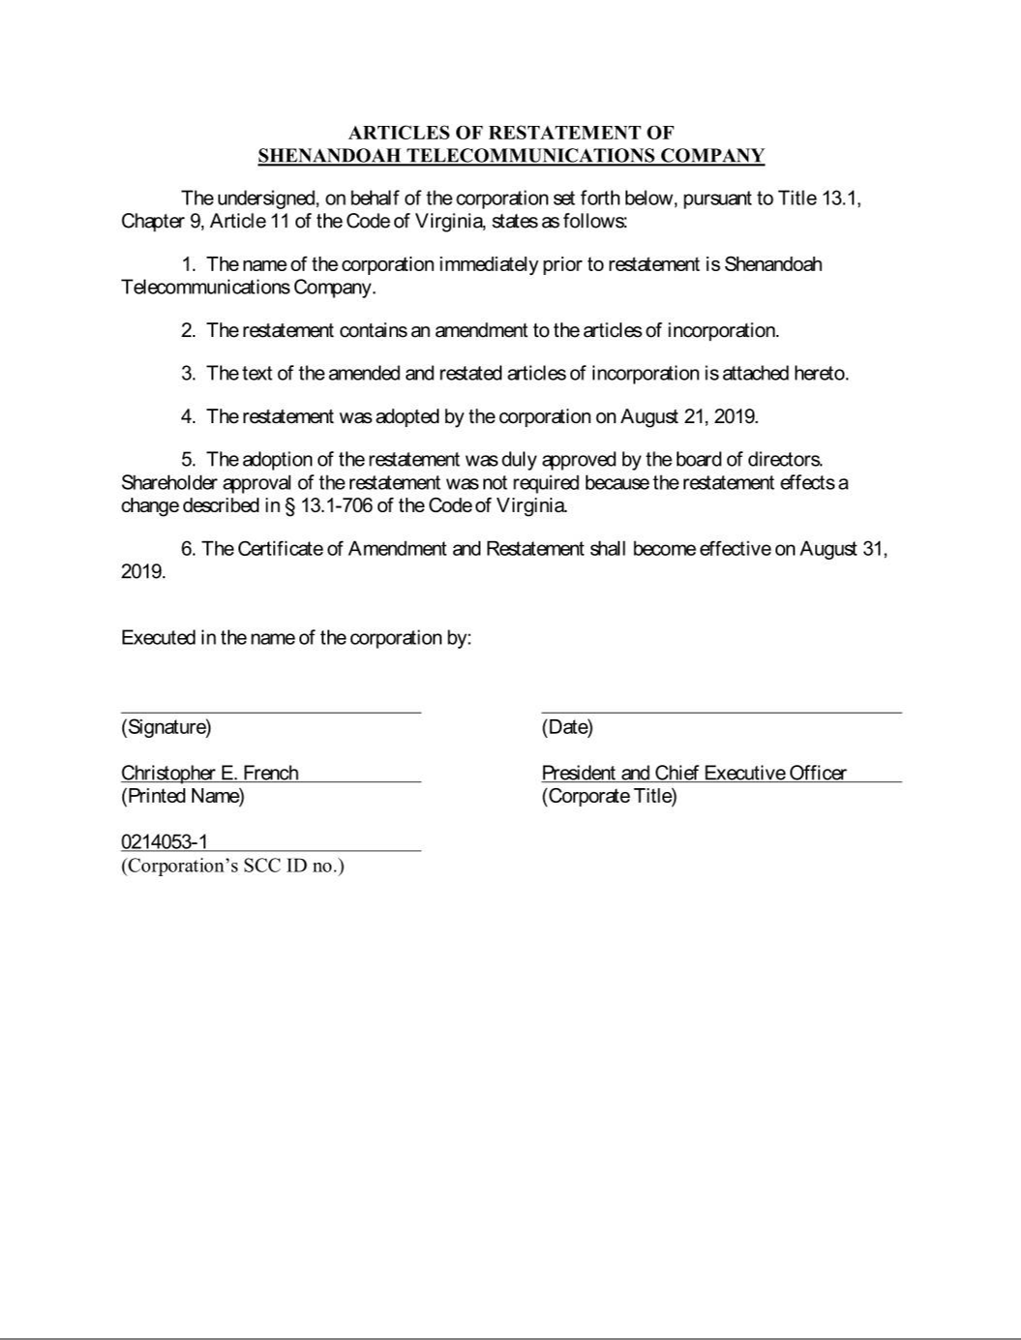

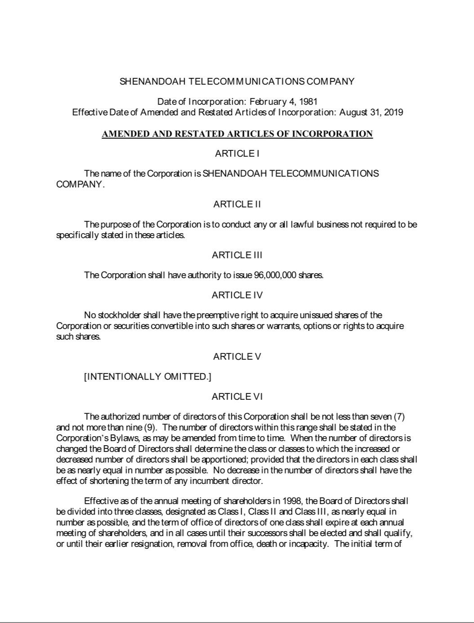

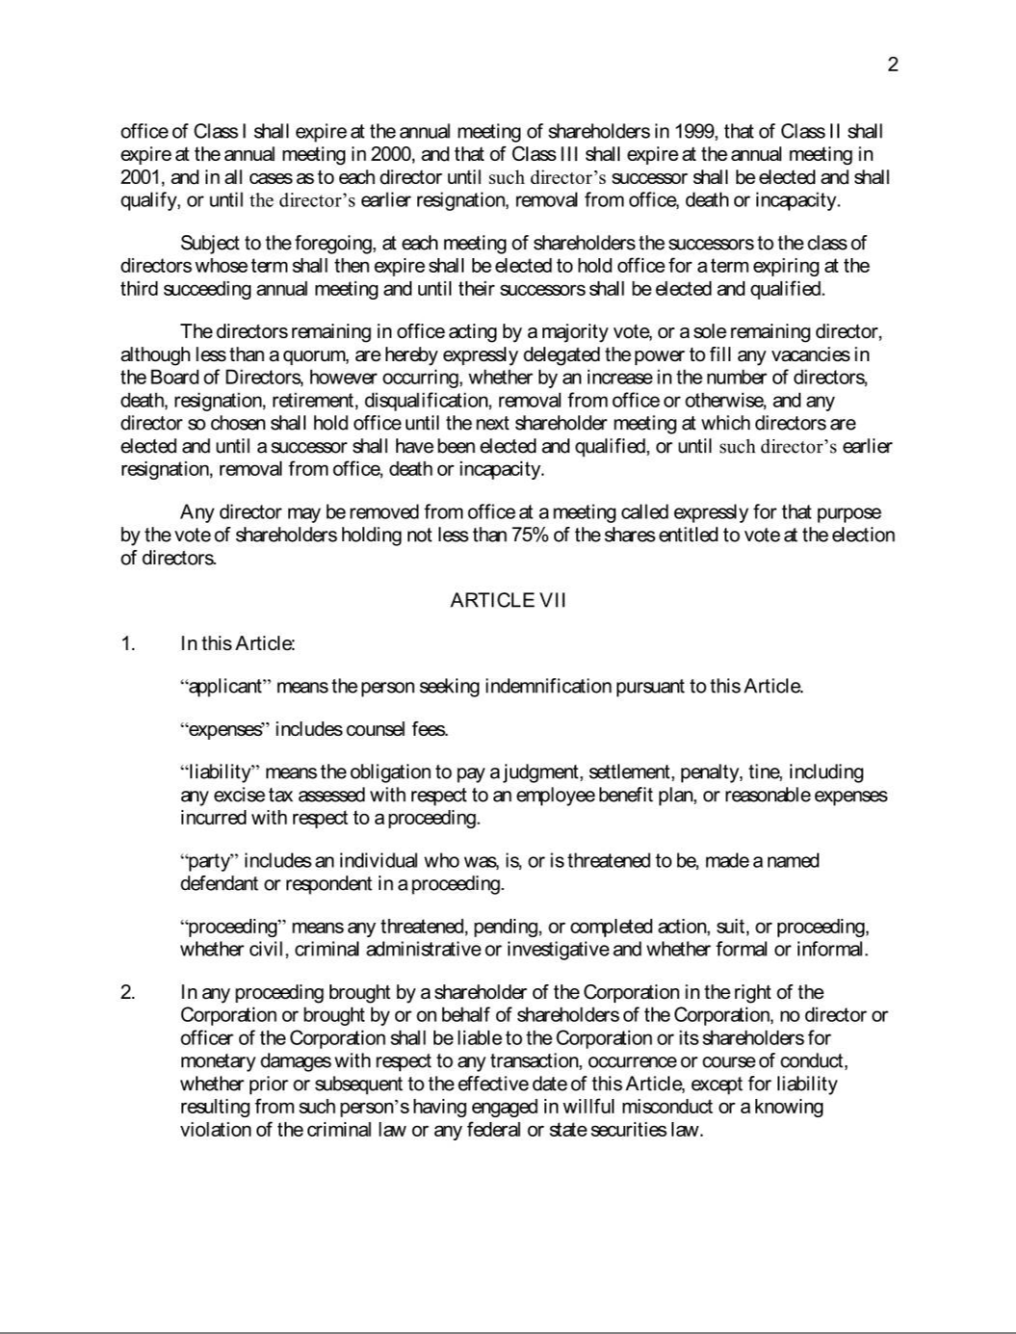

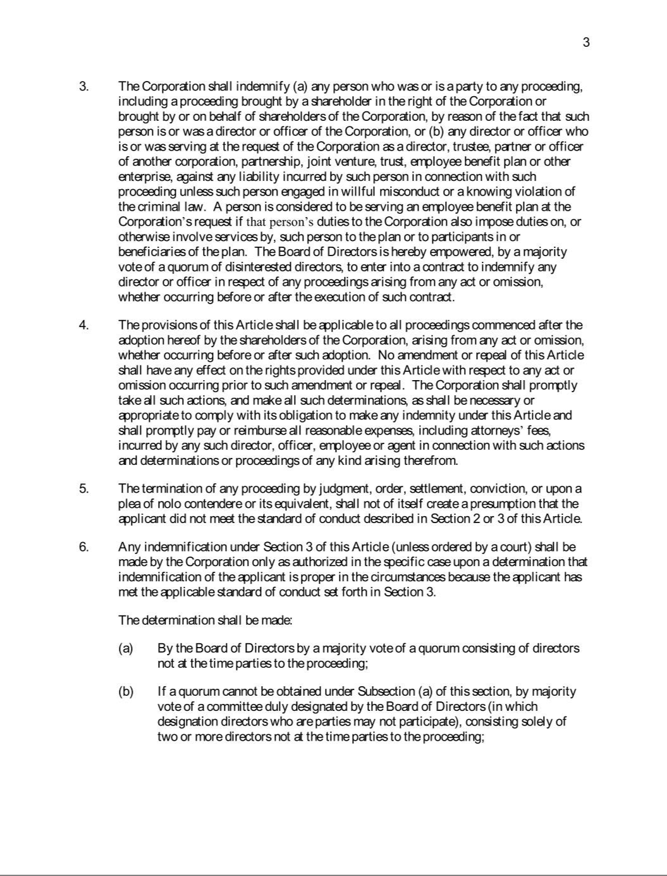

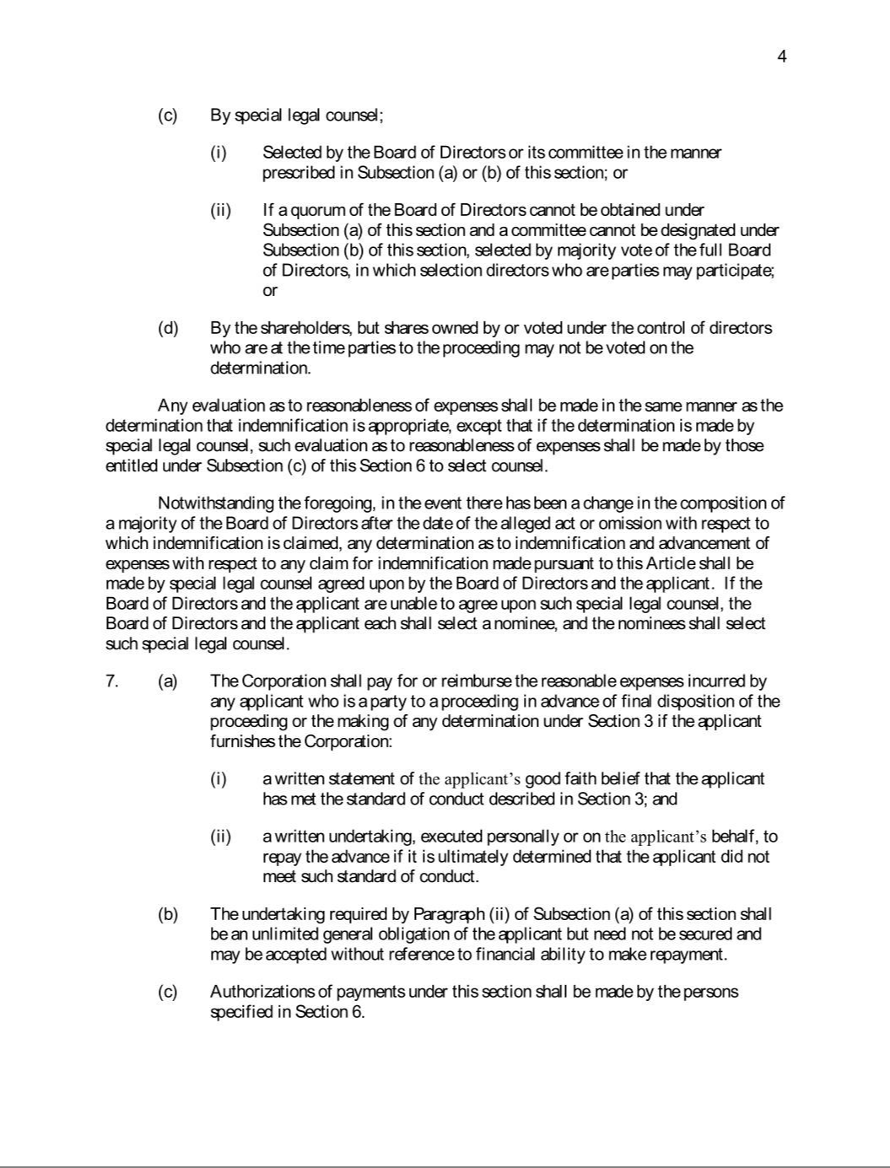

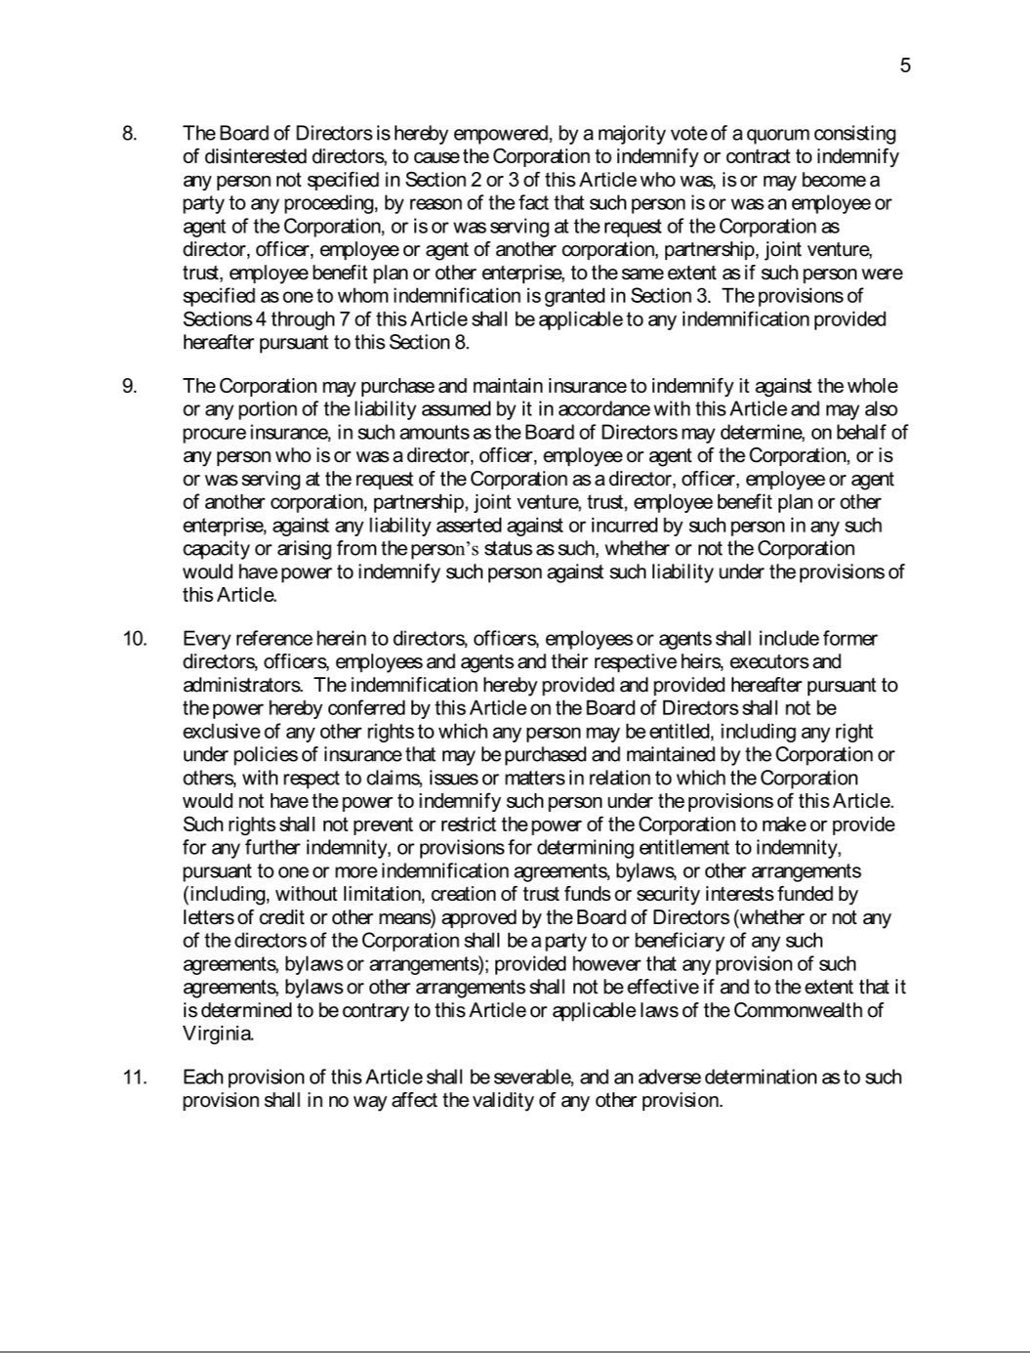

EXHIBIT 31.1

CERTIFICATION

I, Christopher E. French, certify that:

- I have reviewed this quarterly report on Form 10-Q of Shenandoah Telecommunications Company;

- Based on my knowledge, this report does not contain any untrue statement of a material fact or omit to state a material fact necessary to make the statements made, in light of the circumstances under which such statements were made, not misleading with respect to the period covered by this report;

- Based on my knowledge, the financial statements, and other financial information included in this report, fairly present in all material respects the financial condition, results of operations and cash flows of the registrant as of, and for, the periods presented in this report;

- The registrant’s other certifying officer(s) and I are responsible for establishing and maintaining disclosure controls and procedures (as defined in Exchange Act Rules 13a-15(e) and 15d-15(e)) and internal control over financial reporting (as defined in Exchange Act Rules 13a-15(f) and 15d‑15(f)) for the registrant and have:

  - Designed such disclosure controls and procedures, or caused such disclosure controls and procedures to be designed under our supervision, to ensure that material information relating to the registrant, including its consolidated subsidiaries, is made known to us by others within those entities, particularly during the period in which this report is being prepared;

  - Designed such internal control over financial reporting, or caused such internal control over financial reporting to be designed under our supervision, to provide reasonable assurance regarding the reliability of financial reporting and the preparation of financial statements for external purposes in accordance with generally accepted accounting principles;

  - Evaluated the effectiveness of the registrant’s disclosure controls and procedures and presented in this report our conclusions about the effectiveness of the disclosure controls and procedures, as of the end of the period covered by this report based on such evaluation; and

  - Disclosed in this report any change in the registrant’s internal control over financial reporting that occurred during the registrant’s most recent fiscal quarter (the registrant’s fourth fiscal quarter in the case of an annual report) that has materially affected, or is reasonably likely to materially affect, the registrant’s internal control over financial reporting; and

- The registrant’s other certifying officer(s) and I have disclosed, based on our most recent evaluation of internal control over financial reporting, to the registrant’s auditors and the audit committee of the registrant’s board of directors (or persons performing the equivalent functions):

  - All significant deficiencies and material weaknesses in the design or operation of internal control over financial reporting which are reasonably likely to adversely affect the registrant’s ability to record, process, summarize and report financial information; and

  - Any fraud, whether or not material, that involves management or other employees who have a significant role in the registrant’s internal control over financial reporting.

/S/ CHRISTOPHER E. FRENCH

Christopher E. French, President and Chief Executive Officer

Date: October 31, 2019

EXHIBIT 31.2

CERTIFICATION

I, James J. Volk, certify that:

- I have reviewed this quarterly report on Form 10-Q of Shenandoah Telecommunications Company;

- Based on my knowledge, this report does not contain any untrue statement of a material fact or omit to state a material fact necessary to make the statements made, in light of the circumstances under which such statements were made, not misleading with respect to the period covered by this report;

- Based on my knowledge, the financial statements, and other financial information included in this report, fairly present in all material respects the financial condition, results of operations and cash flows of the registrant as of, and for, the periods presented in this report;

- The registrant’s other certifying officer(s) and I are responsible for establishing and maintaining disclosure controls and procedures (as defined in Exchange Act Rules 13a-15(e) and 15d-15(e)) and internal control over financial reporting (as defined in Exchange Act Rules 13a-15(f) and 15d‑15(f)) for the registrant and have:

    - Designed such disclosure controls and procedures, or caused such disclosure controls and procedures to be designed under our supervision, to ensure that material information relating to the registrant, including its consolidated subsidiaries, is made known to us by others within those entities, particularly during the period in which this report is being prepared;

    - Designed such internal control over financial reporting, or caused such internal control over financial reporting to be designed under our supervision, to provide reasonable assurance regarding the reliability of financial reporting and the preparation of financial statements for external purposes in accordance with generally accepted accounting principles;

    - Evaluated the effectiveness of the registrant’s disclosure controls and procedures and presented in this report our conclusions about the effectiveness of the disclosure controls and procedures, as of the end of the period covered by this report based on such evaluation; and

    - Disclosed in this report any change in the registrant’s internal control over financial reporting that occurred during the registrant’s most recent fiscal quarter (the registrant’s fourth fiscal quarter in the case of an annual report) that has materially affected, or is reasonably likely to materially affect, the registrant’s internal control over financial reporting; and

  - The registrant’s other certifying officer(s) and I have disclosed, based on our most recent evaluation of internal control over financial reporting, to the registrant’s auditors and the audit committee of the registrant’s board of directors (or persons performing the equivalent functions):

    - All significant deficiencies and material weaknesses in the design or operation of internal control over financial reporting which are reasonably likely to adversely affect the registrant’s ability to record, process, summarize and report financial information; and

    - Any fraud, whether or not material, that involves management or other employees who have a significant role in the registrant’s internal control over financial reporting.

/s/JAMES J. VOLK

James J. Volk, Senior Vice President - Chief Financial Officer

(Principal Financial Officer)

Date: October 31, 2019

EXHIBIT 31.3

CERTIFICATION

I, Chase Stobbe, certify that:

- I have reviewed this quarterly report on Form 10-Q of Shenandoah Telecommunications Company;

- Based on my knowledge, this report does not contain any untrue statement of a material fact or omit to state a material fact necessary to make the statements made, in light of the circumstances under which such statements were made, not misleading with respect to the period covered by this report;

- Based on my knowledge, the financial statements, and other financial information included in this report, fairly present in all material respects the financial condition, results of operations and cash flows of the registrant as of, and for, the periods presented in this report;

- The registrant’s other certifying officer(s) and I are responsible for establishing and maintaining disclosure controls and procedures (as defined in Exchange Act Rules 13a-15(e) and 15d-15(e)) and internal control over financial reporting (as defined in Exchange Act Rules 13a-15(f) and 15d‑15(f)) for the registrant and have:

    - Designed such disclosure controls and procedures, or caused such disclosure controls and procedures to be designed under our supervision, to ensure that material information relating to the registrant, including its consolidated subsidiaries, is made known to us by others within those entities, particularly during the period in which this report is being prepared;

    - Designed such internal control over financial reporting, or caused such internal control over financial reporting to be designed under our supervision, to provide reasonable assurance regarding the reliability of financial reporting and the preparation of financial statements for external purposes in accordance with generally accepted accounting principles;

    - Evaluated the effectiveness of the registrant’s disclosure controls and procedures and presented in this report our conclusions about the effectiveness of the disclosure controls and procedures, as of the end of the period covered by this report based on such evaluation; and

    - Disclosed in this report any change in the registrant’s internal control over financial reporting that occurred during the registrant’s most recent fiscal quarter (the registrant’s fourth fiscal quarter in the case of an annual report) that has materially affected, or is reasonably likely to materially affect, the registrant’s internal control over financial reporting; and

  - The registrant’s other certifying officer(s) and I have disclosed, based on our most recent evaluation of internal control over financial reporting, to the registrant’s auditors and the audit committee of the registrant’s board of directors (or persons performing the equivalent functions):

    - All significant deficiencies and material weaknesses in the design or operation of internal control over financial reporting which are reasonably likely to adversely affect the registrant’s ability to record, process, summarize and report financial information; and

    - Any fraud, whether or not material, that involves management or other employees who have a significant role in the registrant’s internal control over financial reporting.

/s/CHASE STOBBE

Chase Stobbe, Vice President - Chief Accounting Officer

(Principal Accounting Officer)

Date: October 31, 2019

EXHIBIT 32

Written Statement of Chief Executive Officer and Chief Financial Officer

Pursuant to Section 906 of the Sarbanes-Oxley Act of 2002

Each of the undersigned, the President and Chief Executive Officer and the Vice President - Finance and Chief Financial Officer, of Shenandoah Telecommunications Company (the “Company”), hereby certifies that, on the date hereof:

- The quarterly report on Form 10-Q of the Company for the three months ended September 30, 2019 filed on the date hereof with the Securities and Exchange Commission (the “Report”) fully complies with the requirements of Section 13(a) or 15(d) of the Securities Exchange Act of 1934; and

- Information contained in the Report fairly presents, in all material respects, the financial condition and result of operations of the Company.

/S/CHRISTOPHER E. FRENCH

Christopher E. French

President and Chief Executive Officer

October 31, 2019

/S/JAMES J. VOLK

James J. Volk

Senior Vice President - Chief Financial Officer

(Principal Financial Officer)

October 31, 2019

The foregoing certification is being furnished solely pursuant to Rule 13a-14(b) under the Securities Exchange Act of 1934 (the “Exchange Act”) and 18 U.S.C. Section 1350 and is not being filed as part of the Report or as a separate disclosure document. This certification shall not be deemed “filed” for purposes of Section 18 of the Exchange Act or otherwise subject to liability under that section. This certification shall not be deemed to be incorporated by reference into any filing under the Securities Act of 1933 or the Exchange Act except to the extent this Exhibit 32 is expressly and specifically incorporated by reference in any such filing.

