UNITED STATES

SECURITIES AND EXCHANGE COMMISSION

Washington, D.C. 20549

FORM 8-K

CURRENT REPORT

Pursuant to Section 13 or 15(d) of the Securities Exchange Act of 1934

Date of Report (Date of earliest event reported): April 20, 2010

___________________

Shenandoah Telecommunications Company

(Exact name of registrant as specified in its charter)

__________________

Virginia

(State or other jurisdiction of incorporation)

0-9881

(Commission File Number)

54-1162807

(IRS Employer Identification No.)

500 Shentel Way

P.O. Box 459

Edinburg, VA

(Address of principal executive offices)

22824

(Zip Code)

Registrant’s telephone number, including area code: (540) 984-4141

Not applicable

(Former name or former address, if changed since last report.)

Check the appropriate box below if the Form 8-K filing is intended to simultaneously satisfy the filing obligation of the registrant under any of the following provisions (see

General Instruction A.2. below):

- Written communications pursuant to Rule 425 under the Securities Act (17 CFR 230.425)

- Soliciting material pursuant to Rule 14a-12 under the Exchange Act (17 CFR 240.14a-12)

- Pre-commencement communications pursuant to Rule 14d-2(b) under the Exchange Act (17 CFR 240.14d-2-(b))

- Pre-commencement communications pursuant to Rule 13e-4(c) under the Exchange Act (17 CFR 240.13e-4(c))

1

Item 5.07 Submission of Matters to a Vote of Security Holders.

On April 20, 2010, Shenandoah Telecommunications Company held its annual shareholder meeting. At the meeting, the following directors were appointed to three year terms, and one proposal, to ratify the selection of KPMG LLP as the Company’s independent registered public accounting firm for 2010, was approved by shareholders voting by proxy or in person. Vote totals for each director and the one proposal were as follows:

 |  | Votes |  | Votes
 |  | For |  | Withheld
Appointment of directors to three year terms:
 | Christopher E. French | 17,861,680 | 274,972
 | Dale S. Lam | 18,057,500 | 79,152
 | James E. Zerkel II | 17,875,006 | 261,646

 |  | Votes For |  | Votes Against |  | Abstentions
 | Ratify selection of KPMG LLP | 17,632,158 | 307,232 |  | 197,262
Item 7.01 Regulation FD Disclosure.

The following information is furnished pursuant to Regulation FD: On April 20, 2010, Shenandoah Telecommunications Company held its annual shareholder meeting. The materials attached hereto as Exhibit 99.1 and Exhibit 99.2 were presented at the meeting. The presentations are also available on the Company’s website.

The presentation may contain forward-looking statements about Shenandoah Telecommunications regarding, among other things, our business strategy, our prospects and our financial position. These statements can be identified by the use of forward-looking terminology such as “believes,” “estimates,” “expects,” “intends,” “may,” “will,” “should,” “could,” or “anticipates” or the negative or other variation of these or similar words, or by discussions of strategy or risks and uncertainties. Shenandoah Telecommunications undertakes no obligation to revise or update such statements to reflect current events or circumstances after the date hereof, or to reflect the occurrence of unanticipated events.

Item 9.01 Financial Statements and Exhibits.

(c) Exhibits

The following exhibits are filed with this Current Report on Form 8-K.

99.1 | Annual Meeting Presentation Slides
99.2 | Annual Meeting Scripts

SIGNATURE

Pursuant to the requirements of the Securities Exchange Act of 1934, the registrant has duly caused this report to be signed on its behalf by the undersigned thereunto duly authorized.

SHENANDOAH TELECOMMUNICATIONS COMPANY

(Registrant)

April 20, 2010 /S/ Adele M. Skolits

Adele M. Skolits

Vice President - Finance and

Chief Financial Officer

(Duly Authorized Officer)

2

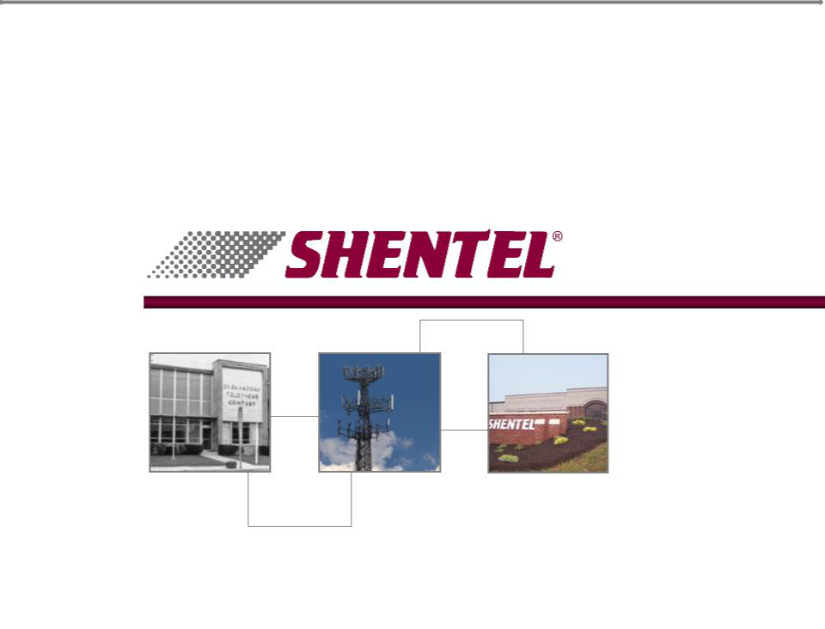
Exhibit 99.1

Annual Shareholder Meeting

April 20, 2010


Safe Harbor Statement

This presentation includes “forward-looking statements” within the meaning of Section 27A of the Securities Act and Section 21E of the Securities Exchange Act of 1934, as amended, regarding, among other things, our business strategy, our prospects and our financial position. These statements can be identified by the use of forward-looking terminology such as “believes,” “estimates,” “expects,” “intends,” “may,” “will,” “should,” “could,” or “anticipates” or the negative or other variation of these similar words, or by discussions of strategy or risks and uncertainties. These statements are based on current expectations of future events. If underlying assumptions prove inaccurate or unknown risks or uncertainties materialize, actual results could vary materially from the Company’s expectations and projections. Important factors that could cause actual results to differ materially from such forward-looking statements include, without limitation, risks related to the following:

qIncreasing competition in the communications industry; and qA complex and uncertain regulatory environment.

A further list and description of these risks, uncertainties and other factors can be found in the Company’s SEC filings which are available online at www.sec.gov, www.shentel.com or on request from the Company. The Company does not undertake to update any forward-looking statements as a result of new information or future events or developments

2

Use of Non-GAAP Financial Measures

Included in this presentation are certain non-GAAP financial measures that are not determined in accordance with US generally accepted accounting principles. These financial performance measures are not indicative of cash provided or used by operating activities and exclude the effects of certain operating, capital and financing costs and may differ from comparable information provided by other companies, and they should not be considered in isolation, as an alternative to, or more meaningful than measures of financial performance determined in accordance with US generally accepted accounting principles. These financial performance measures are commonly used in the industry and are presented because Shentel believes they provide relevant and useful information to investors. Shentel utilizes these financial performance measures to assess its ability to meet future capital expenditure and working capital requirements, to incur indebtedness if necessary, return investment to shareholders and to fund continued growth. Shentel also uses these financial performance measures to evaluate the performance of its businesses and for budget planning purposes.

3

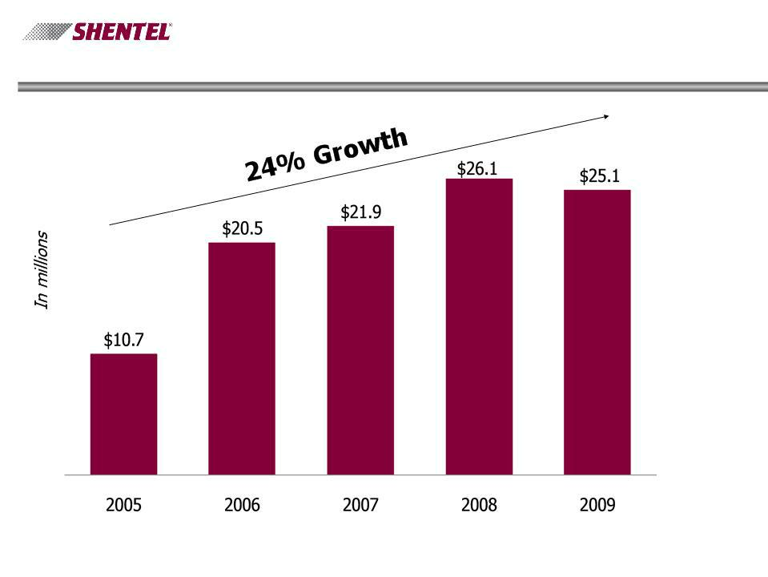
Net Income from Continuing Operations

4

Cable Segment Operating Losses

5

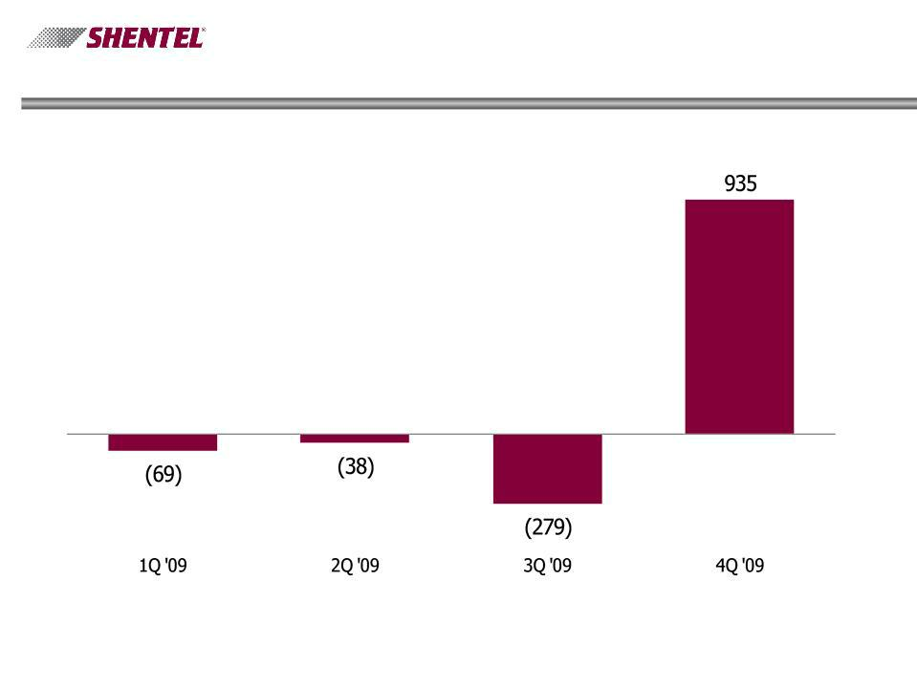
Cable Segment RGU Growth

Excludes the impact of RGU’s in markets sold in 4Q’09

6

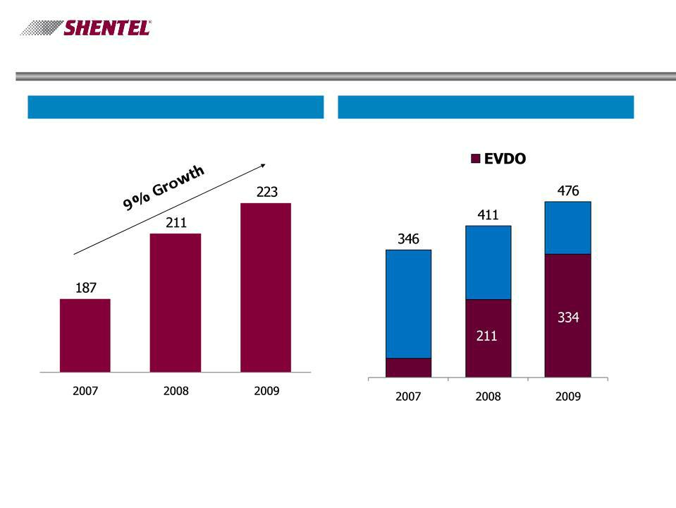
Wireless Segment

PCS Subscribers (000s) Number of Cell Sites

7

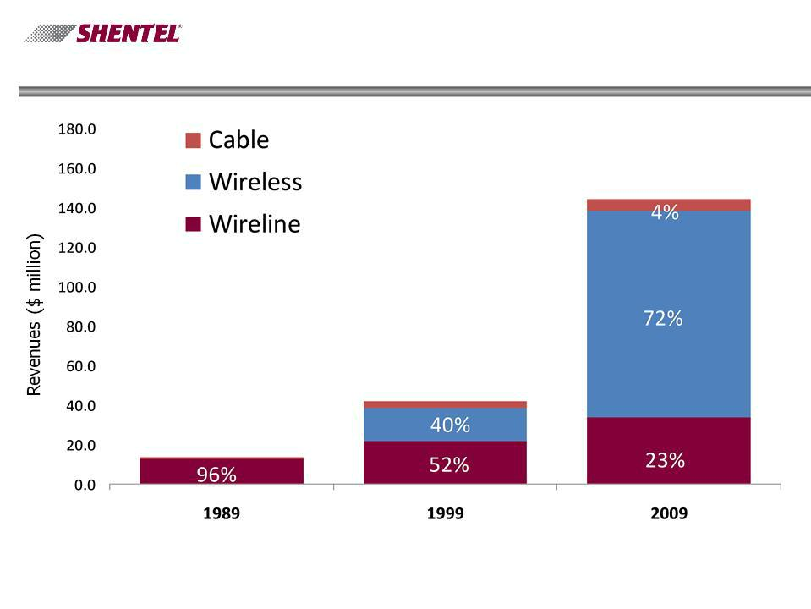
Need for Diversification

8

Acquisition of Jet Broadband

- Diversification

- Scale

- Coaxial Network

- Synergies

- Geographic Fit

- Leveraging Core Competencies

9

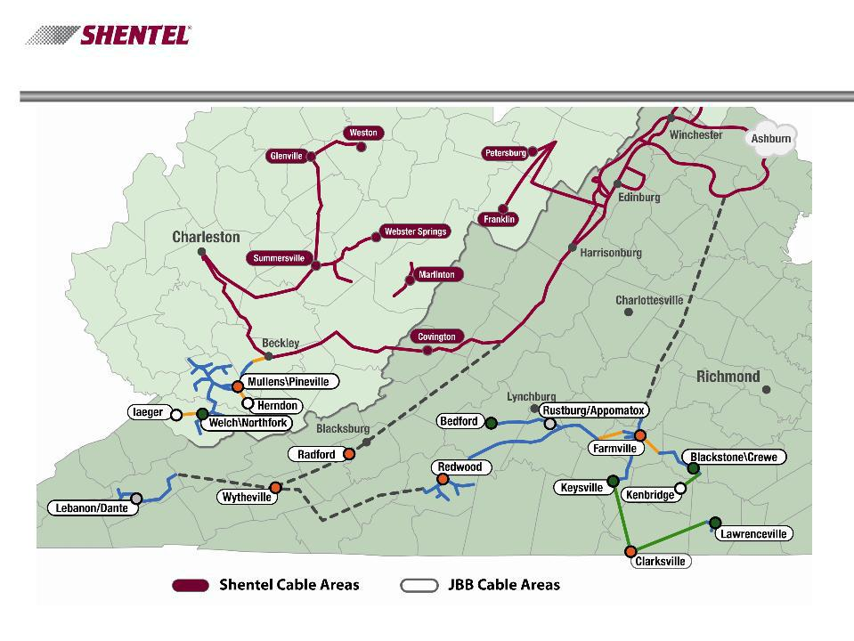
JBB Network

10

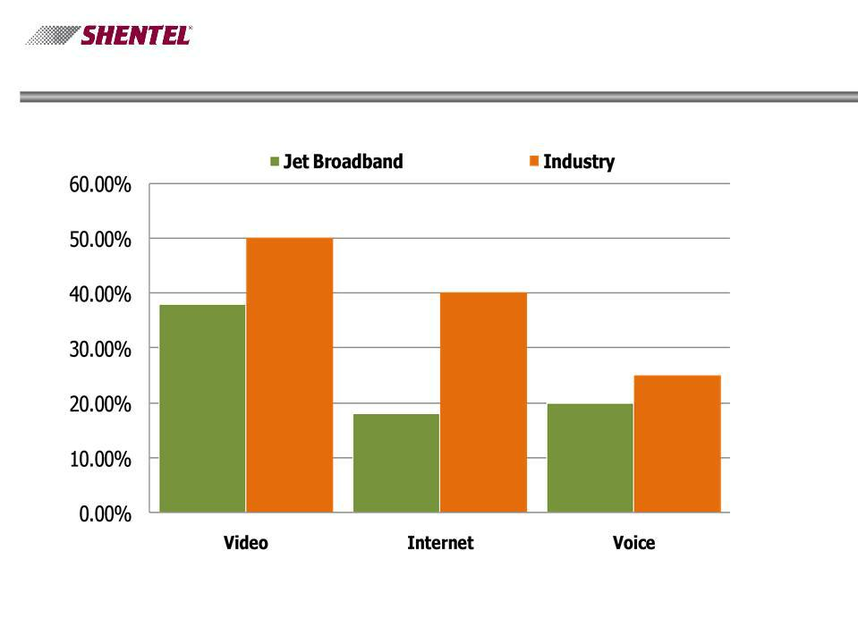
Percent of Homes Passed with Services

11

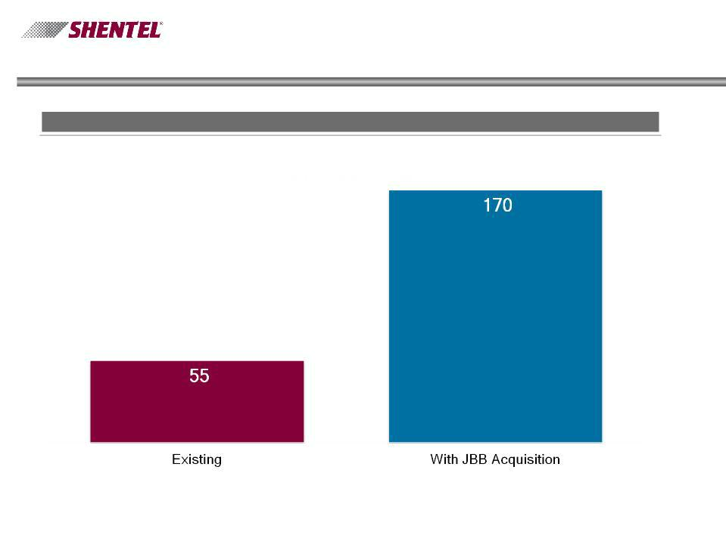
Key Operational Metrics With Jet Broadband

Pro Forma for Periods Ending December 31, 2009

Cable Homes Passed (in 000’s)

12

Key Operational Metrics With Jet Broadband

Pro Forma for Periods Ending December 31, 2009

RGU’s (in 000’s)

13

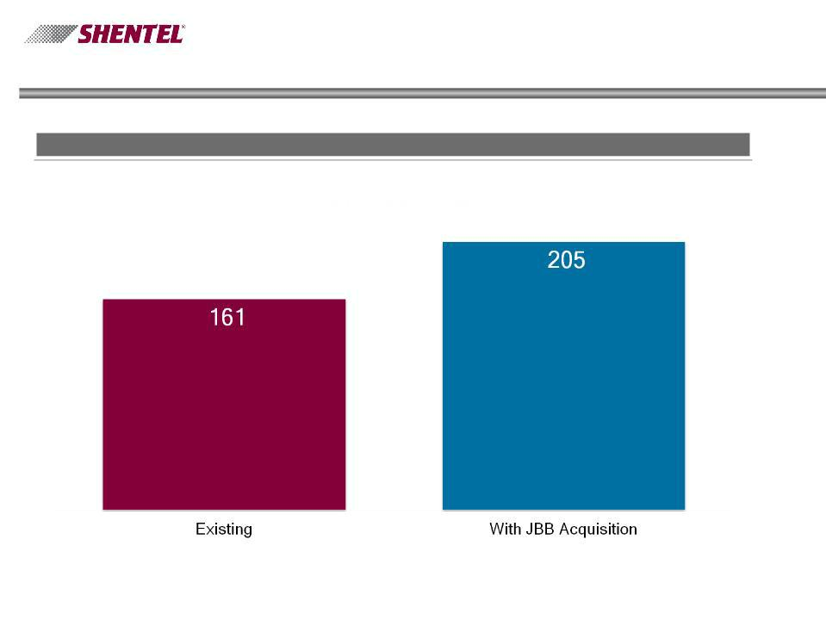
Key Operational Metrics - With Acquisition

Pro Forma for Periods Ending December 31, 2009

Revenues (in millions)

14

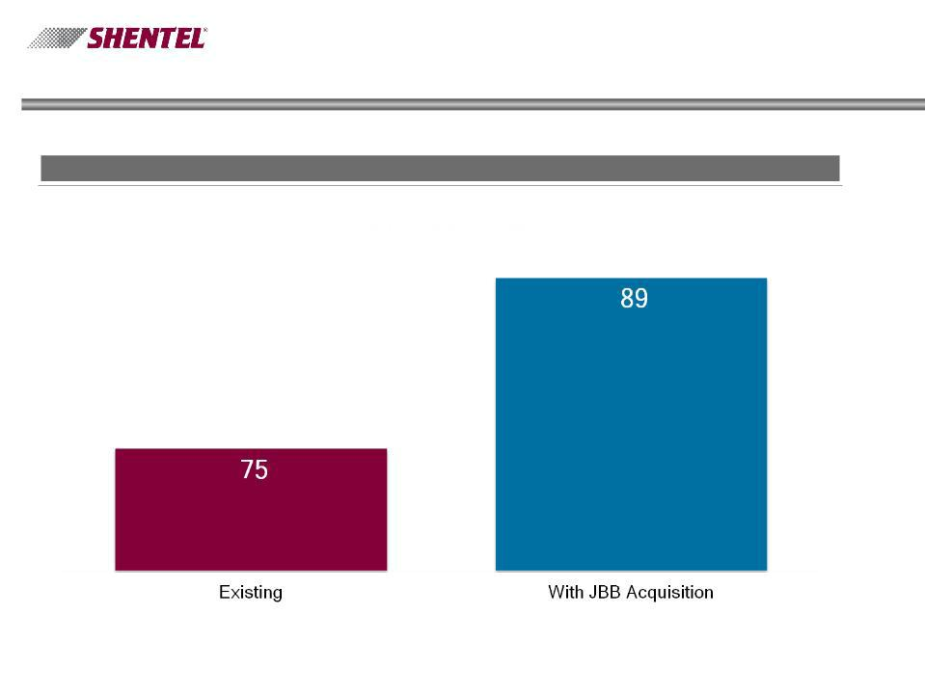
Key Operational Metrics - With Acquisition

Pro Forma for Periods Ending December 31, 2009

Operating Income Before Depreciation and Amortization (in millions)

15

Adele Skolits

CFO and VP of Finance

16

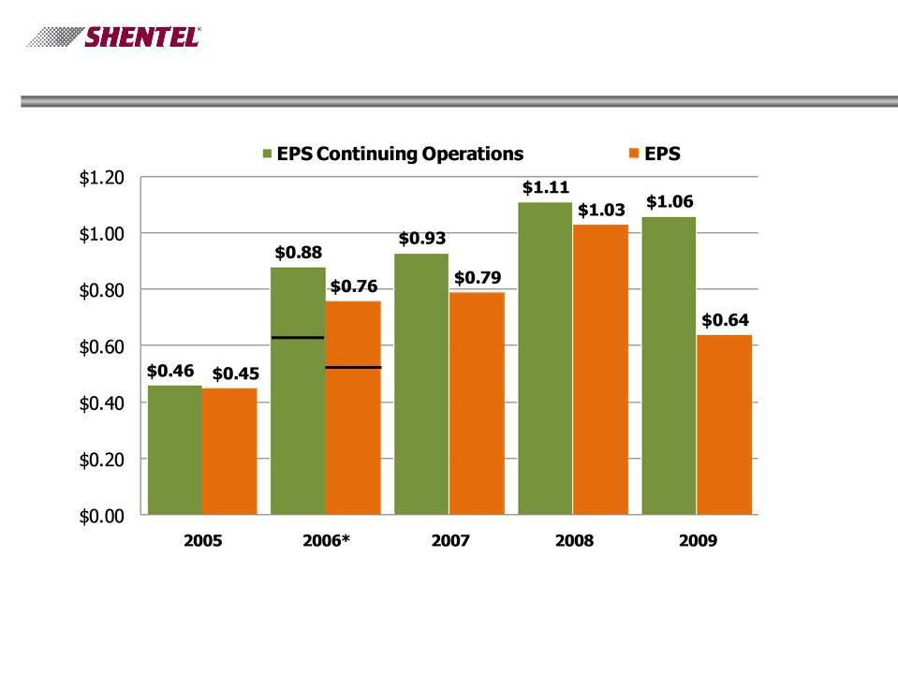
Earnings Per Share (EPS)

*-Includes gain on sale of Rural Telephone Bank stock of $.27 in EPS from Continuing
Operations and EPS | 17

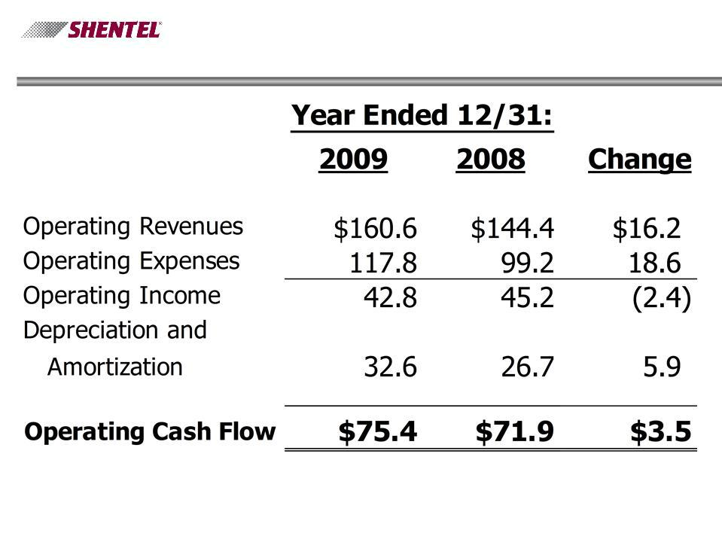
Profitability ($millions)

18

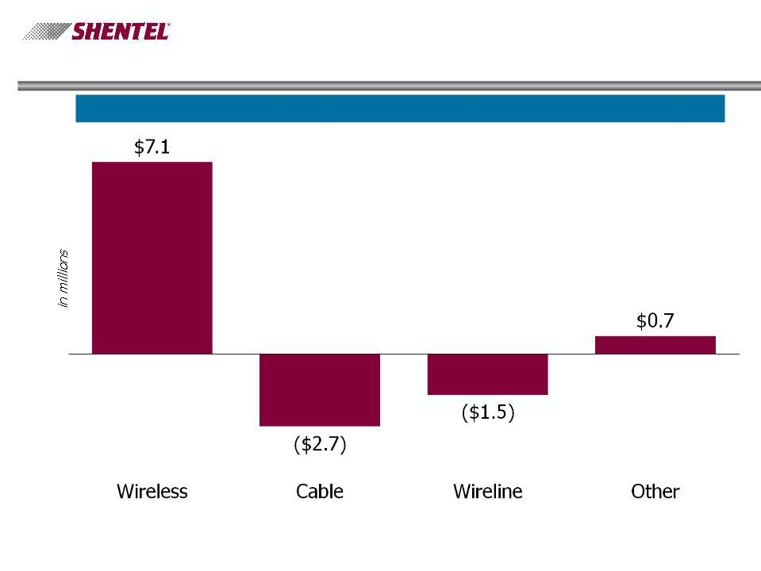
Operating Cash Flow

Change between 2008 and 2009

19

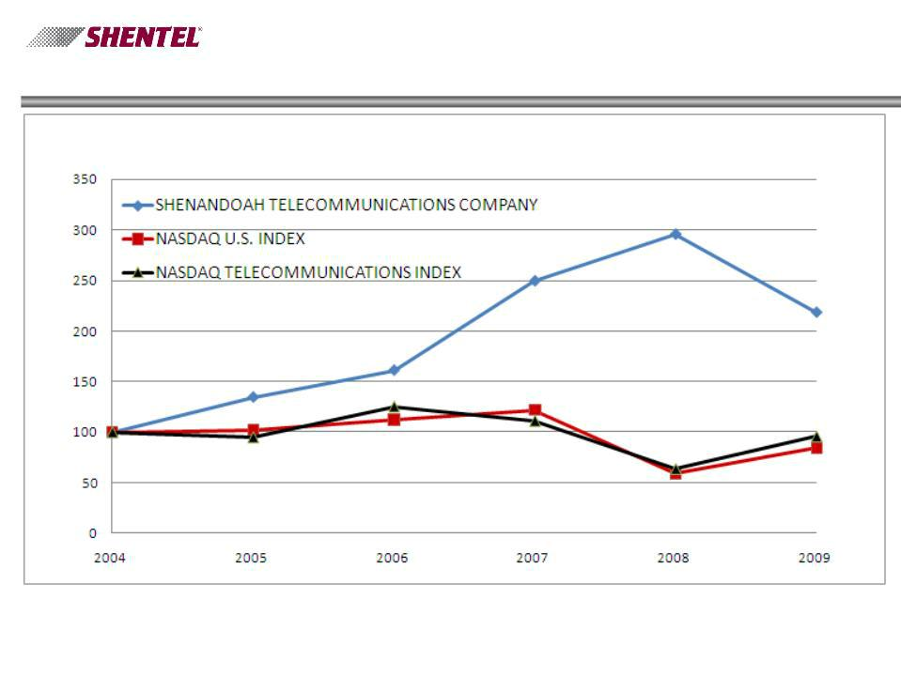
Total Return - 5 Years

20

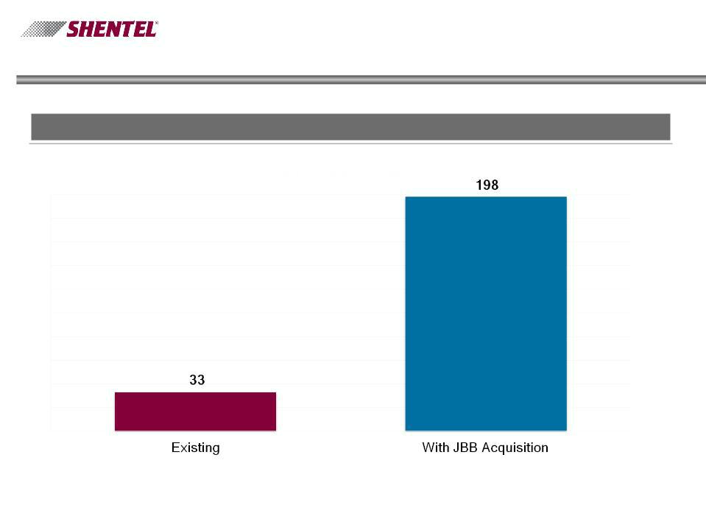
Level of Debt

Periods Ending December 31, 2009

Debt (in millions)

21

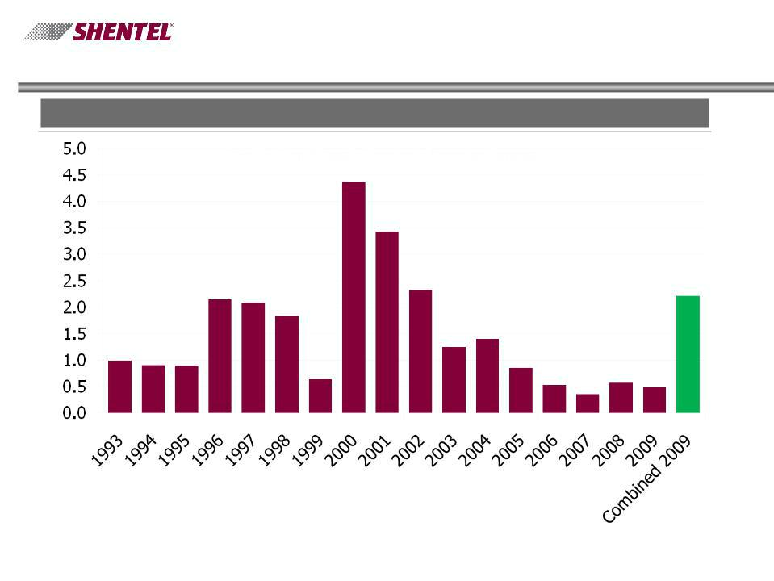
Level of Debt

Debt to Operating Cash Flow

22


Shareholder Services

Direct Registration

-Eliminates the need for physical stock certificates -Eliminates the risk of certificates being lost, stolen
or destroyed

-To use, need to surrender paper certificates -Entirely optional

Householding

-Will now only send one copy of the proxy statement and annual report to a household

-Still will get separate proxy cards for each shareholder account
-Can elect to continue receiving multiple copies

-Information will be mailed in coming weeks

23

Earle MacKenzie

COO and EVP

24

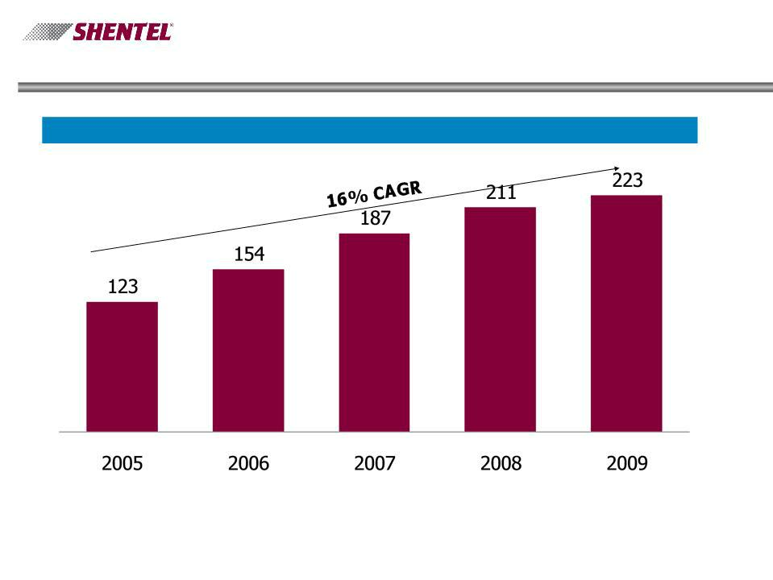
Key Operational Results - Wireless

PCS Retail Subscribers (000s)

25

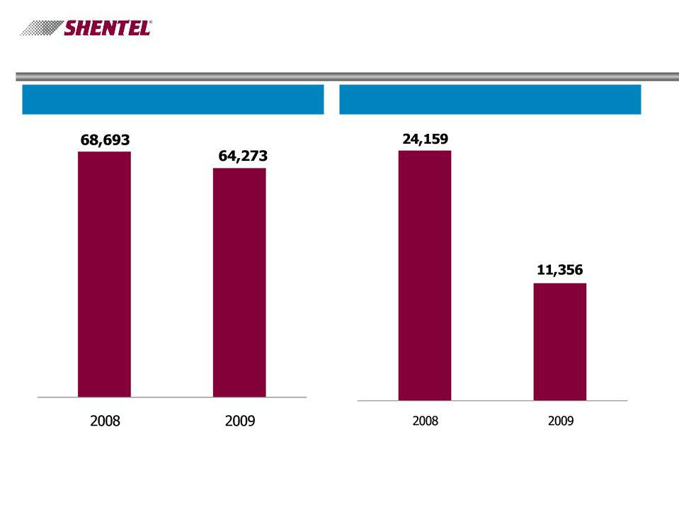
Key Operational Results - Wireless

PCS Gross Additions PCS Net Additions

26

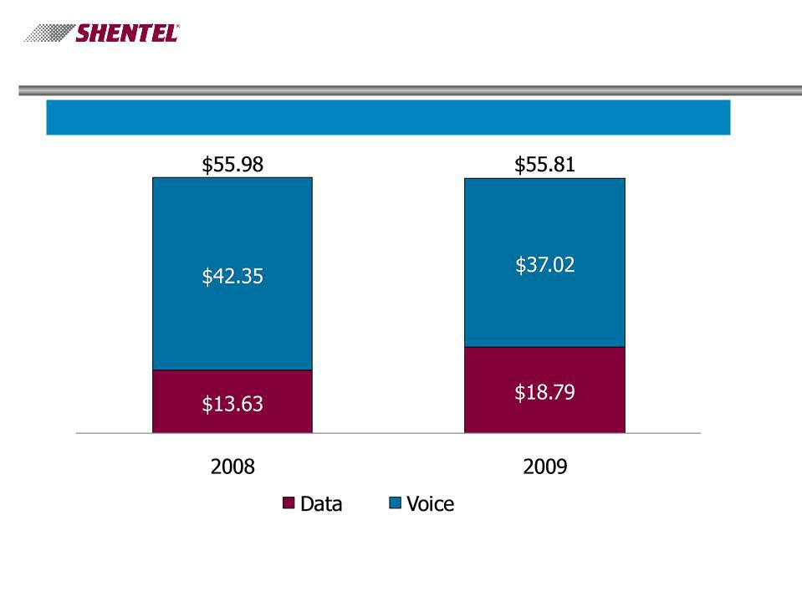
Key Operational Results - Wireless

PCS Gross Billed Data & Voice

27

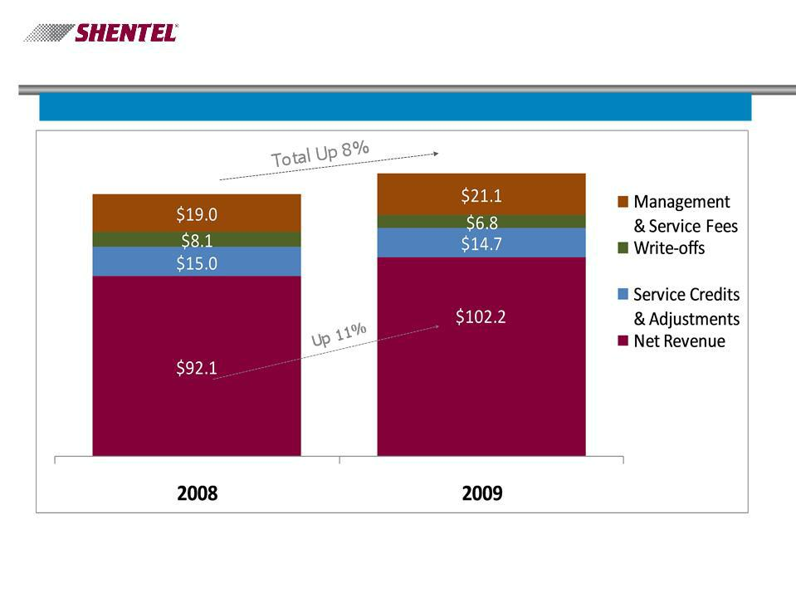
Key Operational Results - Wireless

PCS Annual Billed Service Revenues (in millions)

$144.8

$134.2

28

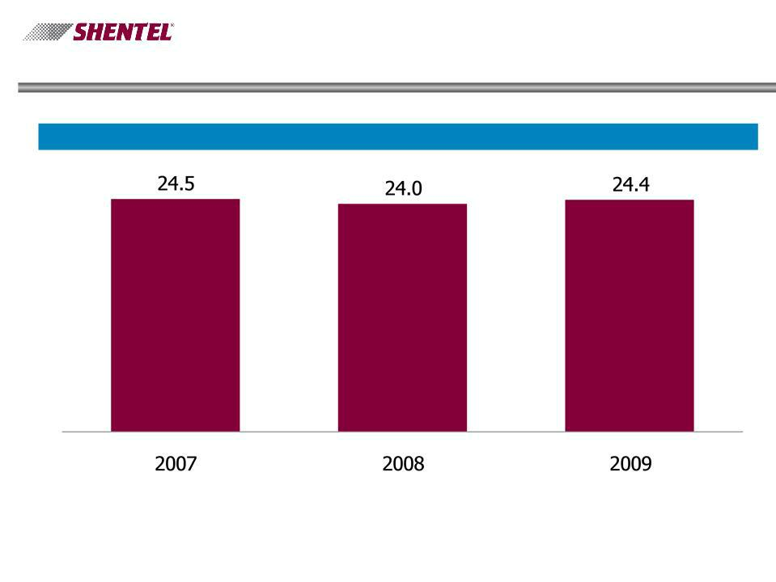
Key Operational Results - Wireline

Access lines (000s)

29

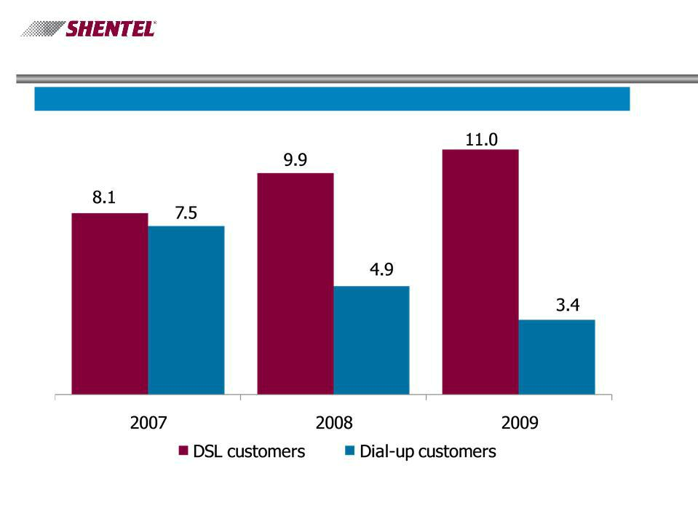
Key Operational Results - Wireline

Internet Customers (000s)

30

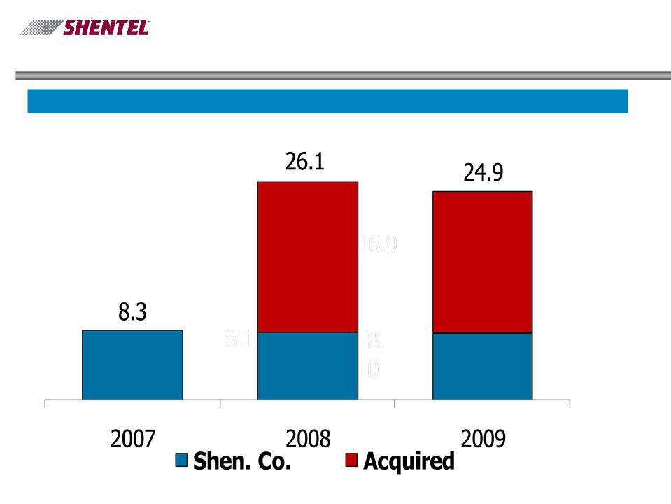
Key Operational Results - Cable

Number of RGUs (000’s)

31

Capital Expenditures by Segment ($ millions)

32

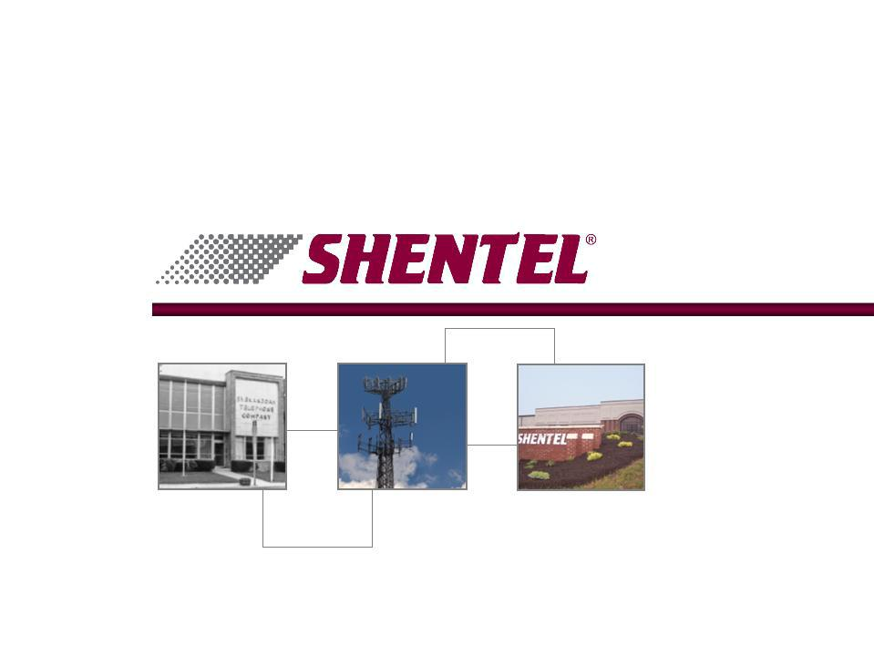

Annual Shareholder Meeting

April 20, 2010

Exhibit 99.2

Shenandoah Telecommunications Company

President’s Report

Annual Meeting of Shareholders, April 20, 2010

[Slide 1]

Before we get into some of the numbers, we have disclosures to make regarding forward-looking statements and our use of non-GAAP financial measures. [Slide

2] The first discloses that our presentations include “forward-looking statements” in accordance with the rules of the Securities and Exchange Commission, and they may contain our current expectations of future events. The second [Slide 3] points out that some of the performance metrics we discuss are not determined in accordance with generally accepted accounting practice, or GAAP, but they are commonly used in our industry and we believe they can provide relevant and useful information regarding our Company’s performance.< /font>

Despite the difficulties in the general economy in 2009, your company again had a good year. We had strong financial and operating results. We continued to grow and improve our PCS business. We successfully integrated the acquired cable business in West Virginia and Covington, Virginia and have begun generating growth in that business segment.

On a consolidated basis, [Slide 4] our net income from continuing operations for the year was $25.1 million, a slight decrease from $26.1 million in 2008, but still a compound annual growth rate of 24% since 2005. Revenues were $161 million, an increase of over $16 million, or more than eleven percent. This strong increase was primarily driven by growth of $9.4 million from cable segment revenues, due to the properties we acquired in late 2008. As a result of our strong financial performance for the year, in December the Company increased its annual cash dividend to 32 cents per share, a seven percent increase over 2008.

Page 1

While our cable segment made a large positive contribution to our revenue growth in 2009, it also had a big negative impact on our operating income. [Slide 5] This was not unexpected, as the properties initially required network enhancements, and we launched our services in each upgraded market with vigorous marketing campaigns. The financial returns on these investments will take a few years to be realized; however, we are off to a good start establishing a reputation for great service, which we view as a prerequisite to operating profitably.

In addition to improving the quality of basic cable service, the network upgrades enable us to offer high speed data and premium video services. They also give us the platform from which to begin offering voice services which we launched in initial markets earlier this month. We count and track each of these services (voice, video and data) as a separate Revenue Generating Unit, or RGU. If a customer only has one of our services, that is counted as one RGU. If a customer has three services, that is three RGUs. Counting RGUs lets us see how well we are doing, not just in adding customers, but also in selling additional services to existing customers.

We see improvements in customer retention and an uptick in growth in RGUs occurring after we complete network upgrades. The bulk of the 2009 upgrade work occurred in the later part of the year, and as you can see on this slide, [Slide 6] it helped drive the big jump in RGUs seen in the fourth quarter. In that quarter, RGUs were up 935, giving us a net gain for the year. This excludes the impact of the sale of certain non-core cable markets in West Virginia.

Although on a much smaller scale, a more recent acquisition was our purchase of North River Telephone Cooperative. The cooperative’s assets were acquired in November 2009 for $600 thousand; and, we invested an additional $2.1 million to make DSL available to 100% of the access lines within a year. We fulfilled this commitment in just five months, and these customers in rural Augusta County now have the access to high speed data services that many in more densely populated areas still do not have.

Page 2

Moving from cable to wireless, on this slide [Slide 7] we have provided highlights of our wireless segment’s results. During 2009, net PCS retail customers grew by over 11,000, bringing total customers to nearly 223,000. This growth led to an increase in average customers of eight percent over 2008. Due to economic conditions, our rates of growth in PCS additions have slowed, but we were pleased with our ability to continue adding customers given the state of the economy. Our ability to do this in 2009 is particularly impressive relative to our industry peers, with some actually losing customers. During the year, we continued to invest in our wireless network, adding 65 new sites, and we further expanded our high speed wir eless data coverage, which now reaches 95 percent of our covered POPS. We have seen increases in billed revenue per user from data services, and these additional sites should help us to continue that growth.

[pause]

For those of you who may have attended these meetings back in the 1990’s, you may recall us talking about our need to diversify away from dependence on our telephone subsidiary. Now part of our wireline segment, telephone was by far our most significant subsidiary, providing the largest source of our revenues and basically all of our profits. Looking back at the 1989 annual report, [Slide 8] our telephone company contributed the bulk of revenues with all of our wireLINE businesses generating 96% of total revenues. That was the year we were just getting ready to start our cellular business.

Jumping ahead to 1999, wireLESS growth from our original cellular and our newer PCS businesses, brought wireLINE revenues down to about 52% of total. Now let’s fast forward to 2009. Last year, wireLINE revenues, which were still growing throughout these years, represented only 23% of total revenues. Growth in our wireLESS business has led that segment to now contribute 72% of total revenues.

Page 3

What should be obvious is that our success with our earlier diversification efforts now has us needing to diversify again, but this time away from wireless into non-wireless areas. Our 2008 acquisition of the Rapid Communications cable properties was an initial step in this direction. I’m sure that many of you are aware of our next, and bigger, step as we announced Friday an acquisition of JetBroadband.

We have signed an agreement to purchase the assets and customers of JetBroadband for a purchase price of $148 million. Jet is a cable TV operator in south-side Virginia and southern West Virginia. This is a bold move for our Company, but one which is also a great strategic fit for our organization. [Slide 9] The acquisition positions us to further grow our cable business and diversify away from our heavy dependence on our relationship with Sprint. I just mentioned that wireless was 72% of our revenues last year, leaving only 28% of revenues coming from non-wireless sources. With the addition of JetBroadband, our non-wireless revenues become almost half of our total.

The acquisition will help improve the economies of scale of our cable business. We are very excited about the growth opportunities in cable, but our current cable operations are not of an adequate size, and do not enjoy the margins benefitting larger operators. Adding the JetBroadband systems will move us closer to that goal.

This map [Slide 10] shows the major towns and cities that are served by Jet. They include the Virginia communities of Farmville, Blackstone, Radford, Bedford and the area around Smith Mountain Lake, in addition to communities in southern West Virginia. Farmville and Radford are growing university towns. Smith Mountain Lake is a major recreation area with a significant number of upscale second homes. We are very familiar with these areas and they are only hours away from Edinburg. The acquisition will allow us to leverage our management team, back office systems and assets, helping to maximize the investment return. This map also shows our existing cable markets and fiber network, and how they align with the JetBroadba nd properties. You see that they fit together nicely.

Page 4

As I stated earlier, the integration of the Rapid Communications acquisition has gone very well and we are now meeting and exceeding our growth expectations. We see great growth potential in the JetBroadband markets. By combining the expertise of our management team with the financial resources we’re able to obtain on attractive terms, we believe we can accelerate the growth curve in these markets. This slide [Slide 11] shows the current penetration levels of services per homes passed. You can see the growth potential just getting the numbers up to the industry averages. Our goal of course is to be better than average, and we hope to exceed those penetration levels.

This acquisition is clearly a big commitment to our cable segment and for our Company. We think it is the right thing to do because we are convinced that the future of telecommunications is broadband, and cable systems have advantages in providing broadband services. Although our roots are deep as a telephone company, the fiber/coax network of a cable system is technically superior and more cost effective at delivering voice, video and data, than is the fiber/twisted pair network of a phone company. Our primary competitors in these areas will be the local telephone companies, primarily Verizon, Frontier and CenturyLink. With our focus on providing quality service, we are confident that we will be able to effectively compete for market share.

The acquisition is expected to cause a downward trend in net income in the next few years, with the biggest negative impact most likely being in 2011 as the first full year of operation. 2012 and beyond is when we should begin to realize the long term positive impact on our results.

Here are a couple of slides [Slide 12] that provide a snapshot of the relative size of JetBroadband and the significant impact it will have on our operations. Today, between the homes passed by cable in Shenandoah County and the areas we purchased from Rapid, we reach approximately 55 thousand homes. With the additional 115 thousand homes passed by JetBroadband, the total will be 170 thousand.

Page 5

As of December 31, 2009, [Slide 13] we had a combined 25 thousand RGUs in our cable segment. With an additional 67 thousand from Jet, we will almost quadruple our RGUs to 92 thousand. Our 2009 [Slide 14] consolidated revenues were $161 million. Jet will bring the combined total to over $200 million. On a combined basis, [Slide 15] our Operating Income before Depreciation and Amortization would grow from $75 million to $89 million, with the potential to rapidly increase in future years.

We are very excited about what we see as significant upside in both revenue and cash flow over the next few years. Although we expect wireless to continue to grow, we believe that the cable segment has the ability to grow even faster. We expect to close this transaction by mid 2010, but the work of integration has already begun.

Our conservative balance sheet has a relatively small amount of debt today, and lenders view us as a very attractive borrower. This gives us access to the debt needed to fund this acquisition. I’ll let Adele talk about the financing she has been able to arrange when she gives her presentation, but we believe the availability of that financing, at attractive prices, is a testament both to the strength of our Company and to the growth prospects this transaction brings to our organization. I look forward to being able to report on our progress at next year’s meeting.

[Slide 16]

Page 6

Annual Meeting of Shareholders, April 20, 2010

The Prepared Remarks of

Adele M. Skolits

Vice President – Finance and Chief Financial Officer

[Slide 16] – Title Slide – Financial Review – Adele Skolits - CFO

Good morning. This morning I’ll be reviewing Shentel’s annual financial results for 2009, and will talk about the financing of the JetBroadband acquisition.

As Chris mentioned, we are pleased with our 2009 results. [Slide 17] The company continues to deliver solid returns for its shareholders. Our earnings per share from continuing operations were $1.06 for 2009 or a decrease of 5 percent over 2008. This decrease was primarily attributable to the losses associated with the acquired cable operations, as I’ll review in greater depth in a moment.

The non-cash impairment charge we recorded in the first quarter of 2009 of $10.7 million after taxes, reduced total earnings per share by $.45. This combined with the impact of the cable operations caused total earnings per share to be $.64. We are still working with potential buyers on the sale of our Converged Services operations, but unfavorable market conditions continue to cause delays. We expect that a sale will be consummated in 2010.

You can see [Slide 18] that operating revenues grew by $16.2 million for the year 2009 relative to 2008, primarily due to increases in wireless revenues and the impact of newly acquired cable operations for the year. Operating expenses grew by $18.6 million for 2009 relative to 2008. Increased costs of the PCS and other networks and newly acquired cable operations drove most of the expense increase. 2009 operating income was $2.4 million below 2008, however, operating cash flow grew by $3.5 million.

You can also see [Slide 19] the segments’ contribution to the change in the cash generated from operations. The Wireless segment generated an additional $7.1 million for 2009 over 2008, as a result in the growth of its customer base. Cash generated from the cable operations decreased by $2.7 million for 2009 over 2008 due to the factors impacting operating income that Chris mentioned. The cable decline for 2008 included just one month of operating the acquired cable business and 2009 includes the impact of operating the business for a full twelve months. The Wireline segment generated $1.5 million less in 2009 as a result of a decrease in the access fees we receive from long distance companies to originate and terminate their traffic .

Page 7

We terminated our defined benefit pension plan in January 2007 and it was only this February when we finally received a favorable determination letter from the

IRS. The final process of distributing the plan assets is underway and expected to be completed in the second quarter of 2010. At that time, we expect to record an incremental

$3.4 million of expense related to terminating the plan and to make a cash contribution of approximately $.6 million to fund the remaining liability.

Let’s take a look at how your stock has performed. This chart [Slide 20] shows the total return you have realized by holding our stock for the past five years. It represents the value you would have had at the end of 2009 if you had invested $100 in Shentel stock at the end of 2004 and reinvested all dividends. By the end of 2009, that original $100 was worth $219, a compound annual growth rate of 17 percent. That’s a great return; but, you can also see that it greatly exceeds the returns of the benchmark indexes, which were down between 1 and 3 percent for the same period.

On this slide, [Slide 21] I have shown the level of debt that Shentel carries as of December 31, 2009 as the maroon bar on the left. In order to finance the purchase of JetBroadband and make the necessary upgrade to its network, we’ll need to borrow at least an additional $198 million. This slide [Slide 22] shows the level of debt Shentel has carried in past years in relation to the cash generated from its operations. The green bar on the right represents the resulting ratio of debt after the acquisition of Jet. You can see that at the high water mark of historical debt ratios was 4.5 times cash from operations. This period in our history was during the early years of our PCS business, when we were very diligently working to develop a robust wireless network. This required a substantial investment in advance of bringing on customers and revenues. You can see the ratio of debt decreased substantially in the next couple of years as the returns from our investments were realized. Although the absolute amount of debt we are borrowing is greater, we had a much higher debt load back in 2000 and 2001 relative both to the size of the company and to our ability to repay that debt. We are very confident that we will generate adequate earnings and cash to repay the debt, grow the business and continue to pay dividends.

Page 8

We have worked with a syndicate of banks to negotiate a debt facility to finance the Jet acquisition. We have structured the facility to include a term loan of $198 million and a revolver of $50 million. We do not expect to draw on the revolver when we close on the acquisition. This facility will be adequate to allow us to fully finance the acquisition with debt, refinance $33 million of existing debt and meet other corporate needs. Our lead arranger and existing lender, CoBank, has solicited commitments to participate in the facility and has received responses which exceed our total needs by more than 50%. We are pleased by the strong vote of confidence this shows in our company and its business plans.

Let me change topics now, and mention two efforts we have implemented to help our shareholders manage their ownership of stock in Shentel. [Slide 23]

We now offer you the option of using Direct Registration for recording stock ownership. Sometimes referred to as book entry record keeping, Direct Registration eliminates the need for you the keep your physical stock certificates. Your shares can now be held in your name and tracked electronically, eliminating the risk of your paper certificates being lost, stolen or destroyed. It seems like every few months we have a shareholder that has to go to the expense and hassle of obtaining a lost security bond to replace a lost stock certificate. Direct Registration will eliminate that problem and concern for you. To participate in this optional service, you will need to surrender your paper certificates. Just let our transfer agent know you are interested and she can provide you with the necessary forms and instructions.

Page 9

Another change we’re making is to further reduce the amount of extra copies of proxy statements and annual reports being mailed to households that have more than one shareholder of record. In the past we allowed shareholders to elect what’s called householding, where we will only send one copy of the proxy statement and annual report to a household. We are now going to make that the default option, but still allow you to elect to receive multiple copies if you wish. In any case, separate proxy cards will always be sent for each shareholder account. You will be receiving a notice of this change in the coming weeks, and instructions on how to opt out of householding if you desire to still receive multiple copies.

Later this year we plan to make available electronic delivery of shareholder materials. This will also be purely optional for you, but will allow us to deliver the annual report and proxy statements electronically, instead of having to print and mail them.

I will turn the podium over to Earle now to go into greater depth on some of the operating factors driving our results.

[Slide 24]

Page 10

[Slide 24] – Title Slide – Operation Review – Earle MacKenzie - COO

Earle MacKenzie

Annual Meeting of Shareholders, April 20, 2010

Thank you Adele.

Taking into account the headwinds of the current economic conditions, we had a successful 2009. Our net additions were not at the level of the past few years, but we continued to grow every quarter. [Slide 25] Our PCS customers have grown at an annual compound rate of 16% over the last four years to nearly 223 thousand at December 31. Although the PCS customer growth rates were down from previous years, [Slide 26] we are pleased that we continue to add quality customers. The traffic into all of our distribution channels was down and that trend continues into 2010, so we are working very hard to take advantage of every contact. For 2009 we added 11,356 net customers, for an i ncrease of 5% in total customers. Approximately 4,400 less gross additions and slightly higher churn on a larger base accounted for the decrease in net additions from 2008. Annual churn grew from 1.86% in 2008 to 2.09% in 2009. To date we are encouraged that we have not seen a significant impact in either churn or bad debt.

Annual gross billed revenue per subscriber before any credits [Slide 27] has decreased to $55.81 per subscriber for 2009 from $55.98 in 2008. Overall revenue per customer has decreased due primarily to the loss of voice overage as customers are taking plans that include larger buckets of minutes and are selecting plans that include the Any Mobile calling plans. However, data revenues per customer have risen, from $13.63 for 2008 to $18.79 in 2009. Data revenue per user was $19.70 in the fourth quarter of 2009. This continues the upward trend that we have seen since the deployment of additional EVDO sites.

Page 11

The Service Revenue line in our financial statements is shown net of fees retained by Sprint, bad debt write-offs and credits and adjustments. [Slide 28] Shown are the components of Service Revenue separately for 2009 compared to 2008. Total billed revenue grew by 8 percent, but net revenue grew by 11%. Write-offs have decreased from 6% of gross billings for 2008 to 4.7% of gross billings in 2009. Credits and adjustments have decreased to 10.2% of gross billings in 2009 compared to 11.2% in 2008. We have made substantial progress with Sprint Nextel in reducing the reliance on credits and adjustments to retain customers.

[Slide 29] Wireline operations continue to be a solid performer. We actually had a net gain of 400 access lines in 2009 as a result of having added 935 North River Telephone Cooperative access lines on November 1, 2009. [Slide 30] We have nearly 11,000 DSL customers or approximately 45% of access lines. Incremental revenues from DSL customer net additions more than offset the loss of dial up customers.

On March 1st 2009 we increased our local rates for the first time in 30 years increasing revenues by approximately $300,000 per year. We also implemented an additional increase on April 1, 2010 averaging $3 per access line. This increase is expected to compensate for a significant percentage of the $1.1 million drop in carrier access fees which occurred in 2009. Even with the increases in the past two years, our local telephone rates are lower than others in the state. Further increases in local rates will likely be needed. We expect that revenue that we receive from the long distance companies to use our network to complete long distance calls will continue to decrease as the number of calls ma de on wireline phones decrease and as regulators and legislators order lower access rates. During the recent session in Richmond, the General Assembly passed a bill that directs Shentel by 2013 to lower the payments it receives from Verizon, AT&T and Sprint and pass the amount on to our customers in the form of a rate increase. Our estimates are that local rates will have to increase approximately $5 per month to keep Shentel revenue neutral.

Page 12

Moving on to our Cable TV results, [Slide 31] we converted the acquired Rapid customers to our billing platform in the second quarter of 2009 and began to upgrade the systems in the second half of 2009. As of December 31, 2009, 64% of the acquired homes passed have been upgraded and are capable of receiving premium cable services, including high-definition, DVR, and high speed data. We launched voice over IP earlier this month and Video on Demand will be available later this year. At year end, the recently acquired properties had 14,752 video customers and 16,835 total RGUs. The decrease in RGUs in 2009 is due to selling systems with approximately 1,750 RGUs in the fourth quarter and the loss of customers that we have experienced and contin ue to experience in systems not yet upgraded. We have universally seen a significant increase in net RGU additions once a market has been upgraded. As a result of the upgrades completed, we had positive net RGU additions of 935 in the fourth quarter. These positive net results have continued into the first quarter of 2010 in spite of the harsh winter conditions we have experienced in the mid-Atlantic area. With our existing cable operations in Shenandoah County, Virginia, we had 24,856 RGUs at the end of 2009.

My final slide [Slide 32] breaks down our historical and expected 2010 capital expenditures by segment. 2010 includes $11.1 million of capital expenditures planned for the Jet acquisition. As you can see, the substantial commitment we made to upgrade our PCS network to enhance our coverage and offer high speed data is substantially complete with wireless Capex spending expected to drop from the high of $45.1 million in 2008 to approximately $12.4 million for 2010. The 2010 expenditures in Wireline are primarily for investments in additional fiber routes and completing our upgrade of broadband speeds and capabilities. We are still in the process of upgrading the acquired cable networks and expect to spend $12.1 million to complete that upgrade in 2010.

I will now turn the podium back over to Chris.

[Slide 33]

Page 13

