UNITED STATES OF AMERICA

SECURITIES AND EXCHANGE COMMISSION

Washington, D. C. 20549

FORM 10-K

(Mark One)

- ANNUAL REPORT PURSUANT TO SECTION 13 OR 15(d) OF THE SECURITIES EXCHANGE ACT OF 1934 For the fiscal year ended December 31, 2022

- TRANSITION REPORT PURSUANT TO SECTION 13 OR 15(d) OF THE SECURITIES EXCHANGE ACT OF 1934 For the transition period from__________ to __________

Commission File No.: 000-09881


SHENANDOAH TELECOMMUNICATIONS COMPANY

(Exact name of registrant as specified in its charter)

Virginia

54-1162807

(State or other jurisdiction of incorporation or organization)

(I.R.S. Employer Identification No.)

500 Shentel Way, Edinburg, Virginia

(Address of principal executive offices)

22824

(Zip Code)

- 984-4141 (Registrant's telephone number, including area code)

SECURITIES REGISTERED PURSUANT TO SECTION 12(B) OF THE ACT:

Common Stock (No Par Value)

(Title of Class)

SHEN

(Trading Symbol)

NASDAQ Global Select Market

(Name of Exchange on which Registered)

50,204,452

(The number of shares of the registrant's common stock outstanding on February 16, 2023)

SECURITIES REGISTERED PURSUANT TO SECTION 12(G) OF THE ACT: NONE

Indicate by check mark if the registrant is a well-known seasoned issuer, as defined in Rule 405 of the Securities Act. Yes ☒ No ☐

Indicate by check mark if the registrant is not required to file reports pursuant to Section 13 or Section 15(d) of the Exchange Act. Yes ☐ No ☒

Indicate by check mark whether the registrant (1) has filed all reports required to be filed by Section 13 or 15(d) of the Securities Exchange Act of 1934 during the preceding 12 months (or for such shorter period that the registrant was required to file such reports), and (2) has been subject to such filing requirements for the past 90 days. Yes ☒ No ☐
Indicate by check mark whether the registrant has submitted electronically every Interactive Data File required to be submitted pursuant to Rule 405 of Regulation S-T (§ 232.405 of this chapter) during the preceding 12 months (or for such shorter period that the registrant was required to submit and post such files). Yes ☒ No ☐

Indicate by check mark whether the registrant is a large accelerated filer, an accelerated filer, a non-accelerated filer, a smaller reporting company, or an emerging growth company. See the definitions of “large accelerated filer,” “accelerated filer,” “smaller reporting company,” and “emerging growth company” in Rule 12b-2 of the Exchange Act.

Large accelerated filer ☒ Accelerated filer ☐ Non-accelerated filer ☐ Smaller reporting company ☐ Emerging growth company ☐

If an emerging growth company, indicate by check mark if the registrant has elected not to use the extended transition period for complying with any new or revised financial accounting standards provided pursuant to Section 13(a) of the Exchange Act. ☐

Indicate by check mark whether the registrant has filed a report on and attestation to its management's assessment of the effectiveness of its internal control over financial reporting under Section 404(b) of the Sarbanes-Oxley Act (15 U.S.C 7262(b)) by the registered public accounting firm that prepared or issued its audit report. Yes ☒ No ☐

If securities are registered pursuant to Section 12(b) of the Exchange Act, indicate by check mark whether the financial statements of the registrant included in the filing reflect the correction of an error to previously issued financial statements. ☐ Indicate by check mark whether any of those error corrections are restatements that required a recovery analysis of incentive-based compensation received by any of the registrant’s executive officers during the relevant recovery period pursuant to § 240.10D-1(b). ☐

Indicate by check mark whether the registrant is a shell company (as defined in Rule 12b-2 of the Exchange Act). Yes ☐ No ☒

The aggregate market value of the registrant’s voting stock held by non-affiliates of the registrant at June 30, 2022 based on the closing price of such stock on the Nasdaq Global Select Market on such date was approximately $0.8 billion.

DOCUMENTS INCORPORATED BY REFERENCE

Portions of the registrant’s definitive proxy statement relating to its 2023 annual meeting of shareholders (the “2023 Proxy Statement”) are incorporated by reference into Part III of this Annual Report on Form 10-K where indicated. The 2023 Proxy Statement will be filed with the U.S. Securities and Exchange Commission within 120 days after the end of the fiscal year to which this report relates.
Auditor Name: RSM US LLP Auditor Location: Fort Lauderdale, Florida Auditor Firm ID: 49

 |  |  |  |  |  |  |  |  |  |  |  |  |  | SHENANDOAH TELECOMMUNICATIONS COMPANY
Item |  |  |  |  |  |  |  |  |  |  |  |  |  |  |  |  | TABLE OF CONTENTS |  |  |  |  |  | Page
Number |  |  |  |  |  |  |  |  |  |  |  |  |  |  |  |  |  |  |  |  |  |  | Number
 |  |  |  |  |  |  |  |  |  |  |  |  |  |  |  |  |  | PART I
1. | Business |  |  |  |  |  |  |  |  |  |  |  |  |  |  |  |  |  |  |  |  |  | 4
1A. | Risk Factors |  |  |  |  |  |  |  |  |  |  |  |  |  |  |  |  |  |  |  |  |  | 17
1B. | Unresolved Staff Comments |  |  |  |  |  |  |  |  |  |  |  |  |  |  |  |  |  |  |  |  |  | 26
2. | Properties |  |  |  |  |  |  |  |  |  |  |  |  |  |  |  |  |  |  |  |  |  | 26
3. | Legal Proceedings |  |  |  |  |  |  |  |  |  |  |  |  |  |  |  |  |  |  |  |  |  | 27
 |  |  |  |  |  |  |  |  |  |  |  |  |  |  |  |  |  | PART II
5. | Market for the Registrant's Common Equity, Related Stockholder Matters and Issuer Purchases of Equity Securities |  |  |  |  |  |  |  |  |  |  |  |  |  |  |  |  |  |  |  |  |  | 28
6. | [Reserved] |  |  |  |  |  |  |  |  |  |  |  |  |  |  |  |  |  |  |  |  |  | 30
7. | Management's Discussion and Analysis of Financial Condition and Results of Operations |  |  |  |  |  |  |  |  |  |  |  |  |  |  |  |  |  |  |  |  |  | 31
7A. | Quantitative and Qualitative Disclosures About Market Risk |  |  |  |  |  |  |  |  |  |  |  |  |  |  |  |  |  |  |  |  |  | 42
8. | Financial Statements and Supplementary Data |  |  |  |  |  |  |  |  |  |  |  |  |  |  |  |  |  |  |  |  |  | 42
9. | Changes in and Disagreements with Accountants on Accounting and Financial Disclosure |  |  |  |  |  |  |  |  |  |  |  |  |  |  |  |  |  |  |  |  |  | 43
9A. | Controls and Procedures |  |  |  |  |  |  |  |  |  |  |  |  |  |  |  |  |  |  |  |  |  | 43
9B. | Other Information |  |  |  |  |  |  |  |  |  |  |  |  |  |  |  |  |  |  |  |  |  | 43
9C. | Disclosure Regarding Foreign Jurisdictions that Prevent Inspections |  |  |  |  |  |  |  |  |  |  |  |  |  |  |  |  |  |  |  |  |  | 43
 |  |  |  |  |  |  |  |  |  |  |  |  |  |  |  |  |  | PART III
10. | Directors, Executive Officers and Corporate Governance |  |  |  |  |  |  |  |  |  |  |  |  |  |  |  |  |  |  |  |  |  | 44
11. | Executive Compensation |  |  |  |  |  |  |  |  |  |  |  |  |  |  |  |  |  |  |  |  |  | 44
12. | Security Ownership of Certain Beneficial Owners and Management and Related Stockholder Matters |  |  |  |  |  |  |  |  |  |  |  |  |  |  |  |  |  |  |  |  |  | 44
13. | Certain Relationships, Related Transactions and Director Independence |  |  |  |  |  |  |  |  |  |  |  |  |  |  |  |  |  |  |  |  |  | 44
14. | Principal Accounting Fees and Services |  |  |  |  |  |  |  |  |  |  |  |  |  |  |  |  |  |  |  |  |  | 44
 |  |  |  |  |  |  |  |  |  |  |  |  |  |  |  |  |  | PART IV
15. | Exhibits and Financial Statement Schedules |  |  |  |  |  |  |  |  |  |  |  |  |  |  |  |  |  |  |  |  |  | 45
16. | Form 10-K Summary |  |  |  |  |  |  |  |  |  |  |  |  |  |  |  |  |  |  |  |  |  | 45

2

Table of Contents

PART I

CAUTIONARY STATEMENT REGARDING FORWARD-LOOKING STATEMENTS:

This annual report includes forward-looking statements within the meaning of Section 27A of the Securities Act of 1933, as amended (the “Securities Act”), and Section 21E of the Securities Exchange Act of 1934, as amended (the “Exchange Act”), regarding, among other things, our plans, strategies and prospects, both business and financial including, without limitation, the forward-looking statements set forth in Part I. Item 1, under the heading “Business” and in Part II. Item 7, under the heading “Management’s Discussion and Analysis of Financial Condition and Results of Operations” in this annual report. Although we believe that our plans, intentions and expectations reflected in or suggested by these forward-looking statements are reasonable, we cannot assure you that we will achieve or realize these plans, intentions or expectations. Forward-looking statements are inherently subject to risks, uncertainties and assumptions, including, without limitation, the factors described in Part I. Item 1A, under “Risk Factors” and in Part II. Item 7, under the heading, “Management’s Discussion and Analysis of Financial Condition and Results of Operations” in this annual report. Many of the forward-looking statements contained in this annual report may be identified by the use of forward‑looking words such as “believe,” “expect,” “anticipate,” “should,” “planned,” “will,” “may,” “intend,” “estimated,” “aim,” “on track,” “target,” “opportunity,” “tentative,” “positioning,” “designed,” “create,” “predict,” “project,” “initiatives,” “seek,” “would,” “could,” “continue,” “ongoing,” “upside,” “increases” and “potential,” among others. Important factors that could cause actual results to differ materially from the forward-looking statements we make in this annual report are set forth in this annual report and in other reports or documents that we file from time to time with the SEC, and include, but are not limited to:

- our ability to sustain and grow revenues and cash flow from operations by offering broadband internet, video, voice, cell tower space, fiber optic network services and other services to residential and commercial customers, to adequately meet the customer demands in our service areas and to maintain and grow our customer base, particularly in the face of increasingly aggressive competition, the need for innovation and the related capital expenditures;
- the impact of competition from other market participants, including but not limited to fiber to the home (“FTTH”) providers, incumbent telephone companies, direct broadcast satellite (“DBS”) operators, wireless broadband and telephone providers, digital subscriber line (“DSL”) providers, incumbent cable providers, video provided over the Internet by (i) market participants that have not historically competed in the multichannel video business, (ii) traditional multichannel video distributors, and (iii) content providers that have historically licensed cable networks to multichannel video distributors, and providers of advertising over the Internet;

- the ability to acquire fiber optic cable, consumer premise equipment, and other materials and equipment in a timely manner needed to expand our network and customer base and maintain our current operations;

- the availability of cash on hand and access to capital to fund the growth of capital expenditures needed to execute our business plan;
- natural disasters, pandemics and outbreaks of contagious diseases and other adverse public health developments, such as COVID-19;

- general business conditions, inflation, economic uncertainty or downturn, unemployment levels and the level of activity in the housing sector;

- our ability to obtain programming at reasonable prices or to raise prices to offset, in whole or in part, the effects of higher programming costs;

- our ability to develop and deploy new products and technologies including mobile products and any other consumer services and service platforms;

- any events that disrupt our networks, information systems or properties and impair our operating activities or our reputation;

- the ability to retain and hire key personnel; and

- our ability to comply with all covenants in our credit facility, any violation of which, if not cured in a timely manner, could trigger an event of default.

All forward-looking statements attributable to us or any person acting on our behalf are expressly qualified in their entirety by this cautionary statement. We are under no duty or obligation to update any of the forward-looking statements after the date of this annual report.

Unless we indicate otherwise, references in this report to “we,” “us,” “our,” “Shentel” and “the Company” means Shenandoah Telecommunications Company and its subsidiaries.

3

Table of Contents

ITEM 1. BUSINESS

Our Company

Shenandoah Telecommunications Company (“Shentel”, “we”, “our”, “us”, or the “Company”), provides broadband services through its high speed, state-of-the-art fiber-optic and cable networks to customers in the Mid-Atlantic United States. The Company's services include: broadband internet, video, and voice; fiber-optic Ethernet, wavelength and leasing; and tower colocation leasing. The Company owns an extensive regional network with over 8,300 route miles of fiber and over 220 macro cellular towers. For more information, please visit www.shentel.com.

Description of Business

Broadband Reporting Segment

Our Broadband segment provides broadband internet, video and voice services to residential and commercial customers in portions of Virginia, West Virginia, Maryland, Pennsylvania, and Kentucky, via fiber optic services under the brand name of Glo Fiber and hybrid fiber coaxial cable under the brand name of Shentel. The Broadband segment also leases dark fiber and provides Ethernet and wavelength fiber optic services to enterprise and wholesale customers throughout the entirety of our service area under the brand names of Glo Fiber Enterprise and Glo Fiber Wholesale. The Broadband segment also provides voice and data services to customers in Virginia’s Shenandoah County and portions of adjacent counties as a Rural Local Exchange Carrier (“RLEC”). These integrated networks are connected by an approximately 8,300 fiber route mile network. The Broadband segment served 220,856 Revenue Generating Units (“RGUs”) at December 31, 2022, representing an increase of 9.2%, from December 31, 2021.

Tower Reporting Segment

Our Tower segment owns over 220 macro cell towers and leases colocation space on the towers to wireless communications providers. Substantially all of our owned towers are built on ground that we lease from the respective landlords.

Competition

Broadband competition

As the incumbent cable provider passing over 212,000 homes, we compete directly against the incumbent local telephone companies in 100% of our passings that provide DSL data and voice services over hybrid fiber and copper-based networks, a broadband overbuilder provider in approximately 13% of our passings that provision broadband service over hybrid fiber coaxial cable or fiber optics networks and indirectly from wireless substitution as the bandwidth speeds from wireless providers have increased with network upgrades to 5th generation technology. Our FTTH service passes over 147,000 homes and competes against the incumbent local telephone companies' DSL and voice services via hybrid fiber and copper-based networks and the incumbent cable companies' broadband service utilizing hybrid fiber coaxial networks.

Competition is also intense and growing in the market for video services. Incumbent cable television companies, which have historically provided video service, face competition from direct broadcast satellite providers such as Dish and DirecTV and on-line video services, such as Netflix, YouTube TV, Hulu, Disney and Amazon. Our ability to compete effectively with our competitors in video will depend, in part, on price, content cost and variety, service quality and the convenience of our service offerings.

A continuing trend toward consolidation, mergers, acquisitions and strategic alliances in the telecommunications industry could also increase the level of competition we face by further strengthening of our competitors.

Tower competition

We compete with other public tower companies, such as American Tower Co., Crown Castle International Corp., SBA Communications Corp., and private tower companies, private equity sponsored firms, carrier-affiliated tower companies, and owners of other alternative structures. We believe that site location and capacity, price, and leasing

4

Table of Contents

terms have been, and will continue to be, significant competitive factors affecting owners, operators and managers of communications sites.

Regulation

Our operations are subject to regulation by the Federal Communications Commission (“FCC”), the Virginia State Corporation Commission (“VSCC”), the West Virginia Public Service Commission, the Maryland Public Service Commission, the Pennsylvania Public Utility Commission, the Kentucky Public Service Commission and other federal, state, and local governmental agencies. The laws governing these agencies, and the regulations and policies that they administer, are subject to constant review and revision, and some of these changes could have material impacts on our revenues and expenses.

Regulation of Broadband Internet and Cable Video Services

We provide broadband internet, video, voice and fiber services to residential and business customers in franchise areas covering portions of Virginia, West Virginia, western Maryland, central Pennsylvania and eastern Kentucky.

The provision of cable service generally is subject to regulation by the FCC, and cable operators typically also must comply with the terms of the franchise agreement between the cable operator and the state or local franchising authority. Some states, including Virginia and West Virginia, have enacted regulations and franchise provisions that also can affect certain aspects of a cable operator’s operations. Our business can be significantly impacted by changes to the existing regulatory framework, whether caused by legislation or administrative or judicial actions.

The FCC originally classified broadband Internet access services, such as those we offer, as an information service, which by law exempts the service from traditional common carrier communications laws and regulations. In 2015, the FCC determined that broadband Internet access services, such as those we offer, were a form of telecommunications service under the Communications Act of 1934, as amended (the “Communications Act”), and, on that basis, imposed rules (commonly referred to as “Net Neutrality” rules) banning service providers from blocking access to lawful content, restricting data rates for downloading lawful content, prohibiting the attachment of non-harmful devices, giving special transmission priority to affiliates, and offering third parties the ability to pay for priority routing. The 2015 rules also imposed a transparency requirement, i.e., an obligation to disclose all material terms and conditions of our service to consumers.

In 2017, the FCC adopted an order repudiating its treatment of broadband as a telecommunications service, reclassifying broadband as an information service, and eliminating the 2015 rules other than the transparency requirement, which was eased in significant ways. The FCC also ruled that state regulators may not impose obligations similar to federal obligations that the FCC removed. In 2019, the U.S. Court of Appeals for the District of Columbia upheld the information service reclassification, but vacated the FCC’s blanket prohibition of state utility regulation of broadband services. The court left open the possibility that individual state laws could still be deemed preempted on a case-by-case basis if it is shown that they conflict with federal law. In October 2020 the FCC, responding to the court’s remand order, issued a further decision clarifying certain aspects of its earlier order. In this decision the FCC re-classified broadband internet access service as an unregulated information service, thus eliminating all federal regulatory “network neutrality” obligations beyond requiring broadband providers to accurately disclose network management practices, performance, and commercial terms of service. These issues may be revisited by the FCC in the current or future administrations. At the same time, several states (including California, but not anywhere we operate) have adopted state obligations replacing the Internet access (“Net Neutrality” type) obligations that the FCC removed, and we expect that additional states will consider the imposition of new regulations on Internet services like those that we offer. For example, New York adopted legislation that would have required Internet service providers to offer a discounted Internet service to qualifying low-income consumers, but a federal district judge enjoined enforcement as likely to be deemed rate regulation of Internet service that would be preempted by federal law. Other state laws and regulations may be adopted in the future, but will likely be subject to legal challenges. California’s legislation has been challenged in court. We cannot predict how any such state legislation and court challenges will be resolved. Various governmental jurisdictions are also considering additional regulations in these and other areas, such as privacy, pricing, service and product quality, imposition of local franchise fees on Internet-related revenue and taxation. The adoption of new Internet regulations or the adaptation of existing laws to the Internet, including potential liability for the infringing activities of Internet subscribers, could adversely affect our business.

5

Table of Contents

Moreover, irrespective of these cases, and as recent history has shown, it is possible that the FCC might further revise its approach to broadband Internet access in the future, or that Congress might enact legislation affecting the rules applicable to the service.

As the Internet has matured, it has become the subject of increasing regulatory interest. Congress and Federal regulators have adopted a wide range of measures directly or potentially affecting Internet use. The adoption of new Internet regulations or policies could adversely affect our business.

On January 29, 2015, the FCC, in a nation-wide proceeding evaluating whether advanced broadband is being deployed in a reasonable and timely fashion, increased the minimum connection speeds required to qualify as advanced broadband service to 25 Mbps for downloads and 3 Mbps for uploads. As a result, the FCC concluded that advanced broadband was not being sufficiently deployed and initiated a new inquiry into what steps it might take to encourage broadband deployment. This action may lead the FCC to adopt additional measures affecting our broadband business. The FCC has ongoing proceedings to allocate additional spectrum for advanced wireless service, which could provide additional wireless competition to our broadband business.

Federal and state governments have launched numerous programs to provide subsidies for the construction of high-speed broadband facilities to unserved homes that do not have access to broadband service of 25 Mbps for downloads and 3 Mbps for uploads. The largest of these is the recently enacted $42.5 billion appropriation in the Infrastructure Investment and Jobs Act for broadband construction and adoption programs that prioritize currently unserved areas. In addition, funding from the American Rescue Plan Act, the Coronavirus Aid, Relief, and Economic Security Act, and the FCC’s Rural Digital Opportunities Fund, and state programs such as the Virginia Telecommunications Initiative (“VATI”), Maryland Network Infrastructure Grant Program and West Virginia Broadband Development Fund are likely to subsidize broadband construction to unserved homes.

On January 30, 2020, the FCC adopted an order approving the Rural Digital Opportunity Fund (“RDOF”) to disburse $20.4 billion over the course of ten years to subsidize the deployment of networks for the provision of high-speed broadband internet access and voice services in unserved areas via a reverse auction, some of which may be directed to competitive providers in some of the states in which we operate. We prevailed as a winning bidder in the auction for certain areas subject to further FCC review of the Company’s long-form application and supporting materials. Subsequent to the auction and prior to completing the long-form application, the Company filed a request with the FCC declining most of the RDOF grants and seeking relief from the related obligations to build networks in certain areas that will soon be, or already are, served by other broadband providers. We may be subject to penalties or other adverse action if the FCC does not grant the requested relief. Our remaining RDOF award, excluding awards declined, is $0.9 million to serve approximately 900 unserved homes. The Company expects to fulfill its obligation during the period from 2023 to 2025.

In 2021, Congress passed the America Rescue Plan Act to subsidize the deployment of high-speed broadband internet access in unserved areas. We were awarded approximately $71 million in grants to serve approximately 23,600 unserved homes in the states of Virginia, West Virginia and Maryland. The grants will be paid to the Company as certain milestones are completed. The Company expects to fulfill its performance obligations during the period from 2023 to 2025.

In November 2021, Congress passed the Infrastructure Investment and Jobs Act that will provide an additional $42.5 billion to states to fund broadband construction and adoption programs that prioritize the expansion of high-speed broadband to unserved homes across the country. The allocation of the federal funds to the states and the process to award the grants is being developed.

With the influx of government grants now available to subsidize broadband FTTH construction to unserved areas, we ceased our Beam fixed wireless network, operations and services in 2022 as it was not designed to compete against the faster broadband services offered by fiber networks. We incurred $12.4 million in impairment, accelerated depreciation and restructuring charges in 2022 as a result.

Pricing and Packaging. Our video and broadband internet services are not subject to rate regulation. In December 2020 these services became subject to a federal law requiring itemization of certain charges in notices and invoices to customers, and we must also comply with generally-applicable marketing and advertising requirements. Congress and the FCC from time to time have considered imposing new pricing, packaging and consumer protection restrictions on cable operators. We cannot predict whether or when any such new marketing restrictions may be imposed on us or what effect they would have on our ability to provide cable service.

6

Table of Contents

Must-Carry/Retransmission Consent. Local broadcast television stations can require a cable operator to carry their signals pursuant to federal “must-carry” requirements. Alternatively, local television stations may require that a cable operator obtain “retransmission consent” for carriage of the station’s signal, which can enable a popular local television station to obtain concessions from the cable operator for the right to carry the station’s signal. Although some local television stations today are carried by cable operators under the must-carry obligation, popular broadcast network affiliated stations, such as ABC, CBS, FOX, CW and NBC, typically are carried pursuant to retransmission consent agreements. The retransmission consent costs charged by broadcast networks affiliate stations have increased dramatically over the past decade. We cannot predict the extent to which such retransmission consent costs may increase in the future or the effect such cost increases may have on our ability to provide cable service.

Copyright Fees. Cable operators pay compulsory copyright fees, in addition to possible retransmission consent fees, to retransmit broadcast programming. Although the cable compulsory copyright license has been in place for more than 45 years, there have been legislative and regulatory proposals to modify or even replace the compulsory license with privately negotiated licenses. We cannot predict whether such proposals will be enacted and how they might affect our business.

Programming Costs. Non-broadcast channels (including satellite-delivered cable programming, such as ESPN, HBO and the Discovery Channel) are not subject to must-carry/retransmission consent regulations or a compulsory copyright license. The Company negotiates directly or through the National Cable Television Cooperative (“NCTC”) with these cable programmers for the right to carry their programming. The cost of acquiring the right to carry cable programming can increase as programmers demand rate increases.

Franchise Matters. Cable and FTTH operators generally must apply for and obtain non-exclusive franchises from local or state franchising authorities before providing video and data services. The terms and conditions of franchises vary among jurisdictions, but franchises generally last for a fixed term and are subject to renewal, require the cable operator to collect a franchise fee of as much as 5% of the cable operator’s gross revenue from video services, and contain certain service quality and customer service obligations. We believe that our ability to obtain franchises or our franchise renewal prospects are generally favorable but cannot guarantee the initial franchise award or future renewal of any individual franchise. A significant number of states today have processes in place for obtaining state-wide franchises, and legislation and regulation have been introduced from time to time in Congress, the FCC, and in various states, including those in which we provide some form of video or data service, that would modify franchising processes, potentially lowering barriers to entry and increasing competition in the marketplace for video services. The states in which we currently operate largely leave franchising responsibility in the hands of local municipalities and counties, but these states govern the local government entities’ awards of such franchises and their conduct of franchise negotiations. We cannot predict the extent to which these rules and other developments will accelerate the pace of new entry into the video or data market or the effect, if any, they may have on our FTTH and cable operations.

Federal law imposes a 5% cap on franchise fees. In 2019, the FCC clarified that the value of in-kind contribution requirements set forth in cable franchises (such as channel capacity set aside for public, educational and governmental (“PEG”) use or free cable service to public buildings) is subject to the statutory cap on franchise fees, and it reaffirmed that state and local authorities are barred from imposing franchise fees on cable systems providing non-cable services such as Internet services. Those rules were upheld by a federal court in 2021, but the court limited the amount of the in-kind franchise fee contribution credit to the operator’s marginal costs rather than its market valuation.

Pole Attachments. The Communications Act requires investor-owned (“IO”) utilities and telecommunications carriers to provide cable systems with access to poles and conduits and simultaneously subjects the rates, terms and conditions of access to either federal or state regulation. The FCC rules do not directly affect pole attachment rates in states that self-regulate (rather than allow the FCC to regulate) pole rates, but many of those states have substantially the same rate for cable and telecommunications attachments. Kentucky, Pennsylvania and West Virginia, three states in which we operate, self-regulate IO pole attachments but do so using essentially the same rate formula and other pole attachment rules as the FCC. The FCC pole attachment rules also do not govern government or cooperatively owned utilities. States, however, are free to regulate such utilities and some do. Of the states in which Shentel operates, Virginia and Kentucky currently regulate cooperatively owned pole attachments. In 2018, the FCC interpreted another federal law governing state and local regulation of public rights of way to impose cost-based limitations on what government entities may charge for pole attachments. This interpretation was upheld against challenge by the United States Court of Appeals for the Ninth Circuit.

7

Table of Contents

In 2018, the FCC adopted rules to permit a “one-touch” make-ready process for poles subject to its jurisdiction. The “one touch” make-ready rules allow new attachers to alter certain components of existing attachments for “simple make-ready” (i.e. where the alteration of existing attachments does not involve a reasonable expectation of a service outage, splicing, pole replacement or relocation of a wireless attachment). The rules are intended to promote broadband deployment and competition by facilitating competing communications providers' service deployment. Certain aspects of the rules are still pending reconsideration at the FCC. Other aspects were upheld against challenge by the United States Court of Appeals for the Ninth Circuit. Although Kentucky, West Virginia and Pennsylvania self-regulate, each of these states has adopted the FCC’s “one touch” make-ready rules.

Privacy. The Company is subject to various federal and state laws intended to protect the privacy of end-users who subscribe to the Company’s services. For example, the Communications Act, limits our ability to collect, use and disclose customers’ personally identifiable information for our cable television/video, voice and Internet services. We are subject to additional federal, state, and local laws and regulations that impose additional restrictions on the collection, use and disclosure of consumer information. Further, the FCC, the Federal Trade Commission (“FTC”), and many states regulate and restrict the marketing practices of communications service providers, including telemarketing and sending unsolicited commercial emails. The FCC also has regulations that place restrictions on the permissible uses that we can make of customer-specific information, known as Customer Proprietary Network Information (“CPNI”), received from telecommunications service subscribers, and that govern procedures for release of such information in order to prevent identity theft schemes. Other laws impose criminal and other penalties for the violation of certain CPNI requirements and related privacy protections. The FCC or other regulators may expand these duties. For example, the FCC is currently considering a proposal to expand the CPNI breach reporting obligations for VoIP and telecommunications providers.

As a result of the FCC’s December 2017 decision to reclassify broadband Internet access service as an “information service,” the FTC has the authority to enforce against unfair or deceptive acts and practices, to protect the privacy of Internet service customers, including our use and disclosure of certain customer information.

Many states and local authorities have considered legislative or other actions that would impose additional restrictions on our ability to collect, use and disclose certain information. California’s Consumer Privacy Act (“CCPA”) and associated regulations, which became effective in 2020, and the California Privacy Rights Act, which amended the CCPA and became effective in January 2023, under certain circumstances regulate the collection, use, retention, sale and disclosure of the personal information of California consumers, grants California consumers certain rights to, among other things, access, correct and delete data about them in certain circumstances, and authorizes enforcement actions by the California Attorney General, the new California Privacy Protection Agency, and certain limited private class actions. Compliance with the CCPA may increase the cost of providing our services to customers who may be residents in California and increase our litigation exposure. In 2020 Virginia enacted a new consumer privacy law. Firms were required to come into compliance by January 2023. The Virginia privacy law imposes requirements on companies, like Shentel, regarding the handling of consumer data, including a requirement to conduct data protection impact assessments; obtain opt-in consent from consumers to use sensitive personal information; and allow consumers to access, delete, correct and port their data, among other things. Shentel's operations are in compliance with the new Virginia law as of December 31, 2022. In 2021, Colorado enacted the Colorado Privacy Act, modeled largely after its predecessor in Virginia and in part after the CCPA, which will go into effect on July 1, 2023. We expect continued federal and other state efforts to regulate online privacy, data security and cybersecurity to continue in 2023. We cannot predict whether any of these efforts will be successful, or how new legislation and regulations, if any, would affect our business. These efforts have the potential to create a patchwork of differing and/or conflicting state and/or federal regulations, and to increase the cost of providing our services.

In addition, restrictions exist, and new restrictions are considered from time to time by Congress, federal agencies and states, on the extent to which customers may receive unsolicited telemarketing calls, text messages, junk e-mail or spam. Congress, federal agencies and certain states also are considering, and may in the future consider imposing, additional requirements on entities that possess consumer information to protect the privacy of consumers. The Company is required to file an annual certification of compliance with the FCC’s CPNI rules. Complying with these requirements may impose costs on the Company or compel the Company to alter the way it provides or promotes its services.

Accessibility. The FCC imposes obligations on multi-channel video programming distributors (“MVPDs”), intended to ensure that individuals with disabilities are able to access and use video programming services and

8

Table of Contents

equipment. FCC rules require video programming delivered on MVPD systems to be closed captioned unless exempt and require MVPDs to pass through captions to consumers and to take all steps needed to monitor and maintain equipment to ensure that captioning reaches the consumer intact. Video programming delivered over the Internet must be captioned if it was delivered previously on television with captions. An MVPD must also pass through audio description provided in broadcast and non-broadcast programming if it has the technical capability to do so, unless it is using the required technology for another purpose. FCC rules also require MVPDs to ensure that critical details about emergencies conveyed in video programming are accessible to persons with disabilities, and that video programming guides are accessible to persons who are blind or visually impaired. We cannot predict if or when additional changes will be made to the current FCC accessibility rules, or whether and how such changes will affect us.

Voice over Internet Protocol “VoIP” Services. We provide voice communications services over our cable network utilizing interconnected VoIP technology and service arrangements. Although similar to telephone service in some ways, our VoIP service arrangement utilizes different technology and is subject to many of the same rules and regulations applicable to traditional telephone service. The FCC order adopted on October 27, 2011 established rules governing intercarrier compensation payments for the origination and termination of telephone traffic between carriers and VoIP providers. In May 2014 the United States Court of Appeals for the Tenth Circuit upheld the FCC order reducing intercarrier compensation payments. The rules have substantially decreased intercarrier compensation payments we may have otherwise received over a multi-year period. The decreases over the multi-year transition have affected both the amounts that we pay to telecommunications carriers and the amounts that we receive from other carriers. The schedule and magnitude of these decreases, however, has varied depending on the nature of the carriers and the telephone traffic at issue. These changes have had a negative impact on our revenues and expenses for voice services at particular times over this multi-year period.

Further regulatory changes are being considered that could impact our VoIP service. The FCC and state regulatory authorities have considered, for example, whether certain common carrier regulations traditionally applied to incumbent local exchange carriers (including RLECs) should be modified or reduced, and the extent to which common carrier requirements should be extended to VoIP providers. The FCC has required VoIP providers to comply with several regulations that apply to other telephone services, including 911 emergency services, the Communications Assistance for Law Enforcement Act (“CALEA”), Universal Service Fund (“USF”) contribution, customer privacy and CPNI issues, number portability, network outage, rural call completion, disability access, battery backup, robocall mitigation, regulatory fees and discontinuance of service. We cannot predict whether the FCC will impose additional obligations on our VoIP services in the future.

Our VoIP telephone services are also subject to certain state and local regulatory fees such as E911 fees and contributions to state universal service funds. Although we believe that VoIP telephone services should otherwise be governed only by federal regulation, some states have attempted to subject cable VoIP services to state level regulation. In March 2007, a federal appeals court affirmed the FCC’s decision concerning federal regulation of certain VoIP services, but declined to specifically find that VoIP service provided by cable companies, such as we provide, should be regulated only at the federal level. As a result, certain states, including West Virginia, began proceedings to subject cable VoIP services to state-level regulation. Although the West Virginia proceeding concluded without any new state-level regulation, it is difficult to predict whether it, or other state regulators, will continue to attempt to regulate our VoIP service. Some other state attempts to regulate VoIP have been blocked by federal courts on the basis of the FCC’s preemption of certain state regulations or on the basis that VoIP services are information services, but as with Internet services, there is uncertainty as to the extent to which courts will preempt state regulation in the future.

We have registered with, or obtained certificates or authorizations from, the FCC and the state regulatory authorities in those states in which we offer competitive voice services in order to ensure the continuity of our services and to maintain needed network interconnection arrangements. Further, it is also unclear whether and how these and other ongoing regulatory matters ultimately will be resolved.

Other Issues. Our ability to provide video service may be affected by a wide range of additional regulatory and related issues, including FCC regulations pertaining to licensing of systems and facilities, set-top boxes, equipment compatibility, program exclusivity blackouts, commercial leased access of video channels by unaffiliated third parties, advertising, maintenance of online public files, accessibility to persons with disabilities, emergency alerts, equal employment opportunity, privacy, consumer protection, and technical standards. Further, the FCC recently adopted a plan to reallocate for other purposes certain spectrum currently used by satellite providers to deliver video programming to individual cable systems, which could be disruptive to the satellite video delivery platform we rely

9

Table of Contents

upon to provide our video services. We cannot predict the nature and pace of these and other developments or the effect they may have on our operations.

Regulation of Shenandoah Telephone Company (“Shenandoah Telephone”)

State Regulation. Shenandoah Telephone Company is a rural incumbent local exchange carrier (“RLEC”) serving Shenandoah County, Virginia and portions of Rockingham and Augusta County Virginia. Shenandoah Telephone’s rates for local exchange service, intrastate toll service, and intrastate access charges are subject to the approval of the VSCC. The VSCC also establishes and oversees implementation of certain provisions of the federal and state telecommunications laws, including interconnection requirements, promotion of competition, and consumer protection standards. The VSCC also regulates rates, service areas, service standards, accounting methods, affiliated transactions and certain other financial transactions. Pursuant to the FCC’s October 27, 2011 order adopting comprehensive reforms to the federal intercarrier compensation and universal service policies and rules (as discussed above and further below), the FCC preempted state regulatory commissions’ jurisdiction over all terminating access charges, including intrastate terminating access charges, which historically have been within the states’ jurisdiction. However, the FCC vested in the states the obligation to monitor the tariffing of intrastate rate reductions for a transition period, to oversee interconnection negotiations and arbitrations, and to determine the network edge, subject to FCC guidance, for purposes of the new “bill-and-keep” framework. A federal appeals court has affirmed the decision. The outcome of those further challenges could modify or delay the effectiveness of the FCC’s rule changes. In 2017 the FCC initiated a further proceeding to consider whether additional changes to interconnection obligations are needed, including how and where companies interconnect their networks with the networks of other providers. Although we are unable to predict the ultimate effect that the FCC’s order will have on the state regulatory landscape or our operations, the rules may decrease or eliminate revenue sources or otherwise limit our ability to recover the full value of our network assets.

Interconnection. Federal law and FCC regulations impose certain obligations on incumbent local exchange carriers (including RLECs) to interconnect their networks with other telecommunications providers (either directly or indirectly) and to enter into interconnection agreements with certain types of telecommunications providers. Interconnection agreements typically are negotiated on a statewide basis and are subject to state approval. If an agreement cannot be reached, parties to interconnection negotiations can submit unresolved issues to federal or state regulators for arbitration. Disputes regarding intercarrier compensation can be brought in a number of forums (depending on the nature and jurisdiction of the dispute) including state public utility commissions (“PUCs”), the FCC, and the courts. The Company is working to resolve routine interconnection and intercarrier compensation-related disputes concerning the volume of traffic exchanged between the Company and third parties, appropriate access rates, and terms for the origination and termination of traffic on third-party networks.

Regulation of Intercarrier Compensation. Shenandoah Telephone participates in the access revenue pools administered by the FCC-supervised National Exchange Carrier Association (“NECA”), which collects and distributes the revenues from interstate access charges that long-distance carriers pay us for originating and terminating interstate calls over our network. Shenandoah Telephone also participates in some NECA tariffs that govern the rates, terms and conditions of our interstate access offerings. Some of those tariffs are under review by the FCC, and we may be obligated to refund affected access charges collected in the past or in the future if the FCC ultimately finds that the tariffed rates were unreasonable. We cannot predict whether, when and to what extent such refunds may be due.

On October 27, 2011, the FCC adopted a number of broad changes to the intercarrier compensation rules governing the interstate access rates charged by small-to-mid-sized RLECs such as Shenandoah Telephone that have had a material impact on our revenues. For example, the FCC adopted a national “bill-and-keep” framework, which will result in substantial reductions in the access charges paid by long distance carriers and other interconnecting carriers, possibly to zero, accompanied by increases to the subscriber line charges paid by business and residential end users. In addition, the FCC has changed some of the rules that determine what compensation voice service providers, including but not limited to wireless carriers, competitive local exchange carriers, VoIP providers and providers of other Internet-enabled services, should pay and receive for originating and terminating traffic that is interconnected with RLEC networks.

The VSCC has jurisdiction over local telephone companies’ intrastate intercarrier compensation rates, and has indicated in the past that it might open a generic proceeding on the rates charged for intrastate access, although the scope and likelihood of such a proceeding is unclear in light of the FCC’s overhaul of the intercarrier compensation rules (discussed above), which affect states’ jurisdiction over intrastate access charges.

10

Table of Contents

Universal Service Fund (“USF”). Shenandoah Telephone receives disbursements from the federal USF. In October 2011, the FCC adopted comprehensive changes to the universal service program. Some of the FCC’s reforms impact the rules that govern disbursements from the USF to RLECs such as Shenandoah Telephone, and to other providers. These rules have resulted in a substantial decrease in intercarrier compensation payments over a multi-year period. The Company is not able to predict if or when additional changes will be made to the USF, or whether and how such changes would affect the extent of our total federal universal service assessments, the amounts we receive, or our ability to recover costs associated with the USF.

If the Universal Service Administrative Company (“USAC”) were required to account for the USF program in accordance with generally accepted accounting principles for federal agencies under the Anti-Deficiency Act (the “ADA”), it could cause delays in USF payments to fund recipients and significantly increase the amount of USF contribution payments charged to wireline and wireless consumers. Each year since 2004, Congress has adopted short-term exemptions for the USAC from the ADA. Congress has from time to time considered adopting a longer term exemption for the USAC from the ADA, but we cannot predict whether any such exemption will be adopted or the effect it may have on the Company.

In 2012, the FCC released an order making substantial changes to the rules and regulations governing the federal USF Lifeline Program, which provides discounted telephone services to low income consumers. The order imposes greater recordkeeping and reporting obligations, and generally subjects providers of Lifeline-supported services to greater oversight. In 2016, the FCC released a second substantial Lifeline order that amended the program to provide support for broadband services and phase out support for voice services. Included among the new rules was a requirement that any eligible telecommunications carrier (“ETC”) which offered broadband service, on its own or through an affiliate, must also offer Lifeline-supported broadband service. Due to this requirement, our Company began offering Lifeline-supported broadband in areas where it operates as an ETC. In 2017, the FCC released a Lifeline order that included clarifications to the 2016 Lifeline order and proposed reforms aimed at improving program integrity. As a result of our Company providing Lifeline-supported services, we are subject to increased reporting and recordkeeping requirements, and could be subject to increased regulatory oversight, investigations or audits.

In May 2021, the FCC introduced the temporary Emergency Broadband Benefit (“EBB”) program to help qualifying disadvantaged households pay for Internet service. The EBB program provides a subsidy of up to $50 per month toward Internet service to the service provider for most eligible low-income households that elect the benefit and demonstrate their qualification. Congress extended this benefit indefinitely through the new Affordable Connectivity Program (“ACP”) that in 2022 replaced EBB with a $30 subsidy for service provided to most of the same consumers. These programs are beneficial to participating service providers by increasing the number of customers who can afford and pay for Internet services. At the same time, participation entails some risk because subsidies will not be received if the customer switches to another provider or if the service provider does not fulfill all program requirements. Non-participation would make it more difficult to compete as effectively for business from low-income consumers. The FCC, USAC and other authorities have conducted, and in the future are expected to continue to conduct, more extensive audits of USF support recipients, as well as other heightened oversight activities. The impact of these activities on the Company, if any, is uncertain.

Other Regulatory Obligations. Shenandoah Telephone is subject to requirements relating to CPNI, CALEA implementation, interconnection, access to rights of way, number portability, number pooling, accessibility of telecommunications for those with disabilities, robocalls mitigation and protection for consumer privacy.

The FCC and other authorities continue to consider policies to encourage nationwide advanced broadband infrastructure development. For example, the FCC has largely deregulated DSL and other broadband services offered by RLECs. Such changes benefit our RLEC, but could make it more difficult for us (or for NECA) to tariff and pool DSL costs. Broadband networks and services are subject to CALEA rules, network management disclosure and prohibitions, requirements relating to consumer privacy, and other regulatory mandates.

911 Services. We are subject to FCC rules that require telecommunications carriers to make emergency 911 services available to their subscribers, including enhanced 911 services that convey the caller’s telephone number and detailed location information to emergency responders. In December 2013, the FCC adopted a rule requiring all 911 service providers that serve a public safety answering point (a “PSAP”) or other local emergency responder, to take reasonable measures to ensure 911 circuit diversity, availability of backup power at central offices that directly serve PSAPs, and diversity of network monitoring links. Further, in August 2019 the FCC adopted new 911-related

11

Table of Contents

requirements for service providers offering customers multiline telephone system solutions to business and enterprise customers. These new requirements require Shentel to take certain additional action to ensure emergency responders can properly respond to 911 calls, such as the delivery of specific location information and notices.

Long Distance Services. We offer long distance service to our customers through our subsidiary, Shenandoah Cable Television, LLC. Our long distance rates are not subject to FCC regulation, but we are required to offer long distance service through a subsidiary other than Shenandoah Telephone, to disclose our long distance rates on a website, to maintain geographically averaged rates, to pay contributions to the USF and make other mandatory payments based on our long-distance revenues, and to comply with other filing and regulatory requirements. In November 2013, the FCC issued an order imposing greater recordkeeping and reporting obligations on certain long distance providers delivering calls to rural areas. The order imposes greater recordkeeping and quarterly reporting obligations on such providers, and generally subjects such providers to greater oversight.

Regulation of Our Other Services

Transfers, Assignments and Changes of Control of Spectrum Licenses. The FCC must give prior approval to the assignment of ownership or control of a spectrum license, as well as transfers involving substantial changes in such ownership or control. The FCC also requires licensees to maintain effective working control over their licenses.

Spectrum licenses are typically granted for ten-year terms. Our spectrum licenses for our service area are scheduled to expire on various dates. Spectrum licensees have an expectation of license renewal if they can satisfy three "safe harbor" certifications which, if made, will result in routine processing and grant of the license renewal application. Those certifications require the licensee to certify that it has satisfied any ongoing provision of service requirements applicable to the spectrum license, that it has not permanently discontinued operations (defined as 180 days continuously off the air), and that it has substantially complied with applicable rules and policies. If for some reason a licensee cannot meet these safe harbor requirements, it can file a detailed renewal showing based on the actual service provided by the station.

Construction and Operation of Tower Facilities.

The construction of new towers, and in some cases the modification of existing towers, may be subject to environmental review pursuant to the National Environmental Policy Act of 1969 (“NEPA”), which requires federal agencies to evaluate the environmental impacts of their decisions under some circumstances. FCC regulations implementing NEPA place responsibility on each applicant to investigate any potential environmental effects of a proposed operation, including health effects relating to radio frequency emissions, and impacts on endangered species such as certain migratory birds, and to disclose any significant effects on the environment to the agency prior to commencing construction. In the event that the FCC determines that a proposed tower would have a significant environmental impact, the FCC would require preparation of an environmental impact statement, which would be subject to public comment.

In addition, tower construction is subject to regulations including the National Historic Preservation Act. Compliance with FAA, environmental or historic preservation requirements could significantly delay or prevent the registration or construction of a particular tower or make tower construction more costly. On July 15, 2016, Congress enacted new tower marking requirements for certain towers located in rural areas, which may increase our operational costs. However, statutory changes adopted by Congress in the 2018 FAA Reauthorization Act may ameliorate or mitigate some of those costs. In some jurisdictions, local laws or regulations may impose similar requirements.

Tower Facilities Siting. States and localities are authorized to engage in forms of regulation, including zoning and land-use regulation, which may affect our ability to select and modify sites for wireless tower facilities. States and localities may not engage in forms of regulation that effectively prohibit the provision of wireless services, discriminate among functionally equivalent services or regulate the placement, construction or operation of wireless tower facilities on the basis of the environmental effects of radio frequency emissions. Courts and the FCC are routinely asked to review whether state and local zoning and land-use actions should be preempted by federal law, and the FCC also is routinely asked to consider other issues affecting wireless facilities siting in other proceedings. We cannot predict the outcome of these proceedings or the effect they may have on us.

12

Table of Contents

Communications Assistance for Law Enforcement Act (“CALEA”). The CALEA was enacted in 1994 to preserve electronic surveillance capabilities by law enforcement officials in the face of rapidly changing telecommunications technology. CALEA requires telecommunications carriers and broadband providers, including the Company, to modify their equipment, facilities and services to allow for authorized electronic surveillance based on either industry or FCC standards.

Human Capital Management

As of December 31, 2022, the Company employed 842 people in and around the Mid-Atlantic region of the United States, of which approximately 31% were female, and 22% of managerial employees were female.

Our Chief Human Resources Officer (“CHRO”) is responsible for developing and executing the Company’s human capital management strategy in alignment with the business. This includes the attraction, acquisition, development, retention and engagement of talent to deliver on the Company’s strategy, the design of employee compensation and benefits programs, and oversight of our diversity and inclusion efforts. Our CHRO continuously evaluates, modifies, and enhances our internal processes and technologies to increase employee engagement, productivity and effectiveness. In addition, the Chief Executive Officer (“CEO”) and CHRO regularly update the Company’s board of directors and its committees on the operation and status of these human capital trends and management programs. Key areas of focus include:

Culture, Values & Ethics

Shentel is committed to operating in a fair, honest, responsible and ethical manner and we expect our employees to commit to these same principles. The Company has adopted a Code of Business Conduct and Ethics, which is also clearly visible to our customers and vendors on our external Shentel website (https://investor.shentel.com/corporate-governance/governance-overview). Additionally, at time of hire and at least annually, we ask all employees and board members to review and certify their commitment to this Code.

In addition to compliance with our Code of Business Conduct and Ethics, the Company attempts to follow a Positive People Philosophy, which creates the foundation for how all employees work together to drive our collective success. Our culture is built upon values of always looking for opportunities to improve, taking ownership for resolving issues, effectively communicating to solve problems, working collaboratively as a team, and providing leadership by setting positive examples for others to follow.

Workplace Safety

The health and safety of our employees is our highest priority. Exceeding the Occupational Safety and Health Administration (“OSHA”) Regulations is the expectation for Shentel. We have achieved this level of success through our deliberate creation and management of both regional and corporate safety committees. Our commitment to safety has also allowed us to achieve a 2022 OSHA Incident Rate of approximately 1.6, compared to the national utilities industry benchmark of 2.1.

Compensation and Benefits

We provide employees with compensation and benefits packages that are market-driven and aligned to a consistent Shentel Compensation and Rewards Philosophy. This philosophy is aligned with the needs of the business, and targeted to be competitive in the Company’s designated talent markets. As well as ensuring compensation competitiveness, the primary objectives of Shentel’s compensation programs are as follows:

- Create a competitive advantage to attract, motivate and retain the necessary talent for the Company;

- Focus both individual and organizational effort around strategy execution, accountability and Company core values for achieving key business outcomes;

- Emphasize individual performance-based differentiation linked to corporate and shareholder values.

- Establish job and salary structures that are market driven and reviewed on an ongoing basis in order to maintain long-term competitiveness;

- Ensure that pay processes are easily understood;

13

Table of Contents

- Provide a consistent approach to delivering ongoing competitive compensation to employees of the Company. Consistency will be measured in terms of pay positioning relative to the Company’s defined competitive survey market as well as in comparison to the Company’s overall internal compensation philosophy and objectives; and
- Target the 50th percentile of the Company’s defined competitive survey market for each relevant compensation component.

Our compensation and rewards program consists of three primary components: Base Salary, Short-Term Incentive and Long-Term Incentive. Base Salary is paid for comparable knowledge, skills and experience. Short-Term Incentive is variable cash compensation designed to recognize and reward extraordinary performance and is based upon the achievement of a combination of Company-wide financial and service performance goals and achievement of individual objectives. Long-Term Incentive is equity based compensation that aligns eligible employees’ interests with those of shareholders and encourages a long term focus and retention.

We also provide eligible employees the ability to participate in a 401(k) Plan which has competitive Company contributions, as well as generous health and welfare benefits, paid time off, employee assistance programs, and educational assistance, among many others.

Diversity and Inclusion

We believe that a diverse workforce is critical to our success. Our recent efforts have been focused in three areas: inspiring innovation through an inclusive and diverse culture; expanding our efforts to recruit, hire and retain experienced, diverse talent; and identifying strategic initiatives to accelerate our inclusion and diversity programs.

Training and Talent Management

To empower employees to realize their full potential, we provide a range of leadership development programs and learning opportunities, which emphasize skills and identify resources they can use to be successful. Our Shentel University platform supplements our talent development strategies and provides an online portal that enables employees to access virtual courses and self-directed web-based courses, leveraging both internally and externally developed and hosted content. In addition, we provide our employees with regular leadership and professional development events that focus on how we may best advance our team, effectively execute our business strategies, and continue to develop the talent and potential of our employees. We leverage our training and talent management efforts to ensure we have ready-now successors identified as the Company continues to grow and evolve.

Employee Engagement

Our annual employee satisfaction survey captures critical indicators of employee engagement and provides an overall understanding of employee favorability. During 2022, we conducted our most recent enterprise-wide engagement survey, with the assistance of third party consultants, which focused on measuring engagement, inclusion, and overall employee satisfaction. We will continue to poll our employees and build action plans to address feedback shared by our team members.

14

Table of Contents

Information About Our Executive Officers

The following table presents information about our executive officers who, other than Christopher E. French, are not members of our board of directors. Our executive officers serve at the pleasure of the Board of Directors.

Name | Title | Age | Date in Position
Christopher E. French | President and Chief Executive Officer | 64 | April 1988
Edward H. McKay | Executive Vice President and Chief Operating Officer | 50 | July 2021
James J. Volk | Senior Vice President and Chief Financial Officer | 58 | June 2019
Elaine M. Cheng | Senior Vice President and Chief Information Officer | 49 | March 2019
Heather K. Tormey | Vice President and Chief Human Resources Officer | 49 | July 2019
Dennis A. Romps | Vice President and Chief Accounting Officer | 55 | July 2021
Richard W. Mason Jr. | Senior Vice President Engineering and Operations | 49 | July 2021
Derek C. Rieger | General Counsel, Vice President Legal and Corporate Secretary | 42 | February 2022
Dara Leslie | Senior Vice President Sales & Marketing | 55 | June 2022

Mr. French is President and Chief Executive Officer for Shentel. He is responsible for the overall leadership and strategic direction of the Company. He has served as President since 1988, and has been a member and Chairman of the Board of Directors since 1996. Prior to appointment as President, Mr. French held a variety of positions with the Company, including Vice President Network Service and Executive Vice President. Mr. French holds a bachelor’s degree in electrical engineering and an MBA, both from the University of Virginia. He has held board and officer positions in both state and national telecommunication associations, including service as a member of the Leadership Committee of the USTelecom Association, a director of the Organization for the Promotion and Advancement of Small Telecommunications Companies (“OPASTCO”) and was president and director of the Virginia Telecommunications Industry Association.

Mr. McKay is Executive Vice President and Chief Operating Officer for Shentel. He has served in this role since July 2021 and is responsible for leading Shentel’s entire integrated broadband business, including the Shentel Cable, Glo Fiber, Glo Fiber Enterprise and Glo Fiber Wholesale brands, and the Company’s tower portfolio. He joined Shentel in 2004 and has more than 25 years of experience in the telecommunications industry. Prior to his current role, he served as Senior Vice President of Engineering & Operations. He played a key role in the growth and success of Shentel's former wireless business, led the expansion of the fiber-rich network supporting the Company’s cable and wireline business, and was responsible for delivering on Shentel’s broadband Fiber First growth strategy for Glo Fiber. Mr. McKay held the title of Senior Vice President - Wireline and Engineering from 2015 to 2018, with responsibility for managing the Company's commercial fiber and dual incumbent cable and RLEC businesses, network planning, engineering, construction and operations for Shentel's networks. Mr. McKay began his telecommunications industry career in 1996, including previous management positions at UUNET and Verizon. He is a graduate of the University of Virginia, where he earned master’s and bachelor’s degrees in electrical engineering. He represents the Company on the Board of ACA Connects and the Board of ValleyNet.

Mr. Volk is Senior Vice President and Chief Financial Officer. He joined Shentel in June 2019. He has more than 27 years of experience in the telecommunications industry, and has served in a variety of senior financial management roles with both large corporations and high growth, early stage telecommunication providers. He most recently served as Vice President, Finance and Investor Relations of Uniti Group Inc. Prior to joining Uniti, he served as CFO of multiple public and private telecommunication companies, including PEG Bandwidth, Hargray Communications and UbiquiTel Inc. He previously held senior finance positions with AT&T and Comcast. Mr. Volk holds a Bachelor of Science Degree in Accounting from the University of Delaware and a Master of Business Administration from Villanova University.

Ms. Cheng is Senior Vice President and Chief Information Officer for Shentel. She leads the Information Technology organization, Enterprise Project Management Office (“EPMO”), and Enterprise Risk Management program, and is responsible for our Customer Care and Tech Support functions. She joined the Company in March

15

Table of Contents

2019 and has more than 20 years of experience in diverse business environments across all areas of Information Technology. Prior to joining Shentel, Ms. Cheng served as Chief Information Officer and Managing Director of Global Strategic Design for CFA Institute in Charlottesville, Va. Prior to her time at CFA Institute, Ms. Cheng held a number of different roles over 16 years with M&T Bank in Buffalo, NY, including Group Vice President, Technology Business Services, Vice President of Retail Operations and Assistant Vice President, Web Product Owner. She received her Bachelor of Arts degree from Vassar College and her Masters of Business Administration from the University of Rochester. Additionally, Ms. Cheng is a founding board member of Charlottesville Women in Tech, a non-profit organization which encourages women to join and thrive in technology careers.

Ms. Tormey (formerly Banks) is Vice President and Chief Human Resources Officer at Shentel. She joined the Company in July 2019. Ms. Tormey brings more than 20 years of experience in leading and managing strategic HR initiatives to Shentel. Prior to joining Shentel, Ms. Tormey was the Chief Human Resources Officer of American Woodmark, headquartered in Winchester, Virginia. Prior to American Woodmark, Ms. Tormey held numerous HR leadership positions with a variety of organizations across a range of industries, including Carlisle FoodService Products, UTC Aerospace Systems, Goodrich Corporation, Northern Power Systems, and IGT. She holds a Bachelor of Science in Psychology from Florida State University and a Master of Arts in Industrial Organizational Psychology from the University of New Haven.

Mr. Romps is Vice President and Chief Accounting Officer for Shentel. He is responsible for all accounting, financial reporting, internal controls, SEC, Sarbanes-Oxley and income tax compliance. Mr. Romps joined the company in July 2021 and has 30 years of progressive accounting and finance experience including six years as Chief Accounting Officer of Continental Building Products, a publicly-traded building materials company, eight years with AT&T (formerly SBC Communications and Ameritech) and four years with Ernst & Young. Mr. Romps is a certified public accountant and earned a B.A. in Accounting from Michigan State University and MBA from the Kellogg Graduate School of Management at Northwestern University.

Mr. Mason is Senior Vice President Engineering and Operations at Shentel and is responsible for leading the Company's network strategy, engineering, construction and operations functions. He joined Shentel in May 2019 as Vice President and Head of Business Operations responsible for Enterprise Program Management, Performance Management and Process Excellence across all business segments. Prior to joining Shentel, Mr. Mason was Head of Install and Repair Operations at Google Fiber. Before that, he held a variety of leadership roles over his 20+ year career with Cincinnati Bell, culminating in Vice President of Field Operations. He received his Bachelor of Science degree in Electrical Engineering from Ohio University and has an MBA from Xavier University.

Mr. Rieger is Vice President Legal, General Counsel & Corporate Secretary for Shentel. He joined Shentel in 2021 and is responsible for all legal and regulatory compliance matters for the Company. He also acts as the Company’s Corporate Secretary. Mr. Rieger began his career in the contact center industry in 2007, and went on to gain experience in both the financial technology and software-as-a-service industries. Mr. Rieger has served as General Counsel for Conduit Global, Executive Vice President, Chief Legal Officer and Corporate Secretary for kgb, and Vice President of Global Corporate and Operational Compliance for Sykes Enterprises. Mr. Rieger received his Bachelor of Science in Business Administration from Villanova University and his Juris Doctor degree from Widener University.

Ms. Leslie is Senior Vice President of Sales and Marketing for Shentel. She joined Shentel in June 2022. She has over 20 years of experience in the broadband industry, including 10 years with Comcast as Vice President of Sales and Marketing for the Big South Region and Vice President of Marketing for the Central Division, seven years with Atlantic Broadband as Vice President/General Manager of the Maryland-Delaware markets and Vice President of Customer Care and Marketing, and six years with Charter in various leadership roles. Ms. Leslie has a master’s degree from Old Dominion University and a bachelor’s degree from the University of North Carolina at Greensboro.

Websites and Additional Information

The Company maintains a corporate website at www.shentel.com. We make available free of charge, through our website, our annual report on Form 10-K, quarterly reports on Form 10-Q, current reports on Form 8‑K and all amendments to those reports, as soon as reasonably practicable after we electronically file or furnish such reports with or to the Securities and Exchange Commission (“SEC”). The contents of our website are not a part of this report. In addition, the SEC maintains a website at www.sec.gov that contains reports, proxy and information statements and other information regarding the Company.

16

Table of Contents

ITEM 1A. RISK FACTORS

Our business and operations are subject to a number of risks and uncertainties. The risks set forth under “Part I Item 1. Business” and the following risk factors should be read carefully in connection with evaluating our business. The following risks (or additional risks and uncertainties not presently known to us) could materially affect our financial condition, liquidity, or operating results, as well as the price of our common stock.

Risks Related to Our Business

Intensifying competition may limit our ability to continue to grow our revenue.

The increasing demand for faster residential internet bandwidth driven by working and learning from home since the outbreak of COVID-19 has increased the availability of capital to fund FTTH overbuilds in areas historically served by incumbent cable and incumbent local telephone providers. If new FTTH competitors overbuild our incumbent cable service areas, some of our subscribers may select other providers’ offerings based on price, bandwidth speeds, capabilities or personal preference. Further, if new competitors offers lower prices, we may need to offer more value to retain our customers driving lower revenue per subscriber. Some of our competitors possess greater resources, have greater brand recognition, have more extensive coverage areas, have access to spectrum or technologies not available to us, are able to offer bundled service offerings that we are not able to duplicate and offer more services than we do. If significant numbers of our subscribers elect to move to competing providers, or if market saturation limits the rate of new subscriber additions, we may not be able to continue to grow our revenue.

Prospective competitors of our Broadband segment may receive grants from federal or state universal service funds or other subsidies. Some of those potential competitors may receive support under the Connect America Fund, Rural Development Opportunity Fund, American Rescue Plant Act or Infrastructure Investment and Jobs Act to build broadband facilities to unserved homes that do not meet the minimum broadband speeds in some areas already served by our DSL networks and adjacent to our cable and FTTH footprint. As a result, new competitors may invest in cable and FTTH markets, increasing the number of competitors we face in our network area and in the areas we hope to expand our broadband network in the future. New competitors in our FTTH markets may lead to lower market share than anticipated and lead to lower returns on investments than originally planned.

Consumers are increasingly accessing video content from alternative sources, such as Internet-based “over the top” providers such as Netflix, YouTube TV, Amazon, Disney+, Hulu, and related platforms. The influx of competitors in this area, together with the development of new technologies to support them, are resulting in significant changes in the video business models and regulatory provisions that have applied to the provision of video and other services. These developments have led to a loss of video subscribers due to “cord cutting” as customers adopt alternative sources and may lead to a decline in the demand, price and profitability of our video services.

Incumbent cable companies like us also face competition from direct broadcast satellite providers, and from large providers of wireline telecommunications services (such as Verizon, Lumen and AT&T), which have upgraded their networks in certain markets outside of our cable footprint to provide video services in addition to voice and broadband services and may offer bundled service offerings that we are not able to duplicate. Wireless providers are also entering the market for broadband and video services. In some areas, direct wireless providers have partnered with large incumbent cable and other telecommunications service providers to offer triple-play services and even quad-play bundles which include wireless plans. If wireless providers or direct broadcast satellite providers collaborate with large wireline telecommunications service providers to expand their upgraded networks into our cable and FTTH footprint, then Shentel would face increased competition within our existing footprint and potential decreases in revenue from existing sources.

The Company’s Commercial Fiber business faces intense competition from several local and national providers. Most of our competitors possess greater resources, have greater brand recognition, have more extensive coverage areas, have access to technologies not available to us, are able to offer bundled service offerings that we are not able to duplicate and offer more services than we do. If a significant numbers of our customers elect to move to competing providers, our Commercial Fiber revenues could be adversely affected.

Nationwide, incumbent local exchange carriers have experienced a decrease in access lines and DSL subscribers due to the effect of broadband and wireless competition. We have experienced reductions in the number of access lines and DSL subscriptions to date, and based on industry experience we anticipate that the long-term trend toward

17

Table of Contents

declining subscriber counts will continue. There is a risk that this downward trend will have an adverse effect on the Company’s landline telephone operations in the future.

Our future growth is primarily dependent upon our expansion strategy, which may or may not be successful.

We are strategically focused on driving growth by expanding our broadband network in order to provide service in communities that are near or adjacent to our network. This expansion strategy includes our FTTH broadband service, which we offer under the Glo Fiber brand. This brand is relatively new in the marketplace and the success of our strategy will depend on the degree to which we are able to successfully establish and continue to enhance this brand, which is not assured. This strategy requires considerable management resources and capital investment and it is uncertain whether and when it will contribute to positive free cash flow and the degree to which we will otherwise achieve our strategic objectives, on a timely basis or at all. As a result, we expect our capital expenditures to exceed the cash flow provided from continuing operations through 2025. Additionally, we must obtain pole attachment agreements, franchises, construction permits and other regulatory approvals to commence operations in these communities. Delays in entering into pole attachment agreements, receiving the necessary franchises and construction permits, procuring needed contractors, materials or supplies, and conducting the construction itself could adversely impact our scheduled construction plans and, ultimately, our expansion strategy. Difficulty in obtaining necessary resources may also adversely affect our ability to expand into new markets as could our ability to adequately market a new brand to customers unfamiliar to us as we expand to markets where we do not currently operate. We may face resistance from competitors who are already in markets we wish to enter. If our expectations regarding our ability to attract customers in these communities are not met, or if the capital requirements to complete the network investment or the time required to attract our expected level of customers are incorrect, our financial performance and returns on investment may be negatively impacted.

We may be materially adversely affected by regulatory, legal and economic changes relating to our physical plant.

Our systems depend on physical facilities, including transmission equipment and miles of fiber and cable. Significant portions of those physical facilities occupy public rights-of-way and are subject to local ordinances and governmental regulations. Other portions occupy private property under express or implied easements, and many miles of the cable are attached to utility poles governed by pole attachment agreements. No assurances can be given that we will be able to maintain and use our facilities in their current locations and at their current costs. Changes in governmental regulations or changes in these relationships could have a material adverse effect on our business and our results of operations.

We may incur more churn than estimated from our largest customer.

We lease space on our towers and provide backhaul and transport services to T-Mobile to support their wireless network in our markets. T-Mobile has announced plans to decommission parts of their recently acquired Sprint network. Shentel estimates revenue churn from T-Mobile is expected to be approximately $9 million. The churn from T-Mobile may be more than we estimated. Further, we may not be able to replace the churn with new revenue from other carriers where our towers and fiber are located in a timely basis or at all leading to lower revenue and earnings.

Some of our competitors are larger than we are and possess greater resources than we do.

In some instances, we compete against companies with greater financial and personnel resources, greater brand name recognition, and long-established relationships with regulatory authorities and customers. We may not be able to successfully compete with these larger competitors to attract new customers and key personnel and retain existing customers and key personnel. As a result, we could experience lower revenues, higher sales and marketing expenses and lower earnings.

Alternative technologies, changes in the regulatory environment and current uncertainties in the marketplace may reduce future demand for existing telecommunication services and materially increase our capital expenditures.

The telecommunications industry is experiencing significant technological change, evolving industry standards, ongoing improvements in the capacity and quality of digital technology, shorter development cycles for new products and enhancements and changes in end-user requirements and preferences. Technological advances,

18

Table of Contents

industry changes and changes in the regulatory environment could cause the technology we use to become obsolete. We may not be able to respond to such changes and implement new technology on a timely basis or at an acceptable cost. Additionally, we may be required to select one developing or new technology over another and may not choose the technology that is ultimately determined to be the most economic, efficient or attractive to customers. We may also encounter difficulties in implementing new technologies, products and services and may encounter disruptions in service as a result. As a result, our financial performance may be negatively impacted.

Climate change could disrupt our operations and our distribution networks, cause us to incur increased costs related to such events, or otherwise negatively affect our business.

Our distribution networks may be subject to weather-related events that could damage our networks and impact service delivery, such as downed transmission lines, flooded facilities, power outages, fuel shortages, network congestion, delay or failure, damaged or destroyed property and equipment, and work interruptions. It is predicted that warming global temperatures will increase the frequency and severity of such weather-related events. If there are more weather-related events, and should such events impact the East Coast region covered by our networks more frequently or more severely than in the past, our revenues and expenses could be materially adversely impacted. Concern over climate change or other environmental, social and governance (ESG) matters may result in new or increased legal and regulatory requirements to reduce or mitigate the effects of climate change. Further, climate change regulations may require us to alter our proposed business plans or increase our operating costs due to increased regulation or environmental considerations, and could adversely affect our business and reputation.

Our programming costs are subject to demands for increased payments.

The cable television industry has continued to experience an increase in the cost of programming, especially sports programming and retransmission fees. In addition, as we add programming to our video services for existing customers or distribute existing programming to more customers, we incur increased programming expenses. Broadcasters affiliated with major over-the-air network services have been increasing their demands for cash payments and other concessions for the right to carry local network television signals on our cable systems. As compared to large national providers, our smaller base of subscribers limits our ability to negotiate lower programming costs. If we are unable to raise our customers’ rates, these increased programming costs could have an adverse impact on our results of operations. Moreover, as our programming contracts and retransmission agreements with programming providers expire, there can be no assurance that they will be renewed on acceptable terms which could lead to a loss of video customers.

We may not benefit from our acquisition strategy.

As part of our business strategy, we regularly evaluate opportunities to enhance the value of the Company by pursuing acquisitions of other businesses. Although we remain subject to financial and other covenants in our credit agreement that may limit our ability to pursue certain strategic opportunities, we intend to continue to evaluate and, when appropriate, pursue strategic acquisition opportunities as they arise. We cannot provide any assurance, however, with respect to the timing, likelihood, size or financial effect of any potential transaction involving the Company, as we may not be successful in identifying and consummating any acquisition or in integrating any newly acquired business into our operations.

The evaluation of business acquisition opportunities and the integration of any acquired businesses pose a number of significant risks, including the following:

- acquisitions may place significant strain on our management and financial and other resources by requiring us to expend a substantial amount of time and resources in the pursuit of acquisitions that we may not complete, or to devote significant attention to the various integration efforts of any newly acquired businesses, all of which will require the allocation of limited resources;
- acquisitions may not have a positive impact on our cash flows or financial performance;

- even if acquired businesses eventually contribute to an increase in our cash flows or financial performance, such acquisitions may adversely affect our operating results in the short term as a result of transaction-related expenses we will have to pay or the higher operating and administrative expenses we may incur in the periods immediately following an acquisition as we seek to integrate the acquired business into our operations;
- we may not be able to realize anticipated synergies, achieve the desired level of integration of the acquired business or eliminate as many redundant costs;

- we may not be able to maintain relationships with customers, suppliers and other business partners of the acquired business;

19

Table of Contents

- our operating and financial systems and controls and information services may not be compatible with those of the businesses we may acquire and may not be adequate to support our integration efforts, and any steps we take to improve these systems and controls may not be sufficient;
- our business plans and projections used to justify the acquisitions and expansion investments may be based on assumptions of revenues per subscriber, penetration rates in specific markets where we operate and expected operating costs and these assumptions may not develop as projected, which may negatively impact our profitability or the value of our intangible assets;
- growth through acquisitions will increase our need for qualified personnel, who may not be available to us or, if they were employed by a business we acquire, remain with us after the acquisition; and
- acquired businesses may have unexpected liabilities and contingencies, which could be significant.

The COVID-19 pandemic has disrupted, and the future outbreak of other highly infectious or contagious diseases could disrupt, the operation of our business resulting in adverse impacts to our financial condition, results of operations, and cash flow and could create significant volatility in the trading and value of the Company’s common stock.

Since being reported in December 2019, various strains of coronavirus (“COVID-19”) have spread globally, including to every state in the United States. In March 2020, the World Health Organization declared COVID-19 a pandemic and the United States declared a national emergency. The COVID-19 pandemic has negatively impacted the global economy, disrupted global supply chains, and created significant volatility and disruption of financial markets, and another pandemic in the future could have similar effects. Given the ongoing and dynamic nature of the circumstances, it is difficult to predict how further outbreaks of COVID-19 or other future pandemics will impact the Company, and there is no guarantee that efforts by Shentel, designed to address adverse impacts of COVID-19 or other pandemics, will be effective.

Although the Company has instituted a distributed-first work environment, further evolution of the current COVID-19 pandemic, or a future pandemic, could have material and adverse effects on our ability to successfully operate and on our financial condition, results of operations and cash flows due to, among other factors:

- additional disruptions or delays in our operations or network performance, as well as network maintenance and construction, testing, supervisory and customer support activities, and inventory and supply procurement;
- increases in operating costs, inventory shortages and/or a decrease in productivity related to travel bans, employee illness or quarantine and social distancing efforts, which could include delays in our ability to install broadband services at customer locations or require our vendors and contractors to incur additional costs that may be passed on to us;
- a deterioration in our ability to operate in affected areas or delays in the supply of products or services to us from vendors that are needed for our efficient operations or growth objectives;
- increases in health insurance and labor-related costs arising from illness, quarantine and the implementation of social distancing and work-from-home measures;

- inability to obtain needed contract labor due to illness, quarantine or increased hospitalizations;

- increased risk of phishing and other cybersecurity attacks, and increased risk of unauthorized dissemination of sensitive personal information or proprietary or confidential information about us, our customers or other third parties as a result of employees or third-party vendors' employees working remotely;
- a decrease in the ability of our counterparties to meet their obligations to us in full, or at all;

- a general reduction in business and economic activity may severely impact our customers and may cause them to be unable to pay for services provided; and

- the potential negative impact on the health of our personnel, particularly if a significant number of them are impacted, could result in a deterioration in our ability to ensure business continuity during a disruption and/or impact the ability for us to manage and implement the planned build out and expansion of our network.

Shentel has implemented policies and procedures designed to mitigate the risk of adverse impacts of the COVID-19 pandemic, or a future pandemic, on the Company’s operations, but may incur additional costs to ensure continuity of business operations caused by progression of the COVID-19 pandemic, or other future pandemics, which could adversely affect its financial condition and results of operations. However, the extent of such impacts will depend on future developments, which are highly uncertain and cannot be predicted, including new information that may emerge concerning the severity of COVID-19 and actions taken to contain COVID-19 or its impact. Additionally, to the extent the COVID-19 pandemic adversely affects our business, financial condition or results of operations, it may heighten other risks described in this “Risk Factors” section.

20

Table of Contents

Disruptions of our information technology infrastructure or operations could harm our business.

A disruption of our information technology infrastructure or operations, or the infrastructure or operations of certain vendors who provide information technology services to us or our customers, could be caused by a natural disaster, energy or manufacturing failure, telecommunications system failure, ransomware attack, cybersecurity or terrorist attack, intrusion or incident, or defective or improperly installed new or upgraded business management systems. Although we make significant efforts to maintain the security and integrity of the Company's information technology infrastructure, there can be no assurance that our security efforts and disaster recovery measures will be effective or that attempted security breaches or catastrophic disruptions would not be successful or damaging, especially in light of the growing sophistication of cyber-attacks and intrusions sponsored by state or other interests. Portions of our information technology infrastructure also may experience interruptions, delays or cessations of service or produce errors in connection with systems integration or migration work that takes place from time to time. In the event of any such disruption, we may be unable to conduct our business in the normal course. Moreover, our business involves the processing, storage and transmission of data, which would also be negatively affected by such an event. A disruption of our information technology infrastructure or operations could also cause us to lose customers and revenue, particularly during a period of heavy demand for our services. We also could incur significant expense in repairing system damage and taking other remedial measures.

Our earnings, margins and stock price may be adversely impacted by our current cost structure.

Our sales, general and administrative costs, including corporate overhead, are a higher percentage of revenue than larger broadband companies due to a lack of relative scale. We have begun to realign our expenses and to scale for our planned construction and development of our FTTH networks in new markets. We anticipate that this initiative will take multiple years and will be enabled by certain of our information technology initiatives. If we cannot further reduce our expenses, our earnings and margins may be lower than our peers which may affect the value of our stock price.

Our success depends on consistent supply of physical goods and services to build and sustain services to customers. Significant disruptions to the supply chain could adversely impact our growth and revenue projections.

The supply of critical physical supplies, such as modems, consumer Wi-Fi equipment, optical equipment and fiber is important to our business operations. These materials form the core components needed to deliver both video and data services to our customers. We work to ensure we have a forward-looking supply of these items and redundancy of supply types and suppliers. However, global impacts to supply chains across all suppliers and manufacturers could result in significant supply issues. If supplies to these items became severely impacted, our plans to build out new networks could be adversely impacted. Additionally, the lack of certain equipment could limit our ability to service existing customers. Significant impact to physical equipment supply chains could materially and adversely affect our business, including reduced revenues, loss of customers and limitations on future growth. Additionally, at times we choose to leverage third-party suppliers to help us deliver services to customers because of efficiency reasons or because third-parties provide a service we cannot replicate easily. Should those third-party suppliers be impacted by either materials, equipment or resources, their inability to provide services to us could also negatively impact our ability to deliver network services or build out future network. Finally, our business growth strategy requires us to leverage third party partners to assist with our planned construction and development of our FTTH networks in new markets. These third party contractors are currently in high demand. Should the Company be unable to secure sufficient third party labor contracts or acquire at a reasonable cost, our growth strategy may be impacted.

Our success largely depends on our ability to retain and recruit key personnel, and any failure to do so could adversely affect our ability to manage our business.

Our historical operational and financial results have depended, and our future results will depend, upon the retention and continued performance of our management team, as well as the attraction and retention of relevant key roles across our organization. The market for talent for key roles in our industry, including executive officers and key personnel to support our engineering, sales, service delivery, information technology, finance and accounting functions, is highly competitive and could adversely impact our ability to retain and hire new key employees and contractors. The loss of the services of key members of executive management or other employees or contractors in critical roles, and the inability or delay in hiring new key employees and contractors could materially and adversely affect our ability to manage and expand our business and our future operational and financial results. Moreover, an

21

Table of Contents

inability to retain sufficient qualified personnel throughout our organization or to attract new personnel as we grow our business could adversely affect our ability to achieve our operational, sales and financial goals impacting our financial results, financial condition and our stock price.

We could suffer a loss of revenue and increased costs, exposure to significant liability, reputational harm and other serious negative consequences if we sustain cyber-attacks or other data security breaches that disrupt our operations or result in the dissemination of proprietary or confidential information about us or our customers or other third parties.

We utilize our information technology infrastructure to manage and store various proprietary information and sensitive or confidential data relating to our operations. We routinely process, store and transmit large amounts of data for our customers, including sensitive and personally identifiable information. We depend on our information technology infrastructure to conduct business operations and provide customer services. We may be subject to data breaches and disruptions of the information technology systems we use for these purposes. Our industry has witnessed an increase in the frequency, intensity and sophistication of cybersecurity incidents caused by threat actors such as foreign governments, criminals, hacktivists, terrorists and insider threats. Threat actors may be able to penetrate our network security and misappropriate or compromise our confidential, sensitive, personal or proprietary information, or that of third parties, and engage in the unauthorized use or dissemination of such information. They may be able to create system disruptions, or cause shutdowns. Threat actors may be able to develop and deploy viruses, worms, ransomware and other malicious software programs that attack our products or otherwise exploit any security vulnerabilities of our systems causing operational damage that could impact our ability to serve customers and result in financial losses. In addition, sophisticated hardware and operating system software and applications that we procure from third parties may contain defects in design or manufacture, including “bugs,” cybersecurity vulnerabilities and other problems that could unexpectedly interfere with the operation or security of our systems.

Like many other companies, we increasingly leverage third-party SaaS solutions and external service providers to help us deliver services to our customers. In the delivery of these services, we are dependent on the security infrastructure of those third-party providers. These providers are also vulnerable to the myriad of cyber-attacks possible in today’s environment. In the case where a third-party provider becomes victim to an attack it could have an impact on our operations or ability to service customers.

To date, interruptions of our information technology infrastructure and third party suppliers have been infrequent and have not had a material impact on our operations. However, because technology is increasingly complex and cyber-attacks are increasingly sophisticated and more frequent, there can be no assurance that such incidents will not have a material adverse effect on us in the future. The consequences of a breach of our security measures or those of a third-party provider, a cyber-related service or operational disruption, or a breach of personal, confidential, proprietary or sensitive data caused by a hacker or other malicious actor could be significant for us, our customers and other affected third parties. For example, the consequences could include damage to infrastructure and property, impairment of business operations, disruptions to customer service, financial costs and harm to our liquidity, costs associated with remediation, loss of revenues, loss of customers, competitive disadvantage, legal expenses associated with litigation, regulatory action, fines or penalties or damage to our brand and reputation.

In addition, the costs to us to eliminate or address the foregoing security challenges and vulnerabilities before or after a cyber-incident could be significant. In addition, our remediation efforts may not be successful and could result in interruptions, delays or cessation of service. We could also lose existing or potential customers for our services in connection with any actual or perceived security vulnerabilities in the services.

We are subject to laws, rules and regulations relating to the collection, use and security of user data. Our operations are also subject to federal and state laws governing information security. In the event of a data breach or operational disruption caused by an information security incident, such rules may require consumer and government agency notification and may result in regulatory enforcement actions with the potential of monetary forfeitures as well as civil litigation. We have incurred, and will continue to incur, expenses to comply with privacy and security standards and protocols imposed by law, regulation, industry standards and contractual obligations. Notification to customers could also result in reputational damage which could result in loss of customers or future customers due to a lack of confidence in our ability to secure their data.

22

Table of Contents

Risks Related to Regulation and Legislation

Regulation by government agencies may increase our costs of providing service or require changes in services, either of which could impair our financial performance.

Our operations are subject to varying degrees of regulation by the FCC, the Federal Trade Commission, the Federal Aviation Administration, the Environmental Protection Agency and the Occupational Safety and Health Administration, as well as by state and local regulatory agencies and franchising authorities. Action by these regulatory bodies could negatively affect our operations and our costs of doing business.

Changes to the FCC's Universal Service Fund framework may adversely our Broadband revenue.

The FCC's USF provides regulatory support to rural local exchange carriers to promote universal service and to eligible schools and libraries through the e-rate program to obtain subsidized internet access and telecommunication services. Recent lawsuits have asked the courts to declare the universal service framework illegal. Any reduction in the USF from these lawsuits, or other means, could negatively impact the regulatory support revenue received by the Company's RLEC business and the ability for schools and libraries to pay the Company for internet access and telecommunication services.

Changes to key regulatory requirements can affect our ability to compete.

Our industry is subject to extensive governmental regulation, which impacts many aspects of our operations. Legislators and regulators at all levels of government frequently consider changing, and sometimes do change, existing statutes, regulations, and interpretations thereof. Future legislative, judicial, or administrative actions may increase our costs or impose additional challenges and restrictions on our business.

Federal law strictly limits the scope of permissible cable rate regulation, and none of our local franchising authorities currently regulate our rates for video services. Our rates for broadband services have historically not been subject to rate regulation. However, as broadband service is increasingly viewed as an essential service, governments could adopt new laws or regulations related to the prices we charge for our services that could adversely impact our existing business model, revenues, earnings and the value of our and cable industry stock prices.

The Company operates data services and cable television systems in largely rural areas of Virginia, West Virginia, Maryland, Pennsylvania and Kentucky pursuant to local franchise agreements. These franchises are not exclusive, and other entities may secure franchise authorizations in the future, thereby increasing direct competition to the Company.

Many franchises establish comprehensive facilities and service requirements, as well as specific customer service standards and monetary penalties for non-compliance. In many cases, franchises are terminable if the franchisee fails to comply with significant provisions set forth in the franchise agreement governing system operations. Franchises are generally granted for fixed terms and must be periodically renewed. Franchising authorities may resist granting a renewal if either past performance or the prospective operating proposal is considered inadequate. Franchise authorities often demand concessions or other commitments as a condition to renewal. If our local franchises are not renewed at expiration we would have to cease operations or, operate under either temporary operating agreements or without a franchise while negotiating renewal terms with the local franchising authorities. Although we have historically renewed our franchises without incurring significant costs, we cannot offer assurance that we will be able to renew, or to renew as favorably, our franchises in the future. A termination of or a sustained failure to renew a franchise in one or more key markets or obtaining such franchise on unfavorable terms could adversely affect our business in the affected geographic area.

Pole attachments are wires and cables that are attached to utility poles. Cable system attachments to investor-owned public utility poles historically have been regulated at the federal or state level, generally resulting in reasonable pole attachment rates for attachments used to provide cable service. In contrast, utility poles owned by municipalities or cooperatives are not subject to federal regulation and are, with exceptions, generally exempt from state regulation and their attachment rates tend to be higher. Future regulatory changes in this area could impact the pole attachment rates we pay utility companies.

23

Table of Contents

The timing of receipt of government grant payments may adversely affect our liquidity and ability to complete our performance obligations.

Although the Company has executed contracts with several municipalities to reimburse a portion of the costs to construct broadband networks to unserved homes, delays in receipt of the grant payments may adversely affect the Company's liquidity and our ability to complete our performance obligations.

The Company may fail to complete its performance obligations in regard to government grant awards and incur liquidated damages and/or create an event of default that could allow the municipality to cancel the grant.

In 2022, the Company was awarded grants totaling approximately $71 million and entered into contracts with the Virginia Department of Housing and Community Development (DHCD) Virginia Telecommunication Initiative (VATI), Department of Housing and Community Development Office of Statewide Broadband Maryland Infrastructure grant and West Virginia Department of Economic Development Office of Broadband grant. Most of the grants administered by the above state agencies are funded through the American Rescue Plan Act. As the recipient of these grants, the Company has committed to expand its broadband network and improve broadband services to approximately 23,600 unserved homes in the states of Virginia, Maryland and West Virginia within a specified period, as agreed to by the Company and each municipality. In the event the Company does not fulfill its commitment to extend its existing broadband network within the time frame allotted, the performance of the broadband network is inadequate, the Company is considered insolvent or the Company fails to meets its funding requirements of the grant projects, the Company may be declared in default of the grant contract. If the default is not cured in a timely manner, the grant contract could be terminated, grant reimbursements maybe withheld by the municipalities and the Company may be required to repay grant monies previously received, as well as additional penalties and liquidated damages. Furthermore, the Company may be liable to pay interest, administrative charges, collection costs, attorneys’ fees, expert fees, consultant fees, and other applicable fees, and interest on any outstanding repayment, all of which could lead to higher Company capital requirements which may not be available, lower homes passed and unfavorable financial results for the Company.

Regulatory constraints could impact our ability to adequately address increases in broadband usage and may cause network capacity limitations, resulting in service disruptions, reduced capacity or slower transmission speeds for our customers.

Video streaming services, gaming and peer-to-peer file sharing applications use significantly more bandwidth than other Internet activity such as web browsing and email. As use of these services continues to grow, our broadband customers will likely use much more bandwidth than in the past. If this occurs, we could be required to make significant capital expenditures to increase network capacity in order to avoid service disruptions, service degradation or slower transmission speeds for our customers. Alternatively, we could choose to implement network management practices to reduce the network capacity available to bandwidth-intensive activities during certain times in market areas experiencing congestion, which could negatively affect our ability to retain and attract customers in affected markets. Competitive or regulatory constraints may preclude us from recovering costs of network investments designed to address these issues, which could adversely impact our operating margins, results of operations, financial condition and cash flows.

Our services may be adversely impacted by legislative or regulatory changes that affect our ability to develop and offer services or that could expose us to liability from customers or others.

The Company provides broadband Internet access services to its fiber, cable, and telephone customers. As the Internet has matured, it has become the subject of increasing regulatory interest. Congress and Federal regulators have adopted a wide range of measures directly or potentially affecting Internet use. The adoption of new Internet regulations or policies could adversely affect our business.

In 2015, the FCC determined that broadband Internet access services, such as those we offer, were a form of “telecommunications service” under the Communications Act and, on that basis, imposed rules banning service providers from blocking access to lawful content, restricting data rates for downloading lawful content, prohibiting the attachment of non-harmful devices, giving special transmission priority to affiliates, and offering third parties the ability to pay for priority routing. The 2015 rules also imposed a “transparency” requirement, i.e., an obligation to disclose all material terms and conditions of our service to consumers.

24

Table of Contents

In December 2017, the FCC adopted an order repudiating its prior (2015) treatment of broadband as a “telecommunications service,” reclassifying broadband as an “information service,” and eliminating the rules it had imposed at that time (other than a transparency/disclosure-requirement, which it eased in significant ways). The FCC also ruled that state regulators may not impose obligations similar to federal obligations that the FCC removed. Various parties have challenged this ruling in court, and, we cannot predict how any such court challenges will be resolved. Moreover, it is possible that the FCC might further revise its approach to broadband Internet access, or that Congress might enact legislation affecting the rules applicable to the service. In 2019, the U.S. Court of Appeals for the District of Columbia upheld the information service reclassification, but vacated the FCC’s blanket prohibition of state utility regulation of broadband services. The court left open the possibility that individual state laws could still be deemed preempted on a case-by-case basis if it is shown that they conflict with federal law. In October 2020 the FCC, responding to the court’s remand order, issued a further decision clarifying certain aspects of its earlier order. In this decision the FCC re-classified broadband internet access service as an unregulated information service, thus eliminating all federal regulatory “network neutrality” obligations beyond requiring broadband providers to accurately disclose network management practices, performance, and commercial terms of service. These issues may be revisited by the FCC in the current or future administrations.

The FCC imposes obligations on telecommunications service providers, including broadband Internet access service providers, and multichannel video program distributors, like our cable company. We cannot predict the nature and pace these requirements and other developments, or the impact they may have on our operations.

Risks Related to our Indebtedness

We may not have sufficient capital to fund our expansion plans and may not be able to repay future indebtedness.

As discussed in the Risks Related to our Business section above, we expect our capital expenditures to exceed the cash flow provided from continuing operations through 2025 as we invest in our network and subscriber growth and expansion initiatives. As of December 31, 2022, we had borrowed $75 million in delayed draw term loans under our 2021 credit agreement which contains: (i) a $100 million, five-year undrawn revolving credit facility, (ii) a $150 million five-year delayed draw amortizing term loan, and (iii) a $150 million seven-year delayed draw amortizing term loan. If our costs to expand our networks are greater than we anticipate, we may not have sufficient capital nor be able to secure additional capital on terms acceptable to us and may have to curtail our expansion plans. Upon drawing on available debt under our credit agreement, we may not be able to generate sufficient cash flows from operations in 2026 and beyond or to raise additional capital in amounts necessary for us to repay the future indebtedness when such indebtedness becomes due and to meet our other cash needs.

Our level of indebtedness could adversely affect our financial health and ability to compete.

As of December 31, 2022, we had $75 million of total indebtedness. We expect to borrow the remaining $225 million available under our delayed draw term loans by June 2023 to fund planned capital expenditures aimed at our network and subscriber growth and expansion initiatives. Our level of indebtedness could have important adverse consequences. For example, it may:

- increase our vulnerability to general adverse economic and industry conditions, including rising interest rates, because as of December 31, 2022, all of our borrowings were, and may continue to be, subject to variable rates of interest;

- require us to dedicate a substantial portion of our cash flow from operations to payments on our indebtedness, thereby reducing the availability of our cash flow to fund working capital, capital expenditures, dividends and other general corporate purposes; and

- place us at a competitive disadvantage relative to companies that have less indebtedness.

Failure to comply with financial and operating covenants or make scheduled payments under our credit agreement may restrict our ability to borrow and could accelerate repayment of outstanding debt.

Under the credit agreement for our delayed draw term loans, we are required to comply with specified financial and operating covenants in addition to making scheduled payments, which may limit our ability to borrow additional funds to alleviate liquidity constraints and limit our flexibility in planning for, or reacting to, changes in our business

25

Table of Contents

and the industry in which we operate and otherwise limit our ability to operate our business as we otherwise might operate it. Our failure to comply with any of these covenants or to meet any payment obligations under the credit agreement could result in an event of default which, if not cured or waived, would result in any amounts outstanding, including any accrued interest and unpaid fees, becoming immediately due and payable. We might not have sufficient working capital or liquidity to satisfy any repayment obligations in the event of an acceleration of those obligations. In addition, if we are not in compliance with the financial and operating covenants at the time we wish to borrow funds, we will be unable to borrow funds.

General Risk Factors

Adverse economic conditions in the United States and in our market area involving significantly reduced consumer spending or high inflation could have a negative impact on our results of operations.

Unfavorable general economic conditions could negatively affect our business. Although it is difficult to predict the impact of general economic conditions on our business, these conditions could adversely affect the affordability of, and customer demand for our services, and could cause customers to delay or forgo purchases of our services. Any national economic weakness, restricted credit markets, high interest rates, high inflation or high unemployment rates could depress consumer spending, increase our expenses and harm our operating performance. In addition, any material adverse economic conditions that affect our geographic markets in particular could have a disproportionately negative impact on our results.

Negative outcomes of legal proceedings may adversely affect our business and financial condition.

We become involved in legal proceedings from time to time. While we are not currently involved in any material legal proceedings, potential future proceedings may be complicated, costly and disruptive to our business operations. We might also incur significant expenses in defending these matters or may be required to pay significant fines, awards and settlements. Any of these potential outcomes, such as judgments, awards, settlements or orders could have a material adverse effect on our business, financial condition, operating results or our ability to do business.

Our business may be impacted by new or changing tax laws or regulations and actions by federal, state and/or local agencies, or how judicial authorities apply tax laws.

In connection with the products and services we sell, we calculate, collect and remit various federal, state and local taxes, surcharges and regulatory fees to numerous federal, state and local governmental authorities, including federal USF contributions and regulatory fees. In addition, we incur and pay state and local taxes and fees on purchases of goods and services used in our business.

Tax laws are subject to change as new laws are passed and new interpretations of the law are issued or applied. In many cases, the application of tax laws is uncertain and subject to differing interpretations, especially when evaluated against new technologies and telecommunications services, such as broadband internet access and cloud related services.

In the event that we have incorrectly calculated, assessed or remitted amounts that were due to governmental authorities, we could be subject to additional taxes, fines, penalties or other adverse actions, which could materially impact our business, financial condition and operating results. In the event that federal, state and/or local municipalities were to significantly increase taxes on our network, operations or services, or seek to impose new taxes, it could have a material adverse effect on our business, financial condition, operating results or ability to do business.

ITEM 1B. UNRESOLVED STAFF COMMENTS

None.

ITEM 2. PROPERTIES

The Company owns or leases switching and data centers, office and retail space, and warehouses that support its operations located across a multi-state area covering large portions of central and western Virginia, south-central Pennsylvania, West Virginia, and portions of Maryland, and Kentucky. The Company also has fiber optic

26

Table of Contents

hubs or points of presence in Pennsylvania, Maryland, Virginia, Kentucky and West Virginia. The Company considers the properties owned or leased generally to be in good operating condition and suitable for its business operations.

ITEM 3. LEGAL PROCEEDINGS

None.

27

Table of Contents

PART II

ITEM 5. MARKET FOR THE REGISTRANT'S COMMON EQUITY, RELATED STOCKHOLDER MATTERS AND ISSUER PURCHASES OF EQUITY SECURITIES

Market Information

The Company's stock is traded on the Nasdaq Global Select Market under the symbol “SHEN.” The following table indicates the closing high and low sales prices per share of common stock as reported by the Nasdaq Global Select Market for each quarter during the last two years:

2022 |  |  | High |  |  | Low
Fourth Quarter |  | $ | 22.79 |  | $ | 15.63
Third Quarter |  |  | 24.50 |  |  | 16.97
Second Quarter |  |  | 25.93 |  |  | 17.06
First Quarter |  |  | 26.58 |  |  | 18.77

2021 |  |  | High |  |  | Low
Fourth Quarter |  | $ | 32.71 |  | $ | 24.44
Third Quarter |  |  | 61.53 |  |  | 28.70
Second Quarter |  |  | 51.82 |  |  | 46.00
First Quarter |  |  | 52.20 |  |  | 38.77

Stock Performance Graph

The following graph and table show the cumulative total shareholder return on the Company’s common stock compared to the Nasdaq US Index and the Nasdaq Telecommunications Index for the period between December 31, 2017 and December 31, 2022. The graph tracks the performance of a $100 investment, with the reinvestment of all dividends, from December 31, 2017 to December 31, 2022.
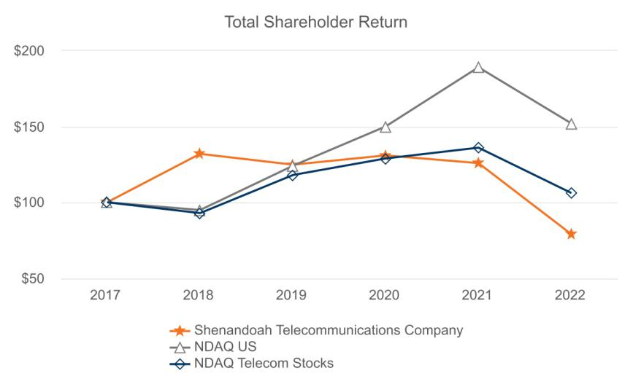

28

Table of Contents
 |  |  | 2017 |  | 2018 |  | 2019 | 2020 |  |  | 2021 |  | 2022
Shenandoah Telecommunications Company |  | $ | 100 | $ | 132 | $ | 125 | $ | 131 | $ | 126 | $ | 79
NDAQ US |  | $ | 100 | $ | 95 | $ | 124 | $ | 150 | $ | 189 | $ | 152
NDAQ Telecom Stocks |  | $ | 100 | $ | 93 | $ | 118 | $ | 129 | $ | 136 | $ | 106

Holders

As of February 16, 2023, there were 4,082 holders of record of the Company’s common stock.

Dividend Policy

Under the Company’s credit agreement, the Company is restricted in its ability to pay dividends in the future. So long as no Default or Event of Default, as defined in the credit agreement, the Company may make, declare and pay lawful cash dividends or distributions to its shareholders or redeem capital stock in an aggregate amount not to exceed, when the Company’s Total Net Leverage Ratio (as defined in the credit agreement) is greater than 4.00:1.00 on a pro forma basis, an amount equal to the greater of 6.0% of the net cash proceeds from any public equity issuance of the Company’s equity interests or 4.0% of the estimated fair market value of the Company’s equity interests or when the Company’s Total Net Leverage (as defined in the credit agreement) is less than or equal to 4.00:1.00 on a pro forma basis, an unlimited amount; provided, however, that the amount of any dividend or distribution that is not paid in cash but is reinvested in equity interests of the Company shall be excluded from this calculation and redemptions of equity interests of the Company surrendered by employees and directors to cover withholding taxes shall be excluded from this calculation.

The table below sets forth the cash dividends per share of our common stock that our board of directors declared during the following years:

 |  |  |  | Years Ended December 31,
 |  | 2018 |  | 2019 |  | 2020 |  | 2021 |  | 2022
Cash Dividend | $ | 0.27 | $ | 0.29 | $ | 0.34 | $ | 18.82 | $ | 0.08

Cash dividends in 2021 include a special dividend of $18.75 per share declared in the third quarter of 2021 (the “Special Dividend”) following the sale of our Wireless operations and assets.

Dividend Reinvestment Plan

The Company maintains a dividend reinvestment plan (the “DRIP”) for the benefit of its shareholders. When shareholders remove shares from the DRIP, the Company issues whole shares in book entry form, pays out cash for any fractional shares, and cancels the fractional shares. In conjunction with the vesting of shares or exercise of stock options, the grantees may surrender awards necessary to cover the statutory tax withholding requirements and any amounts required to cover stock option strike prices associated with the transaction.

Purchases of Equity Securities by the Issuer or Affiliated Purchasers

None.

29

Table of Contents

ITEM 6. [Reserved]

30

Table of Contents

ITEM 7. MANAGEMENT'S DISCUSSION AND ANALYSIS OF FINANCIAL CONDITION AND RESULTS OF OPERATIONS

You should read the following discussion and analysis of our financial condition and results of operations in conjunction with our consolidated financial statements and notes thereto appearing elsewhere in this Annual Report on Form 10-K. In addition to historical consolidated financial information, the following discussion and analysis may contain forward-looking statements that involve risks, uncertainties and assumptions. Our actual results could differ materially from those anticipated by forward-looking statements as a result of many factors. We discuss factors that we believe could cause or contribute to these differences below and elsewhere in this Annual Report on Form 10-K, including those set forth under “Part I. Cautionary Statement Regarding Forward-Looking Statements” and “Part I. Item 1A. Risk Factors”.

Overview

Shenandoah Telecommunications Company (“Shentel”, “we”, “our”, “us”, or the “Company”), is a provider of a comprehensive range of broadband communication services and cell tower colocation space in the Mid-Atlantic portion of the United States.

Management’s Discussion and Analysis is organized around our reporting segments. Refer to Item 1 above for our description of our reporting segments and a description of their respective business activities. Also see Note 15, Discontinued Operations, and Note 14, Segment Reporting, in our consolidated financial statements for additional information.

2022 Developments

Beam fixed wireless:

In the fourth quarter of 2021, due to the availability of grants awarded under various governmental initiatives, and in support of rural fiber to the home (“FTTH”) broadband network expansion projects, we decided to cease further expansion of our Beam branded fixed wireless edge-out strategy. During the second quarter of 2022, the Company permanently ceased operating 20 of our Beam fixed wireless sites. On August 23, 2022, the Company entered into a definitive asset purchase agreement (the “Spectrum Purchase Agreement”) with a wireless carrier pursuant to which the Company agreed to sell certain Federal Communications Commission (“FCC”) spectrum licenses and leases utilized in the Company's Beam branded fixed wireless service for total consideration of approximately $21.5 million, composed of $17.7 million cash and approximately $3.8 million of liabilities to be assumed by the wireless carrier (the “Spectrum Transaction”). The Spectrum Transaction is expected to close in the first half of 2023, subject to the receipt of regulatory approvals and other customary closing conditions. As a result of the Spectrum Transaction, the Company ceased its Beam service at the remaining Beam fixed wireless sites in the fourth quarter 2022. The Company is no longer reporting Beam customers as part of its Broadband Revenue Generating Units (“RGUs”).

31

Table of Contents

Results of Operations

Year Ended December 31, 2022 Compared to Year Ended December 31, 2021

The Company’s consolidated results from operations are summarized as follows:

 |  |  | Year Ended December 31, |  |  |  |  |  | Change
($ in thousands) |  | 2022 | % of Revenue |  |  | 2021 | % of Revenue |  | $ |  |  | %
Revenue | $ | 267,371 | 100.0 |  | $ | 245,239 | 100.0 |  | 22,132 |  |  | 9.0
Operating expenses |  | 275,329 | 103.0 |  |  | 247,669 | 101.0 | 27,660 |  |  |  | 11.2
Operating loss |  | (7,958) | (3.0) |  |  | (2,430) | (1.0) | (5,528) |  |  |  | 227.5
Other (expense) income, net |  | (1,348) | (0.5) |  |  | 8,665 | 3.5 | (10,013) |  |  |  | (115.6)
(Loss) income before taxes |  | (9,306) | (3.5) |  |  | 6,235 | 2.5 | (15,541) |  |  |  | (249.3)
Income tax benefit |  | (927) | (0.3) |  |  | (1,694) | (0.7) | 767 |  |  |  | 45.3
(Loss) income from continuing operations |  | (8,379) | (3.1) |  |  | 7,929 | 3.2 | (16,308) |  |  |  | (205.7)
Income from discontinued operations, net of tax |  | — | — |  |  | 990,902 | 404.1 | (990,902) |  |  |  | (100.0)
Net (loss) income | $ | (8,379) | (3.1) |  | $ | 998,831 | 407.3 | (1,007,210) |  |  |  | (100.8)

Revenue

Revenue increased approximately $22.1 million, or 9.0%, in 2022 compared with 2021, driven by 9.2% growth in Broadband and 6.9% growth in the Tower segments. Refer to the discussion of the results of operations for the Tower and Broadband segments, included within this annual report, for additional information.

Operating expenses

Operating expenses increased approximately $27.7 million, or 11.2%, in 2022 compared with 2021, primarily driven by $29.1 million in incremental Broadband operating expenses primarily incurred to support cessation of Beam operations and services and the continuing expansion of Glo Fiber. Tower operating expenses were up $0.7 million. Corporate operating expenses were down $2.1 million primarily due to lower professional fees. Refer to the discussion of results of operations for the Tower and Broadband segments, included within this annual report, for additional information.

Other (expense) income, net

Other income, net decreased $10.0 million, or 115.6%, in 2022 compared with 2021, primarily driven by lower net actuarial gains recognized for the Company's pension plan in 2022, decreases in patronage income derived from the CoBank patronage program and decreases in transitional service agreement (“TSA”) income realized in 2022.

Income tax benefit

Income tax benefit of approximately $0.9 million decreased approximately $0.8 million compared with 2021, primarily driven by higher benefit realized in 2021 as a result of the 2021 disposition of Wireless assets and operations.

Income from discontinued operations, net of tax

Income from discontinued operations, net of tax, decreased $1.0 billion, or 100.0%. The decrease was due to the completion of the disposition of our Wireless assets and operations in 2021, with no additional activity occurring in 2022.

Broadband

Our Broadband segment provides broadband internet, video and voice services to residential and commercial customers in portions of Virginia, West Virginia, Maryland, Pennsylvania, and Kentucky, via hybrid fiber coaxial cable under the brand name of Shentel, fiber optics under the brand name of Glo Fiber. The Broadband segment also leases dark fiber and provides Ethernet and Wavelength fiber optic services to enterprise and wholesale customers throughout the entirety of our service area. The Broadband segment also provides voice and DSL telephone services to customers in Virginia’s Shenandoah County and

32

Table of Contents

portions of adjacent counties as a Rural Local Exchange Carrier (“RLEC”). These integrated networks are connected by over 8,300 fiber route mile network.

The following table indicates selected operating statistics of Broadband:
 |  | December 31, |  |  | December 31, |  |  | December 31,
 |  | 2022 |  |  | 2021 |  |  | 2020
Broadband homes and businesses passed (1) |  | 359,529 |  |  | 286,309 |  |  | 237,343
Incumbent Cable |  | 212,050 |  |  | 211,120 |  |  | 208,691
Glo Fiber |  | 147,479 |  |  | 75,189 |  |  | 28,652
Residential & SMB RGUs:
Broadband Data |  | 133,930 |  |  | 117,722 |  |  | 102,713
Incumbent Cable |  | 109,644 |  |  | 106,345 |  |  | 98,555
Glo Fiber |  | 24,286 |  |  | 11,377 |  |  | 4,158
Video |  | 46,975 |  |  | 49,945 |  |  | 52,817
Voice |  | 39,951 |  |  | 34,513 |  |  | 32,646
Total Residential & SMB RGUs (excludes RLEC) |  | 220,856 |  |  | 202,180 |  |  | 188,176
Residential & SMB Penetration (2)
Broadband Data |  | 37.3 % |  |  | 41.1 % |  |  | 43.3 %
Incumbent Cable |  | 51.7 % |  |  | 50.4 % |  |  | 47.2 %
Glo Fiber |  | 16.5 % |  |  | 15.1 % |  |  | 14.5 %
Video |  | 13.1 % |  |  | 17.4 % |  |  | 22.3 %
Voice |  | 11.7 % |  |  | 12.8 % |  |  | 14.8 %
Residential & SMB ARPU (3)
Broadband Data | $ | 80.14 |  | $ | 78.62 |  | $ | 77.93
Incumbent Cable | $ | 81.31 |  | $ | 79.00 |  | $ | 77.97
Glo Fiber | $ | 73.48 |  | $ | 74.02 |  | $ | 78.90
Video | $ | 102.80 |  | $ | 100.35 |  | $ | 93.17
Voice | $ | 26.23 |  | $ | 28.60 |  | $ | 29.44
Fiber route miles |  | 8,346 |  |  | 7,392 |  |  | 6,794
Total fiber miles (4) |  | 656,033 |  |  | 518,467 |  |  | 394,316

_______________________________________________________

- Homes and businesses are considered passed (“passings”) if we can connect them to our network without further extending the distribution system. Passings is an estimate based upon the best available information. Passings will vary among video, broadband data and voice services.
- Penetration is calculated by dividing the number of users by the number of passings or available homes, as appropriate.

- Average Revenue Per Data RGU calculation = (Residential & SMB Revenue * 1,000) / average data RGUs / 12 months

- Total fiber miles are measured by taking the number of fiber strands in a cable and multiplying that number by the route distance. For example, a 10 mile route with 144 fiber strands would equal 1,440 fiber miles.

33

Table of Contents
Broadband results from operations are summarized as follows:
 |  |  |  | Year Ended December 31, |  |  |  |  |  | Change
($ in thousands) |  |  | 2022 | % of Revenue |  |  | 2021 | % of Revenue |  | $ |  |  | %
Broadband operating revenue
Residential & SMB |  | $ | 193,974 | 77.9 |  | $ | 177,530 | 77.8 | 16,444 |  |  |  | 9.3
Commercial Fiber |  |  | 38,830 | 15.6 |  |  | 34,931 | 15.3 | 3,899 |  |  |  | 11.2
RLEC & Other |  |  | 16,211 | 6.5 |  |  | 15,619 | 6.8 | 592 |  |  |  | 3.8
Total broadband revenue |  |  | 249,015 | 100.0 |  |  | 228,080 | 100.0 | 20,935 |  |  |  | 9.2
Broadband operating expenses
Cost of services |  |  | 102,267 | 41.1 |  |  | 97,283 | 42.7 | 4,984 |  |  |  | 5.1
Selling, general, and administrative |  |  | 56,776 | 22.8 |  |  | 47,840 | 21.0 | 8,936 |  |  |  | 18.7
Restructuring expense |  |  | 849 | 0.3 |  |  | 202 | 0.1 | 647 |  |  |  | 320.3
Impairment expense |  |  | 5,241 | 2.1 |  |  | 5,986 | 2.6 | (745) |  |  |  | (12.4)
Depreciation and amortization |  |  | 63,175 | 25.4 |  |  | 47,937 | 21.0 | 15,238 |  |  |  | 31.8
Total broadband operating expenses |  |  | 228,308 | 91.7 |  |  | 199,248 | 87.4 | 29,060 |  |  |  | 14.6
Broadband operating income |  | $ | 20,707 | 8.3 |  | $ | 28,832 | 12.6 | (8,125) |  |  |  | (28.2)

Residential & SMB revenue

Residential & SMB revenue increased approximately $16.4 million, or 9.3%, in 2022 compared with 2021, primarily driven by launching services in new markets resulting in 13.8% growth in broadband RGUs.

Commercial Fiber revenue

Commercial Fiber revenue increased approximately $3.9 million, or 11.2%, in 2022 compared with 2021, primarily driven by increased connections.

Cost of services

Cost of services increased approximately $5.0 million, or 5.1%, in 2022 compared with 2021, primarily driven by the expansion of Glo Fiber and inflation. Payroll related costs were up $3.9 million, primarily due to higher salaries, wages and incentive costs and headcount to support the Glo Fiber expansion. Maintenance costs were up $1.6 million, primarily due to higher fuel, supplies, and contractor costs.

Selling, general and administrative

Selling, general and administrative expense increased $8.9 million, or 18.7%, in 2022 compared with 2021, primarily driven by the expansion of Glo Fiber and inflation. Payroll related costs increased $2.7 million, primarily due to higher salaries, wages and incentive costs and headcount to support the Glo Fiber expansion. Advertising costs increased $2.5 million due primarily to the expansion of Glo Fiber. Software related costs and professional fees increased $2.0 million related to operational system upgrades. Other costs, including bad debt and operating taxes increased $1.7 million.

Restructuring expense

Restructuring expense increased $0.6 million, or 320.3%, in 2022 compared with 2021, primarily driven by the ceasing of Beam operations.

Impairment

Impairment expense decreased $0.7 million, or 12.4%, in 2022 compared with 2021. Impairment expense in 2021 and 2022 was primarily driven by the Company's decision to permanently cease Beam operations.

Depreciation and amortization

Depreciation and amortization increased $15.2 million, or 31.8%, in 2022 compared with 2021, primarily driven by the Company's network expansion of our Glo Fiber network and the accelerated depreciation of Beam network assets associated with the Company’s decision to permanently cease Beam operations.

34

Table of Contents

Tower

Our Tower segment owns cell towers and leases colocation space on the towers to wireless communications providers. Substantially all of our owned towers are built on ground that we lease from the respective landlords.

The following table indicates selected operating statistics of the Tower segment:
 |  |  | December 31, |  |  |  | December 31, |  |  | December 31,
 |  |  |  | 2022 |  |  |  | 2021 |  | 2020
Macro tower sites |  |  |  | 222 |  |  |  | 223 |  |  |  |  | 223
Tenants |  |  |  | 446 |  |  |  | 485 |  |  |  |  | 427
Average tenants per tower |  |  |  | 1.9 |  |  |  | 2.1 |  |  |  |  | 1.8
Tower results from operations are summarized as follows:
 |  |  |  | Year Ended December 31, |  |  |  |  |  | Change
($ in thousands) |  |  | 2022 | % of Revenue |  |  | 2021 | % of Revenue |  | $ |  |  | %
Tower revenue | $ |  | 18,919 | 100.0 |  | $ | 17,704 | 100.0 % |  | 1,215 |  |  | 6.9
Tower operating expenses |  |  | 9,407 | 49.7 |  |  | 8,688 | 49.1 |  | 719 |  |  | 8.3
Tower operating income | $ |  | 9,512 | 50.3 |  | $ | 9,016 | 50.9 |  | 496 |  |  | 5.5

Revenue

Revenue increased approximately $1.2 million, or 6.9%, in 2022 compared with 2021, primarily driven by a 4.1% increase in average revenue per tenant.

Operating expenses

Operating expenses increased approximately $0.7 million, or 8.3%, in 2022 compared with 2021, primarily driven by higher costs of service as a result of higher rent costs and higher depreciation.

35

Table of Contents

Year Ended December 31, 2021 Compared to Year Ended December 31, 2020

The Company’s consolidated results from operations are summarized as follows:

 |  |  | Year Ended December 31, |  |  |  |  |  | Change
($ in thousands) |  | 2021 | % of Revenue |  |  | 2020 | % of Revenue |  | $ |  |  | %
Revenue | $ | 245,239 | 100.0 |  | $ | 220,775 | 100.0 |  | 24,464 |  |  | 11.1
Operating expenses |  | 247,669 | 101.0 |  |  | 223,376 | 101.2 | 24,293 |  |  |  | 10.9
Operating loss |  | (2,430) | (1.0) |  |  | (2,601) | (1.2) | 171 |  |  |  | (6.6)
Other income, net |  | 8,665 | 3.5 |  |  | 3,187 | 1.4 | 5,478 |  |  |  | 171.9
Income before taxes |  | 6,235 | 2.5 |  |  | 586 | 0.3 | 5,649 |  |  |  | 964.0
Income tax benefit |  | (1,694) | (0.7) |  |  | (990) | (0.4) | (704) |  |  |  | (71.1)
Income from continuing operations | $ | 7,929 | 3.2 |  | $ | 1,576 | 0.7 | 6,353 |  |  |  | 403.1
Income from discontinued operations, net of tax |  | 990,902 | 404.1 |  |  | 124,097 | 56.2 | 866,805 |  |  |  | 698.5
Net income | $ | 998,831 | 407.3 |  | $ | 125,673 | 56.9 | 873,158 |  |  |  | 694.8

Revenue

Revenue increased approximately $24.5 million, or 11.1%, in 2021 compared with 2020, driven by 11.6% growth in Broadband and 3.8% growth in the Tower segments. Refer to the discussion of the results of operations for the Tower and Broadband segments, included within this annual report, for additional information.

Operating expenses

Operating expenses increased approximately $24.3 million, or 10.9%, in 2021 compared with 2020, primarily driven by $7.4 million in incremental Broadband operating expenses incurred to support the continuing expansion of Glo Fiber, $1.7 million of restructuring expenses and $6.0 million of impairment expenses incurred primarily as a result of our decision to cease expansion of Beam, $6.4 million in depreciation from growth in our broadband networks, $5.8 million in Broadband maintenance due primarily to higher cable replacements costs, obsolete inventory charges and expensing of software development costs related to our previous ERP system that was replaced in 2022, partially offset by a decline in corporate expenses.

Other income, net

Other income, net increased $5.5 million primarily due to actuarial gains recognized for the Company's post-retirement benefit plans and TSA income realized in 2021.

Income tax benefit

Income tax benefit of approximately $1.7 million increased approximately $0.7 million compared with 2020, primarily due to $5.0 million of non-cash tax benefits derived from the revaluation of our deferred tax liabilities. This revaluation was driven by the change in our estimated state tax rate that was triggered by the disposition of our Wireless assets and operations and a change in West Virginia tax regulations, and was partially offset by a $1.6 million reclassification of income taxes from other comprehensive income resulting from termination of our interest rate swaps, a $1.1 million reduction in excess tax benefits from share based compensation and other, and $1.6 million as a result of changes in taxable income.

Income from discontinued operations, net of tax

Income from discontinued operations, net of tax, increased $0.9 billion, or 698.5%. The increase was primarily due to the completion of the disposition of our Wireless assets and operations for proceeds of approximately $1.9 billion resulting in a gain of $1.2 billion, net of approximately $0.3 billion of income tax expense.

36

Table of Contents

Broadband

Broadband results from operations are summarized as follows:
 |  |  | Year Ended December 31, |  |  |  |  |  | Change
($ in thousands) |  | 2021 | % of Revenue |  |  | 2020 | % of Revenue |  | $ |  |  | %
Broadband operating revenue
Residential & SMB | $ | 177,530 | 77.8 |  | $ | 155,017 | 75.9 | 22,513 |  |  |  | 14.5
Commercial Fiber |  | 34,931 | 15.3 |  |  | 32,759 | 16.0 | 2,172 |  |  |  | 6.6
RLEC & Other |  | 15,619 | 6.8 |  |  | 16,571 | 8.1 | (952) |  |  |  | (5.7)
Total broadband revenue |  | 228,080 | 100.0 |  |  | 204,347 | 100.0 % | 23,733 |  |  |  | 11.6
Broadband operating expenses
Cost of services |  | 97,283 | 42.7 |  |  | 84,893 | 41.5 | 12,390 |  |  |  | 14.6
Selling, general, and administrative |  | 47,840 | 21.0 |  |  | 39,472 | 19.3 | 8,368 |  |  |  | 21.2
Restructuring expense |  | 202 | 0.1 |  |  | — | — | 202 |  |  |  | —
Impairment expense |  | 5,986 | 2.6 |  |  | — | — | 5,986 |  |  |  | —
Depreciation and amortization |  | 47,937 | 21.0 |  |  | 41,076 | 20.1 | 6,861 |  |  |  | 16.7
Total broadband operating expenses |  | 199,248 | 87.4 |  |  | 165,441 | 81.0 | 33,807 |  |  |  | 20.4
Broadband operating income | $ | 28,832 | 12.6 |  | $ | 38,906 | 19.0 | (10,074) |  |  |  | (25.9)

Residential & SMB revenue

Residential & SMB revenue increased approximately $22.5 million, or 14.5%, during 2021 primarily driven by launching services in new markets resulting in 15.9% growth in broadband RGUs.

Commercial Fiber revenue

Commercial Fiber revenue increased approximately $2.2 million, or 6.6%, during 2021 due primarily to $1.0 million of growth in circuit connections, $0.7 million non-recurring amortized revenue reduction in 2020 and $0.5 million in non-recurring dark fiber sales-type leases in 2021.

RLEC & Other revenue

RLEC & Other revenue decreased approximately $1.0 million, or 5.7%, compared with 2020 due primarily to a decline in residential DSL subscribers, lower switched access revenue, and lower intercompany phone service.

Cost of services

Cost of services increased approximately $12.4 million, or 14.6%, compared with 2020, primarily driven by $5.8 million increase in maintenance due primarily to higher cable replacements costs, obsolete network asset charges and expensing of software development costs related to our previous ERP system, $3.6 million in higher compensation costs to support the expansion of Glo Fiber and Beam, and $1.7 million in higher programming fees.

Selling, general and administrative

Selling, general and administrative expense increased $8.4 million or 21.2% compared with 2020 primarily due to $3.8 million in higher compensation and advertising costs to support the expansion of Glo Fiber and Beam, a $2.4 million increase in software development and service fees as we upgrade our operating support, customer relationship and enterprise resource systems and a $1.7 million increase in property taxes, facility expense and other costs.

Restructuring expense

Restructuring expense was primarily due to severance related expenses from the sale of Wireless assets and operations.

Impairment

During the fourth quarter, we ceased further expansion of our fixed wireless edge-out strategy. As a result, in the fourth quarter of 2021, the Company incurred approximately $6.0 million of expenses for impairment of expansionary Beam construction assets.

37

Table of Contents

Depreciation and amortization

Depreciation and amortization increased $6.9 million or 16.7%, compared with 2020, primarily as a result of our network expansion and the deployment of infrastructure necessary to support our new fiber-to-the-home service, Glo Fiber.

Tower

Tower results from operations are summarized as follows:

 |  |  | Year Ended December 31, |  |  |  |  |  |  | Change
($ in thousands) |  | 2021 | % of Revenue |  |  | 2020 | % of Revenue |  | $ |  |  |  | %
Tower revenue | $ | 17,704 | 100.0 |  | $ | 17,055 | 100.0 |  |  | 649 |  |  | 3.8
Tower operating expenses |  | 8,688 | 49.1 |  |  | 8,232 | 48.3 |  |  | 456 |  |  | 5.5
Tower operating income | $ | 9,016 | 50.9 |  | $ | 8,823 | 51.7 |  |  | 193 |  |  | 2.2

Revenue

Revenue increased approximately $0.6 million, or 3.8%, in 2021 compared with 2020. This increase was due to a 13.6% increase in tenants and was partially offset by a 3.2% decline in average revenue per tenant.

Operating expenses

Operating expenses increased approximately $0.5 million, or 5.5%, compared to the prior year period, due primarily to increases in ground lease rent expense, and expansion of our tower network team resulting in higher payroll costs, partially offset by a decrease in professional services.

38

Table of Contents

Financial Condition, Liquidity and Capital Resources

Sources and Uses of Cash: Our principal sources of liquidity are our cash and cash equivalents, cash generated from operations, and borrowings under our Credit Agreement, dated July 1, 2021 (the “Credit Agreement”).

In 2021, Congress passed the America Rescue Plan Act to subsidize the deployment of high-speed broadband internet access in unserved areas. We were awarded approximately $71 million in grants to serve approximately 23,600 unserved homes in the states of Virginia, West Virginia and Maryland. The grants will be paid to the Company as certain milestones are completed. The Company expects to its fulfill its performance obligations during the period from 2023 to 2025.

As of December 31, 2022, our cash and cash equivalents totaled $44.1 million and the availability under our delayed draw term loans and revolving line of credit was $325.0 million, for total available liquidity of $369.1 million.

Operating activities from continuing operations generated approximately $74.9 million in 2022, representing an increase of $11.4 million compared with 2021, driven by higher non-cash add backs to net loss, including higher depreciation, stock-based compensation, and bad debt expense, and lower non-cash add backs for income taxes benefits, partially offset by lower income (loss) from operations.

Net cash used in investing activities for continuing operations increased $24.4 million in 2022, compared with 2021, primarily due to a $29.5 million increase in capital expenditures for our Broadband segment to enable our Glo Fiber market expansion, partially offset by an increase in cash received for refunds of FCC spectrum licenses of $4.0 million and sales of assets, including a sale of investments from Shentel's rabbi trust which generated $0.8 million of proceeds.

Financing activities from continuing operations generated approximately $69.0 million in 2022, compared to net cash used in financing activities for continuing operations of $943.9 million in 2021. The change was primarily the result of a decrease in dividend payments, as the Company made a special dividend payment of $936.3 million in 2021. The Company also generated an additional $75.0 million in cash as a result of borrowings against its delayed draw term loans during 2022.

Indebtedness: Throughout 2022, we borrowed $37.5 million under each of the delayed draw term loan facilities available under the Credit Agreement for a total of $75.0 million. We expect to borrow the remaining $225.0 million available under these term loans by June 2023 to fund planned capital expenditures to continue our Glo Fiber network expansion. As of December 31, 2022, the Company’s indebtedness totaled approximately $75 million, net of unamortized loan fees of $46.0 thousand, with an annualized overall weighted average interest rate of approximately 4.63%. Refer to Note 9, Debt in the Company's 2022 Consolidated Financial Statements for information about the Company's Credit Agreement.

As of December 31, 2022, the Company was in compliance with the financial covenants in our Credit Agreement.

We expect our cash on hand, cash flow from continuing operations, and availability of funds from our Credit Agreement as well as government grants will be sufficient to meet our anticipated liquidity needs for business operations for the next twelve months. There can be no assurance that we will continue to generate cash flows at or above current levels.

We expect our capital expenditures to exceed the cash flow provided from continuing operations through 2025, as we expand our Glo Fiber broadband network to potentially reach over 450,000 passings.

The actual amount and timing of our future capital requirements may differ materially from our estimates depending on the demand for our products and services, new market developments and expansion opportunities.

Our cash flows from continuing operations could be adversely affected by events outside our control, including, without limitation, changes in overall economic conditions including rising inflation, regulatory requirements, changes in technologies, changes in competition, demand for our products and services, availability of labor resources and capital, natural disasters, pandemics and outbreaks of contagious diseases and other adverse public health developments, such as COVID-19, and other conditions. Our ability to attract and maintain a sufficient customer base, particularly in our Broadband markets, is critical to our ability to maintain a positive cash flow from operations. The foregoing events individually or collectively could affect our results.

Critical Accounting Policies

We prepare our consolidated financial statements in accordance with U.S. generally accepted accounting principles (“GAAP”). The preparation of these consolidated financial statements requires us to make estimates and assumptions that affect our

39

Table of Contents

reported amounts of assets, liabilities, revenue and expenses, as well as related disclosures. To the extent that there are material differences between these estimates and actual results, our financial condition or operating results would be affected. We base our estimates on past experience and other assumptions that we believe are reasonable under the circumstances, and we evaluate these estimates on an ongoing basis. We refer to accounting estimates of this type as critical accounting policies and estimates, which we discuss further below.

Our significant accounting policies are described in Note 2, Summary of Significant Accounting Policies in our consolidated financial statements. The following are the accounting policies that we believe involve a greater degree of judgment and complexity and are the most critical to aid in fully understanding and evaluating our consolidated financial condition and results of operations.

Revenue Recognition

The Company recognizes revenue in accordance with Accounting Standards Codification (“ASC”) 606, Revenue from contracts with customers, (“ASC 606”).

Our Broadband segment provides broadband data, video and voice services to residential, small and midsize businesses (“SMB”) and commercial customers in portions of Virginia, West Virginia, Maryland, Pennsylvania and Kentucky, via fiber optic and hybrid fiber coaxial cable networks. The Broadband segment also provides voice and DSL telephone services to customers in Virginia’s Shenandoah County and portions of adjacent counties as a RLEC.

These contracts are generally cancellable at the customer’s discretion without penalty at any time. We allocate the total transaction price in these transactions based upon the standalone selling price of each distinct good or service. We generally recognize these revenues over time as customers simultaneously receive and consume the benefits of the service, with the exception of equipment sales and home wiring, which are recognized as revenue at a point in time when control transfers and when installation is complete, respectively. A significant portion of the Company’s revenues are derived from customers who may cancel their subscriptions at any time without penalty. As such, the amount of deferred revenue related to unsatisfied performance obligations is not necessarily indicative of the future revenue to be recognized from the Company’s existing customers. Installation fees charged upfront without transfer of commensurate goods or services to the customer are allocated to services and are recognized ratably over the longer of the contract term or the period in which the unrecognized fee remains material to the contract, which we estimate to be one year. Additionally, the Company incurs commission expenses related to in-house and third-party vendors which are capitalized and amortized over the expected customer benefit period.

Our Broadband segment also provides Ethernet and Wavelength fiber optic services to commercial fiber customers under capacity agreements, and the related revenue is recognized over time. In some cases, non-refundable upfront fees are charged for connecting commercial fiber customers to our fiber network. Those amounts are recognized ratably over the initial contract term.

The Broadband segment also leases dedicated fiber optic strands to customers as part of “dark fiber” agreements, which are accounted for as leases under ASC 842, Leases (“ASC 842”).

Our Tower segment leases space on owned cell towers to our Broadband segment, and to other wireless carriers. Revenue from these leases is accounted for under ASC 842.

Cable franchise rights

Cable franchise rights represent the value attributable to agreements with local franchising authorities, which allows access to homes and businesses via public rights of way. Shentel's cable franchise rights were primarily acquired through business combinations. Cable franchise rights have an indefinite life; therefore, no amortization is recorded for these assets. Costs incurred in negotiating and renewing cable franchise rights are expensed as incurred.

The terms and conditions of franchises vary among jurisdictions, but franchises generally last for a fixed term and are subject to renewal. The renewal process for our state franchises is specified by state law and tends to be a simple process, requiring the filing of a renewal application with information no more burdensome than that contained in our original application. Franchising authorities may resist granting a renewal if either past performance or the prospective operating proposal is considered inadequate. Franchise authorities often demand concessions or other commitments as a condition to renewal. If our local franchises are not renewed at expiration we would have to cease operations or, operate under either temporary operating agreements or without a franchise while negotiating renewal terms with the local franchising authorities.

40

Table of Contents

Although renewal is not assured, there are provisions in the law that protect the Company from arbitrary or unreasonable denial. In our experience, state and local franchising authorities encourage our entry into the market, and we have historically been successful in renewing these agreements.

Shentel evaluates the recoverability of its cable franchise rights at least annually on October 1, or more frequently whenever events or substantive changes in circumstances indicate that the assets might be impaired. As a result of the 2022 analysis, we did not identify any cable franchise right assets in which the fair value was less than the carrying value, therefore we did not recognize any impairment charges for the year ended December 31, 2022.

To estimate fair value in the impairment analysis, we used a greenfield model, a method under the income approach, which reflected the expected discounted cash flows of a notional start-up business with no assets other than the cable franchise rights being valued. The estimates and assumptions made in our impairment analysis are inherently subject to significant uncertainties, many of which are beyond our control, and there is no assurance that these results can be achieved. The primary assumptions for which there is a reasonable possibility of the occurrence of a variation that would significantly affect the measurement value include the assumptions regarding revenue growth, the amount and timing of capital expenditures, EBITDA margins and the discount rate utilized.

Recently Issued Accounting Standards

Recently issued accounting standards and their expected impact, if any, are discussed in Note 2, Summary of Significant Accounting Policies in our consolidated financial statements.

41

Table of Contents

ITEM 7A. QUANTITATIVE AND QUALITATIVE DISCLOSURES ABOUT MARKET RISK

Throughout 2022, we borrowed a total of $75 million pursuant to the variable rate delayed draw term loans available under the Credit Agreement, and we expect to continue to borrow under our Credit Agreement as needed to fund the Company's future capital expenditures. We expect to draw an additional $225.0 million against the Credit Agreement by June 2023. Fluctuations in interest rates on future borrowings could result in increased market risk.

As of December 31, 2022, the Company had $75 million of gross variable rate debt outstanding, bearing interest at a weighted average rate of 4.63%. An increase in market interest rates of 1.00% would add approximately $0.7 million to annual interest expense.

ITEM 8. FINANCIAL STATEMENTS AND SUPPLEMENTARY DATA

Our consolidated financial statements and supplementary data are included as a separate section included within Item 15 of this Annual Report on Form 10-K commencing on page F-1 and are incorporated herein by reference.

42

Table of Contents

ITEM 9. CHANGES IN AND DISAGREEMENTS WITH ACCOUNTANTS ON ACCOUNTING AND FINANCIAL DISCLOSURE

None.

ITEM 9A. CONTROLS AND PROCEDURES

Evaluation of Disclosure Controls and Procedures

Our Chief Executive Officer, Chief Financial Officer, and Principal Accounting Officer (the certifying officers) have conducted an evaluation of the effectiveness of the design and operation of our disclosure controls and procedures (as defined in Rules 13a-15(e) and 15d-15(e) under the Securities Exchange Act of 1934, as amended (the Exchange Act)) as of December 31, 2022. Our certifying officers concluded that our disclosure controls and procedures were effective as of December 31, 2022.

Changes in Internal Control over Financial Reporting

As disclosed in our Annual Report on Form 10-K for the year ended December 31, 2021, the Company pursued a multi-year, phased approach to remediate its material weaknesses. During the quarter ended December 31, 2022, the Company completed implementation of management's remediation plan. Our 2022 accomplishments are summarized below.

- We formed a Company wide, cross functional task force of employees, charged with implementing the remediation plan with regular reports on progress provided to the Principal Executive Officer and Principal Financial Officer.

- We completed an implementation of a new enterprise resource planning (“ERP”) system and a lease accounting system. In the process of deploying these new systems, we designed and implemented new, or otherwise enhanced existing, internal control activities to complement operational and administrative process changes required to support the functionality of our new ERP and lease accounting systems.

- We completed a reevaluation of our accounting policies including those established in conjunction with management’s remediation plan as reported in Item 9A of our 2021 Form 10-K. As a result of this effort, we did not identify any new significant financial reporting risks that required implementation or enhancement of new or existing policies or key internal control activities.

- Employee incentives and professional development opportunities were thoughtfully designed and drove employee engagement, retention, and focus on our remediation plan. Employee turnover did not have a significant impact on our remediation efforts.

Internal Control over Financial Reporting

The Company’s management is responsible for establishing and maintaining adequate internal control over financial reporting. The Company’s internal control system was designed to provide reasonable assurance as to the integrity and reliability of the published financial statements. The Company’s management assessed the effectiveness of the Company’s internal control over financial reporting as of December 31, 2022. In making this assessment, the Company’s management used the criteria set forth by the Committee of Sponsoring Organizations of the Treadway Commission (COSO) in Internal Control - Integrated Framework (2013 framework). Based on its assessment, the Company’s management believes that, as of December 31, 2022, the Company’s internal control over financial reporting is effective based on those criteria.

RSM US LLP, an independent registered public accounting firm, which audited the Company’s consolidated financial statements included in this Annual Report, has issued an attestation report on the Company’s internal control over financial reporting containing the disclosure required by this Item.

ITEM 9B. OTHER INFORMATION

None.

ITEM 9C. DISCLOSURE REGARDING FOREIGN JURISDICTIONS THAT PREVENT INSPECTIONS

Not applicable.

43

Table of Contents

PART III

ITEM 10. DIRECTORS, EXECUTIVE OFFICERS AND CORPORATE GOVERNANCE

See “Executive Officers of the Registrant” in Part 1, Item 1 of this report for information about our executive officers, which is incorporated by reference in this Item 10. Other information required by this Item 10 is incorporated by reference to the Company's definitive proxy statement for its 2023 Annual Meeting of Shareholders, referred to as the “2023 proxy statement,” which we will file with the SEC on or before 120 days after our 2022 fiscal year end, and which appears in the 2023 proxy statement under the captions “Election of Directors” and “Section 16(a) Beneficial Ownership Reporting Compliance.”

We have adopted a code of ethics applicable to our chief executive officer and all senior financial officers, who include our principal financial officer, principal accounting officer, and persons performing similar functions. The code of ethics, which is part of our Code of Business Conduct and Ethics, is available on our website at www.shentel.com. To the extent required by SEC rules, we intend to disclose any amendments to our code of conduct and ethics, and any waiver of a provision of the code with respect to the Company’s directors, principal executive officer, principal financial officer, principal accounting officer, or persons performing similar functions, on our website referred to above within four business days following such amendment or waiver, or within any other period that may be required under SEC rules from time to time.

ITEM 11. EXECUTIVE COMPENSATION

Information required by this Item 11 is incorporated herein by reference to the 2023 proxy statement, including the information in the 2023 proxy statement appearing under the captions “Election of Directors-Director Compensation” and “Executive Compensation.”

ITEM 12. SECURITY OWNERSHIP OF CERTAIN BENEFICIAL OWNERS AND MANAGEMENT AND RELATED STOCKHOLDER MATTERS

Information required by Item 12 is incorporated herein by reference to the 2023 proxy statement appearing under the caption “Security Ownership.”

The Company grants stock awards to its employees meeting certain eligibility requirements under its shareholder-approved Company Stock Incentive Plan, referred to as the 2014 Equity Incentive Plan. The 2014 Equity Incentive Plan authorizes grants of up to an additional 4.2 million shares over a ten-year period beginning in 2014. Outstanding awards and the number of shares available for future issuance as of December 31, 2022 were as follows:

 | Number of securities to be issued upon exercise of |  |  | Weighted average exercise price of |  | Number of securities remaining
 | outstanding options and RSUs |  |  | outstanding options |  | available for future issuance
2014 Equity Incentive Plan | 857,511 |  | $ | — |  | 2,099,886

ITEM 13. CERTAIN RELATIONSHIPS, RELATED TRANSACTIONS AND DIRECTOR INDEPENDENCE

Information required by Item 13 is incorporated herein by reference to the 2023 proxy statement, including the information in the 2023 proxy statement appearing under the caption “Executive Compensation-Certain Relationships and Related Transactions.”

ITEM 14. PRINCIPAL ACCOUNTANT FEES AND SERVICES

Information required by Item 14 is incorporated herein by reference to the 2023 proxy statement, including the information in the 2023 proxy statement appearing under the caption “Shareholder Ratification of Independent Registered Public Accounting Firm.”

44

Table of Contents

PART IV

ITEM 15. EXHIBITS AND FINANCIAL STATEMENT SCHEDULES

The following is a list of documents filed as a part of this report:

- Financial Statements

- Financial Statement Schedule

- Exhibits

The exhibits required to be filed by Item 601 of Regulation S-K are listed in the Exhibit Index directly following the Financial Statements beginning on page F-1, within this Annual Report on Form 10-K.

ITEM 16. FORM 10-K SUMMARY

None.

45

Table of Contents
 | SHENANDOAH TELECOMMUNICATIONS COMPANY
 | AND SUBSIDIARIES
 | Index to the Consolidated 2022 Financial Statements
 |  | Page
Reports of Independent Registered Public Accounting Firm as of and for the Year Ended December 31, 2022 |  |  |  | F-2
Report of Independent Registered Public Accounting Firm as of and for the Years Ended December 31, 2021 and 2020 |  |  |  | F-5
Consolidated Financial Statements
Consolidated Balance Sheets as of December 31, 2022 and 2021 |  |  |  | F-6
Consolidated Statements of Comprehensive (Loss) Income for the years ended December 31, 2022, 2021 and 2020 |  |  |  | F-7
Consolidated Statements of Shareholders’ Equity for the years ended December 31, 2022, 2021 and 2020 |  |  |  | F-8
Consolidated Statements of Cash Flows for the years ended December 31, 2022, 2021 and 2020 |  |  |  | F-9
Notes to Consolidated Financial Statements |  | F-10
Financial Statement Schedule
Valuation and Qualifying Accounts |  | F-29
 | F-1

Table of Contents

Report of Independent Registered Public Accounting Firm

To the Shareholders and the Board of Directors Shenandoah Telecommunications Company

Opinion on the Financial Statements

We have audited the accompanying consolidated balance sheet of Shenandoah Telecommunications Company and its subsidiaries (the Company) as of December 31, 2022, the related consolidated statements of comprehensive (loss) income, shareholders’ equity, and cash flows, for the year then ended, and the related notes to the consolidated financial statements and Schedule II – Valuation and Qualifying Accounts (collectively, the financial statements). In our opinion, the financial statements present fairly, in all material respects, the financial position of the Company as of December 31, 2022, and the results of its operations and its cash flows for the year ended December 31, 2022, in conformity with accounting principles generally accepted in the United States of America.

We have also audited, in accordance with the standards of the Public Company Accounting Oversight Board (United States) (PCAOB), the Company's internal control over financial reporting as of December 31, 2022, based on criteria established in Internal Control — Integrated Framework issued by the Committee of Sponsoring Organizations of the Treadway Commission in 2013, and our report dated February 22, 2023 expressed an unqualified opinion on the effectiveness of the Company's internal control over financial reporting.
Basis for Opinion

These financial statements are the responsibility of the Company's management. Our responsibility is to express an opinion on the Company's financial statements based on our audit. We are a public accounting firm registered with the PCAOB and are required to be independent with respect to the Company in accordance with U.S. federal securities laws and the applicable rules and regulations of the Securities and Exchange Commission and the PCAOB.

We conducted our audit in accordance with the standards of the PCAOB. Those standards require that we plan and perform the audit to obtain reasonable assurance about whether the financial statements are free of material misstatement, whether due to error or fraud. Our audit included performing procedures to assess the risks of material misstatement of the financial statements, whether due to error or fraud, and performing procedures that respond to those risks. Such procedures included examining, on a test basis, evidence regarding the amounts and disclosures in the financial statements. Our audit also included evaluating the accounting principles used and significant estimates made by management, as well as evaluating the overall presentation of the financial statements. We believe that our audit provides a reasonable basis for our opinion.

Critical Audit Matter

The critical audit matter communicated below is a matter arising from the current period audit of the financial statements that was communicated or required to be communicated to the audit committee and that: (1) relate to accounts or disclosures that are material to the financial statements and (2) involved our especially challenging, subjective or complex judgments. The communication of the critical audit matter does not alter in any way our opinion on the financial statements, taken as a whole, and we are not, by communicating the critical audit matter below, providing separate opinions on the critical audit matter or on the accounts or disclosures to which it relates.

Determining the Fair Value of Cable Franchise Rights

As described in Notes 2 and 6 to the financial statements, the Company’s indefinite-lived cable franchise rights are $64.3 million as of December 31, 2022. The Company evaluates the recoverability of its cable franchise rights annually on October 1, or more frequently whenever events or substantive changes in circumstances indicate that it is more likely than not that the cable franchise rights’ carrying value exceeds its estimated fair value. The Company performed a quantitative analysis which involved estimating the fair value of the cable franchise rights. Management used a Greenfield Model, which is a valuation method under the income approach. Under this approach, fair value is based on estimated after-tax discounted future cash flows, assuming an initial hypothetical start-up operation maturing into an average performing operation with similar rights. The valuation technique used by management included theoretical assumptions of the costs that would be incurred to start-up operations when the only owned asset is the cable franchise right and the associated revenues, operating margins and capital expenditures expected to be incurred in the start-up years, which are inherently judgmental.

We identified the cable franchise rights impairment assessment as a critical audit matter because of the significant estimates and assumptions management used in the impairment analysis. Auditing management’s judgments used in the impairment assessment regarding forecasts of future revenue, operating margins, capital expenditures, and the discount rate to be applied involved a high degree of auditor judgment and increased audit effort, including the use of our valuation specialist.

F-2

Table of Contents

Our audit procedures related to the Company’s cable franchise rights impairment assessment included the following, among others:

- Obtaining an understanding of the relevant controls related to the Company’s cable franchise rights impairment analysis, and tested such controls for design and operating effectiveness, including controls over management’s review of the significant assumptions described above.
- Testing management’s process for developing the forecasts by (i) understanding management’s process for developing the forecasted revenue growth rates, forecasted margins, and forecasted capital expenditures during the start-up and growth phases, (ii) testing the completeness, accuracy, and relevance of the underlying data used in the forecast, and (iii) comparing these assumptions to historical results and to forecasted information included in external industry reports; and,
- Utilizing our valuation professionals to assist in (i) assessing the appropriateness of the valuation model method, and (ii) evaluating the reasonableness of the Company’s discount rate.

/s/ RSM US LLP

We have served as the Company's auditor since 2022.

Ft. Lauderdale, Florida

February 22, 2023

F-3

Table of Contents

Report of Independent Registered Public Accounting Firm

To the Shareholders and the Board of Directors Shenandoah Telecommunications Company

Opinion on the Internal Control Over Financial Reporting

We have audited Shenandoah Telecommunications Company’s (the Company) internal control over financial reporting as of December 31, 2022, based on criteria established in Internal Control - Integrated Framework issued by the Committee of Sponsoring Organizations of the Treadway Commission in 2013. In our opinion, Shenandoah Telecommunications Company (the Company) maintained, in all material respects, effective internal control over financial reporting as of December 31, 2022, based on the COSO criteria.

We have also audited, in accordance with the standards of the Public Company Accounting Oversight Board (United States) (PCAOB), the consolidated balance sheet of the Company as of December 31, 2022, the related consolidated statements of comprehensive (loss) income, shareholders’ equity, and cash flows for the year ended December 31, 2022, and the related notes to the consolidated financial statements and Schedule II – Valuation and Qualifying Accounts, and our report dated February 22, 2023 expressed an unqualified opinion thereon.

Basis for Opinion

The Company’s management is responsible for maintaining effective internal control over financial reporting and for its assessment of the effectiveness of internal control over financial reporting included in the accompanying Management’s Report on Internal Control Over Financial Reporting. Our responsibility is to express an opinion on the Company’s internal control over financial reporting based on our audit. We are a public accounting firm registered with the PCAOB and are required to be independent with respect to the Company in accordance with U.S. federal securities laws and the applicable rules and regulations of the Securities and Exchange Commission and the PCAOB.

We conducted our audit in accordance with the standards of the PCAOB. Those standards require that we plan and perform the audit to obtain reasonable assurance about whether effective internal control over financial reporting was maintained in all material respects. Our audit included obtaining an understanding of internal control over financial reporting, assessing the risk that a material weakness exists, and testing and evaluating the design and operating effectiveness of internal control based on the assessed risk. Our audit also included performing such other procedures as we considered necessary in the circumstances. We believe that our audit provides a reasonable basis for our opinion.

Definition and Limitations of Internal Control Over Financial Reporting

A company’s internal control over financial reporting is a process designed to provide reasonable assurance regarding the reliability of financial reporting and the preparation of financial statements for external purposes in accordance with generally accepted accounting principles. A company’s internal control over financial reporting includes those policies and procedures that (1) pertain to the maintenance of records that, in reasonable detail, accurately and fairly reflect the transactions and dispositions of the assets of the company; (2) provide reasonable assurance that transactions are recorded as necessary to permit preparation of financial statements in accordance with generally accepted accounting principles, and that receipts and expenditures of the company are being made only in accordance with authorizations of management and directors of the company; and (3) provide reasonable assurance regarding prevention or timely detection of unauthorized acquisition, use, or disposition of the company’s assets that could have a material effect on the financial statements.

Because of its inherent limitations, internal control over financial reporting may not prevent or detect misstatements. Also, projections of any evaluation of effectiveness to future periods are subject to the risk that controls may become inadequate because of changes in conditions, or that the degree of compliance with the policies or procedures may deteriorate.

/s/ RSM US LLP

Ft. Lauderdale, Florida

February 22, 2023

F-4

Table of Contents

Report of Independent Registered Public Accounting Firm

To the Shareholders and Board of Directors

Shenandoah Telecommunications Company:

Opinion on the Consolidated Financial Statements

We have audited the accompanying consolidated balance sheet of Shenandoah Telecommunications Company and subsidiaries (the Company) as of December 31, 2021, the related consolidated statements of comprehensive (loss) income, shareholders’ equity, and cash flows for each of the years in the two-year period ended December 31, 2021, and the related notes and financial statement schedule II – Valuation and Qualifying Accounts (collectively, the consolidated financial statements). In our opinion, the consolidated financial statements present fairly, in all material respects, the financial position of the Company as of December 31, 2021, and the results of its operations and its cash flows for each of the years in the two-year period ended December 31, 2021, in conformity with U.S. generally accepted accounting principles.

Basis for Opinion

These consolidated financial statements are the responsibility of the Company’s management. Our responsibility is to express an opinion on these consolidated financial statements based on our audits. We are a public accounting firm registered with the Public Company Accounting Oversight Board (United States) (PCAOB) and are required to be independent with respect to the Company in accordance with the U.S. federal securities laws and the applicable rules and regulations of the Securities and Exchange Commission and the PCAOB.

We conducted our audits in accordance with the standards of the PCAOB. Those standards require that we plan and perform the audit to obtain reasonable assurance about whether the consolidated financial statements are free of material misstatement, whether due to error or fraud. Our audits included performing procedures to assess the risks of material misstatement of the consolidated financial statements, whether due to error or fraud, and performing procedures that respond to those risks. Such procedures included examining, on a test basis, evidence regarding the amounts and disclosures in the consolidated financial statements. Our audits also included evaluating the accounting principles used and significant estimates made by management, as well as evaluating the overall presentation of the consolidated financial statements. We believe that our audits provide a reasonable basis for our opinion.

/s/ KPMG LLP

We served as the Company’s auditor from 2001 to 2022.

McLean, Virginia

February 28, 2022

F-5

Table of Contents
SHENANDOAH TELECOMMUNICATIONS COMPANY AND SUBSIDIARIES
CONSOLIDATED BALANCE SHEETS
December 31, 2022 and 2021
(in thousands) |  |  | 2022 |  |  | 2021
ASSETS
Current assets:
Cash and cash equivalents |  | $ | 44,061 |  | $ | 84,344
Accounts receivable, net of allowance for doubtful accounts of $776 and $352, respectively |  |  | 20,615 |  |  | 22,005
Income taxes receivable |  |  | 29,755 |  |  | 30,188
Prepaid expenses and other |  |  | 11,509 |  |  | 29,830
Current assets held for sale |  |  | 22,622 |  |  | —
Total current assets |  |  | 128,562 |  |  | 166,367
Investments |  |  | 12,971 |  |  | 13,661
Property, plant and equipment, net |  |  | 687,553 |  |  | 554,162
Goodwill and intangible assets, net |  |  | 81,515 |  |  | 89,831
Operating lease right-of-use assets |  |  | 53,859 |  |  | 56,414
Deferred charges and other assets |  |  | 13,259 |  |  | 10,298
Total assets |  | $ | 977,719 |  | $ | 890,733
LIABILITIES AND SHAREHOLDERS’ EQUITY
Current liabilities:
Current maturities of long-term debt, net of unamortized loan fees |  | $ | 648 |  | $ | —
Accounts payable |  |  | 49,173 |  |  | 28,542
Advanced billings and customer deposits |  |  | 12,425 |  |  | 11,128
Accrued compensation |  |  | 9,616 |  |  | 9,653
Current operating lease liabilities |  |  | 2,829 |  |  | 3,318
Accrued liabilities and other |  |  | 17,906 |  |  | 14,649
Current liabilities held for sale |  |  | 3,824 |  |  | —
Total current liabilities |  |  | 96,421 |  |  | 67,290
Long-term debt, less current maturities, net of unamortized loan fees |  |  | 74,306 |  |  | —
Other long-term liabilities:
Deferred income taxes |  |  | 84,600 |  |  | 86,014
Asset retirement obligations |  |  | 9,932 |  |  | 9,615
Benefit plan obligations |  |  | 3,758 |  |  | 8,216
Non-current operating lease liabilities |  |  | 50,477 |  |  | 51,692
Other liabilities |  |  | 20,218 |  |  | 25,631
Total other long-term liabilities |  |  | 168,985 |  |  | 181,168
Commitments and contingencies (Note 13)
Shareholders’ equity:
Common stock, no par value, authorized 96,000; 50,110 and 49,965 issued and outstanding at December 31, 2022 and 2021, respectively |  |  | — |  |  | —
Additional paid in capital |  |  | 57,453 |  |  | 49,351
Retained earnings |  |  | 580,554 |  |  | 592,924
Total shareholders’ equity |  |  | 638,007 |  |  | 642,275
Total liabilities and shareholders’ equity |  | $ | 977,719 |  | $ | 890,733

See accompanying notes to consolidated financial statements.

F-6

Table of Contents
SHENANDOAH TELECOMMUNICATIONS COMPANY AND SUBSIDIARIES
CONSOLIDATED STATEMENTS OF COMPREHENSIVE (LOSS) INCOME
Years Ended December 31, 2022, 2021 and 2020
(in thousands, except per share amounts) |  |  | 2022 |  |  | 2021 |  |  | 2020
Service revenue and other |  | $ | 267,371 |  | $ | 245,239 |  | $ | 220,775
Operating expenses:
Cost of services exclusive of depreciation and amortization |  |  | 107,546 |  |  | 102,299 |  |  | 89,657
Selling, general and administrative |  |  | 92,392 |  |  | 82,451 |  |  | 85,016
Restructuring expense |  |  | 1,251 |  |  | 1,727 |  |  | —
Impairment expense |  |  | 5,241 |  |  | 5,986 |  |  | —
Depreciation and amortization |  |  | 68,899 |  |  | 55,206 |  |  | 48,703
Total operating expenses |  |  | 275,329 |  |  | 247,669 |  |  | 223,376
Operating loss |  |  | (7,958) |  |  | (2,430) |  |  | (2,601)
Other (expense) income:
Other (expense) income, net |  |  | (1,348) |  |  | 8,665 |  |  | 3,187
(Loss) income from continuing operations before income taxes |  |  | (9,306) |  |  | 6,235 |  |  | 586
Income tax benefit |  |  | (927) |  |  | (1,694) |  |  | (990)
(Loss) income from continuing operations |  |  | (8,379) |  |  | 7,929 |  |  | 1,576
Discontinued operations:
Income from discontinued operations, net of tax |  |  | — |  |  | 94,667 |  |  | 124,097
Gain on the sale of discontinued operations, net of tax |  |  | — |  |  | 896,235 |  |  | —
Total income from discontinued operations, net of tax |  |  | — |  |  | 990,902 |  |  | 124,097
Net (loss) income |  |  | (8,379) |  |  | 998,831 |  |  | 125,673
Other comprehensive income (loss):
Unrealized income (loss) on interest rate hedge, net of tax |  |  | — |  |  | 4,706 |  |  | (5,014)
Comprehensive (loss) income |  | $ | (8,379) |  | $ | 1,003,537 |  | $ | 120,659
Net (loss) income per share, basic and diluted:
Basic - (Loss) income from continuing operations |  | $ | (0.17) |  | $ | 0.16 |  | $ | 0.03
Basic - Income from discontinued operations, net of tax |  | $ | — |  | $ | 19.81 |  | $ | 2.49
Basic net (loss) income per share |  | $ | (0.17) |  | $ | 19.97 |  | $ | 2.52
Diluted - (Loss) income from continuing operations |  | $ | (0.17) |  | $ | 0.16 |  | $ | 0.03
Diluted - Income from discontinued operations, net of tax |  | $ | — |  | $ | 19.76 |  | $ | 2.48
Diluted net (loss) income per share |  | $ | (0.17) |  | $ | 19.92 |  | $ | 2.51
Weighted average shares outstanding, basic |  |  | 50,155 |  |  | 50,026 |  |  | 49,901
Weighted average shares outstanding, diluted
 |  |  | 50,155 |  |  | 50,149 |  |  | 50,024
Cash dividends declared per share
 |  | $ | 0.08 |  | $ | 18.82 |  | $ | 0.34

See accompanying notes to consolidated financial statements.

F-7

Table of Contents

SHENANDOAH TELECOMMUNICATIONS COMPANY AND SUBSIDIARIES

CONSOLIDATED STATEMENTS OF SHAREHOLDERS' EQUITY

Years Ended December 31, 2022, 2021 and 2020

(in thousands)

 | Shares of Common | Additional Paid in |  |  |  |  | Accumulated Other
 | Stock (no par |  |  | Retained Earnings |  |  | Comprehensive Income | Total
 | value) |  | Capital |  |  |  | (Loss) | Total
Balance, December 31, 2019 | 49,671 |  | 42,110 |  | 425,717 |  | 308 | 468,135
Net income | — |  | — |  | 125,673 |  | — | 125,673
Net loss on interest rate swaps, net of tax | — |  | — |  | — |  | (5,014) | (5,014)
Dividends declared | — |  | — |  | (16,950) |  | — | (16,950)
Dividends reinvested in common stock | — |  | (2) |  | — |  | — | (2)
Stock-based compensation | 156 |  | 6,833 |  | — |  | — | 6,833
Stock options exercised | — |  | 36 |  | — |  | — | 36
Common stock issued | 1 |  | 31 |  | — |  | — | 31
Annual dividend reinvestment | 12 |  | 526 |  | — |  | — | 526
Shares surrendered for settlement of employee taxes upon issuance of vested
equity awards | (48) |  | (2,217) |  | — |  | — | (2,217)
Common stock issued to acquire non-controlling interest in nTelos | 76 |  | — |  | — |  | — | —
Balance, December 31, 2020 | 49,868 |  | 47,317 |  | 534,440 |  | (4,706) | 577,051
Net income | — |  | — |  | 998,831 |  | — | 998,831
Net gain on interest rate swaps, net of tax | — |  | — |  | — |  | 4,706 | 4,706
Dividends declared | — |  | — |  | (940,347) |  | — | (940,347)
Stock-based compensation | 133 |  | 3,661 |  | — |  | — | 3,661
Shares surrendered for settlement of employee taxes upon issuance of vested
equity awards | (36) |  | (1,627) |  | — |  | — | (1,627)
Balance, December 31, 2021 | 49,965 |  | 49,351 |  | 592,924 |  | — | 642,275
Net loss | — |  | — |  | (8,379) |  | — | (8,379)
Dividends declared | — |  | — |  | (3,991) |  | — | (3,991)
Stock-based compensation | 194 |  | 9,178 |  | — |  | — | 9,178
Shares surrendered for settlement of employee taxes upon issuance of vested
equity awards | (49) |  | (1,076) |  | — |  | — | (1,076)
Balance, December 31, 2022 | 50,110 | $ | 57,453 | $ | 580,554 | $ | — $ | 638,007

See accompanying notes to consolidated financial statements.

F-8

Table of Contents

SHENANDOAH TELECOMMUNICATIONS COMPANY AND SUBSIDIARIES

CONSOLIDATED STATEMENTS OF CASH FLOWS

Years Ended December 31, 2022, 2021 and 2020

(in thousands) |  | 2022 |  |  | 2021 |  |  | 2020
Cash flows from operating activities:
Net (loss) income | $ | (8,379) |  | $ | 998,831 |  | $ | 125,673
Income from discontinued operations, net of tax |  | — |  |  | 990,902 |  |  | 124,097
(Loss) income from continuing operations |  | (8,379) |  |  | 7,929 |  |  | 1,576
Adjustments to reconcile net income to net cash provided by operating activities:
Depreciation |  | 68,175 |  |  | 54,389 |  |  | 47,964
Amortization |  | 724 |  |  | 817 |  |  | 739
Accretion of asset retirement obligations |  | 531 |  |  | 421 |  |  | 333
Bad debt expense |  | 1,972 |  |  | 1,028 |  |  | 1,220
Stock-based compensation expense, net of amount capitalized |  | 8,528 |  |  | 3,408 |  |  | 5,907
Deferred income taxes |  | (1,414) |  |  | 22,263 |  |  | 14,906
Restructuring expense |  | 1,251 |  |  | 1,727 |  |  | —
Impairment expense |  | 5,241 |  |  | 5,986 |  |  | —
Other, net |  | (824) |  |  | 481 |  |  | (1,311)
Changes in assets and liabilities:
Accounts receivable |  | (583) |  |  | 163 |  |  | (7,318)
Current income taxes |  | 434 |  |  | (25,149) |  |  | (15,896)
Operating lease right-of-use assets |  | 6,322 |  |  | 4,779 |  |  | 3,980
Other assets |  | (451) |  |  | (7,005) |  |  | (2,505)
Accounts payable |  | 19 |  |  | 2,976 |  |  | (663)
Lease liabilities |  | (5,471) |  |  | (4,333) |  |  | (3,067)
Other deferrals and accruals |  | (1,180) |  |  | (6,427) |  |  | 7,494
Net cash provided by operating activities - continuing operations |  | 74,895 |  |  | 63,453 |  |  | 53,359
Net cash (used in) provided by operating activities - discontinued operations |  | — |  |  | (314,387) |  |  | 249,508
Net cash provided by (used in) operating activities |  | 74,895 |  |  | (250,934) |  |  | 302,867
Cash flows from investing activities:
Capital expenditures |  | (189,609) |  |  | (160,101) |  |  | (120,450)
Cash disbursed for acquisitions |  | — |  |  | — |  |  | (1,890)
Refund received (cash disbursed) for deposit on FCC spectrum leases |  | 3,996 |  |  | — |  |  | (16,118)
Proceeds from sale of assets and other |  | 1,434 |  |  | 366 |  |  | 370
Net cash used in investing activities - continuing operations |  | (184,179) |  |  | (159,735) |  |  | (138,088)
Net cash provided by (used in) investing activities - discontinued operations |  | — |  |  | 1,944,089 |  |  | (17,500)
Net cash (used in) provided by investing activities |  | (184,179) |  |  | 1,784,354 |  |  | (155,588)
Cash flows from financing activities:
Proceeds from term loan borrowings |  | 75,000 |  |  | — |  |  | —
Payments for debt issuance costs |  | — |  |  | (841) |  |  | —
Dividends paid, net of dividends reinvested |  | (3,991) |  |  | (940,256) |  |  | (16,424)
Taxes paid for equity award issuances |  | (1,076) |  |  | (1,627) |  |  | (2,217)
Payments for financing arrangements and other |  | (932) |  |  | (1,193) |  |  | (769)
Net cash provided by (used in) financing activities - continuing operations |  | 69,001 |  |  | (943,917) |  |  | (19,410)
Net cash used in financing activities - discontinued operations |  | — |  |  | (700,556) |  |  | (34,123)
Net cash provided by (used in) financing activities |  | 69,001 |  |  | (1,644,473) |  |  | (53,533)
Net (decrease) increase in cash and cash equivalents |  | (40,283) |  |  | (111,053) |  |  | 93,746
Cash and cash equivalents, beginning of period |  | 84,344 |  |  | 195,397 |  |  | 101,651
Cash and cash equivalents, end of period | $ | 44,061 |  | $ | 84,344 |  | $ | 195,397

See accompanying notes to consolidated financial statements.

F-9

Table of Contents

SHENANDOAH TELECOMMUNICATIONS COMPANY AND SUBSIDIARIES

NOTES TO CONSOLIDATED FINANCIAL STATEMENTS

Note 1. Nature of Operations

Shenandoah Telecommunications Company and its subsidiaries (collectively, “Shentel”, “we”, “our”, “us”, or the “Company”) provide broadband data, video and voice services to residential and commercial customers in portions of Virginia, West Virginia, Maryland, Pennsylvania and Kentucky, via fiber optic and hybrid fiber coaxial cable networks. We also lease dark fiber and provide Ethernet and Wavelength fiber optic services to enterprise and wholesale customers throughout the entirety of our service area. The Broadband segment also provides voice and DSL telephone services to customers in Virginia’s Shenandoah County and portions of adjacent counties as a Rural Local Exchange Carrier (“RLEC”). These integrated networks are connected by a fiber network. All of these operations are contained within our Broadband reporting segment.

Our Tower segment owns 222 cell towers and leases colocation space on those towers to wireless communications providers, refer to Note 14, Segment Reporting, for additional information.

Note 2. Summary of Significant Accounting Policies

Principles of consolidation: The accompanying consolidated financial statements include the accounts of Shenandoah Telecommunications Company and all of its wholly owned subsidiaries. All intercompany accounts and transactions for continuing operations have been eliminated in consolidation.

Use of estimates: The preparation of financial statements in conformity with accounting principles generally accepted in the United States, requires us to make estimates and assumptions that affect reported amounts of assets, liabilities, revenues and expenses and related disclosures. Due to the inherent uncertainty involved in making estimates, actual results to be reported in future periods could differ from our estimates.

Revenue recognition: The Company recognizes revenue in accordance with Accounting Standards Codification (“ASC”) 606, Revenue from contracts with customers, (“ASC 606”).

Our Broadband segment provides broadband data, video and voice services to residential, small and midsize businesses (“SMB”) and commercial customers in portions of Virginia, West Virginia, Maryland, Pennsylvania and Kentucky, via fiber optic and hybrid fiber coaxial cable networks. The Broadband segment also provides voice and DSL telephone services to customers in Virginia’s Shenandoah County and portions of adjacent counties as an RLEC.

These contracts are generally cancellable at the customer’s discretion without penalty at any time. Transaction price is measured as the amount billed, which is generally determined by list prices for goods and services less discounts offered. We allocate the total transaction price in these transactions based upon the standalone selling price of each distinct good or service. We generally recognize these revenues over time as customers simultaneously receive and consume the benefits of the service, with the exception of equipment sales and home wiring, which are recognized as revenue at a point in time when control transfers and when installation is complete, respectively. A significant portion of the Company’s revenues are derived from customers who may cancel their subscriptions at any time without penalty. As such, the amount of deferred revenue related to unsatisfied performance obligations is not necessarily indicative of the future revenue to be recognized from the Company’s existing customers. Installation fees charged upfront without transfer of commensurate goods or services to the customer are allocated to services and are recognized ratably over the longer of the contract term or the period in which the unrecognized fee remains material to the contract, which we estimate to be one year. Additionally, the Company incurs commission expenses related to in-house and third-party vendors which are capitalized and amortized over the expected customer benefit period.

Our Broadband segment also provides Ethernet and Wavelength fiber optic services to commercial fiber customers under capacity agreements, and the related revenue is recognized over time. In some cases, non-refundable upfront fees are charged for connecting commercial fiber customers to our fiber network. Those amounts are recognized ratably over the initial contract term.

The Broadband segment also leases dedicated fiber optic strands to customers as part of “dark fiber” agreements, which are accounted for as leases under ASC 842, Leases (“ASC 842”).

Our Tower segment leases space on owned cell towers to our Broadband segment, and to other wireless carriers. Revenue from these leases is accounted for under ASC 842.

F-10

Table of Contents

Advertising Costs: The Company expenses advertising costs and marketing production costs as incurred and includes such costs within selling, general and administrative expenses in the consolidated statements of operations. Advertising expense for the years ended December 31, 2022, 2021 and 2020 was $6.8 million, $4.4 million and $2.7 million, respectively.

Fair value measurements: The Company measures certain assets and liabilities at fair value. Fair value is defined as the exchange price that would be received to sell an asset or paid to transfer a liability in the principal or most advantageous market for the asset or liability in an orderly transaction between market participants on the measurement date. The Company uses the fair value hierarchy to evaluate inputs used in determining the fair value of its assets and liabilities. The three levels of inputs used to measure fair value are (i) observable inputs, such as quoted prices in active markets (level 1); (ii) inputs other than quoted prices in active markets that are observable either directly or indirectly (level 2); and (iii) unobservable inputs that require the Company to use present value and other valuation techniques in the determination of fair value (level 3).

The Company remeasures long-lived assets such as property, plant and equipment, intangible assets and goodwill at fair value when they are deemed to be impaired. The fair value of these assets is determined with valuation techniques using the best information available and may include quoted market prices, market comparables or discounted cash flow models.

The carrying amounts reported in the Company’s consolidated financial statements for cash and cash equivalents, accounts receivable, accounts payable and accrued liabilities approximate fair value because of the short-term nature of these financial instruments. The carrying amount of the Company's debt balance from term loans, which have a floating interest rate, approximate fair value.

Cash and cash equivalents: Cash equivalents include all investments with an original maturity of three months or less. The Company places its temporary cash investments with high credit quality financial institutions. Generally, such investments are in excess of FDIC or SIPC insurance limits.

Allowance for doubtful accounts: Accounts receivable have been reduced by an allowance for amounts that may be uncollectible in the future. This estimated allowance is based primarily on the aging category, historical collection experience and management’s evaluation of the financial condition of the customer. The Company writes off accounts receivable balances deemed uncollectible against the allowance for credit losses generally when the account is turned over for collection to an outside collection agency.

Investments: The Company investments measured at fair value primarily consist of Supplemental executive retirement plan (“SERP”) investments in a rabbi trust as a source of funding for future payments under the plan. The SERP’s investments were designated as trading securities and will be liquidated and paid out to the participants six months after retirement. The benefit obligation to participants is always equal to the value of the SERP assets under ASC 710, Compensation.

The Company's investments measured at cost primarily consist of CoBank’s Class A common stock derived from the CoBank patronage program. The investment is recognized as the Company’s initial investment in CoBank plus subsequent patronage distributions received from CoBank.

Property, plant and equipment: Property, plant and equipment is stated at cost less accumulated depreciation and amortization. The Company capitalizes all costs associated with the purchase, deployment and installation of property, plant and equipment, including interest costs and internal labor costs on major capital projects during the period of their construction. Maintenance expense is recognized as incurred when repairs are performed that do not extend the life of property, plant and equipment. Expenses for major renewals and improvements, which significantly extend the useful lives of existing property and equipment, are capitalized and depreciated. Depreciation is calculated on the straight-line method over the estimated useful lives of the assets. Labor costs associated with customer installation activities at existing service locations are expensed as incurred under industry specific guidance. Leasehold improvements are amortized over the lesser of their useful lives or respective lease terms. Land is not depreciated. Refer to Note 5, Property, Plant and Equipment, for additional information.

Indefinite-lived intangible assets: Goodwill represents the excess of acquisition costs over the fair value of tangible net assets and identifiable intangible assets of the businesses acquired. Cable franchise rights provide us with the non-exclusive right to provide video services in a specified area. Spectrum licenses are issued by the Federal Communications Commission (“FCC”) and provide us with either an exclusive or priority access right to utilize designated radio frequency spectrum within specific geographic service areas to provide wireless communication services. While some cable franchises and spectrum licenses are issued for a fixed time (generally ten years and up to fifteen years, respectively), renewals have been granted routinely and at nominal costs. The Company believes it will be able to meet all requirements necessary to secure renewal of its cable franchise rights and spectrum licenses. Moreover, the Company has determined that there are currently no legal, regulatory, contractual,

F-11

Table of Contents

competitive, economic or other factors that limit the useful lives of our cable franchises or spectrum licenses and as a result, we account for cable franchise rights and spectrum licenses as indefinite-lived intangible assets.

Indefinite-lived intangible assets are not amortized, but rather, are subject to impairment testing annually, in the fourth quarter, or whenever events or changes in circumstances indicate that the carrying amount may not be fully recoverable. Goodwill is evaluated for impairment based on the identification of reporting units. Our reporting units align with our reportable segments. We evaluated our reporting units for impairment on October 1, 2022 on the basis of qualitative factors. Our consideration of qualitative factors included but was not limited to macroeconomic conditions, industry and market conditions, company specific events, changes in circumstances, after tax cash flows and market capitalization trends. We concluded that there were no indicators that a reporting unit impairment was more likely than not.

We evaluated our cable franchise rights for impairment on October 1, 2022 utilizing a quantitative assessment. Our quantitative assessment compared an estimated fair value of the cable franchise rights to their book value. To estimate fair value we used a greenfield model, a method under the income approach, which reflected the expected discounted cash flows of a notional start-up business with no assets other than the cable franchise rights being valued. The primary assumptions utilized in the analysis include assumptions regarding revenue growth, the amount and timing of capital expenditures, EBITDA margins and the discount rate utilized. We concluded that no impairment existed.

Long-lived assets: Finite-lived intangible assets, property, plant, and equipment, and other long-lived assets held for use are amortized or depreciated over their estimated useful lives, as summarized in the respective notes below. These assets are evaluated for impairment based on the identification of asset groups. Our asset groups align with our reportable segments. We evaluated our asset groups for impairment during the fourth quarter of 2022 and concluded that there were no indicators that an asset group impairment was more likely than not, with the exception of those described in Note 5, Property, Plant and Equipment.

Asset retirement obligations: Certain of the Company’s lease agreements contain provisions requiring the Company to restore facilities or remove property in the event that the lease agreement is not renewed. The Company records an estimate for the cost to comply with these provisions based on what a willing third party would charge for the retirement activity on the date of recognizing the asset retirement obligation. Upon retirement of the related asset and performance of the asset retirement activities, the Company derecognizes the asset retirement obligation and records a gain or loss to reflect the difference between the Company's estimate and the actual cost to retire the asset.

Benefit plan obligations: The Benefit Plan Obligations caption includes the following:
($ in thousands) |  | December 31, 2022 |  |  | December 31, 2021
Pension plan | $ | — |  | $ | 2,393
Postretirement medical benefits plan |  | 1,869 |  |  | 3,506
Supplemental executive retirement plan |  | 1,889 |  |  | 2,317
Total | $ | 3,758 |  | $ | 8,216

The pension plan is a frozen defined benefit plan. Benefits under the plan vested after five years of plan service and were based on years of service and an average of the five highest consecutive years of compensation subject to certain reductions if the employee elects to receive the benefit prior to age 65. This plan was amended on December 31, 2012, to freeze future benefit plan accruals for participants.

As of December 31, 2022 and 2021, the fair value of our pension plan assets were $21.3 million and $31.1 million, respectively. These investments are held in mutual funds, and are valued based on the net asset value per share. Our Pension Plan's projected benefit obligation was $24.7 million and $33.5 million, at December 31, 2022 and 2021, respectively. The Pension Plan liability was discounted at 4.90% and 2.74% at December 31, 2022 and 2021, respectively.

On October 13, 2021, the Company adopted a resolution to terminate its pension plan. The expected termination will result in a payout of all existing obligations either through lump sum payments or through the purchase of annuity contracts at the option of the pension plan's participants. The Company expects the pension plan termination to be completed by December 31, 2023. Consequently, the net benefit plan obligation for the pension plan, with a balance of approximately $3.4 million, is presented in accrued liabilities and other in the Company's consolidated balance sheet at December 31, 2022.

The postretirement medical benefits plan is a frozen, unfunded, defined benefit plan. The postretirement plan liability was discounted at 5.00% and 2.70% at December 31, 2022 and 2021, respectively.

F-12

Table of Contents

The SERP is a benefit plan that provides deferred compensation to certain employees. The Company holds investments in a rabbi trust as a source of funding for future payments under the plan. The SERP’s investments were designated as trading securities and will be liquidated and paid out to the participants upon retirement. The benefit obligation to participants is always equal to the value of the SERP assets under ASC 710 Compensation. Changes to the investments’ fair value are presented in Other income, net, while the reciprocal changes in the liability representative of compensatory expense, are presented in selling, general and administrative expense in the Company's consolidated statement of comprehensive (loss) income.

Leases: The Company leases various telecommunications sites, warehouses, retail stores, and office facilities for use in our business. These agreements include fixed rental payments as well as variable rental payments such as those based on relevant inflation indices. The accounting lease term includes optional renewal periods that we are reasonably certain to exercise based on our assessment of relevant contractual and economic factors. The related lease payments are discounted at lease commencement using the Company's incremental borrowing rate in order to measure the lease liability and right-of-use asset.

The incremental borrowing rate is determined using a portfolio approach based on the rate of interest that the Company would have to pay to borrow an amount equal to the lease payments on a collateralized basis over a similar term. The Company uses the observable unsecured borrowing rate and risk-adjusts that rate to approximate a collateralized rate.

Income taxes: The Company accounts for income taxes under the asset and liability method, which requires the recognition of deferred tax assets and liabilities for the expected future tax consequences of events that have been included in the consolidated financial statements. Under this method, deferred tax assets and liabilities are determined based on the differences between the financial statement and tax basis of assets and liabilities using enacted tax rates in effect for the year in which the differences are expected to reverse. The effect of a change in tax rates on deferred tax assets and liabilities is recognized in income in the period that includes the enactment date.

In assessing the ability to realize deferred tax assets, the Company considers whether it is more likely than not that some portion or all of the deferred tax assets will not be realized. The ultimate realization of deferred tax assets is dependent upon generating future taxable income during the periods in which those temporary differences become deductible. The Company considers the scheduled reversal of deferred tax liabilities, projected future taxable income, taxable income in prior carryback years if available and tax planning strategies in making this assessment. Based upon the level of historical taxable income, projections for future taxable income over the periods for which the deferred tax assets are deductible, and the option to elect out of bonus depreciation on in-serviced fixed assets, the Company believes it more likely than not that the net deferred tax assets will be realized.

The Company recognizes a tax benefit from an uncertain tax position when it is more likely than not that the position will be sustained upon examination, including resolutions of any related appeals or litigation processes, based on the technical merits. The Company records a liability for the difference between the benefit recognized and measured for financial statement purposes and the tax position taken or expected to be taken on the tax return. Changes in the estimate are recorded in the period in which such determination is made.

Stock-based compensation: The cost of employee services received in exchange for share-based awards classified as equity is measured using the estimated fair value of the award on the date of the grant, and the related expense is recorded using the straight-line method consistent with the recipient's respective service period. The fair value for the Company's restricted stock units (“RSUs”) are determined using the Company's stock price and the fair value for the Company's Relative Total Shareholder Return (“RTSR”) awards are determined using a Monte Carlo simulation. The Company records forfeitures for its RSUs and RTSRs as they occur. Certain of the Company's share-based awards contain retirement clauses which state that awards will continue to vest without the requirement of continuous employment after a participant achieves certain service- and age-based requirements (“Retirement Eligibility”). The Company accelerates expense associated with eligible awards for employees who have achieved Retirement Eligibility on the later of the grant date or the date in which Retirement Eligibility is achieved.

Segments: The Company’s chief operating decision maker (“CODM”) regularly reviews the Company’s results to assess performance and allocates resources at the level of the Company's two operating segments, Broadband and Tower. Given the differences in the characteristics of the Company's operating segments, management has determined that the operating segments cannot be combined into one reportable segment. As such, the Company has two reportable segments, Broadband and Tower.

F-13

Table of Contents

New Accounting Standards

In November 2021, the Financial Accounting Standards Board (“FASB”) issued Accounting Standard Update (“ASU”) 2021-10, “Government Assistance (Topic 832), Disclosures by Business Entities About Government Assistance,” (“ASU 2021-10”) which requires entities to provide disclosures on material government assistance transactions for annual reporting periods. The disclosures include information about the nature of the assistance, the related accounting policies used to account for government assistance, the effect of government assistance on the entity’s financial statements and any significant terms and conditions of the agreements, including commitments and contingencies. We adopted ASU 2021-10 in 2022 and have included the new disclosure requirements in Note 12, Government Grants.

Note 3. Revenue from Contracts with Customers

Our Broadband segment provides broadband data, video and voice services to residential, SMB and commercial customers in portions of Virginia, West Virginia, Maryland, Pennsylvania and Kentucky, via fiber optic and hybrid fiber coaxial cable networks. The Broadband segment also provides voice and DSL telephone services to customers in Virginia’s Shenandoah County and portions of adjacent counties as an RLEC.

Contract Assets

The Company’s contract assets primarily include commissions incurred to acquire contracts with customers. The Company incurs commission expenses related to in-house and third-party vendors which are capitalized and amortized over the expected customer benefit period which is approximately six years. Amortization of capitalized commission expenses is recorded in selling, general and administrative expenses in the Company's consolidated statements of comprehensive (loss) income.

The following tables present the activity of current and non-current contract assets:
(in thousands) |  | 2022 |  |  | 2021
Beginning Balance | $ | 8,147 |  | $ | 7,358
Commission payments |  | 3,355 |  |  | 3,229
Contract asset amortization |  | (2,856) |  |  | (2,440)
Ending Balance | $ | 8,646 |  | $ | 8,147

Contract Liabilities

The Company’s contract liabilities include services that are billed in advance and recorded as deferred revenue, as well as installation fees that are changed upfront without transfer of commensurate goods or services to the customer. The Company’s current contract liabilities are included in advanced billings and customer deposits in its consolidated balance sheets and the Company’s non-current contract liabilities are included in other liabilities in its consolidated balance sheets. The current contract liabilities at December 31, 2021 were recognized within revenues in the Company’s consolidated statement of comprehensive (loss) income during 2022. Shentel anticipates the current contract liability balance of $9.5 million as of December 31, 2022 to be recognized within revenues in the next twelve months and the non-current contract liability balance of $1.9 million to be recognized within revenues after twelve months.

No customers accounted for more than 10% of revenue for the years ended December 31, 2022, 2021, and 2020 and no customer made up more than 10% of accounts receivable at December 31, 2022 and 2021.

Refer to Note 14, Segment Reporting, for a summary of the Company's revenue streams.

F-14

Table of Contents

Note 4. Investments

Investments consist of the following:

(in thousands)

SERP investments at fair value

Cost method investments

Equity method investments

Total investments

 | December 31, |  |  | December 31,
 | 2022 |  |  | 2021
$ | 1,889 |  | $ | 2,317
 | 10,749 |  |  | 11,004
 | 333 |  |  | 340
$ | 12,971 |  | $ | 13,661

SERP investments at fair value: The fair value of the SERP investments are based on unadjusted quoted prices in active markets and are classified as Level 1 of the fair value hierarchy. Changes to the investments' fair value are presented in Other income (expense), while the reciprocal changes in the liability are presented in selling, general and administrative expense. At December 31, 2021, $0.8 million of SERP investments were presented as prepaid expenses and other (current assets). Those investments were liquidated in July 2022 to pay the current portion of our SERP obligation.

Cost method investments: Our investment in CoBank’s Class A common stock, derived from the CoBank patronage program, represented substantially all of our cost method investments with a balance of $10.0 million and $10.3 million at December 31, 2022 and 2021, respectively. We recognized approximately $70.7 thousand, $2.0 million and $4.2 million of patronage income in other income (expense) in 2022, 2021 and 2020, respectively. Historically, approximately 75% of the patronage distributions were collected in cash and 25% in equity.

Equity method investments: At December 31, 2022, the Company had a 20.0% ownership interest in Valley Network Partnership (“ValleyNet”). The Company and ValleyNet purchase capacity on one another’s fiber network through related party transactions. We recognized revenue of $0.7 million, $0.7 million, and $0.9 million from providing service to ValleyNet during 2022, 2021, and 2020, respectively. We recognized cost of service of $0.1 million, $1.2 million, and $2.7 million for the use of ValleyNet’s network during 2022, 2021, and 2020, respectively.

F-15

Table of Contents
Note 5. Property, Plant and Equipment
Property, plant and equipment consist of the following:
(in thousands) |  | Estimated Useful Lives |  | December 31, |  |  |  | December 31,
 |  |  |  | 2022 |  |  |  | 2021
Land |  |  |  | $ | 3,722 |  | $ | 3,771
Land improvements |  | 10 years |  |  | 3,483 |  |  | 3,478
Buildings and structures |  | 10 - 45 years |  |  | 93,461 |  |  | 96,323
Cable and fiber |  | 15 - 30 years |  |  | 593,771 |  |  | 453,405
Equipment and software |  | 4 - 8 years |  |  | 317,347 |  |  | 391,293
Plant in service |  |  |  |  | 1,011,784 |  |  | 948,270
Plant under construction |  |  |  |  | 144,534 |  |  | 79,963
Total property, plant and equipment |  |  |  |  | 1,156,318 |  |  | 1,028,233
Less: accumulated depreciation and amortization |  |  |  |  | (468,765) |  |  | (474,071)
Property, plant and equipment, net |  |  |  | $ | 687,553 |  | $ | 554,162

Property, plant and equipment, net increased due primarily to capital expenditures in the Broadband segment driven by our Glo Fiber market expansion. The Company's accounts payable as of December 31, 2022 included amounts associated with capital expenditures of approximately $43.8 million. Cash flows for accounts payable and capital expenditures exclude this activity. Depreciation and amortization expense was $68.2 million, $54.4 million, and $48.0 million for the years ended December 31, 2022, 2021, and 2020, respectively. In 2022, the Company improved internal controls over property, plant, and equipment. The enhanced controls identified fully depreciated assets no longer held by the Company. Accordingly, the Company made adjustments to reduce the cost of buildings and structures, cable and fiber, and equipment and software by $0.3 million, $0.1 million, and $62.9 million, respectively, with an offset to accumulated depreciation at December 31, 2022.

In the fourth quarter of 2021, due to the availability of grants awarded under various governmental initiatives in support of rural fiber to the home (“FTTH”) broadband network expansion projects, we decided to cease further expansion of our Beam branded fixed wireless edge-out strategy, which is offered under our Broadband segment. During the second quarter of 2022, the Company permanently ceased operating 20 of our 55 Beam fixed wireless sites. Consequently, Shentel recorded an impairment charge of $4.1 million. On August 23, 2022, the Company entered into a definitive asset purchase agreement (the “Spectrum Purchase Agreement”) with a wireless carrier pursuant to which the Company agreed to sell certain FCC spectrum licenses and leases utilized in the Company's Beam branded fixed wireless service for total consideration of approximately $21.5 million, composed of $17.7 million cash and approximately $3.8 million of liabilities to be assumed by the wireless carrier (the “Spectrum Transaction”). The Spectrum Transaction is expected to close in the first half of 2023, subject to the receipt of regulatory approvals and other customary closing conditions. As a result of the Spectrum Transaction, the Company ceased its remaining Beam operations in the fourth quarter of 2022 and accelerated depreciation for remaining Beam network assets. Shentel recorded $7.4 million in accelerated depreciation for the year ended December 31, 2022.

F-16

Table of Contents

Note 6. Goodwill and Intangible Assets

The Company’s goodwill and intangible assets consist of the following:

 |  |  |  | December 31, 2022 |  |  |  |  |  |  |  |  | December 31, 2021
 |  | Gross |  |  | Accumulated |  |  |  |  |  | Gross |  |  | Accumulated
(in thousands) |  | Carrying |  |  | Amortization and |  |  | Net |  |  | Carrying |  |  | Amortization and |  |  | Net
(in thousands) |  | Amount |  |  | Other |  |  |  |  |  | Amount |  |  | Other |  |  | Net
Goodwill - Broadband | $ | 3,244 |  | $ | — |  | $ | 3,244 |  | $ | 3,244 |  | $ | — |  | $ | 3,244
Indefinite-lived intangibles:
Cable franchise rights | $ | 64,334 |  | $ | — |  | $ | 64,334 |  | $ | 64,334 |  | $ | — |  | $ | 64,334
FCC spectrum licenses |  | 12,122 |  |  | — |  |  | 12,122 |  |  | 13,839 |  |  | — |  |  | 13,839
Railroad crossing rights |  | 141 |  |  | — |  |  | 141 |  |  | 141 |  |  | — |  |  | 141
Total indefinite-lived intangibles |  | 76,597 |  |  | — |  |  | 76,597 |  |  | 78,314 |  |  | — |  |  | 78,314
Finite-lived intangibles:
FCC spectrum licenses |  | — |  |  | — |  |  | — |  |  | 6,811 |  |  | (672) |  |  | 6,139
Subscriber relationships |  | 28,425 |  |  | (26,910) |  |  | 1,515 |  |  | 28,425 |  |  | (26,451) |  |  | 1,974
Other intangibles |  | 488 |  |  | (329) |  |  | 159 |  |  | 463 |  |  | (303) |  |  | 160
Total finite-lived intangibles |  | 28,913 |  |  | (27,239) |  |  | 1,674 |  |  | 35,699 |  |  | (27,426) |  |  | 8,273
Total goodwill and intangible assets | $ | 108,754 |  | $ | (27,239) |  | $ | 81,515 |  | $ | 117,257 |  | $ | (27,426) |  | $ | 89,831

Amortization expense was $0.7 million, $0.8 million and $0.7 million for the years ended December 31, 2022, 2021 and 2020, respectively.

During the third quarter of 2020, the Company was awarded certain indefinite-lived Citizens Broadband Radio Service (“CBRS”) spectrum licenses to be used within the Broadband segment. The Company paid an aggregate deposit of $16.1 million with respect to the licenses subject to final approval and issuance by the FCC. The licenses will provide us priority access rights over general access users other than incumbents, in that specific band, in accordance with the FCC’s three-tier CBRS band spectrum sharing framework. The FCC approved the Company’s final application for the licenses in the third quarter of 2022, resulting in the issuance of the licenses with a deposit value of $12.1 million. The Company recorded these licenses as indefinite-lived intangible assets. These licenses are not subject to the Spectrum Transaction described above. The remaining $4.0 million of the deposit was returned to the Company in the form of a cash refund in the fourth quarter of 2022.

As described in Note 5, Property, Plant and Equipment, the Company entered into the Spectrum Purchase Agreement to sell FCC spectrum licenses associated with Beam. As a result of the expected sale, the Company concluded that the FCC spectrum licenses met the held-for-sale criteria; accordingly, $13.8 million of indefinite-lived licenses and $5.9 million of finite-lived licenses are presented as held for sale, along with the corresponding $3.8 million of operating lease liabilities related to the finite-lived licenses. The Company evaluated the events described here and in Note 5, Property, Plant and Equipment and determined that these events do not represent a strategic shift in the Company’s business.

Our finite-lived intangible assets are amortized over the following estimated useful lives:

 | Estimated Useful Life
Subscriber relationships | 3 - 10 years
Other intangibles | 15 - 20 years

F-17

Table of Contents
The following table summarizes expected amortization of intangible assets at December 31, 2022:
(in thousands) |  |  | Amortization of Intangible Assets
2023 | $ |  | 489
2024 |  |  | 489
2025 |  |  | 483
2026 |  |  | 103
2027 |  |  | 65
Thereafter |  |  | 45
Total |  | $ | 1,674

Note 7. Other Assets and Accrued Liabilities
Prepaid expenses and other, classified as current assets, included the following:
(in thousands) | December 31, |  |  |  | December 31,
(in thousands) | 2022 |  |  |  | 2021
Deposit for FCC spectrum licenses | $ | — |  | $ | 16,118
Prepaid maintenance expenses |  | 7,444 |  |  | 8,391
Broadband contract acquisition costs |  | 2,809 |  |  | 2,502
SERP investments |  | — |  |  | 801
Other |  | 1,256 |  |  | 2,018
Prepaid expenses and other | $ | 11,509 |  | $ | 29,830
Deferred charges and other assets, classified as long-term assets, included the following:
(in thousands) | December 31, |  |  |  | December 31,
(in thousands) | 2022 |  |  |  | 2021
Broadband contract acquisition costs | $ | 5,837 |  | $ | 5,645
Prepaid expenses and other |  | 7,422 |  |  | 4,653
Deferred charges and other assets | $ | 13,259 |  | $ | 10,298
Accrued liabilities and other, classified as current liabilities, included the following:
(in thousands) | December 31, |  |  |  | December 31,
(in thousands) | 2022 |  |  |  | 2021
Accrued programming costs |  | 3,306 |  | $ | 3,084
Pension plan |  | 3,341 |  |  | —
Restructuring accrual |  | 146 |  |  | 1,761
Other current liabilities |  | 11,113 |  |  | 9,804
Accrued liabilities and other | $ | 17,906 |  | $ | 14,649

F-18

Table of Contents
Other liabilities, classified as long-term liabilities, included the following:
(in thousands) |  | December 31, |  |  |  | December 31,
 |  | 2022 |  |  |  | 2021
Noncurrent portion of deferred revenue |  | $ | 18,679 |  | $ | 19,749
Noncurrent portion of financing leases |  |  | 1,500 |  |  | 1,614
FCC spectrum license obligations |  |  | — |  |  | 3,807
Other |  |  | 39 |  |  | 461
Other liabilities |  | $ | 20,218 |  | $ | 25,631

Restructuring activities

During 2021, as a result of the sale of our Wireless assets and operations, we implemented a restructuring plan whereby certain employees were notified of their pending dismissal under the workforce reduction program. We made $1.7 million and $2.1 million in severance payments for the years ended December 31, 2022 and 2021, respectively. For the year ended December 31, 2021, we recognized expenses of $1.7 million and $2.2 million, presented in continuing and discontinued operations, respectively.

Asset Retirement Obligations:

Our asset retirement obligations (“ARO”) arise from certain of our leases and generally require us to remove our towers from ground leases. Current ARO liabilities are recorded in accrued liabilities and other in the Company’s consolidated balance sheets. Below is a summary of our current and non-current asset retirement obligations:
(in thousands) |  |  |  |  | Years Ended December 31,
(in thousands) |  | 2022 |  |  | 2021 |  |  | 2020
Balance at beginning of year | $ | 9,824 |  | $ | 5,113 |  | $ | 6,152
Additional asset retirement obligations recorded and changes to prior
estimates |  | 1,198 |  |  | 4,290 |  |  | (1,371)
Liabilities settled |  | (185) |  |  | — |  |  | —
Accretion expense |  | 531 |  |  | 421 |  |  | 332
Balance at end of year | $ | 11,368 |  | $ | 9,824 |  | $ | 5,113

Note 8. Leases

At December 31, 2022, our operating leases had a weighted average remaining lease term of twenty years and a weighted average discount rate of 4.5%. Our finance leases had a weighted average remaining lease term of thirteen years and a weighted average discount rate of 5.2%.

We recognized $7.6 million, $7.1 million and $6.6 million of operating lease expense for the years ended December 31, 2022, 2021 and 2020, respectively. We recognized $0.6 million of interest and depreciation expense on finance leases for each of the years ended December 31, 2022, 2021 and 2020. Operating lease expense is presented in cost of service or selling, general and administrative expense based on the use of the relevant facility. Variable lease payments and short-term lease expense were both immaterial. We remitted $6.1 million, $5.6 million, and $4.4 million of operating lease payments during the years ended December 31, 2022, 2021 and 2020, respectively. We also obtained $2.5 million, $11.1 million and $6.8 million of leased assets in exchange for new operating lease liabilities, including new and modified agreements, recognized during the years ended December 31, 2022, 2021 and 2020, respectively.

F-19

Table of Contents
The following table summarizes the expected maturity of lease liabilities at December 31, 2022:
(in thousands) |  | Operating Leases |  |  | Finance Leases |  |  |  | Total
2023 |  | $ | 4,987 |  | $ | 176 |  | $ | 5,163
2024 |  |  | 5,102 |  |  | 178 |  |  | 5,280
2025 |  |  | 4,897 |  |  | 180 |  |  | 5,077
2026 |  |  | 4,405 |  |  | 153 |  |  | 4,558
2027 |  |  | 3,634 |  |  | 155 |  |  | 3,789
2028 and thereafter |  |  | 64,443 |  |  | 1,359 |  |  | 65,802
Total lease payments |  |  | 87,468 |  |  | 2,201 |  |  | 89,669
Less: interest |  |  | (34,162) |  |  | (604) |  |  | (34,766)
Present value of lease liabilities |  | $ | 53,306 |  | $ | 1,597 |  | $ | 54,903

We recognized $18.4 million, $11.1 million, and $9.1 million of operating lease revenue for the years ended December 31, 2022, 2021 and 2020, respectively, related to the cell site colocation space and dedicated fiber optic strands that we lease to our customers, which is included in service revenue and other in the consolidated statements of comprehensive (loss) income. Substantially all of our lease revenue relates to fixed lease payments.

Below is a summary of our contractual minimum rental receipts expected under the lease agreements in place at December 31, 2022:

(in thousands) |  | Operating Leases
2023 | $ | 15,100
2024 |  | 13,710
2025 |  | 12,791
2026 |  | 9,754
2027 |  | 8,258
2028 and thereafter |  | 21,572
Total | $ | 81,185

Note 9. Debt

Our Credit Agreement, dated July 1, 2021 (the “Credit Agreement”) contains (i) a $100 million, five-year undrawn revolving credit facility (the “Revolver”), (ii) a $150 million five-year delayed draw amortizing term loan (“Term Loan A-1”) and (iii) a $150 million seven-year delayed draw amortizing term loan (“Term Loan A-2” and collectively with Term Loan A-1, the “Term Loans”). The following loans were outstanding under the Credit Agreement:

(in thousands) | December 31, |  |  |  | December 31,
(in thousands) | 2022 |  |  |  | 2021
Term loan A-1 | $ | 37,500 |  | $ | —
Term loan A-2 |  | 37,500 |  |  | —
Total debt |  | 75,000 |  |  | —
Less: unamortized loan fees |  | (46) |  |  | —
Total debt, net of unamortized loan fees | $ | 74,954 |  | $ | —

Both Term Loan A-1 and Term Loan A-2 bear interest at one-month LIBOR plus a margin of 1.50%. The margin of 1.50% is variable and determined by the Company’s net leverage ratio. Interest is paid monthly. The interest rate was 4.39% at December 31, 2022. Our cash payments for interest were $0.6 million, $10.4 million and $18.6 million for the years ended December 31, 2022, 2021 and 2020, respectively. Interest paid in 2021 and 2020 was incurred and paid under a prior credit agreement which was repaid in connection with the sale of the Wireless business in 2021. Refer to Note 15, Discontinued Operations, for details concerning the sale of the Wireless business. Shentel is charged commitment fees on unutilized portions

F-20

Table of Contents

of its Revolver and Term Loans. The Company recorded $0.7 million related to these fees for the year ended December 31, 2022, which is included in other (expense) income, net in the consolidated statements of comprehensive (loss) income.

The Credit Agreement contains a borrowing deadline of June 30, 2023, after which the Company will not be able to borrow against the undrawn portion of the Term Loans. The Company expects to borrow the remaining $225.0 million available under the Term Loans by the borrowing deadline.

The Credit Agreement includes various covenants, including total net leverage ratio and debt service coverage ratio financial covenants.

The Credit Agreement is fully secured by a pledge and unconditional guarantee from the Company and all of its subsidiaries, except Shenandoah Telephone Company. This provides the lenders a security interest in substantially all of the assets of the Company.

Shentel’s Term Loans require quarterly payments based on a percentage of the outstanding balance. Based on the outstanding balance as of December 31, 2022, Term Loan A-1 requires quarterly principal repayments of $0.2 million from September 30, 2023 through June 30, 2024; then increasing to $0.5 million quarterly from September 30, 2024 through March 31, 2026, with the remaining balance due June 30, 2026. Based on the outstanding balance as of December 31, 2022, Term Loan A-2 requires quarterly principal repayments of $0.1 million through March 31, 2028, with the remaining balance due June 30, 2028. These scheduled payments are also summarized below:

(in thousands) |  | Amount
2023 | $ | 656
2024 |  | 1,781
2025 |  | 2,250
2026 |  | 34,125
2027 |  | 375
2028 and thereafter |  | 35,813
Total | $ | 75,000

Shentel has not made any borrowings under its Revolver as of December 31, 2022. In the event borrowings are made in the future, the entire outstanding principal amount borrowed is due June 30, 2026.

The International Exchange (ICE) Benchmark Administration ceased the publication of one-week and two-month LIBOR on December 31, 2021 and the remaining tenors (overnight, one-month, three-month, six-month and 12-month) will cease to be published on June 30, 2023. Our term loans and revolver identify LIBOR as a reference rate for tenors ceasing on June 30, 2023 and maturing after 2023. Alternative reference rates that replace LIBOR may not yield the same or similar economic results over the terms of the financial instruments. The transition from LIBOR could result in us paying higher or lower interest rates on our current LIBOR-indexed term loans. Our Credit Agreement includes provisions that provide for the identification of a LIBOR replacement rate. Due to the uncertainty regarding the transition from LIBOR-indexed financial instruments and the manner in which an alternative reference rate will apply, we cannot yet reasonably estimate the expected financial impact of the LIBOR transition. Any changes to the reference rate will be agreed through an amendment to the Credit Agreement and are expected to reference the Secured Overnight Financing Rate, though the timing of such amendment and applicability to any future amounts owed under the Credit Agreement are not certain at this time.

F-21

Table of Contents

Note 10. Income Taxes

The Company files a consolidated U.S. federal income tax return and various state income tax returns. The provision for the federal and state income taxes attributable to income (loss) consists of the following components:

(in thousands) |  |  |  | Years Ended December 31,
(in thousands) |  | 2022 |  |  | 2021 |  |  | 2020
Current expense (benefit)
Federal taxes | $ | 673 |  | $ | (21,392) |  | $ | (13,748)
State taxes |  | (186) |  |  | (2,565) |  |  | (2,148)
Total current provision |  | 487 |  |  | (23,957) |  |  | (15,896)
Deferred (benefit) expense
Federal taxes |  | (1,119) |  |  | 25,518 |  |  | 13,325
State taxes |  | (295) |  |  | (3,255) |  |  | 1,581
Total deferred (benefit) expense |  | (1,414) |  |  | 22,263 |  |  | 14,906
Income tax benefit | $ | (927) |  | $ | (1,694) |  | $ | (990)
Effective tax rate |  | 10.0 % |  |  | (27.2)% |  |  | (168.9)%

A reconciliation of income tax expense (benefit) determined by applying the federal and state tax rates to income before income taxes is as follows:

(in thousands) |  |  |  | Years Ended December 31,
(in thousands) |  | 2022 |  |  | 2021 |  |  | 2020
Expected tax (benefit) expense at federal statutory | $ | (1,954) |  | $ | 1,310 |  | $ | 24
State income taxes, net of federal tax effect |  | (410) |  |  | 438 |  |  | 54
Revaluation of deferred tax liabilities |  | — |  |  | (5,206) |  |  | —
Stranded tax effects reclassified from other comprehensive income |  | — |  |  | 1,620 |  |  | —
Excess tax expense (benefit) from share based compensation and other expense, net |  | 818 |  |  | 144 |  |  | (1,068)
Valuation allowance |  | 619 |  |  | — |  |  | —
Income tax benefit | $ | (927) |  | $ | (1,694) |  | $ | (990)

The change in effective tax rate between 2022 and 2021 was primarily a result of decreased income tax benefit due to a one-time benefit realized in 2021 as a result of the 2021 disposition of Wireless assets and operations (see Note 15, Discontinued Operations).

The Company's cash payments for income taxes were $0.1 million and $11.2 million for the years ended December 31, 2022 and 2021, respectively. The Company's cash refunds for income taxes were $9.5 million for the year ended December 31, 2020.

F-22

Table of Contents

Deferred tax assets and liabilities are measured using enacted tax rates that are expected to apply in the year of reversal or settlement and arise from temporary differences between the US GAAP and tax bases of the following assets and liabilities:

(in thousands) |  | December 31, |  |  | December 31,
(in thousands) |  | 2022 |  |  | 2021
Deferred tax assets:
Leases | $ | 14,809 |  | $ | 15,483
Asset retirement obligations |  | 2,972 |  |  | 2,581
Net operating loss carry-forwards |  | 28,398 |  |  | 5,878
Pension liabilities |  | 978 |  |  | 2,148
Accruals and stock-based compensation |  | 3,087 |  |  | 2,572
Other |  | 5,767 |  |  | 6,300
Total gross deferred tax assets |  | 56,011 |  |  | 34,962
Less valuation allowance |  | (619) |  |  | —
Net deferred tax assets |  | 55,392 |  |  | 34,962
Deferred tax liabilities:
Property, plant and equipment |  | 109,852 |  |  | 92,449
Leases |  | 14,541 |  |  | 15,410
Intangible assets |  | 12,867 |  |  | 10,710
Prepaid assets and other |  | 2,732 |  |  | 2,407
Total gross deferred tax liabilities |  | 139,992 |  |  | 120,976
Net deferred tax liabilities | $ | 84,600 |  | $ | 86,014

The Company has a deferred tax asset of $28.4 million related to federal and various state net operating losses. As of December 31, 2022, the Company had approximately $125.6 million of federal net operating losses, including approximately $97.8 million of federal net operating losses generated after 2017. Federal net operating losses generated prior to 2018 expire through 2027. The Company also had approximately $40.0 million of state net operating losses, which can be carried forward indefinitely. The Company's income tax benefit for the year ended December 31, 2022 included tax expense of $0.6 million for a valuation allowance on deferred tax assets related to federal net operating losses expected to expire unutilized. The Company had no valuation allowances on deferred tax assets as of December 31, 2021.

As of December 31, 2022 and 2021, the Company had no unrecognized tax benefits.

The Company is not currently subject to state or federal income tax audits as of December 31, 2022. The Company's returns are generally open to examination from 2019 forward and the net operating losses acquired from nTelos are open to examination from 2003 forward.

Note 11. Stock Compensation, Earnings per Share, and Dividends

The Company's 2014 Stock Incentive Plan (the “Plan”) allows for the grant of equity based incentive compensation to all employees. The Plan authorizes grants of up to an additional 4,200,000 shares over a ten-year period beginning in 2014. Under the Plan, grants may take the form of stock awards, awards of options to acquire stock, stock appreciation rights and other forms of equity based compensation; both options to acquire stock and stock awards were granted. As of December 31, 2022, the only forms of stock awards outstanding are RSUs and RTSRs.

The Company granted approximately 518,000 RSUs at a weighted average grant price of $21.56 to employees and directors during the year ended December 31, 2022. Approximately 153,000 RSUs with a weighted average grant price of $27.50 vested and 53,000 RSUs with a weighted average grant price of $25.89 were forfeited during the year ended December 31, 2022. The total fair value of RSUs vested was $3.3 million during the year ended December 31, 2022. Approximately 649,000 RSUs with a weighted average grant price of $23.39 remained outstanding as of December 31, 2022.

The Company granted approximately 100,000 RTSRs at a weighted average grant price of $23.83 to employees during the year ended December 31, 2022. Approximately 46,000 RTSRs with a weighted average grant price of $33.83 vested and 6,000 RTSRs with a weighted average grant price of $36.28 were forfeited during the year ended December 31, 2022. The total fair

F-23

Table of Contents

value of RSUs vested was $1.2 million during the year ended December 31, 2022. Approximately 202,000 RTSRs with a weighted average grant price of $29.46 remained outstanding as of December 31, 2022. As described above, the amount of RTSRs issued are adjusted on the vesting date. The amounts above exclude the adjustment and issuance of RTSRs based on actual performance, which totaled approximately 9,000 awards for the year ended December 31, 2022.

The Company's RSUs generally have service conditions only or performance and service conditions with vesting periods ranging from one year for directors to five years for employees. RTSR awards vest approximately three years from the grant date. The performance condition applied to the RTSR awards is based upon the Company's stock performance compared to a group of peer companies. The actual number of shares to be issued can range from 0% to 150% of the awards granted.

Stock-based compensation expense was as follows:
 |  |  |  | Years Ended December 31,
(in thousands) |  | 2022 |  |  | 2021 |  |  | 2020
Stock compensation expense | $ | 9,142 |  | $ | 3,552 |  | $ | 6,227
Capitalized stock compensation |  | 614 |  |  | 144 |  |  | 320
Stock compensation expense, net | $ | 8,528 |  | $ | 3,408 |  | $ | 5,907

As of December 31, 2022, there was $9.2 million of total unrecognized compensation cost related to non-vested incentive awards which is expected to be recognized over weighted average period of 2.4 years.

We utilize the treasury stock method to calculate the impact on diluted earnings per share that potentially dilutive stock-based compensation awards have. The following table indicates the

computation | of | basic | and |  | diluted | earnings |  |  | per |  | share:
(in thousands, except per share amounts) |  |  |  |  |  |  | Years Ended December 31,
 |  |  |  |  | 2022 |  |  | 2021 |  |  | 2020
Calculation of net income per share:
(Loss) income from continuing operations |  |  | $ |  | (8,379) | $ |  | 7,929 | $ |  | 1,576
Income from discontinued operations, net of tax |  |  | $ |  | — | $ |  | 990,902 | $ |  | 124,097
Net (loss) income |  |  |  | $ | (8,379) |  | $ | 998,831 |  | $ | 125,673
Basic weighted average shares outstanding |  |  |  |  | 50,155 |  |  | 50,026 |  |  | 49,901
Basic net (loss) income per share - continuing operations |  |  |  | $ | (0.17) |  | $ | 0.16 |  | $ | 0.03
Basic net income per share - discontinued operations |  |  |  | $ | — |  | $ | 19.81 |  | $ | 2.49
Basic net (loss) income per share |  |  |  | $ | (0.17) |  | $ | 19.97 |  | $ | 2.52
Effect of stock-based compensation awards outstanding:
Basic weighted average shares outstanding |  |  |  |  | 50,155 |  |  | 50,026 |  |  | 49,901
Effect from dilutive shares and options outstanding |  |  |  |  | — |  |  | 123 |  |  | 123
Diluted weighted average shares outstanding |  |  |  |  | 50,155 |  |  | 50,149 |  |  | 50,024
Diluted net (loss) income per share - continuing operations |  |  |  | $ | (0.17) |  | $ | 0.16 |  | $ | 0.03
Diluted net income per share - discontinued operations |  |  |  | $ | — |  | $ | 19.76 |  | $ | 2.48
Diluted net (loss) income per share |  |  |  | $ | (0.17) |  | $ | 19.92 |  | $ | 2.51

There were approximately 365,000, 259,000, and 30,000 anti-dilutive awards outstanding for the years ended December 31, 2022, 2021 and 2020, respectively.

The Company paid a special dividend of $18.75 per share on August 2, 2021 (the “Special Dividend”). The total amount paid pursuant to the Special Dividend to Shentel shareholders, including amounts reinvested in the Company’s stock via the Company’s Dividend Reinvestment Plan, was approximately $937 million.

Note 12. Government Grants

In 2021, Shentel commenced negotiations with various governmental entities to receive awards under broadband infrastructure grant programs to strategically expand the Company's broadband network in order to provide broadband services to unserved residences in the partnering counties in Virginia, Maryland and West Virginia. Throughout 2021 and 2022, in partnership with

F-24

Table of Contents

counties in the respective states, Shentel has been awarded grants under the Virginia Telecommunication Initiative (“VATI”) and the Rural Digital Opportunity Fund (“RDOF”) in Virginia, the Connect Maryland Network Infrastructure Grant Program (“Connect MD”) in Maryland, and the Major Broadband Projects Strategies (“MBPS”) in West Virginia.

The following table summarizes the awards under each program:
(in thousands) |  | Awards
VATI | $ | 58,918
RDOF |  | 887
Connect MD |  | 10,200
MBPS |  | 1,349
Total | $ | 71,354

To receive such grant distributions, we entered into agreements with each partnering county in Virginia and Maryland and expect to complete similar agreement in West Virginia. These agreements outline certain build-out milestones. The network is required to meet certain performance conditions to ensure that minimum download and upload speeds are able to be provided to the underserved residences.

The Company recognizes grant receivables at the time it becomes probable that the Company will be eligible to receive the grant, which is estimated to correspond with the date when specified build-out milestones are achieved. The grant is treated as a reduction to the corresponding property, plant and equipment asset balance and is recognized through a reduction in depreciation expense over the life of the corresponding asset. Reimbursable amounts are dependent upon the actual construction costs. The Company has not recognized any amounts under these programs as of December 31, 2022 and 2021.

Note 13. Commitments and Contingencies

We are committed to make payments to satisfy our lease liabilities. The scheduled payments under those obligations are summarized in Note 8, Leases. We also have outstanding unconditional purchase commitments to procure marketing services and IT software licenses through 2026. For the years ended December 31, 2022, 2021 and 2020 we paid $5.2 million, $3.4 million and $1.4 million, respectively, for the programming, marketing and IT software license purchase commitments. The Company is obligated to make the following future minimum payments under the non-cancelable terms of these commitments as of December 31, 2022:

(in thousands) |  | Purchase Commitments
2023 | $ | 4,684
2024 |  | 3,267
2025 |  | 1,993
2026 |  | 1,044
2027 |  | 609
2028 and thereafter |  | 109
Total | $ | 11,706

The Company is subject to claims and legal actions that may arise in the ordinary course of business. The Company does not believe that any of these pending claims or legal actions are either probable or reasonably possible of a material loss.

Note 14. Segment Reporting

The divestiture of our Wireless operations on July 1, 2021 represented a strategic shift in the Company’s business which therefore qualified the segment as a discontinued operation. As a result, for all periods presented, the operating results and cash flows related to the Wireless segment were reflected as a discontinued operation in our consolidated statements of comprehensive (loss) income and the consolidated statements of cash flows. The tables below reflect the results of operations of the Company's reportable segments in continuing operations, consistent with internal reporting used by the Company. Intercompany revenue is primarily derived from services provided to the discontinued operation, for periods prior to the divestiture.

F-25

Table of Contents
Year ended December 31, 2022:
(in thousands) |  |  | Broadband |  |  | Tower |  |  | Corporate & |  |  | Consolidated
External revenue |  |  |  |  |  |  |  |  | Eliminations
Residential & SMB |  | $ | 193,974 |  | $ | — |  | $ | — |  | $ | 193,974
Commercial Fiber |  |  | 38,821 |  |  | — |  |  | — |  |  | 38,821
RLEC & Other |  |  | 16,035 |  |  | — |  |  | — |  |  | 16,035
Tower lease |  |  | — |  |  | 18,541 |  |  | — |  |  | 18,541
Service revenue and other |  |  | 248,830 |  |  | 18,541 |  |  | — |  |  | 267,371
Intercompany revenue and other |  |  | 185 |  |  | 378 |  |  | (563) |  |  | —
Total revenue |  |  | 249,015 |  |  | 18,919 |  |  | (563) |  |  | 267,371
Operating expenses
Cost of services |  |  | 102,267 |  |  | 5,712 |  |  | (433) |  |  | 107,546
Selling, general and administrative |  |  | 56,776 |  |  | 1,279 |  |  | 34,337 |  |  | 92,392
Restructuring expense |  |  | 849 |  |  | — |  |  | 402 |  |  | 1,251
Impairment expense |  |  | 5,241 |  |  | — |  |  | — |  |  | 5,241
Depreciation and amortization |  |  | 63,175 |  |  | 2,416 |  |  | 3,308 |  |  | 68,899
Total operating expenses |  |  | 228,308 |  |  | 9,407 |  |  | 37,614 |  |  | 275,329
Operating income (loss) |  | $ | 20,707 |  | $ | 9,512 |  | $ | (38,177) |  | $ | (7,958)
Capital expenditures |  | $ | 188,729 |  | $ | 620 |  | $ | 260 |  | $ | 189,609
Year ended December 31, 2021:
(in thousands) |  |  | Broadband |  |  | Tower |  |  | Corporate & |  |  | Consolidated
 |  |  |  |  |  |  |  |  | Eliminations
External revenue
Residential & SMB |  | $ | 177,530 |  | $ | — |  | $ | — |  | $ | 177,530
Commercial Fiber |  |  | 30,842 |  |  | — |  |  | — |  |  | 30,842
RLEC & Other |  |  | 15,249 |  |  | — |  |  | — |  |  | 15,249
Tower lease |  |  | — |  |  | 12,393 |  |  | — |  |  | 12,393
Service revenue and other |  |  | 223,621 |  |  | 12,393 |  |  | — |  |  | 236,014
Revenue for service provided to the discontinued Wireless operations |  |  | 4,459 |  |  | 5,311 |  |  | (545) |  |  | 9,225
Total revenue |  |  | 228,080 |  |  | 17,704 |  |  | (545) |  |  | 245,239
Operating expenses
Cost of services |  |  | 97,283 |  |  | 5,438 |  |  | (422) |  |  | 102,299
Selling, general and administrative |  |  | 47,840 |  |  | 1,197 |  |  | 33,414 |  |  | 82,451
Restructuring expense |  |  | 202 |  |  | — |  |  | 1,525 |  |  | 1,727
Impairment expense |  |  | 5,986 |  |  | — |  |  | — |  |  | 5,986
Depreciation and amortization |  |  | 47,937 |  |  | 2,053 |  |  | 5,216 |  |  | 55,206
Total operating expenses |  |  | 199,248 |  |  | 8,688 |  |  | 39,733 |  |  | 247,669
Operating income (loss) |  | $ | 28,832 |  | $ | 9,016 |  | $ | (40,278) |  | $ | (2,430)
Capital expenditures |  | $ | 156,131 |  | $ | 977 |  | $ | 2,993 |  | $ | 160,101
 |  |  | F-26

Table of Contents
Year ended December 31, 2020:
(in thousands) |  |  | Broadband |  |  | Tower |  |  | Corporate & |  |  | Consolidated
 |  |  |  |  |  |  |  |  | Eliminations |  |  | Consolidated
External revenue
Residential & SMB |  | $ | 154,956 |  | $ | — |  | $ | — |  | $ | 154,956
Commercial Fiber |  |  | 24,431 |  |  | — |  |  | — |  |  | 24,431
RLEC & Other |  |  | 15,971 |  |  | — |  |  | — |  |  | 15,971
Tower lease |  |  | — |  |  | 7,402 |  |  | — |  |  | 7,402
Service revenue and other |  |  | 195,358 |  |  | 7,402 |  |  | — |  |  | 202,760
Revenue for service provided to the discontinued Wireless operations |  |  | 8,989 |  |  | 9,653 |  |  | (627) |  |  | 18,015
Total revenue |  |  | 204,347 |  |  | 17,055 |  |  | (627) |  |  | 220,775
Operating expenses
Cost of services |  |  | 84,893 |  |  | 4,896 |  |  | (132) |  |  | 89,657
Selling, general and administrative |  |  | 39,472 |  |  | 1,430 |  |  | 44,114 |  |  | 85,016
Depreciation and amortization |  |  | 41,076 |  |  | 1,906 |  |  | 5,721 |  |  | 48,703
Total operating expenses |  |  | 165,441 |  |  | 8,232 |  |  | 49,703 |  |  | 223,376
Operating income (loss) |  | $ | 38,906 |  | $ | 8,823 |  | $ | (50,330) |  | $ | (2,601)
Capital expenditures |  | $ | 117,246 |  | $ | 2,001 |  | $ | 1,203 |  | $ | 120,450

A reconciliation of the total of the reportable segments’ operating (loss) income to consolidated (loss) income from continuing operations before income taxes is as follows:

 |  |  | Years Ended December 31,
(in thousands) |  | 2022 |  |  | 2021 |  |  |  | 2020
Total consolidated operating loss | $ | (7,958) |  | $ | (2,430) |  |  | $ | (2,601)
Other (expense) income, net |  | (1,348) |  |  | 8,665 |  |  |  | 3,187
(Loss) income from continuing operations before income taxes | $ | (9,306) |  | $ | 6,235 |  |  | $ | 586

The Company’s CODM does not currently review total assets by segment since the assets are centrally managed and some of the assets are shared by the segments, accordingly total assets by segment are not applicable.

F-27

Table of Contents

Note 15. Discontinued Operations

On July 1, 2021, pursuant to the Asset Purchase Agreement (the “Purchase Agreement”), dated May 28, 2021, between Shentel and T-Mobile, Shentel completed the sale to T-Mobile of its Wireless assets and operations for cash consideration of approximately $1.94 billion, inclusive of the approximately $60 million settlement of the waived management fees by Sprint, and net of certain transaction expenses (the “Transaction”).

The assets and liabilities that transferred in the Transaction (the “disposal group”) were presented as held for sale within our historical consolidated balance sheets, and discontinued operations within our historical consolidated statements of comprehensive (loss) income.

Income from discontinued operations, net of tax in the consolidated statements of comprehensive income consist of the following for the years ended December 31, 2021 and 2020:

(in thousands)

Revenue: |  | 2021 |  |  | 2020
Service revenue and other | $ | 201,076 |  | $ | 401,035
Equipment revenue |  | 12,253 |  |  | 41,338
Total revenue |  | 213,329 |  |  | 442,373
Operating expenses:
Cost of services |  | 38,144 |  |  | 116,394
Cost of goods sold |  | 11,964 |  |  | 40,642
Selling, general and administrative |  | 17,514 |  |  | 34,011
Severance expense |  | 465 |  |  | —
Depreciation and amortization |  | — |  |  | 62,930
Total operating expenses |  | 68,087 |  |  | 253,977
Operating income |  | 145,242 |  |  | 188,396
Other (expense) income: |  | (11,032) |  |  | —
Debt extinguishment |  | (11,032) |  |  | —
Interest expense and other, net |  | (9,178) |  |  | (20,455)
Gain on sale of disposition of Wireless assets and operations |  | 1,227,531 |  |  | —
Income before income taxes |  | 1,352,563 |  |  | 167,941
Income tax expense |  | 361,661 |  |  | 43,844
Income from discontinued operations, net of tax | $ | 990,902 |  | $ | 124,097

There was no material income from discontinued operations for the year ended December 31, 2022.

F-28

Table of Contents

Schedule II

Valuation and Qualifying Accounts

Changes in the Company’s allowance for doubtful accounts for accounts receivable for the years ended December 31, 2022, 2021 and 2020 are summarized below:

 | Balance at Beginning |  |  | Recoveries added to |  | Bad debt expense |  | Write-offs | Balance at End of Year
(in thousands) |  | of Year |  | allowance |  | Bad debt expense |  | Write-offs
Year Ended December 31, 2022
Allowance for doubtful accounts | $ | 352 | $ | 414 | $ | 1,972 | $ | (1,962) | $ | 776
Year Ended December 31, 2021
Allowance for doubtful accounts | $ | 614 | $ | 530 | $ | 1,028 | $ | (1,820) | $ | 352
Year Ended December 31, 2020
Allowance for doubtful accounts | $ | 533 | $ | 758 | $ | 1,220 | $ | (1,897) | $ | 614
 |  |  |  | F-29

Table of Contents
Exhibits Index
 | Exhibit |  |  |  | Exhibit Description
 | Number
2.1 |  |  |  |  | Asset Purchase Agreement, dated May 28, 2021, between Shenandoah Telecommunications Company and T-Mobile USA, Inc. (incorporated by reference from Exhibit 2.1 to
 |  |  |  |  | the Company's Current Report on Form 8-K filed on June 1, 2021).
3.1 |  |  |  |  | Amended and Restated Articles of Incorporation of Shenandoah Telecommunications Company, effective August 31, 2019, filed as exhibit 3.2 to the Company's Quarterly
 |  |  |  |  | Report on Form 10-Q dated September 30, 2019.
3.2 |  |  |  |  | Amended and Restated Bylaws of Shenandoah Telecommunications Company, effective October 25, 2022, filed as exhibit 3.1 to the Company's Current Report on Form 8-K
 |  |  |  |  | filed on October 27, 2022.
4.1 |  |  |  |  | Description of the Company's Common Stock Registered Under Section 12 of the Exchange Act of 1934.
4.2 |  |  |  |  | Shenandoah Telecommunications Company Dividend Reinvestment Plan filed as Exhibit 4.4 to the Company’s Registration Statement on Form S-3D (No. 333-74297).
10.1 |  |  |  |  | Credit Agreement, dated July 1, 2021, by and among Shenandoah Telecommunications Company, certain of its subsidiaries as guarantors, CoBank ACB, as administrative
 |  |  |  |  | agent, and the other lenders party thereto (incorporated by reference from Exhibit 10.1 to the Company's Current Report on Form 8-K filed on July 1, 2021).
10.2 |  |  |  |  | Supplemental Executive Retirement Plan as amended and restated, filed as Exhibit 10.14 to the Company’s Current Report on Form 8-K dated March 23, 2007.
10.3 |  |  |  |  | 2014 Equity Incentive Plan filed as Appendix A to the Company’s Definitive Proxy Statement filed on March 13, 2014 (No. 333-196990).
10.4 |  |  |  |  | Form of Stock Option Awards for Executives under the 2014 Equity Incentive Plan.
*10.5 |  |  |  |  | Form of Restricted Stock Unit Award for Executives under the 2014 Equity Incentive Plan.
*10.6 |  |  |  |  | Form of RTSR Performance Share Unit Award for Executives under the 2014 Equity Incentive Plan.
10.7 |  |  |  |  | Form of Severance Agreement, filed as Exhibit 10.1 to the Company's Current Report on Form 8-K filed on February 11, 2020.
10.8 |  |  |  |  | Form of Strategic Retention Performance Share Unit Award, filed as Exhibit 10.1 to the Company's Current Report on Form 8-K filed on September 23, 2022.
*21 |  |  |  |  | List of Subsidiaries.
*23.1 |  |  |  |  | Consent of RSM US LLP, Independent Registered Public Accounting Firm.
*23.2 |  |  |  |  | Consent of KPMG LLP, Independent Registered Public Accounting Firm.
*31.1 |  |  |  |  | Certification of Chief Executive Officer pursuant to Rule 13a-14(a) under the Securities Exchange Act of 1934.
*31.2 |  |  |  |  | Certification of Principal Financial Officer pursuant to Rule 13a-14(a) under the Securities Exchange Act of 1934.
*31.3 |  |  |  |  | Certification of Principal Accounting Officer pursuant to Rule 13a-14(a) under the Securities Exchange Act of 1934.
 |  |  |  |  |  |  |  |  |  |  | F-30

Table of Contents

**32 Certifications pursuant to Rule 13a-14(b) under the Securities Exchange Act of 1934 and 18 U.S.C. § 1350.

- Formatted in XBRL (Extensible Business Reporting Language)

101.INS | XBRL Instance Document - the instance document does not appear in the interactive data filing because its XBRL tags are embedded within the Inline
 | XBRL document
101.SCH | XBRL Taxonomy Extension Schema Document
101.CAL | XBRL Taxonomy Extension Calculation Linkbase Document
101.DEF | XBRL Taxonomy Extension Definition Linkbase Document
101.LAB | XBRL Taxonomy Extension Label Linkbase Document
101.PRE | XBRL Taxonomy Extension Presentation Linkbase Document
104 | Cover Page Interactive Data File (embedded within the Inline XBRL document)

* Filed herewith

- This certification is deemed not filed for purposes of Section 18 of the Securities Exchange Act of 1934, as amended (Exchange Act), or otherwise subject to the liability of that section, nor shall it be deemed incorporated by reference into any filing under the Securities Act of 1933, as amended (Securities Act), or the Exchange Act.

Table of Contents

SIGNATURES

Pursuant to the requirements of Sections 13 or 15(d) of the Securities Exchange Act of 1934, the Registrant has duly caused this report to be signed on its behalf by the undersigned, thereunto duly authorized.

SHENANDOAH TELECOMMUNICATIONS COMPANY

February 22, 2023 | /S/ CHRISTOPHER E. FRENCH
 | Christopher E. French, President & Chief Executive Officer
 | (Principal Executive Officer)

Pursuant to the requirements of the Securities Exchange Act of 1934, this report has been signed by the following persons on behalf of the Registrant and in the capacities and on the dates indicated.

/s/CHRISTOPHER E. FRENCH |  |  |  |  |  |  |  |  |  |  | President & Chief Executive Officer,
February 22, 2023 |  |  |  |  |  |  |  |  |  |  | Director (Principal Executive Officer)
Christopher E. French
/s/JAMES J. VOLK |  |  |  |  |  |  |  |  |  |  | Senior Vice President – Chief Financial Officer
February 22, 2023 |  |  |  |  |  |  |  |  |  |  | (Principal Financial Officer)
James J. Volk
/s/DENNIS A. ROMPS |  |  |  |  |  |  |  |  |  |  | Vice President - Chief Accounting Officer
February 22, 2023 |  |  |  |  |  |  |  |  |  |  | (Principal Accounting Officer)
Dennis A. Romps
/s/THOMAS A. BECKETT |  |  |  |  |  |  |  |  |  |  | Director
February 22, 2023
Thomas A. Beckett
/s/TRACY FITZSIMMONS |  |  |  |  |  |  |  |  |  |  | Director
February 22, 2023
Tracy Fitzsimmons
/s/JOHN W. FLORA |  |  |  |  |  |  |  |  |  |  | Director
February 22, 2023
John W. Flora
/s/ RICHARD L. KOONTZ, JR. |  |  |  |  |  |  |  |  |  |  | Director
February 22, 2023
Richard L. Koontz, Jr.
/s/KENNETH L. QUAGLIO |  |  |  |  |  |  |  |  |  |  | Director
February 22, 2023
Kenneth L. Quaglio
/s/LEIGH ANN SCHULTZ |  |  |  |  |  |  |  |  |  |  | Director
February 22, 2023
Leigh Ann Schultz
/s/VICTOR C. BARNES |  |  |  |  |  |  |  |  |  |  | Director
February 22, 2023
Victor C. Barnes

F-32

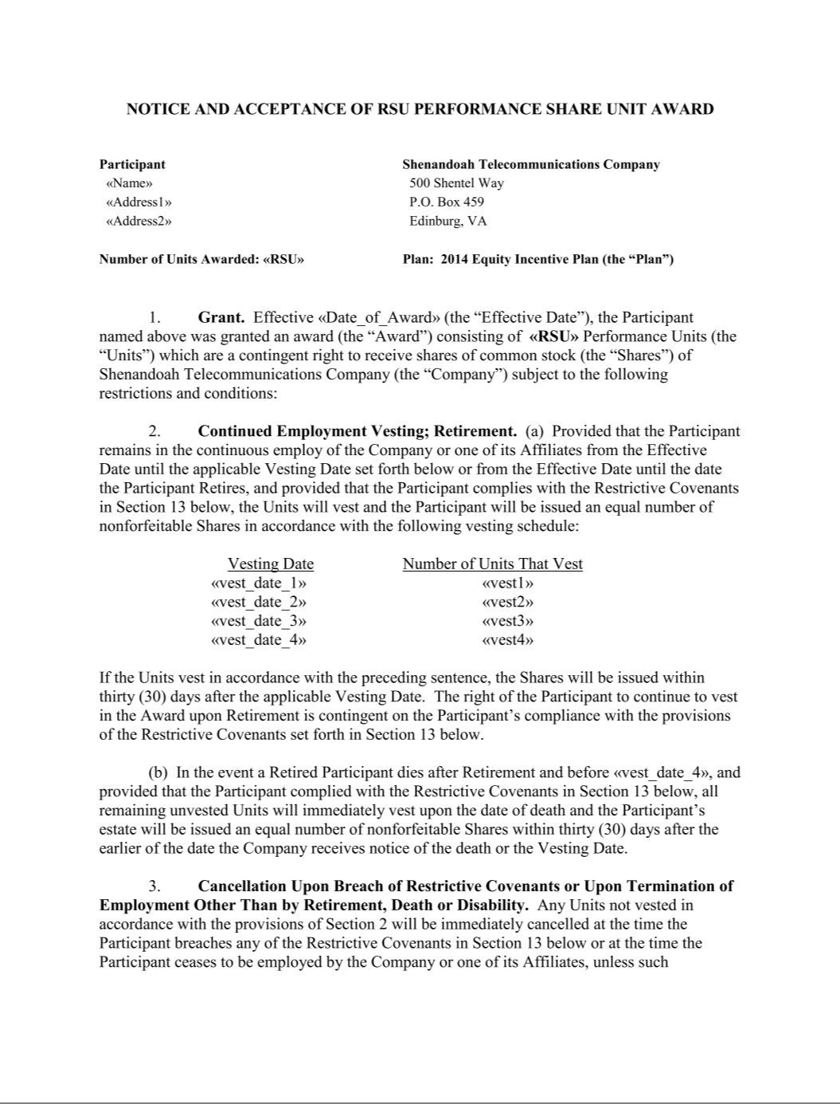

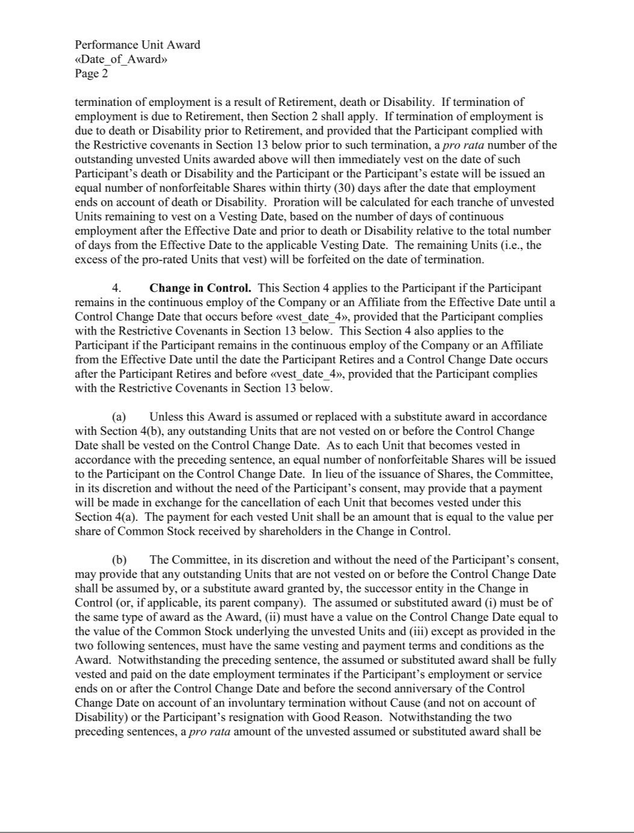

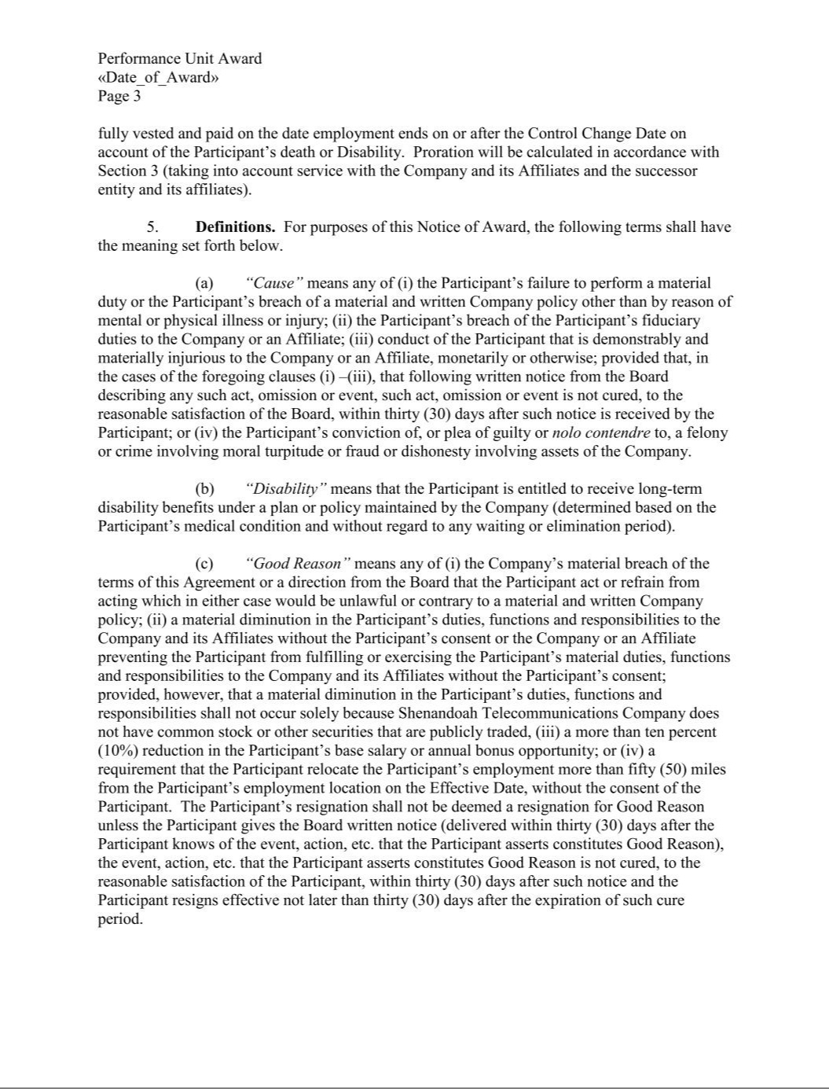

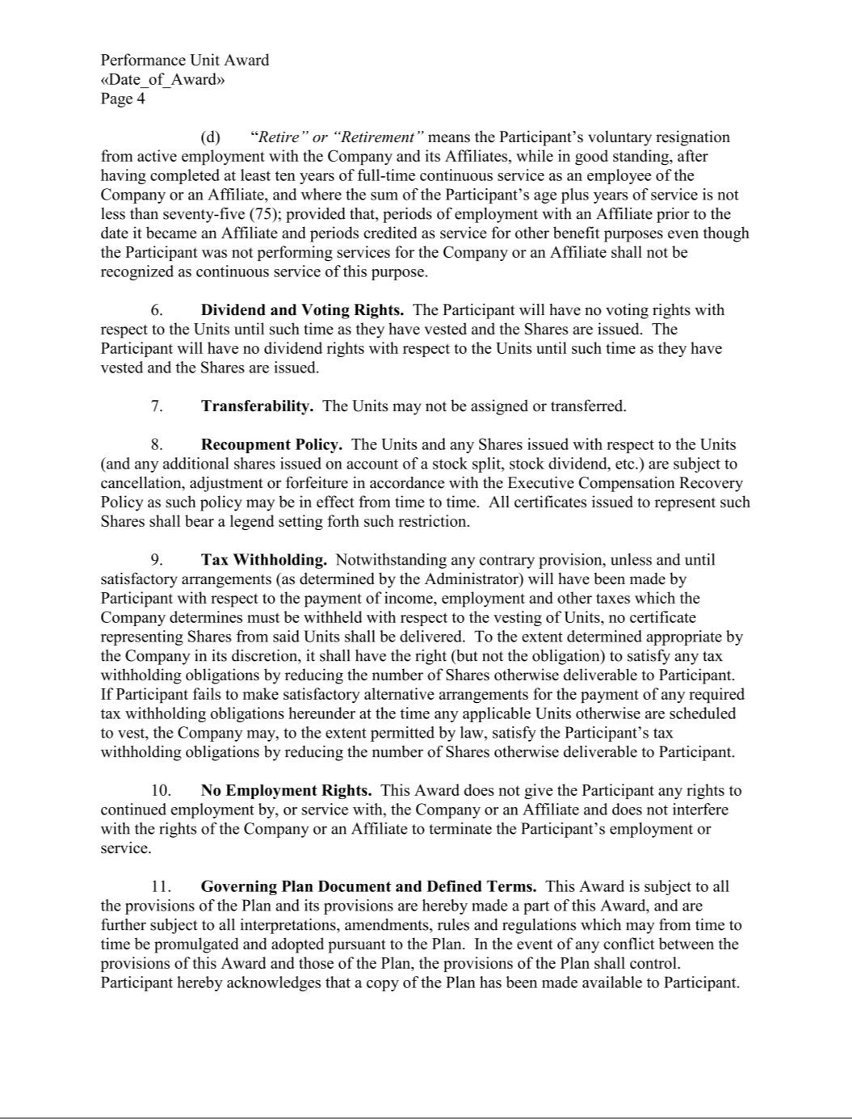

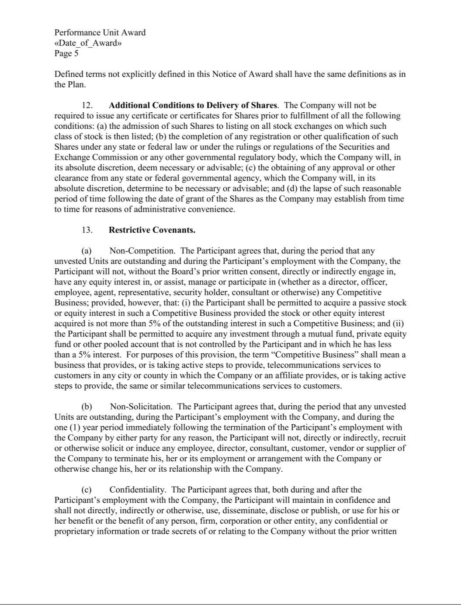

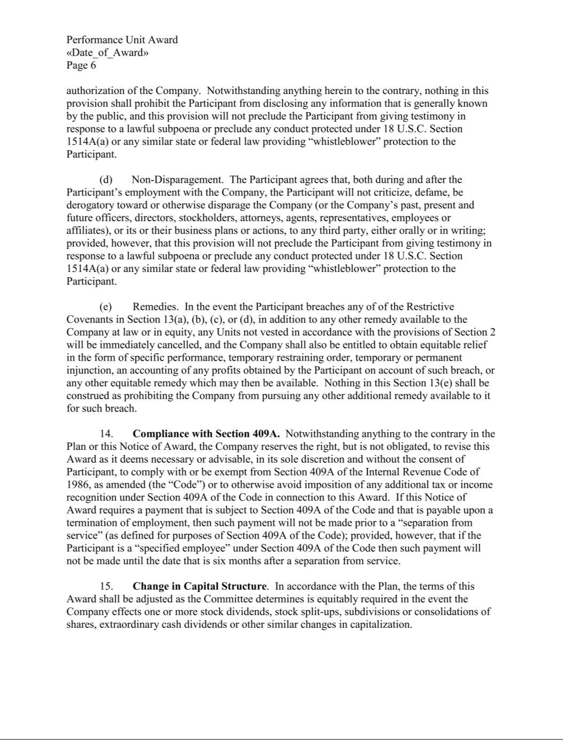

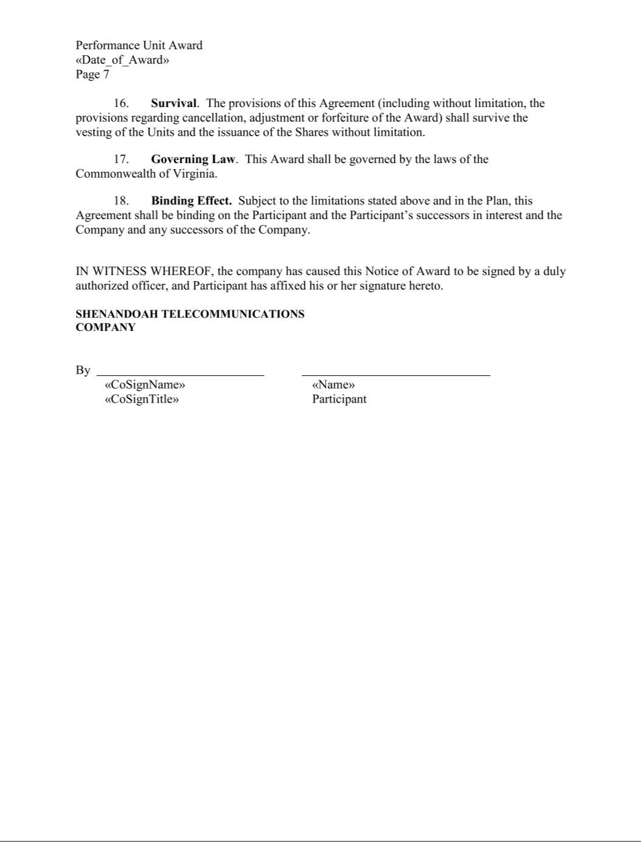

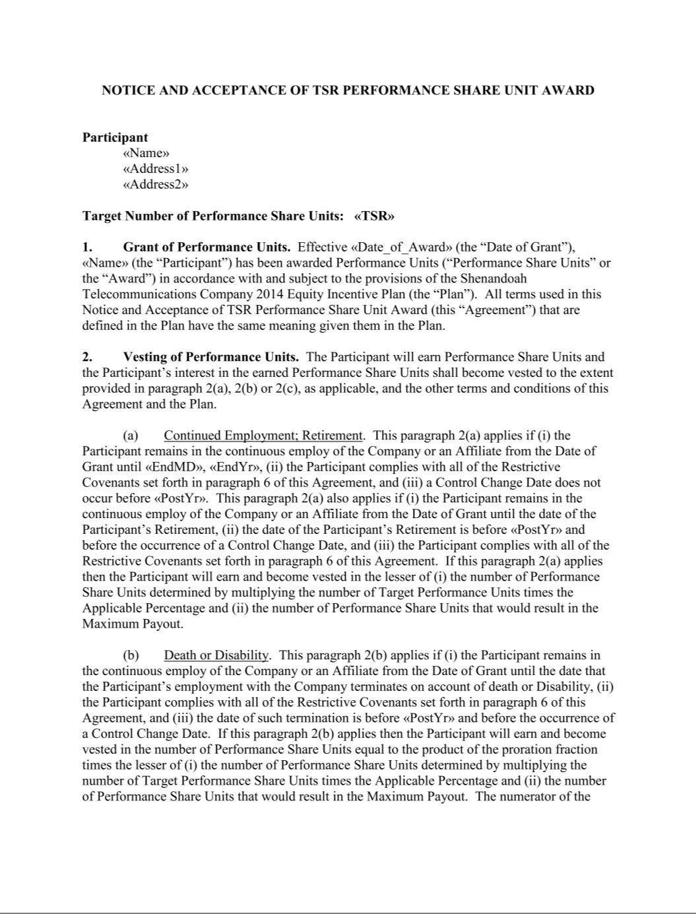

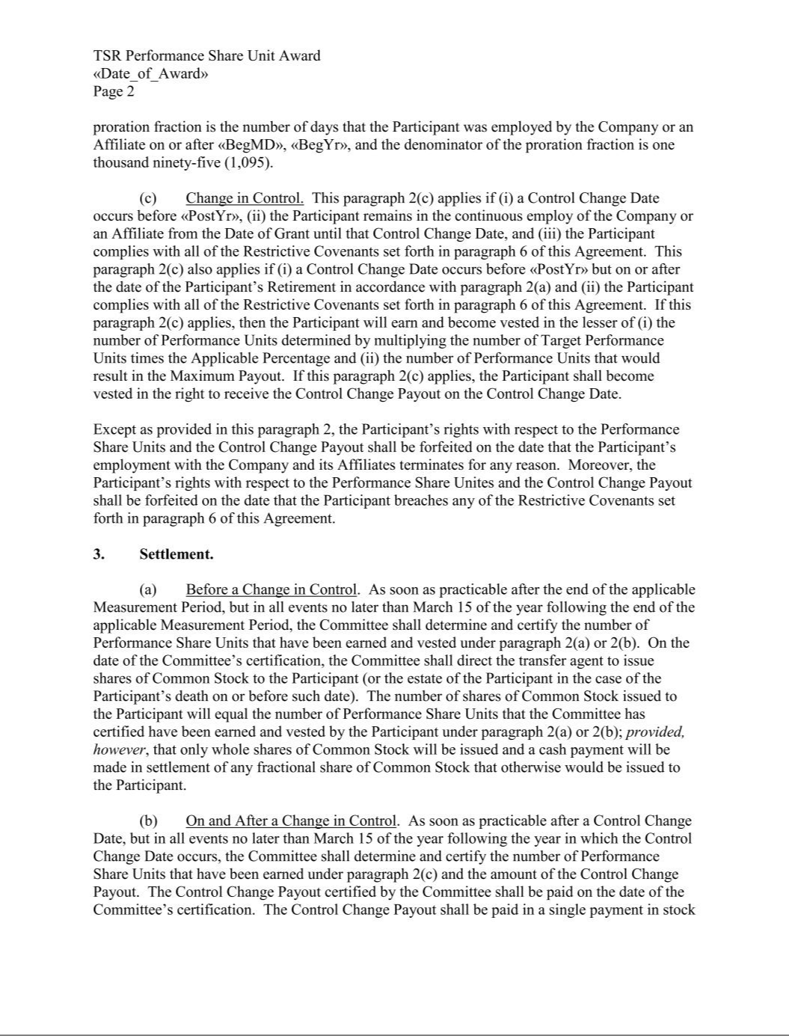

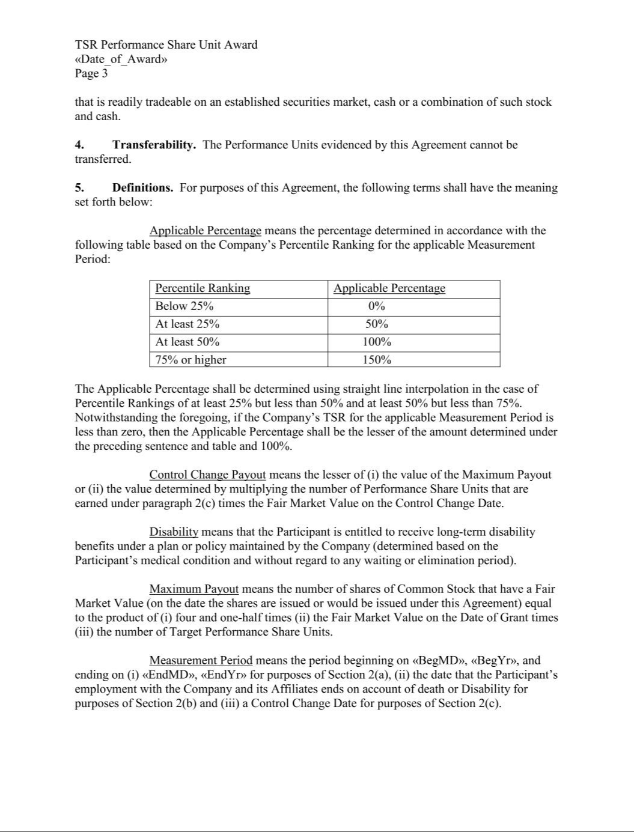

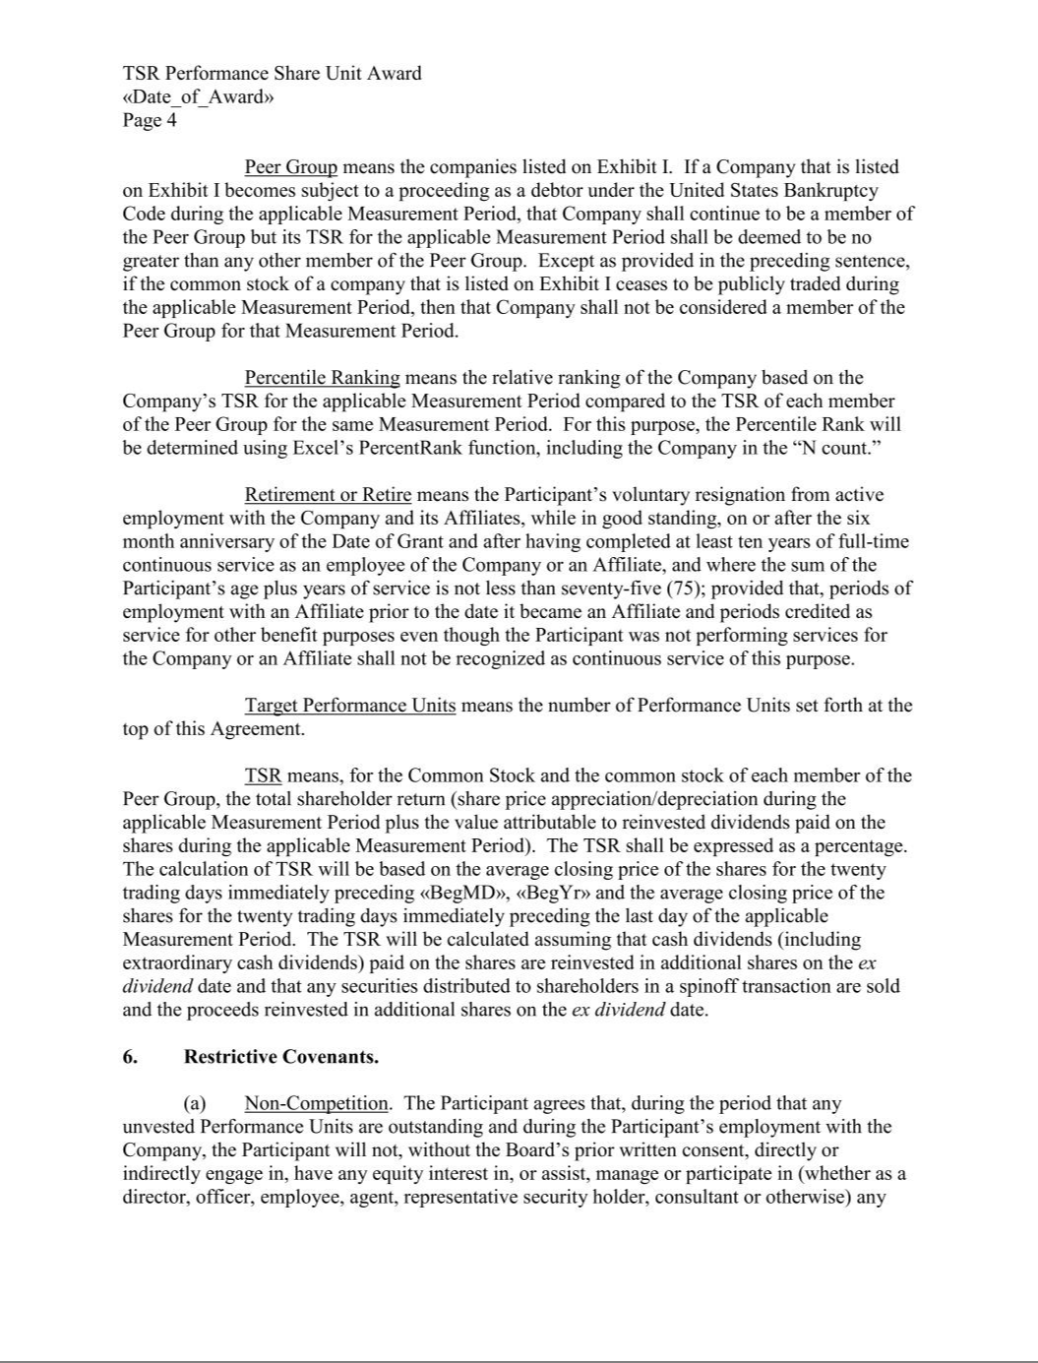

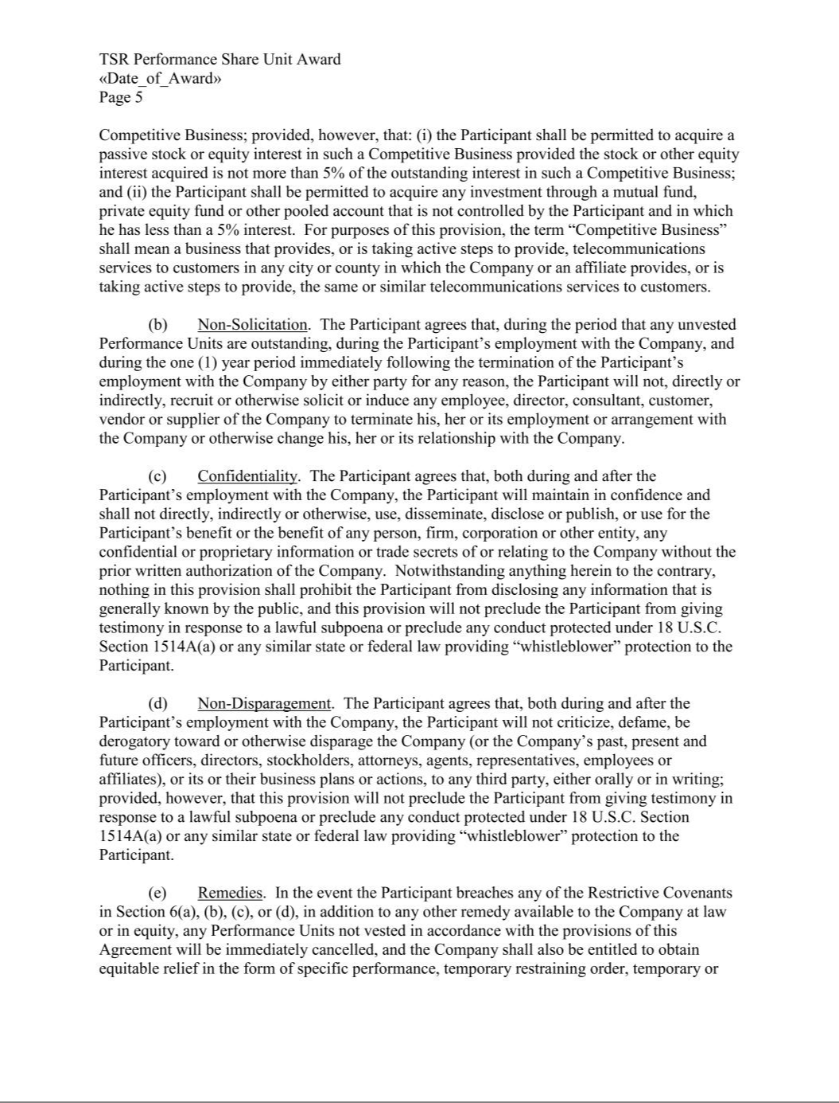

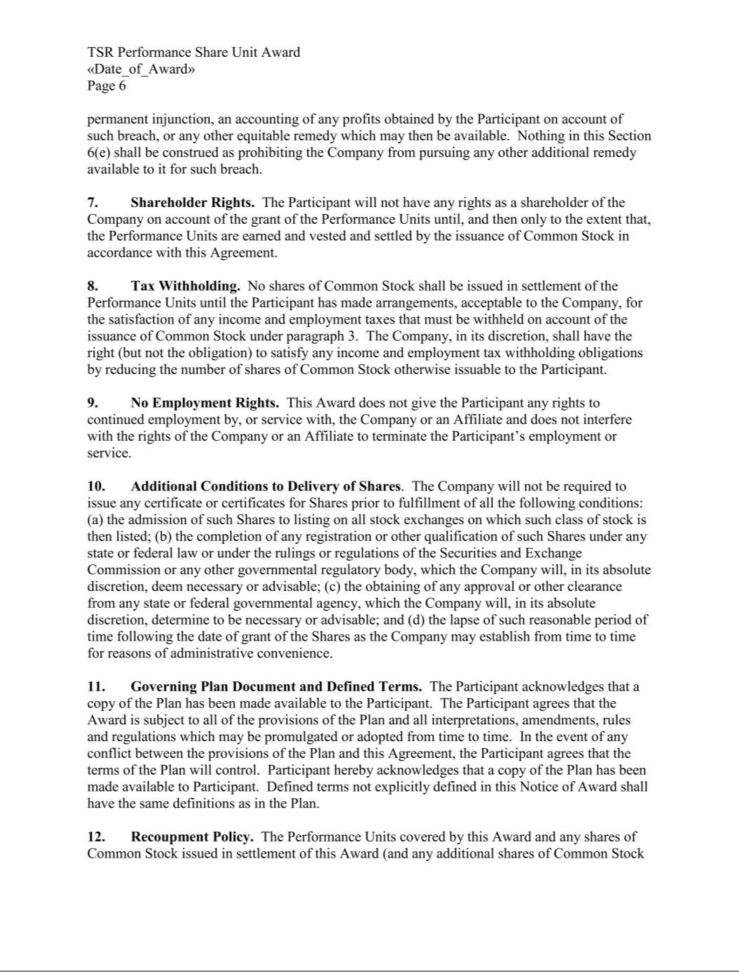

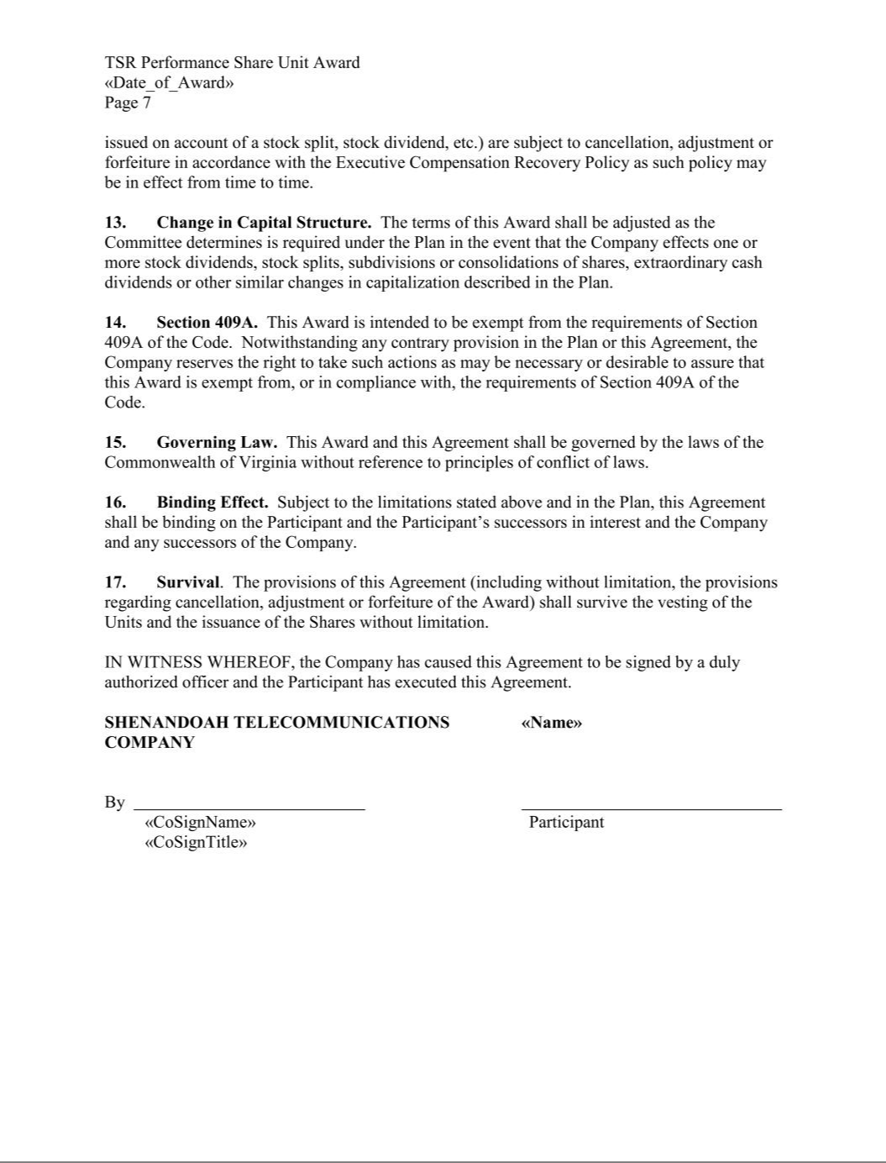



EXHIBIT 21 LIST OF SUBSIDIARIES

SHENANDOAH TELECOMMUNICATIONS COMPANY AND SUBSIDIARIES

The following are all significant subsidiaries of Shenandoah Telecommunications Company, and are organized in the Commonwealth of Virginia.

Shenandoah Cable Television, LLC

Shenandoah Mobile, LLC

Shenandoah Personal Communications, LLC

Shenandoah Telephone Company

Shentel Management Company

Exhibit 23.1

Consent of Independent Registered Public Accounting Firm

The Board of Directors

Shenandoah Telecommunications Company:

We consent to the incorporation by reference in the Registration Statements on Form S-3D (No. 333-74297) and on Form S-8 (No. 333-196990) of Shenandoah Telecommunications Company of our reports dated February 22, 2023, relating to the consolidated financial statements, the financial statement schedule and the effectiveness of internal control over financial reporting of Shenandoah Telecommunications Company, appearing in this Annual Report on Form 10-K of Shenandoah Telecommunications Company for the year ended December 31, 2022.

/s/ RSM US LLP

Ft. Lauderdale, Florida

February 22, 2023

Exhibit 23.2

Consent of Independent Registered

Public Accounting Firm

The Board of Directors

Shenandoah Telecommunications Company:

We consent to the incorporation by reference in the registration statements (No. 333-74297) on Form S-3D and (No. 333-196990) on Form S-8 of our report dated February 28, 2022, with respect to the consolidated financial statements and financial statement schedule II — Valuation and Qualifying Accounts of Shenandoah Telecommunications Company, which report appears in the December 31, 2022 annual report on Form 10-K of Shenandoah Telecommunications Company.

/s/ KPMG LLP

McLean, VA

February 22, 2023

EXHIBIT 31.1

CERTIFICATION

I, Christopher E. French, certify that:

- I have reviewed this annual report on Form 10-K of Shenandoah Telecommunications Company, Inc.;

- Based on my knowledge, this report does not contain any untrue statement of a material fact or omit to state a material fact necessary to make the statements made, in light of the circumstances under which such statements were made, not misleading with respect to the period covered by this report;

- Based on my knowledge, the financial statements, and other financial information included in this report, fairly present in all material respects the financial condition, results of operations and cash flows of the registrant as of, and for, the periods presented in this report;

- The registrant’s other certifying officer(s) and I are responsible for establishing and maintaining disclosure controls and procedures (as defined in Exchange Act Rules 13a-15(e) and 15d-15(e)) and internal control over financial reporting (as defined in Exchange Act Rules 13a-15(f) and 15d‑15(f)) for the registrant and have:

  - Designed such disclosure controls and procedures, or caused such disclosure controls and procedures to be designed under our supervision, to ensure that material information relating to the registrant, including its consolidated subsidiaries, is made known to us by others within those entities, particularly during the period in which this report is being prepared;

  - Designed such internal control over financial reporting, or caused such internal control over financial reporting to be designed under our supervision, to provide reasonable assurance regarding the reliability of financial reporting and the preparation of financial statements for external purposes in accordance with generally accepted accounting principles;

  - Evaluated the effectiveness of the registrant’s disclosure controls and procedures and presented in this report our conclusions about the effectiveness of the disclosure controls and procedures, as of the end of the period covered by this report based on such evaluation; and

  - Disclosed in this report any change in the registrant’s internal control over financial reporting that occurred during the registrant’s most recent fiscal quarter (the registrant’s fourth fiscal quarter in the case of an annual report) that has materially affected, or is reasonably likely to materially affect, the registrant’s internal control over financial reporting; and

- The registrant’s other certifying officer(s) and I have disclosed, based on our most recent evaluation of internal control over financial reporting, to the registrant’s auditors and the audit committee of the registrant’s board of directors (or persons performing the equivalent functions):

  - All significant deficiencies and material weaknesses in the design or operation of internal control over financial reporting which are reasonably likely to adversely affect the registrant’s ability to record, process, summarize and report financial information; and

  - Any fraud, whether or not material, that involves management or other employees who have a significant role in the registrant’s internal control over financial reporting.

/S/ CHRISTOPHER E. FRENCH

Christopher E. French, President and Chief Executive Officer

(Principal Executive Officer)

Date: February 22, 2023

EXHIBIT 31.2

CERTIFICATION

I, James J. Volk, certify that:

- I have reviewed this annual report on Form 10-K of Shenandoah Telecommunications Company, Inc.;

- Based on my knowledge, this report does not contain any untrue statement of a material fact or omit to state a material fact necessary to make the statements made, in light of the circumstances under which such statements were made, not misleading with respect to the period covered by this report;

- Based on my knowledge, the financial statements, and other financial information included in this report, fairly present in all material respects the financial condition, results of operations and cash flows of the registrant as of, and for, the periods presented in this report;

- The registrant’s other certifying officer(s) and I are responsible for establishing and maintaining disclosure controls and procedures (as defined in Exchange Act Rules 13a-15(e) and 15d-15(e)) and internal control over financial reporting (as defined in Exchange Act Rules 13a-15(f) and 15d‑15(f)) for the registrant and have:

  - Designed such disclosure controls and procedures, or caused such disclosure controls and procedures to be designed under our supervision, to ensure that material information relating to the registrant, including its consolidated subsidiaries, is made known to us by others within those entities, particularly during the period in which this report is being prepared;

  - Designed such internal control over financial reporting, or caused such internal control over financial reporting to be designed under our supervision, to provide reasonable assurance regarding the reliability of financial reporting and the preparation of financial statements for external purposes in accordance with generally accepted accounting principles;

  - Evaluated the effectiveness of the registrant’s disclosure controls and procedures and presented in this report our conclusions about the effectiveness of the disclosure controls and procedures, as of the end of the period covered by this report based on such evaluation; and

  - Disclosed in this report any change in the registrant’s internal control over financial reporting that occurred during the registrant’s most recent fiscal quarter (the registrant’s fourth fiscal quarter in the case of an annual report) that has materially affected, or is reasonably likely to materially affect, the registrant’s internal control over financial reporting; and

- The registrant’s other certifying officer(s) and I have disclosed, based on our most recent evaluation of internal control over financial reporting, to the registrant’s auditors and the audit committee of the registrant’s board of directors (or persons performing the equivalent functions):

  - All significant deficiencies and material weaknesses in the design or operation of internal control over financial reporting which are reasonably likely to adversely affect the registrant’s ability to record, process, summarize and report financial information; and

  - Any fraud, whether or not material, that involves management or other employees who have a significant role in the registrant’s internal control over financial reporting.

/s/JAMES J. VOLK

James J. Volk, Senior Vice President – Chief Financial Officer

(Principal Financial Officer)

Date: February 22, 2023

EXHIBIT 31.3

CERTIFICATION

I, Dennis A. Romps, certify that:

- I have reviewed this annual report on Form 10-K of Shenandoah Telecommunications Company, Inc.;

- Based on my knowledge, this report does not contain any untrue statement of a material fact or omit to state a material fact necessary to make the statements made, in light of the circumstances under which such statements were made, not misleading with respect to the period covered by this report;

- Based on my knowledge, the financial statements, and other financial information included in this report, fairly present in all material respects the financial condition, results of operations and cash flows of the registrant as of, and for, the periods presented in this report;

- The registrant’s other certifying officer(s) and I are responsible for establishing and maintaining disclosure controls and procedures (as defined in Exchange Act Rules 13a-15(e) and 15d-15(e)) and internal control over financial reporting (as defined in Exchange Act Rules 13a-15(f) and 15d‑15(f)) for the registrant and have:

  - Designed such disclosure controls and procedures, or caused such disclosure controls and procedures to be designed under our supervision, to ensure that material information relating to the registrant, including its consolidated subsidiaries, is made known to us by others within those entities, particularly during the period in which this report is being prepared;

  - Designed such internal control over financial reporting, or caused such internal control over financial reporting to be designed under our supervision, to provide reasonable assurance regarding the reliability of financial reporting and the preparation of financial statements for external purposes in accordance with generally accepted accounting principles;

  - Evaluated the effectiveness of the registrant’s disclosure controls and procedures and presented in this report our conclusions about the effectiveness of the disclosure controls and procedures, as of the end of the period covered by this report based on such evaluation; and

  - Disclosed in this report any change in the registrant’s internal control over financial reporting that occurred during the registrant’s most recent fiscal quarter (the registrant’s fourth fiscal quarter in the case of an annual report) that has materially affected, or is reasonably likely to materially affect, the registrant’s internal control over financial reporting; and

- The registrant’s other certifying officer(s) and I have disclosed, based on our most recent evaluation of internal control over financial reporting, to the registrant’s auditors and the audit committee of the registrant’s board of directors (or persons performing the equivalent functions):

  - All significant deficiencies and material weaknesses in the design or operation of internal control over financial reporting which are reasonably likely to adversely affect the registrant’s ability to record, process, summarize and report financial information; and

  - Any fraud, whether or not material, that involves management or other employees who have a significant role in the registrant’s internal control over financial reporting.

/s/DENNIS A. ROMPS

Dennis A. Romps, Vice President - Chief Accounting Officer

(Principal Accounting Officer)

Date: February 22, 2023

EXHIBIT 32

Written Statement of Chief Executive Officer and Chief Financial Officer

Pursuant to Section 906 of the Sarbanes-Oxley Act of 2002

Each of the undersigned, the President and Chief Executive Officer and the Senior Vice President - Chief Financial Officer, of Shenandoah Telecommunications Company (the “Company”), hereby certifies that, on the date hereof:

- The annual report on Form 10-K of the Company for the year ended December 31, 2022 filed on the date hereof with the Securities and Exchange Commission (the “Report”) fully complies with the requirements of Section 13(a) or 15(d) of the Securities Exchange Act of 1934; and

- Information contained in the Report fairly presents, in all material respects, the financial condition and result of operations of the Company.

/S/CHRISTOPHER E. FRENCH

Christopher E. French

President and Chief Executive Officer

(Principal Executive Officer)

February 22, 2023

/S/JAMES J. VOLK

James J. Volk

Senior Vice President – Chief Financial Officer

(Principal Financial Officer)

February 22, 2023

The foregoing certification is being furnished solely pursuant to Rule 13a-14(b) under the Securities Exchange Act of 1934 (the “Exchange Act”) and 18 U.S.C. Section 1350 and is not being filed as part of the Report or as a separate disclosure document. This certification shall not be deemed “filed” for purposes of Section 18 of the Exchange Act or otherwise subject to liability under that section. This certification shall not be deemed to be incorporated by reference into any filing under the Securities Act of 1933 or the Exchange Act except to the extent this Exhibit 32 is expressly and specifically incorporated by reference in any such filing.

