UNITED STATES
SECURITIES AND EXCHANGE COMMISSION
Washington, D. C. 20549
FORM 10-Q
(Mark One)
☒ |  |  | QUARTERLY REPORT PURSUANT TO SECTION 13 OR 15(d) OF THE SECURITIES EXCHANGE ACT OF 1934
For the quarterly period ended March 31, 2026
☐ |  |  | TRANSITION REPORT PURSUANT TO SECTION 13 OR 15(d) OF THE SECURITIES EXCHANGE ACT OF 1934
For the transition period from__________ to __________

Commission File No.: 000-09881


SHENANDOAH TELECOMMUNICATIONS COMPANY
(Exact name of registrant as specified in its charter)
Virginia |  |  |  |  |  | 54-1162807
(State or other jurisdiction of incorporation or organization) |  |  |  |  |  | (I.R.S. Employer Identification No.)

500 Shentel Way, Edinburg, Virginia 22824
(Address of principal executive offices) (Zip Code)

(540) 984-4141
(Registrant's telephone number, including area code)
SECURITIES REGISTERED PURSUANT TO SECTION 12(B) OF THE ACT:

Common Stock (No Par Value) |  |  | SHEN |  |  | NASDAQ Global Select Market |  |  | 55,322,001
(Title of Class) |  |  | (Trading Symbol) |  |  | (Name of Exchange on which Registered) |  |  | (The number of shares of the registrant's common stock outstanding on April 24, 2026)

Indicate by check mark whether the registrant (1) has filed all reports required to be filed by Section 13 or 15(d) of the Securities Exchange Act of 1934 during the preceding 12 months (or for such shorter period that the registrant was required to file such reports), and (2) has been subject to such filing requirements for the past 90 days. Yes ☒ No ☐

Indicate by check mark whether the registrant has submitted electronically every Interactive Data File required to be submitted pursuant to Rule 405 of Regulation S-T (§232.405 of this chapter) during the preceding 12 months (or for such shorter period that the registrant was required to submit such files). Yes ☒ No ☐

Indicate by check mark whether the registrant is a large accelerated filer, an accelerated filer, a non-accelerated filer, smaller reporting company, or an emerging growth company. See the definitions of “large accelerated filer,” “accelerated filer,” “smaller reporting company,” and “emerging growth company” in Rule 12b-2 of the Exchange Act.
Large accelerated filer |  |  | ☒ |  |  | Accelerated filer |  |  | ☐ |  |  | Non-accelerated filer |  |  | ☐ |  |  | Smaller reporting company |  |  | ☐ |  |  | Emerging growth company |  |  | ☐
If an emerging growth company, indicate by check mark if the registrant has elected not to use the extended transition period for complying with any new or revised financial accounting standards provided pursuant to Section 13(a) of the Exchange Act. ☐

Indicate by check mark whether the registrant is a shell company (as defined in Rule 12b-2 of the Exchange Act).
Yes ☐ No ☒

SHENANDOAH TELECOMMUNICATIONS COMPANY
INDEX

Page
Numbers
PART I. |  |  | FINANCIAL INFORMATION
Item 1. |  |  | Financial Statements
 |  |  | Unaudited Condensed Consolidated Balance Sheets |  |  | 3
 |  |  | Unaudited Condensed Consolidated Statements of Operations |  |  | 4
 |  |  | Unaudited Condensed Consolidated Statements of Comprehensive Loss |  |  | 5
 |  |  | Unaudited Condensed Consolidated Statements of Temporary Equity and Shareholders’ Equity |  |  | 6
 |  |  | Unaudited Condensed Consolidated Statements of Cash Flows |  |  | 7
 |  |  | Notes to Unaudited Condensed Consolidated Financial Statements |  |  | 8
Item 2. |  |  | Management’s Discussion and Analysis of Financial Condition and Results of Operations |  |  | 21
Item 3. |  |  | Quantitative and Qualitative Disclosures about Market Risk |  |  | 29
Item 4. |  |  | Controls and Procedures |  |  | 29
PART II. |  |  | OTHER INFORMATION
Item 1. |  |  | Legal Proceedings |  |  | 30
Item 1A. |  |  | Risk Factors |  |  | 30
Item 2. |  |  | Unregistered Sales of Equity Securities and Use of Proceeds |  |  | 30
Item 5. |  |  | Other Information |  |  | 30
Item 6. |  |  | Exhibits |  |  | 31
 |  |  | Signatures |  |  | 32

2
Table of Contents

SHENANDOAH TELECOMMUNICATIONS COMPANY AND SUBSIDIARIES
UNAUDITED CONDENSED CONSOLIDATED BALANCE SHEETS
(in thousands) |  |  | March 31,  2026 |  |  |  |  |  | December 31,  2025
ASSETS
Current assets:
Cash and cash equivalents |  |  | $ | 43,767 |  |  |  |  | $ | 27,259
Restricted cash and cash equivalents |  |  | 27,311 |  |  |  |  |  | 20,945
Accounts receivable, net of allowance for credit losses of $1,096 and $829, respectively |  |  | 24,759 |  |  |  |  |  | 31,497
Income taxes receivable |  |  | 2,544 |  |  |  |  |  | 2,544
Prepaid expenses and other |  |  | 15,843 |  |  |  |  |  | 15,198
Total current assets |  |  | 114,224 |  |  |  |  |  | 97,443
Investments |  |  | 16,113 |  |  |  |  |  | 16,510
Property, plant and equipment, net |  |  | 1,629,208 |  |  |  |  |  | 1,601,609
Goodwill |  |  | 67,538 |  |  |  |  |  | 67,538
Intangible assets, net |  |  | 88,960 |  |  |  |  |  | 89,353
Operating lease right-of-use assets |  |  | 19,084 |  |  |  |  |  | 19,657
Deferred charges and other assets |  |  | 17,835 |  |  |  |  |  | 18,652
Total assets |  |  | $ | 1,952,962 |  |  |  |  | $ | 1,910,762
LIABILITIES, TEMPORARY EQUITY AND SHAREHOLDERS’ EQUITY
Current liabilities:
Accounts payable |  |  | $ | 54,187 |  |  |  |  | $ | 61,355
Advanced billings and customer deposits |  |  | 17,884 |  |  |  |  |  | 16,909
Accrued compensation |  |  | 12,316 |  |  |  |  |  | 13,334
Current operating lease liabilities |  |  | 2,850 |  |  |  |  |  | 2,819
Accrued liabilities and other |  |  | 14,325 |  |  |  |  |  | 14,079
Total current liabilities |  |  | 101,562 |  |  |  |  |  | 108,496
Long-term debt, net of unamortized loan fees |  |  | 693,887 |  |  |  |  |  | 628,237
Other long-term liabilities:
Deferred income taxes |  |  | 153,510 |  |  |  |  |  | 157,618
Benefit plan obligations |  |  | 4,161 |  |  |  |  |  | 4,150
Non-current operating lease liabilities |  |  | 10,096 |  |  |  |  |  | 10,632
Other liabilities |  |  | 32,705 |  |  |  |  |  | 32,340
Total other long-term liabilities |  |  | 200,472 |  |  |  |  |  | 204,740
Commitments and contingencies (Note 13)
Temporary equity:
Redeemable noncontrolling interest |  |  | 90,083 |  |  |  |  |  | 88,506
Shareholders’ equity:
Common stock, no par value, authorized 96,000; 55,302 and 54,899 issued and outstanding at March 31, 2026 and December 31, 2025, respectively |  |  | — |  |  |  |  |  | —
Additional paid in capital |  |  | 160,719 |  |  |  |  |  | 157,216
Retained earnings |  |  | 706,239 |  |  |  |  |  | 723,567
Total shareholders’ equity |  |  | 866,958 |  |  |  |  |  | 880,783
Total liabilities, temporary equity and shareholders’ equity |  |  | $ | 1,952,962 |  |  |  |  | $ | 1,910,762
See accompanying notes to unaudited condensed consolidated financial statements.

3
Table of Contents
SHENANDOAH TELECOMMUNICATIONS COMPANY AND SUBSIDIARIES
UNAUDITED CONDENSED CONSOLIDATED STATEMENTS OF OPERATIONS
(in thousands, except per share amounts) |  |  |  |  |  | Three Months Ended  March 31,
 |  |  |  |  |  | 2026 |  |  |  |  |  | 2025
Service revenue and other |  |  |  |  |  | $ | 92,153 |  |  |  |  | $ | 87,898
Operating expenses:
Cost of services, exclusive of depreciation and amortization |  |  |  |  |  | 31,824 |  |  |  |  |  | 33,030
Selling, general and administrative |  |  |  |  |  | 33,387 |  |  |  |  |  | 30,992
Restructuring, integration and acquisition |  |  |  |  |  | 2,440 |  |  |  |  |  | 510
Depreciation and amortization |  |  |  |  |  | 34,971 |  |  |  |  |  | 29,458
Total operating expenses |  |  |  |  |  | 102,622 |  |  |  |  |  | 93,990
Operating loss |  |  |  |  |  | (10,469) |  |  |  |  |  | (6,092)
Other (expense) income:
Interest expense |  |  |  |  |  | (9,435) |  |  |  |  |  | (4,892)
Other income, net |  |  |  |  |  | 45 |  |  |  |  |  | 733
Loss before income taxes |  |  |  |  |  | (19,859) |  |  |  |  |  | (10,251)
Income tax benefit |  |  |  |  |  | (4,108) |  |  |  |  |  | (1,119)
Net loss |  |  |  |  |  | (15,751) |  |  |  |  |  | (9,132)
Dividends on redeemable noncontrolling interest |  |  |  |  |  | 1,577 |  |  |  |  |  | 1,472
Net loss attributable to common shareholders |  |  |  |  |  | $ | (17,328) |  |  |  |  | $ | (10,604)
Net loss per share attributable to common shareholders, basic and diluted:
Net loss per share |  |  |  |  |  | $ | (0.31) |  |  |  |  | $ | (0.19)
Weighted average shares outstanding |  |  |  |  |  | 55,554 |  |  |  |  |  | 54,959

See accompanying notes to unaudited condensed consolidated financial statements.

4
Table of Contents
SHENANDOAH TELECOMMUNICATIONS COMPANY AND SUBSIDIARIES
UNAUDITED CONDENSED CONSOLIDATED STATEMENTS OF COMPREHENSIVE LOSS
(in thousands) |  |  |  |  |  | Three Months Ended  March 31,
 |  |  |  |  |  | 2026 |  |  |  |  |  | 2025
Net loss |  |  |  |  |  | $ | (15,751) |  |  |  |  | $ | (9,132)
Other comprehensive loss:
Net change in unrealized loss |  |  |  |  |  | — |  |  |  |  |  | (222)
Amounts reclassified from accumulated other comprehensive loss |  |  |  |  |  | — |  |  |  |  |  | (408)
Comprehensive loss |  |  |  |  |  | (15,751) |  |  |  |  |  | (9,762)
Dividends on redeemable noncontrolling interest |  |  |  |  |  | 1,577 |  |  |  |  |  | 1,472
Comprehensive loss attributable to common shareholders |  |  |  |  |  | $ | (17,328) |  |  |  |  | $ | (11,234)

See accompanying notes to unaudited condensed consolidated financial statements.

5
Table of Contents
SHENANDOAH TELECOMMUNICATIONS COMPANY AND SUBSIDIARIES
UNAUDITED CONDENSED CONSOLIDATED STATEMENTS OF TEMPORARY EQUITY AND SHAREHOLDERS' EQUITY
(in thousands)
 |  |  |  |  |  | Redeemable Noncontrolling Interest |  |  |  |  |  |  |  |  |  |  |  |  |  |  | Common Stock
 |  |  |  |  |  | Shares |  |  |  |  |  | Amount |  |  |  |  |  |  |  |  | Shares  (no par value) |  |  |  |  |  | Additional Paid in Capital |  |  |  |  |  | Retained Earnings |  |  |  |  |  | Accumulated Other Comprehensive Income |  |  |  |  |  | Total Shareholders’ Equity
Balance, December 31, 2025 |  |  |  |  |  | 81 |  |  |  |  |  | $ | 88,506 |  |  |  |  |  |  |  | 54,899 |  |  |  |  |  | $ | 157,216 |  |  |  |  | $ | 723,567 |  |  |  |  | $ | — |  |  |  |  | $ | 880,783
Net loss |  |  |  |  |  | — |  |  |  |  |  | — |  |  |  |  |  |  |  |  | — |  |  |  |  |  | — |  |  |  |  |  | (15,751) |  |  |  |  |  | — |  |  |  |  |  | (15,751)
Stock-based compensation |  |  |  |  |  | — |  |  |  |  |  | — |  |  |  |  |  |  |  |  | 516 |  |  |  |  |  | 4,971 |  |  |  |  |  | — |  |  |  |  |  | — |  |  |  |  |  | 4,971
Common stock issued |  |  |  |  |  | — |  |  |  |  |  | — |  |  |  |  |  |  |  |  | 1 |  |  |  |  |  | 14 |  |  |  |  |  | — |  |  |  |  |  | — |  |  |  |  |  | 14
Shares surrendered for settlement of employee taxes upon issuance of vested equity awards |  |  |  |  |  | — |  |  |  |  |  | — |  |  |  |  |  |  |  |  | (114) |  |  |  |  |  | (1,482) |  |  |  |  |  | — |  |  |  |  |  | — |  |  |  |  |  | (1,482)
Preferred stock dividends - paid in kind |  |  |  |  |  | — |  |  |  |  |  | 1,577 |  |  |  |  |  |  |  |  | — |  |  |  |  |  | — |  |  |  |  |  | (1,577) |  |  |  |  |  | — |  |  |  |  |  | (1,577)
Balance, March 31, 2026 |  |  |  |  |  | 81 |  |  |  |  |  | $ | 90,083 |  |  |  |  |  |  |  | 55,302 |  |  |  |  |  | $ | 160,719 |  |  |  |  | $ | 706,239 |  |  |  |  | $ | — |  |  |  |  | $ | 866,958

 |  |  |  |  |  | Redeemable Noncontrolling Interest |  |  |  |  |  |  |  |  |  |  |  |  |  |  | Common Stock
 |  |  |  |  |  | Shares |  |  |  |  |  | Amount |  |  |  |  |  |  |  |  | Shares of Common Stock (no par value) |  |  |  |  |  | Additional Paid in Capital |  |  |  |  |  | Retained Earnings |  |  |  |  |  | Accumulated Other Comprehensive Income |  |  |  |  |  | Total Shareholders’ Equity
Balance, December 31, 2024 |  |  |  |  |  | 81 |  |  |  |  |  | $ | 82,464 |  |  |  |  |  |  |  | 54,605 |  |  |  |  |  | $ | 147,733 |  |  |  |  | $ | 768,997 |  |  |  |  | $ | 1,853 |  |  |  |  | $ | 918,583
Net loss |  |  |  |  |  | — |  |  |  |  |  | — |  |  |  |  |  |  |  |  | — |  |  |  |  |  | — |  |  |  |  |  | (9,132) |  |  |  |  |  | — |  |  |  |  |  | (9,132)
Unrealized loss on interest rate hedge, net of tax |  |  |  |  |  | — |  |  |  |  |  | — |  |  |  |  |  |  |  |  | — |  |  |  |  |  | — |  |  |  |  |  | — |  |  |  |  |  | (222) |  |  |  |  |  | (222)
Amounts reclassified from accumulated other comprehensive income |  |  |  |  |  | — |  |  |  |  |  | — |  |  |  |  |  |  |  |  | — |  |  |  |  |  | — |  |  |  |  |  | — |  |  |  |  |  | (408) |  |  |  |  |  | (408)
Stock-based compensation |  |  |  |  |  | — |  |  |  |  |  | — |  |  |  |  |  |  |  |  | 318 |  |  |  |  |  | 3,897 |  |  |  |  |  | — |  |  |  |  |  | — |  |  |  |  |  | 3,897
Common stock issued |  |  |  |  |  | — |  |  |  |  |  | — |  |  |  |  |  |  |  |  | 1 |  |  |  |  |  | 14 |  |  |  |  |  | — |  |  |  |  |  | — |  |  |  |  |  | 14
Shares surrendered for settlement of employee taxes upon issuance of vested equity awards |  |  |  |  |  | — |  |  |  |  |  | — |  |  |  |  |  |  |  |  | (67) |  |  |  |  |  | (787) |  |  |  |  |  | — |  |  |  |  |  | — |  |  |  |  |  | (787)
Preferred stock dividends - paid in kind |  |  |  |  |  | — |  |  |  |  |  | 1,472 |  |  |  |  |  |  |  |  | — |  |  |  |  |  | — |  |  |  |  |  | (1,472) |  |  |  |  |  | — |  |  |  |  |  | (1,472)
Balance, March 31, 2025 |  |  |  |  |  | 81 |  |  |  |  |  | $ | 83,936 |  |  |  |  |  |  |  | 54,857 |  |  |  |  |  | $ | 150,857 |  |  |  |  | $ | 758,393 |  |  |  |  | $ | 1,223 |  |  |  |  | $ | 910,473

See accompanying notes to unaudited condensed consolidated financial statements.

6
Table of Contents
SHENANDOAH TELECOMMUNICATIONS COMPANY AND SUBSIDIARIES
UNAUDITED CONDENSED CONSOLIDATED STATEMENTS OF CASH FLOWS
(in thousands) |  |  | Three Months Ended  March 31,
 |  |  | 2026 |  |  |  |  |  | 2025
Cash flows from operating activities:
Net loss |  |  | $ | (15,751) |  |  |  |  | $ | (9,132)
Adjustments to reconcile net loss to net cash provided by operating activities:
Depreciation and amortization |  |  | 34,543 |  |  |  |  |  | 28,984
Amortization of intangible assets |  |  | 428 |  |  |  |  |  | 474
Stock-based compensation expense, net of amount capitalized |  |  | 4,798 |  |  |  |  |  | 3,717
Deferred income taxes |  |  | (4,108) |  |  |  |  |  | (1,119)
Provision for credit losses |  |  | 433 |  |  |  |  |  | 288
Other, net |  |  | 1,427 |  |  |  |  |  | 480
Changes in assets and liabilities:
Accounts receivable |  |  | 904 |  |  |  |  |  | 2,490
Current income taxes |  |  | — |  |  |  |  |  | 164
Operating lease assets and liabilities, net |  |  | (18) |  |  |  |  |  | (135)
Other assets |  |  | 298 |  |  |  |  |  | (682)
Accounts payable |  |  | 19 |  |  |  |  |  | 992
Other deferrals and accruals |  |  | 1,398 |  |  |  |  |  | (5,997)
Net cash provided by operating activities |  |  | 24,371 |  |  |  |  |  | 20,524
Cash flows from investing activities:
Capital expenditures |  |  | (75,821) |  |  |  |  |  | (83,236)
Government grants received |  |  | 11,548 |  |  |  |  |  | 6,929
Proceeds from sale of assets and other |  |  | 163 |  |  |  |  |  | 47
Net cash used in investing activities |  |  | (64,110) |  |  |  |  |  | (76,260)
Cash flows from financing activities:
Proceeds from credit facility borrowings |  |  | 65,000 |  |  |  |  |  | 100,000
Principal payments on long-term debt |  |  | — |  |  |  |  |  | (2,178)
Payments for debt issuance and amendment costs |  |  | (429) |  |  |  |  |  | —
Taxes paid for equity award issuances |  |  | (1,482) |  |  |  |  |  | (787)
Payments for financing arrangements and other |  |  | (476) |  |  |  |  |  | (24)
Net cash provided by financing activities |  |  | 62,613 |  |  |  |  |  | 97,011
Net increase in cash and cash equivalents |  |  | 22,874 |  |  |  |  |  | 41,275
Cash, cash equivalents, and restricted cash, beginning of period |  |  | 48,204 |  |  |  |  |  | 46,272
Cash, cash equivalents, and restricted cash, end of period |  |  | $ | 71,078 |  |  |  |  | $ | 87,547
Supplemental Disclosures of Cash Flow Information
Interest paid, net of amounts capitalized |  |  | $ | (9,741) |  |  |  |  | $ | (4,262)
Income tax refunds received |  |  | $ | — |  |  |  |  | $ | 164

The following table provides a reconciliation of the cash, cash equivalents, and restricted cash balances as of March 31, 2026 and December 31, 2025 as shown above:

(in thousands) |  |  | March 31,  2026 |  |  |  |  |  | December 31,  2025
Cash and cash equivalents |  |  | $ | 43,767 |  |  |  |  | $ | 27,259
Restricted cash |  |  | 27,311 |  |  |  |  |  | 20,945
Cash, cash equivalents, and restricted cash |  |  | $ | 71,078 |  |  |  |  | $ | 48,204

See accompanying notes to unaudited condensed consolidated financial statements.

7
Table of Contents
SHENANDOAH TELECOMMUNICATIONS COMPANY AND SUBSIDIARIES
NOTES TO UNAUDITED CONDENSED CONSOLIDATED FINANCIAL STATEMENTS

Note 1. Basis of Presentation and Other Information

Shenandoah Telecommunications Company and its subsidiaries (collectively, “Shentel”, “we”, “our”, “us”, or the “Company”) provide broadband data, video and voice services to residential and commercial customers in portions of Virginia, West Virginia, Maryland, Pennsylvania, Kentucky, Delaware, Ohio and Indiana, via fiber optic and hybrid fiber coaxial (“HFC”) cable networks. We also lease dark fiber and provide Ethernet and Wavelength fiber optic services to enterprise and wholesale customers throughout the entirety of our service area. Shentel’s Broadband business also provides voice and digital subscriber line (“DSL”) services as a Rural Local Exchange Carrier (“RLEC”) to customers in Shenandoah County and portions of adjacent counties in Virginia, and in Ross County and portions of adjacent counties in Ohio. These integrated networks are connected by a fiber network.

The accompanying unaudited condensed consolidated financial statements have been prepared in accordance with the instructions to Form 10-Q and Rule 10-01 of Regulation S-X for interim financial information. All normal recurring adjustments considered necessary for a fair presentation have been included. Certain disclosures normally included in annual consolidated financial statements prepared in accordance with accounting principles generally accepted in the United States (“U.S. GAAP”) have been omitted. These unaudited condensed consolidated financial statements should be read in conjunction with the audited consolidated financial statements and notes contained in our Annual Report on Form 10-K for the year ended December 31, 2025.

The preparation of the unaudited condensed consolidated financial statements in conformity with U.S. GAAP requires management to make estimates and assumptions that affect reported amounts of assets, liabilities, revenues and expenses and related disclosures. On an on-going basis we evaluate estimates and assumptions, including, but not limited to, revenue recognition, stock-based compensation, estimated useful lives of assets, impairment of goodwill and indefinite-lived intangible assets, realizability of intangible assets subject to amortization and the computation of income taxes. Future events and their effects cannot be predicted with certainty; accordingly, the Company’s accounting estimates require the exercise of judgment. The accounting estimates used in the preparation of the financial statements will change as new events occur, as additional information is obtained, and as the Company’s operating environment changes. Management evaluates and updates assumptions and estimates on an ongoing basis. Actual results may differ from these estimates under different assumptions or conditions.

New Accounting Standards

In October 2023, the Financial Accounting Standards Board (“FASB”) issued Accounting Standards Update (“ASU”) 2023-06, “Disclosure Improvements: Codification Amendments in Response to the Securities and Exchange Commission’s (“SEC”) Disclosure Update and Simplification Initiative,” (“ASU 2023-06”), which aligns the disclosure and presentation requirements of a variety of the FASB’s Accounting Standards Codification (“ASC”) Topics with the requirements described in the SEC’s Disclosure Update and Simplification Initiative. ASU 2023-06 will become effective for each amendment on the effective date of the SEC’s corresponding disclosure rule changes; however, if by June 30, 2027, the SEC has not removed the applicable requirement from Regulation S-X or Regulation S-K, the pending content of the related amendment will be removed from the Codification and will not become effective for any entity. The Company is currently assessing the impact of adopting ASU 2023-06 on the consolidated financial statements and related disclosures.

In November 2024, FASB issued ASU 2024-03 “Income Statement—Reporting Comprehensive Income—Expense Disaggregation Disclosures (Subtopic 220-40)” (“ASU 2024-03”). This accounting update requires disclosure of disaggregated expense in prescribed categories underlying any relevant income statement expense caption. The updated disclosure requirements are to be adopted for annual periods beginning after December 15, 2026, and interim reporting periods beginning after December 15, 2027. The Company is currently assessing the impact of adopting ASU 2024-03 on the consolidated financial statements and related disclosures.

In December 2025, the FASB issued ASU 2025-10, “Government Grants (Topic 832): Accounting for Government Grants Received by Business Entities” (“ASU 2025-10”). This accounting update establishes guidance for the recognition, measurement, presentation and disclosure of government grants. The updated requirements are effective for public business entities for annual reporting periods beginning after December 15, 2028, and interim periods therein, with early adoption permitted. The Company is currently assessing the impact of adopting ASU 2025-10 on its consolidated financial statements and related disclosures.

8
Table of Contents
There have been no additional material developments related to recently issued accounting standards beyond those noted above, including the expected dates of adoption and estimated effects on the Company’s unaudited condensed consolidated financial statements and note disclosures from those disclosed in the Company’s Annual Report on Form 10-K for its fiscal year ended December 31, 2025, that would be expected to impact the Company.

Note 2. Revenue from Contracts with Customers
The Company’s revenues by activity type were as follows:
Three Months Ended
March 31,
(in thousands) |  |  |  |  |  | 2026 |  |  |  |  |  | 2025
Residential & SMB - Incumbent Broadband Markets1 |  |  |  |  |  | $ | 41,143 |  |  |  |  | $ | 43,359
Residential & SMB - Glo Fiber Expansion Markets2 |  |  |  |  |  | 24,828 |  |  |  |  |  | 18,444
Commercial Fiber |  |  |  |  |  | 20,542 |  |  |  |  |  | 19,612
RLEC & Other |  |  |  |  |  | 5,640 |  |  |  |  |  | 6,483
Service revenue and other |  |  |  |  |  | $ | 92,153 |  |  |  |  | $ | 87,898
_______________________________________________________
1.Revenue from residential and small and medium business (“SMB”) customers in Incumbent Broadband Markets is primarily earned through the Company’s provision of data, video and voice services over primarily HFC cable and to a lesser extent FTTH networks in incumbent markets.
2.Revenue from residential and SMB customers in Glo Fiber Expansion Markets is primarily earned through the Company’s provision of data, video and voice services over FTTH networks in new greenfield expansion markets.

Shentel had $20.3 million and $19.5 million of gross trade receivables from customers as of March 31, 2026 and December 31, 2025, respectively.

Contract Assets and Liabilities

The following table presents the Company’s contract asset and contract liability balances and their respective locations in the unaudited condensed consolidated balance sheets:
(in thousands) |  |  | March 31,  2026 |  |  |  |  |  | December 31,  2025
Contract assets
Prepaid expenses and other |  |  | $ | 3,967 |  |  |  |  | $ | 3,818
Deferred charges and other |  |  | 9,709 |  |  |  |  |  | 9,288
Total contract assets |  |  | $ | 13,676 |  |  |  |  | $ | 13,106
Contract liabilities
Advanced billings and customer deposits |  |  | $ | 14,056 |  |  |  |  | $ | 13,436
Other liabilities |  |  | 11,296 |  |  |  |  |  | 11,139
Total contract liabilities |  |  | $ | 25,352 |  |  |  |  | $ | 24,575

The Company’s contract assets primarily include commissions incurred to acquire contracts with customers. The Company incurs commission expenses related to in-house and third-party vendors which are capitalized and amortized over the expected customer benefit period, which is approximately six years. The company incurred $1.1 million and $0.9 million in amortization of capitalized commission expenses during the three months ended March 31, 2026 and 2025, respectively. This expense is recorded in selling, general and administrative expenses in the Company’s unaudited condensed consolidated statements of operations.

The Company’s contract liabilities include services that are billed in advance and recorded as deferred revenue, as well as installation fees that are charged upfront without transfer of commensurate goods or services to the customer. Shentel expects its current contract liability balances to be recognized as revenues during the twelve-month periods following the respective balance sheet dates. The majority of Shentel’s non-current contract liability balance is expected to be recognized as revenues within approximately 5 years. Revenues recognized related to contract liabilities existing at January 1, 2026 and 2025 were $10.7 million and $9.9 million for the three months ended March 31, 2026 and 2025, respectively.
9
Table of Contents

Note 3. Investments

Investments consisted of the following:
(in thousands) |  |  | March 31,  2026 |  |  |  |  |  | December 31,  2025
SERP investments at fair value |  |  | $ | 3,056 |  |  |  |  | $ | 3,056
Cost method investments |  |  | 12,852 |  |  |  |  |  | 13,250
Equity method investments |  |  | 205 |  |  |  |  |  | 204
Total investments |  |  | $ | 16,113 |  |  |  |  | $ | 16,510

SERP investments at fair value: The fair value of the supplemental executive retirement plan (“SERP”) investments is based on unadjusted quoted prices in active markets and are classified as Level 1 of the fair value hierarchy.

Cost method investments: Shentel’s primary cost method investment in CoBank’s Class A common stock, derived from the CoBank patronage program, represented substantially all of the Company’s cost method investments with a balance of $12.2 million and $12.6 million as of March 31, 2026 and December 31, 2025, respectively. As further described in Note 8, Debt, on December 5, 2025, Shentel completed a refinancing of the Company’s debt arrangements which resulted in the repayment of the outstanding long-term debt obligations under the Previous Credit Agreement. CoBank patronage income will no longer be earned beginning in 2026.

Note 4. Property, Plant and Equipment

Property, plant and equipment consisted of the following:

($ in thousands) |  |  | Estimated Useful Lives |  |  |  |  |  | March 31,  2026 |  |  |  |  |  | December 31,  2025
Land |  |  |  |  |  |  |  |  | $ | 4,493 |  |  |  |  | $ | 4,498
Land improvements |  |  | 10 years |  |  |  |  |  | 3,630 |  |  |  |  |  | 3,699
Buildings and structures |  |  | 10 - 45 years |  |  |  |  |  | 54,539 |  |  |  |  |  | 54,562
Cable and fiber |  |  | 12 - 30 years |  |  |  |  |  | 1,570,116 |  |  |  |  |  | 1,519,669
Equipment and software |  |  | 4 - 12 years |  |  |  |  |  | 484,383 |  |  |  |  |  | 476,939
Total plant in service |  |  |  |  |  |  |  |  | 2,117,161 |  |  |  |  |  | 2,059,367
Plant under construction |  |  |  |  |  |  |  |  | 181,510 |  |  |  |  |  | 181,060
Total property, plant and equipment |  |  |  |  |  |  |  |  | 2,298,671 |  |  |  |  |  | 2,240,427
Less: accumulated depreciation and amortization |  |  |  |  |  |  |  |  | (669,463) |  |  |  |  |  | (638,818)
Property, plant and equipment, net |  |  |  |  |  |  |  |  | $ | 1,629,208 |  |  |  |  | $ | 1,601,609

Property, plant and equipment, net increased primarily due to capital expenditures to support the Company’s Glo Fiber market expansion. The Company’s accounts payable as of March 31, 2026 and December 31, 2025 included amounts associated with capital expenditures of approximately $48.4 million and $55.6 million, respectively. Depreciation and amortization expense was $31.7 million and $29.0 million during the three months ended March 31, 2026 and 2025, respectively. The Company wrote off $2.8 million plant under construction inventory assets during the three months ended March 31, 2026. The write-off primarily related to permitting and engineering costs for markets abandoned due to changing market returns. The amounts are presented in depreciation and amortization in the Company’s unaudited condensed consolidated statements of operations.

10
Table of Contents
Note 5. Goodwill and Intangible Assets

Goodwill and intangible assets consisted of the following:
 |  |  | March 31, 2026 |  |  |  |  |  |  |  |  |  |  |  |  |  |  |  |  |  | December 31, 2025
(in thousands) |  |  | Gross  Carrying  Amount |  |  |  |  |  | Accumulated Amortization and Other |  |  |  |  |  | Net |  |  |  |  |  | Gross  Carrying  Amount |  |  |  |  |  | Accumulated Amortization and Other |  |  |  |  |  | Net
Goodwill |  |  | $ | 67,538 |  |  |  |  | $ | — |  |  |  |  | $ | 67,538 |  |  |  |  | $ | 67,538 |  |  |  |  | $ | — |  |  |  |  | $ | 67,538
Indefinite-lived intangibles:
Cable franchise rights |  |  | 64,334 |  |  |  |  |  | — |  |  |  |  |  | 64,334 |  |  |  |  |  | 64,334 |  |  |  |  |  | — |  |  |  |  |  | 64,334
FCC Spectrum licenses |  |  | 12,122 |  |  |  |  |  | — |  |  |  |  |  | 12,122 |  |  |  |  |  | 12,122 |  |  |  |  |  | — |  |  |  |  |  | 12,122
Railroad crossing rights and other |  |  | 591 |  |  |  |  |  | — |  |  |  |  |  | 591 |  |  |  |  |  | 557 |  |  |  |  |  | — |  |  |  |  |  | 557
Total indefinite-lived intangibles |  |  | 77,047 |  |  |  |  |  | — |  |  |  |  |  | 77,047 |  |  |  |  |  | 77,013 |  |  |  |  |  | — |  |  |  |  |  | 77,013
Finite-lived intangibles:
Subscriber relationships |  |  | 43,012 |  |  |  |  |  | (31,213) |  |  |  |  |  | 11,799 |  |  |  |  |  | 43,012 |  |  |  |  |  | (30,792) |  |  |  |  |  | 12,220
Other intangibles |  |  | 537 |  |  |  |  |  | (423) |  |  |  |  |  | 114 |  |  |  |  |  | 537 |  |  |  |  |  | (417) |  |  |  |  |  | 120
Total finite-lived intangibles |  |  | 43,549 |  |  |  |  |  | (31,636) |  |  |  |  |  | 11,913 |  |  |  |  |  | 43,549 |  |  |  |  |  | (31,209) |  |  |  |  |  | 12,340
Total intangible assets |  |  | $ | 120,596 |  |  |  |  | $ | (31,636) |  |  |  |  | $ | 88,960 |  |  |  |  | $ | 120,562 |  |  |  |  | $ | (31,209) |  |  |  |  | $ | 89,353

Amortization expense was $0.4 million and $0.5 million during the three months ended March 31, 2026 and 2025, respectively.

As of October 1, 2025, management concluded that the estimated fair value of the broadband reporting unit exceeded the carrying value by 8%. During the three months ended March 31, 2026, the Company performed goodwill impairment monitoring procedures and identified no indicators of impairment or triggering events. The Company will continue to monitor its reporting unit for any triggers that could impact recoverability of goodwill.

Note 6. Other Assets and Accrued Liabilities

Prepaid expenses and other, classified as current assets, included the following:
(in thousands) |  |  | March 31,  2026 |  |  |  |  |  | December 31,  2025
Prepaid maintenance expenses |  |  | $ | 8,184 |  |  |  |  | $ | 7,055
Broadband contract acquisition costs |  |  | 3,967 |  |  |  |  |  | 3,818
Other |  |  | 3,692 |  |  |  |  |  | 4,325
Prepaid expenses and other |  |  | $ | 15,843 |  |  |  |  | $ | 15,198

Deferred charges and other assets, classified as long-term assets, included the following:
(in thousands) |  |  | March 31,  2026 |  |  |  |  |  | December 31,  2025
Broadband contract acquisition costs |  |  | $ | 9,709 |  |  |  |  | $ | 9,288
Other |  |  | 8,126 |  |  |  |  |  | 9,364
Deferred charges and other assets |  |  | $ | 17,835 |  |  |  |  | $ | 18,652
11
Table of Contents

Accrued liabilities and other, classified as current liabilities, included the following:
(in thousands) |  |  | March 31,  2026 |  |  |  |  |  | December 31,  2025
Accrued programming costs |  |  | $ | 3,405 |  |  |  |  | $ | 3,232
Other |  |  | 10,920 |  |  |  |  |  | 10,847
Accrued liabilities and other |  |  | $ | 14,325 |  |  |  |  | $ | 14,079

Other liabilities, classified as long-term liabilities, included the following:
(in thousands) |  |  | March 31,  2026 |  |  |  |  |  | December 31,  2025
Noncurrent portion of deferred revenue |  |  | $ | 27,062 |  |  |  |  | $ | 27,246
Other |  |  | 5,643 |  |  |  |  |  | 5,094
Other liabilities |  |  | $ | 32,705 |  |  |  |  | $ | 32,340
Reduction in Force
On February 23, 2026, the Company announced a reduction in force of approximately 10% of its employees to prepare and align the business with the wind-down of the Glo Fiber expansion phase that is expected to be substantially complete by end of 2026. During the three months ended March 31, 2026, Shentel recorded $2.1 million in expense primarily related to severance costs and retention bonuses, included in restructuring, integration and acquisition expense in the condensed consolidated statements of operations. No severance payments were made during this period.

Note 7. Leases

The Company leases various broadband network sites, fiber optic cable routes, warehouses, retail stores and office facilities for use in our business.

The components of lease costs were as follows:

 |  |  | Classification |  |  |  |  |  | Three Months Ended  March 31,
(in thousands) |  |  |  |  |  |  |  |  | 2026 |  |  |  |  |  | 2025
Finance lease cost
Amortization of leased assets |  |  | Depreciation and amortization |  |  |  |  |  | $ | 189 |  |  |  |  | $ | 188
Interest on lease liabilities |  |  | Interest expense |  |  |  |  |  | 37 |  |  |  |  |  | 24
Operating lease cost |  |  | Operating expense1 |  |  |  |  |  | 1,015 |  |  |  |  |  | 1,164
Lease cost |  |  |  |  |  |  |  |  | $ | 1,241 |  |  |  |  | $ | 1,376
_________________________________________
(1)Operating lease expense is presented in cost of services or selling, general and administrative expense based on the use of the relevant facility.

12
Table of Contents
The following table summarizes the expected maturity of lease liabilities as of March 31, 2026:
(in thousands) |  |  |  |  |  | Operating Leases |  |  |  |  |  | Finance Leases |  |  |  |  |  | Total
2026 (remainder of the year) |  |  |  |  |  | $ | 2,738 |  |  |  |  | $ | 417 |  |  |  |  | $ | 3,155
2027 |  |  |  |  |  | 2,738 |  |  |  |  |  | 408 |  |  |  |  |  | 3,146
2028 |  |  |  |  |  | 2,181 |  |  |  |  |  | 364 |  |  |  |  |  | 2,545
2029 |  |  |  |  |  | 1,685 |  |  |  |  |  | 368 |  |  |  |  |  | 2,053
2030 |  |  |  |  |  | 1,430 |  |  |  |  |  | 368 |  |  |  |  |  | 1,798
2031 and thereafter |  |  |  |  |  | 6,813 |  |  |  |  |  | 3,637 |  |  |  |  |  | 10,450
Total lease payments |  |  |  |  |  | 17,585 |  |  |  |  |  | 5,562 |  |  |  |  |  | 23,147
Less: Interest |  |  |  |  |  | (4,639) |  |  |  |  |  | (2,530) |  |  |  |  |  | (7,169)
Present value of lease liabilities |  |  |  |  |  | $ | 12,946 |  |  |  |  | $ | 3,032 |  |  |  |  | $ | 15,978

Other information related to operating and finance leases was as follows:

 |  |  | March 31,  2026 |  |  |  |  |  | December 31,  2025
Finance leases
Weighted average remaining lease term (years) |  |  | 14.5 |  |  |  |  |  | 17.3
Weighted average discount rate |  |  | 6.6 |  | % |  |  |  | 6.5 |  | %
Operating leases
Weighted average remaining lease term (years) |  |  | 8.6 |  |  |  |  |  | 8.4
Weighted average discount rate |  |  | 6.4 |  | % |  |  |  | 6.3 |  | %

Three Months Ended
March 31,
(in thousands) |  |  |  |  |  | 2026 |  |  |  |  |  | 2025
Cash paid for operating lease liabilities |  |  |  |  |  | $ | 1,112 |  |  |  |  | $ | 1,264
Operating lease right-of-use assets obtained in exchange for new lease liabilities (includes new leases or modification of existing leases) |  |  |  |  |  | 731 |  |  |  |  |  | 51

The Company also has other operating lease arrangements which generate revenue from leasing the excess fiber capacity of its fiber network assets. Contract terms for these arrangements can range from 1 to 40 years and are billed monthly. Lease revenue from these arrangements was $1.7 million for both the three months ended March 31, 2026 and 2025. These amounts are presented in service revenue and other in the Company’s unaudited condensed consolidated statements of operations. Contractual minimum rental receipts expected under the lease agreements in place as of March 31, 2026 is as follows:
(in thousands) |  |  |  |  |  | Operating Leases
2026 (remainder of the year) |  |  |  |  |  | $ | 2,871
2027 |  |  |  |  |  | 3,650
2028 |  |  |  |  |  | 3,457
2029 |  |  |  |  |  | 3,303
2030 |  |  |  |  |  | 3,097
2031 and thereafter |  |  |  |  |  | 14,921
Total |  |  |  |  |  | $ | 31,299

13
Table of Contents
Note 8. Debt

Shentel’s outstanding long-term debt obligations as of March 31, 2026 and December 31, 2025 are as follows:

(in thousands) |  |  | Interest Rates |  |  |  |  |  | March 31,  2026 |  |  |  |  |  | December 31,  2025
Shentel Issuer Class A-2 Notes |  |  | 5.64% |  |  |  |  |  | $ | 489,142 |  |  |  |  | $ | 489,142
Shentel Issuer Class B Notes |  |  | 6.03% |  |  |  |  |  | 78,263 |  |  |  |  |  | 78,263
Shentel Issuer Variable Funding Note ("VFN") |  |  | Floating(1) |  |  |  |  |  | 40,000 |  |  |  |  |  | —
Shentel Broadband Revolving Credit Facility ("RCF") |  |  | Floating(2) |  |  |  |  |  | 100,000 |  |  |  |  |  | 75,000
Total debt |  |  |  |  |  |  |  |  | 707,405 |  |  |  |  |  | 642,405
Less: unamortized loan fees |  |  |  |  |  |  |  |  | (13,518) |  |  |  |  |  | (14,168)
Total debt, net of unamortized loan fees |  |  |  |  |  |  |  |  | $ | 693,887 |  |  |  |  | $ | 628,237
(1) The VFN bears interest at one-month term SOFR plus a fixed margin. This interest rate was 5.41% at March 31, 2026.
(2) The RCF bears interest at one-month term SOFR plus a margin. The margin is variable and determined by the Company’s net leverage ratio. This interest rate was 6.16% at March 31, 2026 and 6.19% at December 31, 2025.

Refinancing Activities

Shentel Broadband, an indirect wholly owned subsidiary of Shentel, had a credit agreement which contained (i) a $150 million revolving credit facility (the “Revolver”) and $525 million in delayed draw amortizing term loans (the “Term Loans” and collectively with Revolver, the “Previous Credit Agreement”). On December 5, 2025, Shentel completed a refinancing of the Previous Credit Agreement with an Asset Backed Securitization (“ABS”) financing, secured by most of our fiber businesses, which resulted in the issuance of the Class A-2 Notes, Class B notes, and the VFN (collectively, the “ABS Notes”) and the RCF loans and the repayment of the outstanding long-term debt obligation under the Previous Credit Agreement. The ABS Notes include $489.1 million and $78.3 million in borrowed Class A-2 Notes and Class B Notes, respectively. In connection with the same ABS Indenture, Shentel Issuer issued the VFN which has a borrowing capacity of $175.0 million, of which Shentel has borrowed $40.0 million in the quarter ended March 31, 2026. As of March 31, 2026, the available capacity of the VFN was $17.8 million. The available capacity of the VFN will increase based on the secured fiber network revenue growth from Shentel Asset Entity I LLC and Shentel Asset Entity II LLC (each a bankruptcy-remote subsidiary of the Company), multiplied by (i) a margin as defined in the agreements governing the VFN (the “ABS Indenture”) and (ii) 6.25x multiple. Also, in connection with the same ABS Indenture, Shentel Issuer issued the Liquidity Funding Note (“LFN”) which has an undrawn borrowing commitment of $25.0 million. Shentel Issuer may draw on the LFN solely for the purpose of funding amounts due and payable for certain Priority of Payments as defined in the ABS Indenture and when restricted cash funds required by ABS Indenture are insufficient. The RCF, as amended March 20, 2026, has a borrowing capacity of $175.0 million, of which Shentel has borrowed $100.0 million as of March 31, 2026.

Fair Values

The carrying amounts of the Company’s long-term debt under the Previous Credit Agreements, which had floating interest rates, approximated their fair values. Similarly, the carrying amount of the Company’s RCF, which has a floating interest rate, approximates its fair value. The estimated fair values of Shentel’s Class A-2 Notes and Class B Notes were based on Level 2 inputs that use interest rates available to us for debt with similar terms and remaining maturities. The fair values of Shentel’s the Class A-2 Notes and Class B Notes were as follows:
(in thousands) |  |  | March 31,  2026 |  |  |  |  |  | December 31,  2025
Shentel Issuer Class A-2 Notes |  |  | $ | 490,805 |  |  |  |  | $ | 494,278
Shentel Issuer Class B Notes |  |  | 78,834 |  |  |  |  |  | 77,676

Commitment Fees

Shentel is charged commitment fees on unutilized portions of its debt. The Company recorded $0.3 million and $0.2 million related to these fees for the three months ended March 31, 2026 and 2025, respectively, which are included in interest expense in the unaudited condensed consolidated statements of operations.

Interest Expense
14
Table of Contents

Shentel pays interest on a monthly basis. Interest expense recorded in Shentel’s unaudited condensed consolidated statements of operations consisted of the following:
Three Months Ended
March 31,
(in thousands) |  |  |  |  |  | 2026 |  |  |  |  |  | 2025
Interest expense |  |  |  |  |  | $ | 11,126 |  |  |  |  | $ | 7,262
Less: capitalized interest |  |  |  |  |  | (1,691) |  |  |  |  |  | (2,370)
Interest expense, net of capitalized interest |  |  |  |  |  | $ | 9,435 |  |  |  |  | $ | 4,892

Maturity Dates and Other Information

Shentel Broadband’s debt includes various covenants, including total net leverage ratio and debt service coverage ratio financial covenants.

The ABS Notes have a contractually stated anticipated repayment date (“ARD”) of December 2030 with the exception of the VFN described below. The legal final maturity date of each class of the ABS Notes is in December 2055. If Shentel has not repaid or refinanced any of the ABS Notes prior to the relevant ARD, the ABS Indenture requires mandatory prepayment of Note principle on each payment date on a pro-rata basis based on the alphanumerical designation of each class of Notes and additional interest (2.0% per annum on Class A-2 Notes, 2.4% per annum on Class B Notes, and 5.0% per annum on VFN) will be charged until the Notes are refinanced or fully redeemed. Amortization on Shentel Issuer’s ABS Notes could be required prior to ARD if Shentel Issuer’s debt service coverage ratio is below certain thresholds in the ABS Indenture.

Shentel Issuer has not made any borrowings under its LFN as of March 31, 2026. Amounts borrowed under the LFN do not have an anticipated repayment date and have a final maturity date of December 2055.

Shentel Issuer’s VFN matures on December 5, 2029 which may be extended, at the option of Shentel, to December 5, 2030, subject to the satisfaction of certain conditions. No principal payments on Shentel’s VFN are required prior to the final maturity date.

Shentel Broadband’s RCF matures on December 5, 2030. No principal payments on Shentel Broadband’s RCF are required prior to the final maturity date.

Shentel has executed letter of credit arrangements totaling $7.2 million that reduce the available balance of the RCF. The letter of credit arrangements were executed primarily pursuant to the requirements of the National Telecommunications and Information government grant program, discussed further in Note 12, Government Grants. These amounts are not considered borrowed, as no cash has been disbursed to Shentel or other parties.

The ABS Notes and the VFN are guaranteed by Shentel Asset Entity I LLC, Shentel Asset Entity II LLC and the ABS Issuer’s parent, Shentel Guarantor LLC (each, a “Notes Guarantor” and together with Shentel Issuer LLC, the “ABS Entities”), and such guarantees and the ABS Notes are secured by security interests in the equity interests the ABS Issuer and substantially all of the assets of the ABS Issuer and the other ABS Entities. The ABS Entities are not in any way liable for the obligations of Shentel Broadband or its non-ABS Entities. Likewise, Shentel and its non-ABS Entities have no recourse to the loans of the ABS Entities.

The RCF is fully secured by a pledge and unconditional guarantee from substantially all of Shentel Broadband’s subsidiaries, excluding the ABS Entities. This provides the lenders a security interest in substantially all of the assets of the Company, excluding assets held by the ABS Entities.

Variable Interest Entities

Under the ASC 810, Consolidation (“ASC 810”), the ABS Entities are considered, as a whole, a variable interest entity (“VIE”) and are consolidated in Shentel’s consolidated financial statements because the Company is the primary beneficiary with both the power to direct the activities of the entity that most significantly impact the entity’s performance and the obligation to absorb losses or the right to receive benefits of the entity. Therefore, the assets and liabilities owned by the ABS Entities and related to Shentel’s VIE arrangements are used to service the obligations under Shentel's ABS Notes and may not be freely transferred to the Non-ABS Entities. Additionally, certain cash and cash equivalent amounts may be restricted from general use by Shentel based on covenants related to the ABS Notes.
15
Table of Contents

The assets and liabilities related to Shentel’s VIE arrangements included in the Company’s unaudited condensed consolidated balance sheets were as follows:

(in thousands) |  |  |  |  |  | March 31,  2026 |  |  |  |  |  | December 31,  2025
ASSETS
Restricted cash and cash equivalents |  |  |  |  |  | $ | 27,311 |  |  |  |  | $ | 20,945
Accounts receivable |  |  |  |  |  | 10,319 |  |  |  |  |  | 12,580
Prepaid expenses and other |  |  |  |  |  | 5,785 |  |  |  |  |  | 5,344
Property, plant and equipment, net |  |  |  |  |  | 806,243 |  |  |  |  |  | 793,874
Intangible assets, net |  |  |  |  |  | 8,017 |  |  |  |  |  | 8,234
Operating lease right-of-use assets |  |  |  |  |  | 10,188 |  |  |  |  |  | 10,199
Deferred charges and other assets |  |  |  |  |  | 128,022 |  |  |  |  |  | 129,635
Total assets |  |  |  |  |  | $ | 995,885 |  |  |  |  | $ | 980,811
LIABILITIES
Current liabilities:
Accounts payable |  |  |  |  |  | $ | 7,876 |  |  |  |  | $ | 7,561
Advanced billings and customer deposits |  |  |  |  |  | 10,070 |  |  |  |  |  | 8,953
Current operating lease liabilities |  |  |  |  |  | 1,333 |  |  |  |  |  | 1,236
Accrued liabilities and other |  |  |  |  |  | 1,663 |  |  |  |  |  | 2,658
Long-term debt, less current maturities, net of unamortized loan fees |  |  |  |  |  | 594,305 |  |  |  |  |  | 554,288
Non-current operating lease liabilities |  |  |  |  |  | 4,843 |  |  |  |  |  | 4,925
Other liabilities |  |  |  |  |  | 29,257 |  |  |  |  |  | 28,703
Total liabilities |  |  |  |  |  | $ | 649,347 |  |  |  |  | $ | 608,324

Note 9. Income Taxes

The Company files U.S. federal income tax returns and various state income tax returns. The Company is currently involved in one state income tax audit and no federal income tax audits as of March 31, 2026. The Company’s income tax returns are generally open to examination from 2022 forward. The net operating losses acquired from Horizon are open to examination from 2013 forward.

The effective tax rates for the three months ended March 31, 2026 and 2025, differ from the statutory U.S. federal income tax rate of 21% primarily due to the state income taxes, excess tax benefits and other discrete items.
Three Months Ended
March 31,
(in thousands) |  |  |  |  |  | 2026 |  |  |  |  |  | 2025
Expected tax benefit at federal statutory rate |  |  |  |  |  | $ | (4,170) |  |  |  |  | $ | (2,153)
State income tax benefit, net of federal tax effect |  |  |  |  |  | (1,059) |  |  |  |  |  | (553)
Excess tax deficiency from share-based compensation and other expense, net |  |  |  |  |  | 1,121 |  |  |  |  |  | 1,587
Income tax benefit |  |  |  |  |  | $ | (4,108) |  |  |  |  | $ | (1,119)

The Company made no payments and received no refunds for income taxes during the three months ended March 31, 2026. The Company made no cash payments for income taxes owed during the three months ended March 31, 2025. The Company received $0.2 million in refunds for income taxes for the three months ended March 31, 2025.

Note 10. Redeemable Noncontrolling Interest

On October 24, 2023, Shentel Broadband Holding Inc. (“Shentel Broadband”), a wholly-owned subsidiary of Shentel, entered into an investment agreement (the “Investment Agreement”) with ECP Fiber Holdings, LP, a Delaware limited partnership (“ECP Investor”), and, solely for the limited purposes set forth therein, Hill City Holdings, LP, a Delaware limited partnership
16
Table of Contents
affiliated with ECP Investor. Subject to the terms and conditions set forth in the Investment Agreement, on April 1, 2024, Shentel Broadband issued to ECP Investor 81,000 shares of Shentel Broadband’s 7% Series A Participating Exchangeable Perpetual Preferred Stock, par value $0.01 per share (the “Series A Preferred Stock”), at a purchase price of $1,000 per share in exchange for $81 million in cash. As of March 31, 2026, 100,000 shares of the Series A Preferred Stock were authorized for issuance and 81,000 shares of the Series A Preferred Stock were outstanding.

The Series A Preferred Stock is exchangeable at the option of the Investor in certain circumstances for shares of Common Stock at an exchange price of $24.50 per share, which may be adjusted pursuant to the terms of the Investment Agreement. As of March 31, 2026, the Series A Preferred Stock was exchangeable for 3,743,003 shares of Common Stock.

Dividends on the Series A Preferred Stock accrue at 7% per annum compounded and payable quarterly in arrears, and, at Shentel’s option, may be paid in cash or in kind (such dividends paid in kind, “PIK Dividends”). The Company has historically elected to issue PIK Dividends which increase the liquidation preference of the Series A Preferred Stock. As of March 31, 2026, the Series A Preferred Stock had a liquidation preference of $91.7 million.

Note 11. Stock Compensation and Earnings (Loss) per Share

Activity related to the Company’s equity compensation, which includes the Company’s restricted stock units (“RSUs”) and performance stock units (“PSUs”), was as follows:

(in thousands, except weighted average grant price) |  |  | Number of Shares |  |  |  |  |  | Weighted Average Grant Price
Outstanding awards, December 31, 2025 |  |  | 1,187 |  |  |  |  |  | $ | 15.39
Granted |  |  | 664 |  |  |  |  |  | 13.18
Vested |  |  | (421) |  |  |  |  |  | 15.93
Forfeited |  |  | (9) |  |  |  |  |  | 15.63
Outstanding awards, March 31, 2026 |  |  | 1,421 |  |  |  |  |  | $ | 14.20

The total fair value of RSUs vested was $5.5 million during the three months ended March 31, 2026.

Activity related to the Company’s Relative Total Shareholder Return RSUs (“RTSRs”) was as follows:

(in thousands, except weighted average grant price) |  |  | Number of Shares |  |  |  |  |  | Weighted Average Grant Price
Outstanding awards, December 31, 2025 |  |  | 360 |  |  |  |  |  | $ | 15.77
Granted |  |  | 118 |  |  |  |  |  | 13.42
Vested |  |  | — |  |  |  |  |  | —
Forfeited |  |  | — |  |  |  |  |  | —
Outstanding awards, March 31, 2026 |  |  | 478 |  |  |  |  |  | $ | 15.19

Stock-based compensation expense was as follows:

Three Months Ended
March 31,
(in thousands) |  |  |  |  |  | 2026 |  |  |  |  |  | 2025
Stock compensation expense |  |  |  |  |  | $ | 4,971 |  |  |  |  | $ | 3,897
Capitalized stock compensation |  |  |  |  |  | (173) |  |  |  |  |  | (180)
Stock compensation expense, net |  |  |  |  |  | $ | 4,798 |  |  |  |  | $ | 3,717

As of March 31, 2026, there was $12.0 million of total unrecognized compensation cost related to non-vested RSUs and RTSRs which is expected to be recognized over weighted average period of 2.7 years.
17
Table of Contents

The following table indicates the computation of basic and diluted earnings (loss) per share:

Three Months Ended
March 31,
(in thousands, except per share amounts) |  |  |  |  |  | 2026 |  |  |  |  |  | 2025
Calculation of net loss income per share:
Net loss |  |  |  |  |  | $ | (15,751) |  |  |  |  | $ | (9,132)
Amounts attributable to common shareholders
Net loss attributable to common shareholders |  |  |  |  |  | $ | (17,328) |  |  |  |  | $ | (10,604)
Basic and diluted weighted average shares outstanding |  |  |  |  |  | 55,554 |  |  |  |  |  | 54,959
Per share amounts attributable to common shareholders
Net loss per share |  |  |  |  |  | $ | (0.31) |  |  |  |  | $ | (0.19)

The Company applies the two-class method when computing net loss per share attributable to common shareholders as the Company has issued preferred stock that meets the definition of a participating security. The Company considers Series A Preferred Stock to be a participating security as the holders are entitled to receive cumulative dividends.

The Company determines the dilutive impact of the Series A Preferred Stock (on an as-converted basis) and the equity awards by applying the if-converted method and the treasury stock method, respectively. The following table presents potentially dilutive instruments:

Three Months Ended
March 31,
(in thousands) |  |  |  |  |  | 2026 |  |  |  |  |  | 2025
Potentially dilutive shares related to the Series A Preferred Stock |  |  |  |  |  | 3,743 |  |  |  |  |  | 3,492
Potentially dilutive equity awards |  |  |  |  |  | 687 |  |  |  |  |  | 450
Total potentially dilutive instruments |  |  |  |  |  | 4,430 |  |  |  |  |  | 3,942

Potentially dilutive instruments were excluded from the calculation of diluted weighted average shares outstanding due to the fact that they were anti-dilutive as a result of the Company’s income loss for the periods.

Note 12. Government Grants

The Company was awarded $152.4 million in grants to build broadband services to unserved residencies in Virginia, Maryland, West Virginia and Ohio and upgrade the middle mile network in Ohio. The Company has substantially completed its grant obligations in Virginia and expects to complete the remaining obligations in 2026. During the three months ended March 31, 2026, the Company was awarded additional grants of $1.1 million to build broadband services to additional unserved residences in Ohio.

The purpose of the grant programs described above was to subsidize the expansion of the Company’s broadband network; therefore, most amounts recognized under these programs have been recorded as a reduction to the related property, plant and equipment and cash receipts are presented as cash flows from investing activities in the Company’s unaudited condensed consolidated statements of cash flows. One government grant allows reimbursements for direct capital expenditures and indirect operating expenses. The portion of government grant reimbursements related to indirect expenses are recorded as reductions of the related cost of service expense or selling, general and administrative expense in the Company’s unaudited condensed consolidated statements of operations and are presented as cash flows from operating activities in the Company’s unaudited condensed consolidated statements of cash flows.

The Company recognizes grant receivables at the time it becomes probable that the Company will be eligible to receive the grant, which is estimated to correspond with the date when specified build-out milestones are achieved. As a result of these programs, the Company received $12.9 million and $6.9 million in cash receipts during the three months ended March 31, 2026
18
Table of Contents
and 2025, respectively, and had approximately $5.1 million and $10.5 million in accounts receivable as of March 31, 2026 and December 31, 2025, respectively.

Note 13. Commitments and Contingencies

We are committed to make payments to satisfy our lease liabilities. The scheduled payments under those obligations are summarized in Note 7, Leases. We also have outstanding unconditional purchase commitments to procure marketing services and IT software licenses through 2029.

From time to time the Company is involved in various litigation matters arising out of the normal course of business. The Company consults with legal counsel on those issues related to litigation and seeks input from other experts and advisors with respect to such matters. Estimating the probable losses or a range of probable losses resulting from litigation, government actions and other legal proceedings is inherently difficult and requires an extensive degree of judgment, particularly where the matters involve indeterminate claims for monetary damages, may involve discretionary amounts, present novel legal theories, are in the early stages of the proceedings, or are subject to appeal. Whether any losses, damages or remedies ultimately resulting from such matters could reasonably have a material effect on the Company’s business, financial condition, results of operations, or cash flows will depend on a number of variables, including, for example, the timing and amount of such losses or damages (if any) and the structure and type of any such remedies. The Company’s management does not believe that the final outcome of any matters that we are currently involved in are reasonably likely to have a material adverse effect on our business, financial condition, results of operations or cash flows.

Note 14. Segment Information

The Company operates as one segment. The accounting policies of the Company’s segment are the same as those described in the summary of significant accounting policies as described in our Annual Report on Form 10-K for the year ended December 31, 2025.

The Company’s Chief Operating Decision Maker (“CODM”) assesses company performance at a consolidated level and decides how to allocate resources based on Earnings before Interest, Taxes, Depreciation and Amortization, as adjusted for certain non-recurring items, (“Adjusted EBITDA”) from operations of the Broadband business.

The measure of segment assets is reported on the balance sheet as total consolidated assets.

The CODM uses (loss) income from operations and Adjusted EBITDA to evaluate income generated from segment assets (return on assets) in deciding whether to reinvest profits into the operations of the Company or for other purposes, such as for acquisitions or to pay dividends.

Adjusted EBITDA is used to monitor budget versus actual results. The CODM also uses Adjusted EBITDA to analyze the Company’s growth by monitoring current results versus prior year results. The analyses are used in assessing performance of the Company and in establishing management’s compensation.

Adjusted EBITDA is a non-GAAP financial measure. The Company defines Adjusted EBITDA as income or loss from operations calculated in accordance with GAAP, adjusted for the impact of depreciation and amortization, impairment expense, other income (expense) net, interest income, interest expense, income tax expense (benefit), stock compensation expense, transaction costs related to acquisition and disposition events (including professional advisory fees, integration costs, and related compensatory matters), restructuring expense, tax on equity award vesting and exercise events, and other non-comparable items. The Company believes that the exclusion of the expense and income items eliminated in calculating Adjusted EBITDA provides management and investors a useful measure for period-to-period comparisons of the Company’s core operating results by excluding items that are not comparable across reporting periods or that do not otherwise relate to the Company’s ongoing operations. Accordingly, the Company believes that Adjusted EBITDA provides useful information to investors and others in understanding and evaluating the Company’s operating results.

19
Table of Contents
The following table summarizes the Company’s revenue, loss from operations, Adjusted EBITDA and significant expenses:
Three Months Ended
March 31,
(in thousand) |  |  |  |  |  | 2026 |  |  |  |  |  | 2025
Service revenue and other |  |  |  |  |  | $ | 92,153 |  |  |  |  | $ | 87,898
Significant expenses and other items:
Cost of services exclusive of depreciation and amortization |  |  |  |  |  | 31,824 |  |  |  |  |  | 33,030
Selling, general and administrative exclusive of stock-based compensation |  |  |  |  |  | 28,589 |  |  |  |  |  | 27,275
Adjusted EBITDA |  |  |  |  |  | 31,740 |  |  |  |  |  | 27,593
Stock-based compensation expense, net of amount capitalized |  |  |  |  |  | 4,798 |  |  |  |  |  | 3,717
Restructuring, integration and acquisition |  |  |  |  |  | 2,440 |  |  |  |  |  | 510
Depreciation and amortization |  |  |  |  |  | 34,971 |  |  |  |  |  | 29,458
Interest expense |  |  |  |  |  | 9,435 |  |  |  |  |  | 4,892
Other1 |  |  |  |  |  | (45) |  |  |  |  |  | (733)
Income tax benefit |  |  |  |  |  | (4,108) |  |  |  |  |  | (1,119)
Net income (loss) |  |  |  |  |  | $ | (15,751) |  |  |  |  | $ | (9,132)

1 Other primarily includes patronage income, interest income, and benefit plan gains.

20
Table of Contents
ITEM 2.MANAGEMENT'S DISCUSSION AND ANALYSIS OF FINANCIAL CONDITION AND RESULTS OF OPERATIONS

The following management’s discussion and analysis includes “forward-looking statements” within the meaning of Section 27A of the Securities Act of 1933 and Section 21E of the Securities Exchange Act of 1934 (the “Exchange Act”). When used in this report, the words “anticipate,” “believe,” “estimate,” “expect,” “intend,” “may,” “will,” “should,” “could” or “plan” and similar expressions as they relate to Shenandoah Telecommunications Company or its management are intended to identify these forward-looking statements. All statements regarding Shenandoah Telecommunications Company’s expected future financial position, operating results and cash flows, business strategy, financing plans, forecasted trends relating to the markets in which Shenandoah Telecommunications Company operates and similar matters are forward-looking statements. We cannot assure you that the Company’s expectations expressed or implied in these forward-looking statements will turn out to be correct. The Company’s actual results could be materially different from its expectations because of various factors, including, but not limited to, those discussed under the caption “Risk Factors” in the Company’s Annual Report on Form 10-K for its fiscal year ended December 31, 2025 (“2025 Form 10-K”). The forward-looking statements included in this Form 10-Q are made only as of the date of the statement. We undertake no obligation to revise or update such statements to reflect current events or circumstances after the date hereof, or to reflect the occurrence of unanticipated events, except as required by law.
The following management’s discussion and analysis should be read in conjunction with the Company’s 2025 Form 10-K, including the consolidated financial statements and related notes included therein.

Overview

Shenandoah Telecommunications Company (“Shentel”, “we”, “our”, “us”, or the “Company”) is a provider of a comprehensive range of broadband communication services in eight contiguous states in the eastern United States.

21
Table of Contents
Results of Operations

Three Months Ended March 31, 2026 Compared with the Three Months Ended March 31, 2025

The Company’s unaudited consolidated results from operations are summarized as follows:
 |  |  |  |  |  | Three Months Ended March 31, |  |  |  |  |  |  |  |  |  |  |  |  |  |  |  |  |  | Change
($ in thousands) |  |  |  |  |  | 2026 |  |  | % of Revenue |  |  |  |  |  | 2025 |  |  | % of Revenue |  |  |  |  |  | $ |  |  |  |  |  | %
External revenue
Residential & SMB - Incumbent Broadband Markets |  |  |  |  |  | $ | 41,143 |  | 44.6 |  | % |  |  |  | $ | 43,359 |  | 49.3 |  | % |  |  |  | $ | (2,216) |  |  |  |  | (5.1) |  | %
Residential & SMB - Glo Fiber Expansion Markets |  |  |  |  |  | 24,828 |  |  | 26.9 |  | % |  |  |  | 18,444 |  |  | 21.0 |  | % |  |  |  | 6,384 |  |  |  |  |  | 34.6 |  | %
Commercial Fiber |  |  |  |  |  | 20,542 |  |  | 22.3 |  | % |  |  |  | 19,612 |  |  | 22.3 |  | % |  |  |  | 930 |  |  |  |  |  | 4.7 |  | %
RLEC & Other |  |  |  |  |  | 5,640 |  |  | 6.2 |  | % |  |  |  | 6,483 |  |  | 7.4 |  | % |  |  |  | (843) |  |  |  |  |  | (13.0) |  | %
Total revenue |  |  |  |  |  | 92,153 |  |  | 100.0 |  | % |  |  |  | 87,898 |  |  | 100.0 |  | % |  |  |  | 4,255 |  |  |  |  |  | 4.8 |  | %
Operating expenses
Cost of services |  |  |  |  |  | 31,824 |  |  | 34.5 |  | % |  |  |  | 33,030 |  |  | 37.6 |  | % |  |  |  | (1,206) |  |  |  |  |  | (3.7) |  | %
Selling, general and administrative |  |  |  |  |  | 33,387 |  |  | 36.2 |  | % |  |  |  | 30,992 |  |  | 35.3 |  | % |  |  |  | 2,395 |  |  |  |  |  | 7.7 |  | %
Restructuring, integration and acquisition |  |  |  |  |  | 2,440 |  |  | 2.6 |  | % |  |  |  | 510 |  |  | 0.6 |  | % |  |  |  | 1,930 |  |  |  |  |  | 378.4 |  | %
Depreciation and amortization |  |  |  |  |  | 34,971 |  |  | 37.9 |  | % |  |  |  | 29,458 |  |  | 33.5 |  | % |  |  |  | 5,513 |  |  |  |  |  | 18.7 |  | %
Total operating expenses |  |  |  |  |  | 102,622 |  |  | 111.4 |  | % |  |  |  | 93,990 |  |  | 106.9 |  | % |  |  |  | 8,632 |  |  |  |  |  | 9.2 |  | %
Operating loss |  |  |  |  |  | (10,469) |  |  | (11.4) |  | % |  |  |  | (6,092) |  |  | (6.9) |  | % |  |  |  | (4,377) |  |  |  |  |  | 71.8 |  | %
Other (expense) income:
Interest expense |  |  |  |  |  | (9,435) |  |  | (10.2) |  | % |  |  |  | (4,892) |  |  | (5.6) |  | % |  |  |  | (4,543) |  |  |  |  |  | 92.9 |  | %
Other income, net |  |  |  |  |  | 45 |  |  | — |  | % |  |  |  | 733 |  |  | 0.8 |  | % |  |  |  | (688) |  |  |  |  |  | (93.9) |  | %
Loss before income taxes |  |  |  |  |  | (19,859) |  |  | (21.6) |  | % |  |  |  | (10,251) |  |  | (11.7) |  | % |  |  |  | (9,608) |  |  |  |  |  | 93.7 |  | %
Income tax benefit |  |  |  |  |  | (4,108) |  |  | (4.5) |  | % |  |  |  | (1,119) |  |  | (1.3) |  | % |  |  |  | (2,989) |  |  |  |  |  | 267.1 |  | %
Net loss |  |  |  |  |  | (15,751) |  |  | (17.1) |  | % |  |  |  | (9,132) |  |  | (10.4) |  | % |  |  |  | (6,619) |  |  |  |  |  | NMF
Dividends on redeemable noncontrolling interest |  |  |  |  |  | 1,577 |  |  | 1.7 |  | % |  |  |  | 1,472 |  |  | 1.7 |  | % |  |  |  | 105 |  |  |  |  |  | NMF
Net loss attributable to common shareholders |  |  |  |  |  | $ | (17,328) |  | (18.8) |  | % |  |  |  | $ | (10,604) |  | (12.1) |  | % |  |  |  | $ | (6,724) |  |  |  |  | NMF

Residential & SMB - Incumbent Broadband Markets revenue
Revenue from residential and small and medium business (“SMB”) customers in Incumbent Broadband Markets is primarily earned through the Company’s provision of data, video and voice services over primarily HFC cable and to a lesser extent FTTH networks in incumbent markets.

Residential & SMB - Incumbent Broadband Markets revenue decreased by $2.2 million, or 5.1%. The decrease was primarily due to a 14.6% decline in video RGUs and a 1.6% decline in data ARPU driven by the Company’s new rate card in a portion of its passings with another broadband provider.

Residential & SMB - Glo Fiber Expansion Markets revenue
Revenue from residential and SMB customers in Glo Fiber Expansion Markets is primarily earned through the Company’s provision of data, video and voice services over FTTH networks in new greenfield expansion markets.

Residential & SMB - Glo Fiber Expansion Markets revenue increased by $6.4 million, or 34.6%. The increase was primarily due to a 33.7% increase in data RGUs driven by the Company’s increase in penetration rates and increase in passings.

22
Table of Contents
Commercial Fiber revenue
Shentel’s Commercial Fiber revenue is primarily earned through the Company’s provision of high-speed Ethernet, dedicated internet access, wavelength services, dark fiber leasing and managed services over fiber optic networks to commercial customers.

Commercial Fiber revenue increased by $0.9 million, or 4.7%. The increase was primarily due to increases in recurring revenue from additional circuit services sold to existing customers.

RLEC & Other revenue
Shentel’s RLEC & Other revenue is primarily earned through the Company’s provision of voice and DSL telephone services over copper networks, primarily in Shenandoah County, Virginia and Ross County, Ohio. Shentel also earns governmental support revenue through the federal USF.

RLEC & Other revenue decreased by $0.8 million, or 13.0%. The decrease was primarily due to a 28.0% decrease in DSL RGUs and $0.3 million decrease in government support revenue.

Cost of services
Cost of services primarily consist of costs to acquire and deliver video programming, internal labor to maintain our network and service our customers, third party network maintenance, and line expenses

Cost of services decreased by $1.2 million, or 3.7%. The decrease was primarily due to government grant reimbursements of certain indirect operating costs and a decrease in video programming costs driven by declining video RGUs.

Selling, general and administrative
Selling, general and administrative expenses consist of employee compensation, advertising, software maintenance, stock-based compensation, and operating taxes.

Selling, general and administrative expense increased by $2.4 million, or 7.7%. The increase was primarily due to an increase in advertising costs and payroll costs driven by expansion of the Glo Fiber homes passed and higher stock compensation.

Restructuring, integration and acquisition
Restructuring, integration and acquisition expense increased by $1.9 million, or 378.4% and primarily relates to accrued severance costs associated with the previously announced reduction in force.

Depreciation and amortization
Depreciation and amortization increased by $5.5 million, or 18.7%. The increase was primarily due to the Company’s expansion of its Glo Fiber network and a $2.8 million write-off of project costs under construction for markets that construction was cancelled due to higher costs to build.

Interest expense
Interest expense increased by $4.5 million, or 92.9%. The increase was primarily due to an increase in the Company’s outstanding debt.

Other income, net
Other income, net decreased by $0.7 million, or 93.9%. The decrease was primarily due to lower patronage income.

Income tax benefit
Income tax benefit increased by $3.0 million, or 267.1%. The increase was primarily due to higher pre-tax loss.

23
Table of Contents
Additional Information

Shentel provides broadband internet, video and voice services to residential and commercial customers in portions of Virginia, West Virginia, Maryland, Pennsylvania, Kentucky, Delaware, Ohio and Indiana, via fiber optic and hybrid fiber coaxial cable networks. We also lease dark fiber and provide Ethernet, Dedicated Internet Access and Wavelength fiber optic services to enterprise and wholesale customers throughout the entirety of our service area. Shentel’s Broadband business also provides voice and DSL telephone services as a Rural Local Exchange Carrier (“RLEC”) to customers in Shenandoah County and portions of adjacent counties in Virginia, and in Ross County and portions of adjacent counties in Ohio. These integrated networks are connected by over 19,400 route miles of fiber.

The following table indicates selected operating statistics.
Three Months Ended
March 31,
 |  |  |  |  |  | 2026 |  |  |  |  |  | 2025
Homes and businesses passed (1)
Incumbent Broadband Markets |  |  |  |  |  | 252,654 |  |  |  |  |  | 240,788
Glo Fiber Expansion Markets |  |  |  |  |  | 449,147 |  |  |  |  |  | 362,861
Total homes and businesses passed |  |  |  |  |  | 701,801 |  |  |  |  |  | 603,649
Residential & SMB RGUs:
Incumbent Broadband Markets |  |  |  |  |  | 111,357 |  |  |  |  |  | 111,860
Glo Fiber Expansion Markets |  |  |  |  |  | 93,922 |  |  |  |  |  | 70,565
Broadband Data |  |  |  |  |  | 205,279 |  |  |  |  |  | 182,425
Video |  |  |  |  |  | 34,861 |  |  |  |  |  | 38,395
Voice |  |  |  |  |  | 26,846 |  |  |  |  |  | 26,037
Total Residential & SMB RGUs (excludes RLEC) |  |  |  |  |  | 266,986 |  |  |  |  |  | 246,857
Residential & SMB Penetration (2)
Incumbent Broadband Markets |  |  |  |  |  | 44.1 |  | % |  |  |  | 46.5 |  | %
Glo Fiber Expansion Markets |  |  |  |  |  | 20.9 |  | % |  |  |  | 19.4 |  | %
Broadband Data |  |  |  |  |  | 29.3 |  | % |  |  |  | 30.2 |  | %
Video |  |  |  |  |  | 5.0 |  | % |  |  |  | 6.4 |  | %
Voice |  |  |  |  |  | 4.1 |  | % |  |  |  | 4.5 |  | %
Residential & SMB ARPU (3)
Incumbent Broadband Markets |  |  |  |  |  | $ | 82.01 |  |  |  |  | $ | 83.31
Glo Fiber Expansion Markets |  |  |  |  |  | $ | 77.29 |  |  |  |  | $ | 77.42
Broadband Data |  |  |  |  |  | $ | 79.90 |  |  |  |  | $ | 81.09
Video |  |  |  |  |  | $ | 132.30 |  |  |  |  | $ | 124.46
Voice |  |  |  |  |  | $ | 32.44 |  |  |  |  | $ | 33.00
Fiber route miles |  |  |  |  |  | 19,463 |  |  |  |  |  | 17,224
Total fiber miles (4) |  |  |  |  |  | 2,021,546 |  |  |  |  |  | 1,893,402
_______________________________________________________
(1)Homes and businesses are considered passed (“passings”) if we can connect them to our network without further extending the distribution system. Passings is an estimate based upon the best available information. Passings will vary among video, broadband data and voice services.
(2)Penetration is calculated by dividing the number of users by the number of passings or available homes, as appropriate.
(3)ARPU calculation = (Residential & SMB Revenue) / average RGUs / 3 months.
(4)Total fiber miles are measured by taking the number of fiber strands in a cable and multiplying that number by the route distance. For example, a 10 mile route with 144 fiber strands would equal 1,440 fiber miles.

24
Table of Contents
Financial Condition, Liquidity and Capital Resources

Sources and Uses of Cash: Shentel’s principal sources of liquidity are our cash and cash equivalents, restricted cash, cash generated from operations, government grants and borrowing capacity available under the Company’s VFN and RCF.

In 2021, Congress passed the American Rescue Plan Act and the Infrastructure Investment and Jobs Act to subsidize the deployment of high-speed broadband internet access in unserved areas. We have been awarded approximately $152.3 million in grants to serve approximately 27,900 unserved homes in the states of Virginia, Ohio, Maryland and West Virginia and to upgrade the capacity of the Ohio middle mile network. The grants will be paid to the Company as certain milestones are completed. As of March 31, 2026, the Company had received a total of $114.5 million in cash receipts and had $37.8 million in remaining reimbursements available under these grant programs. The Company expects to fulfill the majority of its obligations under these programs by the end of 2026.

As of March 31, 2026, the Company’s total available liquidity was $194.5 million, consisting of (i) unrestricted cash and cash equivalents totaling $43.8 million; (ii) restricted cash as required by the ABS indenture totaling $27.3 million (iii) $67.8 million of availability under Shentel Broadband’s RCF; (iv) $17.8 million under Shentel Issuer’s VFN; and (v) an aggregate of $37.8 million remaining reimbursements available under government grants, which reimbursements are subject to fulfilling the terms of the underlying agreements. In addition, the Company has $117.2 million of VFN commitments that are not available to draw as of March 31, 2026. The available capacity of the VFN will increase based on the secured fiber network revenue growth from the ABS Entities multiplied by (i) a margin as defined in the ABS Indenture and (ii) 6.25x multiple.

Net cash provided by operating activities from operations was approximately $24.4 million during the three months ended March 31, 2026, representing an increase of $3.8 million compared with the prior year period, primarily driven by increases in revenue and timing of changes in working capital.

Net cash used in investing activities from operations was approximately $64.1 million during the three months ended March 31, 2026, representing a decrease of $12.2 million compared with the prior year period, primarily driven by a $7.4 million decrease in capital expenditures as Shentel approaches the completion of its major Glo Fiber market expansion project and a $4.6 million increase in cash receipts from government grant programs.

Net cash provided by financing activities from operations was approximately $62.6 million during the three months ended March 31, 2026, representing a decrease of $34.4 million compared with the prior year period, primarily driven by a decrease in borrowings under various debt facilities.

Indebtedness: As of March 31, 2026, the Company’s net indebtedness was approximately $693.9 million, including $707.4 million in outstanding ABS Notes, the VFN, and the RCF, net of unamortized loan fees of $13.5 million. The borrowed Class A-2 Notes and the Class B Notes incur interest at 5.64% and 6.03%, respectively. The borrowed VFN and RCF bear interest at a variable rate determined by one-month term SOFR, plus a margin based on net leverage. The weighted-average interest rate was 5.74% for the ABS Notes, VFN, and RCF at March 31, 2026.

Shentel’s ABS Notes, which include Class A-2 Notes and Class B Notes, have outstanding balances of $489.1 million and $78.3 million, respectively. Shentel Issuer’s VFN has an outstanding balance of $40.0 million. Shentel’s RCF has an outstanding balance of $100.0 million. The ABS Notes have a contractually stated anticipated repayment date (“ARD”) of December 2030 with the exception of the VFN. The initial anticipated repayment date for the VFN is December 2029 which may be extended, at the option of Shentel, to December 2030, subject to the satisfaction of certain conditions. Shentel has not made any borrowings under its LFN as of March 31, 2026. Amounts borrowed under the LFN do not have an anticipated repayment date. The legal final maturity date of each class of the ABS Notes is in December 2055. If Shentel has not repaid or refinanced any Series 2025-1 Notes prior to the relevant ARD, additional interest will accrue on outstanding principal. Shentel Broadband’s RCF matures on December 5, 2030. No principal payments on Shentel Broadband’s RCF are required prior to the final maturity date.

Shentel and its non-ABS Entities have no recourse of the loans of the ABS Entities. Likewise, the ABS Entities have no recourse of the loans of Shentel Broadband.

Refer to Note 8, Debt, in the Company’s unaudited condensed consolidated financial statements within this Form 10-Q and Note 10, Debt, in the Company’s consolidated financial statements in the Company’s 2025 Form 10-K for more information about the outstanding debt.

As of March 31, 2026, the Company was in compliance with the financial covenants related to our outstanding debt.

25
Table of Contents
We expect our cash on hand, restricted cash, cash flows from operations, availability of funds from our RCF and VFN agreements and government grants will be sufficient to meet our anticipated liquidity needs for business operations for the next twelve months. There can be no assurance that we will continue to generate cash flows at or above current levels.

During the three months ended March 31, 2026, our capital expenditures of $75.8 million exceeded our net cash provided by operating activities by $51.5 million, and we expect our capital expenditures to exceed the cash flows provided from operations through 2026, as we expand our Glo Fiber broadband network.

The actual amount and timing of our future capital requirements may differ materially from our estimates depending on the demand for our products and services, new market developments and expansion opportunities.

Our cash flows from operations could be adversely affected by events outside our control, including, without limitation, changes in overall economic conditions including rising inflation, regulatory requirements, changes in technologies, changes in competition, demand for our products and services, availability of labor resources and capital, natural disasters, pandemics and other adverse public health developments, such as COVID-19, and other conditions. Our ability to attract and maintain a sufficient customer base, particularly in our Broadband markets, is critical to our ability to maintain a positive cash flow from operations. The foregoing events individually or collectively could affect our results.

During 2025, Shentel formed Shentel Guarantor LLC, Shentel Issuer LLC, Shentel Asset Entity I LLC and Shentel Asset Entity II LLC (collectively, the “ABS Entities”), each a bankruptcy-remote subsidiary of the Company. The ABS Entities were formed as part of a securitization transaction, pursuant to which certain of the Company’s fiber network assets and related customer contracts primarily in Virginia, Ohio, Pennsylvania, Indiana, Maryland and West Virginia were contributed to Shentel Asset Entity I LLC and Shentel Asset Entity II LLC (collectively, the “ABS Asset Entities”). As of March 31, 2026, all of the Company’s commercial fiber network assets and approximately 307,000 Glo Fiber passings were contributed to the ABS Asset Entities. The cash flow from these contributed assets are used to service the obligations under Shentel’s ABS Notes.

Our RCF requires consolidated financial statements of restricted subsidiaries under the RCF (the “Non-ABS Entities” or the “Restricted Subsidiaries”) and unrestricted subsidiaries (the “ABS Entities” or the “Unrestricted Subsidiaries”). Below is the unaudited condensed consolidating balance sheet as of March 31, 2026 and December 31, 2025, and the unaudited condensed consolidating statement of operations for the three months ended March 31, 2026.
26
Table of Contents
UNAUDITED CONDENSED CONSOLIDATED BALANCE SHEETS
 |  |  |  |  |  | As of March 31, 2026
(in thousands) |  |  |  |  |  | Unrestricted Subsidiaries (ABS Entities) |  |  |  |  |  | Restricted Subsidiaries (Non-ABS Entities) |  |  |  |  |  | Eliminations |  |  |  |  |  | Consolidated
ASSETS
Current assets:
Cash and cash equivalents |  |  |  |  |  | $ | — |  |  |  |  | $ | 43,767 |  |  |  |  | $ | — |  |  |  |  | $ | 43,767
Restricted cash and cash equivalents |  |  |  |  |  | 27,311 |  |  |  |  |  | — |  |  |  |  |  | — |  |  |  |  |  | 27,311
Accounts receivable |  |  |  |  |  | 10,319 |  |  |  |  |  | 22,407 |  |  |  |  |  | (7,967) |  |  |  |  |  | 24,759
Prepaid expenses and other |  |  |  |  |  | 5,785 |  |  |  |  |  | 15,007 |  |  |  |  |  | (2,405) |  |  |  |  |  | 18,387
Total current assets |  |  |  |  |  | 43,415 |  |  |  |  |  | 81,181 |  |  |  |  |  | (10,372) |  |  |  |  |  | 114,224
Investments |  |  |  |  |  | — |  |  |  |  |  | 373,769 |  |  |  |  |  | (357,656) |  |  |  |  |  | 16,113
Property, plant and equipment, net |  |  |  |  |  | 806,243 |  |  |  |  |  | 822,965 |  |  |  |  |  | — |  |  |  |  |  | 1,629,208
Goodwill and intangible assets, net |  |  |  |  |  | 8,017 |  |  |  |  |  | 148,481 |  |  |  |  |  | — |  |  |  |  |  | 156,498
Operating lease right-of-use assets |  |  |  |  |  | 10,188 |  |  |  |  |  | 8,896 |  |  |  |  |  | — |  |  |  |  |  | 19,084
Deferred charges and other assets |  |  |  |  |  | 128,022 |  |  |  |  |  | 7,825 |  |  |  |  |  | (118,012) |  |  |  |  |  | 17,835
Total assets |  |  |  |  |  | $ | 995,885 |  |  |  |  | $ | 1,443,117 |  |  |  |  | $ | (486,040) |  |  |  |  | $ | 1,952,962
LIABILITIES, TEMPORARY EQUITY AND SHAREHOLDERS’ EQUITY
Current liabilities:
Accounts payable |  |  |  |  |  | $ | 7,876 |  |  |  |  | $ | 54,278 |  |  |  |  | $ | (7,967) |  |  |  |  | $ | 54,187
Advanced billings and customer deposits |  |  |  |  |  | 10,070 |  |  |  |  |  | 10,219 |  |  |  |  |  | (2,405) |  |  |  |  |  | 17,884
Accrued compensation |  |  |  |  |  | — |  |  |  |  |  | 12,316 |  |  |  |  |  | — |  |  |  |  |  | 12,316
Accrued liabilities and other |  |  |  |  |  | 2,996 |  |  |  |  |  | 15,148 |  |  |  |  |  | (969) |  |  |  |  |  | 17,175
Total current liabilities |  |  |  |  |  | 20,942 |  |  |  |  |  | 91,961 |  |  |  |  |  | (11,341) |  |  |  |  |  | 101,562
Long-term debt, less current maturities, net of unamortized loan fees |  |  |  |  |  | 594,305 |  |  |  |  |  | 99,582 |  |  |  |  |  | — |  |  |  |  |  | 693,887
Other long-term liabilities:
Deferred income taxes |  |  |  |  |  | — |  |  |  |  |  | 153,510 |  |  |  |  |  | — |  |  |  |  |  | 153,510
Other liabilities |  |  |  |  |  | 34,100 |  |  |  |  |  | 129,905 |  |  |  |  |  | (117,043) |  |  |  |  |  | 46,962
Total other long-term liabilities |  |  |  |  |  | 34,100 |  |  |  |  |  | 283,415 |  |  |  |  |  | (117,043) |  |  |  |  |  | 200,472
Temporary equity:
Redeemable noncontrolling interest |  |  |  |  |  | — |  |  |  |  |  | 90,083 |  |  |  |  |  | — |  |  |  |  |  | 90,083
Shareholders’ equity:
Total shareholders’ equity |  |  |  |  |  | 346,538 |  |  |  |  |  | 878,076 |  |  |  |  |  | (357,656) |  |  |  |  |  | 866,958
Total liabilities, temporary equity and shareholders’ equity |  |  |  |  |  | $ | 995,885 |  |  |  |  | $ | 1,443,117 |  |  |  |  | $ | (486,040) |  |  |  |  | $ | 1,952,962

27
Table of Contents
 |  |  |  |  |  | As of December 31, 2025
(in thousands) |  |  |  |  |  | Unrestricted Subsidiaries (ABS Entities) |  |  |  |  |  | Restricted Subsidiaries (Non-ABS Entities) |  |  |  |  |  | Eliminations |  |  |  |  |  | Consolidated
ASSETS
Current assets:
Cash and cash equivalents |  |  |  |  |  | $ | — |  |  |  |  | $ | 27,259 |  |  |  |  | $ | — |  |  |  |  | $ | 27,259
Restricted cash and cash equivalents |  |  |  |  |  | 20,945 |  |  |  |  |  | — |  |  |  |  |  | — |  |  |  |  |  | 20,945
Accounts receivable |  |  |  |  |  | 12,580 |  |  |  |  |  | 31,880 |  |  |  |  |  | (12,963) |  |  |  |  |  | 31,497
Prepaid expenses and other |  |  |  |  |  | 5,344 |  |  |  |  |  | 14,803 |  |  |  |  |  | (2,405) |  |  |  |  |  | 17,742
Total current assets |  |  |  |  |  | 38,869 |  |  |  |  |  | 73,942 |  |  |  |  |  | (15,368) |  |  |  |  |  | 97,443
Investments |  |  |  |  |  | — |  |  |  |  |  | 392,737 |  |  |  |  |  | (376,227) |  |  |  |  |  | 16,510
Property, plant and equipment, net |  |  |  |  |  | 793,874 |  |  |  |  |  | 807,735 |  |  |  |  |  | — |  |  |  |  |  | 1,601,609
Goodwill and intangible assets, net |  |  |  |  |  | 8,234 |  |  |  |  |  | 148,657 |  |  |  |  |  | — |  |  |  |  |  | 156,891
Operating lease right-of-use assets |  |  |  |  |  | 10,199 |  |  |  |  |  | 9,458 |  |  |  |  |  | — |  |  |  |  |  | 19,657
Deferred charges and other assets |  |  |  |  |  | 129,635 |  |  |  |  |  | 7,794 |  |  |  |  |  | (118,777) |  |  |  |  |  | 18,652
Total assets |  |  |  |  |  | $ | 980,811 |  |  |  |  | $ | 1,440,323 |  |  |  |  | $ | (510,372) |  |  |  |  | $ | 1,910,762
LIABILITIES, TEMPORARY EQUITY AND SHAREHOLDERS’ EQUITY
Current liabilities:
Accounts payable |  |  |  |  |  | $ | 7,561 |  |  |  |  | $ | 66,757 |  |  |  |  | $ | (12,963) |  |  |  |  | $ | 61,355
Advanced billings and customer deposits |  |  |  |  |  | 8,953 |  |  |  |  |  | 10,361 |  |  |  |  |  | (2,405) |  |  |  |  |  | 16,909
Accrued compensation |  |  |  |  |  | — |  |  |  |  |  | 13,334 |  |  |  |  |  | — |  |  |  |  |  | 13,334
Accrued liabilities and other |  |  |  |  |  | 3,894 |  |  |  |  |  | 14,116 |  |  |  |  |  | (1,112) |  |  |  |  |  | 16,898
Total current liabilities |  |  |  |  |  | 20,408 |  |  |  |  |  | 104,568 |  |  |  |  |  | (16,480) |  |  |  |  |  | 108,496
Long-term debt, less current maturities, net of unamortized loan fees |  |  |  |  |  | 554,288 |  |  |  |  |  | 73,949 |  |  |  |  |  | — |  |  |  |  |  | 628,237
Other long-term liabilities:
Deferred income taxes |  |  |  |  |  | — |  |  |  |  |  | 157,618 |  |  |  |  |  | — |  |  |  |  |  | 157,618
Other liabilities |  |  |  |  |  | 33,628 |  |  |  |  |  | 131,159 |  |  |  |  |  | (117,665) |  |  |  |  |  | 47,122
Total other long-term liabilities |  |  |  |  |  | 33,628 |  |  |  |  |  | 288,777 |  |  |  |  |  | (117,665) |  |  |  |  |  | 204,740
Temporary equity:
Redeemable noncontrolling interest |  |  |  |  |  | — |  |  |  |  |  | 88,506 |  |  |  |  |  | — |  |  |  |  |  | 88,506
Shareholders’ equity:
Total shareholders’ equity |  |  |  |  |  | 372,487 |  |  |  |  |  | 884,523 |  |  |  |  |  | (376,227) |  |  |  |  |  | 880,783
Total liabilities, temporary equity and shareholders’ equity |  |  |  |  |  | $ | 980,811 |  |  |  |  | $ | 1,440,323 |  |  |  |  | $ | (510,372) |  |  |  |  | $ | 1,910,762
28
Table of Contents
UNAUDITED CONDENSED CONSOLIDATED STATEMENTS OF OPERATIONS
 |  |  |  |  |  | Three Months Ended March 31, 2026
(in thousands) |  |  |  |  |  | Unrestricted Subsidiaries |  |  |  |  |  | Restricted Subsidiaries |  |  |  |  |  | Eliminations |  |  |  |  |  | Consolidated
Service revenue and other |  |  |  |  |  | $ | 42,630 |  |  |  |  | $ | 62,297 |  |  |  |  | $ | (12,774) |  |  |  |  | $ | 92,153
Operating expenses:
Cost of services exclusive of depreciation and amortization |  |  |  |  |  | 18,016 |  |  |  |  |  | 20,093 |  |  |  |  |  | (6,285) |  |  |  |  |  | 31,824
Selling, general and administrative |  |  |  |  |  | 7,627 |  |  |  |  |  | 32,249 |  |  |  |  |  | (6,489) |  |  |  |  |  | 33,387
Restructuring, integration and acquisition |  |  |  |  |  | — |  |  |  |  |  | 2,440 |  |  |  |  |  | — |  |  |  |  |  | 2,440
Depreciation and amortization |  |  |  |  |  | 16,463 |  |  |  |  |  | 18,508 |  |  |  |  |  | — |  |  |  |  |  | 34,971
Total operating expenses |  |  |  |  |  | 42,106 |  |  |  |  |  | 73,290 |  |  |  |  |  | (12,774) |  |  |  |  |  | 102,622
Operating (loss) income |  |  |  |  |  | 524 |  |  |  |  |  | (10,993) |  |  |  |  |  | — |  |  |  |  |  | (10,469)
Other (expense) income:
Interest expense |  |  |  |  |  | (8,128) |  |  |  |  |  | (1,307) |  |  |  |  |  | — |  |  |  |  |  | (9,435)
Other income (expense), net |  |  |  |  |  | 227 |  |  |  |  |  | (182) |  |  |  |  |  | — |  |  |  |  |  | 45
Loss before income taxes |  |  |  |  |  | (7,377) |  |  |  |  |  | (12,482) |  |  |  |  |  | — |  |  |  |  |  | (19,859)
Income tax benefit |  |  |  |  |  | — |  |  |  |  |  | (4,108) |  |  |  |  |  | — |  |  |  |  |  | (4,108)
Net loss |  |  |  |  |  | $ | (7,377) |  |  |  |  | $ | (8,374) |  |  |  |  | $ | — |  |  |  |  | $ | (15,751)

Critical Accounting Policies

There have been no material changes to the critical accounting policies previously disclosed in Part II, Item 8 of our 2025 Form 10-K for the year ended December 31, 2025.

ITEM 3.QUANTITATIVE AND QUALITATIVE DISCLOSURES ABOUT MARKET RISK

As of March 31, 2026, the Company has an outstanding debt balance of $707.4 million, which includes ABS Notes, VFN, and the RCF. Shentel’s ABS Notes, which include Class A-2 Notes and Class B Notes, have outstanding balances of $489.1 million and $78.3 million, respectively. The borrowed Class A-2 Notes and the Class B Notes incur interest at the fixed rate 5.64% and 6.03%, respectively; therefore, the Class A-2 and the Class B Notes are not subject to fluctuations in market interest rates. The borrowed RCF bears interest at a variable rate determined by one-month term SOFR, plus a margin based on net leverage. The borrowed VFN bears interest at a variable rate determined by a one-month term SOFR, plus a fixed margin.

As of March 31, 2026, the Company had $40.0 million and $100.0 million of gross variable rate debt outstanding under the VFN and RCF, respectively. The interest rate was 5.41% and 6.16% for the VFN and RCF, respectively, at March 31, 2026. An increase in market interest rates of 1.00% would add approximately $1.4 million to annual interest expense.

ITEM 4.CONTROLS AND PROCEDURES

Evaluation of Disclosure Controls and Procedures

Our Chief Executive Officer, Chief Financial Officer, and Principal Accounting Officer (the certifying officers) have conducted an evaluation of the effectiveness of the design and operation of our disclosure controls and procedures (as defined in Rules 13a-15(e) and 15d-15(e) under the Securities Exchange Act of 1934, as amended (the “Exchange Act”)) as of March 31, 2026. Our certifying officers concluded that our disclosure controls and procedures were effective as of March 31, 2026.

Changes in Internal Control over Financial Reporting

There have been no changes in our internal control over financial reporting during the fiscal quarter ended March 31, 2026 that have materially affected, or are reasonably likely to materially affect, our internal control over financial reporting.

29
Table of Contents
PART II

ITEM 1. LEGAL PROCEEDINGS

We are currently involved in, and may in the future become involved in, legal proceedings, claims and investigations in the ordinary course of our business. Although the results of these legal proceedings, claims and investigations cannot be predicted with certainty, we do not believe that the final outcome of any matters that we are currently involved in are reasonably likely to have a material adverse effect on our business, financial condition, results of operations or cash flows. Regardless of final outcomes, however, any such proceedings, claims, and investigations may nonetheless impose a significant burden on management and employees and be costly to defend, with unfavorable preliminary or interim rulings.

ITEM 1A. RISK FACTORS

We discuss in our Annual Report on Form 10-K various risks that may materially affect our business. We use this section to update this discussion to reflect material developments since our Form 10-K was filed. As of March 31, 2026, the Company has identified an additional risk factor due to ongoing global geopolitical conflicts, including conflicts impacting energy-producing regions, contributing to increased volatility in global oil and fuel markets. Actions taken by governments globally in response to such conflicts, including sanctions and trade restrictions, have increased uncertainty regarding global oil and fuel supply and pricing.

Continued geopolitical instability or further governmental actions globally could result in additional increases in oil and fuel costs, which may adversely affect our operating expenses and financial results.

Ongoing geopolitical tensions and military conflicts in the Middle East, including the conflict involving Iran, may adversely affect our operations. Escalating conflict in or near major oil-producing or shipping corridors could lead to higher fuel and energy prices, increasing our transportation and other operational costs. Any sustained increase in fuel prices could negatively impact our margins and may have an adverse effect on our business and results of operations.

ITEM 2.UNREGISTERED SALES OF EQUITY SECURITIES AND USE OF PROCEEDS

Unregistered Sales of Equity Securities

None.

Use of Proceeds from Registered Securities

None.

Purchases of Equity Securities by the Issuer or Affiliated Purchasers

In conjunction with the vesting of stock awards or exercise of stock options, the grantees may surrender awards necessary to cover the statutory tax withholding requirements and any amounts required to cover stock option strike prices associated with the transaction. The following table provides information about shares surrendered during the quarter ended March 31, 2026, to settle employee tax withholding obligations related to the vesting of stock awards.

(in thousands, except per share amounts) |  |  | Number of Shares  Surrendered |  |  |  |  |  | Average Price  Paid per Share
January 1 to January 31 |  |  | — |  |  |  |  |  | $—
February 1 to February 28 |  |  | 114 |  |  |  |  |  | 12.98
March 1 to March 31 |  |  | — |  |  |  |  |  | —
Total |  |  | 114

ITEM 5. OTHER INFORMATION

During the three months ended March 31, 2026, none of our officers or directors adopted or terminated any “Rule 10b5-1 trading arrangement” or any “non-Rule 10b5-1 trading arrangement” as each term is defined in Item 408 of Regulation S-K.

30
Table of Contents
ITEM 6. Exhibits Index

Exhibit No. |  |  | Exhibit Description
10.1* |  |  | Amendment No. 1 to Credit Agreement, dated March 20, 2026, among Shentel Broadband Operations LLC, as borrower, Shentel Broadband Holding Inc., as Holdco and a guarantor, certain subsidiaries of Holdco, as guarantors, the lenders party thereto and Bank of America, N.A., as administrative agent.
31.1* |  |  | Certification of Principal Executive Officer pursuant to Rule 13a-14(a) under the Securities Exchange Act of 1934.
31.2* |  |  | Certification of Principal Financial Officer pursuant to Rule 13a-14(a) under the Securities Exchange Act of 1934.
31.3* |  |  | Certification of Principal Accounting Officer pursuant to Rule 13a-14(a) under the Securities Exchange Act of 1934.
32** |  |  | Certifications pursuant to Rule 13a-14(b) under the Securities Exchange Act of 1934 and 18 U.S.C. § 1350.
(101) |  |  | Formatted in Inline XBRL (Extensible Business Reporting Language)
 |  |  | 101.INS |  |  | Inline XBRL Instance Document - the instance document does not appear in the interactive data file because its XBRL tags are embedded within the Inline XBRL document
 |  |  | 101.SCH |  |  | Inline XBRL Taxonomy Extension Schema Document
 |  |  | 101.CAL |  |  | Inline XBRL Taxonomy Extension Calculation Linkbase Document
 |  |  | 101.DEF |  |  | Inline XBRL Taxonomy Extension Definition Linkbase Document
 |  |  | 101.LAB |  |  | Inline XBRL Taxonomy Extension Label Linkbase Document
 |  |  | 101.PRE |  |  | Inline XBRL Taxonomy Extension Presentation Linkbase Document
104 |  |  | Cover Page Interactive Data File (embedded within the Inline XBRL document)

* Filed herewith
** This certification is deemed not filed for purposes of Section 18 of the Securities Exchange Act of 1934, as amended (Exchange Act), or otherwise subject to the liability of that section, nor shall it be deemed incorporated by reference into any filing under the Securities Act of 1933, as amended (Securities Act), or the Exchange Act.

31
Table of Contents
SIGNATURES

Pursuant to the requirements of the Securities Exchange Act of 1934, the registrant has duly caused this report to be signed on its behalf by the undersigned thereunto duly authorized.

SHENANDOAH TELECOMMUNICATIONS COMPANY
/s/ James J. Volk
James J. Volk
Senior Vice President and Chief Financial Officer
(Principal Financial Officer)
Date: May 1, 2026

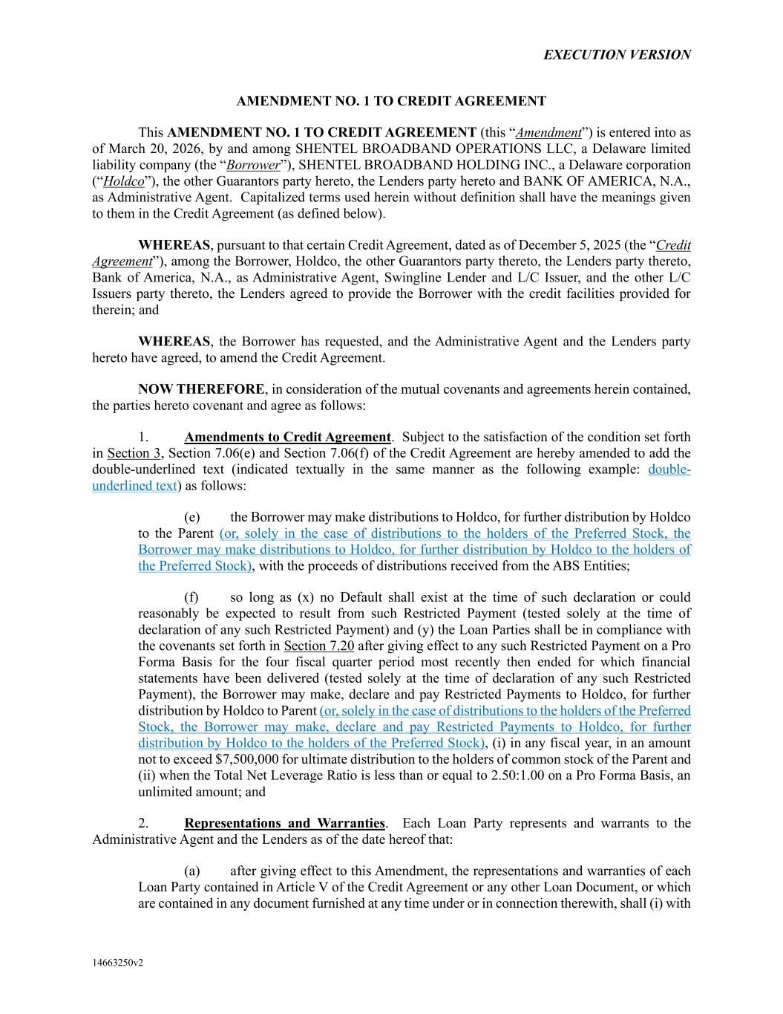
32
EXECUTION VERSION 14663250v2 AMENDMENT NO. 1 TO CREDIT AGREEMENT This AMENDMENT NO. 1 TO CREDIT AGREEMENT (this “Amendment”) is entered into as of March 20, 2026, by and among SHENTEL BROADBAND OPERATIONS LLC, a Delaware limited liability company (the “Borrower”), SHENTEL BROADBAND HOLDING INC., a Delaware corporation (“Holdco”), the other Guarantors party hereto, the Lenders party hereto and BANK OF AMERICA, N.A., as Administrative Agent. Capitalized terms used herein without definition shall have the meanings given to them in the Credit Agreement (as defined below). WHEREAS, pursuant to that certain Credit Agreement, dated as of December 5, 2025 (the “Credit Agreement”), among the Borrower, Holdco, the other Guarantors party thereto, the Lenders party thereto, Bank of America, N.A., as Administrative Agent, Swingline Lender and L/C Issuer, and the other L/C Issuers party thereto, the Lenders agreed to provide the Borrower with the credit facilities provided for therein; and WHEREAS, the Borrower has requested, and the Administrative Agent and the Lenders party hereto have agreed, to amend the Credit Agreement. NOW THEREFORE, in consideration of the mutual covenants and agreements herein contained, the parties hereto covenant and agree as follows: 1. Amendments to Credit Agreement. Subject to the satisfaction of the condition set forth in Section 3, Section 7.06(e) and Section 7.06(f) of the Credit Agreement are hereby amended to add the double-underlined text (indicated textually in the same manner as the following example: double- underlined text) as follows: (e) the Borrower may make distributions to Holdco, for further distribution by Holdco to the Parent (or, solely in the case of distributions to the holders of the Preferred Stock, the Borrower may make distributions to Holdco, for further distribution by Holdco to the holders of the Preferred Stock), with the proceeds of distributions received from the ABS Entities; (f) so long as (x) no Default shall exist at the time of such declaration or could reasonably be expected to result from such Restricted Payment (tested solely at the time of declaration of any such Restricted Payment) and (y) the Loan Parties shall be in compliance with the covenants set forth in Section 7.20 after giving effect to any such Restricted Payment on a Pro Forma Basis for the four fiscal quarter period most recently then ended for which financial statements have been delivered (tested solely at the time of declaration of any such Restricted Payment), the Borrower may make, declare and pay Restricted Payments to Holdco, for further distribution by Holdco to Parent (or, solely in the case of distributions to the holders of the Preferred Stock, the Borrower may make, declare and pay Restricted Payments to Holdco, for further distribution by Holdco to the holders of the Preferred Stock), (i) in any fiscal year, in an amount not to exceed $7,500,000 for ultimate distribution to the holders of common stock of the Parent and (ii) when the Total Net Leverage Ratio is less than or equal to 2.50:1.00 on a Pro Forma Basis, an unlimited amount; and 2. Representations and Warranties. Each Loan Party represents and warrants to the Administrative Agent and the Lenders as of the date hereof that: (a) after giving effect to this Amendment, the representations and warranties of each Loan Party contained in Article V of the Credit Agreement or any other Loan Document, or which are contained in any document furnished at any time under or in connection therewith, shall (i) with

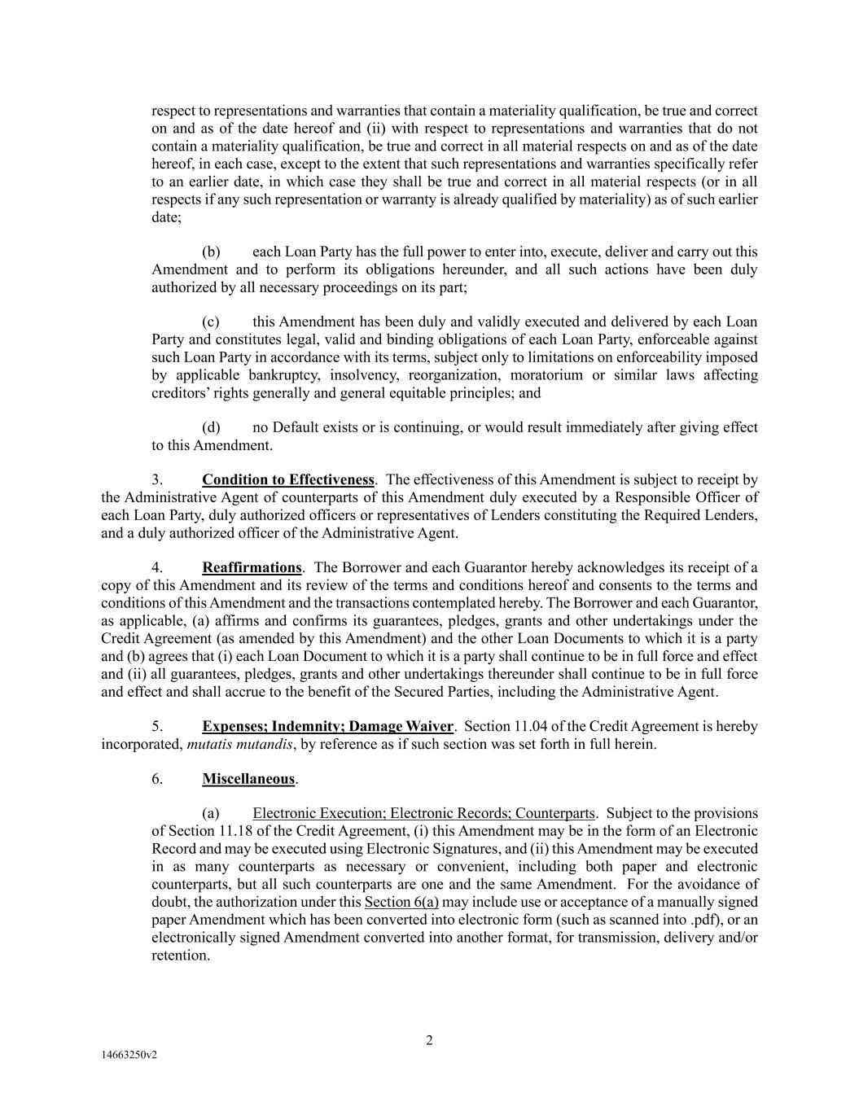
2 14663250v2 respect to representations and warranties that contain a materiality qualification, be true and correct on and as of the date hereof and (ii) with respect to representations and warranties that do not contain a materiality qualification, be true and correct in all material respects on and as of the date hereof, in each case, except to the extent that such representations and warranties specifically refer to an earlier date, in which case they shall be true and correct in all material respects (or in all respects if any such representation or warranty is already qualified by materiality) as of such earlier date; (b) each Loan Party has the full power to enter into, execute, deliver and carry out this Amendment and to perform its obligations hereunder, and all such actions have been duly authorized by all necessary proceedings on its part; (c) this Amendment has been duly and validly executed and delivered by each Loan Party and constitutes legal, valid and binding obligations of each Loan Party, enforceable against such Loan Party in accordance with its terms, subject only to limitations on enforceability imposed by applicable bankruptcy, insolvency, reorganization, moratorium or similar laws affecting creditors’ rights generally and general equitable principles; and (d) no Default exists or is continuing, or would result immediately after giving effect to this Amendment. 3. Condition to Effectiveness. The effectiveness of this Amendment is subject to receipt by the Administrative Agent of counterparts of this Amendment duly executed by a Responsible Officer of each Loan Party, duly authorized officers or representatives of Lenders constituting the Required Lenders, and a duly authorized officer of the Administrative Agent. 4. Reaffirmations. The Borrower and each Guarantor hereby acknowledges its receipt of a copy of this Amendment and its review of the terms and conditions hereof and consents to the terms and conditions of this Amendment and the transactions contemplated hereby. The Borrower and each Guarantor, as applicable, (a) affirms and confirms its guarantees, pledges, grants and other undertakings under the Credit Agreement (as amended by this Amendment) and the other Loan Documents to which it is a party and (b) agrees that (i) each Loan Document to which it is a party shall continue to be in full force and effect and (ii) all guarantees, pledges, grants and other undertakings thereunder shall continue to be in full force and effect and shall accrue to the benefit of the Secured Parties, including the Administrative Agent. 5. Expenses; Indemnity; Damage Waiver. Section 11.04 of the Credit Agreement is hereby incorporated, mutatis mutandis, by reference as if such section was set forth in full herein. 6. Miscellaneous. (a) Electronic Execution; Electronic Records; Counterparts. Subject to the provisions of Section 11.18 of the Credit Agreement, (i) this Amendment may be in the form of an Electronic Record and may be executed using Electronic Signatures, and (ii) this Amendment may be executed in as many counterparts as necessary or convenient, including both paper and electronic counterparts, but all such counterparts are one and the same Amendment. For the avoidance of doubt, the authorization under this Section 6(a) may include use or acceptance of a manually signed paper Amendment which has been converted into electronic form (such as scanned into .pdf), or an electronically signed Amendment converted into another format, for transmission, delivery and/or retention.

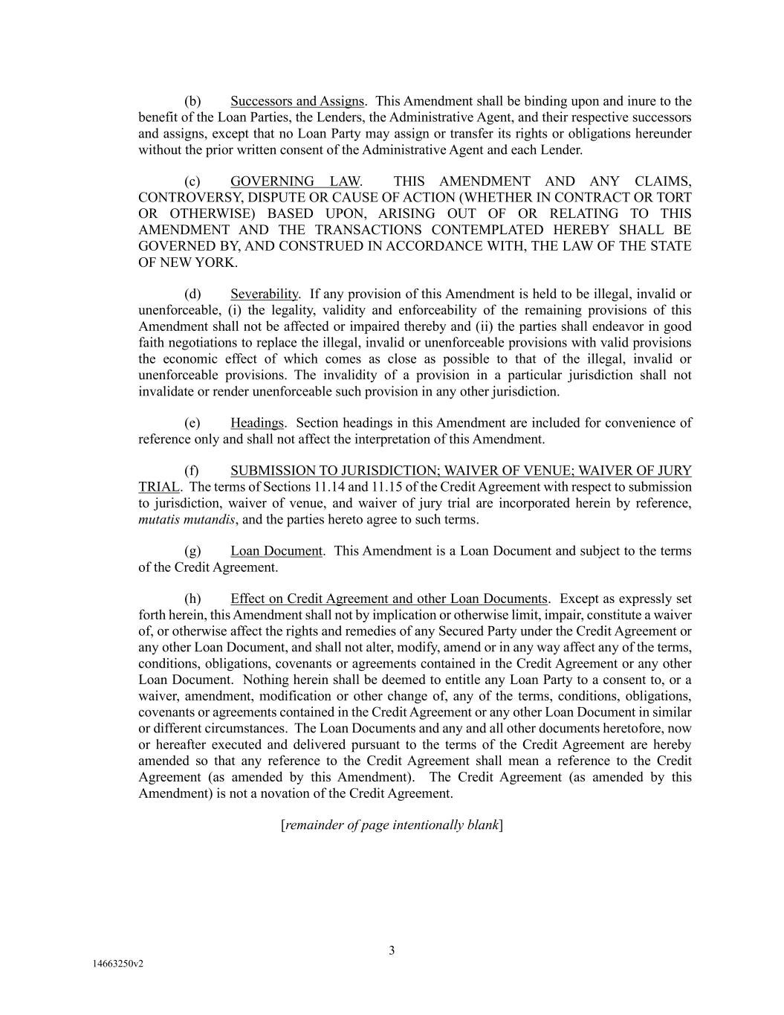
3 14663250v2 (b) Successors and Assigns. This Amendment shall be binding upon and inure to the benefit of the Loan Parties, the Lenders, the Administrative Agent, and their respective successors and assigns, except that no Loan Party may assign or transfer its rights or obligations hereunder without the prior written consent of the Administrative Agent and each Lender. (c) GOVERNING LAW. THIS AMENDMENT AND ANY CLAIMS, CONTROVERSY, DISPUTE OR CAUSE OF ACTION (WHETHER IN CONTRACT OR TORT OR OTHERWISE) BASED UPON, ARISING OUT OF OR RELATING TO THIS AMENDMENT AND THE TRANSACTIONS CONTEMPLATED HEREBY SHALL BE GOVERNED BY, AND CONSTRUED IN ACCORDANCE WITH, THE LAW OF THE STATE OF NEW YORK. (d) Severability. If any provision of this Amendment is held to be illegal, invalid or unenforceable, (i) the legality, validity and enforceability of the remaining provisions of this Amendment shall not be affected or impaired thereby and (ii) the parties shall endeavor in good faith negotiations to replace the illegal, invalid or unenforceable provisions with valid provisions the economic effect of which comes as close as possible to that of the illegal, invalid or unenforceable provisions. The invalidity of a provision in a particular jurisdiction shall not invalidate or render unenforceable such provision in any other jurisdiction. (e) Headings. Section headings in this Amendment are included for convenience of reference only and shall not affect the interpretation of this Amendment. (f) SUBMISSION TO JURISDICTION; WAIVER OF VENUE; WAIVER OF JURY TRIAL. The terms of Sections 11.14 and 11.15 of the Credit Agreement with respect to submission to jurisdiction, waiver of venue, and waiver of jury trial are incorporated herein by reference, mutatis mutandis, and the parties hereto agree to such terms. (g) Loan Document. This Amendment is a Loan Document and subject to the terms of the Credit Agreement. (h) Effect on Credit Agreement and other Loan Documents. Except as expressly set forth herein, this Amendment shall not by implication or otherwise limit, impair, constitute a waiver of, or otherwise affect the rights and remedies of any Secured Party under the Credit Agreement or any other Loan Document, and shall not alter, modify, amend or in any way affect any of the terms, conditions, obligations, covenants or agreements contained in the Credit Agreement or any other Loan Document. Nothing herein shall be deemed to entitle any Loan Party to a consent to, or a waiver, amendment, modification or other change of, any of the terms, conditions, obligations, covenants or agreements contained in the Credit Agreement or any other Loan Document in similar or different circumstances. The Loan Documents and any and all other documents heretofore, now or hereafter executed and delivered pursuant to the terms of the Credit Agreement are hereby amended so that any reference to the Credit Agreement shall mean a reference to the Credit Agreement (as amended by this Amendment). The Credit Agreement (as amended by this Amendment) is not a novation of the Credit Agreement. [remainder of page intentionally blank]

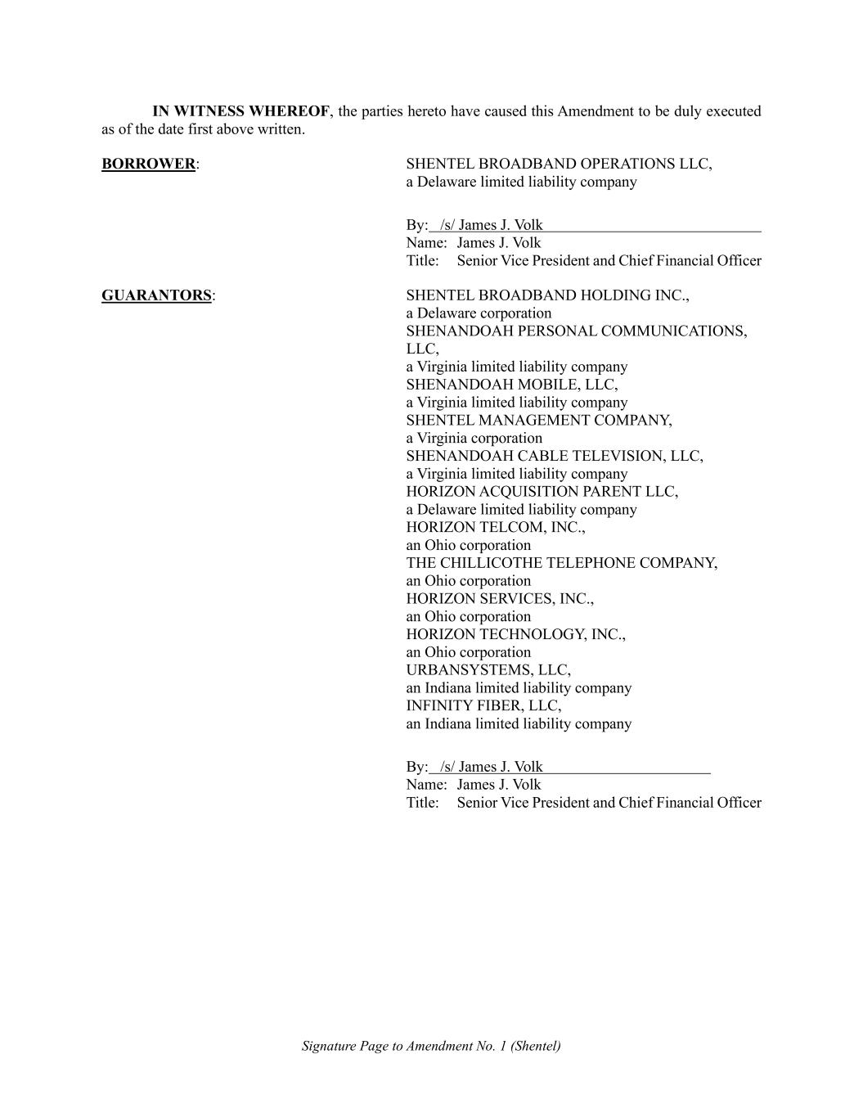
Signature Page to Amendment No. 1 (Shentel) IN WITNESS WHEREOF, the parties hereto have caused this Amendment to be duly executed as of the date first above written. BORROWER: SHENTEL BROADBAND OPERATIONS LLC, a Delaware limited liability company By: /s/ James J. Volk Name: James J. Volk Title: Senior Vice President and Chief Financial Officer GUARANTORS: SHENTEL BROADBAND HOLDING INC., a Delaware corporation SHENANDOAH PERSONAL COMMUNICATIONS, LLC, a Virginia limited liability company SHENANDOAH MOBILE, LLC, a Virginia limited liability company SHENTEL MANAGEMENT COMPANY, a Virginia corporation SHENANDOAH CABLE TELEVISION, LLC, a Virginia limited liability company HORIZON ACQUISITION PARENT LLC, a Delaware limited liability company HORIZON TELCOM, INC., an Ohio corporation THE CHILLICOTHE TELEPHONE COMPANY, an Ohio corporation HORIZON SERVICES, INC., an Ohio corporation HORIZON TECHNOLOGY, INC., an Ohio corporation URBANSYSTEMS, LLC, an Indiana limited liability company INFINITY FIBER, LLC, an Indiana limited liability company By: /s/ James J. Volk Name: James J. Volk Title: Senior Vice President and Chief Financial Officer

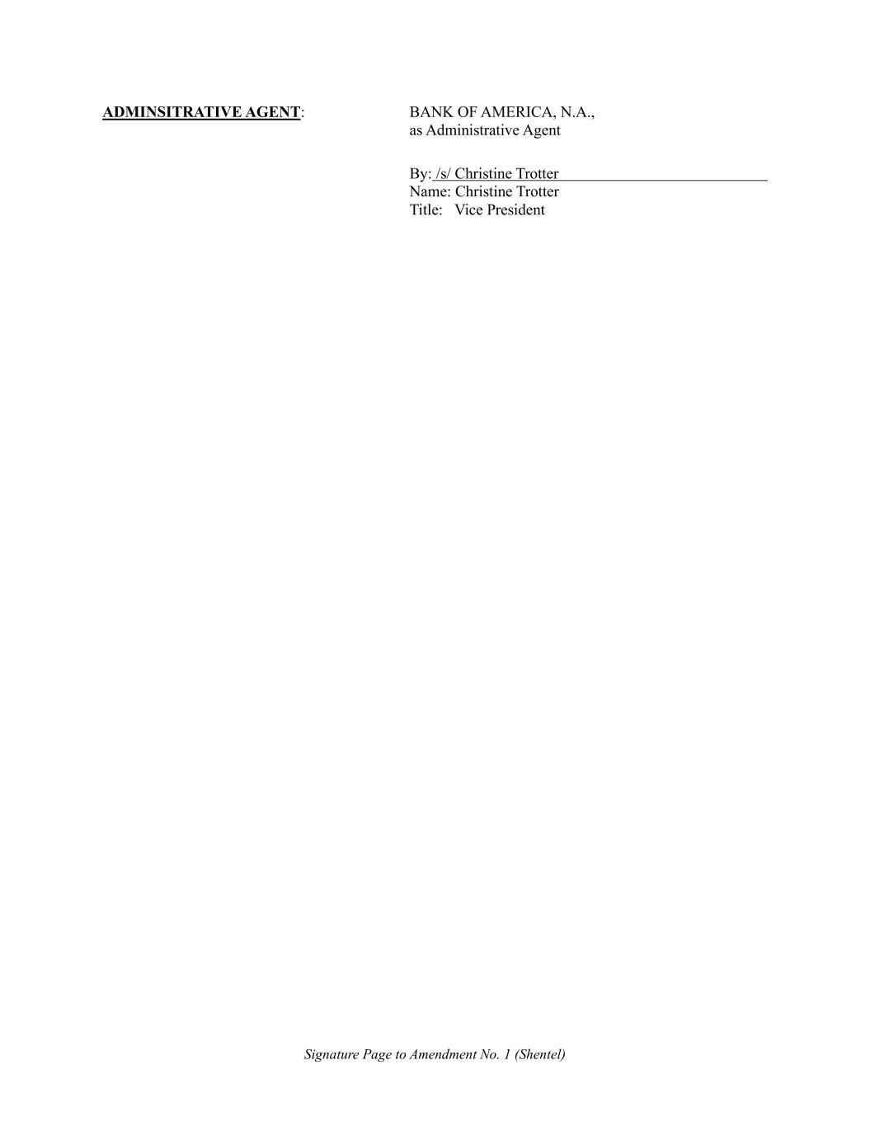
Signature Page to Amendment No. 1 (Shentel) ADMINSITRATIVE AGENT: BANK OF AMERICA, N.A., as Administrative Agent By: /s/ Christine Trotter Name: Christine Trotter Title: Vice President

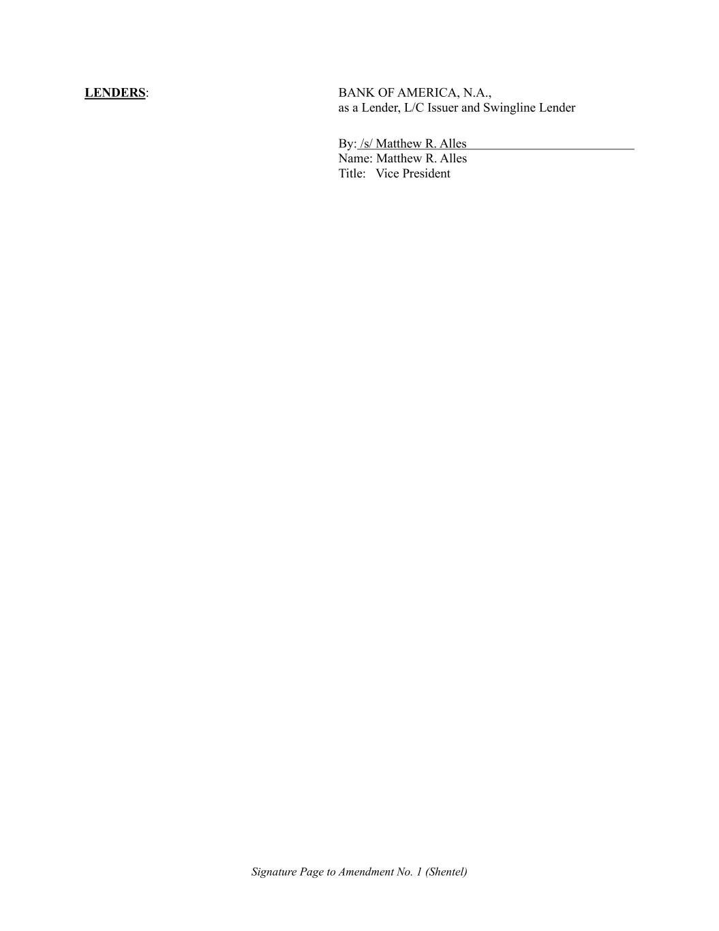
Signature Page to Amendment No. 1 (Shentel) LENDERS: BANK OF AMERICA, N.A., as a Lender, L/C Issuer and Swingline Lender By: /s/ Matthew R. Alles Name: Matthew R. Alles Title: Vice President


Signature Page to Amendment No. 1 (Shentel) CITIZENS BANK, N.A., as a Lender By: /s/ Robert Maddox Name: Robert Maddox Title: Senior Vice President


Signature Page to Amendment No. 1 (Shentel) FIFTH THIRD BANK, NATIONAL ASSOCIATION, as a Lender By: /s/ Nick Meece Name: Nick Meece Title: Principal


Signature Page to Amendment No. 1 (Shentel) TRUIST BANK, as a Lender By: /s/ J. Matthew Rowand Name: J. Matthew Rowand Title: Director


Signature Page to Amendment No. 1 (Shentel) MORGAN STANLEY SENIOR FUNDING, INC., as a Lender By: /s/ Atu Koffie-Lart Name: Atu Koffie-Lart Title: Vice President


Signature Page to Amendment No. 1 (Shentel) COBANK, ACB, as a Lender and, solely with respect to the Existing Letters of Credit, as L/C Issuer By: /s/ K. Cameron Dawkins Name: K. Cameron Dawkins Title: Managing Director

EXHIBIT 31.1

CERTIFICATION

I, Edward H. McKay, certify that:

1.I have reviewed this quarterly report on Form 10-Q of Shenandoah Telecommunications Company;
2.Based on my knowledge, this report does not contain any untrue statement of a material fact or omit to state a material fact necessary to make the statements made, in light of the circumstances under which such statements were made, not misleading with respect to the period covered by this report;
3.Based on my knowledge, the financial statements, and other financial information included in this report, fairly present in all material respects the financial condition, results of operations and cash flows of the registrant as of, and for, the periods presented in this report;
4.The registrant’s other certifying officer(s) and I are responsible for establishing and maintaining disclosure controls and procedures (as defined in Exchange Act Rules 13a-15(e) and 15d-15(e)) and internal control over financial reporting (as defined in Exchange Act Rules 13a-15(f) and 15d-15(f)) for the registrant and have:

(1)Designed such disclosure controls and procedures, or caused such disclosure controls and procedures to be designed under our supervision, to ensure that material information relating to the registrant, including its consolidated subsidiaries, is made known to us by others within those entities, particularly during the period in which this report is being prepared;
(2)Designed such internal control over financial reporting, or caused such internal control over financial reporting to be designed under our supervision, to provide reasonable assurance regarding the reliability of financial reporting and the preparation of financial statements for external purposes in accordance with generally accepted accounting principles;
(3)Evaluated the effectiveness of the registrant’s disclosure controls and procedures and presented in this report our conclusions about the effectiveness of the disclosure controls and procedures, as of the end of the period covered by this report based on such evaluation; and
(4)Disclosed in this report any change in the registrant’s internal control over financial reporting that occurred during the registrant’s most recent fiscal quarter (the registrant’s fourth fiscal quarter in the case of an annual report) that has materially affected, or is reasonably likely to materially affect, the registrant’s internal control over financial reporting; and
5.The registrant’s other certifying officer(s) and I have disclosed, based on our most recent evaluation of internal control over financial reporting, to the registrant’s auditors and the audit committee of the registrant’s board of directors (or persons performing the equivalent functions):

(1)All significant deficiencies and material weaknesses in the design or operation of internal control over financial reporting which are reasonably likely to adversely affect the registrant’s ability to record, process, summarize and report financial information; and
(2)Any fraud, whether or not material, that involves management or other employees who have a significant role in the registrant’s internal control over financial reporting.

/S/ EDWARD H. MCKAY
Edward H. McKay, President and Chief Executive Officer
(Principal Executive Officer)
Date: May 1, 2026

EXHIBIT 31.2

CERTIFICATION

I, James J. Volk, certify that:
1.I have reviewed this quarterly report on Form 10-Q of Shenandoah Telecommunications Company;
2.Based on my knowledge, this report does not contain any untrue statement of a material fact or omit to state a material fact necessary to make the statements made, in light of the circumstances under which such statements were made, not misleading with respect to the period covered by this report;
3.Based on my knowledge, the financial statements, and other financial information included in this report, fairly present in all material respects the financial condition, results of operations and cash flows of the registrant as of, and for, the periods presented in this report;
4.The registrant’s other certifying officer(s) and I are responsible for establishing and maintaining disclosure controls and procedures (as defined in Exchange Act Rules 13a-15(e) and 15d-15(e)) and internal control over financial reporting (as defined in Exchange Act Rules 13a-15(f) and 15d-15(f)) for the registrant and have:

(1)Designed such disclosure controls and procedures, or caused such disclosure controls and procedures to be designed under our supervision, to ensure that material information relating to the registrant, including its consolidated subsidiaries, is made known to us by others within those entities, particularly during the period in which this report is being prepared;
(2)Designed such internal control over financial reporting, or caused such internal control over financial reporting to be designed under our supervision, to provide reasonable assurance regarding the reliability of financial reporting and the preparation of financial statements for external purposes in accordance with generally accepted accounting principles;
(3)Evaluated the effectiveness of the registrant’s disclosure controls and procedures and presented in this report our conclusions about the effectiveness of the disclosure controls and procedures, as of the end of the period covered by this report based on such evaluation; and
(4)Disclosed in this report any change in the registrant’s internal control over financial reporting that occurred during the registrant’s most recent fiscal quarter (the registrant’s fourth fiscal quarter in the case of an annual report) that has materially affected, or is reasonably likely to materially affect, the registrant’s internal control over financial reporting; and
(5)The registrant’s other certifying officer(s) and I have disclosed, based on our most recent evaluation of internal control over financial reporting, to the registrant’s auditors and the audit committee of the registrant’s board of directors (or persons performing the equivalent functions):

(1)All significant deficiencies and material weaknesses in the design or operation of internal control over financial reporting which are reasonably likely to adversely affect the registrant’s ability to record, process, summarize and report financial information; and
(2)Any fraud, whether or not material, that involves management or other employees who have a significant role in the registrant’s internal control over financial reporting.

/s/JAMES J. VOLK
James J. Volk, Senior Vice President – Chief Financial Officer
(Principal Financial Officer)
Date: May 1, 2026

EXHIBIT 31.3

CERTIFICATION

I, Tracy Willis, certify that:
1.I have reviewed this quarterly report on Form 10-Q of Shenandoah Telecommunications Company;
2.Based on my knowledge, this report does not contain any untrue statement of a material fact or omit to state a material fact necessary to make the statements made, in light of the circumstances under which such statements were made, not misleading with respect to the period covered by this report;
3.Based on my knowledge, the financial statements, and other financial information included in this report, fairly present in all material respects the financial condition, results of operations and cash flows of the registrant as of, and for, the periods presented in this report;
4.The registrant’s other certifying officer(s) and I are responsible for establishing and maintaining disclosure controls and procedures (as defined in Exchange Act Rules 13a-15(e) and 15d-15(e)) and internal control over financial reporting (as defined in Exchange Act Rules 13a-15(f) and 15d-15(f)) for the registrant and have:

(1)Designed such disclosure controls and procedures, or caused such disclosure controls and procedures to be designed under our supervision, to ensure that material information relating to the registrant, including its consolidated subsidiaries, is made known to us by others within those entities, particularly during the period in which this report is being prepared;
(2)Designed such internal control over financial reporting, or caused such internal control over financial reporting to be designed under our supervision, to provide reasonable assurance regarding the reliability of financial reporting and the preparation of financial statements for external purposes in accordance with generally accepted accounting principles;
(3)Evaluated the effectiveness of the registrant’s disclosure controls and procedures and presented in this report our conclusions about the effectiveness of the disclosure controls and procedures, as of the end of the period covered by this report based on such evaluation; and
(4)Disclosed in this report any change in the registrant’s internal control over financial reporting that occurred during the registrant’s most recent fiscal quarter (the registrant’s fourth fiscal quarter in the case of an annual report) that has materially affected, or is reasonably likely to materially affect, the registrant’s internal control over financial reporting; and
5.The registrant’s other certifying officer(s) and I have disclosed, based on our most recent evaluation of internal control over financial reporting, to the registrant’s auditors and the audit committee of the registrant’s board of directors (or persons performing the equivalent functions):

(1)All significant deficiencies and material weaknesses in the design or operation of internal control over financial reporting which are reasonably likely to adversely affect the registrant’s ability to record, process, summarize and report financial information; and
(2)Any fraud, whether or not material, that involves management or other employees who have a significant role in the registrant’s internal control over financial reporting.

/S/TRACY WILLIS
Tracy Willis, Vice President - Chief Accounting Officer
(Principal Accounting Officer)
Date: May 1, 2026

EXHIBIT 32

Written Statement of Chief Executive Officer and Chief Financial Officer
Pursuant to Section 906 of the Sarbanes-Oxley Act of 2002

Each of the undersigned, the President and Chief Executive Officer and the Senior Vice President - Chief Financial Officer, of Shenandoah Telecommunications Company (the “Company”), hereby certifies that, on the date hereof:

(1) The quarterly report on Form 10-Q of the Company for the three months ended March 31, 2026 filed on the date hereof with the Securities and Exchange Commission (the “Report”) fully complies with the requirements of Section 13(a) or 15(d) of the Securities Exchange Act of 1934; and

(2) Information contained in the Report fairly presents, in all material respects, the financial condition and result of operations of the Company.

/S/EDWARD H. MCKAY
Edward H. McKay
President and Chief Executive Officer
(Principal Executive Officer)
May 1, 2026
/S/JAMES J. VOLK
James J. Volk
Senior Vice President – Chief Financial Officer
(Principal Financial Officer)
May 1, 2026

The foregoing certification is being furnished solely pursuant to Rule 13a-14(b) under the Securities Exchange Act of 1934 (the “Exchange Act”) and 18 U.S.C. Section 1350 and is not being filed as part of the Report or as a separate disclosure document. This certification shall not be deemed “filed” for purposes of Section 18 of the Exchange Act or otherwise subject to liability under that section. This certification shall not be deemed to be incorporated by reference into any filing under the Securities Act of 1933 or the Exchange Act except to the extent this Exhibit 32 is expressly and specifically incorporated by reference in any such filing.

